Serena Jonathan - 2306363
2306363@student.uwtsd.ac.uk
Research, and case scenario in Data Security and Compliance
L5 - Data Security and Compliance (FT - ACCA5034)

Table of Contents
Table of Contents 1
Table of Figures 1
List of Acronyms 2
RESEARCH, AND CASE SCENARIO IN DATA SECURITY AND COMPLIANCE 3
Task 1 3
Security Technologies such as Firewalls, access controls, VPNs, etc. 3
Introduction 3
Types of Security Technologies 3
How these Security Technologies Protect, Detect, React and Safeguards organisations 4
i. Firewalls 4
ii. Access Controls 4
iii. VPNs 5
iv. Intrusion Detection Systems 6
Conclusion 7
Task 2 7
Introduction 7
My Approach 8
Organisation Structure 8
Policies and Procedures 9
Compliance: Law and Ethics 11
Governance and Strategic Planning for Security 13
Risk Management and Protection Mechanisms 17
Contingencies Planning 17
Recommendation 17
Conclusion 18
Bibliography 18

Table of Figures
Figure 1. Firewall Filtering Traffic [5] 3
Figure 2. Characteristic of MAC and DAC[10] 5
Figure 3. Improving Security is the Most Common Reason People Purchase a VPN[13] 5
Figure 4. How a VPN Works [14] 5
Figure 5. The Process of IDS [16] 6
Figure 6. Information Technology Organisation Chart [20] 8
Figure 7. Seven Phases of Incident Response Plan [22] 10
Figure 8. What does the CISO usually do?[28] 12
Figure 9. Business Continuity Planning Process [31] 13
Figure 10. How to Write a Disaster Recovery Plan [33] 14
Figure 11. Disasters that May Call for DRP[34] 15

List of Acronyms
- IDS - Intrusion Detection Systems
- VPN - Virtual Private Network
- MAC - Mandatory Access Control
- DAC - Discretionary Access Control
- LAN - Local Area Network
- WAN - Wide Area Network
- CSS - CyStresSolution
- ISU - Information Security Unit
- IT - Information Technology
- CISO - Chief Information Security Officer
- HR - Human Resources
- VPN - Virtual Private Network
- SIEM - Security Information and Event Management
- BCP - Business Continuity Plan
- DRP - Disaster Recovery Plan
- NIST - National Institute of Standards and Technology
- IEC - International Electrotechnical Commission
- ISO - International Organization for Standardization
- GDPR - General Data Protection Regulation
- LAN - Local Area Network
- BIA - Business Impact Analysis
- CCTV - Closed Circuit Television
- FBI - Federal Bureau of Investigation
- CIA - Central Intelligence Agency
- ITSM - IT Service Management
- PAM - Privileged Access Management
- IAM - Identity and Access Management
- IDS - Intrusion Detection System
- IPS - Intrusion Prevention System
- DLP - Data Loss Prevention
- AES - Advanced Encryption Standard
- TTPs - Tactics, Techniques, and Procedures
- RAT - Remote Access Trojan
- NAC - Network Access Control
- RAT - Remote Access Trojan
- SOC - Security Operations Centre

RESEARCH, AND CASE SCENARIO IN DATA SECURITY AND COMPLIANCE
Serena C Jonathan
Student University of Wales Trinity St David, Swansea, Wales
2306363@student.uwtsd.ac.uk

Task 1
Abstract- This paper will discuss various security technologies, including firewalls, access controls, VPNs, and Intrusion Detection Systems (IDS). It presents research on how these security systems help organisations protect their data. These technologies safeguard against unauthorised access, detect potential security threats, and provide quick and effective responses to risk alerts. These security technologies’ role is to secure networks and sensitive data. The paper will explore this, focusing on their features for protection, detection, and reaction to cyber-attacks.

Security Technologies such as Firewalls, access controls, VPNs, etc.

Introduction
Security technologies are components and policies put in place to secure data, property, and assets. These security technologies can assist by only allowing authorised access, identifying potential attacks, and initiating fast responses when issues arise. This discourages criminal activity and obtains important evidence if a breach occurs. [1]

Types of Security Technologies
One type of these technologies includes firewalls. A firewall is a network security system that examines incoming and outgoing traffic. It controls access by permitting or blocking data based on security policies that have been established by the organisation. [2]
Another type would be access controls. Access controls decipher who gains access to specific data, applications and resources as well as how much authority they will have when they do so. They control who has access to the digital environment, much like keys in the physical world. Access controls use techniques such as authentication and authorisation to verify the identity of a user and the level of access they should have. This is based on features such as device, location, role, and other factors.[3]
A third type would be VPNs. A VPN is a function that protects your internet connection and privacy when surfing the web. It stands for “Virtual Private Network”. A VPN offers protection by creating an encrypted tunnel for the user’s data, protecting their identity online. It hides the user’s IP address, making public Wi-Fi safe for the user to use as private information such as their bank card details will also be hidden.[4]
These are just a few examples, there are many more notable security technologies such as Intrusion Detection Systems (IDS) and encryption.

How these Security Technologies Protect, Detect, React and Safeguards organisations

Firewalls
Firewalls help protect an organisation’s IT infrastructure as they are the first stage of defence within the hardware or software. As the below figure shows, a firewall is used to filter traffic coming from outside untrusted networks into the inside, trusted network.
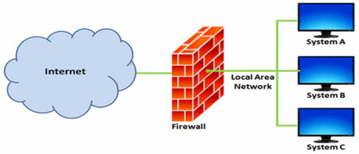
Figure 1. Firewall Filtering Traffic [5]
Firewalls have many processing modes. Some of these include packet filtering, application layer proxy, MAC layer firewall and hybrids. However, most organisations will have a single firewall that conducts all the above functions. [6]
A firewall can detect suspicious activity as it inspects all traffic before allowing it to pass into the LAN. It compares the data to a threat database and inspects its origin and the port it utilises as well as the application it is associated with.[7] It will depend on the policies set by the organisation, but if the data seems innocent, the firewall will allow it to enter the WAN. However, if the firewall detects unusual activity such as malware, it will shut it down.[8]
Without firewalls, computers within an organisations network could be susceptible to cyber-attacks, thus making it a great tool for protection and detection of threat. However, the organisation may find it difficult to choose the correct firewall for their needs. It will depend on the business and how they operate, such as if they have an onsite team or if they will need to outsource to build a firewall. There needs to be a perfect balance between cost and protection for the organisation. Although, data security is crucial, it can often be challenging to convince management to spend the revenue needed for top grade security.[6]

Access Controls
Access controls assist with protecting organisations’ data as it ensures that only verified users can access data. It protects the organisation’s building, employees, data and assets by reducing the risk of unauthorised trespassers. [9] Even within the organisation there will be less chance of a breech between departments. For example, the Finance team will have access to the business’ finance data but no access at all the HR’s department’s data. Thus, access control is a selective method of security.
There are various types of access controls. These include MAC, DAC and nondiscretionary control. MAC stands for Mandatory Access Control. It is a structured and strict verification scheme that deciphers what users are allowed to access depending on their credentials and preassigned levels. As it is a structured, strict and automated system, it is often used within organisations such as the military. [6]
DAC stands for Discretionary access controls. It is access controls that are implemented at the discretion of another user. An example of this would be when a smartphone applications requests permission from the user to access their camera, the app can only do so under the user’s discretion. DAC provide organisations protection by ensuring there is no cross contamination of data between departments and adding an extra layer of security. This is because it can hide certain attributes such as the size of the file or file path. [10] This offers organisation a lot of flexibility and an element of security. However, as shown in the below table it offers less security than MAC as users can share data without oversight so there is added insider risk. Thus, it is better suited for small companies rather than large organisations.
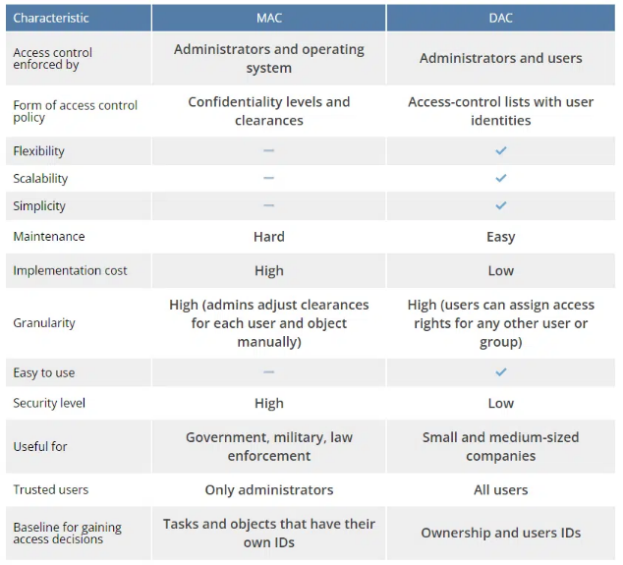
Figure 2. Characteristic of MAC and DAC [10]
Thirdly, nondiscretionary controls are access controls that are implemented by a central authority. This means that access is granted or denied based on policies rather than by discretion of users.[11]
Overall, all types of access control lean on four mechanisms which show four important features. These include identification, authentication, authorisation and accountability. Although access controls can protect assets, provide management with flexibility and authority while also protecting sensitive data, they can also be complicated to implement and maintain because they require constant updates to align with changing user roles, policies, and organisational needs

VPNs
VPNs protect organisations’ data by ensuring that confidential data is kept private even on public networks such as free Wi-Fi in public places.
It is very popular among networking and telecommunications organisations as it is a cost-effective security technology, and it can be challenging to convince management to invest more in security. VPNs use open networks to create highly secure communication channels between large organisations, isolated sites, and individual users.[12] The below figure presents VPN’s popularity especially with the purpose of data security.
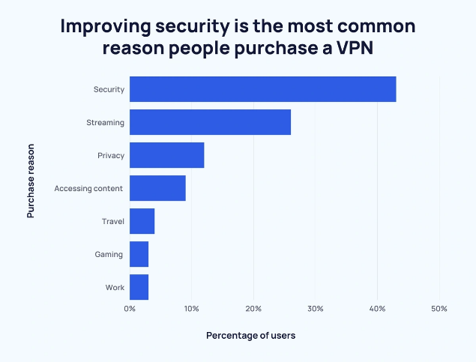
Figure 3. Improving Security is the Most Common Reason People Purchase a VPN [13]
As shown, Figure 3 shows that the most common use of a VPN is for data security. VPNs safeguard sensitive data with the use of encryption and hides the user’s IP address. With a VPN, cyber criminals will be unable to decipher the data, even those with access to the network the organisation is using. [7] This process is represented in the diagram below: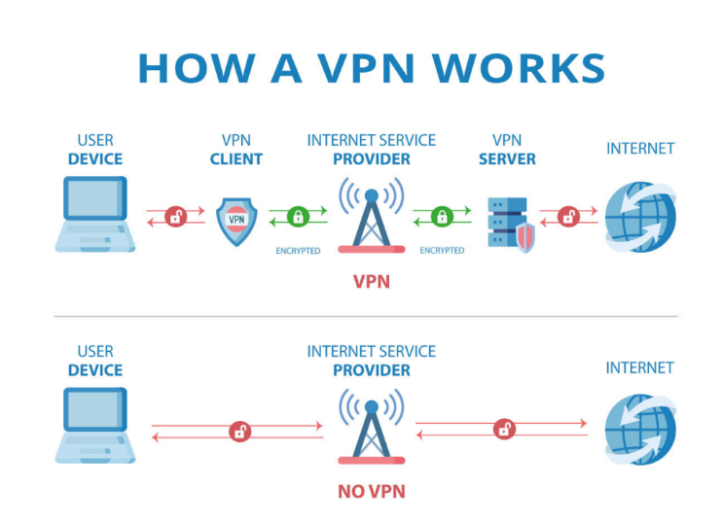
Figure 4. How a VPN Works [14]
There are three main types of VPNs: Trusted VPNs (using private dedicated lines), Secure VPNs which use encryption, and Hybrid VPNs, which are a combining of both.[6] As stated, VPNs transform the open Internet into a private network through two modes of operation. One of these include Transport Mode. This is where only the data inside the IP packets is encrypted, making it suitable for end-to-end encryption or remote worker access. This is very effective for organisations as many have employees that work remotely. Thus, a VPN is advantageous for remote workers to ensure the data they utilise remains secure and confidential.
The other mode is Tunnel Mode. This is when the whole data package is encrypted to ensure that no if there are any trespassers then data is still hidden and protected. This is perfect for organisations with employees that work online a lot and may be using unsecured networks such as public Wi-Fi in coffee shops.[7]
Overall, VPNs have become a crucial tool for protecting user’s IP addresses and sensitive data, especially proving useless for those who work remotely. However, because of the process of encryption it may slow down the connection and they will not protect the user from voluntarily offering data to sites such as Google or Facebook for example.

Intrusion Detection Systems
Intrusion Detection Systems (IDS) scan all incoming and outgoing traffic to identify if any suspicious activity is occurring. This can include strange activity. Its main goal is to identify any possible data breaches from outside the organisation or from within the organisation such as misuse of data by a disgruntled employee who is keen to sabotage.[15]
As IDS is constantly scanning the incoming and outgoing traffic it can detect threats within an organisation easily. As it gets to know the nature of the network, it is quickly able to pick up on any abnormal patterns or known attack signatures, as presented within the flowchart below.
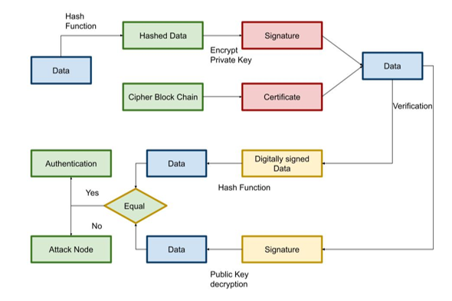
Figure 5. The Process of IDS [16]
As shown in the above figure, IDS uses methods such as signature-based detection. It does this by comparing the traffic against a database of known threats. It also uses anomaly-based detection which ensures to raise concern when suspicious behaviour is spotted. It does this by surveying logs, network packets and systems event in present time. It detects unauthorised access, malware and unusual activity and alerts the administrators to prompt reaction to the attack, minimising the anticipated damage.[17]
Once a threat is detected, it sets off an alarm to alert that there has been a breech. It reacts by blocking the intruder or blocking the server to protect the organisation’s data.[18]
Thus, organisations would benefit from IDS as it safeguards data by constantly monitoring traffic and sending out alerts when unusual activity is spotted and blocks access. However, IDS can be memory intensive. Furthermore, if an attack is within the organisation’s generally accepted protocol behaviour it may potentially enter.
Lastly, every organisation will have unique policies and protocol implementation from one another or even from operating system to operating systems within the same organisation. A protocol implementation is the undertaking of designing, coding, and deploying a set of rules and policies to confirm communication between systems, devices and software operates as designed. Thus, a drawback of the IDS security system would be that if an organisation’s protocol implementation varies from operating system to operating system, then IDS may not detect intrusions effectively and threats and attacks will go amiss. [17]

Conclusion
In conclusion, security technologies such as firewalls, access controls, VPNs, and IDS play a crucial role in safeguarding organisations' data and providing security. Firewalls act as the first line of defence by filtering and monitoring network traffic, while access controls ensure only authorised users have the necessary access to sensitive data. Additionally, VPNs provide secure communication when using public Wi-Fi, which is particularly beneficial for remote workers. Also, IDS continuously monitor for suspicious activity to identify and alert administration about potential threats. Together, these security technologies enhance an organisation's ability to protect, detect, and react to security risks, though their effectiveness depends on careful implementation, regular updates, and alignment with organisational policies.

‌

Task 2

Introduction
This assignment will cover a thorough and thoughtful approach for creating and implementing a security unit within CyStresSolution (CSS). CyStresSolution are a fast-expanding threat intelligence and consultancy business who specialise in combatting cyber threats and attacks. This assignment will focus on a design for a security framework with the organisation’s structures and policies in mind. It will discuss way in which to approach implementing the security unit with an attitude of priority toward compliance, strategic planning, risk management, contingency planning and protection.

My Approach
It is crucial to cover all assets when creating an information security unit (ISU) for CyStresSolution. It must implement and enforce CSS’ policies and protect their assets. It will prevent unauthorised access and reduce the threat of cyber-attacks.

Organisation Structure
CSS should consider the structure of the company when creating a security unit to ensure that confidential employee and client data is safeguarded. Based on the case study given, it seems that CSS is a smaller sized company although it is fast growing, it is still a niche market and seems to find most of its clientele online.[19] Therefore, CSS should use a structural plan very similar to the one demonstrated within the below figure with regards to its organisation structure with an ISU in mind.
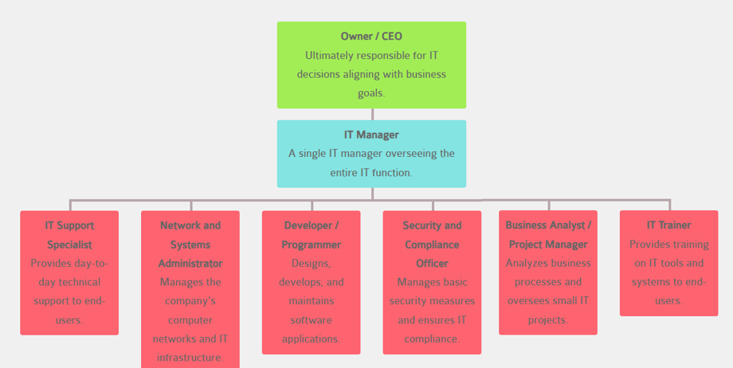
Figure 6. Information Technology Organisation Chart [20]
As demonstrated the CEO or owner of the company should be at the top of the chain. They will be responsible for overseeing decisions made by the IT department and ensure that the choices they make align with CSS’ policies and goals. Next, there is an IT Manager who is responsible for overseeing the members of the team. Underneath this role you will have the IT Support Specialist who is responsible for ensuring day-to-day business is running smoothly, offering support with computer systems and networks. [21] The team also includes a Network and Systems Administrator who manages and maintains the IT infrastructure. As well as a Software Developer who designs and optimises software applications. There is also a Security and Compliance Officer who ensures basic security measures are in place. Next there is the Business Analyst who evaluates processes to improve efficiency. Finally, there is the IT Trainer provides staff with the skills needed to use technology effectively.
The most important thing for CSS to remember is that their structure for the IT department should adapt and change as the business grows, to ensure a robust system to assist with data security.

Policies and Procedures
Every ISU plan should always align with the business’ policies and procedures. As CSS specialty is threat intelligence but also offer consultancy and cloud-based solutions, the ISU approach should mirror these objectives. Thus, the ISU should provide security for internal staff and networks as well as their customers.[1]
With a business like CSS, it is likely that they will have an access control policy. This policy is implemented with intent on restricting access to sensitive data based on individual’s roles within the business. Thus, CSS should have access controls put in place. Access controls will ensure that only verified users can access data. It protects the organisation’s data and assets by reducing the risk of unauthorised trespassers. For example, as stated in ‘Task 1’, only the HR team should be granted access to sensitive data such as medical records, whereas the Finance team should not, as it is irrelevant to their roles. [9]
Furthermore, an incident response plan should be put in place that clearly lays out a step-by-step plan for action if a cyber-attack was to take place. The below figure presents a seven-step plan for if an incident were to occur. It would be wise for CSS to take heed of this and conduct and similar plan themselves.
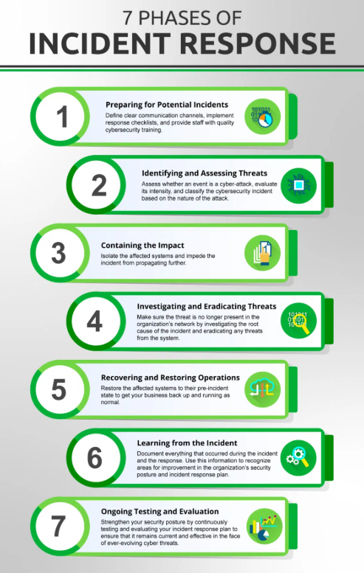

Figure 7. Seven Phases of Incident Response Plan [22]

The following proposal is a suggested incident response plan for CSS. [23]

- Preparation Stage - This stage occurs before an attack has occurred. At this stage, CSS should carry out a risk assessment to search for any vulnerabilities within their network and clearly establish their security policies. A firewall could be especially useful here as they filter the traffic coming in and out of the company’s network.[6] Security procedures should be developed at this stage and systems should be upgraded.

- Threat Identification Stage - The IT department should guard the alerts they receive indicating any unusual activity.[17] Some alerts may be false. However, as soon as a threat has been detected, the team should investigate the nature of it. They should uncover what type of threat it is; it’s source and its aim. Next, the team will communicate with stakeholders of the company and inform them of the next steps that should be taken.

- Threat Containment Stage – This is arguably the most important step; it includes containing the threat as soon as possible. The length of time that the attacker has access, correlates directly with the amount of damage they can inflict. The Security and Compliance Officer must act with haste to isolate any systems, applications or assets that are under attack from the networks. This is a preventative measure with the aim of denying the attacker access to any other parts of the organisation.

- Threat Elimination stage – This stage is where removal of the attacker and any malware they may have left behind takes place. The IT team may have to assist with taking systems offline and simultaneously inform stakeholder of their progress.

- Recovery and Restoration Stage – This stage may take several hours or more to complete depending on the severity of the attack. Once the threat has been eliminated the IT team will take the time to restore systems, recover data from backup and oversee any areas where the attacker has affected. This is to ensure the team remains on high alert, should the attacker return while also working to prevent this.

- Feedback and Refinement Stage – Once the threat has cleared and the data and network are secure once more, an evaluation will occur. This is where the team will assess their process and learn from their actions to identify if any improvements could be made should an attack occur again. This is to ensure CSS’ security is strengthened.
- Quality Assurance Stage – This stage is the final stage where testing takes place to ensure everything is running as expected and all data is safe from the wrong hands. Once satisfied with the quality of the performance and satisfied that the network is safe once more, the team will put the network back online.

Although these are the completed steps for incident response, CSS should know that these steps are a cycle, and the first stage of preparation should be revisited often based on any lessons learned from any attacks or any advancements in technology as the business grows and make changes accordingly.

Compliance: Law and Ethics
The ISU approach for CSS must comply with government laws and implement them throughout the company. Since CSS is a threat intelligence and consultancy business, it is crucial the internal processes of the business and the services they offer comply with the relevant laws and ethics standards. They should adhere to data protection laws.
Given CSS's role as a threat intelligence and consultancy provider, it is imperative that both the internal operations and the services offered to clients comply with relevant regulatory standards and frameworks. The Data Protection Act 2018 states how customer’s data can and should be used by businesses and the government. It states that customers have the right to any stored personal data, can have incorrect data corrected or even deleted upon request. [24] To comply with this, CSS can take various actions. For example, they could carry out regular audits and create Data Processing Agreements with stakeholders.[25]
CSS should also ensure that there are data security measures put in place so that sensitive data is not leaked. Encryption would be great for this. To achieve this, the use of VPNs would be optimal. A VPN is also likely to be popular with CSS’ CEO as they are cost-effective an efficient way of assisting with data security. VPNs use encryption to veil user’s data. Even unauthorised users with access to CSS’ network with be unable to decipher customers’ or workers’ data [7].
Furthermore, CSS should aim for an IEC 27001 certification as it is the standard organisations should aim for regarding data security. Although, it is not a legislation requirement, it is highly recommended and should be a part of the company’s policy. This is because this certificate would gain trust from customers and improve CSS’ reputation. It will also assist with identifying any weaknesses and help develop and establish strong security measures to protect against any cyber-attacks or breaches.[26]
Additionally, CSS should also consider the NIST (National Institute of Standards and Technology) Cybersecurity Framework. This is a great set of guidelines organisations use to manage their cybersecurity risks while also ensuring compliance with security standards. This framework helps identify, protect, detect, respond and recover. [27] Thus, it would be wise for CSS to use a firewall within their ISU.[6] Firewalls are the first stage of protection.[5] A firewall inspects all traffic, detecting suspicious activity before allowing it into the LAN. As CSS is a small but growing company it would be wise for them to outsource to build a firewall. This would save time and resources while ensuring their first line of cyber defence is built by specialised professionals as they spend time on improving their own data security skills.

Governance and Strategic Planning for Security

One way to enforce governance within CSS is to appoint a Chief Information Security Officer (CISO). As shown from the figure below, there are many responsibilities a CISO has regarding data security and thus, many benefits.
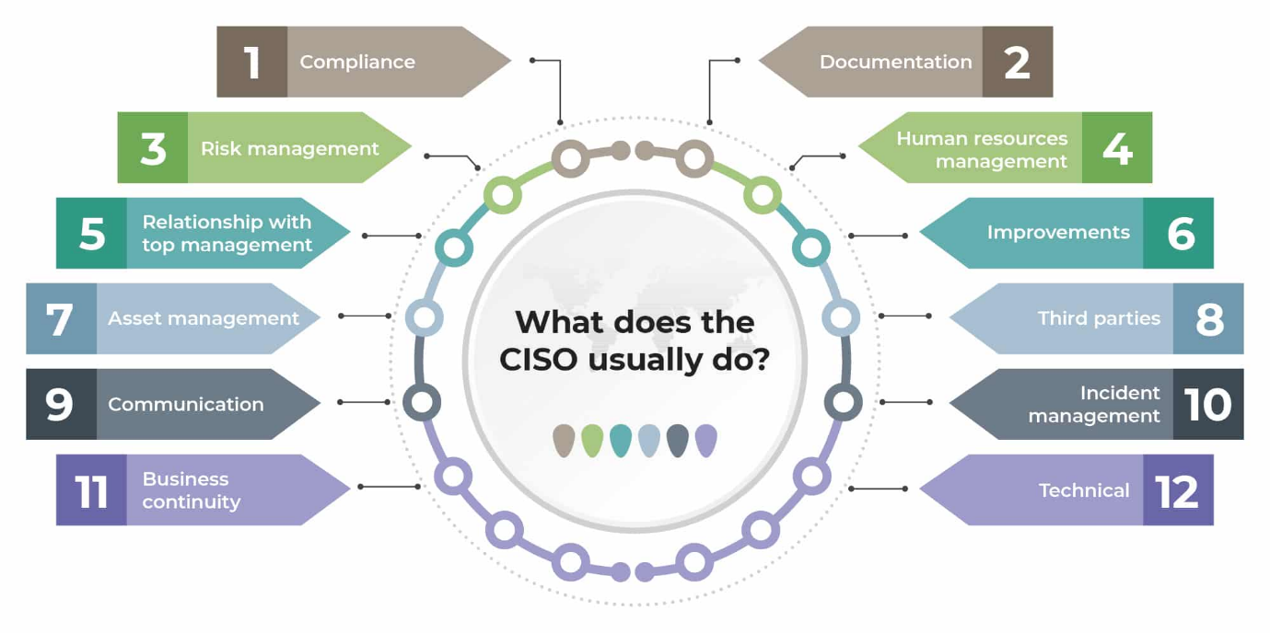
Figure 8. What does the CISO usually do?[28]
CISO are responsible for various tasks such as communication, risk management and many more. Having a CISO means that CSS will reduce their vulnerabilities, enhance incident response and ensures the company complies with legislation like ISO/IEC 27001 and GDPR by conducting regular audits.
In terms of planning within an ISU, CSS should perform regular risk assessments and prioritise identifying any weaknesses in their systems to reduce any potential cyber-threats. ISS should also set goals within their policies to achieve important certifications. CSS should ensure they spend time and money on training their employees about potential cyber risks to ensure that human error is minimised as much as possible. This should also involve awareness and implementation of their incident response plan as previously mentioned. SIEM will also be a great tool for a strategic data security plan. SIEM stands for Security Information and Event Management. It is a solution that integrates various security functions into a singular system. It can analyse threats in real time and analyse data logs and events. It is a great tool for monitoring, auditing and ensuring compliance.[29] SIEM assists and improves the company’s incident response plan and quickens response time as some aspects of SIEM can be automated.
CSS should also put a BCP and a DRP with regular testing. BCP stands for Business Continuity Plan. The goal of a BCP is to ensure that the business can operate as normal with critical data and assets protected even in the event of a cyber-attack. A BCP will include things like ensuring data backups and recovery processes are in place. It protects data loss and maintains access to important company systems. Data backups and recovery should be put in place to minimise CSS’ time spent on recovery. An efficient and effective BCP should ensure CSS can recover promptly from a cyber-attack and continue operations as normal while simultaneously protecting all data.[30] Thus, as shown in the figure below, there are four main steps CSS should take to conduct a BCP to improve data security and planning. These include risk management, business impact analysis, incident response and recovery plan.
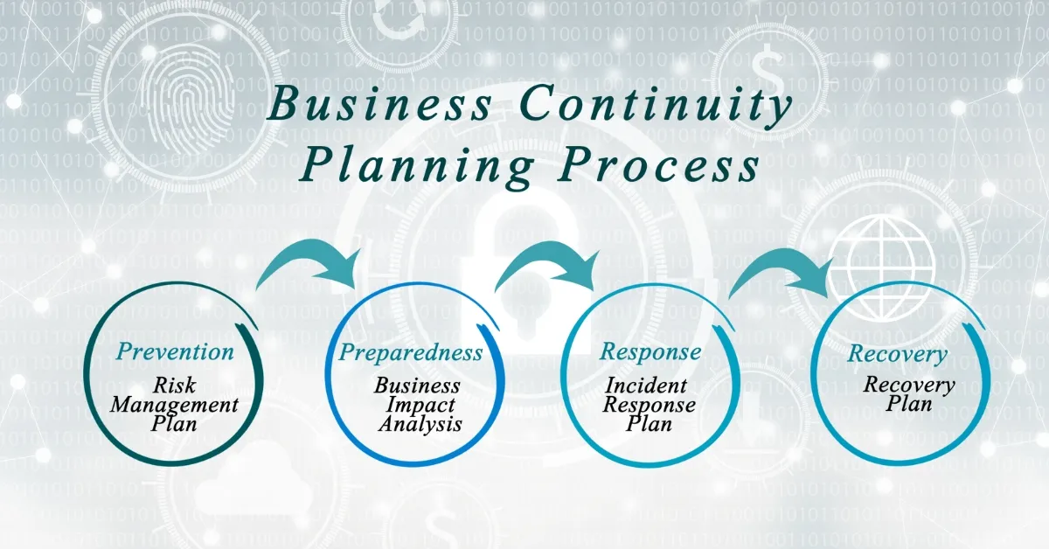
Figure 9. Business Continuity Planning Process [31]
Following on, DRP stands for Disaster Recovery Plan. It is a plan that emphasises the processes and policies that a business will implement to recover and restore its systems, data and infrastructure after a cyber-attack. Its aim is to so with minor data loss and time loss.[32] Since CSS is a threat intelligence organisation that operates mainly online, a DRP will be crucial for protecting sensitive data and gaining and maintaining customer faith and satisfaction. There are six steps CSS should take when writing a DRP as presented in the figure below.
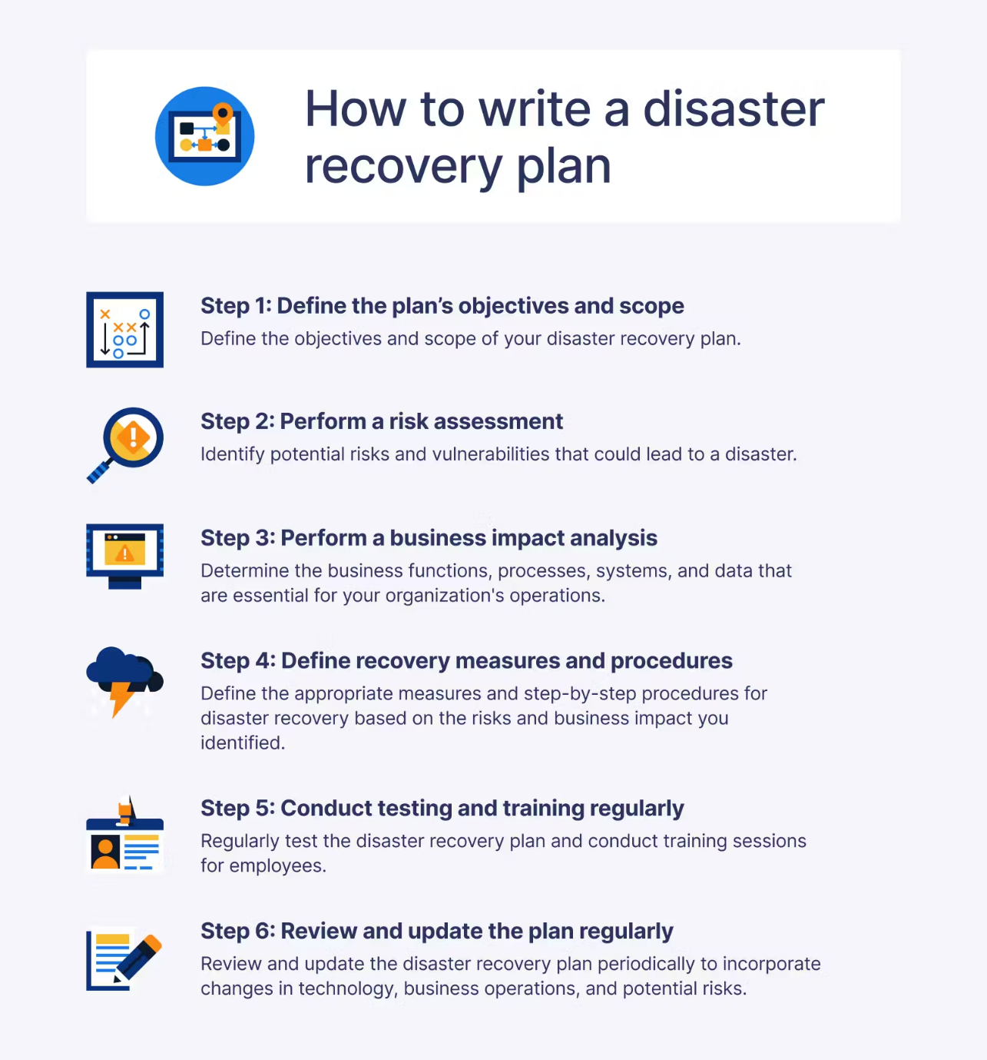
Figure 10. How to Write a Disaster Recovery Plan [33]
The first step is to define the plan, and the scope of disaster recovery needed. CSS should focus on protecting their assets and sensitive data while ensuring operations can run as normal should a disaster take place.
Step two includes performing a risk assessment. This is to identify potential vulnerabilities and weaknesses. This could include ensuring that if they outsource any work, that these organisations have plans and procedures that align with CSS. It could also include considering anything that may cause disaster to network issues such as human errors, server issues, fire damage or severe weather as presented in the figure below.
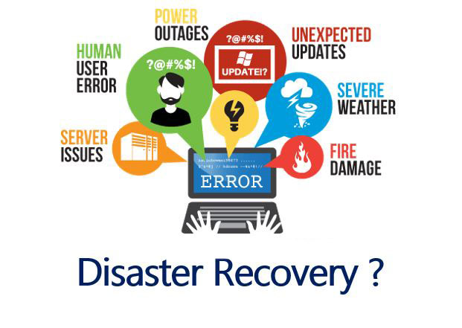
Figure 11. Disasters that May Call for DRP [34]
The third step is to perform business impact analysis. This involves deciding on crucial systems that need to remain operatable should a disaster take place and how long the recovery time could be.
The fourth step is defining recovery measures and procedures. It is the show of remaining operatable if disaster takes place. This involves ensuring all crucial data backups are in place should any main systems fail or ensuring there are way employees can work should the office become inaccessible such as ensuring they can work remotely safely. VPNs would be great tool for this. [4] VPNs use encryption to disguise IP addresses. This means even if one of CSS employees uses public Wi-Fi their data is still secure. This step should also cover clear communication paths so each of CSS’ employees knows who to get in touch with should a disaster or an attack occur.
Step five includes regularly testing the plans and procedures made and their network security. It also involves investing time and money into training their employees so that they are aware of CSS’ policies and the procedure should disaster happen. This ensures CSS will be prepared and so will be better equipped should a disaster or an attack take place.
The final step involves regularly reviewing and updating the DRP to identify any new risks or changes within the running of the business and technology.

Risk Management and Protection Mechanisms
The risk management aspect of an ISU should highlight identifying, analysing and mitigating security risks to protect CSS’ assets and networks. The following is a suggestion of how CSS could structure their risk management.[35]
Firstly, CSS should identify all risks, internal and external. This can involve things such as systems failing, cyber-attacks, or human errors. Secondly, as previously stated, they should carry out risk assessments regularly and prioritise the risks with the highest potential for most disruption to business operation. Mitigation is also a major aspect of risk management, this involves implementing safeguards such as VPNs [4], firewalls [2]and access controls [2]. CSS should also implement intrusion detection systems to help with detecting any unusual activity within incoming or outgoing traffic.[15] This will also involve employee training on awareness of the previous things stated and how to operate tasks safely with data security in mind. Furthermore, regular surveillance of system and networks for weaknesses is an important aspect of risk management. CSS could use tools such as SIEM to achieve this. As SIEM is an automated tool it will save a lot of time and resources.[29]
Thus, if CSS establishes strong risk management procedures within its ISU. CSS’ defence techniques will be enhanced, and it will more likely that CSS will be able to operate as normal should a disaster or attack occur.

Contingencies Planning
Contingency planning includes creating a plan to assist systems and operations to continue operation as soon as possible. It also assists with ensuring data is protected should an attack or disaster take place. NIST has documentation has lays out a contingency plan that many organisations follow.[36] The plan consists of seven steps. The first step is developing a contingency plan policy statement. The second stage is to a business impact analysis (BIA). A BIA would predict the effect of a cyber-attack or disaster on CSS and collects information helpful with developing recovery strategies. The third stage is to create contingency plan strategies such as putting back-ups in place. The next stages are creating contingency strategies, developing and information security plan and carrying out testing and training. The final stage is maintaining the plan, which would include regular updates to the plan to reflect technological advancements and business growth.

Recommendation
It is recommended that CSS have a Chief Information Security Officer internally to establish clear leadership regarding security and compliance. CSS should also invest time and money into employee training to prevent human error. Security technologies should also be put in place such as firewalls, VPNs and SIEM systems to build a robust defence system. CSS should also create and implement a Business Continuity Plan (BCP) and Disaster Recovery Plan (DRP). These procedures should also be tested regularly to ensure they are strong enough to withstand or come back from cyber-attacks and that data is protected. CSS should also aim to gain an ISO/IEC 27001 certification. This will add to their clients’ trust in them. Lastly, what should be stressed mostly is incident response plans are tested and updated on a regular basis to ensure that threats can be handled with minor to no loss of data.

Conclusion
Implementing a well thought out ISU for CSS is crucial for protecting client and employee data during internal and external operations. This is especially because their business is within the threat intelligence and consultancy industry and will conduct most operation online. Thus, an ISU that coincides with CSS policies and procedures that complies with laws and regulations will act as a strong security framework. Thid framework will be secure and strengthened with use of tools such as firewalls, VPNs and access controls. The focus for CSS however should be repeating the cycle of analysing traffic, overseeing detection, looking over defence mechanisms and evacuating their own performance after attacks to always improve their defences. In conclusion, strong defence systems are vital, but proactive preparation is equally important for strong data security within an ISU.

Bibliography
[1] “Security Technology Overview & Industry Trends for 2023 + PDF,” Avigilon. [Accessed:22.11.2024]. https://www.avigilon.com/blog/security-technology
[2] Cisco, “What Is a Firewall?,” Cisco, 2019.[Accessed:22.11.2024]. https://www.cisco.com/c/en_uk/products/security/firewalls/what-is-a-firewall.html
[3] Microsoft, “What Is Access Control? | Microsoft Security,” www.microsoft.com, 2024. https://www.microsoft.com/en-gb/security/business/security-101/what-is-access-control
[4] NordVPN, “What Is A VPN? Virtual Private Network Explained | NordVPN,” nordvpn.com, Oct. 21, 2015. [Accessed:22.11.2024]. https://nordvpn.com/what-is-a-vpn/
[5] C. N. Modi and K. Acha, “Virtualization layer security challenges and intrusion detection/prevention systems in cloud computing: a comprehensive review,” The Journal of Supercomputing, vol. 73, no. 3, pp. 1192–1234, Jul. 2016, doi: [Accessed: 22.11.2024]. https://doi.org/10.1007/s11227-016-1805-9.
[6] Prof. C. Campbell, Security Technology: Access Controls, Firewalls and VPNs, PowerPoint, Moodle, 21 Oct 2024. [Online]. Available: Moodle platform. [Accessed: 22.11.2024]. https://moodle.uwtsd.ac.uk/pluginfile.php/966886/mod_folder/content/0/Lecture%206-SC.pptx?forcedownload=1
[7] J Michael Stewart, Network Security, Firewalls And Vpns. Jones & Bartlett Learning, 2020. [Accessed: 22.11.2024].
[8]CheckPoint, “What is a Firewall,” Check Point Software, 2023. [Accessed:22.11.2024]. https://www.checkpoint.com/cyber-hub/network-security/what-is-firewall/
[9]“Why Access Control Security is Important for Your Business,” Avigilon. https://www.avigilon.com/blog/importance-of-access-control [Accessed:22.11.2024].
[10]E. Katz, “6 Examples of Discretionary Access Control (DAC),” 6 Examples of Discretionary Access Control (DAC), Dec. 22, 2022. https://spectralops.io/blog/examples-of-discretionary-access-control/#:~:text=A%20typical%20example%20of%20DAC,must%20manually%20grant%20these%20permissions. (accessed Nov. 22, 2024).
[11] A. Babko, “Mandatory (MAC) vs Discretionary Access Control (DAC) Differences | Syteca,” Syteca, Apr. 19, 2023. (accessed Nov. 22, 2024). https://www.syteca.com/en/blog/mac-vs-dac
[12]Y. K. Sharma and C. Kaur, “The Vital Role of Virtual Private Network (VPN) in Making Secure Connection Over Internet World,” Blue Eyes Intelligence Engineering, Mar. 2020. (accessed Nov. 22, 2024) https://papers.ssrn.com/sol3/Delivery.cfm?abstractid=4032918
[13]J. Howarth, “30+ VPN Statistics, Trends & Facts (2023-2027),” Exploding Topics, Jan. 23, 2023. https://explodingtopics.com/blog/vpn-stats (accessed Nov. 22, 2024)
[14]“Maximizing Online Privacy: Tips and Best Practices for Using VPN Services Effectively,” Maximizing Online Privacy: Tips and Best Practices for Using VPN Services Effectively, Feb. 26, 2024. https://axiomq.com/blog/maximizing-online-privacy-tips-and-best-practices-for-using-vpn-services-effectively/ (accessed Nov. 23, 2024).
[15]Book. B. Akselsen, Intrusion detection systems. Valley Cottage, Ny: Scitus Academics Llc, 2017. (accessed Nov. 23, 2024). https://www.google.co.uk/books/edition/Intrusion_Detection_Systems/yqXdjwEACAAJ?hl=en
[16] B. R. Rexhepi, A. Kumar, M. S. Gowtham, R. Rajalakshmi, Divya Paikaray, and P. K. Adhikari, “An Secured Intrusion Detection System Integrated with the Conditional Random Field For the Manet Network,” International Journal of Intelligent Systems and Applications in Engineering, vol. 11, no. 3s, pp. 14–21, Mar. 2023, Accessed: Nov. 23, 2024. [Online]. Available: https://ijisae.org/index.php/IJISAE/article/view/2526
[17]Umesh Hodeghatta Rao and Umesha Nayak, The InfoSec Handbook : an Introduction to Information Security. Berkeley, Ca: Apress, 2014. Accessed: Nov. 23, 2024.
[18]B. Lutkevich, “What is an intrusion detection system (IDS)? Definition from SearchSecurity,” TechTarget, Oct. 2021. Accessed: Nov. 23, 2024. https://www.techtarget.com/searchsecurity/definition/intrusion-detection-system
[19]“Organization Design,” Google Books, 2024. https://books.google.co.uk/books?hl=en&lr=&id=W3wnJLIPwgMC&oi=fnd&pg=PR5&dq=give+me+an+idea+for+an+information+security+unit+with+organisation+structure/chart+in+mind%3F+&ots=0OD1og7-8n&sig=VyGHE726oVLAv859r9ZGeUsMAf8&redir_esc=y#v=onepage&q&f=false (accessed Dec. 01, 2024).
‌[20] Giva Authorship Team, “IT Organizational Charts: 11 Examples for Any Business,” IT Organizational Charts: 11 Examples for Any Business, Jan. 18, 2024. https://www.givainc.com/blog/it-organizational-charts/ (accessed Dec. 01, 2024).
[21]“What is a IT Support Specialist? - Roles, Skills, Tools, and Career Path | IT Insights,” Getguru.com, 2024. https://www.getguru.com/reference/it-support-specialist (accessed Dec. 01, 2024).
[22] J. Rodrigues, “7 Phases of Incident Response,” TitanFile, Oct. 03, 2022. https://www.titanfile.com/blog/phases-of-incident-response/ (accessed Dec. 01, 2024).
[23]P. Kral, Incident Handler’s Handbook. 2012. Accessed: Dec. 01, 2024. [Online]. Available: https://www.sans.org/white-papers/33901/
[24]Gov.UK, “Data Protection Act,” GOV.UK, 2018. https://www.gov.uk/data-protection Dec. 01, 2024
[25]O. Amaral, Muhammad Ilyas Azeem, Sallam Abualhaija, and L. C. Briand, “NLP-Based Automated Compliance Checking of Data Processing Agreements Against GDPR,” IEEE Transactions on Software Engineering, vol. 49, no. 9, pp. 4282–4303, Sep. 2023, doi: https://doi.org/10.1109/tse.2023.3288901. Dec. 01, 2024
[26]“Is ISO 27001 a Legal Requirement?,” Isova.co.uk, 2023. https://www.isova.co.uk/posts/is-iso-27001-a-legal-requirement (accessed Dec. 03, 2024).
[27]R. Woerner, linkedin.com, and linkedin.com, Carpenteria, CA. Security for the SMB: Implementing the NIST Cybersecurity Framework., (2020). (accessed Dec. 08, 2024).
[28]“CISO roles and responsibilities in ISO 27001,” advisera.com. https://advisera.com/27001academy/knowledgebase/what-is-the-job-of-chief-information-security-officer-ciso-in-iso-27001/ (accessed Dec. 08, 2024).
[29]F. Adelodun, linkedin.com, and linkedin.com, Carpenteria, CA. Introduction to Security Information and Event Management (SIEM)., (2023). (accessed Dec. 08, 2024).

[30]Hawkins, S.M., Yen, D.C. and Chou, D.C. (2000), "Disaster recovery planning: a strategy for data security", Information Management & Computer Security, Vol. 8 No. 5, pp. 222-230. https://doi.org/10.1108/09685220010353150 (accessed Dec. 08, 2024).

[31]“What Is a Business Continuity Plan?,” www.isecurenet.net. https://www.isecurenet.net/article.cfm?ArticleNumber=174 (accessed Dec. 08, 2024).
[32]E. Maiwald and W. Sieglein, “Security Planning & Disaster Recovery.” Available: http://benjamin.davy.free.fr/Auditoria/0072224630.McGraw.Security.Planning.Disaster.Recovery.pdf (accessed Dec. 08, 2024).
[33]A. Fitzgerald, Blog. “How to Write a Disaster Recovery Plan + Template,” Secureframe, Jul. 26, 2023. https://secureframe.com/blog/disaster-recovery-plan (accessed Dec. 08, 2024).
[34]“Why you need a backup and disaster recovery plan,” Blog. Cheeky Munkey, Oct. 01, 2020. https://cheekymunkey.co.uk/blog/why-you-need-a-backup-and-disaster-recovery-plan/ (accessed Dec. 08, 2024).
[35]“Security Risk Management,” Google Books, 2024. https://books.google.co.uk/books?hl=en&lr=&id=cW1ytnWjObYC&oi=fnd&pg=PP1&dq=risk+management+stage+of+a+information+security+unit&ots=Up2TFmLW5A&sig=ENU_ivqgX780h4lV17GlVNMPOfY&redir_esc=y#v=onepage&q&f=false (accessed Dec. 08, 2024).
[36] Hafizh Ghozie Afiansyah, Septia Ulfa Sunaringtyas, and Amiruddin Amiruddin, “Perancangan Rencana Pemulihan Bencana Menggunakan NIST SP 800-34 Rev 1, NIST SP 800-53 Rev 5 dan SNI 8799 (Studi Kasus: Unit TI XYZ),” Jurnal teknologi informasi dan ilmu komputer (Online), vol. 10, no. 2, 2023, doi: 10.25126/jtiik.20231026507. https://librarysearch.uwtsd.ac.uk/permalink/44WHELF_UWTSD/1ir6fgh/cdi_doaj_primary_oai_doaj_org_article_7484bd42a4b349bc97ecf050aab1311f (accessed Dec. 08, 2024).

