8a Using loops (2) – For

1. Write a for loop that counts from 0 to 12 (print the counter on the screen).

Note: only two lines of code are required

Sample output:

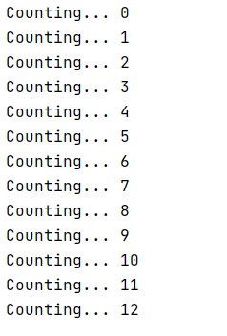

2. Write a for loop that counts from 4 to 16 and goes up in increments of 2:

Sample output:

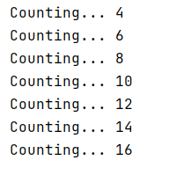

3a. Print "XXXXX" on the screen. This is the width (5) of a rectangle.

Using a for loop, repeat this down the screen so that you achieve a 5 x 7 rectangle. You can do this in two lines of code

Sample output:

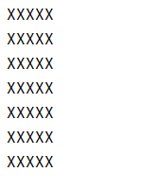

3b Extend your solution to allow the user to choose the height of their rectangle (but the width stays as XXXXX)

Sample output:

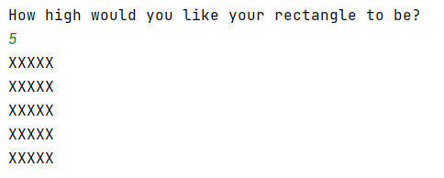

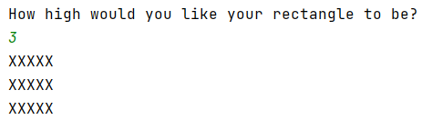

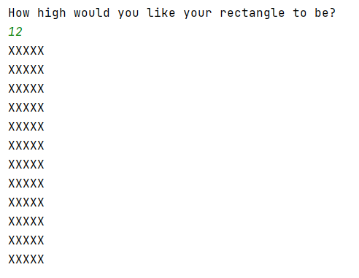
4. Write a child's program to simulate a rocket blasting off. Use a for loop for the countdown.

Note: You do not have to draw the rocket (but it is fun )

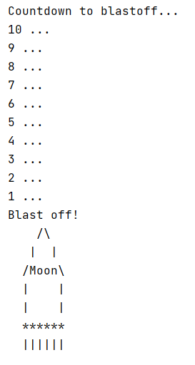

5a. Write a for loop that counts from 1 to 12 and goes up in increments of 1.

Sample output:

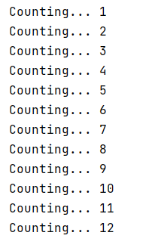

5b Adapt your for loop to do some simple calculations to reproduce the 7 times table.

Multiple myCounter by 7 each time around the loop, store the result, and then print the result.

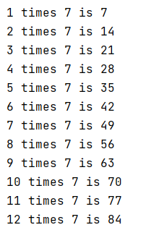

5c Adapt your solution to allow the user to choose the times table they want.

Sample output:



