  Component One: Student Journal (learning log) 750 words +/- 10%  Contribution to Overall Module Assessment: 25% | Student No: | 2235127
 | Module Title: | Hotel Administration and Front Office Operations
 | Module Code: | BMIH4004
 | Lecturer: | Daniel Payne
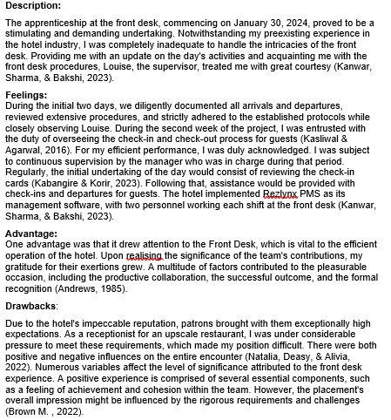
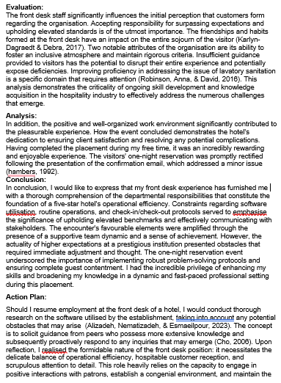
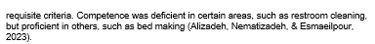

Component Two
Contribution to Overall Module Assessment: 25%
Trip Advisor Review Response 150 words +/-10%
Screen shot of referenced Trip Advisor review used:
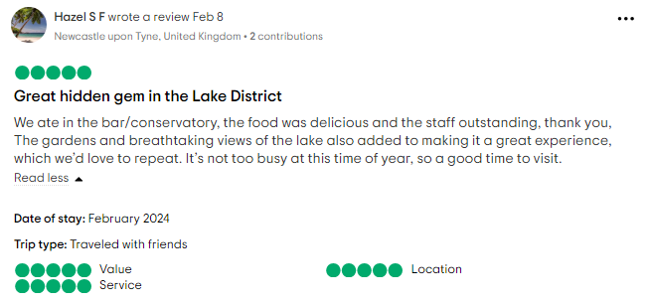
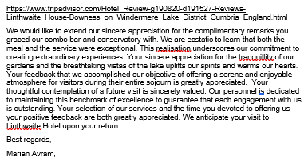

Letter of complaint response 500 words +/- 1-%
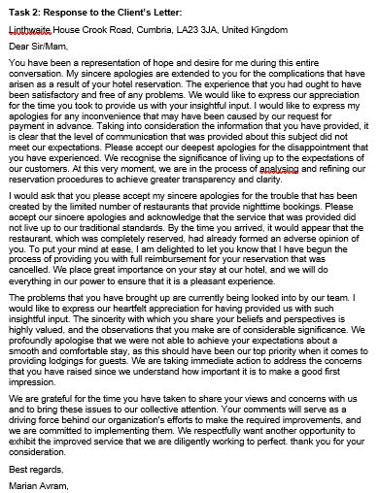

Component Three:
Contribution to Overall Module Assessment: 50% (1000 words +/- 10%)
Writing in essay format
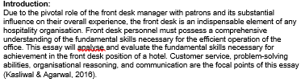

Key Skill 1 – Customer Service Skills

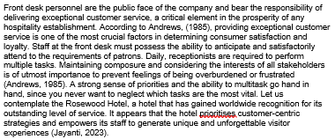
Key Skill 2 – Communication Skills

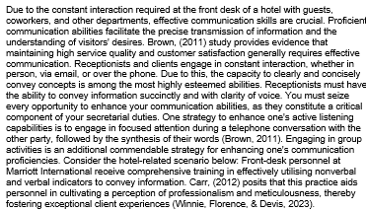
Key Skill 3 – Organisational Skills

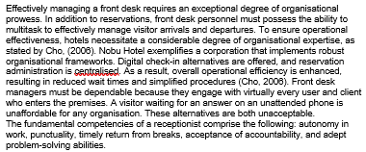
Key Skill 4 – Problem Solving Skills

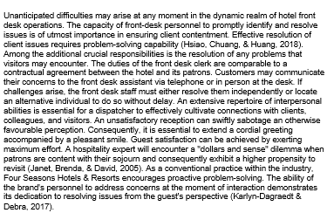

Reference List


