

Programme: Master of Business Administration
Module code: LCMB7023
Module: Human Capital Management
Assessment component 1: Individual report

Title: Innovating Working Practices and Developing Talent: A Strategic Human Capital Management Report for NexSpace Health Systems (NHSX)

Name: Dhruv Jitubhai Mangukiya
Student ID: 2611141
Total Words: 2564
Date of Submission: 15th October 2026

AI Declaration
I declare that no artificial intelligence (AI) tools were used in the preparation, research, writing, editing or completion of this report. All analysis, interpretations and recommendations presented are my own work, developed through independent research and critical evaluation.

Executive Summary
This report provides a critical evaluation of the human capital management strategies used to promote innovation and collaboration at NHSX. Traditional work design and modern concepts are discussed, and cross-functional collaboration, hybrid work, employee empowerment, agile teaming, and digital collaboration technologies are recommended. Based on the Learning Organisation Theory, Psychological Safety Theory, and Self-Determination Theory, a talent development framework is proposed for continuous learning, career development, inclusive leadership, performance management, and employee well-being. The reflective analysis considers and discusses AI as a support tool in HR strategic decision-making, focusing on highlighting ethical responsibility, human judgement and professional development through SMART capability-building objectives.

Table of Contents
TASK A: Designing Innovative Working Practices 5
1.1 Critical Evaluation of Traditional Work Design Versus Contemporary Innovative Working Practices 5
1.1.1 Traditional Work Design 5
1.1.2 Contemporary Work Design Theories 5
1.1.3 Critical Comparison and Strategic Implications 8
1.2 Recommendations for Innovative Working Practices at NHSX 8
TASK B: Breeding an Environment Where Talent May Grow 10
2.1 Critical Evaluation of How Organisations Create Environments Where Talent Flourishes 10
2.1.1 Learning Organisation Theory (Senge) 10
2.1.2 Psychological Safety Theory (Edmondson) 11
2.1.3 Self-Determination Theory (SDT) 11
2.2 Comprehensive Talent Growth Strategy for NexSpace Health Systems 12
TASK C: Reflective Report 15
3.1 Artificial Intelligence (AI) as a Strategic Tool 15
3.2 Reflective Analysis 15
3.3 Personal Capability Development Plan 16
Reference List 17

TASK A: Designing Innovative Working Practices

1.1 Critical Evaluation of Traditional Work Design Versus Contemporary Innovative Working Practices

1.1.1 Traditional Work Design
Traditional work design is characterised by hierarchical structures, centralised decision-making, specialised job roles and formal procedures (Jerab and Mabrouk, 2023). These arrangements can generate aspects such as the establishment of clear accountability, consistency, as well as control in the processes of working, particularly in healthcare technology where product efficiency and patient safety are crucial. However, hierarchy in an excessive manner slows down decision-making, restricts employee autonomy, and thereby discourages innovation (Díaz-Leyva and Cascón-Pereira, 2026).
Such a limitation is one of the major obstacles to NHSX's functioning, as rapid knowledge transfer and interdisciplinarity are critical for AI-driven innovations in healthcare. For this reason, the conventional organisational structures must be preserved for the purpose of governance activities while being adapted for participation and organisational agility.

1.1.2 Contemporary Work Design Theories

High-Performance Work Systems (HPWS)
The HPWS involve the development of workers, participative decision-making, performance management, training, and rewards, which are relevant to building the capabilities of the organisation. The study by Arshad, Hassan and Azam (2024) analyses and links the connection between HPWS and innovative behaviour of employees, considering the social capital and knowledge sharing.
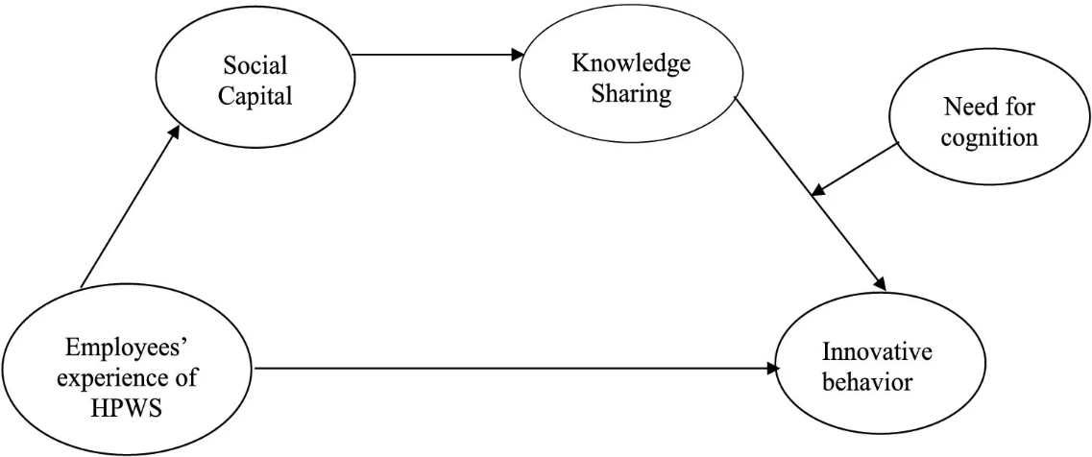
Figure 1: Framework for High-Performance Work Systems
(Source: Arshad, Hassan and Azam, 2024)
HPWS could be useful for NHSX in terms of higher cooperation and innovativeness; however, when the emphasis on performance becomes high, the well-being of the employees may be at stake.

Hybrid Working Models
Hybrid working focuses on a model which considers a combination of office-based and remote working, which offers flexibility and chances for networking. According to Nagori and Lawton (2024), technology, communication, leadership and wellbeing are some of the factors which should be considered while designing hybrid working.
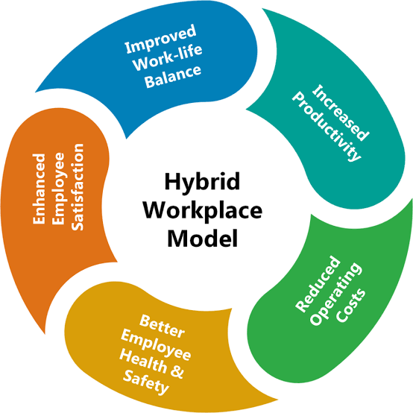
Figure 2: Hybrid Working Model
(Source: Self-created, concept taken from Nagori and Lawton, 2024)
It can be stated that hybrid arrangements have the ability to improve the work-life balance and recruitment of international talent in NHSX. However, lack of participation, as well as digital opportunities and chances for informal networking, can hinder collaboration if the organisation does not address this challenge.

Sociotechnical Systems Theory
Sociotechnical Systems theory offers a way of looking at things, suggesting the need to develop socio-technological systems to achieve organisational effectiveness jointly. According to the study by Govers and Van Amelsvoort (2023), principles surrounding sociotechnical design could assist organisations to cope with their digital transformation.
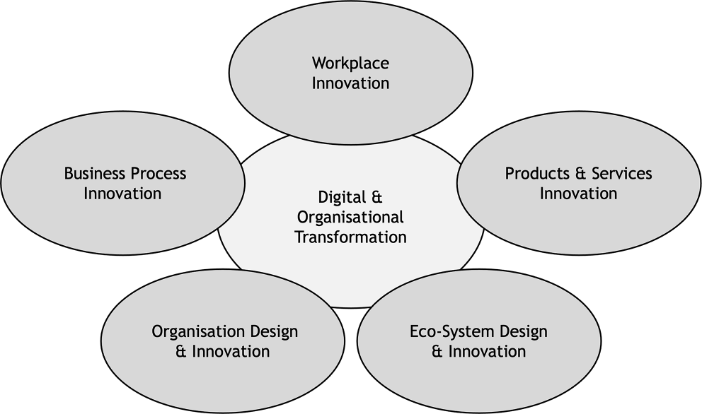
Figure 3: Sociotechnical Systems Theoretical Framework
(Source: Govers and Van Amelsvoort, 2023)
The focused linking of AI platforms and skills possessed by the NHS workforce, as well as independence and collaboration at NHSX, could lead to greater innovations and efficiencies. However, redesign which is considerably technology-led without participation of the employees risks areas such as increasing complexity and reducing acceptance.

1.1.3 Critical Comparison and Strategic Implications
While the traditional work design offers standardisation, authoritative management, and supervision, the modern work design stresses flexibility, autonomy, and teamwork in solving problems (Arshad, Hassan and Azam, 2024). Imbalanced performance expectations could lead to increased risk factors and susceptibility to HPWS; however, poor management and design of risks could lead to reduced innovation. In a similar manner, the consideration of hybrid working supports flexibility but may particularly weaken social interaction and wellbeing when poorly designed (Hall et al., 2024).
On the other hand, the sociotechnical design is one solution that brings about integration of both humans and technology, but this is achieved through participation, training and coordination (Govers and Van Amelsvoort, 2023). In this context, rigid hierarchy and autonomous flexibility are not enough for NHSX. An integrated model should include clear accountability and healthcare protection measures, empowered teams, inclusive processes of digital collaboration and flexible working, in line with job requirements, throughout the UK, India and UAE.

1.2 Recommendations for Innovative Working Practices at NHSX
Working practice | Recommendation for NHSX | Implementation approach
Cross-functional collaboration | Multidisciplinary teams should be established comprising AI developers, clinicians, data analysts, HR professionals and product managers (Temjanovski, Loku and Bezovski, 2025). | For this, fortnightly knowledge-sharing sessions and collaborative problem-solving workshops should be organised to integrate technical and clinical expertise.
Hybrid and flexible working | Consideration for role-based hybrid arrangements can be done that balance employee flexibility with collaboration requirements. | The focus should be on core collaboration hours across the UK, India and UAE, supported by flexible schedules and documented communication protocols.
Employee autonomy | In this context, the employees should be empowered to make decisions within clearly defined responsibilities and regulatory boundaries. | A delegated decision-making, employee-led improvement proposals and protected experimentation time should be introduced which are subject to clinical safety and data governance requirements (Marett and Marett, 2026).
Agile project teams | Here, cross-functional as well as time-limited project teams should be Adopted using iterative development and continuous feedback. | Two-week sprints, regular retrospectives and measurable milestones can be used to accelerate product development and respond to changing healthcare needs.
Digital collaboration technologies | Secure and integrated digital platforms for communication, project tracking and knowledge management should be implemented (Cuozzo et al., 2025). | Approved collaboration tools, shared documentation, asynchronous updates and searchable knowledge repositories can be used, supported by cybersecurity training and accessibility standards.
Taking into consideration, the stated practices can assist in enhancing the organisational performance of NHSX through fast decision-making and reduction of silos within departments while ensuring knowledge transfer between international teams. Working within cross-functional teams brings both medical knowledge and technical know-how, resulting in safe and more significant digital health innovations (Temjanovski, Loku and Bezovski, 2025).
At the same time, flexible working and hybrid working will also help improve the work-life balance of the workers and their retention when communication and workload remain low (Marett and Marett, 2026). Autonomy increases ownership, creativity and quick problem-solving, and agile project teams come in handy in testing and getting fast responses on feedback from the stakeholders (Cuozzo et al., 2025). Tools for digital collaboration are important in the preservation of knowledge and coordination. All these strategies will help in increasing innovation, workforce engagement, agility and accountability and yet maintain compliance with regulations.

TASK B: Breeding an Environment Where Talent May Grow

2.1 Critical Evaluation of How Organisations Create Environments Where Talent Flourishes
Organisations create and focus on a working environment that is established in which talent can flourish through the continuous process of learning, feeling psychologically safe and motivated from within. Such aspects are important for NHSX as the technology can be developed fast, scaled up globally, and employees can switch jobs, requiring adaptation, experimentation and learning.

2.1.1 Learning Organisation Theory (Senge)
The theory of the learning organisation by Senge revolves around the concepts of systems thinking, shared vision, team learning, personal mastery, and questioning of existing mental models (Dziarnowska, 2025). Organisations adopting such theory will encourage knowledge sharing, reflection on failures, and individual development in order to achieve organisational objectives. In this regard, Hillberg Jarl (2024) determined that leadership behaviour, relational support, and shared meaning influence workplace learning.
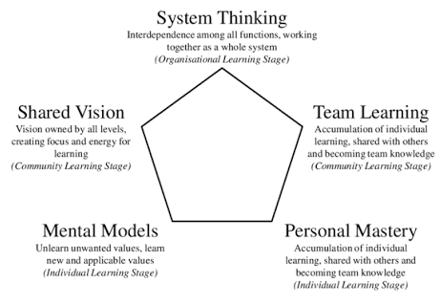
Figure 4: Learning Organisation Theory (Senge)
(Source: Self-created, Concept taken from Hillberg Jarl, 2024)
However, it can be noted that the learning organisation is a costly proposition, as it requires investment as well as a dedicated time for learning and the leaders that bring training into the workplace (Dziarnowska, 2025). Training alone will not create a learning culture if employees face excessive workloads or knowledge remains confined within departments.

2.1.2 Psychological Safety Theory (Edmondson)
Psychological safety, according to Edmondson, refers to the group’s mutual understanding that no staff member will be embarrassed or punished for taking interpersonal risks such as raising questions, speaking out when there are errors, and giving suggestions. As mentioned by Edmondson and Bransby (2023), it is an attribute linked with learning behaviour and leadership/team effectiveness in uncertain situations, among others. For example, Google’s Project Aristotle similarly identified psychological safety as an important characteristic of effective teams (Psychsafety.com, 2024).
The psychologically safe teams for NHSX may be able to identify software defects earlier and question any unsafe suggestions from the AI. Nevertheless, although psychological safety may involve tolerating underperformance, it does not entail discarding accountability (Edmondson and Bransby, 2023). Leadership should be able to strike a balance between constructive challenge and evidence-based decision-making.

2.1.3 Self-Determination Theory (SDT)
Self-Determination Theory stands as a framework that tries to outline how the fulfilment of psychological needs in terms of self-determination will increase motivation and improve well-being among employees: autonomy, competence, and relatedness (Ryan and Deci, 2022). By way of autonomy, employees would be able to influence how they carry out their duties; through competence, they develop themselves through constructive learning and feedback, whereas relatedness helps them feel part of the organisation. Liu et al. (2024) have identified positive correlations between inclusive leadership and employee vitality and workplace wellbeing, where developmental feedback enhances such correlations.
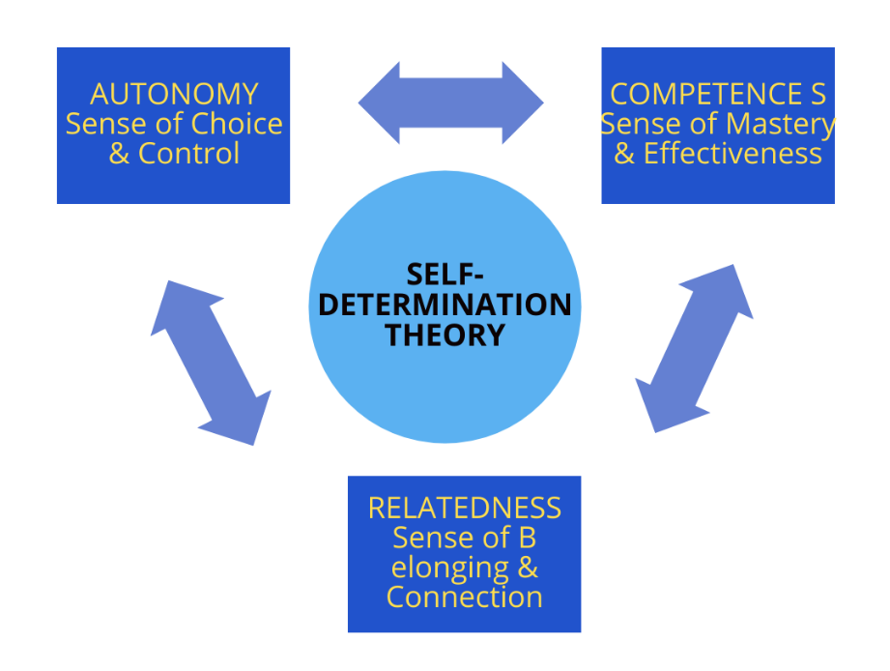
Figure 5: Self-Determination Theory (SDT)
(Source: Self-created, Concept taken from Ryan and Deci, 2022)
For example, Microsoft is one of the organisations that offers an outstanding illustration of the importance of continuous learning, growth mindset, and career development (Microsoft, 2024). However, autonomy without adequate resources can cause stress, while development can lack effectiveness if there are no prospects for promotion (Ryan and Deci, 2022). Hence, NHSX should combine employee choice with structured development as well as supportive leadership and transparent career pathways.

2.2 Comprehensive Talent Growth Strategy for NexSpace Health Systems
NHSX must create a unified strategy for developing talent that will connect workforce planning, continuous learning, development, well-being of employees, and performance management. The strategy must change the focus from the perspective of using employees as resources necessary to achieve operational objectives to strategic contributors who can contribute to healthcare innovation.
Strategic priority | Recommended interventions | Expected outcomes
1. Continuous learning and development | Establish an NHSX Digital Learning Academy that offers training in AI, data analytics, cybersecurity, digital healthcare, and leadership. Introduce personalised learning pathways, mentoring and quarterly development reviews (Koshanova, Zakirova and Tynyshkali, 2024). | Improved workforce capabilities, adaptability and internal skills development.
2. Career progression and talent mobility | Create transparent technical and managerial career pathways, internal vacancies, cross-functional assignments, and international project opportunities across the UK, India, and the UAE. | Higher retention, equitable progression and reduced dependence on external recruitment (Mirkov and Tankosić, 2025).
3. Psychological safety and inclusive leadership | Train managers to encourage employee voice, constructive feedback, experimentation and learning from mistakes (Sibunruang and Kawai, 2024). Establish confidential reporting channels and regular team retrospectives. | Build greater trust, knowledge sharing, employee engagement, and early risk identification.
4. Performance and employee recognition | Introduce balanced performance reviews that measure innovation, collaboration, learning progress, service quality, and individual contributions (Seyi-Lande, Arowogbadamu and Oziri, 2022). Recognise knowledge sharing and responsible experimentation alongside results. | Improved motivation, accountability and alignment between individual and organisational objectives (Sibunruang and Kawai, 2024).
5. Wellbeing and employee experience | Conduct regular engagement surveys, monitor workload and burnout indicators, and provide flexible working, wellbeing support and reasonable workload expectations (Behie et al., 2023). | Sustainable performance, improved work–life balance and reduced voluntary turnover.
The strategy must be developed as a three-phase process in NHSX. HR must conduct skills-gap analysis and measure baseline for turnover, engagement, and internal mobility within the first three months. NHSX must introduce the learning academy, mentoring program and career pathways within NHSX in months 4 to 9, particularly in teams working on AI and digital health. HR must evaluate the pilots within months 10 to 12 and thereby establish the size of the interventions that must be used internationally.
The KPIs which are to be measured on a quarterly basis include completion of training, internal promotion and employee engagement, voluntary turnover, cross functional project engagement and success in projects should be used for assessing success (Seyi-Lande, Arowogbadamu and Oziri, 2022). These results should be analysed geographically and demographically for any potential inequities. In a holistic manner, this strategy will create a sustainable talent ecosystem which allows employees to gain valuable skills, enjoy a rewarding career and contribute to innovation within the organisation (Sibunruang and Kawai, 2024). The senior executives will be responsible for the provision of necessary resources and will be responsible for success in development; all employees will participate in the development process (Behie et al., 2023). This approach will allow NHSX to be attractive to talented people and to compete successfully in the area of healthcare technology.

TASK C: Reflective Report

3.1 Artificial Intelligence (AI) as a Strategic Tool
In terms of strategic HRM, AI can help with such tasks as analysing employee data, anticipating skills shortages, identifying trends related to employee turnover and improving recruitment. The use of predictive analytics can help in anticipating the needs of employees, ensuring talent development in accordance with organisational needs and taking measures to prevent future problems (Jayakani, Geethika and Kumar, 2026). At the same time, recommendations provided by AI can have old biases included in them, violate the privacy of employees or harm underrepresented groups due to biased data or algorithms.
Therefore, the need to use artificial intelligence technology as an enhancement rather than a replacement for professional judgment is critical. It is crucial for Human Resource professionals to validate findings, safeguard confidential information, and ensure compliance of the data with the laws pertaining to data protection and employment (El Maknouzi, 2022). Although initially the individual must get an understanding of what needs to be done, it is important to note that empathy of humans is still crucial when handling matters related to complaints, wellbeing, and career decisions of employees. Transparency, accountability, fairness and meaningful human oversight are essential to ensure that efficiencies gained do not impact employee dignity or organisational trust when it comes to responsible AI adoption.

3.2 Reflective Analysis
AI stands to be considerably helpful in both my academic and professional life in order to gain efficiency and consider its limitations. At first, AI was helpful for me in scheduling my activities related to work and study, which helped me in managing my time, but there was a need for some changes in the proposed schedule according to any unexpected obligations.
Second, AI was also helpful in enhancing my e-mails and business correspondence. It will help me improve my written communication, but if I rely on suggested writing too often, then it may limit my independent style of writing.
Third, AI was also helpful in understanding unknown concepts and preparation for exams with the help of AI. The explanation was simple and understandable for me, but it taught me to verify information from books and reliable sources. This experience has made me learn to critically use AI, to cross-check outputs and hold myself accountable for my choices.

3.3 Personal Capability Development Plan
Objective | S – Specific | M – Measurable | A – Achievable | R – Relevant | T – Time-bound
1. HR analytics | Develop skills in Excel and workforce data analysis. | Complete two practical HR dashboards. | Practise using online tutorials and datasets. | Supports evidence-based HR decisions. | Within 3 months.
2. AI and ethics | Learn responsible AI applications in recruitment and talent management. | Complete one course and analyse two HR case studies. | Use accessible online learning resources. | Strengthens ethical digital HR practice. | Within 4 months.
3. Communication | Improve professional writing, presentations and active listening. | Deliver two presentations and obtain feedback. | Practise monthly through academic or workplace activities. | Supports stakeholder engagement and employee relations. | Within 6 months.
4. Professional development | Build HR knowledge through networking and practical experience. | Attend two HR events and complete one relevant project. | Use professional networks and available opportunities. | Improves employability and practical competence. | Within 9 months.

Reference List
Arshad, B., Hassan, H. and Azam, A., (2024). The impact of employees’ experience of high-performance work systems on innovative behavior in professional service firms. Frontiers in psychology, 14, p.1324474. https://doi.org/10.3389/fpsyg.2023.1324474
Behie, S.W., Pasman, H.J., Khan, F.I., Shell, K., Alarfaj, A., El-Kady, A.H. and Hernandez, M., (2023). Leadership 4.0: The changing landscape of industry management in the smart digital era. Process safety and environmental protection, 172, pp.317-328. https://www.researchgate.net/profile/Stewart-Behie-2/publication/368432604_Leadership_40_The_Changing_Landscape_of_Industry_Management_in_the_Smart_Digital_Era/links/66c6298197265406eaa0459b/Leadership-40-The-Changing-Landscape-of-Industry-Management-in-the-Smart-Digital-Era.pdf
Cuozzo, B., Russo, G., Pascucci, F. and Fella, S., (2025). Knowledge management in a dynamic context in the digital era. European journal of innovation management, 28(5), pp.2080-2100. https://iris.univpm.it/bitstream/11566/343612/7/Attached%20standard%20file_%20%285%29.PDF
Díaz-Leyva, C. and Cascón-Pereira, R., (2026). Beyond formal managerial hierarchy: Reimagining HRM in self-managing organisations. Human Resource Management Review, 36(4), p.101166. https://doi.org/10.1016/j.hrmr.2026.101166
Dziarnowska, W., (2025). The intricacies of academic personal mastery and systems thinking in the reflections of university staff involved in teaching. Edukacyjna Analiza Transakcyjna, (14), pp.309-327. https://www.ceeol.com/search/article-detail?id=1416152
Edmondson, A.C. and Bransby, D.P., (2023). Psychological safety comes of age: Observed themes in an established literature. Annual review of organizational psychology and organizational behavior, 10(1), pp.55-78. https://doi.org/10.1146/annurev-orgpsych-120920-055217
El Maknouzi, M.E.H., (2022). Human resource management in the era of artificial intelligence: future HR work practices, anticipated skill set, financial and legal implications. Strategic Management Journal, 21(S1), pp.1-14. https://www.academia.edu/download/94768200/Human-resource-management-in-the-era-of-artificial-intelligence-future-hr-work-practices_-anticipated-skill-set-financial-and-legal-impl.pdf
Govers, M. and Van Amelsvoort, P., (2023). A theoretical essay on socio-technical systems design thinking in the era of digital transformation. Gruppe. Interaktion. Organisation. Zeitschrift für Angewandte Organisationspsychologie (GIO), 54(1), pp.27-40. https://doi.org/10.1007/s11612-023-00675-8
Hall, C.E., Brooks, S.K., Mills, F., Greenberg, N. and Weston, D., (2024). Experiences of working from home: umbrella review. Journal of Occupational Health, 66(1), p.uiad013. https://doi.org/10.1093/joccuh/uiad013
Hillberg Jarl, F., (2024). The impact of leadership on the workplace learning of individuals and teams: A literature review and synthesis. The Learning Organization, 31(3), pp.411-439. https://doi.org/10.1108/TLO-11-2022-0144
Jayakani, S., Geethika, S.S. and Kumar, C., (2026). Predictive HR Analytics for Workforce Optimization in FinTech Firms. Scriptora International Journal of Research and Innovation (SIJRI), pp.59-68. https://scriptora.org/index.php/files/article/download/151/103
Jerab, D. and Mabrouk, T., (2023). How to Design an Effective Organizational Structure & the 21 Century Trends. Available at SSRN 4584646. https://papers.ssrn.com/sol3/Delivery.cfm?abstractid=4584646
Koshanova, D., Zakirova, A. and Tynyshkali, A., (2024). Development of a personalised learning pathway on the basis of a competency-based approach. Ensaio: Avaliação e Políticas Públicas em Educação, 32(124). http://educa.fcc.org.br/pdf/ensaio/v32n124/1809-4465-ensaio-32-124-e0244464.pdf
Liu, Y., Fang, Y., Hu, L., Chen, N., Li, X. and Cai, Y., (2024). Inclusive leadership and employee workplace well-being: the role of vigor and supervisor developmental feedback. BMC psychology, 12(1), p.540. https://doi.org/10.1186/s40359-024-02029-5
Marett, K. and Marett, E.G., (2026). Speaking up for security: the role of safety voice in improving organizational information security. Organizational Cybersecurity Journal: Practice, Process and People, pp.1-17. https://www.emerald.com/ocj/article-pdf/doi/10.1108/OCJ-08-2025-0033/11863802/ocj-08-2025-0033en.pdf
Microsoft (2024). Culture | Microsoft careers. [online] careers.microsoft.com. Available at: https://careers.microsoft.com/v2/global/en/life-at-microsoft/culture.html (Accessed: 10 October 2026).
Mirkov, M. and Tankosić, J.V., (2025). Internal and external recruitment process in support of sustainable business development. Environments, 2(3). https://www.fimek.edu.rs/downloads/casopisi/jatem/issue/v8_2/8_(8)JATEM_1527_1535_XLRE2200.pdf
Nagori, R. and Lawton, N.R., (2025). The design of hybrid work for improved employee engagement and well-being: perspectives for HRD practice. International Journal of Human Resource Development: Practice, Policy and Research, 8(2), pp.83-99. https://doi.org/10.2478/ijhrd-2024-0010
Psychsafety.com (2024). Google’s project Aristotle. [online] Available at: https://psychsafety.com/googles-project-aristotle/ (Accessed: 10 October 2026).
Ryan, R.M. and Deci, E.L., (2022). Self-determination theory. In Encyclopedia of quality of life and well-being research (pp. 1-7). Cham: Springer International Publishing. https://selfdeterminationtheory.org/wp-content/uploads/2023/01/2022_RyanDeci_SDT_Encyclopedia.pdf
Seyi-Lande, O.B., Arowogbadamu, A.A.G. and Oziri, S.T., (2022). Cross-Functional Key Performance Indicator Frameworks for Driving Organizational Alignment and Sustainable Business Growth. International Journal of Multidisciplinary Futuristic Development, 1(2), pp.1-18. https://gisrrj.com/paper/GISRRJ225350.pdf
Sibunruang, H. and Kawai, N., (2024). The proactive nature of employee voice: The facilitating role of supervisor developmental feedback. Journal of Management & Organization, 30(4), pp.1100-1118. https://aisberg.unibg.it/retrieve/4edd83d4-2005-42cd-85b9-4f4751e080b6/the-proactive-nature-of-employee-voice-the-facilitating-role-of-supervisor-developmental-feedback.pdf
Temjanovski, R., Loku, A. and Bezovski, Z., (2025). Transforming human resource management in healthcare: The role of artificial intelligence and Industry 5.0. Journal of Economics, 10(1), pp.54-71. https://js.ugd.edu.mk/index.php/JE/article/download/7432/5757

