Community Engagement
Name: Mario-Lucian Neacsu
ID: 2215254
Table of Contents
INTRODUCTION 3
Element 1: Community Outreach 3
Element 2: Stakeholder Mapping Exercise 6
Element 3: Community Engagement Plan 6
Element 4: Practical Discussion 13
REFERENCES 16

INTRODUCTION
Establishing and putting into practice best practices for involving the community especially the Global Rahmah Foundation in Manchester is the goal of this portfolio. Manchester with its complex socioeconomic landscape is among the nation’s most socially diverse cities in terms of the geographic distribution of individuals ages ethnicities and social classes. Thus this non-governmental organisation is a worldwide humanitarian effort that aims to transform Manchester communities and save lives while contributing to multifaceted aid delivery in the area. In order to effectively address the specific concerns of the community it interacts with the portfolio seeks to collaborate with this organisation (Global Rahmah Foundation, 2024).
First the Community Outreach section uses statistical data and ethical considerations to assess the demographic characteristics through outreach. This is the first of the four major areas that make up a portfolios overall structure. Second to aid in the identification and examination of the stakeholders of community along with Stakeholder Mapping Exercise creates an infographic. Thirdly the plan for Community Engagement delineates a specific course of action concerning objectives approaches and outreach. The Practical Discussion concludes by talking about the engagement activities their advantages their potential challenges the lessons the author has personally learned and suggestions for the future.

Element 1: Community Outreach
Global Rahmah Foundation: Mission and Key Activities
A global humanitarian organisation called GRF works to change communities and save lives. The NGO thinks it can help people in need all over the world both immediately and in the long run by focusing on multifaceted aspects of aid. GRF is of the opinion that every individual regardless of identity or background is unique and deserving of good health safety and nutrition. The NGO will put forth endless effort to help as many people as they can everywhere in the world to escape adversity and poverty (McNeill et al., 2020). NGO projects include building masjids, restoring homes and accommodations, building clean water projects, food assistance, orphan sponsorship education, healthcare emergency, medical aid, refugee assistance and much more.
Demographic Analysis of the Community Served
In this sense the population of Manchester as a whole is fairly diverse both in terms of socioeconomic background and cultural profile. As a result a wide range of age groups ethnic backgrounds and socioeconomic statuses are included in the community that GRF serves.
Age Distribution: The age distribution of the residents of this community is quite varied with young people under 25 making up the largest group. This is especially true considering that Manchester is thought to be a young city with a large student population the majority of whom are people of colour. A sizeable portion of the working age population nevertheless also faces difficult financial circumstances such as unemployment or low pay. It also goes after the elderly the majority of whom are sick or lonely.
Ethnic Composition: However it is noteworthy to mention that Manchester population is distributed ethnically in a rather wealthy manner. People with origins in Eastern Europe the Middle East South Asia and the African-Caribbean are among the clients that GRF targets. The diverse community at Kingsley-Park is something to be proud of but the issue is that each culture must be acknowledged and the majority of people speak different languages.
Socio-Economic Status: Therefore it is noteworthy that people in the community can have relatively high or low socioeconomic status. The high unemployment rate low employment rate and reliance on social welfare are indicators of the economic difficulties faced by the residents (Singh, Ibohal and Ngangbam, 2020). Among the issues GRF assists in resolving with the aid of all its services are cases of homelessness and poverty.
Summary of Outreach Activities Conducted
Additionally the Global Rahmah Foundation conducts a range of outreach initiatives to address community needs. including community interviews targeted group discussions and sample surveys. The GRF staff members interact with people when performing outreach programs in a variety of settings including community centers events and schools. Understanding the specific needs of various population groups and the areas where an intervention would be most beneficial is the primary goal. Through these brief interactions GRF has identified a few areas of concern including inadequate financial security homelessness inadequate access to opportunities for education and work and loneliness.
Ethical Considerations and Social, Economic, and Cultural Factors
In order to ensure that the community engagement process is morally sound and appropriate for all parties involved GRF adheres to various ethical guidelines when interacting with the community.
- Confidentiality and Privacy: This involves safeguarding the identity of customers staff members or anybody else involved in a transaction among other things. Every time data is gathered for an outreach project great care is taken to ensure that no ones personal information is misused (Gall, Vollbrecht and Tobias, 2020).
- Inclusivity and Cultural Sensitivity: Since the ethnic group in the area varies it is necessary to make sure that the outreach initiatives being carried out there are acceptable from a cultural standpoint. It entails providing services and information in multiple languages honoring cultural customs and values and extending a warm welcome to all members of the community.
- Economic Barriers: Being aware of the financial limitations faced by many locals GRF strives to keep its services accessible to all. Informing the targeted people about accessible or reasonably priced services that could help them is one of these activities.
- Social Inclusion: Among the fundamentals that GRF aims to address in society is social integration. An individuals participation in programs and activities that improve social and economic well-being is the goal of awareness interventions.
The purpose of GRF is to improve the lives of the underprivileged in Manchester so outreach is crucial to the organisation. In this manner the organisation will be able to offer the community programs that will meet its needs according to its demographics and that are both relevant and effective.

Element 2: Stakeholder Mapping Exercise
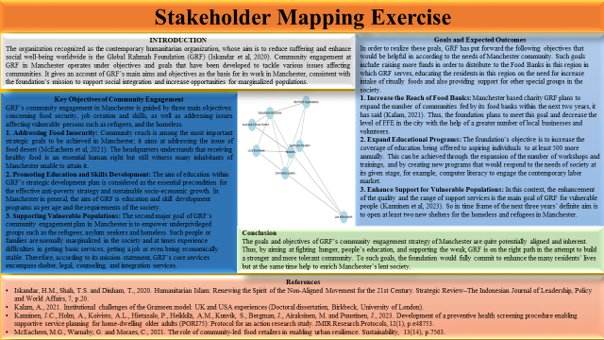

Element 3: Community Engagement Plan
Slide 1
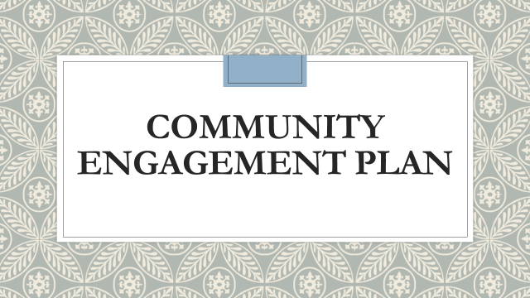
Slide 2
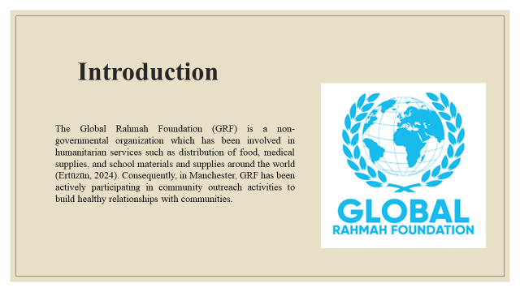
Notes:
This engagement Plan provides information on the key activities, partnerships, challenges, as well as the extent of influence of the community engagement strategy of GRF in Manchester town.
Slide 3
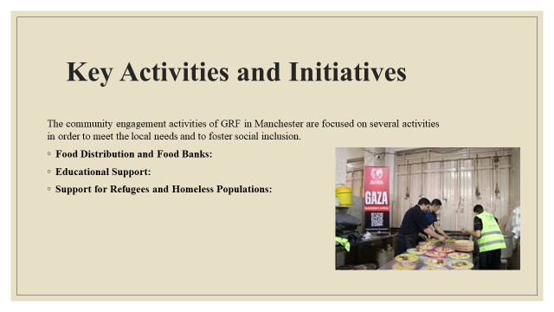
Notes:
These programs entail feeding projects, awareness creation, and support towards refugees and the less privileged in the society such as the homeless.
Food Distribution and Food Banks: Additionally, GRF has set distribution points commonly referred to as food banks across different areas in Manchester to supply basic foods to households and individuals in need (Kalam, 2021). It partners with supermarkets, employers, employees, and food banks volunteers to see that the food banks are well stocked with culturally acceptable foods.
2. Educational Support: Thus, like for the people from Manchester, GRF also delivers long-term aims like education to cater their basic requirements. Workshops and training sessions are held by the foundation targeting children, youth, and the rest of the population. The languages taught under these programs include languages skills, vocational skills, and computer literacy. Thus, through education, GRF seeks to eliminate all barriers that perpetuate poor and illiterates in order to improve the standards of living of communities that are considered disadvantaged in Manchester.
3. Support for Refugees and Homeless Populations: Refugees and homeless are also prevalent issues in Manchester; as it is the case with many other cities in the UK (Lombard, 2023). They work with GRF that assists these categories of people offering them shelters, clothes, legal aid, and psychologists. Their strategy is interdisciplinary and comprehensive because it is impossible to help homeless people with temporary necessities only, but it is also necessary to rebuild their lives and adapt them to society.
Slide 4
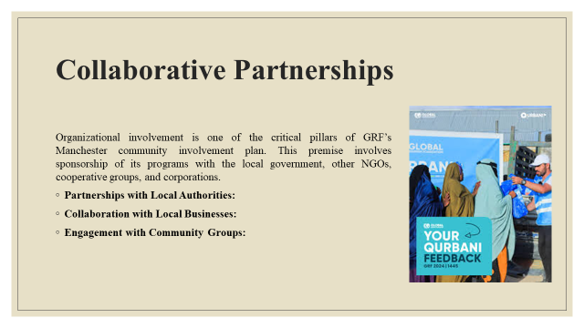
Notes:
Partnerships with Local Authorities: It has the groove to collaborate with the Manchester City Council to ensure that it’s operational plan is in harmony with the districts (McCabe et al, 2020). It also guarantees that the foundation work is aligned with the tasks of the state and includes all necessary services for vulnerable populations.
2. Collaboration with Local Businesses: Local sources of income that GRF relies on include the local businesses in Manchester that help fund some of its community projects. Most of the businesses drop off their foods, clothes and make cash contributions Others make financial contributions and encourage their employees to offer their services in any of GRF’s events.
3. Engagement with Community Groups: Based on its development on GRF works closely in cooperation with different groups within Manchester comprise faith-based organizations, youth’s groups and cultural associations. This way, these groups assist GRF to pinpoint the precise requirements of the various targeted communities and to introduce culturally appropriate opportunities.
Slide 5
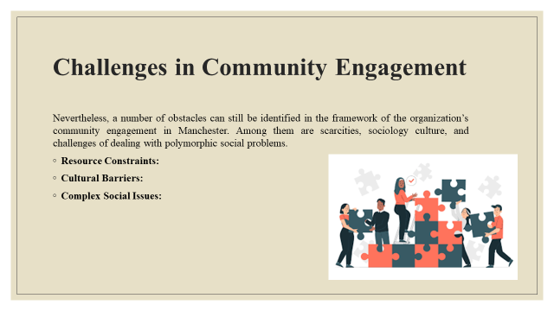
Notes:
Resource Constraints: Similar to most NGOs, GRF is a center with short money and personnel in the country (Morley, 2021). The need for services usually outstrips resources, including funding and time for carrying out activities and choosing priorities. This is true in all organizations regularly engaged in fundraising activities since this is an area that is experiencing the effects of donor fatigue within the current socio- economic environment.
2. Cultural Barriers: Thus, Manchester is a cosmopolitan city where people of different cultural and ethnic roots live. This diversity must be considered an advantage but at the same time it can be troublesome. These cultural differences are universal, and therefore GRF has to be aware of them in a bid to serve all its clientele in the community. This may mean a certain degree of contortion in the form of service delivery, and a very close understanding of the needs of the community in question at large.
3. Complex Social Issues: These are social problems, which GRF faces in Manchester and they are all linked to one another. For instance, the problem of homelessness, and the people that are affected often have mental problems as well as substance abuse problems, and may be unemployed. Besides dealing only with the symptoms, the following points illustrate that GRF has to work with other organizations and specialists using a multi-disciplinary approach in order to face these problems at their core.
Slide 6
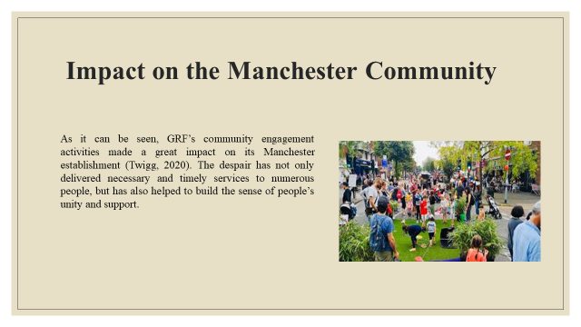
Notes:
This way, GRF has positively impacted the social and economic development of Manchester and priority population groups who are in need of immediate solutions to minor issues and support in dealing with problems that may take years to solve.
Slide 7
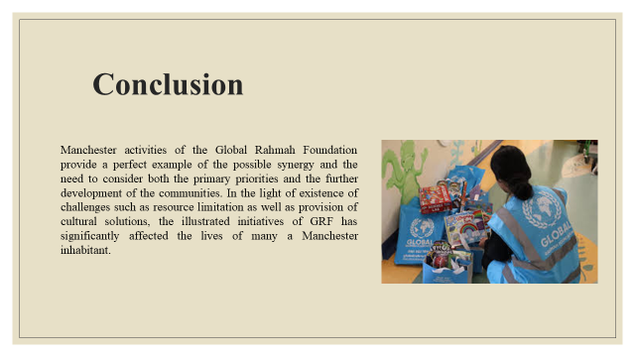
Notes:
Hence, sustaining and expanding the community engagement efforts in the city will require more collaborations in the future, imaginative strategies, and recognition of marginalized voices as going forward strategies.
Slide 8
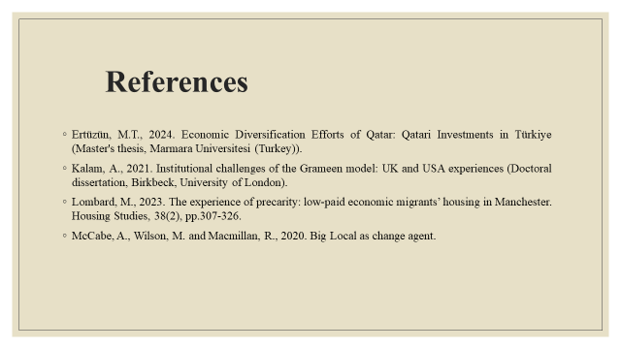
Notes:
Morley, P., 2021. From Manchester with love: The life and opinions of Tony Wilson. Faber & Faber.
Twigg, J., 2020. COVID-19 as a ‘critical juncture’: A scoping review. Global Policy, 6(December), pp.1-20.

Element 4: Practical Discussion
The mapping and evaluation of the practice of the strategy are essential for GRF to attain its goals in Manchester (Fu et al, 2022). This section defines how GRF plans to roll out its initiatives, the resources that will be availed and the method that the organization will adopt in order to assess the efficiency of its community engagement program.
Implementation Strategy
The strategic plans for community engagement within Manchester would be conducted by GRF in a stepwise manner with proper regard to the documentation of efficient resource utilization and effectiveness.
- Phase 1: Needs Assessment and Planning: The first strategy highlighted is to carry out a community needs’ assessment for a purpose of being in a position to determine the needs of various segments in Manchester for GRF. This entails struggling with the locals; people of the area, leaders of the area, the local administration etc.
- Phase 2: Resource Allocation and Partner Engagement: For any implementation process to be effective, financial, human and material resources need to be properly distributed (Heckert et al, 2020). Since sustainable funding is a concern, GRF will engage its partners such as local businesses, volunteers and other NGO’s to seek for the required capital. Working relations will be done through the signing of Memorandums of Understanding (MOUs) in order to define responsibilities.
- Phase 3: Execution and Community Engagement: With resources in place, GRF will start the implementation of its strategies it is implementing mainly its initiatives. During this stage, the additional Food Banks will be inaugurated, the campaign of Educational workshops will start and Homes and shelters to the Homeless and Refugees will be set.
Monitoring and Evaluation
Over the past few years, monitoring and evaluation (M&E) have become an essential part of what GRF does to ensure that the interventions are effective in their delivery of the planned changes.
- Monitoring Framework: In essence, GRF shall establish a monitoring system that will entail a set of indicators for each of the initiative to be implemented (Moreira et al, 2024). These are, Inputs: e. g, resources mobilized, Outputs: e. g, number of beneficiaries targeted, Outcomes: e. g, Food security.
- Community Feedback Mechanisms: To ensure that GRF receives views and experiences of the community members it will set feedback mechanisms. Some of these methods shall be as follows; Surveys, focus group, and consistent consultation with the stakeholders.
- Evaluation and Reporting: Annual review of the community engagement plan at GRF will be done at the end of each year in Manchester. It will also provide an overview of the various outcomes resulting from these initiatives and would help in planning for the future.
The processes of application and control of the community engagement strategy in Manchester allow the foundation to consider GRF’s initiatives relevant, efficient and adopted to the local population needs. Therefore, with the successful adoption of a phased approach to implementation and a comprehensive monitoring framework, GRF is poised to deliver on its objectives and impact the quality of Manchester residents’ lives.

REFERENCES
Books and journals
Fu, W., Yu, C., Xu, Z., Yang, J. and Wu, Y., 2022. Revisiting some common practices in cooperative multi-agent reinforcement learning. arXiv preprint arXiv:2206.07505.
Gall, A.J., Vollbrecht, P.J. and Tobias, T. (2020). Developing Outreach Events That Impact Underrepresented students: Are We Doing It right? European Journal of Neuroscience, 52(6), pp.3499–3506.
Heckert, A., Forsythe, L.P., Carman, K.L., Frank, L., Hemphill, R., Elstad, E.A., Esmail, L. and Lesch, J.K., 2020. Researchers, patients, and other stakeholders’ perspectives on challenges to and strategies for engagement. Research Involvement and Engagement, 6, pp.1-18.
McNeill, L.H., Wu, I.H.C., Cho, D., Lu, Q., Escoto, K. and Harris, C. (2020). Community Outreach and Engagement Strategies to Address Breast Cancer Disparities. Current Breast Cancer Reports, 12(4), pp.209–215.
Moreira, G.G., dos Santos, R.J.R., de Carvalho, V.D.H., Rosário, F.J.P. and dos Santos, A.J., 2024. Potential for Frugal Innovation in a Brazilian Regional System: A Study Based on a Multicriteria Approach. Societies, 14(6), p.95.
Singh, Ibohal and Ngangbam, T. (2020). Community Outreach and Inclusive Programmes in library: Stakeholder Feedback. LIBRARY HERALD, 59(1), pp.89–102.
Online
Global Rahmah Foundation. (2024). Global Rahmah Foundation. [online] Available at:

