

Final Project – Implementing Lean to Create a Self-Funding Energy Reduction Project
Liam Gill – 1550481 | MSc Lean and Agile Operations | 10/07/2022

Executive Summary/Abstract
This report was created to generate a new methodology based around the improvement of energy performance. With the financial constraints and burdens currently being faced within industry, it is understandable that organisations will be reluctant or not have the ability to spend excessive amounts of money to fund and support projects. To combat this, it was also the aim of this report that the project methodology created should require little to no funding to implement.
The report carried out a thorough investigation into well-established project methodologies that are frequently used within industry. These methodologies were Six Sigma, Prince2, Lean and ISO50001. All these methodologies have been proven to be extremely successful when correctly implemented in both large organisations and SMEs. Although the benefits of these methodologies have been well documented, there have also been some limitations noted for them. These limitations include the complexity of the processes and tools involved with Prince2 and Six Sigma. It was discovered that there is a lot of training and experience required to have a in depth understanding of these methodologies and how to implement them in a successful manor. This training and experience will come at a cost to the organisation whether they decide to train internal staff or employ new staff.
In addition to these the ISO 50001 framework was also investigated as it related directly to the management of energy. This also has been proven to be successful in the management of energy in industrial environments across the globe, but has been noted that unless there is an effective energy management system in place then it could be extremely difficult to validate any savings. This framework has also shown to be extremely time consuming in its implementation as it requires an Energy Management System.
The methodology created by this report took inspiration from and adapted various steps used within Lean, Six Sigma, Prince2 and ISO 50001 to create a new methodology that is as simple as possible to implement to achieve a result of energy performance improvement. This report created a four-stage approach that would include the planning, auditing, implementation of energy efficiency improvements, and review section to achieve a zero/low-cost methodology that would improve an organisations energy performance and thus have strong financial benefits.
Alongside the suggestions being made by this report, a trail project was also conducted out to test the suggested methodologies effectiveness, and learn where it has the potential to be improved. During this trail project it was established that the suggested methodology had the potential to be extremely successful, though there were a few areas noted where it could also be improved.

Acknowledgements
Thank you to my supervisor, Andrew Thorn, for providing guidance and feedback throughout this project as well as the whole course. Your knowledge and direction through this project have been vital during every step. Thanks also to my wife Carly, for putting up with my days and nights being sat at the computer generating this report and constantly supporting me through the last three years. Lastly, I would like to thank my employer and UWTSD for their support during the completion of this course.

Declaration Statement

‘This thesis is the result of the author’s original research. It has been composed by the author and has not been previously submitted for examination which has led to the award of a degree.’

Signed: L.Gill Date: 23/04/2023

Table of Contents
Executive Summary/Abstract 1
Acknowledgements 3
Declaration Statement 4
List of Figures and Tables 7
Project Introduction 9
Literature Review 11
Different Forms of Energy 11
Completing Effective Energy Audits 12
Lean and the 9 Wastes 15
Six Sigma 18
ISO 50001 27
Prince 2 Project Management 29
Principles 30
Themes 31
Processes 32
Main Body Chapters 36
Step 1 – Project Plan and Foundation 39
Project Team 39
Problem Statement 40
Project Objective 41
Project Scope 41
Energy Consumption Map 41
Energy Sources 41
Measurement Methods and Equipment 42
Initial Funding 42
Reinvestment Funding 42
Project Timing Plan 43
Communication Plan 43
Step 1 - PLAN - TRIAL 44
Project Definition From 44
Project Timing Plan 46
Energy Consumption Map 47
Step 1 - PLAN - FINDINGS 49
Step 2 – Auditing and Measurement 50
Audit Preparation 50
High Level Audit 50
Low Level Audit 52
Observational Auditing and Waste Identification 57
Step 2 – AUDIT – TRIAL 64
HIGH LEVEL AUDIT 64
LOW LEVEL AUDIT 66
Observational Audit 71
STEP 2 – AUDIT - FINDINGS 78
Step 3 – Implementation and Improvement Methods and Projects 79
Project Information Table – Live Document 79
Project Correlation Table 81
Project Prioritization Table 83
Project Timing Plan 86
Step 3 - IMPLEMENTATION - TRIAL 88
Project Information Table – Live Document 88
Project Correlation Table 90
Project Prioritization Table 91
Project Timing Plan 94
Step 3 – IMPLEMENTATION - Findings 97
Step 4 – REVIEW 98
Step 4 – REVIEW – TRIAL 101
Step 4 – REVIEW – FINDINGS 104
Conclusion 105
Recommendations and Further Work 108
References 109

List of Figures and Tables
Figure 1 - Capability Analysis Table (ISixSigma, 2010) 21
Figure 2 - Fishbone Diagram (Go Lean Six Sigma, 2022) 22
Figure 3 - Five Why Process (Kanbabize, 2022) 23
Figure 4 - DMAIC Energy (Falcon, et al., 2012) 25
Figure 5 - The Keys to Lean Six Sigma (Maxim Consultants, 2015) 26
Figure 6 - Plan-Do-Check-Act Cycle (ASQ, 2022) 27
Figure 7 - The Structure of Prince 2 (Alexos, 2020) 29
Figure 8 - Prince 2 Seven Processes (Alexos, 2020) 34
Figure 9 - Process illustration proposed by this report 38
Figure 10 - Project Definition Form - Completed 45
Figure 11 - Project Timing Plan - Completed 46
Figure 12 - Electricity consumption map for UK1 47
Figure 13 - Gas consumption map for UK1 48
Figure 14 - Electricity consumption map for UK2 48
Figure 15 - High Level Audit 51
Figure 16 - HVAC Audit 53
Figure 17 - Lighting System Audit 54
Figure 18 - Building Fabric Audit 55
Figure 19 - Compressed Air System Audit 56
Figure 20 - Office Based Audit 59
Figure 21 - Production Based Audit 61
Figure 22 - Wastage Identification Audit 63
Figure 23 - High level audit - Trial 65
Figure 24 - Low Level Energy Audit – Compressed Air 67
Figure 25 - Low Level Energy Audit – HVAC 68
Figure 26 - Low Level Energy Audit – Fabrication 69
Figure 27 - Low Level Energy Audit – Lighting 70
Figure 28 - Audit Completed on UK Office Area 72
Figure 29 - Audit Completed on UK Forming Production Area 74
Figure 30 - Wastage identification audit – Completed 77
Figure 31 - Project information table 80
Figure 32 - Project Correlation Table 82
Figure 33 - Project Correlation Relationship Strength Key 82
Figure 34 - Project Prioritization Table 84
Figure 35 - Priority Table Criteria Value Scale 85
Figure 36 - Project Timing Plan 87
Figure 37 - In Progress Project Information Table 89
Figure 38 - Completed Project Correlation Table 91
Figure 39 - Completed Project Prioritization Table 92
Figure 40 - Priority Table Criteria Value Scale 93
Figure 41 - Project Timing Plan - Completed 95
Figure 42 - Project Review Form 99
Figure 43 - Project Review Form - Completed 102

Project Introduction
The focus of this project will be on creating a new methodology or improvement model based on the foundations of Lean that can be used by organisations to improve energy performance. The new methodology being proposed by this report model should be simple and easy to implement, this will alleviate the need for any specialist training or recruitment, thus reducing its implementation costs. Further to this the new model should be effective in its purpose of guidance in improving energy efficiency. It is the belief of this proposal the suggested methodology should be self-funding by carrying out zero/low-cost improvement projects first, and investing a portion of the cost savings to fund larger improvement projects.
The proposed model will firstly need to be either extremely low cost or self-funding to achieve buy in from leadership teams. Secondly the model will also need to be extremely easy to follow and not require any specialist training. It will be the aim of this project to create a model that could be used in any situation in both large industries and SME where the results from any energy improvement projects can be monitored and verified, even if only on a high-level.
Currently there are well used methods of reducing or improving energy efficiency such as ISO50001 and Six Sigma,
The largest and most well used methodologies is the ISO 50001 standards which are used to create an energy management system with the aim of continually improving the energy efficiency of an organisation (Heidi, et al., 2020). Whilst this method of energy management is proven to be extremely effective, its limitation is where it does not detail how energy reduction projects will be achieved or funded, but instead focuses on the management of energy.
Further to this the Six Sigma methodology has also been successfully implemented in many of the largest organisations in the world to improve their operational performance (Parmar & Desai, 2020). It is predicted that individual organisations have achieved cost savings in the amount of billions of US dollars. In its evolution, Six Sigma has successfully been applied to continuous improvement projects based on energy efficiencies. There have been issues highlighted with the application of Six Sigma in that many SME’s may not be able to implement its usage due to the costs involved with its application (Deeb, et al., 2018). This is because the methodology is so complex it requires multiple staff both part time and full time to carry out projects (Jones, 2014). Further to this, a major contributor within the DMAIC process is the Pareto Analysis, by using this tool it is established that a vast majority of outputs are caused by a small number of inputs (Goldsby & Martichenko, 2005), an example of this is where a manufacturing line could see 80% of defects being caused by 20% of faults. This method again may not be possible for SME as this tool does not take into account the cost of rectifying the 20% of faults, and these may be too high for SME’s to fund.
By investigating these two main methods of energy reduction, it has been established that they can be used in conjunction with each other, where the ISO 50001 will provide the management framework and the Six Sigma will provide the continuous improvement methodology. It is the belief of this report that by doing this an organisation is likely to be able to carry out effective energy efficiency improvements. However, this report also finds that due to the cost to implement Six Sigma within an organisation it may not be a viable option for Small and Medium Enterprises (SME). This is again because it has been recommended to have a number of dedicated resources applied to six sigma projects. Building on from these points this report finds that there is a lack of low-cost model for SME’s that could be used in industry, this project will look to create and implement a new model that will be self-funding, flexible enough to be used in SME’s and Large organisations and be simple enough to follow that no excessive formal training would be required.
To examine whether any efficiency improvements have been effective as part of the newly designed model both, participant and non-participant research will need to be carried out. Participant research will be carried out in the early stages of any improvement projects such as raising awareness and non-participant research will be needed to verify if there have been any culture changes as a result.
These research methods will not be exhaustive of what would need to be carried out and as the model and project develops it will become clear that other methods will also need to be used.

Literature Review

Different Forms of Energy
As the main focus of this project is going to be based around energy and energy reduction, the first area this report will carry out research on is the different types of energy and the varying costs associated with them.
Morvay & Gvozdenac (2008) state that there are three types of energy that could be considered in industry, these are Primary Energy, Intermediate Energy and Final Energy. These energy types are described as the following:
Primary Energy – is in reference to all energy sources where energy is created directly from the natural resource (Zohuri & McDaniel, 2021). Primary energy form can be further classified into two groups depending on whether they are drawn from a depleting source (Clover & Bertram, 2010):
  - Renewable - ‘Renewable energy is derived from natural sources that are replenished at a higher rate than they are consumed’ (United Nations, 2022). Examples of renewable energy include Solar, Wind, Geothermal, Hydropower, Bioenergy and tidal (Morvay & Gvozdenac, 2008) (United Nations, 2022). Also on the borderline of renewable is nuclear power (Clover & Bertram, 2010).
  - Non-Renewable Energy - ‘Energy source that is not replaced on a continuous basis or is replaced only very slowly, but dependent completely on natural processes’ (Gnosh & Prelas, 2009). Examples of non-renewable energy include Oil, coal gas and uranium (Zohuri & McDaniel, 2021) (Gnosh & Prelas, 2009) (Morvay & Gvozdenac, 2008).
Intermediate (secondary) Energy – energy that is created by converting primary energy sources into other forms (Morvay & Gvozdenac, 2008). Examples of Intermediate or secondary energy include biofuels, manufactured solid fuels, petroleum products and electricity (Griha, 2021).
Final Energy - Final energy is also known as consumption energy and is referred to as ‘the form of energy that consumers buy or receive to perform desired activities’ (Morvay & Gvozdenac, 2008). This finding was supported by Unece (2022) when they stated the final energy was the end consumers of transformed energy such as petroleum and primary fuels such as natural gas and solar.

Completing effective energy audits
With regards to energy, an audit is considered as an assessment of the energy used by a building or process (Rashidi, et al., 2022). This finding is supported by Landsberg & Stewart (1980) when they stated an energy audit is ‘the techniques used for assessing building energy consumption and identifying methods for reducing it’. Thumann & Younger (2003) found that energy audits are valuable tools to determine the baseline for improvement projects and are essential for an organisation to verify results post project. This finding is supported by Balaras (2020) when they identified that energy audits are used to analyse the findings of energy efficiency improvement efforts.
Yajima & Arimura (2022) state there are more than 100 different types of energy auditing completed worldwide, but the international standard is ISO 50001. As a result of this, this report will use this form of audit as the basis, and then will adjust based on further findings to suit the environment more greatly. It is also found by Thumann & Younger (2003) that there are three types of basic energy audits that could be completed:
- Walk Through Audit
- Standard Audit
- Computer Simulation
Further to this Landsberg & Stewart (1980) identified three classes of energy audit, these were:
Class A - being visited on-site by an energy auditor who may potentially conduct inspections of the buildings (although this is not required). This audit will highlight economic savings that could be achieved through selected modifications.
Class B – A questionnaire completed by the building owner/operator which will then be analysed. The findings from these completed questionnaires could then be analysed by an auditor to identify areas of improvement.
Class C – using supporting information the building owners/operators can evaluate their own findings to identify potential economic savings from identified modifications.
In these classifications, ‘Class C’ would be the lowest cost to implement as it does not require external auditors. However, Class A and B could be most beneficial due to the expert knowledge of specific energy auditors. One way of achieving a compromise between cost and effectiveness would be to run a small training session for internal employees to learn how to effectively complete energy audits.
To effectively create an energy audit plan Nopec (2019) identifies six key areas to consider, these are:
- Identify any Air Leaks
- Check Insulation Levels
- Check Thermostats
- Inspect HVAC Systems
- Investigate Lighting
- Assess Night-time Power Consumption
Supporting this point Business Energy Scotland (2022) has created an energy audit checklist template to support businesses identify and prioritize energy reduction opportunities. This audit includes in depth checks of many areas including:
- HVAC (Heating, Ventilation and Air-Conditioning) Equipment
- Hot Water
- Building Fabric
- Lighting: Lamps
- Lighting: Controls
- Compressed Air
- Electric Motors
- Steam
- Other Equipment (e.g. Refrigeration and IT)
- Staff Awareness

Lean and the 9 wastes
Taiichi Ohno began to develop lean principles during the 1940s whilst working to improve the changeover process of a stamping press die for Toyota. The western solution to this was to install hundreds of stamping presses, allowing for dedicated presses for each individual part, thus eliminating the need for die change over for potentially years. This solution however was not suitable for Taiichi Ohno as this solution was suited to produce over a million cars a year, whereas Toyotas production only required a few thousand cars per year. Instead, Ohno focused his efforts on simplifying the die changeover process, he done this by creating simple adjustment mechanisms for the dies and the installation of rollers to move the dies in and out of position. This resulted in a huge reduction in changeover time from 24 hours to 3 minutes. As an unexpected consequence of the smaller production runs Toyota were producing, it was also identified that these runs were more cost effective than larger production runs. This was due to two reasons, one being that if there were any defects with the stamped components, then this would be found quickly and would not necessarily affect as many components as it would have if it was a large production run. Secondly there were financial savings from not having to carry the cost of larger inventories. (Dennis, 2007)(Womack, et al., 1990) (Madigan, et al., 2017) (Ivanov, et al., 2021). The methodologies created and used by Taiichi Ohno was later developed into the Toyota Production System before becoming more widely known as ‘Lean Manufacturing’ during the late 1980s and early 1990s (Womack, et al., 1990).
Currently Lean is considered a continuous improvement methodology that focuses on the reduction of waste in many forms (Kumar, et al., 2022). This finding is supported by Sweeney (2015; Page 23) when he found Lean was focused on using various tools to support the continuous improvement of eliminating waste within a business or organisation. Lean is built upon two Pillars, ‘providing quality at a low cost and customer happiness’ (Kumar, et al., 2022). To achieve its goals, Lean maximizes resources to reduce waste through Non-Value-Added activities (Deshmukh, et al., 2022). Value added activities are considered steps in the process that the customer would be willing to pay for, on a first time through basis. Non-value-added activities are considered activities that the customer would not be willing to pay for such as reworks.
Originally there were 7 types of waste identified within the Toyota Production System, but over time this has evolved to a commonly known 8 wastes of lean. In addition to this some industries have now included a 9th form of waste. These are:
- Waiting
- Over production
- Over Processing
- Transportation
- Motion
- Inventory
- Defects
- Non-Utilized Talent
- Energy
(Sweeney, 2015) (Mofolasayo, et al., 2022)
Lean is very well accepted by practitioners and academics as a superior performer in continuous improvement (Pearce, et al., 2021). The reason for this includes the many benefits that have been linked to the implementation of Lean, these benefits include:
- Increased Operational Efficiency
- Improved Profitability
- Resource Optimization
- Reduced Costs
- Improved Equipment Uptime
- Waste Reduction
- Improved Customer Satisfaction
- Improved Market Standing
- Improved FTT
- Systems / Process Simplification
- Increased Productivity
- Increased Employee Motivation
- More Sustainable and Green Production
(Jewalikar & Shelke, 2017) (Hariyani & Mishra, 2022) (Eskandari, et al., 2022)
Although the advantages of the lean system are agreed and accepted by most users around the world, there has been some that believe the system does have some disadvantages which include:
- Very Time Consuming
- High Cost
- Inflexible Process
- Not applicable to all Sectors
- Resistance to Change
(Karim, et al., 2011)

Six sigma
In 1986 Six Sigma was developed by the American multinational telecommunications company Motorola. The Six Sigma methodology was created to be used as a powerful tool to help Motorola reduce the number of defects being produced to a target of 3.6 parts per million opportunities. Since its creation and implementation by Motorola, it is claimed to have reduced costs by over $17 Billion. The term six sigma has a literal meaning in that a sigma is one standard deviation in a data set and that six standard deviations should occur before a defect is shown in the process. Snee & Hoerl (2003) states that six sigma aims to reduce process variations and thus defects through two major ways,
- ‘Shifting the process average to the desired target level
- Reducing variation around the process average.’
The Six Sigma methodology guides the user to use the correct tools, in the correct place and in the correct way to solve complex problems and ‘provide a rigorous and structured approach to help manage and improve performance’ (Morgan & Brenig-Jones, 2009). Building on this statement Morgan & Brenig-Jones (2014, Page 1) published Six Sigma is a process for quality improvement and is regarded as the most effective method of improving business and organizational performance by problem solving.
As well as improving quality the focus of Six Sigma also focuses on the customer satisfaction and bottom line of a product or service (Taghizadegan, 2006).
In Six sigma there is one primary improvement methodology, this is the 5-step approach known as DMAIC (4 - Leading six sigma Page 10). This is supported by Holpp & Pande, (2001) when they identified DMAIC as a six-sigma methodology to help achieve its goals of waste and defect reduction. The acronym DMAIC represents the following steps:
- Define – The problem, the system, improvement activity, goals, opportunity for improvement, requirements and VOC.
- Measure – Collect necessary data to measure process performance and critical elements of the process.
- Analyse – Collected data to determine variation root causes and relationships between factors.
- Improve – Improve process performance using six sigma and other innovation-based tools to address and eliminate identified root causes.
- Control – The improved process performance to ensure future achievement of performance goals.
(Sweeney, 2015) (ASQ, 2022)
Within each step of the DMAIC methodology, there are various tools that can be used to obtain a complete and well-defined understanding of the process and the current issues being faced. Some of the tools that can be used in each stage are;
DEFINE
Project Charter – Also known as project scope statements, a project charter is a written document that is prepared for each project. The document created should include the project justification, problem statement, any deliverables of the project, project objectives, metrics to be used and scope of the project. Gygi & Williams (2012) found that up to 50% of the success achieved by a project is affected by how well the project has been defined.
Voice of the Customer (VOC) - the purpose of the VOC is to determine the wishes and desires of what the customer requires. The customer being evaluated can be considered internal or external. The internal customer could be the next step within a process, so could be part of the same organization. The external customer could be considered the end user of a product or service. From gathering the VOC and understanding their requirements, metrics can be created known as Critical to Quality (CTQ).
Value Stream Map (VSM) - This step has been considered a potential tool to be used in either the define phase or the measure phase of DMAIC. When delivering a product or service to a customer, the information or materials must pass through a number of steps. The purpose of the value stream map is to create a visual guide that includes all the value-added steps and non-value-added steps in the process of delivering a product or service. The VSM can include stakeholders at each step and well as cycle / lead times to help identify potential bottlenecks or limitations.
Project Management Plan - The project management plan should include a list of activities to be carried out during the project, the resources needed, potential barriers / obstacles and timings of the project. The timing milestones of the project can be outlined using a Gantt chart. Further to this the project management plan should also include the performance metrics to be measured and the measurement techniques to be used.
SIPOC – SIPOC is an acronym for a high-level process map which stands for Supplier, Input, Process, Output and Customer. A SIPOC can align the focus on understanding the process of the organisation.
MEASURE
Value Stream Mapping - This step has been considered a potential tool to be used in either the define phase or the measure phase of DMAIC. For the purpose of this report a description of this tool has been generated under the define phase.
Pareto - a pareto chart is essentially a bar chart where the bar represents a frequency of an event, for example a break down caused by a specific reason such as ‘Tool Clamping Failure’. The value of the bars is arranged so that the highest frequencies are on the left-hand side of the chart in descending order. By arranging them in this way it is easy to visually identify which failures are occurring with the highest frequency, and so these failures can be prioritized. Within the Pareto analysis it is generally accepted that there is a principle that for many situations, up to 80% of defects come from as little as 20% of causes.
Capability Analysis - capability analysis uses a set of calculations to statistically compare the output of the process to the customer requirements / specifications. By completing a process capability analysis, it can be determined if the process is incapable, meaning the spread of the variation is too high, or whether the process is off target, meaning the process average is off centre.
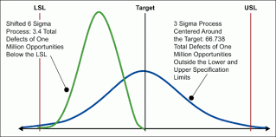
Figure 1 - Capability Analysis Table (ISixSigma, 2010)

FMEA - There are many different forms of Failure Mode Effects Analysis. These include System FMEA, Design DFMEA, Process PFMEA and Equipment FMEA. For the purpose of this report the focus will remain on the core FMEA. The aim of carrying out FMEA is to improve the reliability, safety, and quality of products. This is achieved by listing at what points in the process failures can occur and what the effect and result of these failures would be. By assigning numerical values to the severity of the failure, the potential of the failure being detected and current controls in place, a ‘Risk Priority Number’ (RPN) can be given to each potential failure and so they can be prioritized. Lastly, actions can be put in place to reduce and risks and the RPN value can be recalculated.
ANALYSE
Cause and Effect – Also known as a fishbone diagram, the cause-and-effect method was first created by Dr Ishikawa to visually display, and group various ideas generated from a brainstorming session. This method helps identify what potential causes of issues are, and drills down into why they occur. For this report, it could be questioned ‘Where and Why is Energy Being Wasted?’ and then investigate this by following the generally accepted 6 categories: Machines, Methods, Materials, Manpower Measurements and Environment. These 6 categories can however be tailored to suit the situations being questioned. An example of this based on Carbon Emissions can be seen in Fig 2.

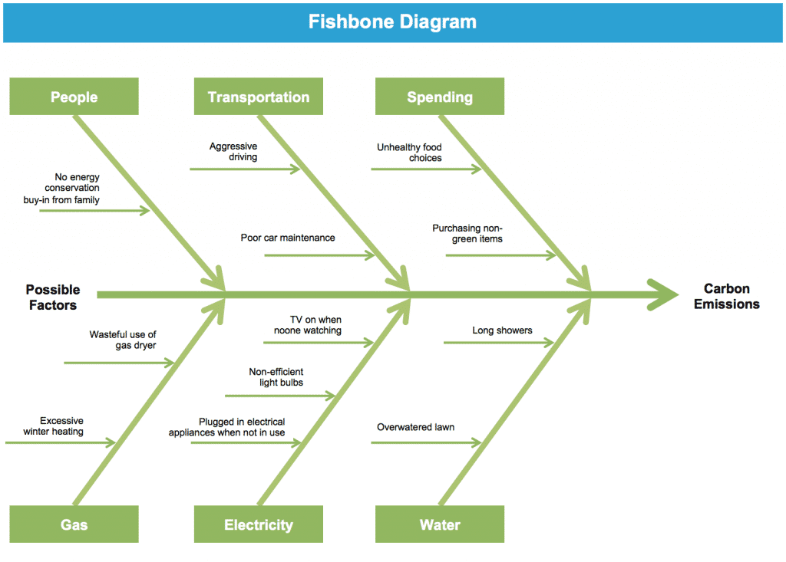
Figure 2 - Fishbone Diagram (Go Lean Six Sigma, 2022)
Root Cause Analysis - to further analyse the findings and potential causes of failure identified in the Cause and Effect’ diagram, root cause analysis may be needed. One established method of root cause analysis is known as ‘5 Whys’. To complete a ‘5 Whys’ analysis, the idea is to keep asking why an issue is occurring until you arrive at the root cause. An example of this with regards to driving through a red traffic light can be seen in Fig 3.

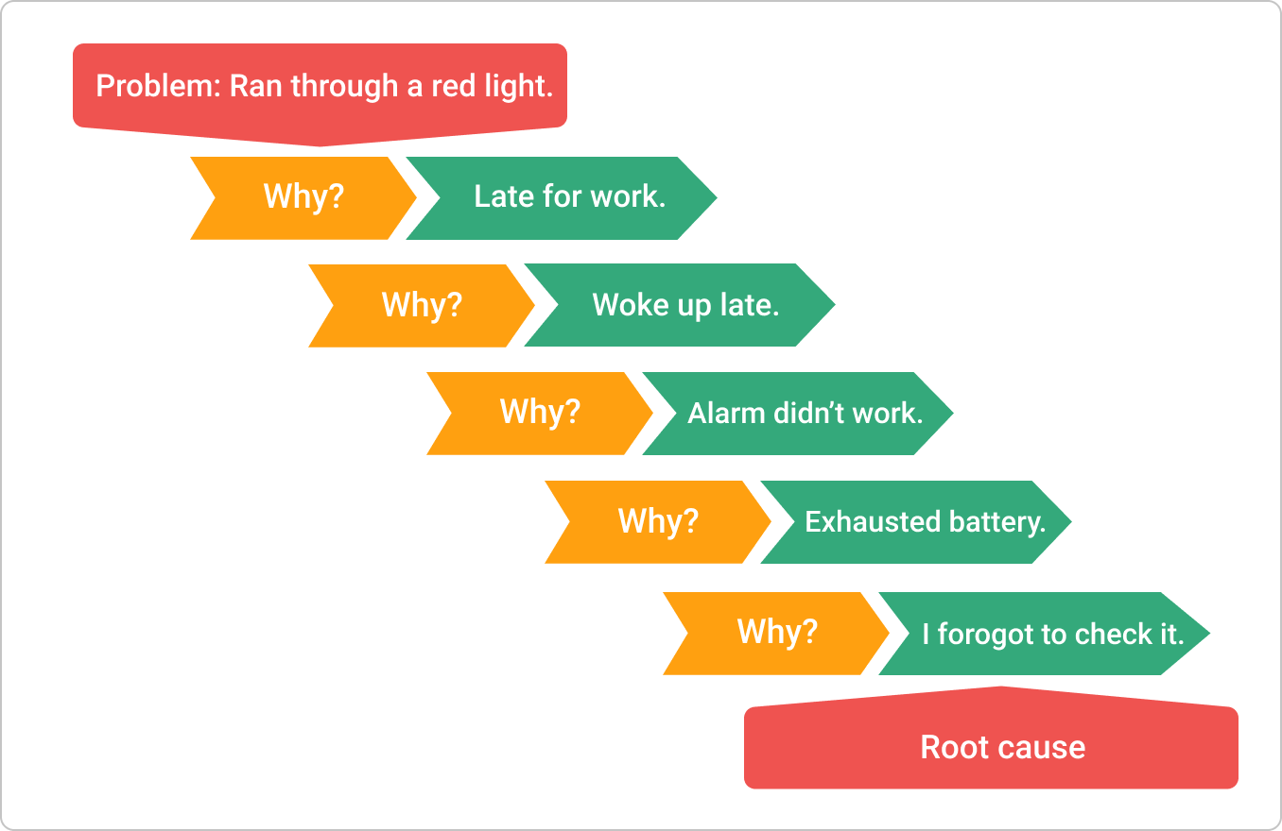
Figure 3 - Five Why Process (Kanbabize, 2022)

IMPROVE
Develop Potential Solutions – from the findings of the ‘Cause and Effect’ and ‘Root Cause Analysis’ in the analyse phase, identify potential solutions to the identified problems. From the identified ‘Potential Solutions’, time should be spent evaluating each of the solutions and optimizing them to achieve the best possible results. Designed experiments can be used at this stage to determine the effectiveness of each selected solution.
Pilot Testing – using a selected number of recommended improvement solutions to run trials on. This will allow for the identification of any potential failures or issues that arise as a result of each solution. This will need to be done on a small scale and could help determine the effectiveness of each solution.
Full Scale Implementation – Officially implement any solution or solutions that have been deemed to be successful in the required performance improvement. Documentation of plans for the full scale roll out should be created which include the performance results, both achieved and expected. Risks and risk registers should be created and monitored from this point onwards.
FMEA Update – the FMEA should be still treated as a live document and so should be updated. The updates should include any new processes, procedures or working practices. The Risk Priority Numbers should be updated also to identify any risk reductions and to capture any potential new risks.
CONTROL
Create New Documentations and Methods Around New Procedures / Methods of Working - for any new procedures, processes, or methods of working that are being implemented, the relevant documentations such as single point lessons should be updated to reflect this. Updates should be document controlled and previous versions should be placed into archive.
Deliver Training on New Procedures / Processes - It is vitally important that relevant training should be giving to all stakeholders and team members regarding any new procedures or working practices. The purpose of this is to ensure that all improvements being implemented are being completed as intended to achieve the maximum performance improvements.
Monitor Performance - new procedures, working practices and system performance should be monitored for an agreed upon length of time. This is to ensure that the desired results are being achieved and that all new procedures and working practices are being completed as intended. If the desired performance results are not being achieved at this stage, then further improvements could be suggested.
Audit Results - an agreed upon number of random audits should be completed at regular intervals to ensure the system is working correctly and to assign real value figures to the savings being achieved.
(Shankar, 2009) (George, 2002) (George, et al., 2005) (Gygi & Williams, 2012; Page 336) (Coutinho, 2021) (Morgan & Brenig-Jones, 2014; Page 55) (Kumar, 2006; Page 55) (Craig, Neil, & Bruce, 2005; Page 252-253) (George M., Rowlands, Price, & Maxey, 2005; Page 7) (Parmenter, 2007; Page 41) (Okes, 2009)

SIX SIGMA IN ENERGY PERFORMANCE
Six sigma has been used in industry to help improve energy performance through the use of DMAIC (Falcon, et al., 2012). FIG 4 is an example of the different tools that have been used by Falcon, et al., (2012) to complete an energy performance improvement project using six sigma within a fuel reforming plant.
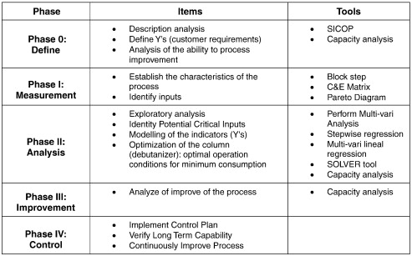
Figure 4 - DMAIC Energy (Falcon, et al., 2012)

SIX SIGMA AND LEAN
It is common for Six Sigma and Lean to be combined to form Lean Six Sigma. When combined, Lean Six Sigma is a methodology that aims to improve performance through the elimination of waste and defects. Sweeney (2015; Page 23) supported this finding when they stated, ‘from the root doctrines of the lean and six sigma programs, we can see a basic compatibility and a shared goal: the elimination of variation’. This is further supported by Morgan & Brenig-Jones (2014) when they found Lean Six Sigma provided a structured framework to manage and improve performance by reducing non-value-added activities and improving existing processes within an organisation.
When considering Lean Six Sigma, George, et al., (2004) highlighted 4 key pillars in the methodology, all of which are based on the foundation of data and facts. The four pillars recognised by George, et al., (2004) are Quality, Speed, Variation and Defects and Process Flow. A visual example of this can be seen in FIG 5. As can be seen in FIG 5. The two pillars ‘Speed’ and ‘Quality’ support the improvement of ‘Customer Delight’ and the two pillars ‘Variation and Defects’ and ‘Process Flow’ support ‘Improving Processes’.
(Sweeney, 2015; Page 23) (George, Rowlands, & Kastle, 2004) (Morgan & Brenig-Jones, 2014)
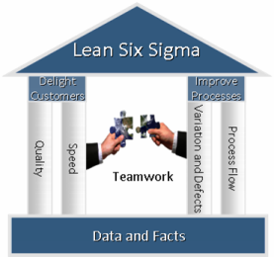
Figure 5 - The Keys to Lean Six Sigma (Maxim Consultants, 2015)

ISO 50001
The International Organization for Standardization describe ISO 50001 as a framework that will guide organizations to continually improve energy management, use data driven decisions on energy usage and develop a policy to allow for more efficient energy usage (International Organization for Standardization, 2022). This finding is support by Fuchs, et al., (2020) when they state, ‘ISO 50001 is the international framework for the holistic and structured practice of managing energy’.
The group of ISO standards were first developed in 1947 in London. The reason for this was in a post war era, 25 countries gathered together to create these international standards which were believed to be a key to reconstructing the world (Tranchard, 2017). As part of these growing international standards and the need to reduce energy consumption on a global level, the ISO 50001 standard was introduced in 2011 and then revised in 2018 to the current standard.
The ISO 50001 suggests using the continuous improvement method of Plan, Do, Check, Act (PDCA) and to measure efficiency improvements using appropriate indicators also known as Energy Performance Indices (EPI). The PDCA cycle is ‘a problem-solving technique that is generally used to resolve problems, issues or concerns.’ (Page, 2002). A Visual representation of the PDCA cycle can be seen in Fig 6.
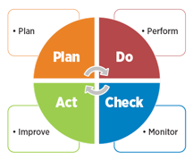
Figure 6 - Plan-Do-Check-Act Cycle (ASQ, 2022)
In each step of the PDCA cycle the following should be completed;
- PLAN – Identify and analyse the Problem.
- DO – Develop Solutions and Implement Plan
- CHECK – Evaluate the Results
- ACT – Use Feedback to Improve and Replan
(Page, 2002)
The British Standards Institute has highlighted a number of benefits associated with the implementation of ISO 50001, these include;
- ‘Identify and manage the risks surrounding your future energy supply.
- Measure and monitor energy use to identify where to improve efficiency.
- Improve overall performance to cut energy consumption and bills.
- Reduce carbon emissions and meet government reduction targets.
- Demonstrate environmental credentials to increase tender opportunities.’
(British Standards Institute, 2022)
Further to this, it was highlighted by Jin, et al., (2021) that ISO 50001 implementation has significant potential to see sizable savings in energy costs and energy efficiency. This has been widely reported from several organizations worldwide who have found that by the long-term use of ISO 50001 they have permanently improved their energy performance.
It has been found by Dall'O', et al., (2020) that some of the drawbacks associated with the ISO 50001 framework is that if there is not already an effective energy monitoring system in place within an organization, then it would be very difficult to validate any potential savings.

Prince 2 Project Management
Prince 2 is a framework that will help guide a project manager through a project lifecycle with the aim of delivering the project on time, in scope and within budget (Alexos, 2020). This finding is supported by Hinde (2017) when they highlighted Prince2 as a methodology that provides a structured approach to working through projects. The acronym Prince stands for PRojects IN Controlled Environments.
The prince2 was created in the 1980 by the Central Computer and Telecommunications agency branch of the UK Government, which was later renamed as the Office of Government Commerce (Taylor, 2011) (ILX Marketing, 2017). The methodology was originally named PROMT 2 and was created to provide an effective standard for managing projects within the UK government's ICT agencies (Molen, 2015) (Graham, 2010). Since its creation, the method evolved into a more generic project management methodology and released to the public in 1996 (Molen, 2015) (Graham, 2010). The trademark of Prince2 is still belonging to the Crown to this day (Taylor, 2011).
The structure of the Prince2 methodology is based around Processes, Themes and Principles, an illustration of this can be seen in Fig 7.
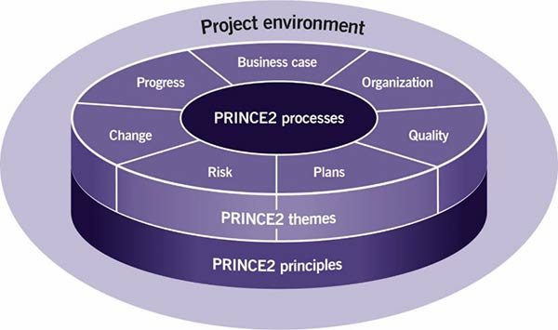
Figure 7 - The Structure of Prince 2 (Alexos, 2020)

Principles
As can be seen in fig 7, the Prince2 Principles are the foundation to the method and provide the structure of best practice for all involved. There are seven principles that should be followed during a project, these are:
Continued Business Justification – this principle is to ensure there is a justification for the project before starting and is revisited throughout the project to ensure the project remains valid.
Learn From Experience – during the start-up of a project, the project manager should create a lessons log. This lessons log can be used for two purposes, one would be to identify lessons that could be taken into this new project from previously completed projects (both internal and external), the other purpose would be document lessons that have been learnt during this project that could be taken into future projects.
Defined Roles and Responsibilities – this will be the structure of the team involved with the project being completed. The structure can include the user, business stakeholder interests and suppliers. All people involved with the project should know what their roles are and the responsibilities involved with that role.
Manage by Stages – the project should be broken down into stages to ensure the project remains manageable. The number of stages within a project should depend on how large, complex, and risky the project is. The larger, more complex, and riskier the project is, the more management stages should be planned.
Manage by Exception – within the project being completed, there will be a number of variables recognised by Prince2, these are cost, time, quality, scope, benefits and risk. With these variables there will be an acceptable level of variance that each level of the project team can work within. For example, if the project is predicted to run over or under cost by 0.5%, then there will likely be no need to immediately notify the project board as this will be an acceptable tolerance. By assigning tolerances for each level of the project team to work within, it ensures the right decisions are made at the right level in the organisation.
Focus on Products – Prince2 referrers to the output of a process as the product. It is important to the quality of the product that during a Prince 2 project, the focus should always remain on the product, and not the activities that feed into the product.
Tailor to Suit the project – A Prince2 project can be both large or small and the tools within the project can be omitted from the project if not relevant. Each area of the project should be tailored to suit the project being completed; this has been shown to increase the chance of success on the outcome of the project.
(Alexos, 2017) (StudyCorgi, 2023) (Hinde, 2017) (Marketing, 2016) (Graham, 2010)

Themes
When completing a Prince2 project there are also ‘Themes’ that should be taken into account. These themes are generated and agreed upon at the beginning of the project and should be monitored throughout the project lifecycle. Essentially, themes are there to outline how the project should be managed. There are seven themes that should be addressed continually and reviewed at the end of each project stage, these are:
Business case – the business case is in place to identify a project that could potentially have value to the organisation. This should be created at the beginning of the project and reviewed through the project lifecycle, preferably at the end of each stage. The business case project should remain viable and worthwhile throughout the project.
Organisation – Linked to the defined roles and responsibilities principle, the project team and their individual roles and responsibilities should be documented and retained. This document should be communicated to the team to ensure everyone is aware of their role. The paths of reporting and delegation could also be documented here. If there is any change to the team structure, this should be updated here.
Quality – During the early stage of the project and its start-up, the project will only have a broad outline. This theme is in place to highlight how the project will strive to meet the quality characteristics of the product being delivered.
Plans - The project plan should be created early in the project and cover the whole project from the initiation stage onwards. Three levels of plans could be considered under this theme, they are the team plan, the stage plan, and the project plan. The plans should focus on how the targets are going to be achieved and in what timescale, as well as identifying costs, product, and quality.
Risk – When projects are being undertaken, there is likely going to be some form of risk involved. It is vitally important that during a Prince2 project, the risks involved are managed. During this theme risks will be identified, assessed, and controlled. There are two forms of risk that could be identified during a Prince2 project, these are positive risks known as opportunities, and negative risks known as threats. All risks should be recorded in a risk register. There is the potential for a budget to be set aside called a risk budget to fund any actions required because of the risks.
Change – It is likely that during a project, change may need to be made. These changes could occur in several different areas, examples could include budgets, timescales or a product not meeting expected outcomes. The purpose of the change theme is to have a system in place to deal with any project changes. The theme requires the assessment, monitoring, and control of any changes as well as recording of them. There is also the opportunity in this theme to allow for a ‘change budget’ to manage any project changes.
Progress – The progress theme sets out to assess the viability of the project to move forward. The project manager should consider and document how the project will be controlled and kept on track. The progress theme will guide the project manager to ask the questions ‘Where are we now?’, ‘Where are we going?’ and ‘Should we continue?’.
(Alexos, 2017) (StudyCorgi, 2023) (Hinde, 2017) (Marketing, 2016) (Graham, 2010)

Processes
Prince 2 is a project management methodology that uses a process-based approach. Alexos (2017) states ‘A process is a structured set of activities designed to accomplish a specific objective. It takes one or more defined inputs and turns them into defined outputs’. There are seven processes identified under Prince2 which guide the project through sets of activities required to manage various parts of a project. These processes are used as a framework to direct and successfully deliver a project.
The seven processes to be completed withing Prince 2 are:
Starting up a project - This step is completed before the project has started. The aim of this step is to outline the potential project to help decide if it would be worthwhile undertaking the project. This step helps eliminate the waste of time and resources of an organisation by having the opportunity to reject an unviable project before inception.
Initiating a Project – During this process, the project manager should lay out a plan for the entire project and how it will achieve the desired outcome. This plan should include how the targets of risk, cost, time, quality, scope and benefits should be managed.
Directing a Project - as can be seen in Fig 8 the ‘Directing a Project’ process is under the ownership of the corporate project board. It can also be seen that this process should run from the initiation process to the project closure. This process is in place to manage ad-hoc direction, stage boundaries and project closure.
Managing a Stage Boundary - at the end of each stage, which were agreed upon during in the ‘Plan’ theme, there will be a stage boundary. At this stage boundary, the project manager and the project board should complete an ‘End Stage Assessment’ and determine whether to continue with the project or not. If proceeding with the project, then the plan for the next stage should be agreed upon here as well as updating any live documents such as the risk register and business case if any changes have taken place.
Controlling a Stage - during the pre-agreed upon stages the project manager will delegate work packages to the project team. It is here where the day to day running of the project is carried out by the project manager. During this stage, the project manager will also complete progress reports on the work being completed by the project team.
Managing Product Delivery - There are three activities that will need to be completed during this process. These are ‘Accepting a Work Package’, ‘Executing a Work Package’ and ‘Delivering a Work Package’. It is during this process that a large portion of the specialist work and testing is completed to the deliverable or products. Communication between the Project Manager and the Project Team is key here.
Closing a Project - Closing a Project is the last of seven processes to be completed. As the name states, it is at this stage the work is completed in the process of shutting down or finishing a project. The step may be completed once a successful deliverable or product has been achieved, or it may occur at the end of a stage if the project was no longer deemed viable. Reviews and analysis should be completed here to determine if the project has achieved it objectives, if there is any more work to complete and if there are any lessons learned. Once completed the process of hand over to the customer should begin.
(Alexos, 2017) (StudyCorgi, 2023) (Hinde, 2017) (Marketing, 2016) (Graham, 2010)
An illustration created by Alexos of the seven processes and how they interact can be seen in Fig 8.
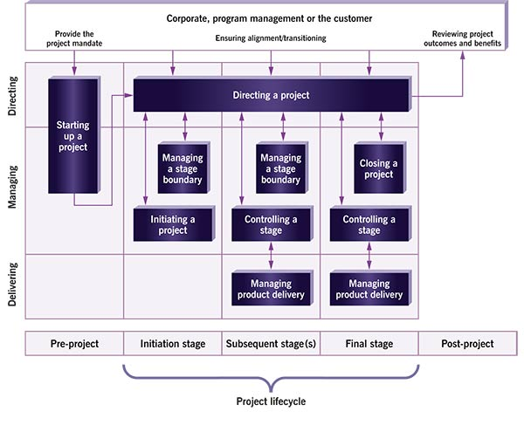
Figure 8 - Prince 2 Seven Processes (Alexos, 2020)

A benefit of the Prince2 method that was featured in a report by Laoyan (2022), was that because the methodology is intended to be used as a framework instead of having fixed rules in place, this allows the method to be extremely flexible and so can be used on almost any project. This finding is supported by Matos & Lopes (2013) when they found Prince2 could be scaled to suit the project needs and so can be flexible in its delivery. Further to these advantages of Prince2, Hedeman, et al. (2009) noted other benefits of using Prince2 as keeping a project in control, maintaining focus on the product and providing a clearly defined organizational structure. All these benefits will contribute to the successful delivery of a project.
One issue highlighted about the Prince2 methodology by Lawton (2015) is that it is very complex, and so it is a large task for anyone to develop and have a solid understanding of the different elements and terminologies in the process. This finding is supported by Miller (2023) when they identified the Prince2 methodology can be complex and cumbersome with excessive documentation. In addition to this they also found that teams may take time to adapt to changes.
Main Body Chapters
This report will attempt to tailor a continuous improvement model regarding energy consumption that will be little to zero cost. To be able to achieve this, the report will draw applicable steps and processes from currently well know and effective improvement models six-sigma, ISO 50001 and Prince2. All these methodologies have a proven track record of successful implementation and improvements within organisations. To keep the proposed methodology usable in all organisations, this report will aim to keep the process simple and effective, this will be in contrast to Six Sigma and Prince2 which Miller (2023) noted can be considered very complex. This finding is supported by White & Fortune (2002) and further noted that these project methodologies have the additional drawback of being ‘too heavy in documentation’ and too time consuming. To ensure the methodology being suggested by this report does not develop the same drawbacks, documentation will be kept simple and contained to as few documents as possible. To achieve this, some documentation will need to remain live throughout the project, this will allow the same document to be reviewed and updated to account for any changes and the previous version could be archived.
To ensure the methodology is memorable to the user an acronym will be used to outline the process. Acronyms ‘use the first letter of words, or phrases, in a list, or sequence of events, to build a new word that can help you to remember better. This means that instead of memorizing the entire list or process in order, you just have to remember one word. The word can then be used as a prompt to help you to recall the entire sequence’ (Absolutely Studying, 2023). This finding is supported by Radovic & Manzey (2019) when they stated the learning of material can be enhanced by creating a learning phrase of the to-be-remembered materials. This will in turn enhance the performance of the recall memory of the material.
A widely used tool within continuous improvement is the Plan-Do-Check-Act method, known as the PDCA cycle (Rajan, 2019). The PDCA cycle popularity is partly due to the fact it is a simple process that doesn’t require much instruction and that the circular illustration of the process encourages continuous improvement (Ionos, 2019). It is for this reason this report will adapt a similar styled system to its proposed process, in addition to this a simple acronym will be used to increase the memorability of the process.
The Acronym for the process going to be proposed by this project is the ‘PAIR’ system. This acronym will stand for:
- Plan – The project plan will include the team members, the project scope, budget, and approximate timeframe to build a definitive direction for the project to move forward.
- Audit – Various levels of auditing will need to be completed to identify opportunities for improvement and potential areas of waste.
- Implement – prioritize the identified energy saving projects and begin implementation.
- Review – Measure the results of the implemented projects and determine savings achieved. At this stage a project closure document can be created.
The illustration of this process is shown in fig 9.

- Project Review Form
- Agree if a new project should be started if further savings can be achieved.
- Project Definition Form
- Project Timing Plan
- Energy Consumption Map

- Project Information Table
- Correlation Table
- Prioritization Table
- Project Timing Plan
- Audit Preparation
- High Level Audit
- Observational Audit

Figure 9 - Process illustration proposed by this report.
To prove effectiveness and trail the process being proposed by this report, a trial project will be run in line with this report implementing its suggested methodology. This will be highlighted at the end of each project step being suggested to provide templates and examples where possible. The purpose of trailing the new process being suggested is to learn if there are any amendments that could be made to improve the suggested process, this practice is supported by Chepul, (2022) when they noted that during the execution of a project you will learn how it can be adapted and improved and so adjustments can be made.

Step 1 – project Plan and foundation
Following ISO50001 framework and the six-sigma methodology, this report will suggest the first step of the process should be ‘Project Plan and Foundation’. This could be a single document containing all the required information known as a project definition form. To create this document various points will be adapted from Prince2, Six Sigma and ISO50001 to create a simple but effective document planning the initial stage of the project. The original signed document should be securely placed in the project file and copies should be distributed to the team. As part of this initial document the following sections could be included:
- Project Team Members
- Problem Statement
- Project Objective
- Project Scope
- Energy Consumption Map
- Energy Sources
- Measurement Methods and Equipment
- Initial Funding
- Reinvestment Funding
- Project Timing Plan

Project Team
The project team should have team members of various levels and responsibilities. For smaller organizations the minimum number of team members that are required is two. However, for larger organizations a larger team may be required.

Project sponsor - Mandatory
As part of the team there should be a member of the senior leadership team which will be known as the ‘Project Sponsor’. The project sponsor will not require a large hands-on approach to the project but will be required to agree and provide and initial funding, agree the reinvestment funding, help define project scope and provide project approval / commissioning. If there is only the mandatory two team members for the project, then the Project Sponsor will also be responsible for auditing the findings of the project managers throughout the project.

Project Manager – Mandatory
The other mandatory team member will be responsible for the running to the project and will be known as the project manager. This role will be capable of carrying out all other tasks of the project, the purpose for this is to maintain as low cost as possible for the project. In a larger team, the project manager will be responsible for selecting team members as well as work delegation. In addition to this they will have the overall responsibility for managing the approved budgets and ensuring work schedules are met.

Energy Auditor – Part Time
The role of ‘Energy Auditor’ will only be required during select times of the project. The first requirement will be to complete ‘as-is’ audits of the organisation to determine any potential ‘opportunities for improvement’. The second requirement will be to complete audits in specific areas once targeted improvements have been made. This is to ensure the desired results are being achieved. It would also be beneficial for the energy auditor to conduct random audits of the organisation periodically after the project has been completed, this would be to ensure any improvements are continuing to be effective and to capture any changes to energy performance early on.

Procurement Advisor – Part Time
Once the opportunities for improvement have been identified by the energy auditor, there will be some areas that will require investment. This investment could be of small or high value depending on the initial investment agreed by the project sponsor or at what phase of reinvestment the project is at. The role of the procurement advisor will be to source any required materials or subcontracted work for the best price possible. This will ensure the most efficient kWh saving per £1 spent is achieved.

Problem Statement
The project problem statement should be a simple justification for the project being undertaken. The statement should identify the gap between where the organisation is currently performing regarding energy efficiency / consumption and state what performance ambitions of the project are. In addition to this the problem statement should include the consequences of the performance gap and what is needed to reduce this gap.

Project Objective
The specific objectives for the project. The objectives can be one line or more detailed but should include the timeline in which the performance improvements will be made. The main points made in a project objective should be to set out specific, qualifiable and measurable values of performance improvement above the baseline discussed in the problem statement (Craig , et al., 2005).

Project Scope
The project scope section of the ‘Project Definition Form’ document should highlight the boundaries of the project. It should include what is ‘in scope’ and ‘out of scope’ for the project being undertaken. This will help ensure the project team stay focused on what improvements can be made rather than improvements where there would be no appetite for change. For example, changing some procedures may have the potential to improve energy efficiency, but this may impact on quality standards and so in some settings, certain process or operational changes may be deemed out of scope due to the related risks.

Energy Consumption Map
The energy consumption map should be designed similar a process flow diagram. This is to ensure the consumption of energy on site is as simple as possible to understand. The flow should follow from the incoming electricity or gas feed and then follow the process of where this is consumed. This will be useful in identifying where potential performance improvements can be made.

Energy Sources
Primary and secondary energy sources should be understood during this early stage of the project. With regards to the primary energy sources, this should be the main infeed to the organization such as Gas and Electricity. The secondary sources of energy could be considered as other forms of energy that are created from the primary energy sources, this could include compressed air, vacuum, lighting, chilled water, heating etc.

Measurement Methods and Equipment
In this section it will be the aim to simply outline the methods that are going to be used to determine baseline performances and project improvement verifications after completion. It is expected that this section will vary widely from organisation to organisation.
There is the option to propose an initial measurement funding at this stage to ensure the correct measurement equipment is used for the project. It may also be that the measurement equipment could also be funded as part of the initial project savings.
Depending on the granularity of energy bills, these have the potential to be used as the measurement during the initial stages to maintain a low project cost. If this method is used, then the project manager should outline in this section how they will aim to prove that any efficiency improvements they make are as a direct result of the project and not due to any other factors.
If portable measurement devices are being used in the project, then their calibration certificates should be included. The suggestion here would be to use a metering system on individual areas being monitored for the most accurate measurements, however with the aim of keeping costs as low as possible this is not essential.

Initial Funding
There may be the possibility of initial funding to support the project at the start. This would allow the project manager to invest in metering systems or to give them the ability to fund some of the early stages of efficiency improvements without the complete reliance on reinvestment funding. Any initial funding would have to be agreed upon and provided by the project sponsor.

Reinvestment Funding
The reinvestment funding is the amount of money that will be reinvested into the project once efficiencies have been made. This reinvestment fund should then be used to support further energy efficiency projects. The percentage of reinvestment funding will need to be agreed upon and provided by the project sponsor. Initial project steps will not require any initial funding and so can be generated by carrying out zero cost efficiencies the generate the cash flow into the project. An example of this would be if a project sponsor agreed for zero initial funding and a 10% reinvestment value, waste elimination projects such as shutdown procedures could be used to generate funds. The reinvestment funding percentage is mandatory for the project and the value should be a realistic amount to be able to support the project in achieving further efficiencies.

Project Timing Plan
The project manager will be responsible for creating this part of the document and will have to seek approval from the project sponsor once the plan is complete. The timing plan should keep focus on suggesting realistic time goals for the work to be completed in step 2: ‘Auditing and Measurement’ as this area will be most reliable. Any proposed time plans for step 3: ‘Energy Improvement Methods and Projects’ will be purely for guidance. The reason for this is step 3 will depend on many factors such as initial funding, contractor lead times and how many improvement cycles will be desired to be completed.

Communication Plan
Within Prince2 it was noted by Tuttle (2012) that communication is vitally important to the success of a project. For this reason, the primary and secondary methods of communication should be clearly identified during this section of the form and the frequency of this communication. For example, setting up weekly meetings with the project team to discuss progressions within the project or meetings at the end of each stage of the project between the project manager and project sponsor to agree on whether to proceed or not.

Step 1 - PLAN - trial
As discussed in the previous chapter, this chapter will follow the suggestions made previously on a live project. The project this will be implemented on is for a large food packaging manufacturer in the South Wales area. For confidentiality purposes the company name will not be disclosed some names have been omitted.

Project Definition From
In order to honour this reports aim of keeping the format as simple as possible, the majority of the first step has been compiled into a single document. This document can be used as a reference throughout the project to ensure the focus remains on the agreed upon scope.
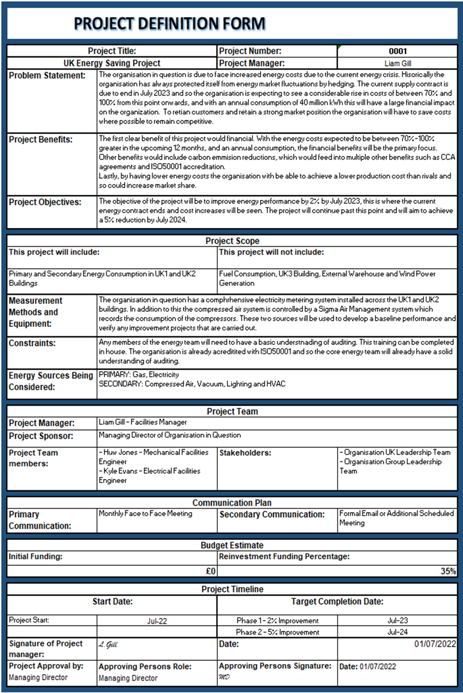
Figure 10 - Project Definition Form - Completed

Project Timing Plan
Figure 11 - Project Timing Plan - Completed

Energy Consumption Map
The below maps in 12, 13 and 14 are the basic consumption maps within the UK1 and UK2 buildings for Gas and Electricity. The building known as UK2 does not have a gas supply map as there is no feed into the building. In these maps the orange-coloured points are in reference to the mains incoming supply of energy, the blue coloured points refer to the transferring of energy from one form into another and the final points in the process are highlighted as green which represent the final consumers of the energy.

Figure 12 - Electricity consumption map for UK1
Figure 13 - Gas consumption map for UK1
Figure 14 - Electricity consumption map for UK2

Step 1 - PLAN - Findings
From completing the suggested steps on a live project, this report has had an opportunity to identify where the suggested steps could perform well, and where they could be improved. Some of these benefits and shortcomings are outlined below:
- The single document format of the first phase is beneficial to the aims of this project as a simple and easy to follow process. Thus, reducing training costs to the business.
- Within the document it should have been included the frequency and required attendees of communication meetings. This could have been included within the ‘Communication Plan’ section of the document. It could also have highlighted who would be responsible for scheduling the regular meetings. By not completing this it could have a detrimental effect of the project as communications meetings may not occur.
- It is the belief of this report the Project Definition Form could be further improved by including a section to highlight the projects that have been completed. This is to ensure there is no duplication of work during the project.
- With businesses and projects constantly changing and adapting to their current needs, it will be beneficial if the Project Definition form was to remain a live document. This could be periodically updated by the project team and the version of the form to be updated in line with this. It would be the suggestion of this report that under the meetings scheduled in the ‘Communication Plan’ of the document, one of the discussion points of the meeting was to review if the document was still relevant. Some examples of changes that could occur in the changing of project team members or the energy sources being considered.

Step 2 – auditing and measurement
During this phase of the process the aim will be to complete Energy audits of the area being investigated. This report will suggest the auditing to be completed on a high level to begin with to understand the process better. Following on from this, the report suggests two further audits, these are a Low-level audit and a wastage identification audit. Within this section there is several audit templates that have been created for this project. These templates can be used in their entirety or adjusted to suit the workplace being audited.

Audit Preparation
Prior to completing any audits, some preparation should be carried out. In this preparation will include the identification of the energy team, audit checklists, auditing scope and audit plan (Russell, 2007) (Hasanbeigi & Price, 2010).

High Level Audit
The first level of auditing that will be suggested by this report is a ‘Class B’, (Landsberg & Stewart; 1980) which the project manager will complete from a predominantly office-based position. To complete this audit from a high level, a simple questionnaire could be used to help the auditor understand from an early stage where potential savings could be made or where further, more in depth auditing could occur. This audit will further help the auditor consider which services are available on site for further auditing and potential savings.
As part of the high-level audit, it should be identified which energy consumers are the ‘Significant Energy Users’. Significant energy users are defined by the Office of Energy Efficiency & Renewable Energy, (2022) as ‘an energy use that accounts for substantial energy consumption and/or offers considerable potential for energy performance improvement.’ This report will suggest creating a simple pareto chart to chart to clearly identify which energy users are the highest consumers. The suggested high level audit form can be seen in Fig 15.
Figure 15 - High Level Audit

Low Level Audit
The low-level audits being recommended will be another form of questionnaire that will be focused on the various areas within the workplace. This form of auditing has been recommended by Business Energy Scotland (2022) in their initiative in working towards net zero. Multiple questionnaires will be created that will be tailored towards various forms or plant or equipment that may be in the workplace. To monitor which audits are required and when they have been completed, the checklist created/completed in the high-level audit can be used.
Not all questionnaires will need to be completed, the relevant questionnaires will need to be selected by the auditor depending on what equipment is identified in the workplace.
This level of auditing will require a greater understanding of the different areas within the workplace, if the required information is not known then it will need to be researched. It is highly likely that this level of auditing will need to be completed both as a desktop exercise and by walking and visiting the areas in question.
Within this level of auditing, this report will aim to maintain a similar form of questions throughout the areas where possible then add targeted questions to the audit for each specific area. The benefits of this would be to keep the process as simple as possible with common questions whilst not missing potential savings by targeting some questions to specific workplace areas. In addition to this, the questions being asked will encourage the auditor to investigate the current maintenance practices to ensure they are suitable and ensuring any equipment is running as efficiently as possible.
During this phase of auditing is where it would be expected to identify the highest volume of potential saving opportunities. The opportunities at this stage are likely to require investment to achieve.
Some examples of the audit questions that could be completed in multiple specific areas can be seen in fig 16, 17, 18 and 19.

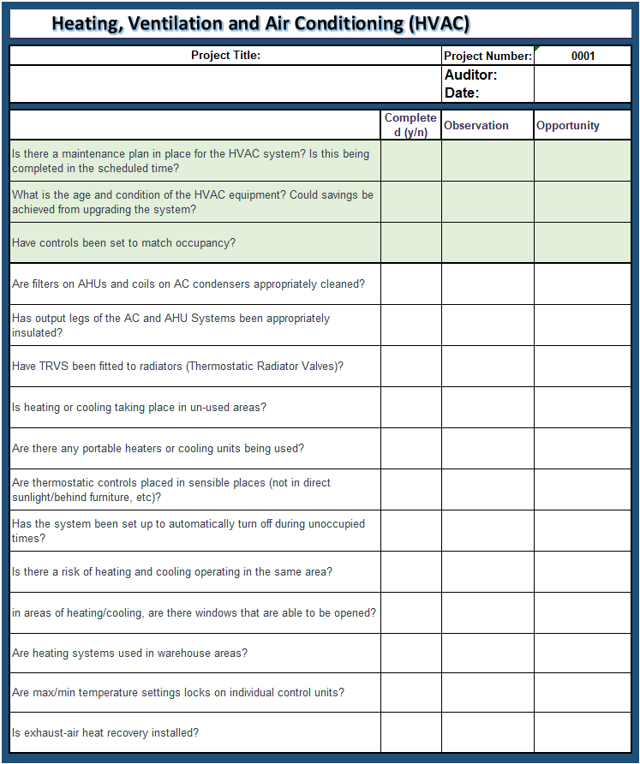
Figure 16 - HVAC Audit
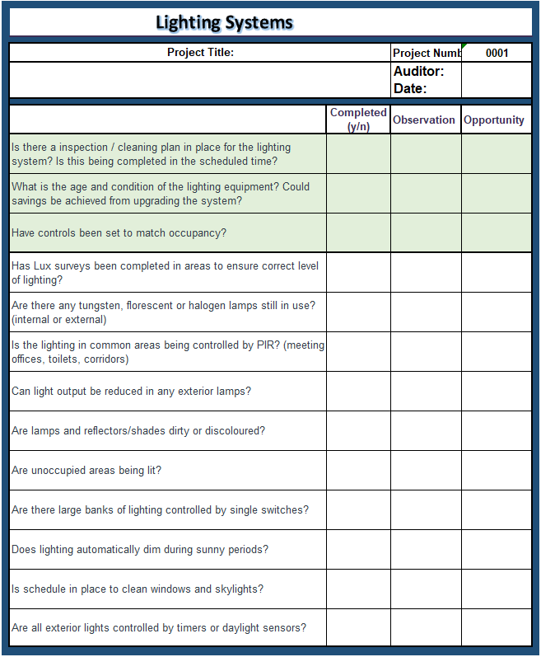
Figure 17 - Lighting System Audit
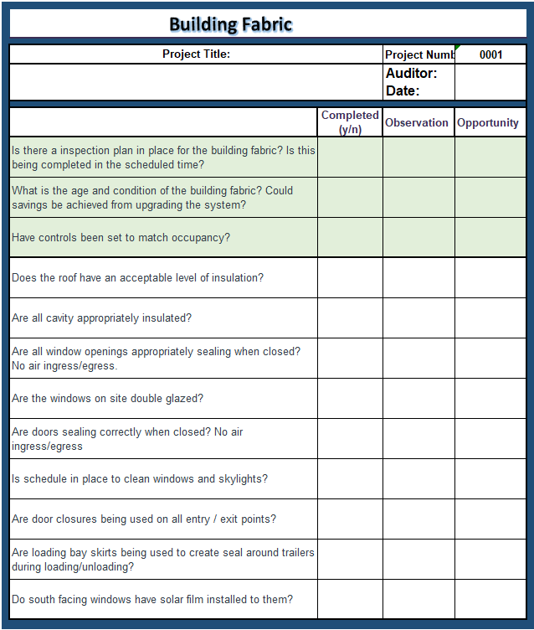
Figure 18 - Building Fabric Audit
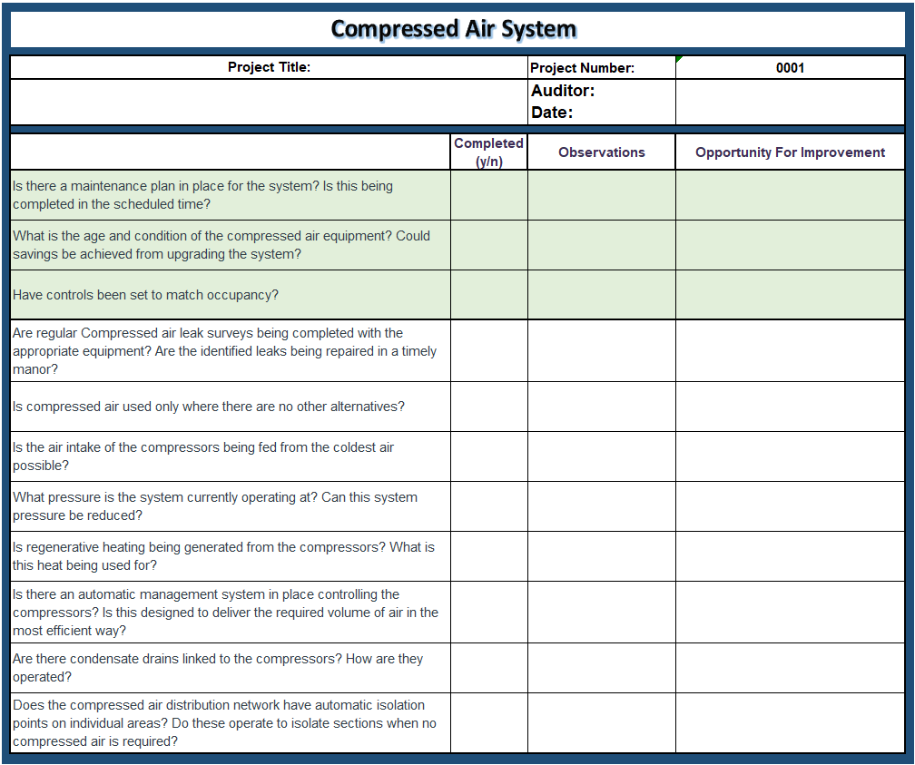
Figure 19 - Compressed Air System Audit

Observational Auditing and Waste Identification
The last phase of auditing will be based around observations seen within the workplace. The purpose for this will be to get the actual as-is energy performance. It was noted by Agency for Healthcare Research and Quality (2021) that observational audits are the best way in which to determine if staff are following the procedures and practices set out by the organization. In addition to this Schubert, et al., (2021) stated that completing observational energy audits can improve the adoption of energy efficiency measures. It is expected that from these audits there will be areas of wastage identified that would have to potential to become zero/low-cost initial projects.
The observational audits being suggested will fall into two categories, one being an office-based audit and the other will be a production area-based audit. The reason for this is due to the differences expected to be seen in each of the areas, there will need to be considerably different procedures and services investigated. In addition to the observational audits, there will also be the option to complete a further desktop-based audit to identify any weekend wastage.

Office Based Audit
During the office-based audit, it is suggested by this report to be completed on two separate occasions. One of the audits should be conducted during office hours to establish the working practices and the areas where the office consumes energy during occupied hours (Steel & Heath, 1998). Another benefit of this is to assess the usage of lighting condition more accurately during daylight hours (Thumann, et al., 2009).
Fig 20. Is a template that could be used to complete the audit within the office environment. The template has included potential areas that could be identified as wastage. These questions are there to assist the auditors in completing the audit effectively. The guided points also help in keeping the audit process easy to follow by highlighting common areas where savings could be achieved, this will further improve the simplicity and reduce training required to complete the project. There have been several blank sections left at the bottom of the audit form to allow for other observations to be included within the audit. This will allow the auditor to tailor the audit to their specific workplace.

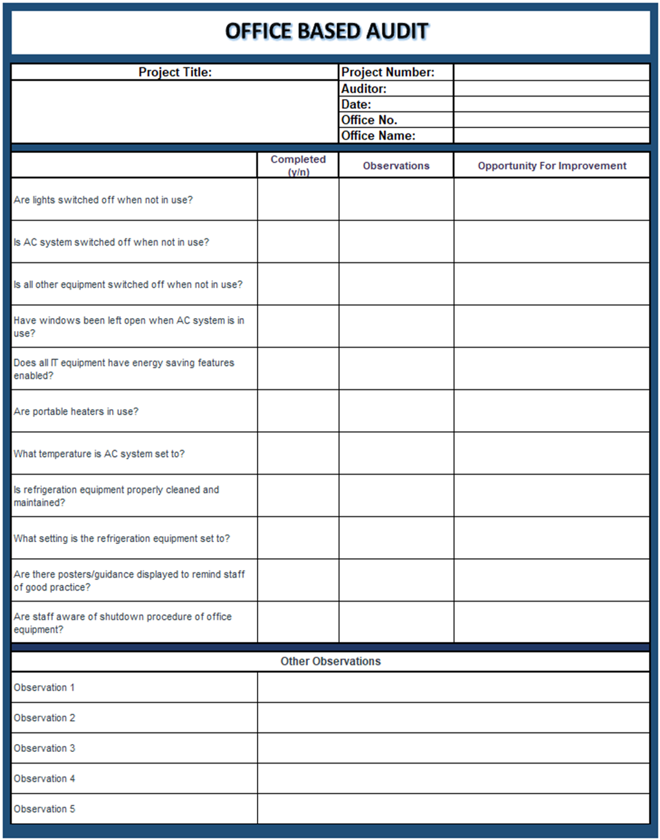
Figure 20 - Office Based Audit

Production Area Based Audit
The format of the production-based audit will remain similar to the template created for the office-based audit. The guidance questions will remain in place but will be guiding the auditor to instead investigate areas related to production environments. The additional observations section of the template will remain in place to maintain the tailoring of the audit to each specific workplace. Regarding the shutdown of machinery, if it is highlighted that machines are powered on when not in use, it would be beneficial to hold a discussion with the production team to ensure there is not a genuine reason for this equipment to be powered on, such as machine warm up or maintenance activities. This could potentially save time and resources in quantifying potential savings and creating shutdown procedures when current shutdown practices are already in place and are effective.
Fig 21 is the suggested template that could be used to audit production areas.
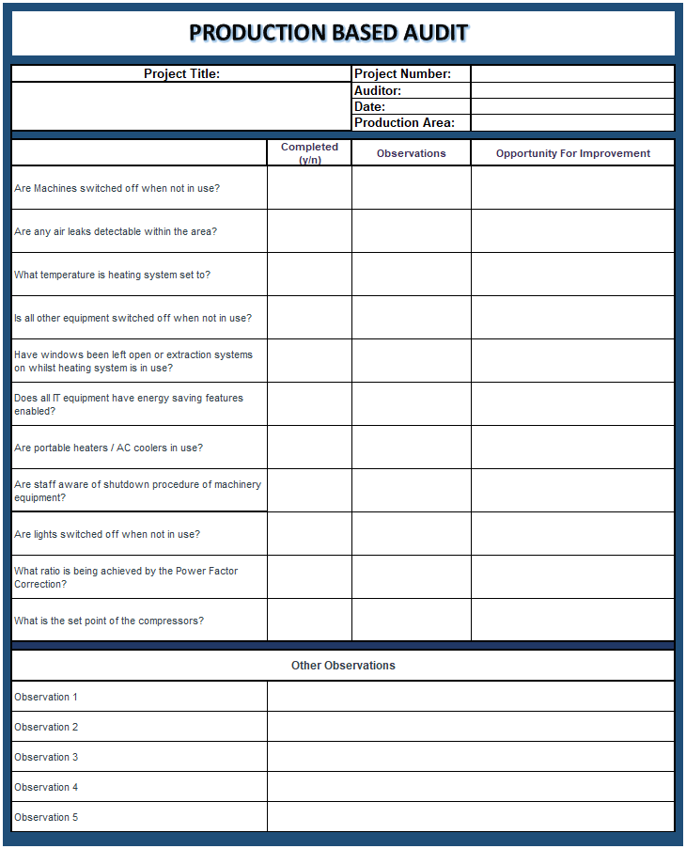
Figure 21 - Production Based Audit

Wastage Identification Audit
It should first be noted that this form of audit will only be possible to complete if the metering and monitoring systems allow. This suggested form of auditing will also assist in quantifying a value to the wastage being generated. To complete this audit, the auditor will be required to use the metering system in place to identify consumers of energy during non-operation hours.
This audit will focus on wastage, which could be completed on the office environment and on the production machines. These two will be similar and focus the energy being consumed during unoccupied or non-production times. This would be completed by using the metering system to draw on the historical energy consumption data of these two areas when they are not in use i.e. on weekends. The time periods in which the wastage could be measure would have already been identified in the ‘High Level Audit’ form under the ‘Operational Hours’ section. These audits will highlight how effective the shutdown procedures of equipment are within the organisation. Any findings here could highlight low cost or free energy improvement projects to begin the financial saving process to fund further projects. During these audits it could be beneficial to establish what the lowest baseline consumption would be to measure other values against this (Energy Hub, 2020). The report will suggest that the baseline consumption data should be taken from Christmas day readings as long as the facility does not operate during this time. The reason for this is because the consumption of energy is likely to be the lowest during this time due to complete plant shutdowns.
In addition to these areas, a audit could also be completed on the wastage being seen on the site services on site where applicable. The first step in this audit will be on the power factor correction, power factor correction is a ratio figure that shows the user how much of the energy being supplied is converted into useful energy output (Alasooly, 2020). The lower the ratio of the power factor correction results in a higher level of energy wastage and higher supply bills for the consumer (Ware, 2006). Building on from the inspections on the power factor correction, measurements should be taken of significant energy users within the site services department, for example compressed air, vacuum, and chilled water systems. During this audit it would be beneficial to use a non-productive day such as Christmas day to qualify how much is being consumed by these services. This will help identify to actual cost of compressed air leaks on site.

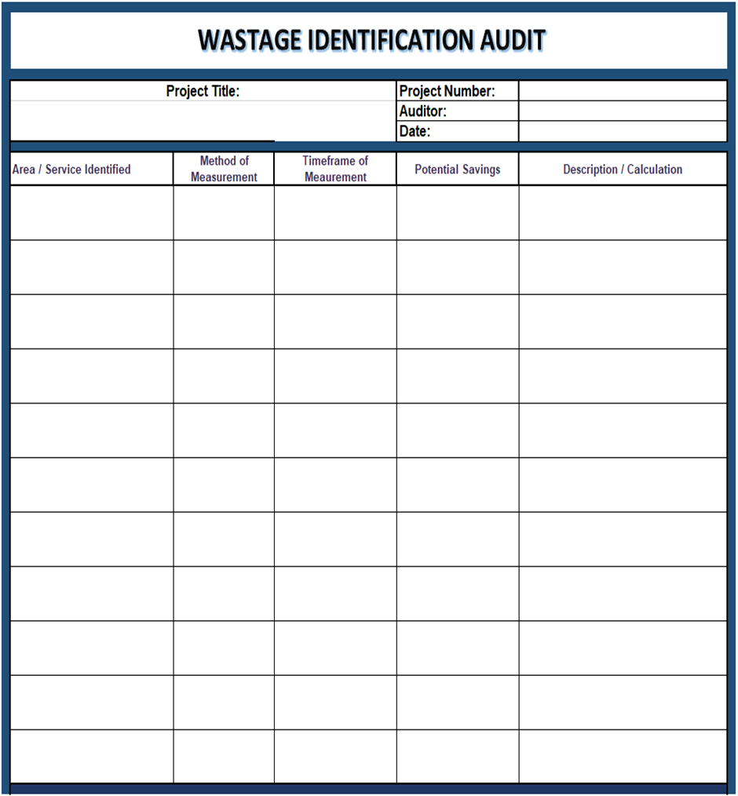
Figure 22 - Wastage Identification Audit

Step 2 – audit – TRIAL
Continuing with the trail of the process being suggested by this report, this chapter will complete the step 2 trial. During this trial audits will be completed at a high level, low level, on working practices (observational) and on wastage identification.

HIGH LEVEL AUDIT
In line with the suggestions made by this report, the first audit completed during the trial was the high-level audit. This involved capturing high level information about the environment where the project is taking place. The findings of the high-level audit can be seen in fig 23.
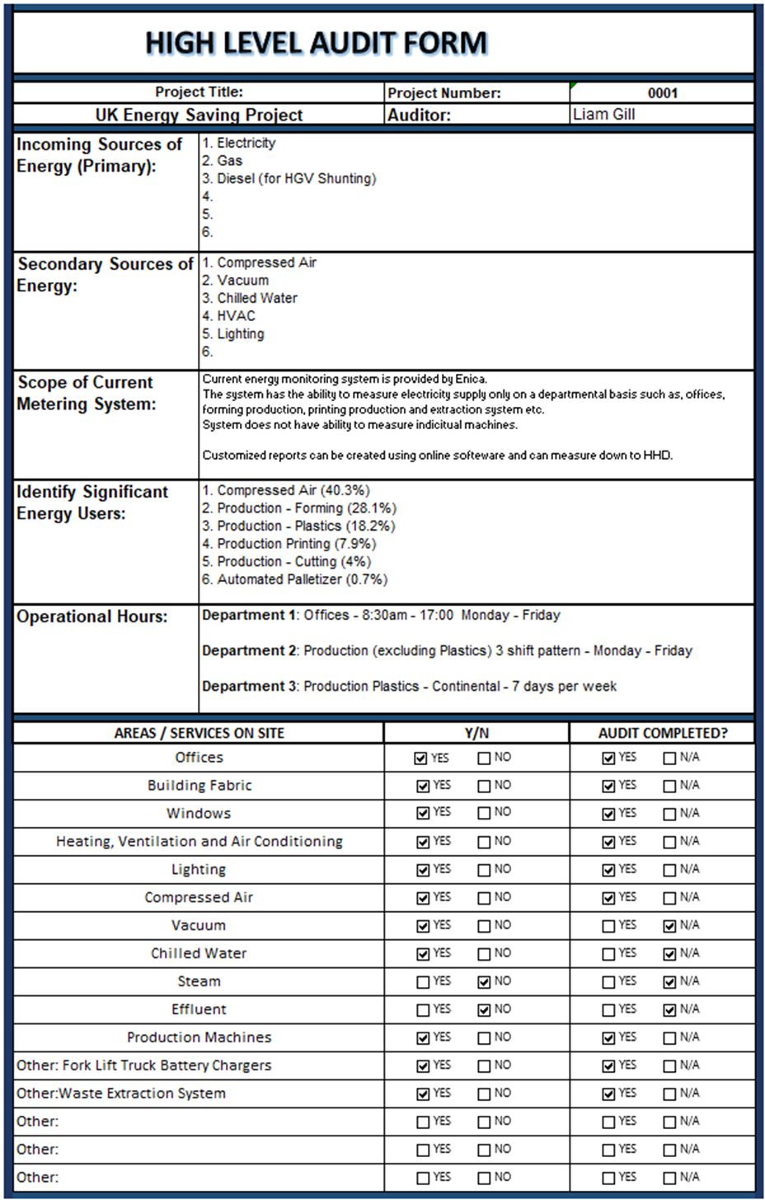
Figure 23 - High level audit - Trial
As can be seen in fig 23 there are only three forms of primary energy that will be consumed on site, in order of highest consumption these energy sources are electricity, gas and diesel. From these primary sources there is also the generation of compressed air, vacuum, chilled water, HVAC and lighting. The 6 largest consumers of energy on site were identified as compressed air, forming production, plastics production, printing production, cutting production and an automated palletizer system. Of these 6 consumers, compressed air was the largest in the organization, consuming 40.3% of electricity on site. As a result of this further focus will be placed on service to improve its efficiency as much as possible.
The high-level audit also outlines the form of energy metering system that is in place and to what granularity consumption information can be generated. The audit indicates the metering system in place is sufficient to base the project measurements on as it can capture HHD and captures consumption data on individual production lines/areas.
Lastly, the operating hours were also identified across different departments, this will give the auditor a good indication of when it would be expected to see lower consumption in different areas as they are non-operational.

LOW LEVEL AUDIT
The energy project being completed alongside these reports suggestions will complete low level audits on the compressed air system, the HVAC equipment, the building fabric and lighting systems. These are because it is believed that these will identify possible energy efficiency improvements that could be made. The audits completed can be seen in fig 24, 25, 26 and 27.

Compressed Air System
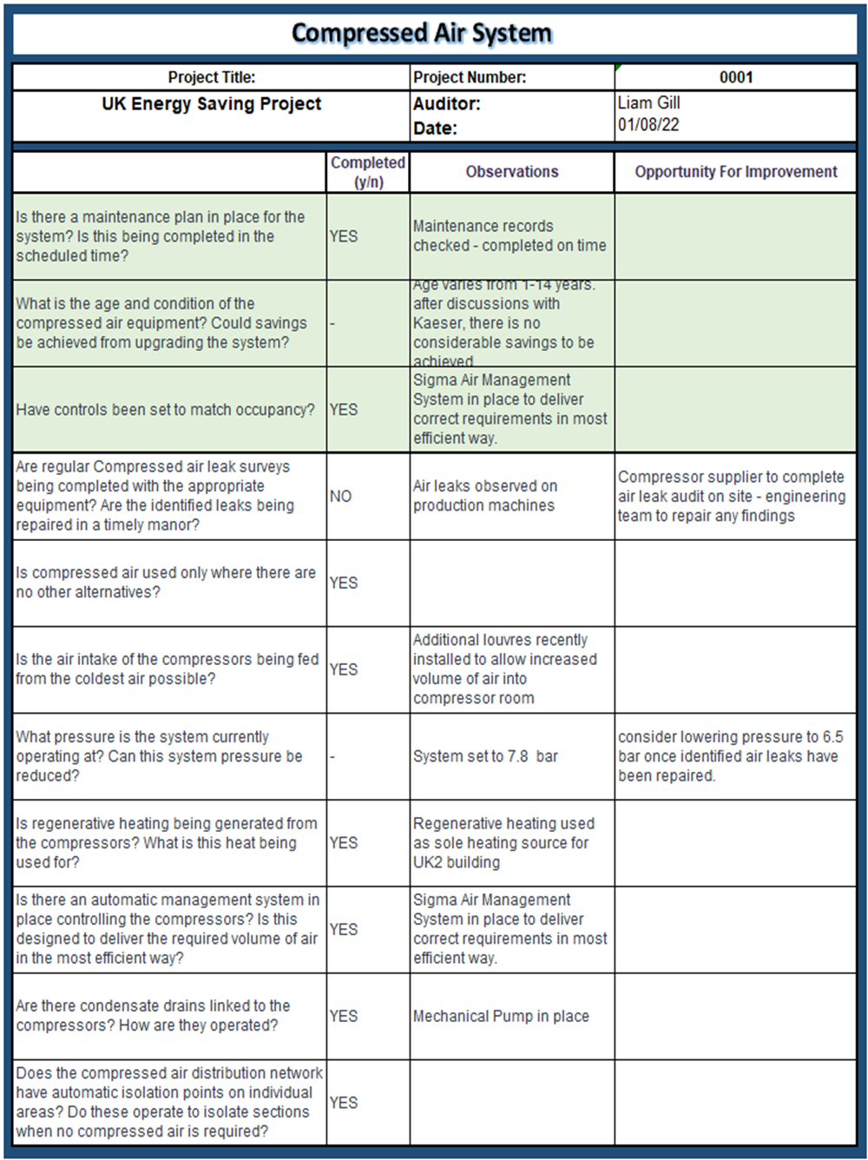
Figure 24 - Low Level Energy Audit – Compressed Air

HVAC Equipment
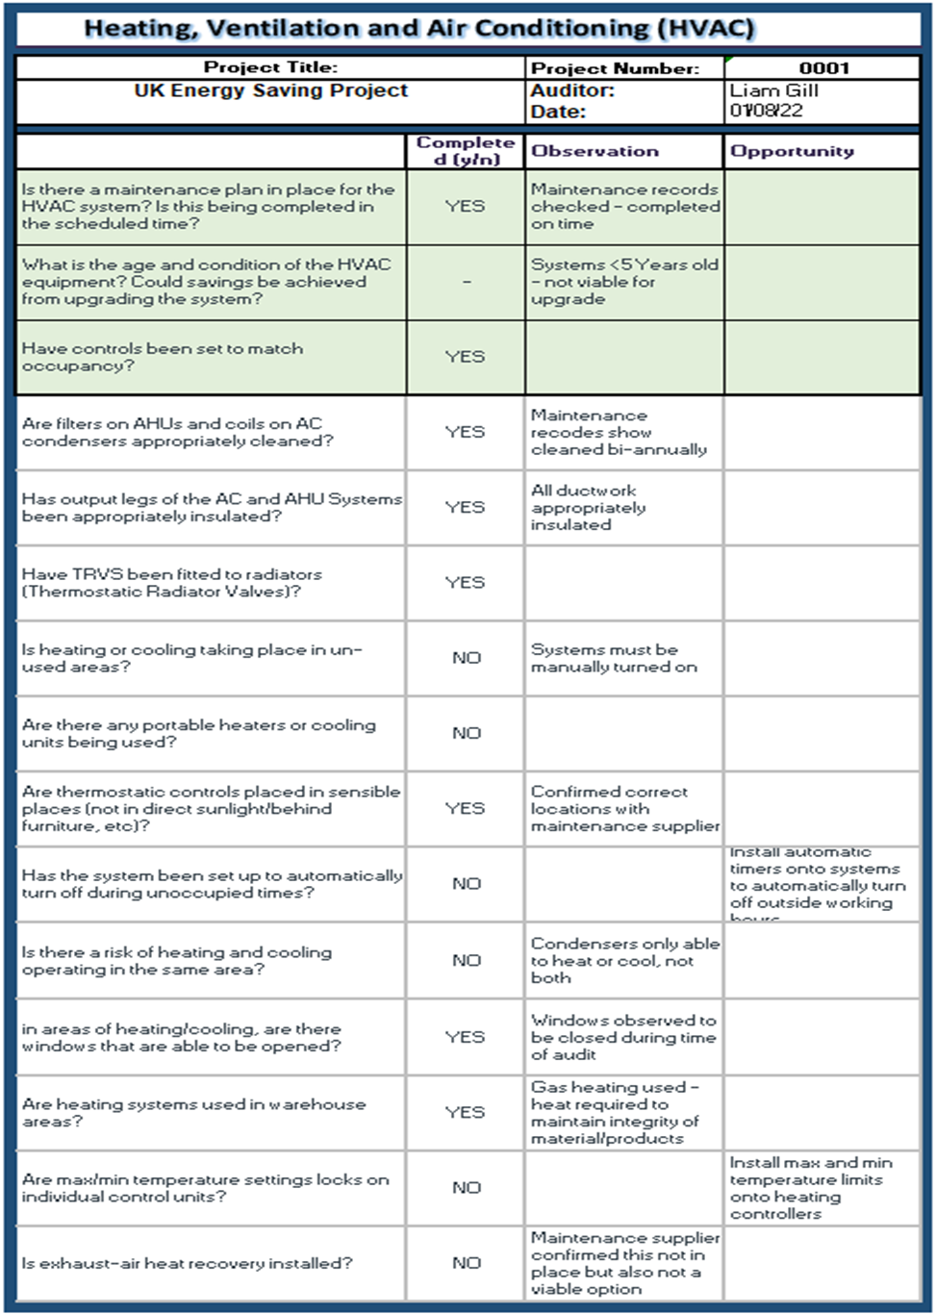
Figure 25 - Low Level Energy Audit – HVAC

Building Fabric Audit
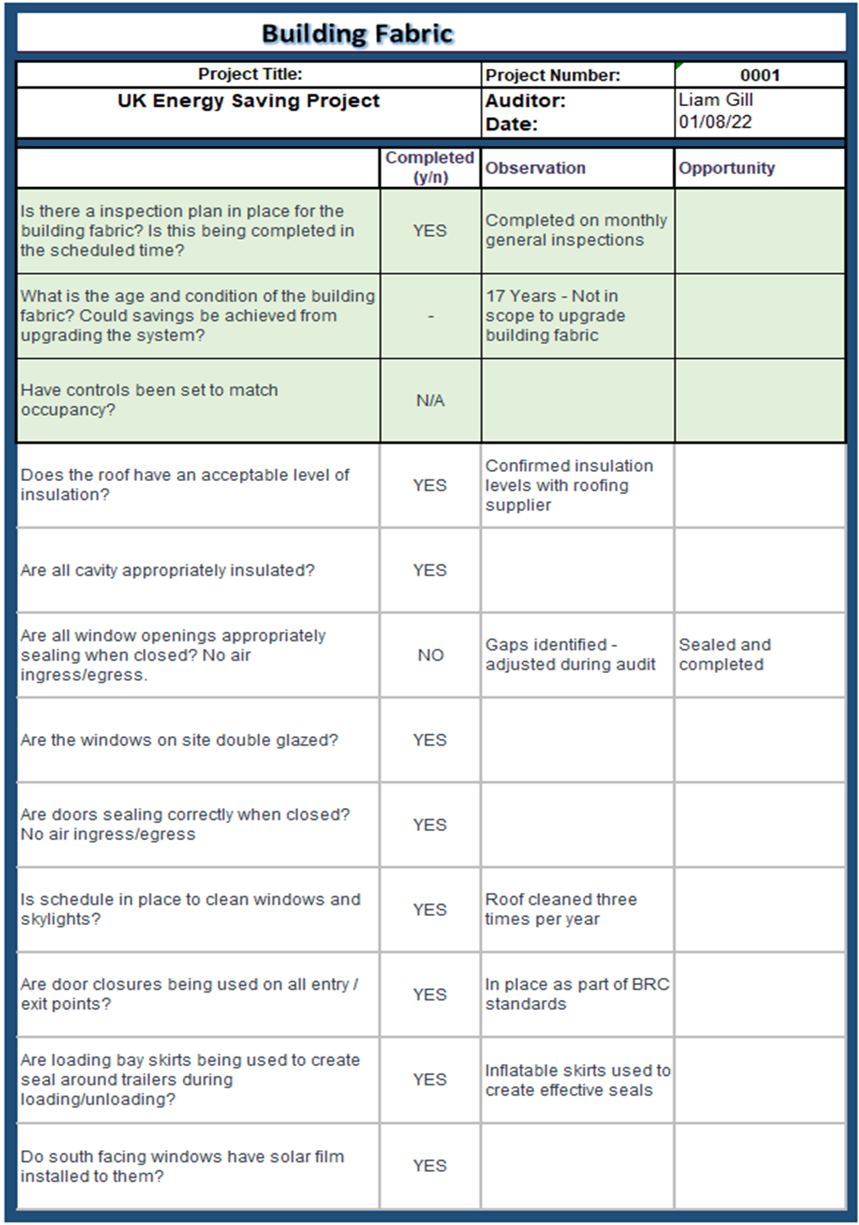
Figure 26 - Low Level Energy Audit – Fabrication

Lighting Audit
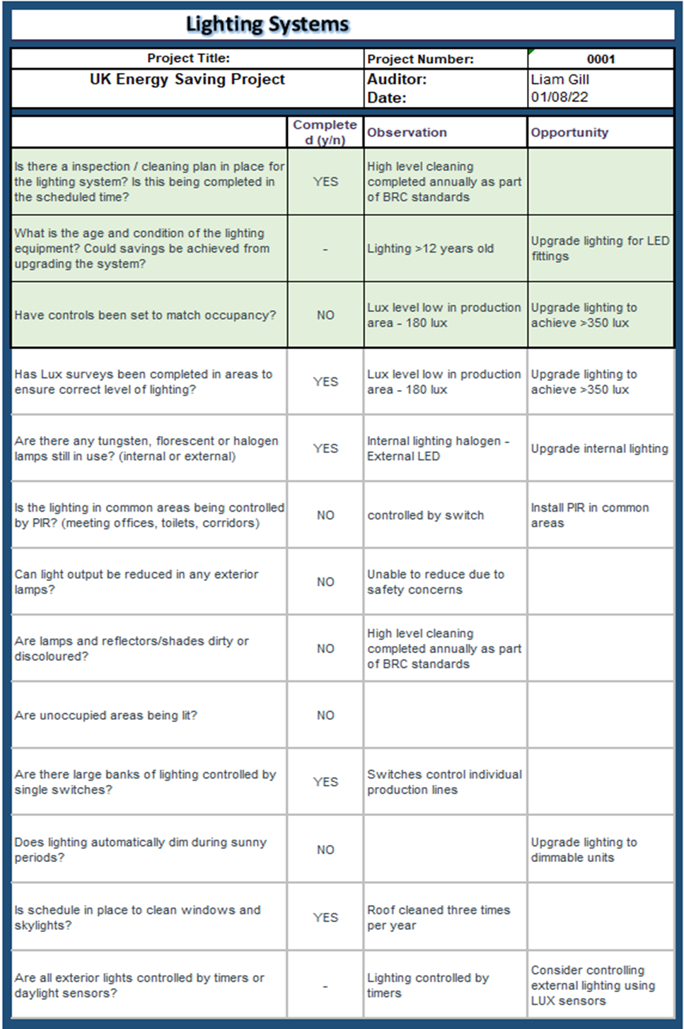
Figure 27 - Low Level Energy Audit – Lighting
From the audits completed in fig 24, 25, 26 and 27 it has been identified there are many areas in which the organization is already performing well such as;
- Regenerative heating being used to heat UK2 building.
- Air Management system installed on compressors to optimize performance.
- Skylights installed on roof space.
- Reflective window film installed on south facing windows.
These finding as well as others show the organization has already completed multiple projects of various sizes with the aim of improving energy performance. In addition to these completed projects, it was also identified a number of areas of potential projects could be completed to improve energy efficiency, these areas were;
- Various air leaks identified.
- High output pressure – could be reduced.
- Automation of office AC system
- Lighting to be upgraded to LED.
- Install PIR sensors in common areas.
- LUX sensor control of external lighting
These observations will be further investigated as potential projects that could be completed as part of the energy efficiency upgrades.

Observational Audit
The next stage of audits carried out in line with the suggestions being made by this report is the observational audits, both in the on-site office areas and the production areas.

Office Area Audit
Office based observational audits were completed throughout all offices at the UK site. During these audits there was a similar trend in the observations being identified. An example of the audits completed and the observations identified can be seen in fig 28.
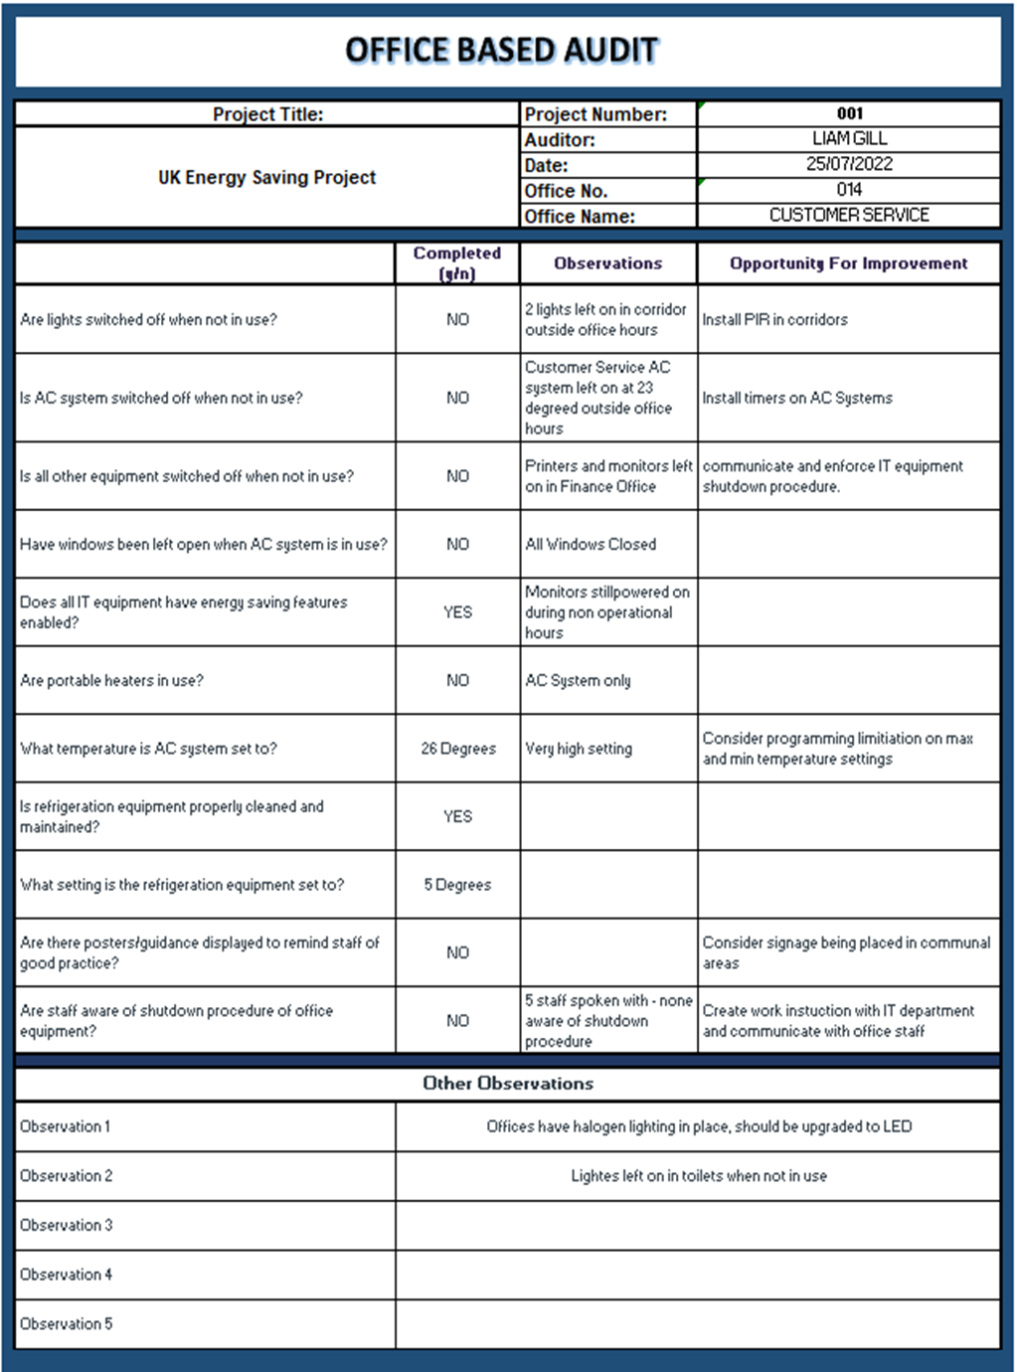
Figure 28 - Audit Completed on UK Office Area
As fig 28 highlights, this particular audit was completed on the customer service office on the 25th July 2022. This audit is a good representation of the findings being seen across all offices audited. Supporting the findings in the low-level audit completed on the HVAC system and the Lighting system, there were a few common observations, these were;
- Automation of office AC system
- Lighting to be upgrade to LED.
- Install PIR sensors in common areas.
In addition to these observations, it was also noted that not all staff were aware of the correct procedures to shutting down the IT equipment, for this reason the need for a correct shut down procedure of the equipment has been raised as an opportunity for improvement. Further to this, it was also identified that another opportunity for improvement would be around the communication on the importance of energy reduction, this could be communicated to the teams, possibly through email or signage in common areas.

Production Area Audit
On the same day as the completion of the office audit, audits were also completed on various areas in the production environment of the organization. For the purpose of this report, the area that has been included is ‘Production Area – Forming’. The reason for this audit being included to represent all the production areas is because it is the largest production area and the area with the most opportunities for improvement. The audit completed in the Forming production area can be seen in fig 29.
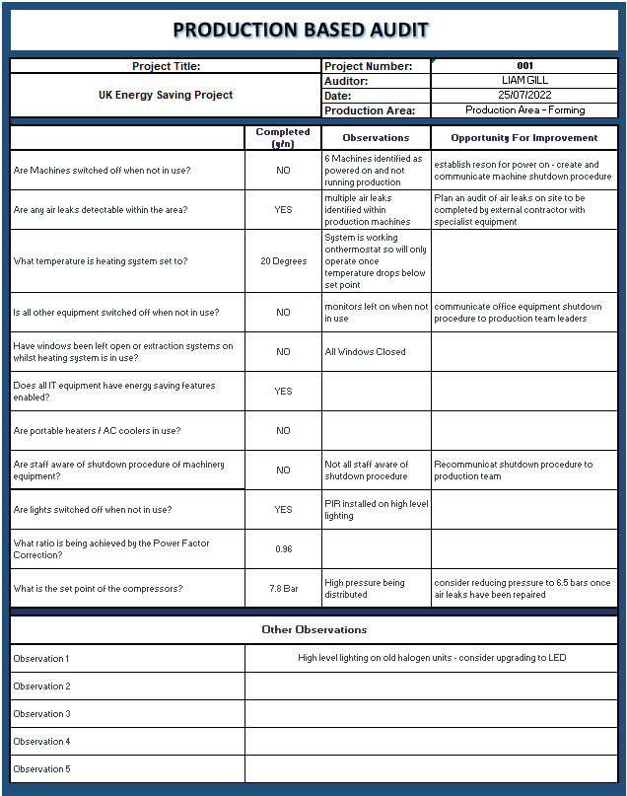
Figure 29 - Audit Completed on UK Forming Production Area
Similarly to the office area audit, there has also been a number of areas in which the organization has made an effort to improve its energy efficiency. These are;
- PIR high level lighting.
- Heating system controlled by thermostat.
- Windows closed when heating system in operation.
Whilst it is seen as a positive that the above measures are in place to improve the energy efficiency of the organization, there were also a high number of opportunities for improvement noted. One of these opportunities was in line with the IT equipment shutdown procedure identified in the office audit completed. The other opportunities have been noted as;
- High level lighting should be upgraded to LED.
- Shutdown procedure to be re-communicated to production teams.
- Investigation and repair of air leaks.
As well as the opportunities noted above there was also a further opportunity identified in support of the finding in the low-level audit completed on the compressed air system. This finding was the possibility of reducing the compressed air system pressure to 6.5 bar from the current set point of 7.8bar.
Other areas that potential energy saving opportunities were identified were on the building's externals and the forklift truck battery charging area. On the externals it was identified the external lighting could be controlled with photocells. Regarding the forklift charging stations it was noted that newer charging units are now available that reduce the energy consumption required to charge the batteries.

Wastage Identification Audit
The last audit completed on the trial of the process being suggested was the ‘Wastage Identification Audit’. The areas that were considered for wastage identification or the quantification of wastage were;
- Air Compressors
- Production Areas
- Offices
The reason for these areas being selected for further investigation is due to them being highlighted the significant energy users earlier in the project trial. During this audit it was identified the shutdown procedures being completed in the printing, plastics and cutting production departments were extremely effective, all of which achieving a consumption of below 30kWh per 24-hour period when not running production.
Contrasting the positive results seen in the other production departments, the forming production department is calculated to consume in excess of 300,000kWh annually, based on consumption seen in a 24-hour period during non-production hours. This supports the finding identified on the observational audit completed on the forming production department that identified several production machines not correctly shut down during non-production. The wastage identification audit also supported a finding highlighted in the office audit completed, this finding was the potential annual saving of 40,000kWh.
The largest area identified of wastage was the consumption of compressed air due to air leaks. The consumption data was taken during Christmas day where there was zero production or manning on site, and still a calculated annual saving of nearly 900,000kWh could be achieved as a result of repairing the air leaks across the two production buildings.
All the findings from the ‘Wastage Identification Audit’ can be seen in fig 30.

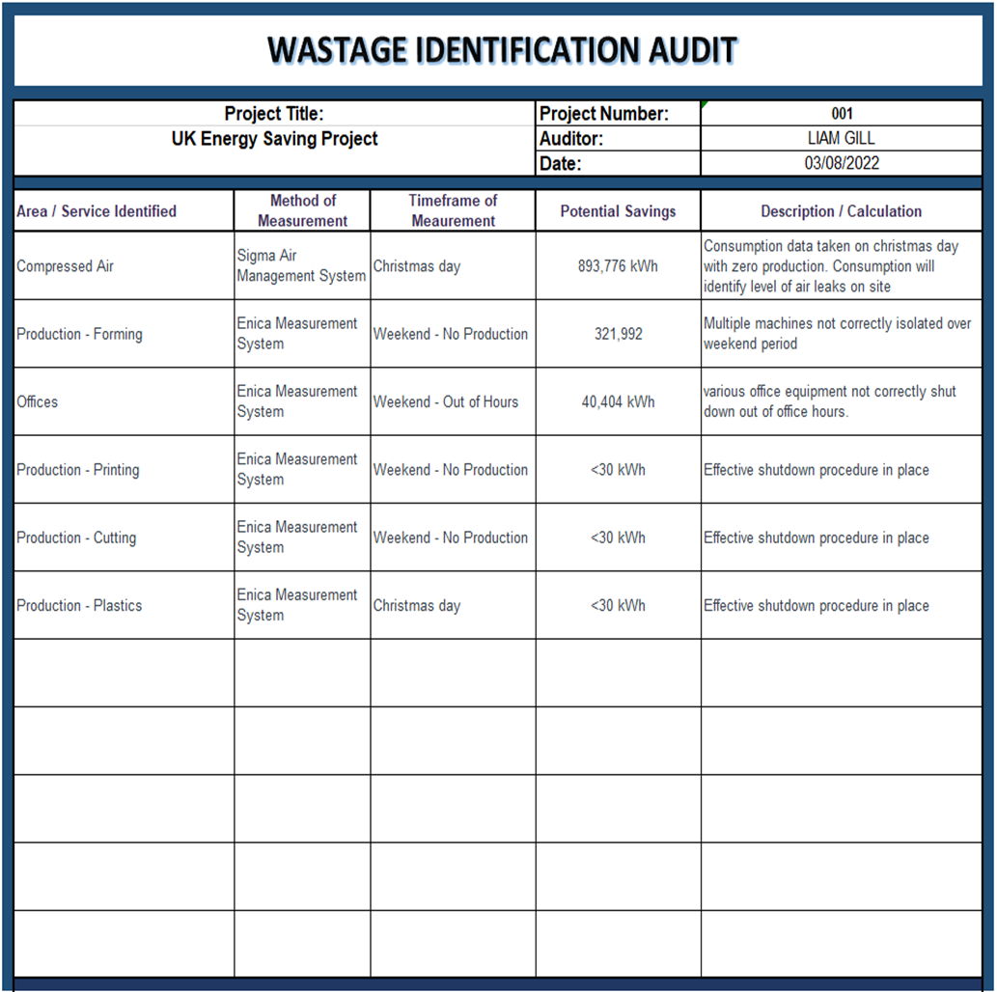
Figure 30 - Wastage identification audit – Completed.

STEP 2 – AUDIT - FINDINGS
From the completion of the ‘Audit’ phase steps in a trial process, there have been some positive findings and some areas where it is believed the process could potentially be improved.
Some of the areas in which this report believes the process worked well was in the usage of the multiple levels of auditing. The high-level audit was a useful tool to gain a solid understanding of where the energy is consumed on site and what the significant energy users were. The identification of the significant energy users highlights where there may be some potential efficiency improvements made. In addition to this, the observational audits were seen as a positive tool as they encouraged the auditor to see where procedures could be created or improved to create cultural change or poke yoke systems that would reduce energy consumption i.e. install PIR lighting to eliminate the need to manually switch off. Lastly the Wastage Identification Audit was successful in supporting the opportunities identified in the previous audits as well as quantifying the amount of energy that is being consumed as wastage.
There were however two areas where improvements could be made, these areas were around the number of audits completed on each area, and which areas were considered for auditing. Firstly, regarding the services on which the low levels audits are completed. The report considered compressed air, HVAC, building fabric and lighting systems, however it is believed further audits would be valuable to be completed on hot water systems and electric motors. In addition to this improvement, it is also believed that multiple observational audits should be completed on production areas and offices. The reason for this is to get a greater understanding of potential areas of energy reduction. With only one audit suggested to completed in and out of office hours, there is the potential to not only miss opportunities for improvement but also focus efforts on a opportunity what was a one off occurrence during the time of the audit.

Step 3 – implementation and improvement methods and projects
During this phase of the project, it will be the aim to analyse the findings of the completed audits and prioritise them into various potential projects. To achieve this there will be four steps that will be suggested, these are a ‘Project Information Table’, a ‘Project Correlation Table’, a ‘Project Prioritization Table’ and a ‘Project Timing Plan’. Once these are completed there should be a clear plan in which the various projects have been identified, and in which sequence they will be completed in to achieve the self-funding approach of this project.

Project Information Table – Live Document
The project information table is a document that will be kept live during the remainder of the project. The purpose of this table will be to track any changes that occur as the energy efficiency improvements take place. These changes could include the estimated cost, savings, or proposed start date of works.
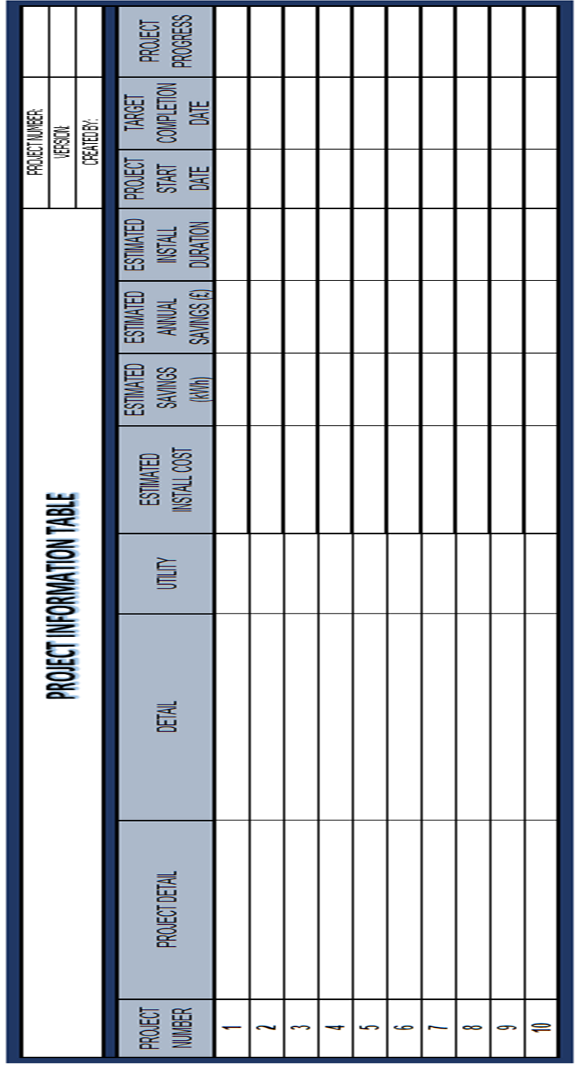
Figure 31 - Project information table

Project Correlation Table
With the potential energy savings projects successfully pinpointed and their savings quantified, the next step will be to determine if any of the projects interact with each other. The correlation between projects will identify the relationship between two projects and if they have a positive, negative or no impact on each other (Bubevski, 2018).
Correlation analysis is used within Six Sigma to determine if there is any relationship between different variables within a process (Harry, et al., 2010). Further to this Bubevski (2017) found that correlation between different projects can also be considered as part of six sigma. This project will propose using a simplified version of correlation analysis to determine if any proposed project interact with each other and what the result of the interaction could be. An example of this could be in lighting projects, two projects such as installing LED lighting and ‘Person in Room’ sensors (PIR) would have an impact on the amount of savings that could be achieved.
The project correlation table being suggested by this report can be seen in fig 32, this table highlights the different projects and a space to highlight if there is any relationship between two projects. A suggested key for this table can also be seen in fig 33, this shows a total of five symbols to highlight the level or relationship between two projects. these levels are ‘Strong Positive Correlation’, ‘Positive Correlation’, ‘No Correlation’, ‘Negative Correlation’ and ‘Strong Negative Correlation’. The suggested levels are guidance and could be adjusted or amended to suit the project being undertaken.
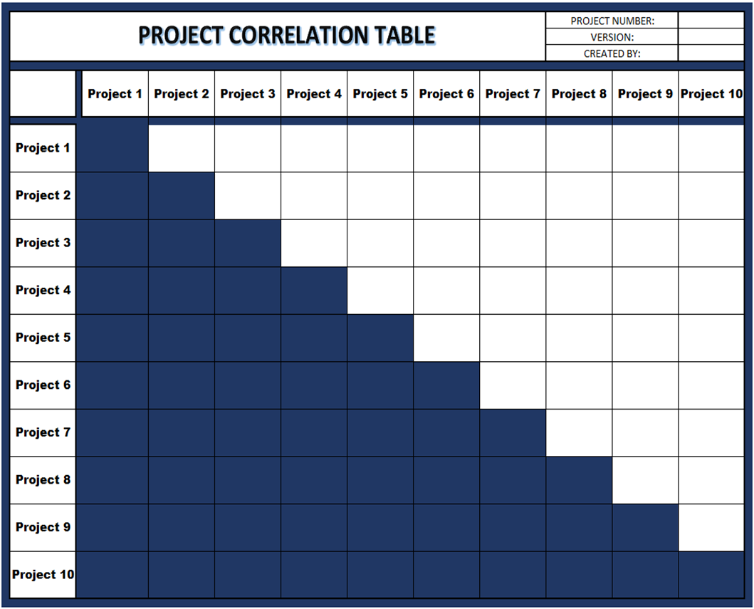
Figure 32 - Project Correlation Table
Figure 33 - Project Correlation Relationship Strength Key

Project Prioritization Table
With the aim of this project to create a self-funding or low initial investment, it will be important to understand in which order the identified projects should be completed. The aim will be to start with zero/low-cost projects to begin generating savings, then the pre-agreed percentage of these savings could be reinvested into larger projects. This suggestion is supported by Sobh (2009) when they highlighted the benefits involved with prioritizing project to understand which projected should be completed first and in which order.
To prioritize the projects identified during the auditing process, there are a number of areas that should be considered. This report suggests taking into consideration the project cost, implementation time, predicted energy savings, return on investment (ROI) and kWh saved per £1 spent. Based on these areas a priority score can be given to each project in order to establish an order in which they should be completed.
The Project Prioritization Table being suggested by this report can be seen in Fig 34. As can be seen in the project prioritization table, all five areas being considered have been included as well and the project name and predicted annual financial savings that would be achieved.
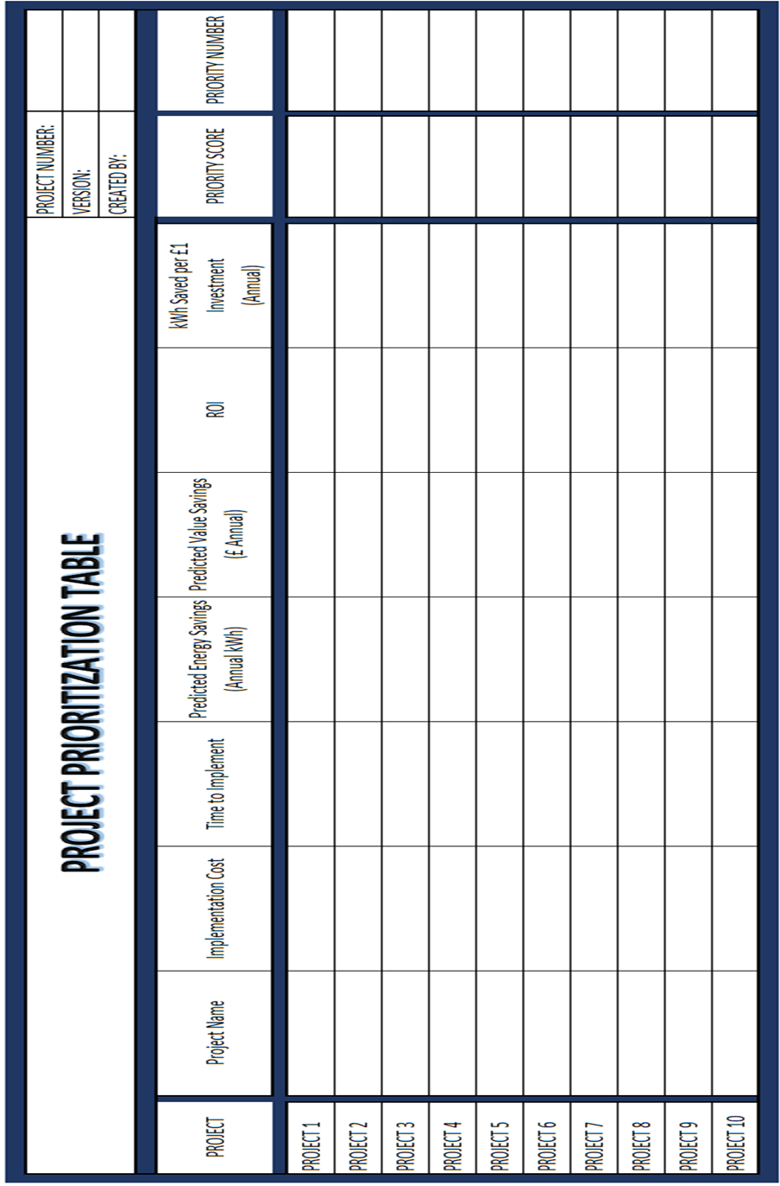
Figure 34 - Project Prioritization Table
The last two columns of the Project Prioritization Table are the Priority Score and Priority Number. The priority score will be generated on a points system based on the values achieved in the Priority Table Criteria Value Scale in fig 35. For each of the criteria, a value will be given depending on the scale achieved within the table. The value achieved for each criteria will be multiplied together to deliver the Priority Score for each project. Based on these scores, the Priority Number or implementation order will be determined by highlighting the project’s priority score from highest to lowest.

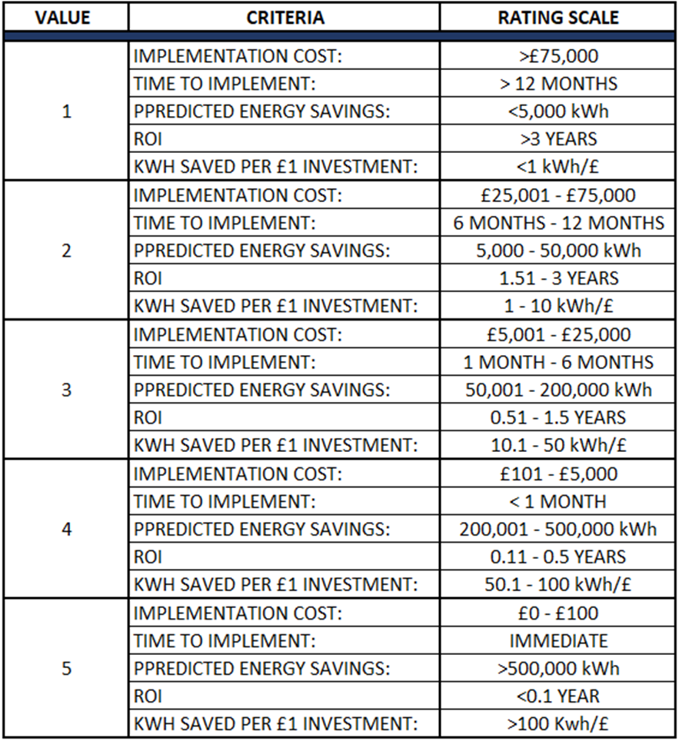
Figure 35 - Priority Table Criteria Value Scale

Project Timing Plan
The last tool to use in step three will be a project timing plan table. Hartman & Ashrafi (2004) found that poor planning of a project is widely accepted to cause the failure of that project, this failure may come in the form of quality, costs, timeframe or not meeting expectations. This finding is supported by Shah & Chandragade (2023) when they state lack of knowledge of effective planning has a direct negative impact on the project performance regarding times and cost. This table will be an important part of the inter project implementations, and its aim will be to ensure the continued success of the project being completed by providing a structure to the proposed energy efficiency improvements. This table will guide the user into a predictive timing plan for the projects and how they will fund each other’s implementation.
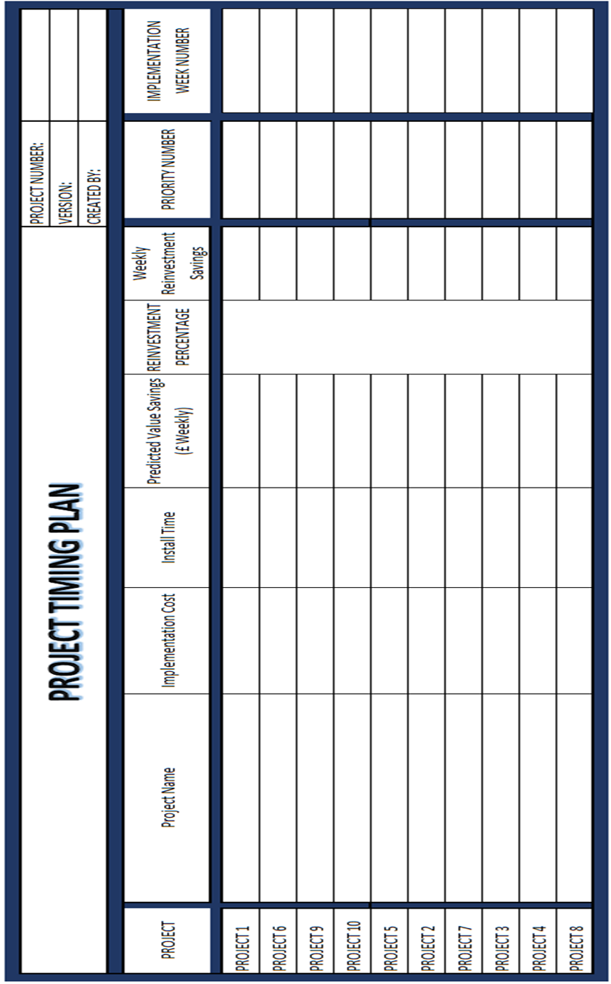
Figure 36 - Project Timing Plan

Step 3 - implementation - TRIAL

Project Information Table – Live Document
From the findings and observations in the completed audits in step three, there were ten energy efficiency projects identified to be completed as part of the larger project. These projects were;
- Production Machinery Shut Down
- Office LED Lighting Upgrades
- UK1 Shop Floor LED Lighting Upgrade
- PIR Controllers on Communal Offices, Toilets and Corridors
- LUX Sensor Control of External Lighting
- Production Machine Pressure Reduction
- Office AC Systems on Automatic Timers
- Installation of Low Consumption FLT Battery Chargers
- Compressed Air Leak Survey and Repair
- Office Equipment Shutdown Procedure
In addition to these projects, more effective communication of the importance of being mindful of energy consumption will also be completed. The forms of communication will include company-wide emails and signage place in common areas. This has not been included as a specific project as the report believes any savings seen as a result would not be accurately quantifiable, so it would not be possible to reinvest any potential savings.
The Project Information Table completed highlighting the various projects and other information such as calculated savings and implementation costs can be seen in fig 37.
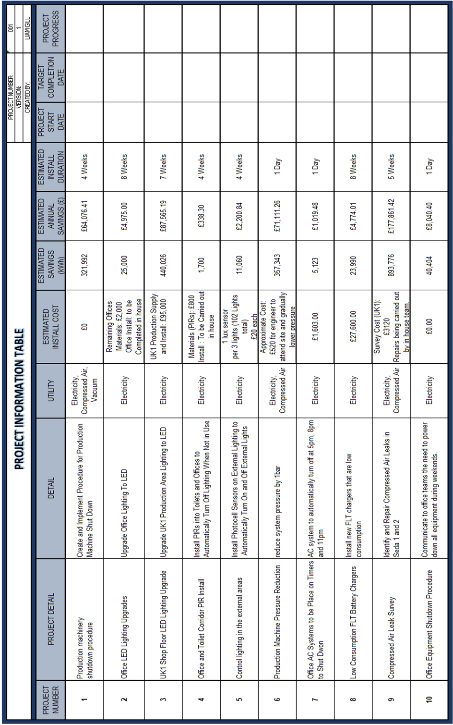
Figure 37 - In Progress Project Information Table
From the investigation of the install costs of the highlighted projects there are two projects that are of little to zero cost, so could be considered as the initial projects to begin the process generating savings for the funding of larger projects. These two projects were around the shutdown procedures of both the production machinery and office equipment. Building on from this there are a further three projects that could be installed for below a cost of £1,000. These projects were the pressure reduction of the compressors which had the potential to deliver a large saving of more than 350,000 kWh. The other two projects in this category were the installation of PIR lighting in common areas and LUX sensors controlling external lighting. On the other end of the scale regarding installation cost, the installation of LED lighting was the highest cost project at £95,000 with an estimated saving of above 440,000 kWh.

Project Correlation Table
With the project information table now populated, the next step in the process was to gain an understanding of how each of these ten projects could interact with each other. During this table completion it was highlighted that the largest number of correlations were between projects 2, 4 and 10. All these projects had a strong correlation with each other and so the estimated savings may alter as all three projects are completed. In addition to this there was also a strong correlation between project 6 (pressure reduction) and project 9 (air leak repairs). The table completed during this trial can be seen in fig 38.
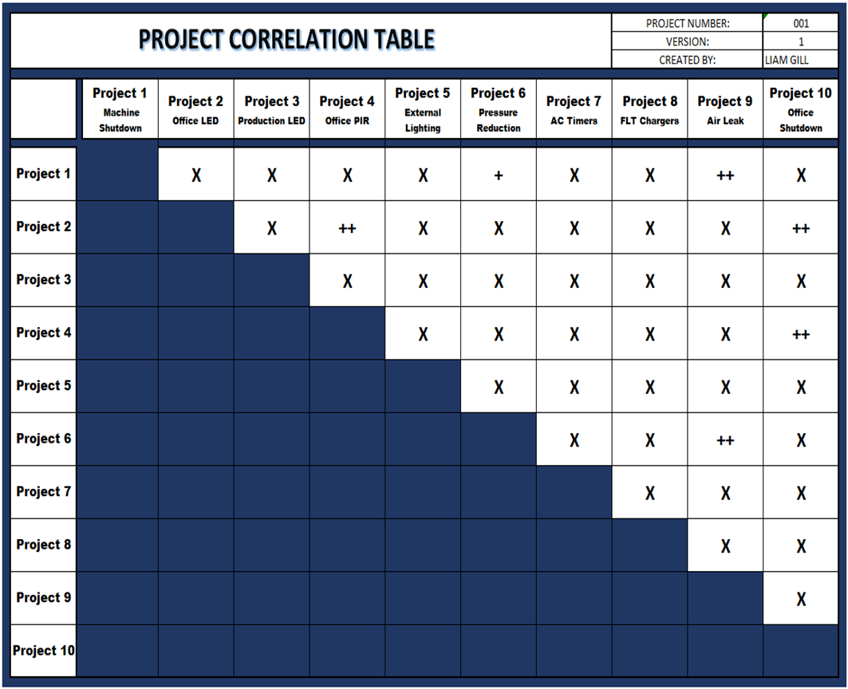
Figure 38 - Completed Project Correlation Table

Project Prioritization Table
For the project to be the self-funding methodology, the order in which the projects are completed is vital. To determine the correct order for the projects to be completed the prioritization table will be completed. The findings of this and the priority value scale used can be seen in fig 39 and 40.
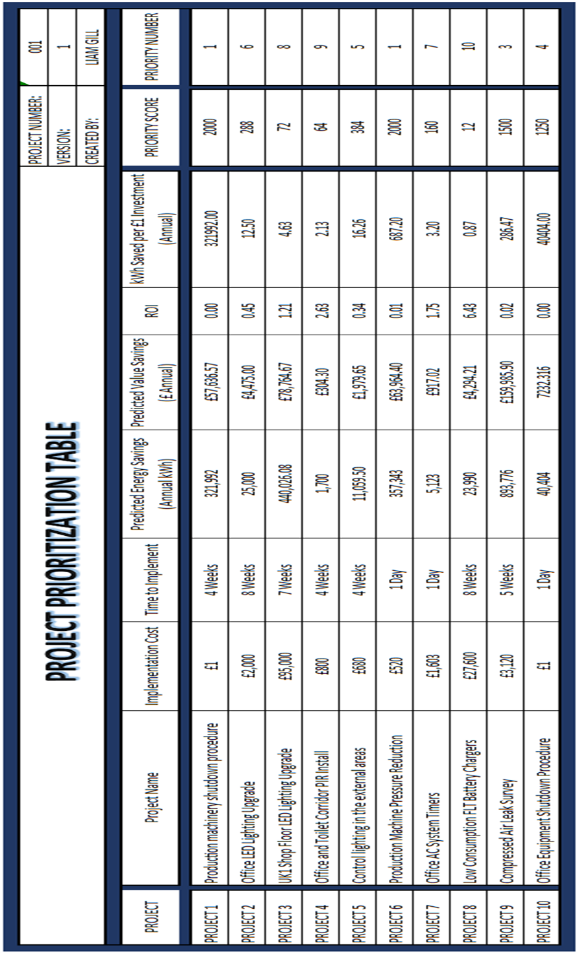
Figure 39 - Completed Project Prioritization Table

Figure 40 - Priority Table Criteria Value Scale
On review of this table there has been an immediate fault identified in its calculation. This fault was in that one of the two projects that were identified to be low / zero cost, and so the first projects to be completed, was highlighted as priority number 4. This priority does not align with the ethos of this self-funding methodology. Aside from this failing, it is believed the rest of the table is a suitable plan for the order of the projects to be completed. In the number 1 priority spot was the other low / zero cost project, machinery shutdown procedures. The second priority project was a suitable project for this position as it was relatively low cost with a very large energy consumption saving. The last project prioritized for completion were the production area LED lighting, common area PIR installation and low consumption battery chargers.

Project Timing Plan
The last tool to be used in this stage of the project will be the ‘Project Timing Plan’ tool. To keep in line with the suggestions made by this report, the order in which the projects are going to be completed will remain in line with the project prioritization tool, despite there being a failure in the priority of project already being identified. The completed timing plan table can be seen in fig 41.
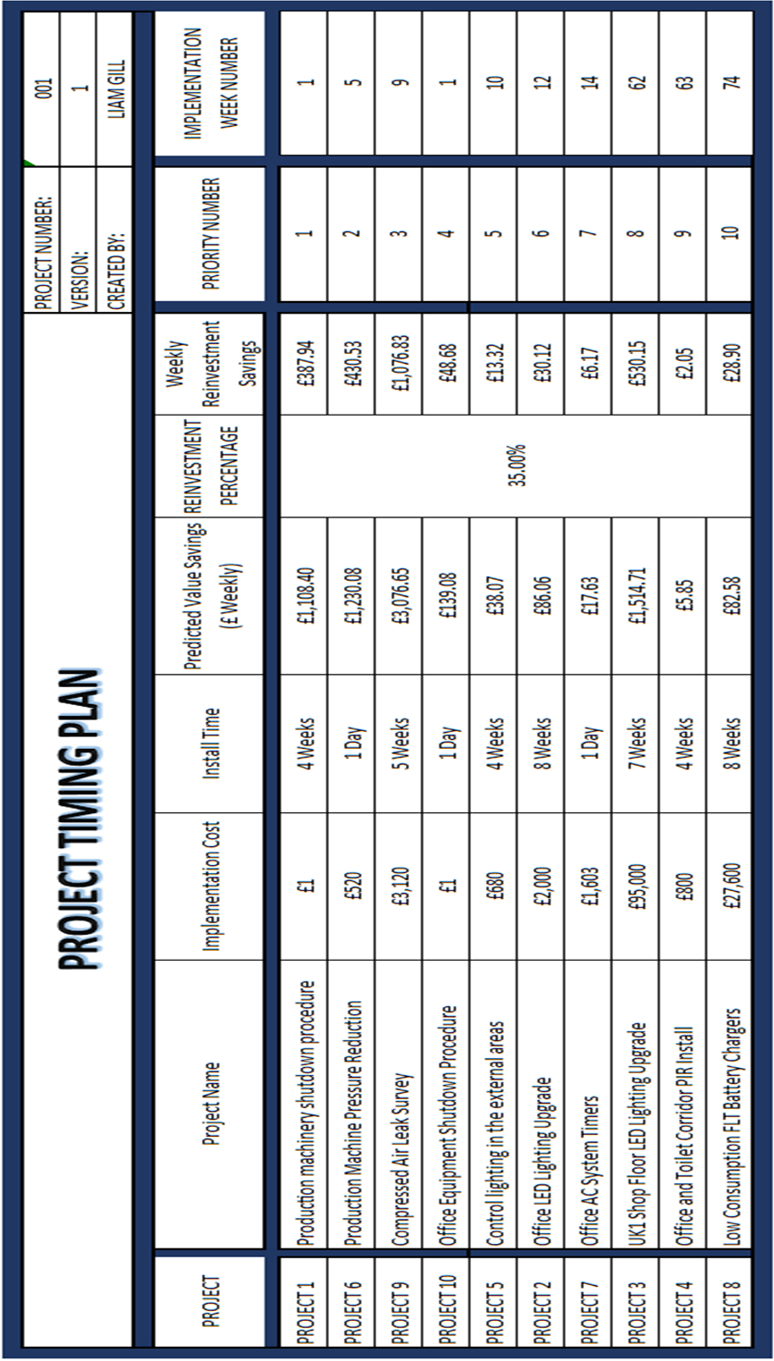
Figure 41 - Project Timing Plan - Completed
Based on the reinvestment value of 35% and the predicted energy savings, the tool estimates the last project will begin at week 74, with completion of the last project at week 82.

Step 3 – IMPLEMENTATION - Findings
During this stage of the project trail, there was one area in which there was an obvious improvement that could be made. This improvement was within the prioritization table which did not place all zero/low-cost projects as the top priority. It should be considered to either alter the value scale tool or place these projects automatically as top priority to align with project goals. Other projects can then be subject to the prioritization evaluation.
Despite this failure it is believed by this project that the rest of the process was completed successfully due to the tools used. Other than the identified single project priority error, it is believed the remaining projects were prioritized in a suitable order. It is the belief that the simple correlation tool was great for generating an understanding of how the different project may interact with eat other during their implementation. In addition to this, the timing plan tool was very useful in generating an estimated timeline for each of the projects and when they will be started and completed. This was particularly well received by the project sponsor as it opened solid discussion points around the different projects and allowed for tracking of the projects during communication meetings.
One further improvement that could be made during this stage was within the timing plan. The timing plan could have the inclusion of the monetary value that could be saved during timeline of the project. It is the belief of this report that highlighting this value would gain further buy in from the project team and most importantly the project sponsor.

Step 4 – rEVIEW
This stage is predicted to be the shortest and simplest stage of the project. The main aim during this stage will be the review the completion of the project, record any findings and handover any documentation. This stage is a mandatory stage and should be completed either at the end of a successful project, or even if it has been deemed necessary to close to project prematurely. The report will aim to complete this document on a single form similar to the ‘Project Definition Form’ created in step one of the project. The reason for this will be to maintain a level of simplicity to the methodology process. At this level of the project the aim will be to complete a successful project closure, it could also be decided whether it is believed to be further savings that could be achieved, in this case the ‘PAIR’ system would restart in a continuous improvement fashion.
Within Prince2 this stage of a project is known as the ‘Closing a Project’ process, this report will look to take some notes from this methodology due to its history of successful project management. Some of the areas this report will look to transfer from Prince2 into its own methodology is capturing lessons learned, handover documents and any follow-on actions required (Graham, 2010).
The single document being suggested by this report to finalise and close the project can be seen in fig 42.

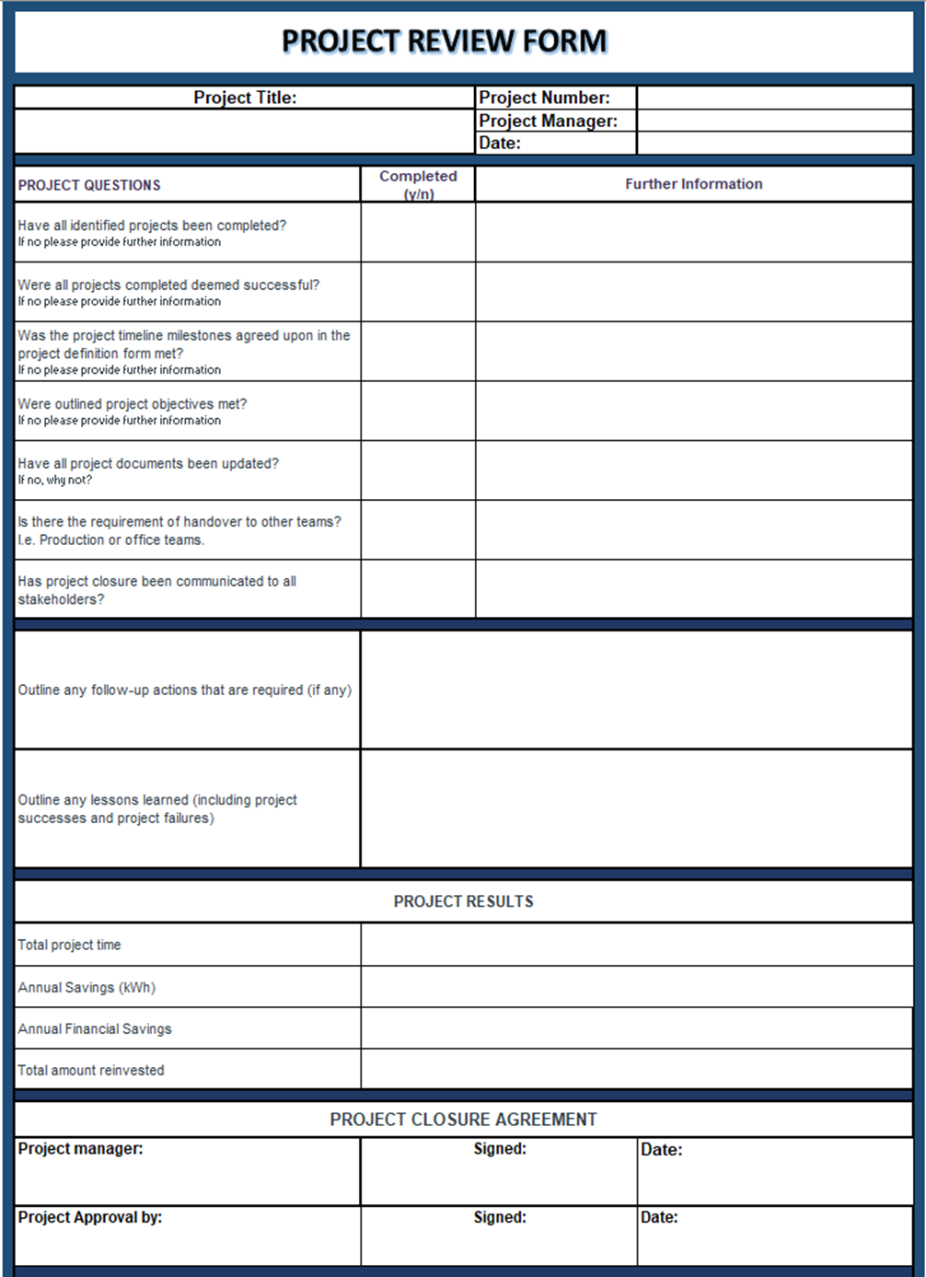
Figure 42 - Project Review Form

Fig 42 has simply been named a project review form and in the top section and follows a similar layout to other documents completed in this project being the project number, project manager name and date are all included. The first stage of the project review form has got some basic questions that will guide the project manager into ensuring that several important steps relating to the closure of a project have been completed. Also, in align with these questions there is the space to be able to include any additional notes that the project manager may consider important. Some of the questions included are based on the level of project completion, the objectives met, documentation updating, and any handovers required.
From these questions the form then allows adequate space for the recording of any lessons learnt during this project, these lessons could include where the project succeeded and where it may have failed. This space will also be useful for recording any notes that would be useful in any other projects in the future. In addition to this space, there is also space for the recording of any follow up actions that may be required after the completion of the project, this could include maintenance or future audits.
Following on from this the next section requires the project manager to record the a few key metrics involved with the project. These metrics are project duration, annual kWh savings, annual financial savings and total amount reinvested. These metrics are deemed to be important as they will provide an immediate insight into whether the project is seen as successful or not.
The last section of the project review form is to obtain the final closure signatures from both the project sponsor and the project manager.

Step 4 – REVIEW – tRIAL
Due to the timeline of the trail project being completed and the report deadline not aligning at the same end date, this project review form has been completed in advance of the completion of the ‘UK Energy Saving Project’. The project review form completion at this stage still can provide insight into how it performs and if it could be improved, in addition to this it will also help establish how the data could be captured if the project was brought to a premature end.
The form completed for the completion of the project trial can be seen in Fig 43.

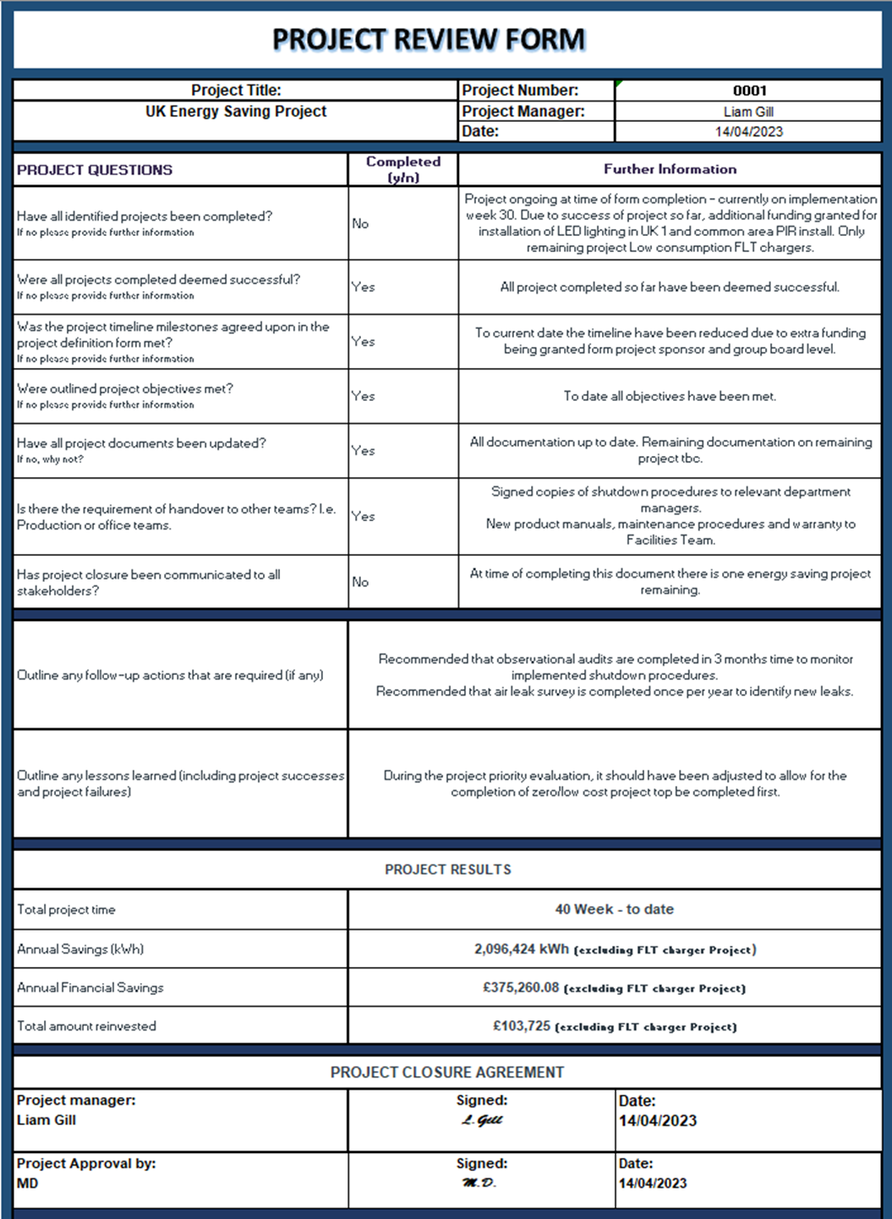
Figure 43 - Project Review Form - Completed

The questionnaire section has highlighted a few key points in relation to the trial project. The first point is that the project has not yet been completed, is currently on week 30 and has one more energy saving opportunity to implement before completion. To date all the nine completed projects have been deemed successful. Due to the successful signs being seen during the implementations of the energy saving opportunities, the project sponsor agreed to offer additional funding to complete the installation of high-level LED lighting throughout the production area of the UK1 building. At the time of writing this the handover of documentation such as maintenance manuals and training procedures have been handed over to the relevant departments.
It was raised in the review form that there should be further observational audits completed in three months’ time, this will be with the aim to ensuring any shutdown procedures implemented as part of this project continue to be adhered to, and so the savings continue to be generated. In Addition to this it was also highlighted that further air leak surveys should be completed on an annual basis to ensure new leaks are identified and repaired continually. In the section regarding lessons learned, the form has acknowledged there should have been a rearranged project priority to ensure the free / low-cost projects were completed first.
Finally, the performance of the project can be seen in the final section, excluding the final energy saving opportunity (which has not yet been implemented) the project has achieved and annual saving of over two million kWh with a reinvestment value of below £104,000. In total the energy saving opportunities will save the organization more than £375,000.

Step 4 – REVIEW – Findings
On the final tool / table of the project it is believed by this report this is a sufficient method of collecting relevant data relating to the project and its performance. Similarly, to previous tools such as the audits, the initial questions on the form guide the project manager in completing important steps such as documentation recording, which will help close the project successfully. In addition to this the questions will help the project manager reflect on the project performance and if the original targets and objectives have been met.
Another area of the review form that is very useful to the project manager is the two questions relating to the follow up actions and lessons learned. This was useful in capturing any information for future projects and for the successful handover of the current project changes.
Lastly, the final section was great for highlighting the overall performance of the project. This section served well in highlighting to the project sponsor and project team how successful the project was and its achievements.
Although the project review form has performed well in the above areas, it was found by this report that there could have been the inclusion of two further points which would improve the project closure. One point would be a section dedicated to highlighting and linking to forms or documents that were created as a part of the project, these forms could include the completed training documents relating to procedures such as machinery shutdowns. The other point which could be included is the agreement of where all project documentation and form will be saved / stored after completion and closure.

Conclusion
The aim of this project was to create a new methodology that would support energy improvement projects within industry. The aim of the new methodology was to be as low cost as possible to implement whilst remaining effective in its outcome.
To establish a solid understanding of other project methodologies currently being used within industry, the report firstly carried out investigations into Lean, Six Sigma and Prince2. The report found that whilst these methodologies have been proven to be very effective with organizations globally, they do have some limitations which include the level of complexity. With high levels of complexity there is an associated cost involved regarding either training current staff members or recruiting experienced professionals. This factor was shown to be a contributing factor to some SMEs for not completing large projects as they don’t have the resource or funding available to support this.
To be a successful methodology in not having the same limitations as Six Sigma and Prince2 this report would aim to be low/zero cost to implement. The methodology being suggested by this report would aim to achieve this by being both simple in its application, to reduce training requirements and would rely on the reinvestment of funding generated from energy efficiency improvements made by this project. To determine the proposed methodologies effectiveness and learn if it could be improved, a trail energy efficiency project was run within a large packaging manufacturer in line with the suggestions being made by this report.
This report suggested that a four-step approach should be used, like the PDCA cycle used within the ISO50001 framework. The four-step approach being suggested by this report would have the memorable acronym PAIR, which would stand for Plan, Audit, Implement and Review. Within each of there
During the planning phase it was suggested to use a single document to gather and agree the required information and parameters of the project to be completed. This document would be known as the ‘Project Definition Form’ and it is suggested to include information important to the project such as the problem statement, project benefits, objectives, and scope. These sections should outline why the project is being initiated, what should be achieved and the boundaries within which the project should be completed. In addition to this, the project definition form included the identification of the project team, initial funding, and reinvestment funding. The form would need to be agreed and signed off by the project sponsor and project manager. In line with the project definition form, a timing plan and energy consumption map are required to be completed at this stage. After the completion of the trial project it was identified that the suggested form was suitable in that is was simple in its approach, but could be improved by the inclusion of the project communication plan and the identification of other project completed in this area to avoid duplication of work.
The next stage of the suggested methodology was Audit, this would include the auditing of various areas through various methods. The audit to be completed in this section were high level, low level, observational and wastage identification. The aim of the high-level audit is to give the project team a solid understanding of the current situation of the energy being consumed within the organisation. Within this audit it will include what forms of energy are being consumed, what services are consuming energy, the organisational operational hours, the energy metering system in place and the significant energy users. The next audit to be completed were the low-level audits which included auditing systems such as HVAC, compressed air, lighting and building fabric. In addition to these, observational audits should be completed in both office and production areas. The last audit to be completed was to monitor the consumption of energy being used in various areas during unoccupied hours. It was identified by this report that the audits being suggested in this stage were good tools and guided the auditor through the audit process, one area in which it was identified this stage could be improved is with the completion of multiple observational audits, as this would allow for a more accurate picture of the current situation.
The third stage of the methodology, named implementation included the planning and completion of the energy improvement opportunities identified during the audit phase. The better understand the individual improvement opportunities and how they should be completed, there were a number to tools created by this report. These first tool was the project information table; this is a live document which included information such as the potential energy saving opportunities of each project as well as implementation time and costs. The next tool to be used in this stage was the correlation table, this was created to understand how the different projects interact with each other. The next two tools were the project prioritization table and the timing plan. These tools will guide the project team in understanding in which order the projects should be completed to allow for the self-funding methodology to be achieved as well as the time in which they should be implemented, and the savings achieved. Although the tools in this section worked very well during the project trial, there was an improvement that could be made to the prioritization table, this was based around the automatic placing of the zero/low-cost projects as the top priorities.
Similarly, to the first stage, the last stage, Review, was a single document to be completed capturing the relevant information to successfully close the project. This document included a small questionnaire to ensure all important steps have been followed in the project closure as well as the capturing of the project’s performance such as total amount of reinvestment, annual savings achieved and project time. In addition to these there are also sections to be completed around the handover of information after project completion and follow up actions that are suggested to be completed. Finally, sign off is required from the project manager and project sponsor to close the project.
Overall, the methodology suggested by this report has provided a foundation for the successful completion of a self-funding energy improvement project. This was proven by the completion of the project in line with the suggestions made by this report. The trail project had zero initial funding and was completed over a period of 40 weeks. During this time the project provided an annual saving to the organization of more than 2,000,000 kWh. Further projects should now be completed using this methodology to further identify areas of potential improvement in different environments.

Recommendations and Further Work
Although the project completed using the suggested ‘PAIR’ methodology is seen to have been successful, it is the recommendation of this report that the ‘PAIR’ methodology should be adjusted to accommodate the findings highlighted in each of the ‘Findings’ sections on each of the four steps.
In addition to this, this report suggests that the ‘PAIR’ methodology should be subject to further tails in different environments as well as further trails within a similar production environment to further learn how effective it could be and if any further amendments are required.

References
Absolutely Studying, 2023. How Acronyms Can Have an Amazing Effect on Your Memory. [Online]
Available at: https://www.absolutelystudying.com/how-to-use-acronyms#:~:text=Acronyms%20use%20the%20first%20letter,have%20to%20remember%20one%20word
[Accessed 12 January 2023].
Agency for Healthcare Research and Quality, 2021. Observational Audits, Rockville: AHRQ.
Alasooly, D. H., 2020. Power Factor Correction. 1 ed. Munich: BookRix.
Alexos, 2017. Managing Successful Projects with Prince2. 7th ed. London: The Stationery Office.
Alexos, 2020. Effective Project Management: The Prince2 Method. 1st ed. London: Stationary Office.
Alexos, 2020. Effective Project Management: Why the PRINCE2 method is more relevant than ever, London: Alexos.
ASQ, 2022. THE DEFINE MEASURE ANALYZE IMPROVE CONTROL (DMAIC) PROCESS. [Online]
Available at: https://asq.org/quality-resources/dmaic#:~:text=What%20Does%20DMAIC%20Stand%20For,(internal%20and%20external)%20requirements.
[Accessed 10 November 2022].
ASQ, 2023. WHAT IS THE PLAN-DO-CHECK-ACT (PDCA) CYCLE?. [Online]
Available at: https://asq.org/quality-resources/pdca-cycle
[Accessed 11 November 2022].
asq, n.d. s.l.: s.n.
Balaras, C., 2020. Building Energy Audits-Diagnosis and Retrofitting. 1st ed. Basel: MDPI.
British Standards Institute, 2022. ISO 50001 Energy Management. [Online]
Available at: https://www.bsigroup.com/en-GB/iso-50001-energy-management/
[Accessed 22 December 2022].
Bubevski, V., 2017. Novel Six Sigma Approaches to Risk Assessment and Management. 1st ed. Hershey: IGI Global.
Bubevski, V., 2018. Novel Six Sigma Approaches to Risk Assessment and Management. 1st ed. Hershey: IGI Global.
Business Energy Scotland, 2022. Make Your Business Greener. [Online]
Available at: https://businessenergyscotland.org/
[Accessed 10 November 2022].
Chepul, T., 2022. Implementation Process: Implementing New Processes and Procedures, Charlotte: Rhythm Systems.
Clover, D. & Bertram, G., 2010. Kicking the Fossil-Fuel Habit: New Zealand's Ninety Percent Renewable Target for Electricity. Generating Electricity in a Carbon-Constrained World, Issue 1, pp. 369-408.
Coutinho, T., 2021. What is Voice of the Customer (VoC) in a Six Sigma Project?. [Online]
Available at: https://www.thinkleansixsigma.com/article/voc
[Accessed 22 December 2022].
Craig , G., Neil, D. & Bruce, W., 2005. Six Sigma for Dummies. New Jersey: Wiley.
Dall'O', G., Ferrari, S., Bramonti, L. & Bruni, E., 2020. Effective implementation of ISO 50001: A case study on energy management for heating load reduction for a social building stock in Northern Italy. Energy and Buildings, 219(1).
Deeb, S., Haouzi, H. B.-E., Aubry, A. & Dassisti, M., 2018. A generic framework to support the implementation of six sigma approach in SMEs. IFAC-Papers Online, 51(11), pp. 921-926.
Dennis, P., 2007. Lean Production Simplified. 2nd ed. Boca Raton: CRC Press.
Deshmukh, M., Gangele, A., Gope, D. K. & Dewangan, S., 2022. Study and implementation of lean manufacturing strategies. Materials Today, 62(3), pp. 1489-1495.
Energy Hub, 2020. Energy Audits, Huntington: GSE Net Zero.
Eskandari, M., Hamid, M., Masoudian, M. & Rabbani, M., 2022. An integrated lean production-sustainability framework for evaluation and improvement of the performance of pharmaceutical factory. Journal of Cleaner Production, 376(1).
Falcon, G., Alonso, V., Fernandez, G. L. & Perez-Lombard, L., 2012. Improving energy efficiency in a naphtha reforming plant using Six Sigma methodology. Fuel Processing Technology, 103(1), pp. 110-116.
Fuchs, H., Aghajanzadeh, A. & Therkelsen, P., 2020. Identification of drivers, benefits, and challenges of ISO 50001 through case study content analysis. Energy Policy, 142(1).
Fuchs, H., Aghajanzadeh, A. & Therkelson, P., 2020. Identification of drivers, benefits, and challenges of ISO 50001 through case study content analysis. Energy Policy.
George, M. L., 2002. Lean Six Sigma: Combining Six Sigma Quality with Lean Speed. 1st ed. New York: McGraw-Hill.
George, M., Rowlands, D. & Kastle, B., 2004. What is Lean Six Sigma. New York: McGraw-Hill.
George, M., Rowlands, D., Price, M. & Maxey, J., 2005. The Lean Six Sigma Pocket Toolbook. New York: McGraw-Hill.
George, M., Rowlands, D., Price, M. & Maxey, J., 2005. The Lean Six Sigma Pockets Toolbook. 1st ed. New York: McGraw-Hill.
Gnosh, T. K. & Prelas, M. A., 2009. Energy Resources and Systems. 1st ed. Missouri: Springer.
Go Lean Six Sigma, 2022. Project Storyboard: How a Family Reduced Their Carbon Footprint & Saved $1,342 Per Year Using Lean Six Sigma. [Online]
Available at: https://goleansixsigma.com/how-lean-six-sigma-reduced-a-familys-carbon-footprint/
[Accessed 18 October 2022].
Goldsby, T. & Martichenko, R., 2005. Lean Six Sigma Logistics. 1st ed. Boca Raton: J.Ross.
Graham, N., 2010. Prince2 For Dummies. 2nd ed. Chicester: Wiley.
Griha, 2021. The Sustainable Habitat Handbook. 3rd ed. Delhi: The Energy and Resources Institute.
Gygi, C. & Williams, B., 2012. Six Sigma for Dummies. New Jersey: Wiley.
Hariyani, D. & Mishra, S., 2022. Drivers for the adoption of integrated sustainable green lean six sigma agile manufacturing system (ISGLSAMS) and research directions. Cleaner Engineering and Technology, 7(1).
Harry, M. J. et al., 2010. Practitioners Guide to Statistics and Lean Six Sigma For Process Improvements. 2nd ed. New Jersey: Wiley.
Hartman, F. & Ashrafi, R., 2004. Development of the SMART Project Planning framework. International Journal of Project Management, 22(6), pp. 499-510.
Hasanbeigi, A. & Price, L., 2010. Industrial Energy Audit Guidebook: Guidelines for Conducting an Energy Audit in Industrial Facilities. Berkeley National Laboratory, 1st(1).
Hedeman, B., Heemst, G. V. V. & Fredriksz, H., 2009. Project Management Based on Prince2. 1st ed. Amersfoort: Van Haren.
Heidi, F., Aghajanzadeh, A. & Therkelson, P., 2020. Identification of drivers, benefits, and challenges of ISO 50001 through case study content analysis. Energy Policy, 142(1).
Hinde, D., 2017. Prince2 Study Guide. 2nd ed. Indiana: Sybex.
ILX Marketing, 2017. History of Prince2, London: Prince2.
International Organization for Standardization, 2022. ISO 50001 Energy Management. [Online]
Available at: https://www.iso.org/iso-50001-energy-management.html
[Accessed 22 December 2022].
Ionos, 2019. The PDCA cycle: more success with the Deming cycle. [Online]
Available at: https://www.ionos.com/startupguide/productivity/pdca-cycle/
[Accessed 12 January 2023].
ISixSigma, 2010. Statistical Six Sigma Definition. [Online]
Available at: https://www.isixsigma.com/new-to-six-sigma/statistical-six-sigma-definition/
[Accessed 15 October 2022].
Ivanov, D., Tsipoulanidis, A. & Schonberger, J., 2021. Global Supply Chain and Operations Management. 3rd ed. Berlin: Springer.
Jewalikar, A. D. & Shelke, A., 2017. Lean Integrated Management Systems in MSME Reasons, Advantages and Barriers on Implementation. Materials Today, 4(2), pp. 1037-1044.
Jin, Y. et al., 2021. An energy management maturity model for China: Linking ISO 50001:2018 and domestic practices. Journal of Cleaner Production, 290(1).
Jones, E. C., 2014. Quality Management for Organizations Using Lean Six Sigma Techniques. 1st ed. Boca Raton: CRC Press.
Kanbabize, 2022. 5 Whys: The Ultimate Root Cause Analysis Tool. [Online]
Available at: https://kanbanize.com/lean-management/improvement/5-whys-analysis-tool
[Accessed 18 October 2022].
Karim, M. A., Aljuhani, M., Duplock, R. & Yarlagadda, P., 2011. Implementation of Lean Manufacturing in Saudi Manufacturing Organisations. Advanced Materials Research, 339(1), pp. 250-253.
Kumar, D., 2006. Six Sigma Best Practices: A Guide to Business Process Excellence for Diverse Industries. 1st ed. Fort Lauderdale: J. Ross Publishing.
Kumar, N. et al., 2022. Lean manufacturing techniques and its implementation. Materials Today, 64(3), pp. 1188-1192.
Landsberg, D. & Stewart, R., 1980. Improving Energy Efficiency in Buildings: A Management Guide. 1st ed. New York: Suny Press.
Laoyan, S., 2022. What is the PRINCE2 project management methodology?, San Francisco: Asana.
Lawton, I., 2015. Prince2 Made Simple. 6th ed. London: P2MS Press.
Madigan, J. E., Maher, T. C. & Ali, M., 2017. Lean For The Cash Strapped Leader: The Path To Growth And Profitability. 2nd ed. Boca Raton: Taylor and Francis.
Majaty, S. E., Touzani, A. & Kasseh, Y., 2022. Results and perspectives of the application of an energy management system based on ISO 50001 in administrative buildings. Materials Proceedings, 1(1).
Marketing, I., 2016. The 7 Principles, Themes and Processes of PRINCE2, London: Prince2.
Matos, S. & Lopes, E., 2013. Prince2 or PMBOK – A Question of Choice. Procedia Technology, 9(1), pp. 787-794.
Maxim Consultants, 2015. http://maximconsultants.com/lean-six-sigma/. [Online]
Available at: http://maximconsultants.com/lean-six-sigma/
Miller, D., 2023. Project Management Methodologies 101: The What, Why, How, & Types Explained, Santa Monica: ProProfs.
Miller, D., 2023. Project Management Methodologies 101: The What, Why, How, & Types Explained. ProProfs, Volume 1.
Mofolasayo, A., Young, S., Martinez, P. & Ahmad, R., 2022. How to adapt lean practices in SMEs to support Industry 4.0 in manufacturing. Procedia Computer Science, 200(1), pp. 934-943.
Molen, M. V. D., 2015. Successful Project Sponsorship. 1st ed. Philadelphia: Kogan Page.
Morgan, J. & Brenig-Jones, M., 2009. Lean Six Sigma. 1st ed. Chichester: John Wiley & Sons.
Morgan, J. & Brenig-Jones, M., 2014. Lean Six Sigma For Dummies. Chichester: Wiley.
Morvay, Z. K. & Gvozdenac, D. D., 2008. Applied Industrial Energy and Environmental Management. 1st ed. Chichester: Wiley.
Nopec, 2019. How to Conduct a Commercial Energy Audit. [Online]
Available at: https://www.nopec.org/sustainability-blog/blog/how-to-conduct-a-commercial-energy-audit
[Accessed 2022 November 10].
Office of Energy Efficiency & Renewable Energy, 2022. ISO 50001 Energy Management, Washington: EERE.
Okes, D., 2009. Root Cause Analysis: The Core of Problem Solving and Corrective Action. Milwaukee: ASQ Quality Press.
Page, S. B., 2002. Achieving 100% Compliance of Policies and Procedures. 1st ed. Westerville: Library of Congress Cataloguing.
Pande, P. & Holpp, L., 2001. What is Six Sigma?. 1st ed. New York: McGraw-Hill.
Parmar, P. & Desai, T., 2020. Evaluating Sustainable Lean Six Sigma enablers using fuzzy DEMATEL: A case of an Indian manufacturing organization. Journal of Cleaner Production, 265(1).
Parmenter, D., 2007. Pareto's 80/20 Rule for Corporate Accountants. New Jersey: John Wiley & Sons.
Pearce, D., Dora, M., Wesana, J. & Gellynck, X., 2021. Toward sustainable primary production through the application of lean management in South African fruit horticulture. Journal of Cleaner Production, 313(1).
Radovic, T. & Manzey, D., 2019. The Impact of a Mnemonic Acronym on Learning and Performing a Procedural Task and Its Resilience Toward Interruptions. Frontiers in Psychology, 2522(10).
Rajan, N., 2019. Manual of Practice Management for Ambulatory Surgery Centers. 1st ed. Cham: Springer.
Rashidi, S. A. A. et al., 2022. A case study on the electrical energy auditing and saving techniques in an educational institution. Case Studies in Thermal Engineering, 31(1).
Russell, J., 2007. The Internal Auditing Pocket Guide. 2nd ed. Milwaukee: ASQ.
Schubert, T., Breitschopf, B. & Plotz, P., 2021. Energy efficiency and the direct and indirect effects of energy audits and implementation support programmes in Germany. Energy Policy, 1(1).
Shah, P. & Chandragade, A. A., 2023. Application of project management tool in construction for Planning, Scheduling and Optimization. Materials Today Proceedings, 77(3), pp. 773-779.
Shankar, R., 2009. Process Improvement Using Six Sigma. 1st ed. Milaukee: Quality Press.
Snee, R. D. & Hoerl, R. W., 2003. Leading Six Sigma. 1st ed. New Jersey: Prentice Hall.
Sobh, T., 2009. Innovations and Advances in Computer Sciences and Engineering. 1st ed. Connecticut: Springer.
Steel, M. & Heath, R., 1998. Energy Efficient Building Use. 1st ed. Oxford: Chandos Publishing.
StudyCorgi, 2023. Comparing Prince2 and Scrum Methodologies. StudyCorgi, 1(1), p. 8.
Sweeney, B., 2015. Lean Six Sigma and Lean Quickstart Guides. New York: ClydeBank Media.
Taghizadegan, S., 2006. Essentials of Lean Six Sigma. 1st ed. Oxford: Elsevier.
Taylor, P., 2011. Leading Successful PMOs. 1st ed. Farnham: Gower.
Thumann, A. & Younger, W. J., 2003. Handbook of Energy Audits. 6th ed. Lilburn: The Fairmont Press.
Thumann, A., Younger, W. J. & Niehus, T., 2009. Handbook of Energy Audits. 8th ed. Boca Raton: Taylor & Francis Group.
Tranchard, S., 2017. ISO celebrates 70 years. [Online]
Available at: https://www.iso.org/news/2017/02/Ref2163.html#:~:text=The%20ISO%20story%20began%20in,to%20the%20world's%20reconstruction%20efforts
[Accessed 22 December 2022].
Tuttle, S., 2012. Prince2 in Action; Project Management in Real Terms. 1st ed. Cambridge: It Governance Limited.
Unece, 2022. Final Energy Consumption, Geneva: United Nations.
United Nations, 2022. What is Renewable Energy. [Online]
Available at: https://www.un.org/en/climatechange/what-is-renewable-energy
[Accessed 30 August 2022].
Ware, J., 2006. Power Factor Correction, London: IEE Wiring.
White, D. & Fortune, J., 2002. Current practice in project management — an empirical study. International Journal of Project Management, 20(1), pp. 1-11.
Womack, J. P., Jones, D. T. & Roos, D., 1990. The Machine That Changed The World. 1st ed. New York: Simon & Schuster Inc..
Yajima, N. & Arimura, T. H., 2022. Promoting energy efficiency in Japanese manufacturing industry through energy audits: Role of information provision, disclosure, target setting, inspection, reward, and organizational structure. Energy Economics, 114(1).
Zohuri, B. & McDaniel, P., 2021. Energy insight: an energy essential guide. Insight Into Nuclear, Renewable, and Non-Renewable Energies, Issue 1, pp. 321-370.

