Assignment 1
Organizational Structure and Culture

Introducing the Modern Work Place

Name: Tsvetelin Emilov Brankov
Student Number:2024471
Lecturer’s Name: Gregory Cowan
Module Code: LCBB4003

LVMH Group

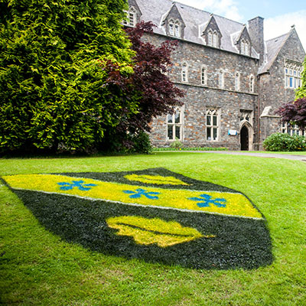

Table of Contents
Introduction 2
Discussion 3
Organizational Behavior and Structures 3
Organizational Culture Development 5
Strategic drift 5
Analyzing culture and cultural web 6
Choosing a Structure 7
Conclusion 8
References 8
Bibliography 9

Introduction

The main purpose of this report will be to show what organization and organizational structure is and what it represents. The selected organization to be made the study on is Louis Vuitton Moet Hennessy (LVMH) one of the best luxury brands worldwide. As a basis in this report, it will be including the relationships in the organization, organizational behavior, and culture by comparing them and give examples with the chosen company.

The story of Louis Vuitton began in the distant 1859, in the beginning, the company began by making and creating handmade bags and suitcases at the request of their customers. Initially, the company had 25 employees and only one store and we reach today when it is one of the most famous and preferred luxury brands in the world. Today, it owns more than 5,000 stores worldwide, making remarkable progress with nearly 3,000 new stores since 2008. LVMH Group today has more than 156 thousand employees who support the company's reputation. Since 1989 it has been run by the Frenchman Bernard Arnault which includes the champagne company Moet and the company Hennessy under its wing. (Sabanoglu, 2020; Gerry Johnson, 2008)

Discussion

Organizational Behavior and Structures
A group of people who strive to achieve a common goal and support each other is called an organization. It aims with the joint efforts of its team to achieve the success that will ultimately satisfy everyone involved in it together with the achieved goal. The organization is
the negotiation process in the form of understandable and responsible relationships to allow the people to work together. Organizations are systems that have formal and informal elements and they work for the benefit of the people. (Armstrong, 2009).
To some extent, they can work and operate formally or informally in a network system of roles and relationships that cross organizational rules and boundaries which does not distinguish them so much. According to Armstrong a process that takes place in the organizational behavior of the group, leadership, and networking, the use of power and politics can have a much stronger effect on how organizations operate from a well - defined organizational chart, supported manual for organizing complex work and description (Armstrong, 2009).

The organizational structures are constantly changing variation of projects which the teams created, managed and glued together by small groups of corporations. Many organizations use teams like those to complement the ‘main’ structure and they could be in a form of taskforces that are set to make progress on the new elements which are part of strategy or those elements provided the regular structure a momentum of the organization where it is not effective. (Gerry Johnson, 2008)
Louis Vuitton has a rather complex but well-made structure, as shown in the chart, the organization owns many other companies in which own 100 percent of it or almost the entire majority stake, but there are some exceptions such as Hermes, of which LVMH owns only 23 percent. The company also has an influence in Asia, which focuses on brands in China, India, and many more but this is not included in the annual report. However, this shows the structure LVMH Groupe has and how well organized and structured it is. (QUIDDITY, 2020)
An organizational structure could include four layers and they are values, beliefs, behaviors and paradigm and that is the assumption of something is taken for granted. The values are the organizational objectives, strategies and missions the company is operating and aiming for. Beliefs are more complex, but they can usually be observed in the way of employees speak about challenges the organization faces, for example, a conviction that the firm does not compete with specific countries, or that technical workers should not have their professional duties appraised by employers. Behaviors is the company’s image and it consist of daily routines and day to day activities such as how is seen by the general public, the people which participate in, how is organized and presented to its customers to show them the perfect structure of the company. Paradigms are the stages of organizational life that are complex for people to clarify. They are referred to as the organizational paradigm in this context. In an organization, a model is a collection of assumptions that are shared and taken for granted.
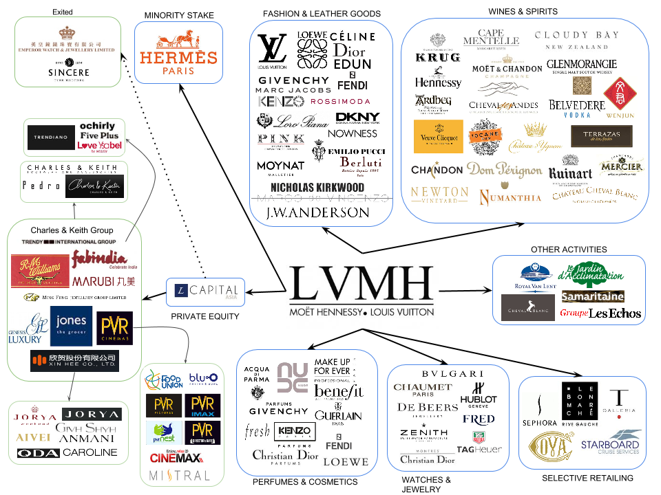
Figure 2: LVMH Brands Structure
source : QUIDDITY, 2020

Although each of us understands the concept of organizational culture in our own way and can be difficult to explain because it is a general concept and has different meanings. However, some people cannot consciously be aware of organizational culture, it still has an impact on their behavior and actions. A way to define organizational culture is to ask how things work around us and how they affect us. According to (Atkinson), organizational culture is the main factor reflecting work performance, such as what is acceptable and unacceptable behavior in the organization and what methods of work are encouraged and discouraged. (Mullins, 2016)

Organizational Culture Development
The culture in an organization can be described as terms of norms, values, and management styles.
According to Armstrong, 2009 historical and cultural insights will aid comprehension of both limitations that companies faced. The corporate world cannot be comprehended without first understanding how it has evolved over time. An organization's skills, particularly those that provide it with a strategic advantage, can have historical origins and have evolved over time in ways that are peculiar to that organization. In doing so, those skills can become part of an organization's culture, the accepted way of doing things and making it impossible for other organizations to replicate. They can, however, be difficult to adjust. Understanding the historical and cultural foundations of those capacities teaches the complexities of strategic transition. Different stakeholders' forces and control are therefore likely to have colonial roots that must be understood.

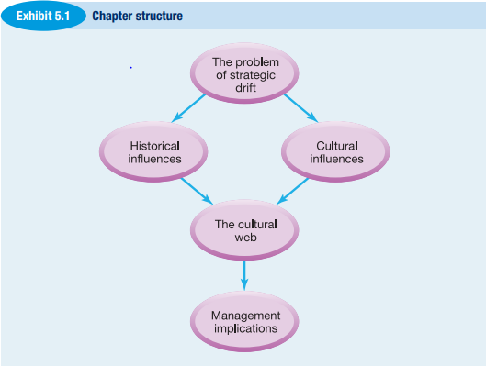
Figure 2: Strategic drift
Source: (Armstrong, 2009)

Strategic drift
Strategic drift means the ability for policies to evolve incrementally in response to historical and cultural influences, but they struggle with an evolving climate. The graphic depicts an image of strategic drift. The causes and effects of strategic drift are crucial to consider, not just because they are normal, but also because they help to understand why businesses often fail. Оorganizational history has a very important part of strategic drift and it must be taken into account by strategists. It is also important for other reasons that would help to better understand the strategy in an organization and also strategic management. For example, many managers relate on their previous experience and history of the company the spend most of their career and it is very helpful when a manager can separate themselves from that history to get a better over view of them and their partners. Another example for which managers can relate to history is when there is a problem who can affect company’s and labor’s optimistic view or their ability to work for the set achievement and then the manger can look back to past situations similar to this one and can make clear statement on what is best for the company and to see how previously the organization deal with those problems. Also, history could affect future plans and decision making. Managers may also be influenced by history and pose a question what if something else happened. It will inspire them to consider what would have been changed even if there were different environmental forces, different reactions from consumers or rivals, or different policies or leadership within their organization. It makes the current situation more obvious as a result of the conditions that are set. Therefore, this could be deal breaker for future plans. (Gerry Johnson, 2008)

Analyzing culture and cultural web

Cultural web is used to help understand in every reference given of the organizational and functional stages the wed is consisted of several elements such as Paradigm which we mentioned already, routines, rituals, stories, symbols, power structure and organizational structure and they are going to be considerate and explained in the report. Firstly, Paradigm we already observed this method but to add on this for people called insiders those are the people who works in a company, it would be difficult to see out of what they are given, that s why is called as well taken for granted because for a person outside of that organization will be much easier to solve a particular problem for instance but for the insider that would be harder because they take the resolving as a granted and can’t see the realistic point of view. Routines are the things people do on a daily basis and they are really common in the structure of any organization and sometimes they can affect the organization negatively because they represent repetitiveness and potentially can be difficult to change and could be consider as a bad habit sometimes. The rituals of an organization every company has its own rituals and often the are events and activities which are very important to the company’s culture those could be interviews, methods of recruiting new staff members, company’s promotion and how to climb the ladder, also organizing conferences and meetings. Stories they are usually shared between staff members to each other or with outsiders’ people out of the organization and they typically tell to present the history, the working atmosphere and mostly to inform people with the importance of an organization. (Gerry Johnson, 2008)

Symbols are things, activities, actions, or people that represent, sustain, or build meaning in addition to their practical purpose. For instance, offices and office style, have a practical role, but they are often decorative, status and hierarchical signs. The mass of people can come to show you especially significant elements of an organization or historical turning points. The symbols usually are separate in the cultural web and many of them are presented as a symbol in the structure. Power structures this is one of the most powerful structures of organization, the power structure can represent directors with strong influence and this is common practice in structures using the strategic drift. Organizational structure shows the hierarchy and the relationships inside the company as well as the importance of certain roles and the impact they are making into the organizational structure. Sometime it shows devoted structures and some of the top managers shares that everyone is working for the orders that are given and that there is no need of working with others its not that valuable in this era and the rivalry and competition is much important. (Gerry Johnson, 2008)

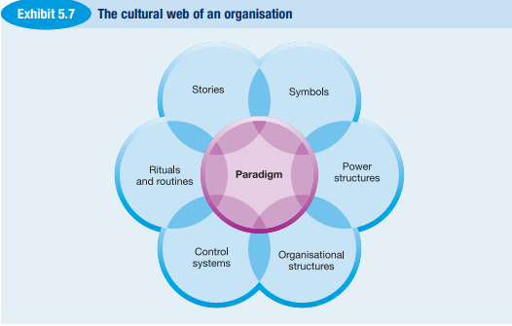

Figure 3: The cultural web
Source: (Armstrong, 2009)

Choosing a Structure

Every structure has its own powerful sides and weaknesses with the help of this diagram could be possible to see the difference Control, Change , Knowledge and Internationalization and with the help of which methods the structure will be most suitable for the people . Looking at the tables in figure 4 we can see that the Transnational Challenge will be most relevant because the more stars it has the more capacity to cope with more challenges and indicates that it would be the best choice by the peoples needs . The structural decision is determined by the competitive problems that the organization faces. (Gerry Johnson, 2008)

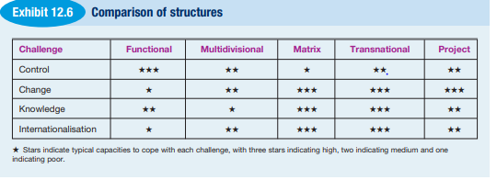
Figure 4: Comparison of structures
Source: (Gerry Johnson, 2008)

Conclusion
In this report I tried to show the main qualities of an organizational structure and what it should look like. I also showed the structure of one of the largest luxury companies in the world and Louis Vuitton and how the company itself was created, what difficulties they had in the very beginning and its development to this day in which everyone has heard this brand.

References
Armstrong, M., 2009. ARMSTRONG’S HANDBOOK of Human Resource Management Practice. 11TH EDITION ed. London: Kogan Page.
Gerry Johnson, K. S., 2008. EXPLORING CORPORATE STRATEGY. EIGHTH EDITION ed. Essex: Pearson Education Limited.
Mullins, L. J., 2016. Management and Organisational Behaviour. Eleventh edition published ed. Harlow: Financial Times Pitman Publishing.
QUIDDITY, 2020. MAP OF BRANDS IN LUXURY FASHION. [Online]
Available at: https://quiddityof.com/2014/08/21/map-of-brands-in-luxury-fashion-lvmh-pt-3/
[Accessed April 2021].
Riot, E., Chamaret, C. & Rigaud, E., 2013. Murakami on the bag: Louis Vuitton's decommoditization strategy. nternational journal of retail & distribution management, 01 11, pp. p.919-939.
Sabanoglu, T., 2020. Statista. [Online]
Available at: https://www.statista.com/statistics/245854/total-number-of-stores-of-the-lvmh-group-worldwide/
[Accessed April 2021].

Bibliography
Armstrong, M., 2009. ARMSTRONG’S HANDBOOK of Human Resource Management Practice. 11TH EDITION ed. London: Kogan Page.
Gerry Johnson, K. S., 2008. EXPLORING CORPORATE STRATEGY. EIGHTH EDITION ed. Essex: Pearson Education Limited.
Mullins, L. J., 2016. Management and Organisational Behaviour. Eleventh edition published ed. Harlow: Financial Times Pitman Publishing.
QUIDDITY, 2020. MAP OF BRANDS IN LUXURY FASHION. [Online]
Available at: https://quiddityof.com/2014/08/21/map-of-brands-in-luxury-fashion-lvmh-pt-3/
[Accessed April 2021].
Riot, E., Chamaret, C. & Rigaud, E., 2013. Murakami on the bag: Louis Vuitton's decommoditization strategy. nternational journal of retail & distribution management, 01 11, pp. p.919-939.
Sabanoglu, T., 2020. Statista. [Online]
Available at: https://www.statista.com/statistics/245854/total-number-of-stores-of-the-lvmh-group-worldwide/
[Accessed April 2021].

