3/24/2025
University of Wales Trinity Saint David
London campus
E-Portfolio Link:
Module Name: Learning In the Digital Era
Module Code: ACCA 4025

Student Name:
Student ID:
Group: 1

Lecturer’s Name: Koushik Modak

LDE Assignment 1
E-Portfolio
Table of Contents
Introduction 2
Main Body 2
Task 1: Essential Academic and Employment Skills for the future career Path 2
Task 1 (a): Report on Essential Academic and Employment Skills 2
Task 1 (b): Evaluation of Task 1 (a) based on Similarity report 2
Task 2: Collaborative Mind Map and Individual Poster 2
Mind Map (Collaborative) 2
Poster (Individual) 2
Task 3: Virtual Collaboration and RefWorks 2
Report on Virtual Collaboration 2
Step-by-step process of using RefWorks with visuals 2
Task 4: E-Portfolio Creation and Evaluation 2
Task 4 (a): E-Portfolio Creation 2
Task 4 (b): Illustrative Review of E-Portfolio tool Selection 2
Conclusion 2
References 2
Task 1 References: 2
Task 3 References: 2

Introduction

Main Body

Task 1: Essential Academic and Employment Skills for the future career Path

Task 1 (a): Report on Essential Academic and Employment Skills
One of the key points of Academic skills is Increasing your knowledge. This is done by making a note of something, highlighting it in a textbook, listen or read something with out taking further action. Another one is memorising and reproducing. Use a mnemonic, make a list of similar things, say it or write it repeatedly, or test yourself or get others to test you. Applying knowledge is one key essential skill. This is done through practicing applying it initially in simple ways, look for examples, work on projects that require this new knowledge, practice using knowledge in reports and essays. This is rounded up with understanding. Think about the knowledge actively in relation to what you know already, consider how the new knowledge relates to what you know, write about it in your own words to make it clear to yourself, break it into sections and discover how they are connected, talk about it, find new information that connects it, make a mind map or other drawing connecting it with other related knowledge, engage in debates, look for ideas or information that might dispel the it [1, p. 16].

Some of the more professional skills are time management and personal development planning [2, p. 6]. This is done through creating a personal sense of time, identifying long term goals, create mid-range strategies, plan your day, make good use of your time, manage meetings, manage delegation, keeping a time log [3, p. 2]. Lastly There is communication principles. One of the key principles is active listening the ability to hear, receive, understand, and respond to information. [4, p. 6]
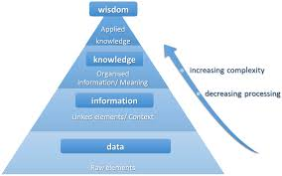

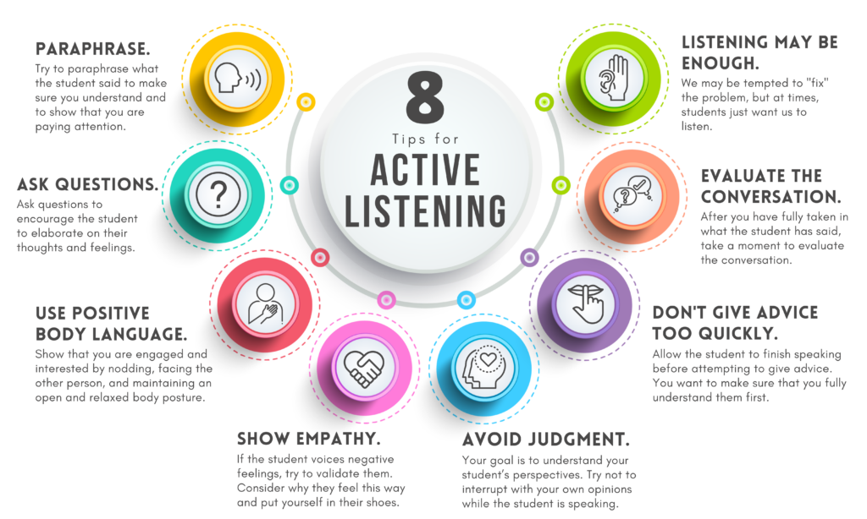

Task 1 (b): Evaluation of Task 1 (a) based on Similarity report

Task 2: Collaborative Mind Map and Individual Poster

Mind Map (Collaborative)

Poster (Individual)

Task 3: Virtual Collaboration and RefWorks

Report on Virtual Collaboration
Put your Chosen topic here

Step-by-step process of using RefWorks with visuals

Task 4: E-Portfolio Creation and Evaluation

Task 4 (a): E-Portfolio Creation

Task 4 (b): Illustrative Review of E-Portfolio tool Selection

Conclusion

References

Task 1 References:

Task 3 References:

References

[1] | K. Turner, B. Krenus, L. Ireland and L. Pointon, Essential Academic Skills (Second Edition), Second ed., B. Gillespie, Ed., 253 Normanby Road. South Melbourne, , Victoria 3205: Oxford University Press, 2011, p. 29.
[2] | K. Gallagher, Essential Study and Employment Skills, Fourth ed., Oxford, England: Oxford University Press, 2022.
[3] | J. Adair and M. Allen, Time Management and Personal Development, London: Thorogood Publishing, 2012.
[4] | I. u. Haq and R. Faizan, Communication Within the Workplace: Systematic Review of, Unknown: International Journal of Applied Business and Management Studies, 2023, p. 18.

