
International Hotel Management (BA)
Contemporary Themes

Student Name:Titu Mia
Student ID: 2020573

Table of Contents
1.0 Introduction 2
1.1 Briefly Introduce the Hotel and Hospitality Sector 2
1.2 The Significance of The Contemporary Theme of Technology 2
1.3 Provide background information on the prevalence of Technology in the sector. specifically focusing on contactless solutions. 3
1.4 Highlight the relevance and importance of contactless solutions for the sector. 4
2.0 Overview of Literature 4
2.1 SWOT Analysis 4
3.0 Application to Hotel And Hospitality Sector 8
3.1 Examine Real-World Impacts of the contemporary Technology 8
3.2 Examples of Management Responses to Technology-Related Issues 9
3.3 Reflect on The Strengths and Limitations of These Management Responses. 9
4.0 Evaluation Future Policy and Management Options 10
4.1 Recommendations for Future Policies 10
4.2 potential innovations and adaptations to further integrate Technology 11
4.3 The Implications of These Recommendations 12
6.0 Conclusion 12
Reference List 13

1.0 Introduction

1.1 The Hotel and Hospitality Sector
The hospitality and hospitality industry are a dynamic and ever-changing industry that caters to the diverse needs of travellers and consumers around the world. This complex industry provides a variety of services from food and accommodation to events and entertainment, making it a major player in the global economy. Interestingly, for the industry, the global hotel and convention industry has reached $1.52 trillion in 2019. However, due to the difficulties caused by the coronavirus pandemic (COVID-19), it will decrease market size, below the billion-dollar threshold in 2020 and 2021. Market forecasts show a recovery of $ 1.21 trillion USD/USD in 2023, showing flexibility and industrial strength in the face of global problems (Statista Research Department, 2023.).
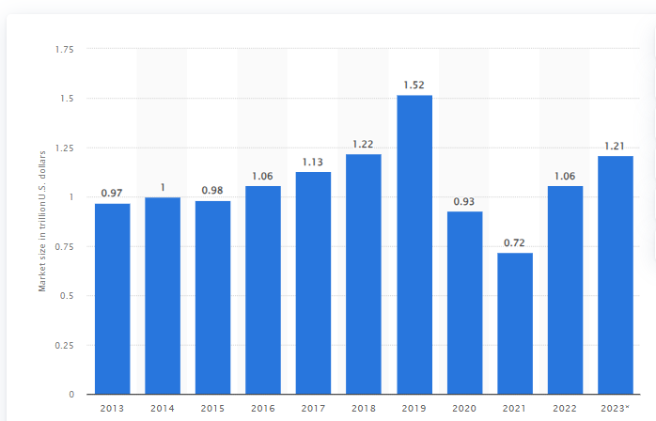
Fig 1: Global hotel and resort industry market size worldwide 2013-2023
(Source: Statista Research Department, 2023)

1.2 The Significance of The Contemporary Theme of Technology
The current theme of technology has caused a tsunami of change in the hotel and leisure industry in recent years. Among the many technological developments, wireless solutions are receiving particular attention. Not only have these developments altered the landscape of the business, but they are also essential to satisfying the needs of a client base that is becoming more and more digitally and convenience-oriented. Given the dynamic nature of the market, it is important to understand the significant impact of the coronavirus pandemic (COVID-19) on the hospitality industry. The industry faced major challenges in 2020, especially in Europe, when hotel occupancy rates fell by 11% in April. Three years later, and in April 2023, the industry showed strength, with hotel occupancy rates in Europe increasing by 68%. This recovery shows the strength of the industry and the ability to recover after the global crisis (Statista Research Department, 2023).
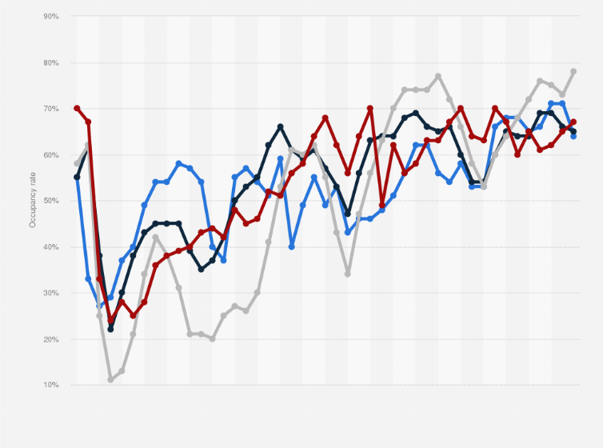
Fig 2: Monthly Hotel Occupancy Rates Worldwide From 2020 To 2023, By Region
(Source: Statista Research Department, 2023)

1.3 Background Information
The technology is widely used in the company, with an emphasis on wireless solutions. With the advent of smartphones, smart devices and advanced computers, the way the restaurant and hotel industry works has changed. The industry is increasingly relying on technology, especially non-cash solutions, for day-to-day operations, improving the guest experience and speeding up order processing. As per Manimuthu et al . (2021), the United Nations Department of Economic and Social Affairs (UN DESA) undertook a computational and statistical data evaluation that projects that by 2050, over 68% of the world's population would live in urban areas. This change is often supported by the need for smarter and networked assets, improved living conditions, modern conveniences, and a modern style of life (Djahel, et al., 2014).

1.4 Importance of Contactless Solutions for The Sector
The importance and usefulness of non-profit solutions in today's cooking world is clear. Increasing health and safety concerns, as well as the global shift to digitalisation, have brought wireless solutions to the fore. In particular, wireless room management, payment and check-in not only improve operational efficiency, but are also important to provide a smooth and safe experience for guests. An average of 8% more guests are satisfied at hotels that use digital concierges, according to a 2023 Oracle Hospitality survey. Additionally, guests who use the digital concierge are more likely to suggest the hotel to friends and family (15%) and return 10% more often (Austin, 2022). 73% of consumers want hotels to have technology that reduces interactions between visitors and staff. Additionally, 74% of respondents expressed interest in hotels using AI to provide more relevant deals.

2.0 Overview of Literature

2.1 SWOT Analysis
In the hotel sector, technology integration—especially with regard to cashless solutions—has resulted in a major change. They may examine the benefits, drawbacks, chances, and risks linked to this technology change by doing a full SWOT analysis.
SWOT Analysis
Strength
Enhanced Guest Experience
Convenience and Efficiency
Contactless solutions significantly enhance operational efficiency, automating processes such as check-in, checkout, and service ordering. According to Skift (2023), 48% of travellers prefer these options, emphasizing the positive impact on the guest experience. The streamlined processes reduce wait times, offering unparalleled convenience to guests.
Personalization and Control
The integration of contactless solutions, particularly through mobile apps, empowers guests to personalize their stay. Room temperature, lighting, and entertainment preferences can be adjusted, resulting in a more tailored and satisfying experience. Oracle Hospitality's findings (2023) report a 15% increase in satisfaction with digital engagement, highlighting the positive reception of such personalization features (Austin, 2022).
Accessibility and Inclusivity
Contactless options, such as voice-activated controls and digital menus, address various barriers in the guest experience. These solutions transcend language barriers, cater to physical limitations, and accommodate age constraints, promoting inclusivity and ensuring a seamless experience for a diverse guest demographic.
Operational Efficiency
Reducing costs is a major benefit of contactless solutions, automating tasks and reducing staff workload. This not only increases efficiency, but allows employees to focus on high-value interactions. Data insights from this technology provide valuable information on visitor preferences, managing strategic resource allocation and targeted marketing efforts.
Improved Brand Image
Embrace innovation, especially by implementing contactless solutions, to meet the expectations of modern travellers. The use of this technology demonstrates the hotel's commitment to progress and quality improvement. This positive perception can increase loyalty and positive reviews, ultimately improving the hotel's market position.
Weakness
Initial Investment Cost
Adopting new technology, especially digital technology, is difficult. A major challenge is the need for specialized hardware, software and integration methods, especially for small or poor businesses in the hospitality industry (Almansour, 2022.).
Limited Technical Skills and Training
Introducing a new agile system requires funding and staff training. Employees require special skills and significant resources to manage them. This problem is particularly problematic in restaurants with a diverse workforce, and each employee needs special training to adapt to the new digital world.
Digital Divide and Guest Experience
Some groups reject technology or prefer old ways, which can change the guest experience. These differences can confuse guests and create challenges for hotels looking to provide a smooth and seamless experience (Sweeney, 2022).
Concerns about Data Security and Privacy
In addition to the above difficulties, worries about data security and privacy add to the flaws of cashless options. Security leaks and data breaches can lower the trust of guests and damage the image of the hotel business. The industry must pledge to security steps to handle these problems and ensure that user data is properly processed, kept and protected.
Opportunities
Growing Market Demand
The increasing consumer demand for contactless options is a great opportunity for flexible hotels. Consumers are looking for contactless solutions because they are convenient and secure, so hotels are ready to meet the increasing demand for more convenient and secure experiences while meeting customer expectations.
Integration with Emerging Technologies
The integration of wireless solutions offers the ability to explore and integrate new technologies. Robotics, voice recognition and artificial intelligence offer many opportunities for the development of better visitor experiences. Hotels at the forefront of technology are positioned as pioneers, setting new benchmarks for travel experiences.
Revenue Generation
For restaurants, contactless technology such as mobile shopping and upselling can open up new revenue streams. The opportunity to use this technology to enhance the guest experience and drive spending (grubbrr.com, 2022). The availability of mobile marketing and increased sales capabilities will increase guest satisfaction and engagement, resulting in better revenue for the hospitality industry.
Innovative Guest Experiences and Sustainability
Contactless solutions for hotels offer new guest experiences, including digital concierge services and app-based controls after the pandemic (Mohanty, and Munir, 2024.). This technology is linked to the growing need for sustainable practices, which reduce the need for physical materials such as paper. This eco-friendly approach appeals to nature travellers and is in line with market trends. A dual focus on innovation and sustainability allows the hotel to serve a diverse and ever-changing customer base.
Threat
Cybersecurity Concerns and Technical Dependence
The hospitality industry relies heavily on technology, creating cyber security issues and affecting guest trust and brand reputation. To protect against threats while maintaining a modern technological experience, a balance must be struck between strong cyber security that protects sensitive data and preventing unauthorized access. Over-reliance on technology increases the risk of system failure, disrupting business, disrupting and spoiling the image of the hotel. Appropriate cybersecurity policies and procedures are in place to mitigate these risks.
Depersonalization and Job Displacement
The rise of automation in the hospitality industry has raised concerns about job losses and downsizing. As tasks become automated, interactions with visitors may become more human-like. Balancing efficiency with human touch is crucial. The threat of job losses is increasing as automation reduces worker needs. Addressing this requires a thoughtful approach that prioritizes guest experience while investing in employee development and training programs. This will ensure technological advancements improve guest interactions and restaurant professionals' lives.

3.0 Application to Hotel And Hospitality Sector
In the hotel industry, this report is focused on the Payment and transaction process as it plays an important role in the guest experience and operational efficiency.

3.1 Examine Real-World Impacts of the contemporary Technology
The hospitality industry has greatly benefited from the integration of free payment options, thereby changing the guest experience. Now, guests can touch their phones or smartphones on the touch-enabled terminal to pay faster, without waiting. It shortens transaction times, increases customer satisfaction, and allows employees to engage in deeper negotiations (Partida, 2021). In addition, the success of the investigation shows how these technological changes are changing the demands of the world. Minimizing guest wait times at the front desk, making the check-in process more efficient and faster. Positive feedback shows that a simple payment process can improve the hotel's image, showing a clear connection between the convenience of mobile payments and high levels of guest satisfaction. In addition, the use of free payment systems will help the operations, and the hotel staff can focus on providing personal service. The positive impact on guest satisfaction and operational efficiency shows how technology is changing the hospitality industry.

3.2Examples of Management Responses to Technology-Related Issues
Hotels are implementing non-cash technologies and providing solutions that cover various sectors. Businesses are investing in advanced systems, including NFC-enabled computers, and ensuring that secure data storage practices are in place to improve their infrastructure (Hollander, 2023). With the help of the development of easy-to-use mobile applications, visitors can easily manage payments and receive services from their devices, increasing convenience. Considering the important role of the employees, hotel management is very important to long-term training. These courses require employees to know how to use technology, solve problems, and inform customers about the benefits of mobile payments. Security is always a key issue and to encourage guest trust, the organization has implemented a robust system to follow data privacy laws and share these practices with the public. In addition, the strong push towards cashless solutions through targeted marketing efforts can drive this technology and improve the visitor experience. These detailed responses demonstrate the hospitality industry's commitment to using technology to increase customer satisfaction and focus on security and compliance issues.

3.3Reflect on The Strengths and Limitations of These Management Responses.
The hospitality industry has greatly benefited from the introduction of mobile payment solutions. A strong investment in security technology shows that improved security measures increase guest confidence and help improve the overall experience. Training has increased staff capacity and ensured a smooth transition for guests to use contactless payment methods. To meet the market's need for more direct interactions, this strategic enhancement shows the organization's ability to innovate. However, some restrictions are clear. For smaller sites, the initial cost of implementing secure wireless technology can be daunting. Despite the training, the digital divide can affect the guest experience because not all guests want to use this payment method. Operators must constantly adapt to technological developments and require regular training updates. On the plus side, contactless payments are convenient, increase operational efficiency and provide a unique guest experience. However, for these current payment methods to be fully effective, issues such as initial investment, understanding customers, and adapting to technological changes must be carefully addressed.

4.0 Evaluation Future Policy and Management Options
Previous studies show the transformation of non-cash solutions in the hospitality industry, showing benefits such as increased security, staff efficiency and strategic marketing. However, it presents limitations, including initial financial challenges, potential gaps in the visitor experience, and the need to adapt to rapid technological changes.

4.1Recommendations for Future Policies
Factors | Recommendation
Financial Support for Smaller Establishments | By implementing policies giving financial support or benefits for smaller hotels to beat initial investment hurdles related to the adoption of wireless solutions.
Comprehensive Guest Education Programs | By developing robust education programs to educate guests, particularly older groups, with cashless payment methods, ensuring a more inclusive and generally positive guest experience.
Agile Training Protocols | By establishing agile training protocols for staff to keep pace with changing technologies. Regular training classes will allow staff to confidently help guests and handle any technological challenges.
Collaboration for Technological Integration | By encouraging collaboration between hotel businesses and technology companies to allow smooth integration and changes, ensuring a healthy relationship between the industry and technological advances.

4.2Potential Innovations and Adaptations To Further Integrate Technology
AI-based personalization uses non-monetary transaction data learned by AI systems to predict visitor tastes, enabling tailored services and recommendations. The introduction of new mobile application features, such as AI-powered virtual housekeeping, real estate aggregators, and personalized recommendations, go beyond traditional payment options (Roether, 2023). Additionally, blockchain technology can enhance the security of non-cash transactions by leveraging its independence and immutability, thereby adding a layer of protection to security risks. Together, these advances are reimagining the guest experience, personalized service delivery, cutting-edge mobile device functionality, and improved security for payment interactions.

4.3 The Implications of These Recommendations
Customer Experience:
Through the introduction of new features, better security, and addressing inequalities, the ideas seek to improve the customer experience. Personalised services and a more open approach are factors that lead to increased happiness from a wide range of guests (Oaky, 2022.).
Efficiency:
Increasing working efficiency is supported by joint technology integration, flexible training processes, and better mobile app capabilities. Service performance is made more efficient by staff preparation and lessened processes (Oaky, 2022.).
Industry Competitiveness:
The hotel sector will be at the centre of technological progress if these ideas are accepted. Businesses become more competitive in the market and draw in tech-savvy and safety-conscious tourists by offering a smooth and secure cashless experience (Oaky, 2022).

6.0 Conclusion
With an emphasis on the adoption of cashless solutions, technology has brought about substantial changes for the hotel and leisure sector, which is an essential part of the global economy. The SWOT analysis highlights the many implications, highlighting the positive aspects like enhanced visitor experiences and operational effectiveness as well as the negative aspects like initial investment expenses and concerns about data security. The payment and transaction process analysis shows real advantages, such as increased visitor satisfaction and speed. Management responses highlight preventive steps, yet limitations still exist, highlighting the need for ongoing adaptation. In order to improve customer experiences, increase efficiency, and increase industrial competitiveness, future recommendations should focus on financial assistance, education initiatives, flexible training, and cooperative integration. The proposed developments, powered by blockchain and AI, further demonstrate the industry's commitment to technological advancement. By implementing these recommendations, the industry positions itself at the forefront of a tech-driven and competitive world, promising a future characterised by seamless, secure, and customised guest experiences.

Reference List
Almansour, M., 2022. Food start-ups: leveraging digital marketing and disruptive information systems innovations to survive in the post-COVID environment. European Journal of Innovation Management.
Austin, 2022. Travelers Want High-Tech, Low-Touch Hotel Stays Shows New Oracle Survey [Online] Available At: https://www.oracle.com/news/announcement/oracle-hospitality-in-2025-consumer-research-study-2022-06-01/ [Accessed On: 29/01/2024]
Buhalis, D. and Moldavska, I., 2021. In-room voice-based AI digital assistants transforming on-site hotel services and guests’ experiences. In Information and Communication Technologies in Tourism 2021: Proceedings of the ENTER 2021 eTourism Conference, January 19–22, 2021 (pp. 30-44). Springer International Publishing.
Djahel, S., Doolan, R., Muntean, G.M. and Murphy, J., 2014. A communications-oriented perspective on traffic management systems for smart cities: Challenges and innovative approaches. IEEE Communications Surveys & Tutorials, 17(1), pp.125-151.
grubbrr.com, 2022. 6 Benefits of Contactless Dining [Online] Avaiable At: https://grubbrr.com/contactless-dining-benefits/ [Accessed On: 28/01/2024]
Hollander, J., 2023. Technology in Hospitality: 20 Trends Shaping the Industry in 2024 [Online] Avaiable At: https://hoteltechreport.com/news/tech-in-hospitality
Manimuthu, A., Dharshini, V., Zografopoulos, I., Priyan, M.K. and Konstantinou, C., 2021. Contactless technologies for smart cities: big data, IoT, and cloud infrastructures. SN computer science, 2(4), p.334.
Mohanty, P.P. and Munir, A., 2024. Contactless Service in Postcovid-19: An Insight from the Hospitality Industry. In Post-COVID Tourism and Hospitality Dynamics (pp. 381-399). Apple Academic Press.
Oaky, 2022. Personalisation in the hospitality industry: 5 steps to stay relevant and delight your guests [Online] Available At: https://oaky.com/en/blog/personalisation-in-hospitality-industry[Accessed On: 28/01/2024]
Partida, D., 2021. Pros and Cons of Touchless Payment Methods in Restaurants [Online ] Available At: https://modernrestaurantmanagement.com/pros-and-cons-of-touchless-payment-methods-in-restaurants/ [Accessed On: 28/01/2024]
Roether, G., 2023. The future of guest personalization through AI [Online] Available At: https://www.hotelmanagement.net/tech/future-guest-personalization-through-ai
Satista Research Department, 2023. Global hotel and resort industry market size worldwide 2013-2023 [Online] Available At: https://www.statista.com/statistics/1186201/hotel-and-resort-industry-market-size-global/[Accessed On: 28/01/2024]
Satista Research Department, 2023. Monthly hotel occupancy rates worldwide from 2020 to 2023, by region [Online] Available At: https://www.statista.com/statistics/206825/hotel-occupancy-rate-by-region/[Accessed On: 28/01/2024]
Sweeney, B., 2022. The Digital Divide: 3 Reasons Why Some Restaurants Outperform Others [Online] Avaiable At: https://www.entrepreneur.com/science-technology/the-digital-divide-3-reasons-why-some-restaurants/426684 [Accessed On: 28/01/2024]

