12/9/2025
Assessment
Portfolio Report on Contemporary Software Applications for Business

Module NaMe: Software solutions for business
Module Code: ACCA 4026
Lecturer: Koushik Modak
Trinity saint david University of Wales (London
Campus)

Student Name: Alexandr Iancovschi
student ID: 2423378



Table of Contents
Introduction 2
Main Body 2
Task 1 2
e-Commerce Website builders/software solutions 2
Task 2 4
Mind-map of Contemporary Software Applications 4
Task 3 7
Office Applications for Creating, Storing, Presenting, and Analysing Data 7
Task 4 19
Communication and Collaboration applications 19
Conclusion 29
References 29

Introduction

In any industry, it is necessary to be creative, and by using imagination and association, multiple ideas can be produced that can be fully assessed and analysed.
In the digital era, the best innovations can be processed and turned into new strategies, products, or services. All of these can be created using the right software apps, which can develop each dream into a real business.
Office applications can help and support the operation of each company, offering efficient running of the organisation.
E-commerce website builders are tools that help individuals or organisations create online stores without the need for coding knowledge. Good communication between employees and employers during daily operations processes can be maintained with the help of communication and collaboration applications.

Main Body

Task 1

e-Commerce Website builders/software solutions

E-commerce systems give the opportunity to get user friendly crossing, working with pre-designed frameworks, different types of editors, and a very clear and simplified process of creating and operating the online store. Also, the systems involve payment options, inventory operation, packing and delivery options, marketing tools, allowing companies to efficiently sell services and products online.

Popular platforms offer solutions for creating outstanding e-commerce websites, considering their weaknesses and strengths. Companies can develop their operations with the help of many successful platforms. The well-known e-commerce websites in 2025 are Shopify, BigCommerce,WooCommerce,Square, Wix [1].
Shopify is a complete platform that provides powerful and robust features and is capable of supporting businesses of all sizes.
Starting, growing, and managing a business is made possible by Shopify, which is a complete commerce platform.
Shopify allows for:
- Build and personalise an online retail establishment
- Sell products in various locations such as web, mobile, social media, online marketplaces, brick-and-mortar locations, and pop-up shops
- Handle products, inventory, payments, and shipping.
Shopify's cloud-based and hosted nature eliminates the need for software or web servers to be updated or maintained. Accessing and running a business from almost anywhere, including a mobile device, is made possible by this flexibility.
As a great platform, it believes that the future of e-market has a lot of opportunities, so they try to reduce the obstructions to business owners to do commerce efficiently for everyone.
Shopify's long-term operation requires the company to invest in our planet. The sustainability fund is designed to reduce carbon emissions and develop solutions for the clients to do the same [2].
Wix is one of the simplest platforms because of its ease of use and focus on design features. The system offers a comprehensive solution, consisting of an enterprise-grade framework, successful SEO and operating tools, enabling individuals to grow online.

Their solutions enable professional website creation, business management, and unlimited expansion. Innovative tools on the platform are designed to help individuals succeed at every stage of their journey.
Individuals can directly engage with shoppers and own their entire customer journey by selling on their e-commerce website that fully represents their unique brand.
By using built-in tools, businesses can expand their reach and increase sales, while also attracting new customers and keeping current ones returning for more.
Create an e-commerce store that is personalised to provide an exceptional shopping experience from the storefront to the checkout [3].
The objective of these platforms is to enhance commerce for everyone. Individuals can achieve independence by making it easier to start, run, and build a successful business through their support.

Task 2

Mind-map of Contemporary Software Applications

a. Mind-mapping is a useful tool that individuals should have in their arsenal when seeking ways to achieve goals or advance their careers.
Mind Map was formalised by Tony Buzan [4] as a method for examining information differently. Users can gain more clarity, better insight, understanding, and peace of mind through diverse perspectives.
According to Bill Gates, Mind Mapping will lead the world to the next stage of new data management.
Businesses can use mind maps as the most effective tools for managing information because they easily and logically organise data to recall things. Furthermore, it facilitates the efficient operation of the organisation.
A central core node in a Mind Map serves as a representation of a topic, picture, or central idea. Different branches can expand to other nodes and topics when referring to the central topic. The representation of branches usually involves connecting lines that lead to other topics.
Mind Maps can be utilised by businesses as a cost-effective tool in their organisational structure. Mind Map can be utilised by companies to analyse their departments and how they are linked and run together.
It is possible to apply functional operations of the business to Mind Maps. In this scenario, employees are classified by their functional operation, and this is known as a hierarchical structure.

An organisational arrangement that involves entities positioned at different levels of authority, like a pyramid with a top-down chain of command, is known as a hierarchical structure. Clear lines of authority are established by this structure, with those at higher levels overseeing and delegating tasks to lower levels. Control, coordination, and efficiency are commonly achieved through the use of this in large organizations [5].

Mind maps are an effective tool for coming up with ideas, planning, and scheduling the operations of the business.
To brainstorm ideas without worrying about order or structure, a mind map is an easy way to do it. It allows you to visually structure your ideas to help with analysis and recall.
A Mind Map is a visual representation of tasks, words, concepts, or items that are linked to and organised around a central idea. The user can construct an intuitive framework around a central concept by using a non-linear graphical layout in this system. A Mind Map can transform a lengthy list of repetitive information into a colourful, memorable, and highly organised diagram.
The Mind Map is an invaluable and innovative way of maximising the creative process. it is a visually graphic approach that triggers the imagination and association, thus powerfully boosting individuals’ creativity and memory. These lead the Mind Mapper to explore ideas and solutions to problems that they might not have previously considered.
Mind Mapping is a powerful skill that, being applied in the running of the business, will revolutionise the company practice and how individuals work [6].

b. Mind Map of day- to- day business / Organisation operations
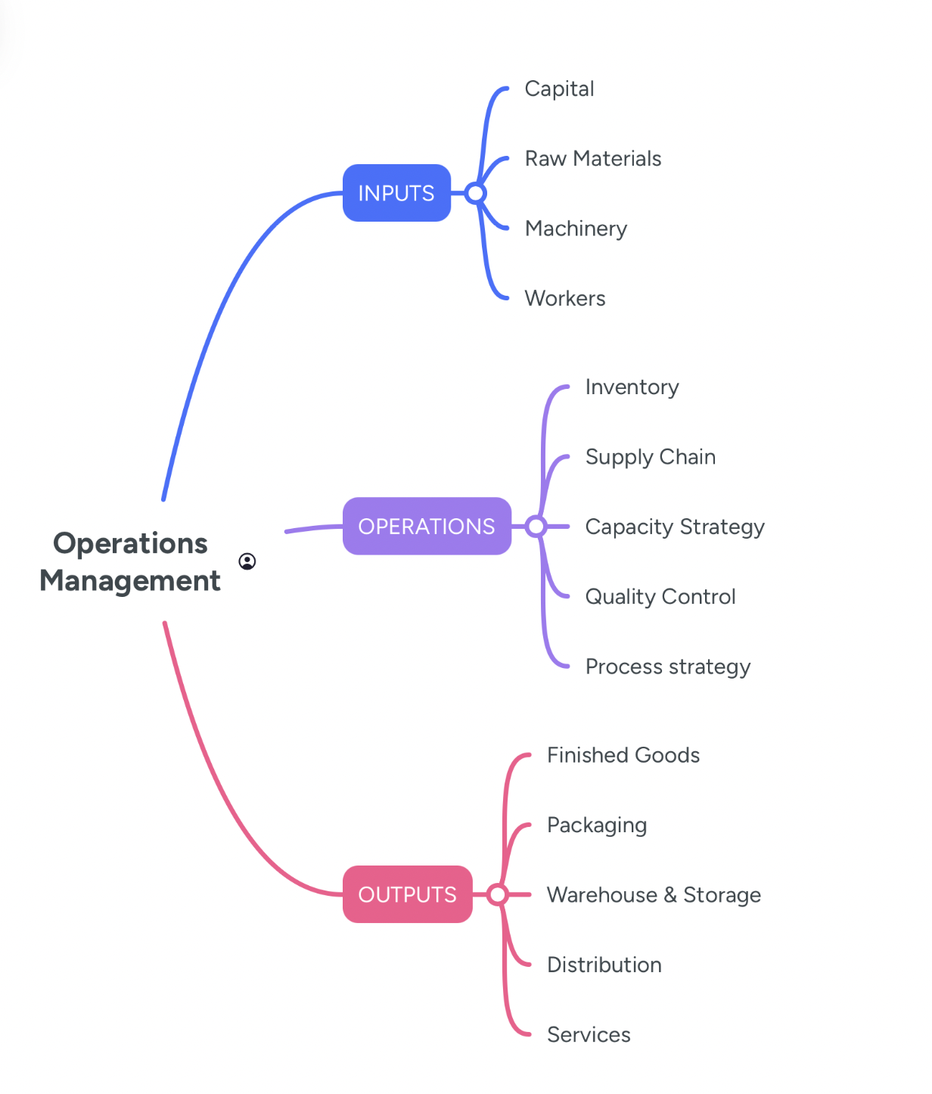

Task 3

Office Applications for Creating, Storing, Presenting, and Analysing Data

a. The most popular forms of documents used worldwide are Microsoft Word, PowerPoint, and Excel, as highlighted by Jeong and Lee. Since its creation in 1981, MS Word has been updated 17 times. The latest version can be accessed through Microsoft 365. It can be downloaded and used as a desktop application or online as part of OneDrive [7].
The modern personal computer introduced word processing as a popular application. The computer and its software have dramatically increased capabilities over time. The expectations of the early users in the 1970s and 1980s have been exceeded. Microsoft has constructed Word updates logically upon the foundation of previous versions. Tabbed visual controls are used in Word instead of complex menus to adapt to the user's actions. Microsoft Word can speed up getting up and running, and then reveal all the innovative features of this popular word processor. Also, it is a word processor that is produced by Microsoft and is sometimes referred to as Microsoft Word, MS Word, or Word. As part of the Microsoft Office suite, it includes one of the office productivity applications.

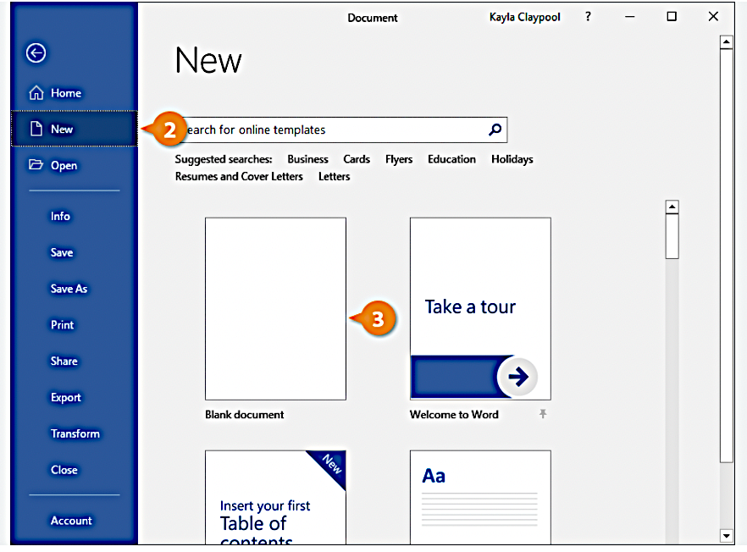

Professional-quality documents, reports, letters, and résumés can be created with the help of Microsoft Word. Microsoft Word is a different type of text editor than a plain text editor, and it has features such as spell check, grammar check, text and font formatting, HTML support, image support, advanced page layout, and more.

Creating, structuring, and adding styles to documents can be done using this system, along with editing and formatting texts.

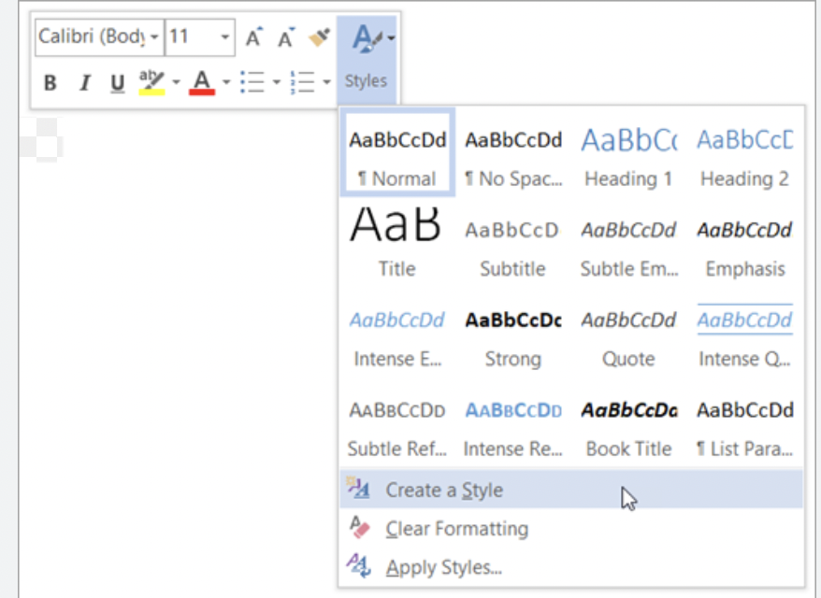

Word's features allow users to quickly add and edit pictures, graphics, videos, hyperlinks, and format shapes.
Equations, symbols, and tables are easy to use and apply in documents for those who want to work with them. It is particularly advantageous for mathematics or science courses.
Working from scratch can make it difficult to insert equations in Word, but it's made easier with placeholders for variables and constants.
By free-hand writing on the mouse or touch screen, users can insert an ink equation, but it has varying accuracy levels.
Word offers some of the most frequently used equations.
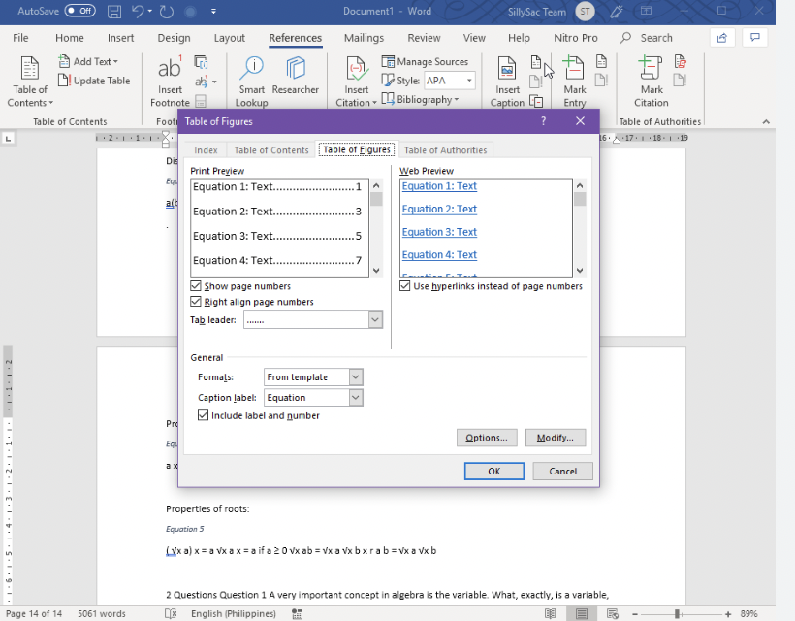
Additionally, there are opportunities to write, share, and collaborate on documents in real-time and on the go using various devices.
Proofreading, indexing, adding citations, and creating tables of contents can all be done with Word's tools. The system is enhanced in reviewing and protecting user documents in a very simple way [8].
Writer is equipped with all the features that can be expected from a modern, fully equipped word processor.
While it's simple enough for a quick memo, it can also create entire books with content, diagrams, indexes, and other features.

There are many useful features in Microsoft Word. It's easy to find tools and options in Microsoft Word due to its easy-to-use layout. The menu allows for quick access to these important functions.
Word's formatting is capable of changing fonts, sizes, colours, and other features to make the documents stand out. Using ready-made templates for different types of documents in Word saves time and gives the work a professional appearance from beginning to end. Images, shapes, charts, and other media elements can be easily added to their documents by users. The use of this feature can enhance the overall presentation by adding visual appeal.
Users can collaborate seamlessly through Microsoft Word. The same document can be worked on simultaneously by multiple individuals. This makes it suitable for collaborative projects and group editing. Real-time co-authoring is also supported by MS Word.
Documents can be reviewed and edited easily thanks to the Track Changes and Comments features.
Checking spelling and grammar is possible with a tool in Microsoft Word. It aids users in discovering and correcting errors in their documents, ensuring they appear polished and error-free.
The appearance of pages can be modified by users by altering margins, orientation, and adding headers and footers. By doing this, documents can be created that look professional and consistent.
Tables of contents can be generated for lengthy documents in MS Word.
Mail merge is a useful tool that allows users to personalise multiple documents, including letters and labels, with specific information for each recipient, saving time.
Users can track the length of their documents by using the word count tool provided by MS Word. Furthermore, it provides information about reading time and sentence count.
Microsoft Word has features that enable language translation, which allows users to translate their documents into various languages.
Microsoft Word enables you to save Word documents in various formats, guaranteeing their accessibility on other devices.
Users have the option to store their documents securely and access them whenever needed.

Microsoft Excel is one of the most powerful spreadsheet software programs in the industry, with its ability to visualise and analyse data.
Formatting, organising, and calculating data in a spreadsheet can be done by users using this software. Data analysts and other users can make information easier to view by organising it using software like Excel when data is added or modified [9].

Excel has a large number of boxes known as cells that are arranged in rows and columns.
Also, it has a term called a Workbook that is used to describe a file created in it. Users can either create a workbook from scratch or use a template. The table where data can be entered is referred to as a worksheet. Across the worksheet, rows are numbered and run horizontally.
The columns are labelled with letters AA to AZ, BA to BZ, and so on.
The worksheet has cells, which are the individual boxes. Each location is indicated by an address. For instance, A1 is located next to B1, and it is directly above A2 [10].

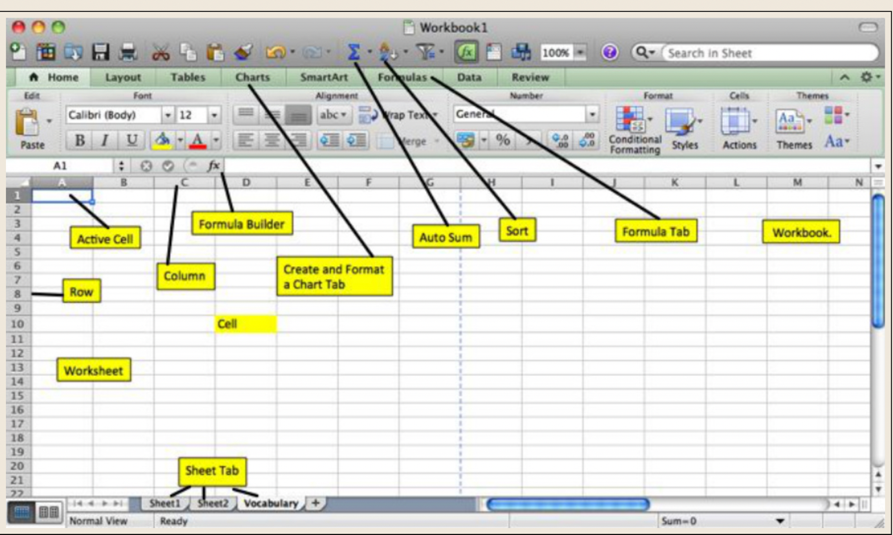

Excel formulas are required by users to perform basic calculations or analyse data.
Excel charts are a visual way to represent data from Excel worksheets, making it easier to interpret and analyse. Trends can be shown, comparisons can be made, patterns can be identified, and insights can be gained from numerical data. Excel provides a vast array of chart types, such as bar, line, and pie charts.
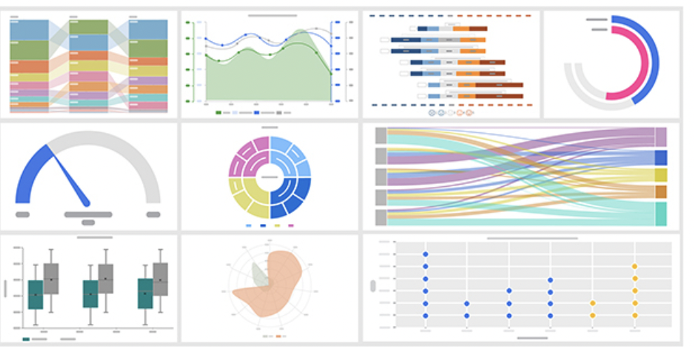
SUM, AVERAGE, COUNT, VLOOKUP, and IF are the five essential Excel functions that every person should know. The use of these functions is crucial for basic calculations, data analysis, and the creation of conditional formulas.

Microsoft Excel offers many advantages for every business, such as enhanced efficiency through automation, enhanced data analysis capabilities, and effective data visualisation tools. Better communication and collaboration are also facilitated by it, and it can be a valuable tool for career advancement.

PowerPoint is a platform that enables users to combine text, images, and multimedia content to create engaging and informative presentations.

Its use is widespread in various settings, including business, education, and personal presentations. Microsoft Office suite software includes it as a standard component, and it is bundled with Word, Excel, and other productivity tools.
MS PowerPoint is a versatile and feature-rich software that can be used to create captivating and professional presentations.
PowerPoint has multiple features, including slide templates and multimedia integration.
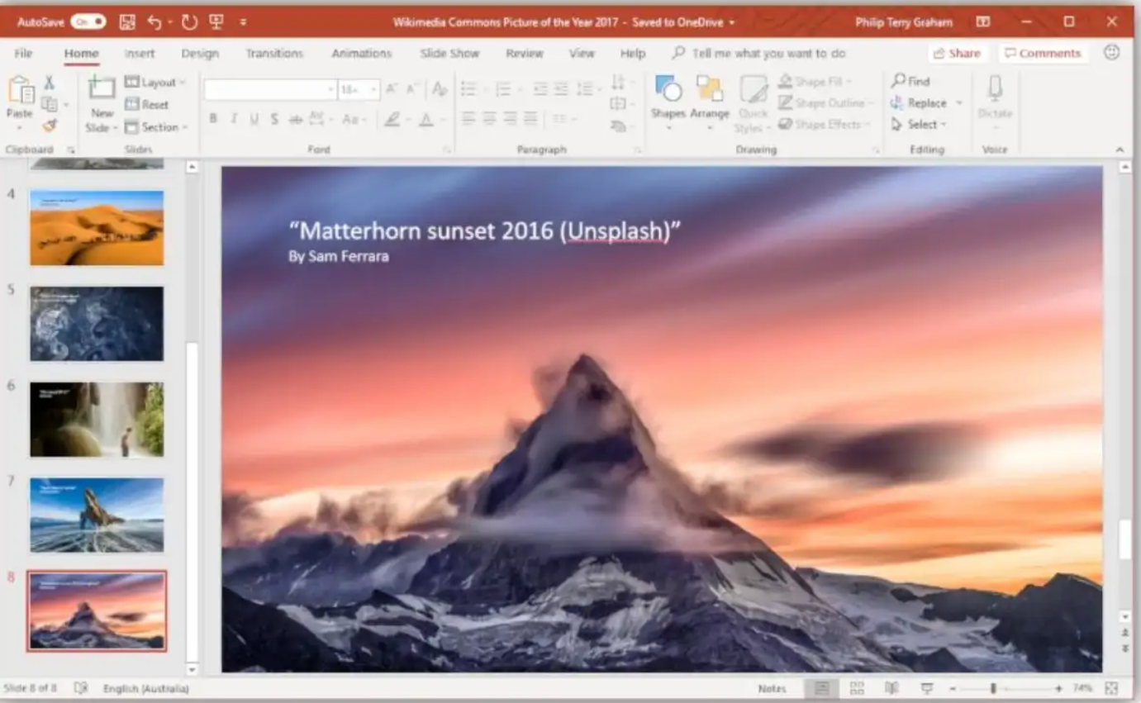

The collection of pre-designed templates provided by PowerPoint makes it simple to create visually appealing slides.
The Slide Master feature enables users to design the entire presentation's layout, font styles, and colour scheme.
Various animation effects and slide transitions can be used in PowerPoint to add visual interest and captivate the audience.
The overall impact can be enhanced by embedding images, videos, and audio files directly into their presentations.
Multiple users can work on a presentation simultaneously in MS PowerPoint, which makes it perfect for team projects and remote collaboration.
A seamless presentation experience is possible by using the Presenter View feature, which allows presenters to access speaker notes, a timer, and a preview of upcoming slides.
The versatility of PowerPoint is enhanced by these features, making it a powerful tool for creating engaging and impactful presentations [11].

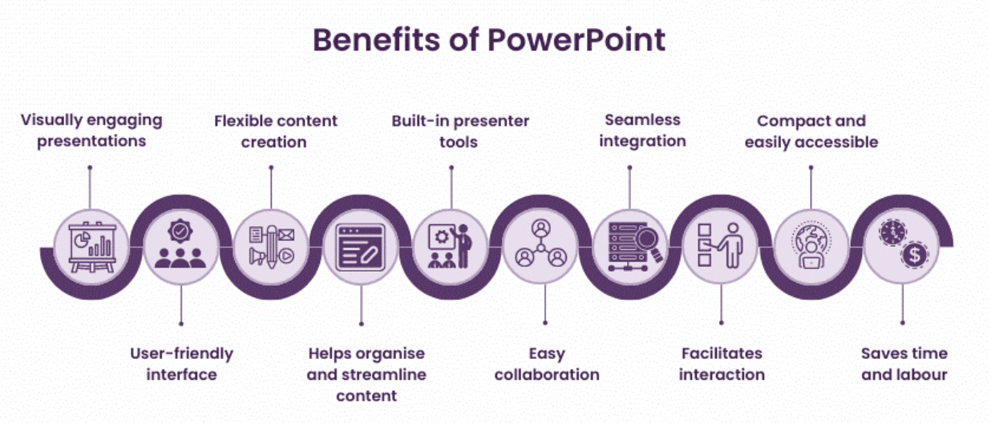

Microsoft PowerPoint's wide range of design tools and features enables users to create visually appealing presentations.
Users of all levels can access PowerPoint due to its user-friendly interface. Content creation can be flexible with it.
Additionally, the program has built-in presenter tools that aid in the smooth delivery of presentations.
PowerPoint makes it easy to collaborate and share presentations.
Integration with other Microsoft Office applications, including Word and Excel, is seamless. Importing data and charts from Excel or copying and pasting content between various Office applications is effortless, leading to time and effort savings.
Professional-looking presentations can be created efficiently within any organisation by using the pre-designed templates, slide layouts, and formatting options [12].

Microsoft Access is a software application that manages relational databases (RDBMS). It is a part of the Microsoft Office suite and can be bought separately in the Professional and higher editions.

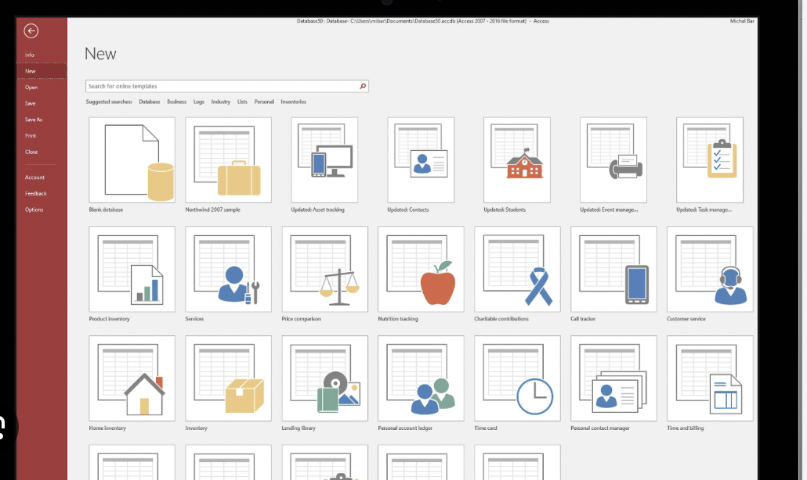

Microsoft Access enables database creation, management, and interaction for users. Data organisation, storage, and retrieval tasks frequently involve using it as a component of the Microsoft Office suite.
Developing databases can be done quickly and easily with Microsoft Access, and it is especially suitable for individuals and small businesses. Access has become the most popular desktop database on the market.
Individual users and small teams can benefit greatly from the many features of Microsoft Access.
Using it is easier than using a client-server database. It is possible to import and export to other Microsoft Office and other applications. Provide templates that are ready for regular users to create and publish data. Enables the effortless creation and publication of web databases. Include a feature called 'Tell Me' that is user-friendly to provide assistance.
Provides developers with the opportunity to create customised solutions using VBA code.
Users can view reports, extra reports are eliminated, and reports are outputted in PDF format.

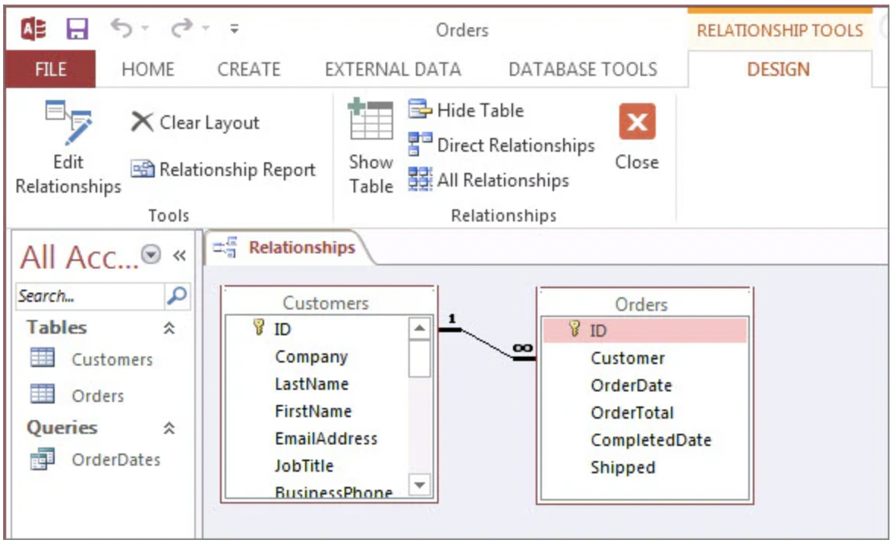

Custom functionality can be created, and repetitive tasks can be automated using macros in Microsoft Access.
Microsoft Access offers a robust query builder that enables users to extract specific data from their databases according to specified criteria. The query builder in Office 365 has improved features and capabilities that make creating complex queries simpler.

Enhancing the functionality and productivity of their databases can be achieved by utilising the integration capabilities of Microsoft Access with other Office 365 applications [13].
By mastering Microsoft Access's features, users can quickly and cost-effectively create database applications that meet organisations' needs. Microsoft Access allows for database enhancements based on individual needs.
Users can identify topics within any organisation, whether it's for-profit or non-profit, and then identify business functions within those topics. It is necessary for the database design to support these business functions.

One reason to establish routine procedures for file maintenance and backup is the possibility of corrupt data. Running the compact and repair process on the database and making regular backups are two important tasks. The frequency of performing each depends on the size of the data file, the number of users, the types of processes, and the potential loss of data. Automating and scheduling the process can minimise the impact on users.

In summary, Microsoft Access in Office 365 offers database users the ability to collaborate, manage data, and improve the productivity of any business [14].
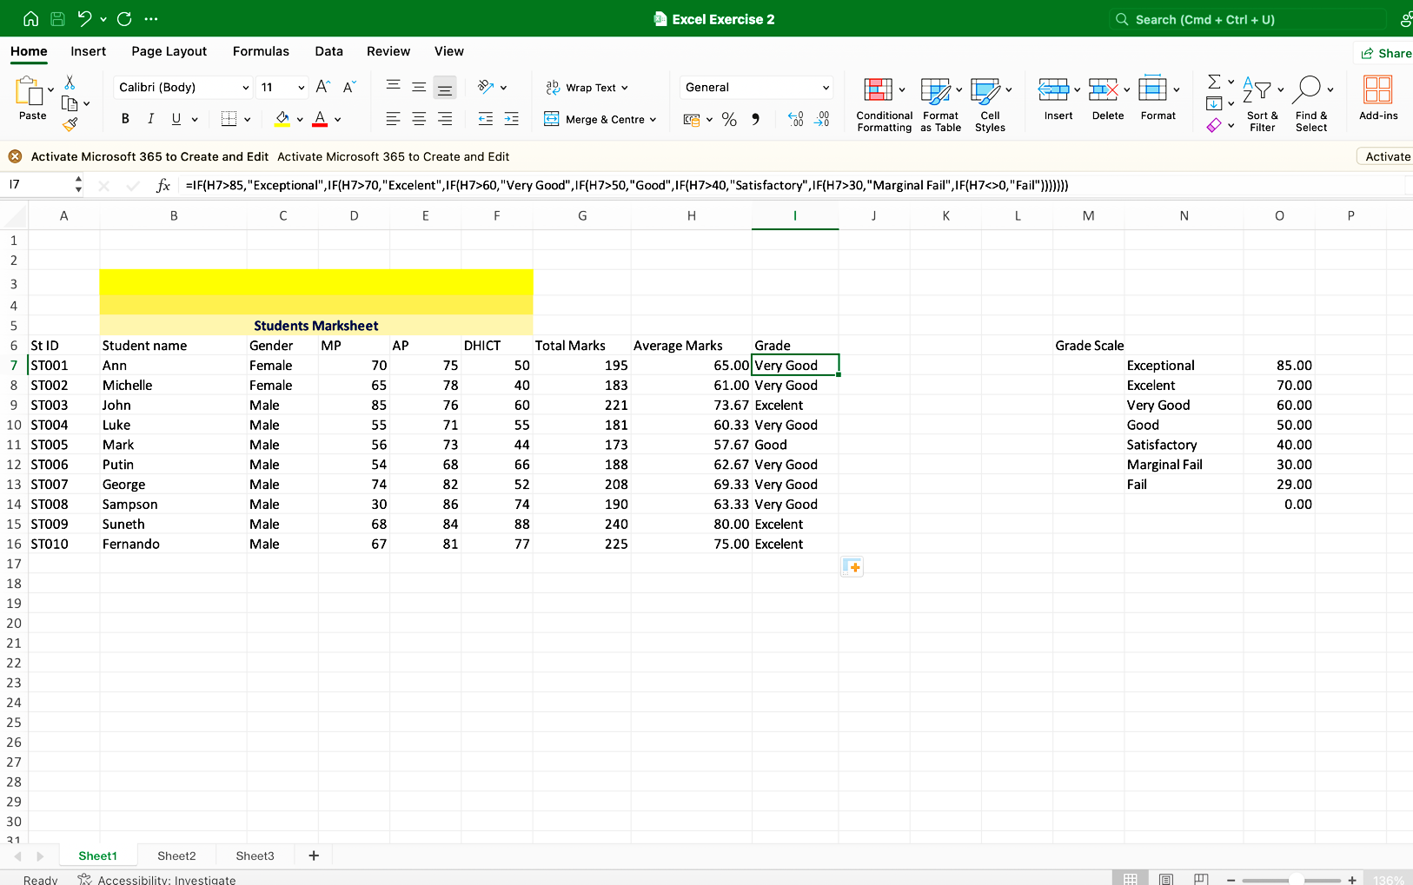
b. One of the most popular functions in Excel, the IF function enables users to compare values to what they expect logically. Two results can be obtained from an IF statement. The first result is true, the second is false. Using the IF function in the table below, the students were able to receive their correct grade based on the 'Grade Scale' and 'Average Marks

The next table shows the use of the IF factor to calculate the exact bonus that drivers can earn if they exceed their mile rate.

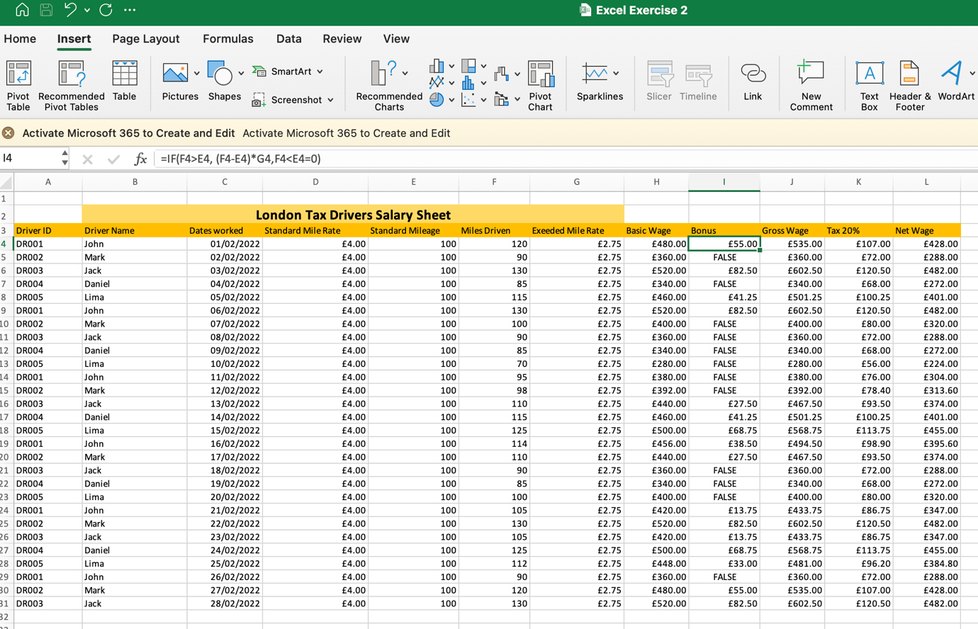

The use of a PivotTable is an interactive method of quickly summarising large amounts of data. Analysing numerical data in detail and answering unanticipated questions about it is possible with the use of a PivotTable [15].

The Pivot Table in Excel can be utilised to examine and analyse information about students' grades, marks, and evaluations during specific periods of study.

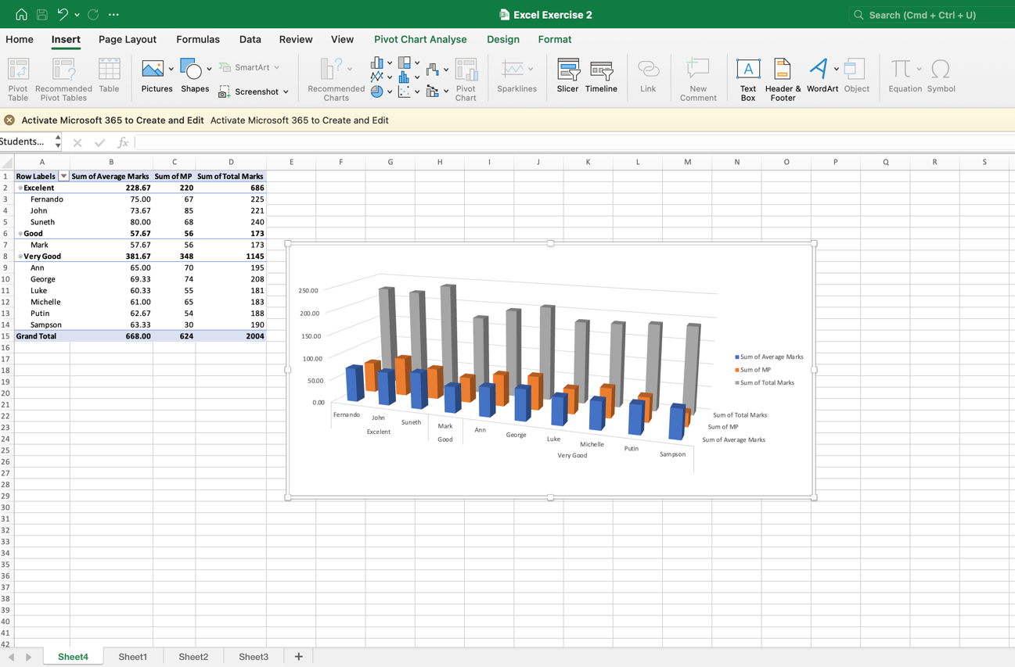

The VLOOKUP formula in Excel is used to retrieve a value from a different column in the same row after searching for a specific value in the first column of a table. The table below shows the salary identification of one specific employee, which includes their ID number.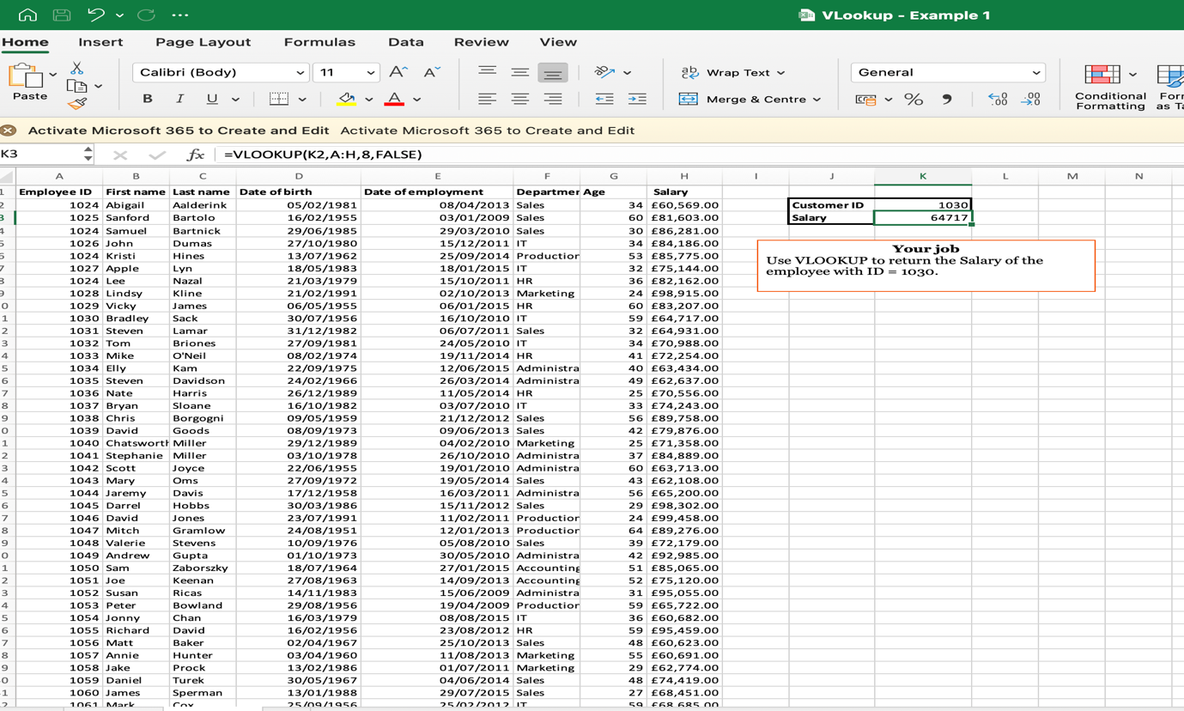

Task 4

Communication and Collaboration applications

Today, there are numerous applications that can assist individuals in running their businesses. Companies can use these systems to schedule professional meetings regardless of where their employees or contractors are located. These apps can efficiently aid in the day-to-day operations of the organisation.

Microsoft Teams is one of the collaboration apps that can be used for personal, family, and business purposes. Users can bring their workplace tools and services together with the help of apps in Teams. It enables individuals and teams to communicate through voice and video, instant messaging, chat, organise groups, and share files all in one place.
Enables audio and video calls for one-on-one or group meetings.
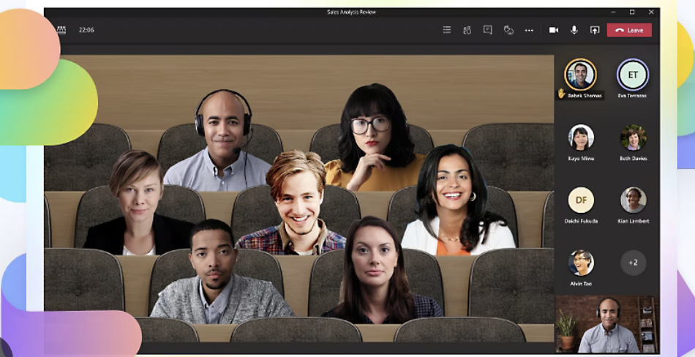
Web conferencing users can share screens, schedule meetings, and record meetings.
The app is easily accessible via desktop, mobile device, or web browser.

The aim of Microsoft is to increase productivity and promote clear communication between colleagues. This is a small modification that can enhance productivity and have a significant effect [16].

An automatic General Channel will be created for every team that has subsections called channels.
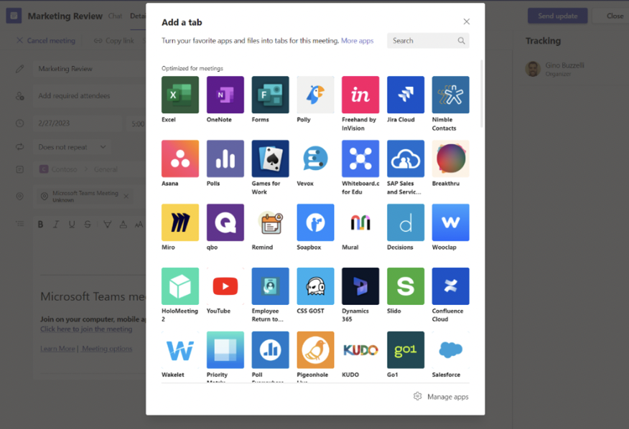
Companies can have multiple channels within a team for sub-teams. For instance, there could be a marketing channel, a finance channel, or an HR channel that pertains to different departments, or it could have a distinct team for each functional area. The size of the business/organisation will determine the choice of what suits their organisation's way of working.
Channels are distinct conversations that can be focused on a specific department, project, or task. Their ability to create sub-teams is exceptional.
Teams has a key feature called Conversations that allows each team/channel to have a centralised discussion that is saved and easily searchable.
All teamwork, from sharing files to video calls, is recorded through conversations as the central component. Teams has a key feature that allows each team/channel to have a central discussion that can be saved and easily searched.
Additionally, they are the primary source of recording all teamwork, from file sharing to video calls.
MS Teams now has access to MS Whiteboard, which is free thanks to Microsoft's integration. Meeting participants can work on it simultaneously on this collaborative whiteboard.
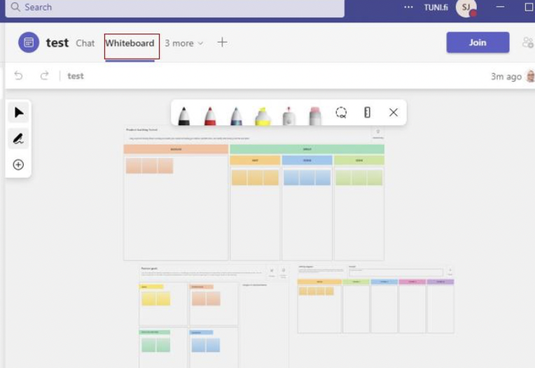
Adding different apps to MS Teams is a simple way to enhance work and collaboration with others. An application can be added by users.
In MS Teams, there are three primary modes of communication: chat, direct conversation, channel, direct sharing with the entire team, or direct real-time meeting.
Unlimited group meetings can be held on Microsoft Teams for up to 60 minutes and up to 100 participants per meeting. Each user can have 5 GB of cloud storage and have unlimited chat with coworkers and customers [17].

On the other hand, as a collaborative communication tool, Microsoft's OneDrive is a cloud storage and file-sharing service that allows users to store, access, and share files from anywhere. Users can collaborate with others, both within and outside their organisation, by uploading, sharing, and syncing their files with this feature. OneDrive is frequently utilised in conjunction with Microsoft 365 and SharePoint, enabling file access from multiple devices.
OneDrive offers a cloud storage platform that is both robust and easy to use, whether it's for small businesses or large enterprises. OneDrive has many advanced enterprise-focused features, unlike other cloud storage providers. Organisations can use OneDrive in whatever way is most beneficial to them because they are available for every subscription type. This guide outlines the available features and how they can be beneficial to the organisation.
Users can view, search for, and interact with files stored in OneDrive from within File Explorer with OneDrive Files On-Demand, without having to download them to their device. The interface provided by the feature is seamless for both OneDrive and local files, and doesn't consume any space on the local hard drive. A cloud icon indicates the status of files that haven't been downloaded, as shown in the screenshot below. The status displays a green checkmark for files that have already been downloaded.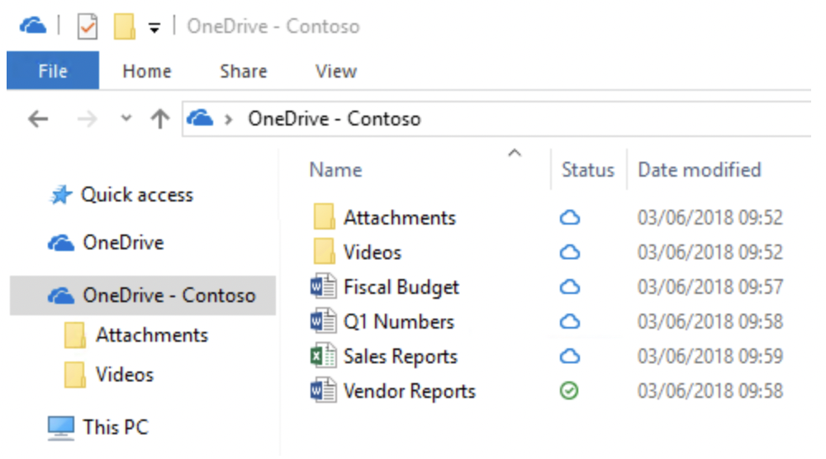

Common customer concerns, specific compliance requirements, or unique functionality available only in OneDrive are addressed by the features listed in this section.

OneDrive's integration with Microsoft Outlook allows for effortless sharing of OneDrive files that appear as email attachments. This feature offers a familiar sharing experience while centralized attachment storage in OneDrive.

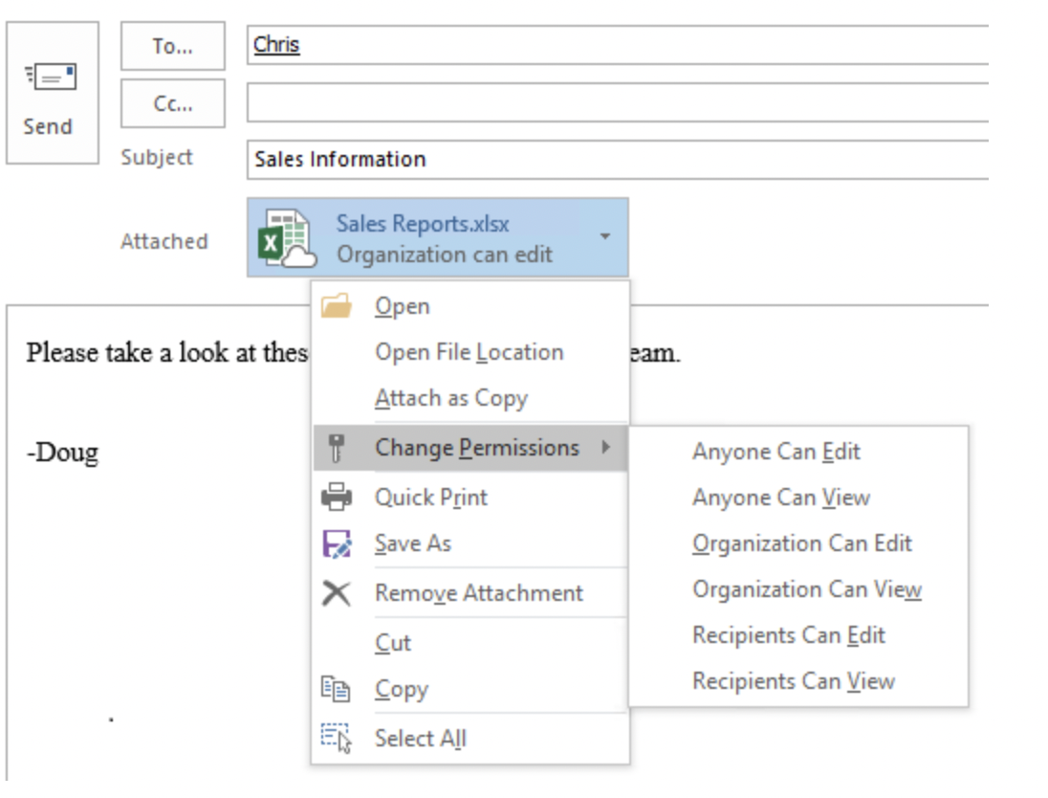

Users have the ability to restore files to any point within the past 30 days with the OneDrive Files Restore feature [18].

b. Zoom is another effective communication application that can be easily implemented in any type of organisation.

This app can assist in organising great meetings, adding schedules to the calendar to remind users of new conversations, and other essential features.

By using the app, users can schedule meetings and inform others when they should join.
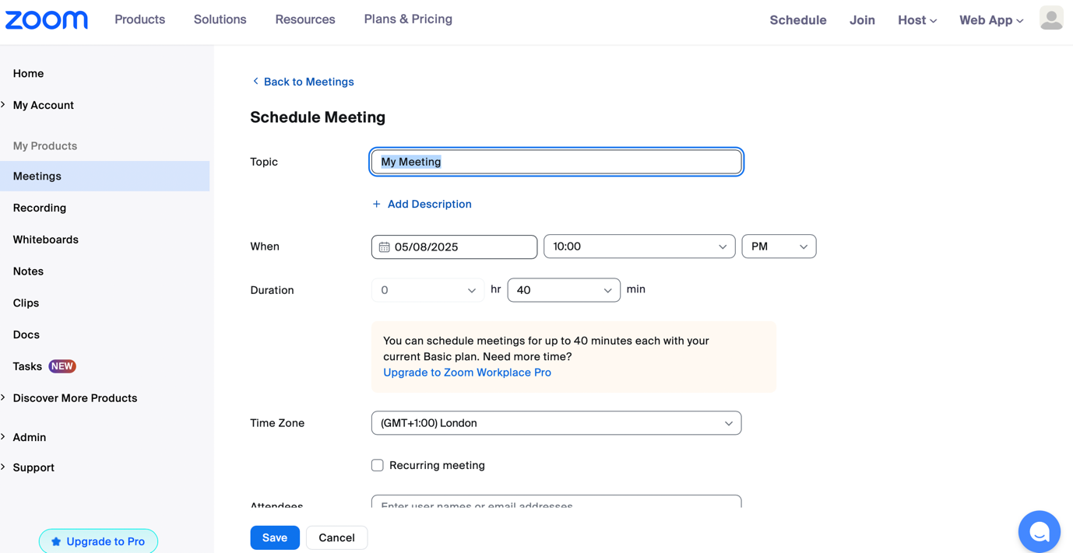

Zoom provides the ability to add contacts or new people to the meeting list.

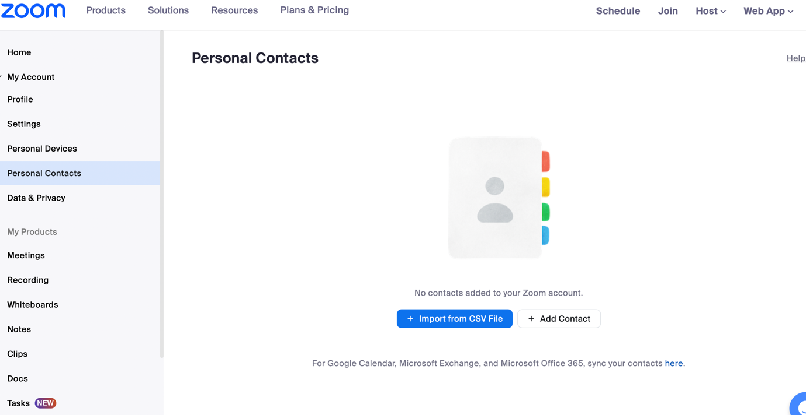

Moreover, the meetings can be recorded and stored for future analysis.
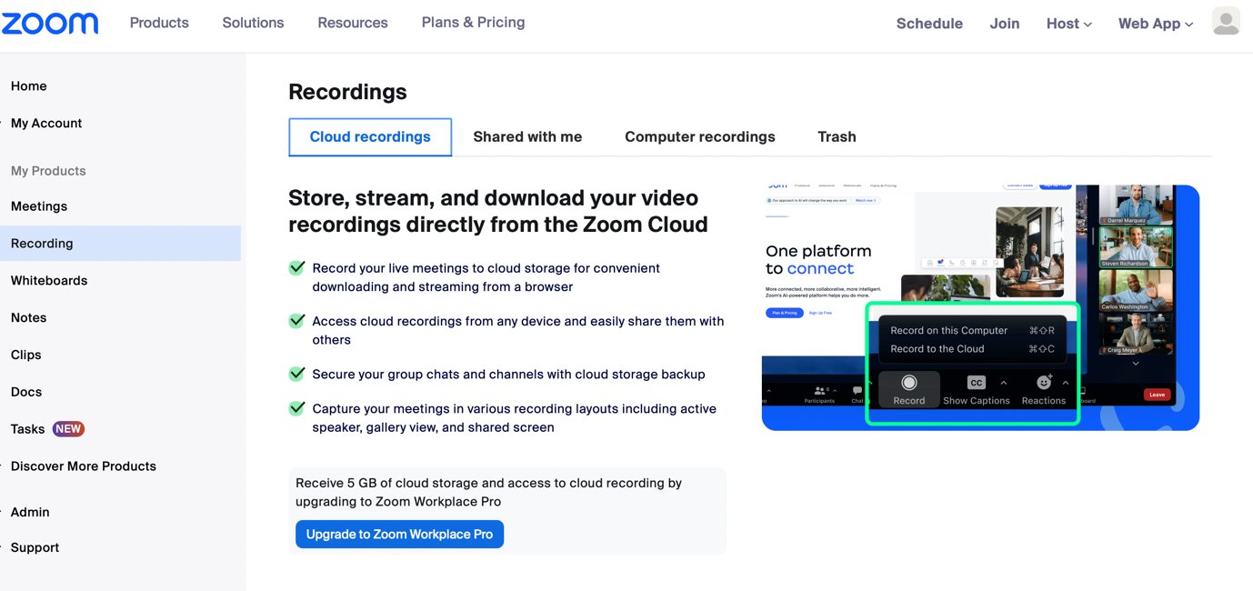

SharePoint, another form of collaboration, is capable of facilitating many tasks for businesses. It involves uploading and sharing files to the document library, collaborating on files with others, creating a team site or communication site, and more.

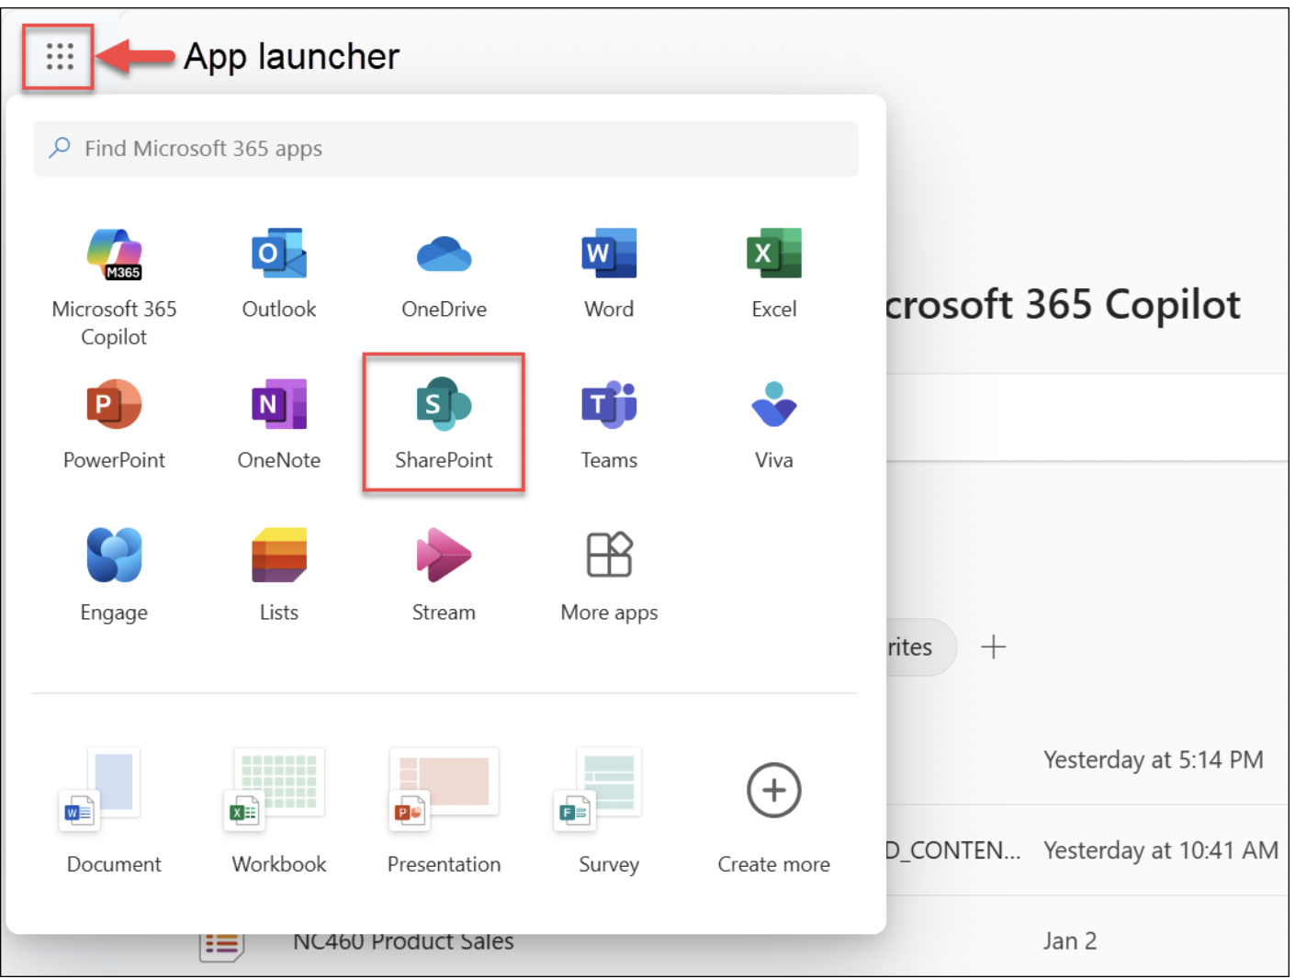

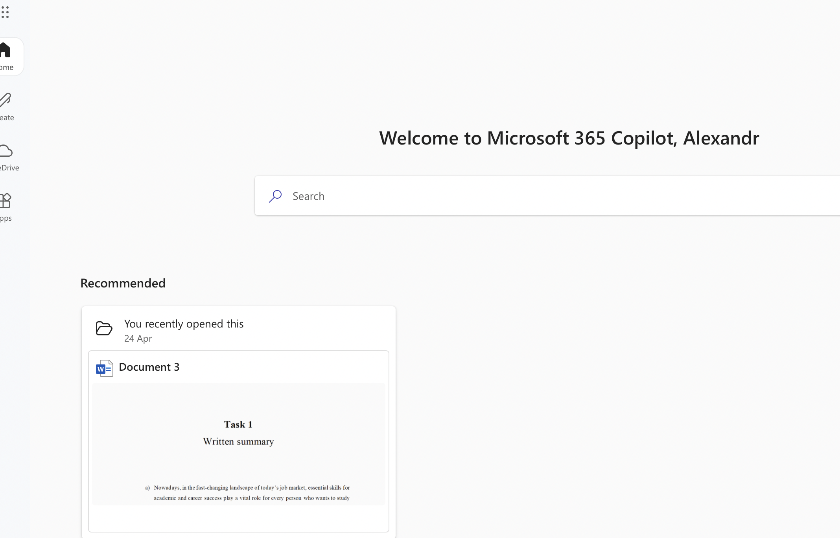

The use of these types of apps within the company's operational structure can aid in the efficient and smooth functioning of various departments.

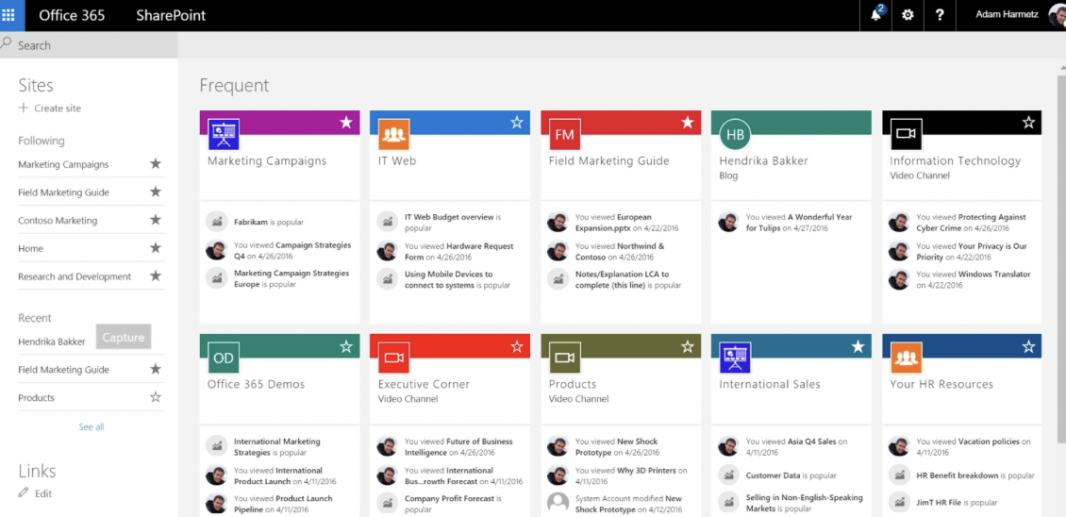

The app provides a multitude of possibilities for creating various types of documents.
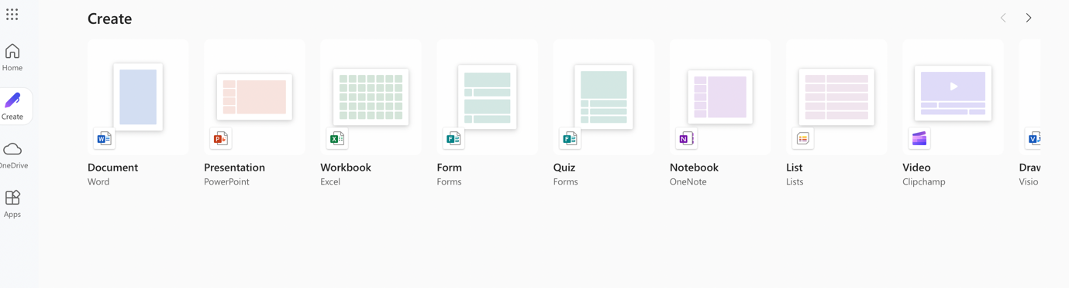
There is a bar with a lot of options, which allow users to share files between members, save fails, create memos, edit documents, etc.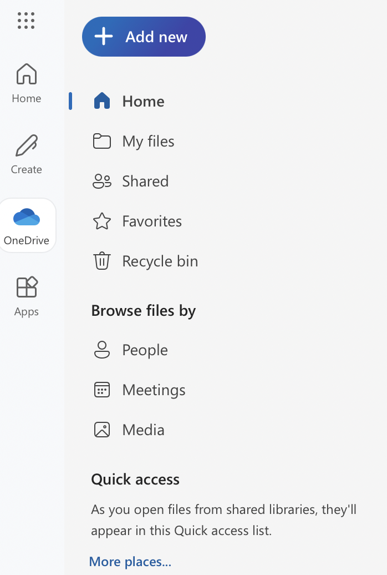
Furthermore, users have access to stored documents through various modes of access.

Conclusion
The components of software include instructions, data, or programs that guide a computer's actions. The digital era is challenging to survive without them. It's crucial to understand the significance of them and how to use them in the company's operations. A company's development is greatly impacted by using tools like Word, PowerPoint, and Excel. Apps such as Mind Map can aid in achieving good organisation and support creativity in practice. Communication and collaboration systems are essential tools for businesses to connect with every member of their company, regardless of their distance. The use of these types of apps can aid successful businesses in achieving significant growth and expanding their marketing efforts to a global and international level.

References

[1] | Zapier, “best e-commerce shoping cart software,” 2025. [Online]. Available: https://zapier.com/blog/best-ecommerce-shopping-cart-software/. [Accessed 29 04 2025].
[2] | shopify, “about,” 24 04 2025. [Online]. Available: https://www.shopify.com/uk/about.
[3] | wix, “e comerce (about us),” wix, 2025. [Online]. Available: https://www.wix.com/about/us. [Accessed 27 04 2025].
[4] | T. Bates, How to Mind Map • 7 Easy Steps to Master Mind Mapping Techniques, Note-taking, Creative Thinking & Brainstorming Skills, Paperback : Lulu Press, Incorporated , 2019.
[5] | bbc, “bbc,” bitesize/guides, 2025. [Online]. Available: https://www.bbc.co.uk/bitesize/guides/z6v847h/revision/1. [Accessed 29 04 2025].
[6] | T. Buzan and C. Griffths, Mind Maps for Business Using the Ultimate Thinking Tool to Revolutionise how You Work, ebook: Perason Education, 2013.
[7] | D. a. L. S. Jeong, “Study on the tracking revision history of MS Word files for forensic investigation’, Digital Investigation,,” Digital Investigation, vol. 23, no. 10.1016, pp. 3-10, 2017.
[8] | S. Basham, Microsoft Word includes smart tips and time-saving shortcuts in easy steps, UK Warwickkshire: Easy Steps Limited, 2021.
[9] | P. Weverka, Microsoft Office 2019 all in one, for dummies, /: for dummies, 2019.
[10] | microsoft, “microsoft-365,” 2025. [Online]. Available: https://www.microsoft.com/en-gb/microsoft-365/excel. [Accessed 01 05 2025].
[11] | K. Jacobs, Kathy Jacobs on PowerPoint, Paperback: Holy Macro, 2004.
[12] | theknowledgeacademy., “what-is-powerpoint,” theknowledgeacademy, 01 03 2022. [Online]. Available: https://www.theknowledgeacademy.com/blog/what-is-powerpoint/. [Accessed 01 05 2025].
[13] | microsoft-office, “how-to-access-microsoft-access-in-office-365,” microsoft-, 2022. [Online]. Available: https://ms.codes/blogs/microsoft-office/how-to-access-microsoft-access-in-office-365. [Accessed 01 05 2025].
[14] | Teresa Hennig, Microsoft Access Small Business Solutions State-of-the-Art Database Models for Sales, Marketing, Customer Management, and More Key Business Activities By Teresa Hennig, Truitt L. Bradly, Larry Linson, Leigh Purvis, Brent Spaulding · 2010, State-of-the-Art Database Models for Sales, 2010.
[15] | support.microsoft., office, 2025. [Online]. Available: https://support.microsoft.com/en-gb/office/overview-of-pivottables-and-pivotcharts-527c8fa3-02c0-445a-a2db-7794676bce96#:~:text=A%20PivotTable%20is%20an%20interactive,unanticipated%20questions%20about%20your%20data.. [Accessed 02 05 2025].
[16] | Forbes, “sites,” quickerbettertech/, 28 08 2022. [Online]. Available: https://www.forbes.com/sites/quickerbettertech/2022/08/28/microsoft-teams-has-more-integration-optionsand-other-small-business-tech-news-this-week/ . [Accessed 02 05 2025].
[17] | microsoftt, “microsoftteams/apps-in-teams,” microsoftt, 2025. [Online]. Available: https://learn.microsoft.com/en-us/microsoftteams/apps-in-teams. [Accessed 01 05 2025].
[18] | microsoft., “earn.microsoft,” sharepoint/onedrive, 2025. [Online]. Available: https://learn.microsoft.com/en-us/sharepoint/onedrive-overview. [Accessed 01 05 2025].

