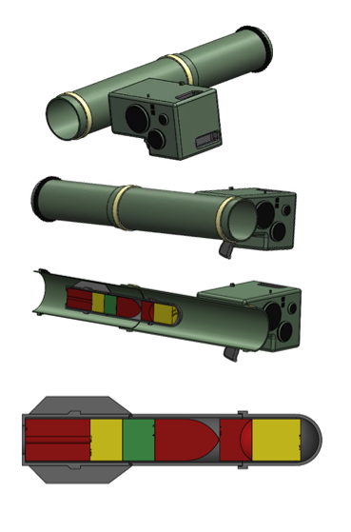  Work Based Group Project  Systems Engineering: Research and Design | 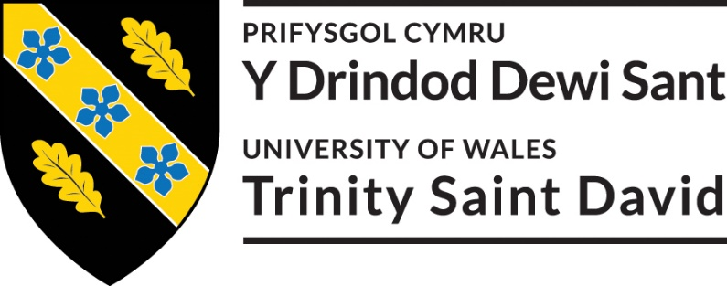  Work Based Group Project: ACDA5022  Student number: 2217522  Gareth James  Abstract:  The following report relates to the Systems Engineering approach to the research and development of a shoulder launched missile system.  The report focuses on the role of Research and Development in a team setting, utilizing the Systems Engineering toolset. Key elements of the process included interactions with the other stakeholders in the project. This included the acquisition of the requirements set from the other stakeholders, how these factors affected the design process, considerations and changes to the design.  Also included are reflections on how knowledge and information can be shared, along with improvements that could be made to improve future projects.

Contents
1. Introduction: 1
2. Requirements Gathering 2
3. Design Development 5
3.1. Design Overview 5
4. Communication and Information Management 8
5. Reflection and Conclusions: 9
6. References 10

Table of Figures
Figure 1 - Stakeholder Influence Map (SIM) 3
Figure 2 - Team Interaction Map 4
Figure 3 - General File Folder 4
Figure 4 - Group Task Folder 5
Figure 5 - Shoulder Launched Missile System Design 7
Figure 6 – Projectile Mk3 7
Figure 7 - Meeting Schedule 24/02-23/03/2025 9

Introduction:
The following report is concerned with Research and Design of a solution to the request from a customer. The customer required an explosive device capable of neutralising a hostile communications centre, housed in a room on the second floor of an office block building. The design needed to meet certain requirements, which included the need for it to be accurately delivered into the room from a distance of at least 100m and deliver an effect event that would minimise collateral damage to adjacent rooms.
A Systems Engineering (SE) approach was adopted to consider the needs of the customer and deliver a design proposal.
The SE approach has been identified as an interdisciplinary approach that utilises a broad array of disciplines, skills and tools to develop reliable and robust system that can perform its intended task [1]. The SE approach of adopting a holistic, methodical and systematic process can reduce development times (and costs) associated with the development cycle of new systems [2].
One of the central themes that runs throughout SE is teamwork [3]. The other teams included Safety by Design (SDT), Safe to Manufacture Team (SMT), Testing, manufacture, and disposal. Where the design was achieved through collaboration, the individual/teams were able to focus on the disciplines and interests of each stakeholder group. By taking a multi-disciplinary approach, the team was able to develop a system that met the needs of the customer and stakeholders.
Research and development (R&D) is crucial in the engineering industry for the development of new systems and products across a broad range of industries [4]. The role of the Research and Development team (R&D) was focused on identifying the requirements from a variety of stakeholders, prioritising these accordingly, identifying solutions that met requirements, taking feedback, identifying alternative solutions (where required) and balancing the requirements of the stakeholders whilst producing a final design that was fit for purpose. Most R&D involvement was focused on the development of the higher system, identifying the key design features, the critical subsystems and critical component(s) within.

Requirements Gathering
Before a solution could be identified it was essential that the requirements of the system be identified. Identifying the requirements from a broad range of stakeholders was the first step in the design process, as the foundation for the entire development of the system [5] [6].
The use of a Stakeholder Influence Map (SIM) helped to identifying the various parties who needed to be consulted in the requirements gathering stage. Understanding their needs and views is critical to system design, and therefore a logical starting point in the process was to identify the stakeholders associated with the system. The SIM can be seen in Figure 1.
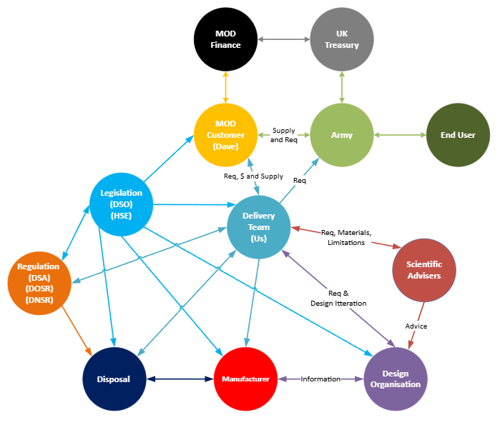
Figure 1 - Stakeholder Influence Map (SIM)
To gather the requirements from the user a Gemba Visit was organised to establish their needs. This opportunity proved beneficial, as the R&D team were able to identify Functional Requirements (FR), Non-Functional Requirements (NFR) in context with limitations and expectations of the end users in an operational environment (albeit a training exercise). This also enabled the R&D team to understand the various considerations of the end-user, including re-supply, transport, storage and operational environment factors which affected the design of the solution.
Where the Safety, manufacture, testing and disposal teams worked from the same location as the Research and Design (R&D) team, the use of a Round-Table meeting was used. This technique enabled each team to communicate their needs/requirements of the system. This approach has been used in a variety of settings and industries to enable groups to work towards a specific goal or outcome, in this case the establishing of requirements [7] [8]. This approach ensured that the appropriate stakeholders engaged with the process, and that suitable requirements were established.
This also provided an essential platform for the teams to provide information to the R&D team on legal limitations and constraints on elements on the project also. Examples of this include the Safety (Design) team highlighting the importance of legislation (the Health and Safety at Work Act 1974 [HSWA 1974]; Explosive Regulations 2014 [ER 2014]; and Defence Safety Authority 02. Defence Ordnance, Munitions and Explosives (OME) Regulations [DSA 02.OME]) and the necessity to ensure that the design adhered to any restrictions and limitations, and risks were reduced within the principles of ALARP (As Low As Reasonably Practicable).
The relationships between the project teams were identified, as the requirements identified by each team had an influence on the final design. The interactions between the teams throughout the development lifecycle should also be understood, as the R&D team was required to integrate the requirements from all teams into the final design. An interaction map can be seen in Figure 2.
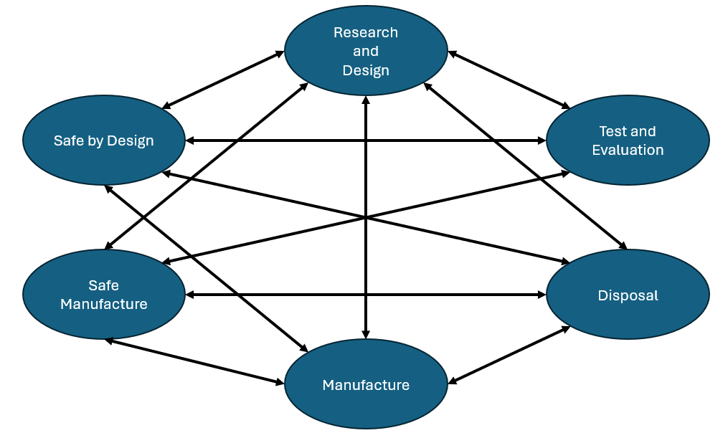
Figure 2 - Team Interaction Map
After gathering a comprehensive set of requirements, the information was stored within a Requirement Traceability Matrix (RTM) in a Microsoft Excel workbook. This was stored and shared using a Microsoft Teams Group, so that there was a record of the requirements set for reference (and continuity) by all teams. This was shared with all members of the group, so that there was a clearly identified location for storage and access of files relating to the project. This also aided in collaboration between the various teams, enabling real-time editing and collaborative working where remote working was necessary. An overview of the file/folder can be seen in Figure 3, with additional file structure for Group Task found in Figure 4.
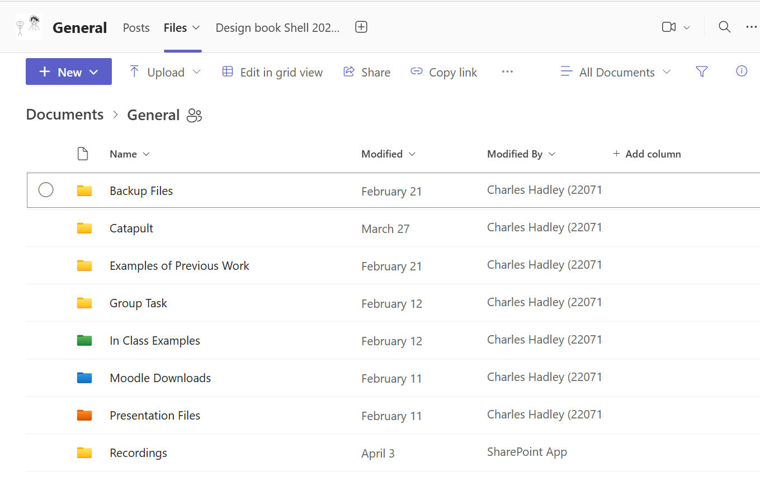
Figure 3 - General File Folder

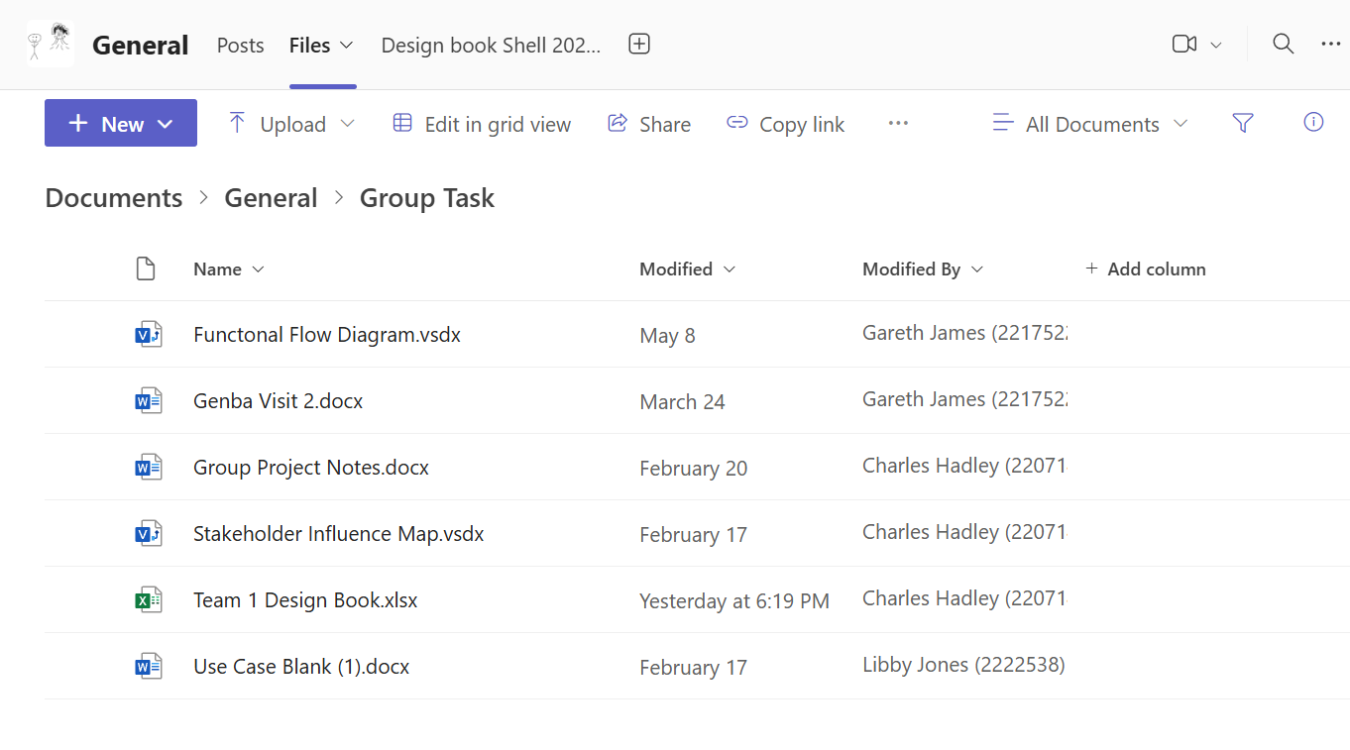
Figure 4 - Group Task Folder

Design Development
To meet the requirements, the higher system was required to perform several functions.
- system must explode and neutralize the target.
- the system should be accurate, be able to gain entry to the room from 100m
- The system should reduce the effect of collateral damage to adjacent rooms inside the target building.

Early suggestions from some members of the team suggested the use of large yield Electro Magnetic Missiles [9] [10]. It was determined that this technology was not yet achievable, and in its current state could not deliver the effect required without causing damage to local infrastructure (such as electrical equipment in nearby hospitals, schools and emergency service equipment) resulting in potentially harmful effects on civilians. The R&D team used this opportunity to re-establish the requirements of the system.

The design process was guided by the SE tool set and process. A System Flow Diagram was created that would show the generalised process to deploy any system, prior to considering how the system could be deployed. Using Systems Function Means Analysis (SFMA) to assess the options early in the design process aided in down-selecting unsuitable solutions. The design was refined using the Systems Functional Failure Modes Effect Analysis (SFFMEA) to identify how the 5 different types of failure could affect the system, which resulted in the first iteration of the solution.

From conducting N2 Analysis 3 Key Design Features were identified. These were the Command and Launch Unit (CLU), the interface between the CLU and the Telescopic Missile Tube (TMT), and the Safety and Arming Unit (SAU). This information was presented to the stakeholders during a team/progress meeting following the first drafts of the concept and prompted several discussions with the Safe by Design Team and Test and Evaluation Team. It was determined that the SAU was the highest priority of these features, as this related directly to the function of the system. If the SAU did not perform its role, a series of failures could result in fatality.

Design Overview
The design consists of 2x parts which fit together via a dovetail joint between the CLU and TMT. Once fitted together, the TMT is extended before the system is aimed, armed and launched. When launched the projectile utilises a 2-stage rocket motor system – the first is to eject it from the tube, the second engages the main rocket motor, which then sustains the flight to the target.
The target was intended to be neutralised by a 2-stage method (or Tandem Attack). During flight the Safety and Arming Unit (SAU) arms the projectile [11]. When the projectile reaches the target, entry is gained via the use of an Explosively Formed Projectile (EFP), designed to defeat a double brick cavity wall. The second stage would be determined by a delayed detonation utilising a fragmenting warhead element that would enter the target room through the hole created by the EFP.
A tandem attack using EFP was selected as the target wall was constructed of double brick cavity wall approximately 300-350mm thick. Depending on the size and weight of an explosive charge, gaining entry to the target room and neutralising the target & contents may have been difficult. Non-lethal methods were considered; however, these would not guarantee neutralisation of the computer equipment inside the target room. This was a functional requirement that had to be met.
CLU
The CLU element was determined to meet the requirements for accurately aiming and locating the target. It was designed with the intention of locking onto the target and programming the projectile so that the chance of failure was reduced to a tolerable level. In combining this with an intelligent guidance unit, it was deemed to meet both user and customer requirements.
TMT
The TMT element was determined to meet the environmental/operational requirements, as it would minimise the need for field maintenance. A waterproof seal either end was designed to be ejected upon firing, which would ensure that the system would function as intended consistently, with minimal effort from the user to maintain this element.
An overview of the design can be seen in Figure 5.
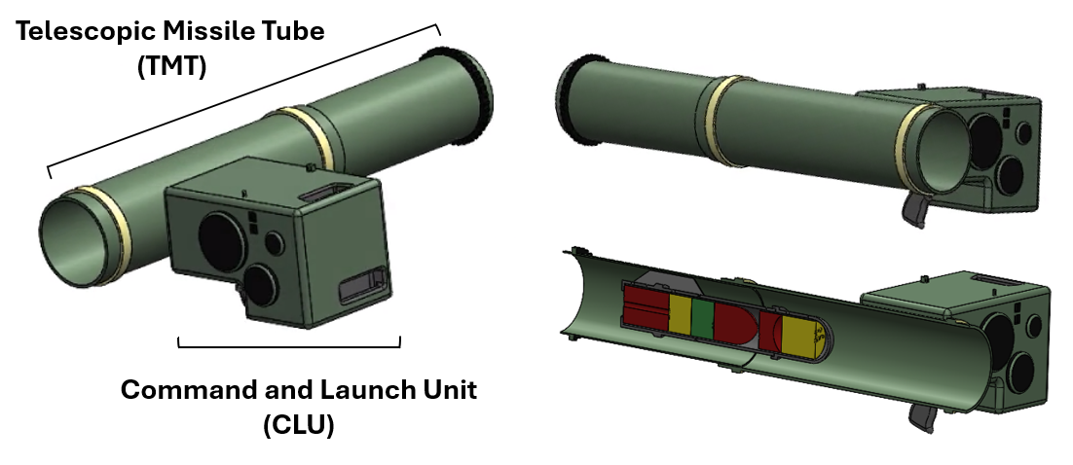
Figure 5 - Shoulder Launched Missile System Design
The R&D team was responsible for designing the projectile, as this was directly linked to the Critical System Function by delivering the required effect. Without the higher system, the projectile would not be able to neutralise the target and fail in meeting the requirements of the customer. An overview of the projectile can be found in Figure 6.
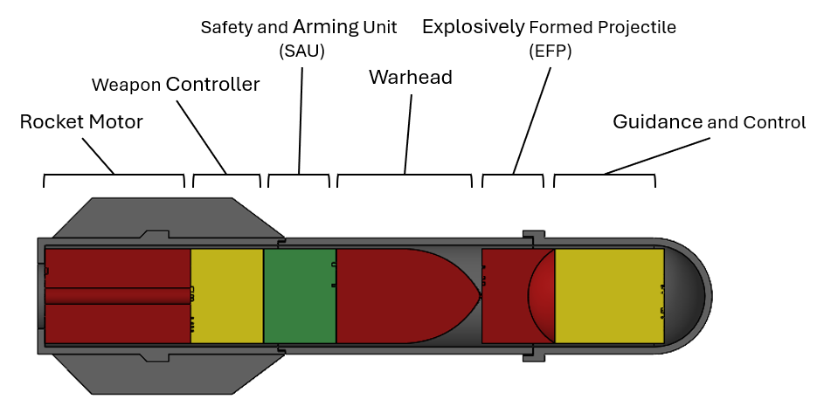
Figure 6 – Projectile Mk3

The development of the projectile was the result of collaboration with the stakeholders involved in the Disposal, Manufacture, SDT and Testing teams. The R&D team considered the requirements of the stakeholders, before arriving at this design. This was done to ensure a suitable solution was identified which would provide a robust solution.
After the initial design proposal was presented to the team, time was allocated to analyse the design from the various stakeholder perspectives. The Disposal team identified that the final design would require the projectile be a modular system. The influence of user requirements and environmental factors (relating to operational conditions) resulted in a sealed TMT. This seal could be removed and the munition extracted, so that Disposal teams would be able to access the energetic materials (EM) inside the system. As the system was yet to go into production, this would include collaborative working with the manufacture teams for both EM and (potentially) specialist tooling that would be required to remove/extract the relevant elements. By adopting a modular design (with regards to the System, TMT and Projectile) the disposal needs could be met sufficiently, delivering a system that met the needs of the end-user, whilst being compact and low maintenance in an operational environment.
Where disposal is closely regulated by the Environmental Protection Act 1990, Health and Safety Executive, and Care of Substances Hazardous to Health (COSHH), and Explosive Regulations 2014, a disposal plan would need to be developed that meets these requirements. From discussions and meetings with the Disposal team it was determined that a modular system would be the most environmentally friendly approach, as each element from the final design could be recycled or disposed of through the most effective means.
This also had an influence on the explosives that were to be used, with an additional effect on the manufacture process. Where considerations were given to one area, the needs of another had to be balanced to meet the requirements of another.

Communication and Information Management
Due to the volume of information generated by each of the teams involved, information management was essential, so that information could be accessed by each of the teams in relation to the project. By using an online or live document, all teams could work simultaneously on various elements of the project. This also enabled accessibility and transparency of the information.
Where SE is a collaborative process, each team needs to understand their interactions within any project. Centralising and recording the requirements in a Requirements Traceability Matrix (RTM) ensured that these remained accessible and easy to access when developing the design. The R&D team relied on the requirements from the various teams to identify suitable solutions.
Working in a virtual environment was also involved in the project. Virtual tools and remote working can increase productivity and enable information to be shared without the need for face-to-face interactions [12]. Where the various teams were not physically present between 24/02/2025 and 24/03/2025, the various teams were able to conduct their own work and attend virtual meetings during this period. A meeting schedule can be seen in Figure 7. This enabled the teams to share their own progress and provide support peer-to-peer support where needed, providing both guidance and feedback on work undertaken between meetings [13]. This collaborative approach enhanced understanding of the relevance of each role within the project, as well as developed knowledge of how requirements influenced the various teams within the project. Where no minutes were taken during these meetings, this could have provided valuable information and updates for the parties who were unable to attend.
As the project design progressed, further requirements emerged that related to the higher system which had to be accounted for as changes were made. Some discussions took place outside of project level meetings, where information and design considerations were developed/refined as a result, any changes and updates were presented to the project team accordingly.
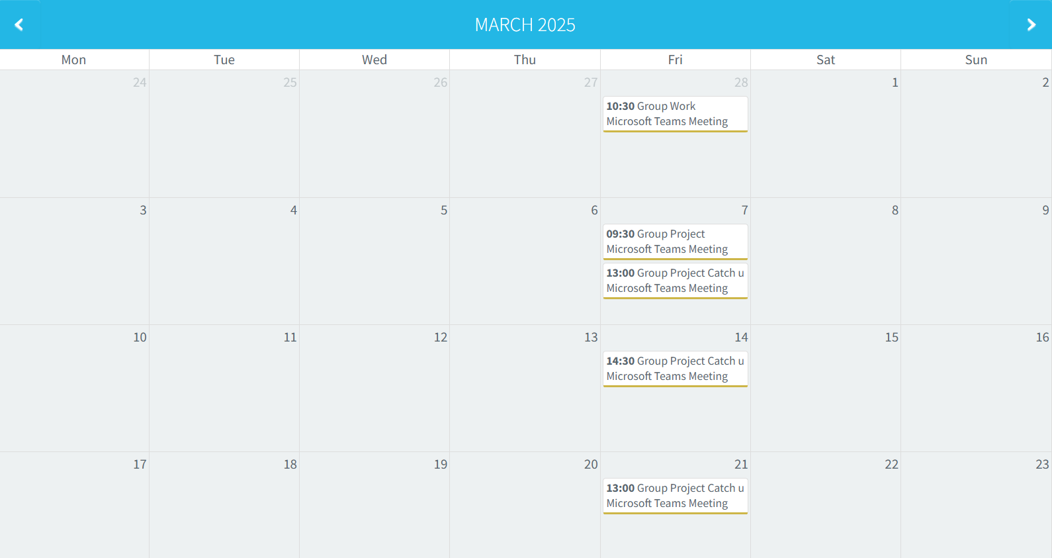
Figure 7 - Meeting Schedule 24/02-23/03/2025

Reflection and Conclusions:
Using the SE approach in a group project environment had clear advantages. It provided a structured approach to the design process and holistic overview of the system.
The Systems Engineering and collaborative approach was effective in reaching a design solution in a condensed timeframe. Where time (and SE experience) was limited, the process and knowledge of the tool set were employed with reasonable success.
The use of round table meetings supported design development, as the teams were able to provide information that shaped the design choices. Collaborative working between SDT, Disposal, Manufacture, Testing and R&D teams was supportive in achieving robust Key Design features, Critical Systems and Critical Components. Individual meetings also assisted in refining/redesigning elements of the design itself. Developing a knowledge management system could support future projects in aligning understanding between the teams involved [14].
Difficulties were encountered whilst editing live documents in meetings. Where multiple individuals were working on some documents, changes made by a second person resulted in changes to formatting, which took time to amend and correct. This could be avoided by individuals working on the document “offline” and uploading work later.

Where the Group Project was saved as a workbook on Microsoft Teams, it remained a live document. Where there are clear benefits to this being saved as changes are made, there could be potential issues in a real-world scenario. The introduction of version management/version control (VM/VC) could be beneficial if introduced. VM can be used to track changes made a version of a document [15]. Having a standard method of organizing, labelling and preserving draft documents could reduce potential loss of data.

Where most of the SE work was conducted on MS Excel, an alternative could be to use MS OneNote. The use of a single place for keeping all project information, including research, information, meeting minutes, and updates could be beneficial [16]. This may aid with organisation and provide a single point of contact for those involved in the project, as meeting minutes could be uploaded and accessed easily.

Overall, the SE approach provided structure to the project, with the individual teams being able to focus on their role resulting in a collaborative approach across the disciplines within the project. As with any project, organisation, knowledge of how to use the appropriate tools, and experience are also valuable in developing new strategies that can be applied next time.

References

[1] | T. M. Shortell, G. J. Roedler, B. A. Delicado, O. Mornas, Y. Yew-Seng and D. Endler, Systems Engineering Handbook: 5th Edition, Hoboken, New Jersey: Wiley, 2023.
[2] | Burge Hughes Walsh Limited, “Systems Engineering,” Burge Hughes Walsh Ltd., 2025. [Online]. Available: https://www.burgehugheswalsh.co.uk/systems-engineering/default.aspx. [Accessed 11 05 2025].
[3] | Burge Hughes Walsh Limited., “Systems Engineering People,” Burge Hughes Walsh Ltd., 2025. [Online]. Available: https://www.burgehugheswalsh.co.uk/systems-engineering/people.aspx. [Accessed 11 05 2025].
[4] | Gateley Capitus, “What is R&D in the engineering industry?,” Gateley Capitus, 13 02 2023. [Online]. Available: https://gateleyplc.com/insight/article/what-is-r-d-in-the-engineering-industry/#:~:text=Engineering%20focuses%20on%20solving%20technical,existing%20assets%20and%20systems%20working.. [Accessed 13 05 2025].
[5] | GeeksForGeeks, “Requirements Gathering - Introduction, Processes, Benefits and Tools,” GeeksForGeeks, 29 12 2023. [Online]. Available: https://www.geeksforgeeks.org/requirements-gathering-introduction-processes-benefits-and-tools/. [Accessed 11 05 2025].
[6] | U. Hamid, M. K. Raza and R. F. Naqvi, “Impact of System Engineering Practices on the Performance of R&D Projects – Initial Results,” International Journal of Computer Theory and Engineering, vol. 5, no. 1, pp. 158-161, 2013.
[7] | Participedia, L. J. Parry, J. Gakhal, S. F. Bowlsby and B. Stelzle, “Round Table,” Participedia, 13 10 2021. [Online]. Available: https://participedia.net/method/roundtable-discussion. [Accessed 12 05 2025].
[8] | O. Renn, “Stakeholder and Public Involvement in Risk Governance,” International Journal of Disaster Risk Science, vol. 6, pp. 8-20, 2015.
[9] | B. Lewis, “Raytheon EMP Missile Tested by Boeing, USAF Research Lab,” Military Embedded Systems, 02 11 2012. [Online]. Available: https://militaryembedded.com/radar-ew/sensors/raytheon-emp-missile-tested-by-boeing-usaf-research-lab. [Accessed 28 03 2025].
[10] | Airforce-technology.com, “Raytheon to continue work on EW payload for USAF’s cruise missiles,” Airforce Technology, 28 03 2016. [Online]. Available: https://www.airforce-technology.com/news/newsraytheon-to-continue-work-on-ew-payload-for-usafs-cruise-missiles-4848693/?cf-view. [Accessed 28 03 2025].
[11] | Pacific Science Energetic Materials Company, “Electronic Safe and Arm Device,” Pacific Science Energetic Materials Company, 2025. [Online]. Available: https://psemc.com/products/electronic-safe-and-arm/. [Accessed 11 05 2025].
[12] | M. S. Bissaliyev, “The Effectiveness of Collaboration Tools on Virtual Project Management,” International Journal of Applied Engineering Research, vol. 12, no. 21, pp. 10747-10755, 2017.
[13] | F. N. b. M. Shah, Z. b. Abdullah, A. b. Dahlan and N. b. M. Dahlan , “Web-Based Task Management System for Improving Group Work Collaboration,” International Journal of Academic Research in Progressive Education and Development, vol. 11, no. 3, p. 1669–1680, 2022.
[14] | B. H. Reich, A. Gemino and C. Sauer, “How knowledge management impacts performance in projects: An empirical study,” International Journal of Project Management, vol. 32, no. 4, pp. 590-602, 2014.
[15] | J. Honig, “What is Version Control & Why Is It Important?,” DocuWare, 16 02 2024. [Online]. Available: https://start.docuware.com/blog/document-management/what-is-version-control-why-is-it-important. [Accessed 13 05 2025].
[16] | Microsoft, “Introducing OneNote,” Microsoft, 2025. [Online]. Available: https://support.microsoft.com/en-us/office/introducing-onenote-38be036d-5b5a-49ad-83be-292fe53ad7b3. [Accessed 14 05 2025].

Please see the Systems Engineering report associated with this module for additional information.
It should be noted that the Gemba Visit was simulated, however based on direct experience, consisted of exercise and operational experience, combined with and conversations had between the author and serving soldiers.
Research into the functions of the CLU required more input from other systems specialists and falls outside of the remit of this report. However, has potential to be an achievable system.

