CERTIFICATE OF HIGHER EDUCATION IN SKILLS FOR THE WORKPLACE

MODULE CODE/ COD Y MODIWL: BMSK4002

EFFECTIVE TEAM WORKING & COMMUNICATION

BY
NAME: Samuel Edayi

Tutor: John Paul Okeke

Definition
Teamwork is word that can mean different things in different workplace as all workplaces process is not the same. Ensuring a common commitment in achieving a task or a goal is quite important in a modern work place. “If people are committed to the goal, then it more probably will be attained” (Hill, 2001). It is difficult to have clear cut definition for “Teamwork” as the term could represent so many facets. (Lewis, 2017)
The Business dictionary define Team work as “A collaborative working process within a of workers to ensure that a target or goal is achieved. Teamwork is a very important often aspect of a successful business, as in most modern workplace, it is necessary for individuals to work together towards a common goal or objective in most situations. Teamwork in many cases means harness the individuals will necessarily have to work together, pulling individual skills and intellectual resources in achieving the task and provide feedback in a constructive manner, even if there is an individual or personal conflict between individuals (Businessdictionary.com, 2017).
Introduction
This is based on a work base essay on my friends experience in APCOA. The theories I have learnt and the experienced has been a valuable contributor to this essay.
Having in place an effective sound communication culture in organizations is very essential. Teams in the work place must be receptive to what colleagues try to communicate, participate with an undivided attention, must have a reasonable comprehension of task, team objectives and requirements. Not having actively listening skills is maybe the most critical of these. Listening should include note taking, making significant inquiries, when not sure of task and when necessary repeating what the other colleague says to clarify any unclear instructions.

Effective Team working and Communication

Organizations regularly request that their employee’s complete tasks that requires them to work as a team on most occasions. The advantages of working as a team outweigh the disadvantages. There are many advantages in cooperating; these advantages include the likelihood of making new personal friends, a feeling of group achievements or accomplishments and the division of labour into various segments. This also paves way for job rotation, enrichment, more skills in perfecting how a job should be done, that is expertise in a task can be achieved by repetition. However, teamwork may also create additional pressure or friction for employees, if factors that could create these pressures are not properly addressed. An organization with a good practise of Effective communication skills can significantly reduce most of the pressures and negative emotions connected with working in or as a team or group. Organizations ought to urge their employees to communicate each other more in a manner that showcases clarity any time they are working as a team. This is particularly essential for smaller organizations; whose workers frequently have to work closely with each other.
Effects of Effective Teamworking Communication
Effective verbal or oral communications is an essential contributor to the achievements or non-achievements of tasks that requires teamwork. Ineffective communication could lead to a collapse of the company. Tasks are easily achieved when members result to asking questions opposed to assumptions, foster trust in the team and create an atmosphere of cordial relationship geared towards achieving team goals or targets. Organizations should ensure that workers, working in a team are trained on the skills of how to work successfully in a team. Training could be internal or external. They could be in form of internal workshops, which could be done by buying prepared materials through different business counselling organizations that specialise in interpersonal skills or in communicating skills. There are also other ways of training that are available in form of seminars, which are conducted by local firms or consultants. Training by these specialist is more robust as they come in form of role plays and use of communications scenarios to reinforce the skills learnt during the learning process.
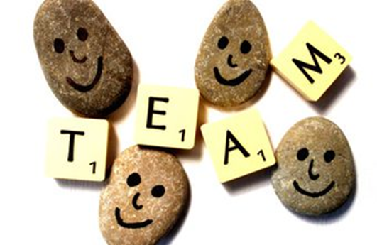
http://smallbusiness.chron.com/effective-communication-team-work-3167.html
Training in Teamwork and Communication
Organizations should ensure that workers working in a team are trained on the skills of how to work successfully in a team. Training could be formal or informal, they could also be internal or external could be inform of workshops, which could be done by buying prepared materials through different business counselling organizations that specialise in interpersonal skills or in communicating skills. There are also other ways of training that are available in form of seminars, which are conducted by local firms or consultants. Training by specialist are usually more robust as they come in form of role plays and use of communications scenarios to reinforce the skills learnt during the learning process (Lewis, 2017).
A solid group communication will often lead to a positive improvement in the professional ability of individual team members and their personal behaviour. Team members are usually easily influenced by their team leaders as they most of the time are looked on as role models. It mainly follows that a well-trained Team leader in communication and leadership skills usually model their teams in line with their personal training when there is a conflict in the team. Grensing-Pophal states that solid team communication skills serve as a tool for managing conflict resolutions within the team. "Too often, we can have a tendency to avoid conflict……By learning to respond to conflict in positive ways, both employees and companies can benefit" (Grensing-Pophal, 2009).
Types of Effective Teamworking Communication
There are always needs for workers on all levels in companies to communicate effectively with each other in different ways. The types of communications in an organization widely depends on their type of services or products. However, the basic type of communication is the traditional correspondence through writing letters, communication in person face to face, telephone conversations, electronic media like emails, circulars on notice boards and by fax. It has been noticed that with good training in various methods of effective communications skills, workers most of the time have been able to improve the way they communicate on all the platforms of communication. These improvements have greatly reduced pressure in the team and thereby an increase in team productivity and team services.
There also ways in which we communicate that essential and needs to be developed. These are basically non-verbal communication. Non-verbal communications include gestures, the volume of our voices, shouting, physically demonstration, eye contact, facial disposition etc. Training and development of non-verbal communications skills are very essential within a major work place. Non-verbal communications can be easily misunderstood as such that it is very essential that we understand effective communications. “Non-verbal communication can be a reliable guide to determine the meaning of a message. (Michael Eaves, 2015)
Warning Signs in Effective Communication

http://smallbusiness.chron.com/effective-communication-team-work-3167.html
It is essential for employers to monitor and structure out a sound communication process for the organization. Ineffective communication must be picked up by managers early to avoid poor output. Signs of poor communication can be spotted by managers through teams output. These could include missing of project deadlines, not measuring up to Key Performance Indicators and stalled progress or non-progress in the issues that requires proactive solutions. It can be deduced that Strategic meetings by teams without focus or team clear direction will not yield any positive result.
Whilst it is important for teams to hold meetings and deliberate on task delegation and sequencing, team meetings that end of in arguments or dissentions must be strictly avoided. A positive change in the workplace or environment can be achieved, by conducting training in communication skills for employees, or engaging the services of an external training consultant to conduct the appropriate training (Ananaba, 1981).
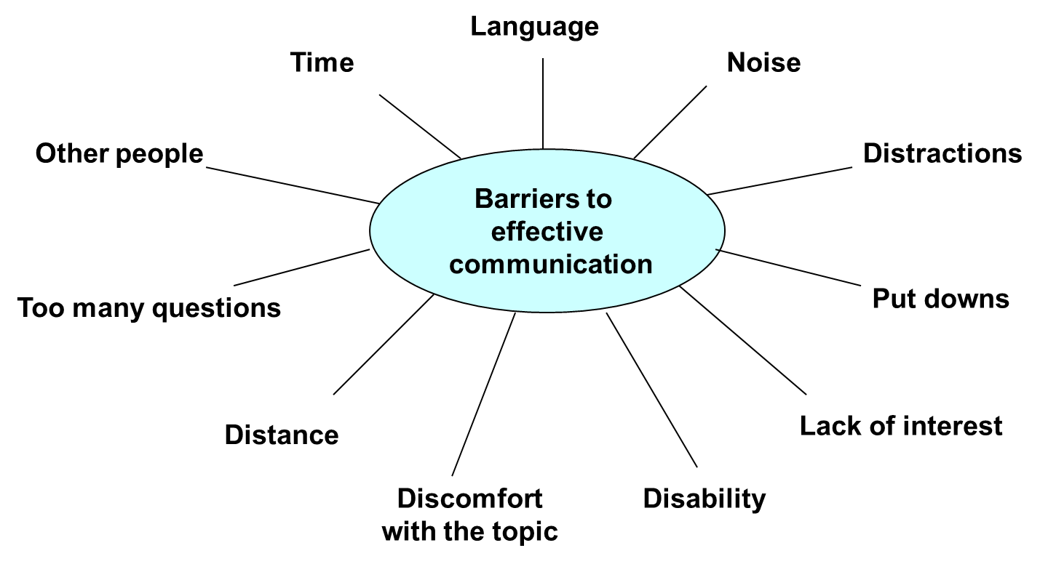
https://ofv.sa.gov.au/__data/.../powerpoint.../effective-communication-presentation
Importance of Team Communication Skills
Team Cohesion
Work groups should function admirably together, and the work group cohesiveness relies upon the building of solid relationships within the work group. Communication is basic and should be driven by the group leader who should work with the group in ensuring a set standard and procedure within the group and works process that will ensure the group is position can achieve its goals and objectives. Bruce Tuckman a business communications researcher states that all groups or teams should experience expected phases of improvement, from forming to storming, then to norming, and at the end, performing. Exploring through these stages viably will enable groups to build good relationships. The forming stage of a team, is a situation when team members are just meeting, and everyone is polite, courteous and nice to each other. This mainly because they are just getting acquainted and communicate with caution. However, it is possible for individuals to have anxiety due to meeting people for the first time may have an anxiety as everyone is a stranger to him or her. Then, when people have already settled and begin to feel more comfortable, some quarrels may arise (Ananaba, 1981).
Sharing Team
Lin Grensing-Pophal stated that at the point when team communications skills are solid, the possibility that proactive ideas, smart thoughts and best practices will be shared between team members are high. He further stated that if sharing of information is not encouraged, team individuals can feel reluctant to give contribution to the team for fear of being reprimanded or having their thoughts or contributions dismissed as irrelevant. Groups that can build up an open, positive and steady communication relationship among colleagues, are better placed to be informed of smart ideas and benefit from these ideas as the team’s best practices increase organization output. (Grensing-Pophal, 2009)
Effective communication reduces the time wasted in misrepresentations and loses incurred when the job is done in a wrong way. A message that is not properly passed across due to team conflict can result in financial loses in organizations, as wrong actions could lead to the production of poor quality goods or services. In a manufacturing organization this could lead to expensive machinery breakdown. Downtime in organizations can also be avoided by effective communication (Michael Eaves, 2015).
The Wisconsin Business Alumni states that, the world business market is currently dynamic, and it is continually changing. Therefore, it is essential to ensure that an effective team communication is prioritised, as it is a vital ingredient in enabling a team to stay aware of the advancing work environment in an organization. Its structure must always be clearly defined (Wisconsin School of Business, 2017).
A modern group team communication structure can withstand changes in the business world, for as the commercial centre gets more complex, the group can keep up on the job and ensure that essential information is shared proficiently. The information that the group needs to ensure that the end business goals and objectives is achieved is communicated to members of the group rapidly, as the team adjusts to business changes and communicate changes to each member of the group effectively.
Benefits of Effective Team Communication
The benefits of effective communication within a team has made the skill as an essential skill within a team. In general, it is common knowledge that when teams have a clear job task and are able to function effectively, organizations revenue will increase considerably as production and quality targets will be achieved.

Conclusion
All groups interpersonal skills are essential for effective communication and are foremost if organizations want to be successful. It is essential irrespective of companies to task or objectives which could be in a creation of new products or planning and execution of a service which could be a hospitality service industry. Relationship building, reactive innovations, best practises and proactive ideas to solutions in the workplace are all bi-products of a solid effective team or group communication.

REFERENCE
Ananaba, T. (1981). Management by motivation. Engineering Management International, 1(1), pp.63-71.
Businessdictionary.com, 2017. Business Dictionary. [Online]
Available at: http://www.businessdictionary.com/definition/teamwork.html
[Accessed 23 December 2017].
Grensing-Pophal, L., 2009. Employee anagement for small business. 3rd ed. Brllingham WA98225 USA: Self-Counsel Press; 3 edition (October 1, 2009).
Lewis, J., 2017. Hearst Newspapers LLC. [Online]
Available at: http://smallbusiness.chron.com/definition-teamwork-workplace-36105.htm
[Accessed 23 December 2017].
Michael Eaves, D. L., 2015. Successfull Nonverbal Communications Principles and Applications, New York: Taylor and Francis.
Wisconsin School of Business, 2017. Wisconsin School of Business. [Online]
Available at: https://wsb.wisc.edu/alumni-giving
[Accessed 26 December 2017].

