MARKETING FUNDAMENTALS(LCBB4004)
TUTOR NAME:TUSHARA BALENDRAN
STUDENT NAME:ION DULUMAN
STUDENT ID:1917721

BLOGGING TO COMMUNICATE - ASSESSMENT 1
Table of Contents
Introduction 2
Blog Post 1: Launch of new products by NEXT Plc 2
Blog Post 2: The Go-To Fashion marketplace of NEXT Plc 3
Blog Post 3: Exciting prices offered by NEXT Plc 4
Blog Post 4: Fashion promotion and branding 5
Blog Post 5: Customer decision journey 5
Blog Post 6: Future of fashion subscription model 6
Blog Post 7: Understanding the needs of workers 7
Blog Post 8: Time to rewire the fashion system 8
Blog Post 9: Try before you buy services 9
Blog Post 10: Fashion Retail and Coronavirus outbreak 9
Justification 10
Conclusion 11
Reference List 12

Introduction
Blogging is regarded as one of the easiest along with the fastest ways in order to interact with prospective customers on the web. It is further considered as a potential element of marketing fundamentals which helps in engaging high-order thinking. The purpose of this study is to communicate the marketing techniques of NEXT plc so as to create awareness for target audiences.

Blog Post 1: Launch of new products by NEXT Plc
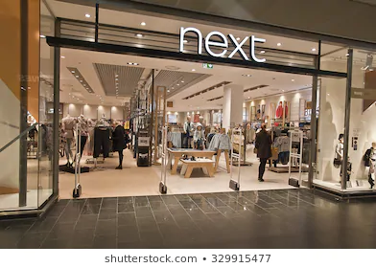
Figure 1: New products of NEXT PLC
(Source: NEXTPLC, 2020)
NEXT plc aims in offering exciting, beautifully designed and excellent quality of clothing along with homewares which aim to meet and exceed the aspiration of customers. In addition to this, the scale of business along with the store network in UK has allowed NEXT to emerge as a potential platform that sells clothing as well as homeware products in UK and Eire. Sitkin and Mangion-Thornley (2020) stated that the introduction of new products helps in the long-term success of the business organisation along with adaption of new consumer preferences and lifestyles. The NEXT products are designed by an in-house design team which offers great style along with a contemporary fashion edge.
Call for action
Click on the link:
https://www.nextplc.co.uk/corporate-responsibility/our-customers-and-products

Blog Post 2: The Go-To Fashion marketplace of NEXT Plc
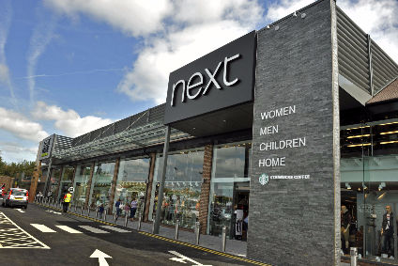
Figure 2: Fashion marketplace of NEXT PLC
(Source: NEXTPLC, 2020)
The scale of online business along with the availability of stores in UK has permitted NEXT to emerge as an aggregator of clothing, home brand and footwear. The business organisation has formulated a chain of more than 510 stores in UK and Eire. The designing and sources of the NEXT branded products that business continues to grow and develop. Additionally, it also provides customer-friendly websites which are reviewed and developed in ensuring the needs of customers. It has around 700 stores, out of which 500 are in the United Kingdom and 200 across Europe, Asia and in the Middle East.
Call for action
Visit our website: https://www.nextplc.co.uk/about-next/our-history

Blog Post 3: Exciting prices offered by NEXT Plc
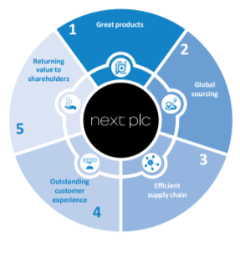
Figure 3: Price mix of NEXT PLC
(Source: NEXTPLC, 2020)
The NEXT Brand continues in the development of overseas through presence online by providing an outstanding experience to the customers. The organisation further ensures in providing seamless transactions to the customers and products are also available at a reasonable price range. According to Chernev (2018), the price mix in the fashion industries aims to provide marketing decisions and labour needed to produce the item. The pricing strategy of NEXT is to ensure a middle ground that neither makes market skimming nor penetration pricing. The organisation further aims in occupying a neutral zone and at the same time portrays the image of quality as well as design at a suitable price for the target customer.
Call for action
Visit our website: https://www.nextplc.co.uk/about-next/our-history

Blog Post 4: Fashion promotion and branding

Figure 4: Fashion promotion and branding of NEXT PLC
(Source: NEXTPLC, 2020)
Fashion enthusiasts and folks involved in the business of fashion have been literary gems that are significantly related to this magnificent industry. However, defining the target audiences have never been a tricky task for the business because of its strong marketing position. Promotion of NEXT has appeared to shift its focus online with advertising along with promotional offers which are further described in its official websites and social media platforms.
Call for action
Click on the official website for exciting offers: https://www.next.co.uk/

Blog Post 5: Customer decision journey
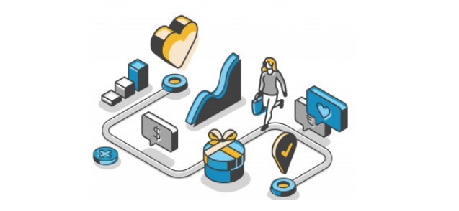
Figure 5: Customer decision journey of NEXT PLC
(Source: NEXTPLC, 2020)
NEXT Plc describes the concept of Customer Journey as the actual path that it chooses in order to encompass all interactions, touchpoints along with experiences of the brand in order to purchase the products and services. The business primarily centres on the customer experience and also embraces e-commerce brand strategies. Additionally, the organisation is aware of the various steps through which products are selected despite of the prophecies. In the year 2020, the context of customer experience has emerged as a prime precedence for the business organisation as it targets men, women and children as their potential consumers.
Call for action
Please provide your valuable feedback and review the products.

Blog Post 6: Future of fashion subscription model
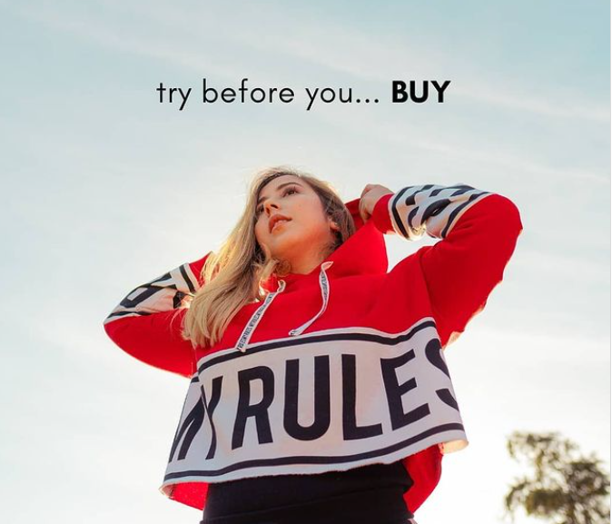
Figure 6: Future of fashion subscription model
(Source: NEXTPLC, 2020)
The primary and predominant objectives of NEXT Plc is to ensure delivery of the long term returns through a combination of customer satisfaction as well as processes involved in reinvention along with experimentation. Lancaster and Massingham (2017) stated that the process mix within the marketing essentials sheds light on the course of action involved in delivering products to the respective customers. In the case of NEXT Plc, the products are always available at the retail stores and have systems that notify when the inventory levels are low.
Call for action
Please visit the nearest stores or click on the official website for exciting offers: https://www.next.co.uk/

Blog Post 7: Understanding the needs of workers
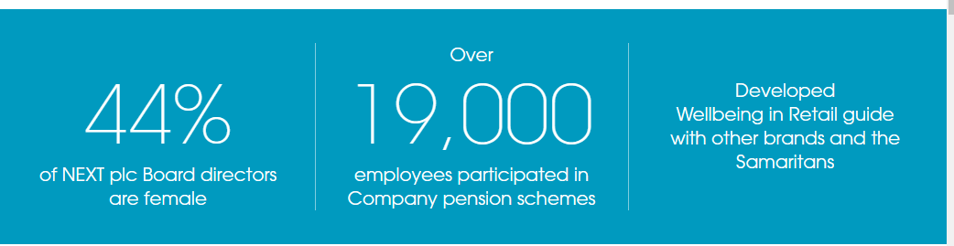
Figure 7: Understanding the needs of workers
(Source: NEXTPLC, 2020)
NEXT Plc is recognised to be committed towards achievement of excellence in the area of health and safety along with welfare and protection of employees. The workers are recognised as an integral part in order to achieve business goals and objectives. The organisation also believes to engage workers that are vital in the achievement of aims. NEXT aims to create a workplace that treats every employee with proper dignity and respect.
Call for action
https://www.nextplc.co.uk/corporate-responsibility/our-people

Blog Post 8: Time to rewire the fashion system
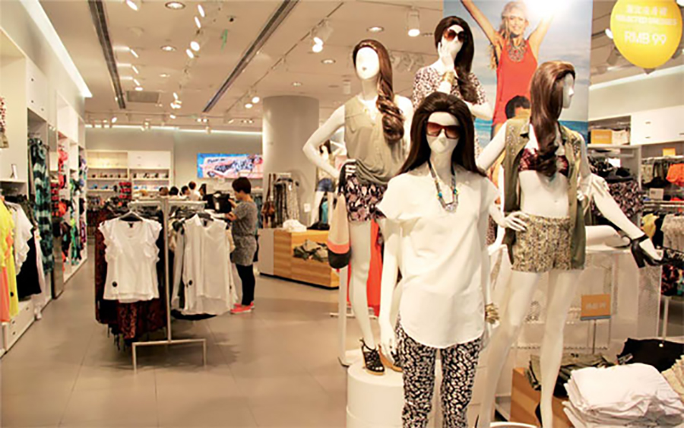
Figure 8: Time to rewire the fashion system
(Source: NEXTPLC, 2020)
Fashion executives and business leaders are focusing on the context of crisis management and contingency planning. According to Hollensen (2016), eventually, marketing professionals are required to shift towards re-imagining the industries on an altogether basis. The dramatic shifts in the global economy and consumer behaviour aftermath of Covid-19 have also adversely impacted the fashion industry in a significant manner.
Call for action
Share your comments on Twitter, Instagram or Facebook of NEXT Plc.

Blog Post 9: Try before you buy services
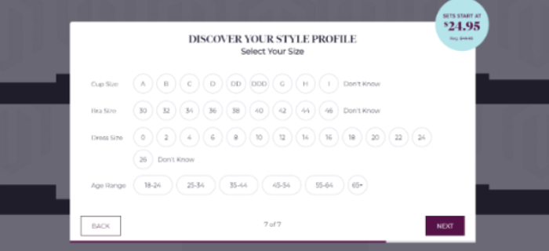
Figure 9: Try before you buy services
(Source: NEXTPLC, 2020)
NEXT Plc now provides the customers in personalising their products and services after several months of beta testing. Rathnayaka (2018) contradicted that beta testing is regarded as the type of user acceptance testing where the product team offers finished products to the target user groups in evaluating product performance. In these customers are offered with the leverage of ordering styles at a time and get discounts in their first order.
Call for action
Click on Try-it-on programs.

Blog Post 10: Fashion Retail and Coronavirus outbreak


Figure 10: Fashion Retail and Coronavirus outbreak
(Source: NEXTPLC, 2020)
NEXT Plc is arguably an important retailer of clothing as well as homeware products in UK. The outbreak of the Covid-19 pandemic has coincided with the “fashion month” which in turn resulted in the cancellation of fashion shows. However, the organisation has made sure of taking necessary actions to deal with the crisis. Consequently, it has also ensured potential live streaming in order to boost the sales of products in the online e-commerce websites.
Call for action
Click on the link:
https://www.nextplc.co.uk/corporate-responsibility/our-customers-and-products

Justification
Since its launch, NEXT PLC has positioned itself as one of the top UK clothing markets and surpassed its main competitors. Blythe and Martin (2019) stated that a marketing mix is a tool which can be used in the assessment of marketing strategies. Other than this, marketing strategies and marketing mix have been incorporated in order to personalise content along with the establishment as a brand and graining grounds on the competitors (Kotler and Armstrong, 2016). In addition to this, through marketing fundamentals such as blogging NEXT has now established a strong customer base which in turn highlights its marketing strategies. NEXT Plc now provides the customers in personalising their products and services after several months of beta testing to provide personalised services. Hendrayati and Gaffar (2016) stated that products and prices are related to the products and services itself and at the same time place and promotions are primarily related to the offerings of the business that is delivered or made available to the consumers. It can be also observed that the organisation ensures flexibility in pricing for the purpose of promotional affairs along with this allows the retailer to remain competitive across all the channels of sales (Jokinen, 2016). It has been also recognised that having several stores also increased the convenience of customers and enabled the most important part of cloth shopping.

Conclusion
In order to conclude this study, it can be recognised that NEXT holds a strong position in the marketplace which shows their growth and development. There has been always room for dealing with crises and changes in a significant manner. Other than this, the organisation has always been ready to embrace positive changes on the aspect of new sales channels and incorporation of technologies. Henceforth, it can be concluded that through marketing fundamentals such as blogging NEXT has now established a strong customer base which in turn highlights its marketing strategies.

Reference List
Blythe, J. and Martin, J., (2019). Essentials of marketing, Eds 7, London: Pearson UK.
Chernev, A., (2018). Strategic marketing management. Journals of Marketing, 89(8), pp. 123-190.
Hendrayati, H. and Gaffar, V., (2016). Innovation and marketing performance of womenpreneur in fashion industry in UK. Procedia-Marketing Fundamentals, 219, pp.299-306.
Hollensen, S., (2016). Global Marketing, Eds 5, London: Pearson
Jokinen, T., (2016). Branding in social media and the impact of social media on brand image. Kotler & Armstrong 15th/16th edition, 56(9), pp. 123-178
Kotler, P. and Armstrong, G., (2016). Principle of Marketing. 15𝑡ℎ edition. New Jersay.
Lancaster, G. and Massingham, L., (2017). Markets and customers: consumer and organizational buyer behaviour and marketing strategy. In Essentials of Marketing Management, Eds 8, Abingdon: Routledge.
Mitterfellner, O., (2019). Fashion Marketing and Communication: Theory and Practice Across the Fashion Industry, Eds 8, Abingdon: Routledge.
Next.co.uk (2020). About Us. Available at: https://www.next.co.uk/ [Accessed on: 23rd November, 2020]
Nextplc.co.uk (2020). Our products and Customers. Available at: https://www.nextplc.co.uk/corporate-responsibility/our-customers-and-products [Accessed on: 29 November, 2020]
Rathnayaka, U., (2018). Role of Digital Marketing in Retail Fashion Industry: A Synthesis of the Theory and the Practice. Journal of Accounting & Marketing, 7(20).
Sitkin, A. and Mangion-Thornley, K., (2020). Absolute Essentials of International Business, Eds 8, Abingdon: Routledge.

