

To place an order please call us on: 01701234500
Collection address: Larbert Avenue, FA53 7AB, Farchen, Muris
Payment will be taken over the phone by card only

Hotel Trinity

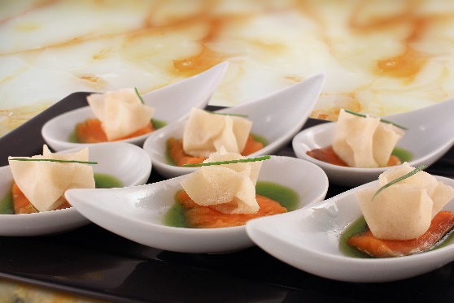
Starters
Chilli Beef Nachos/4
Crispy Duck Salad/5
Cajun Chicken Caesar Salad/4
Deep Fried Breaded Brie/5
Desserts
Chocolate cake volcano/7
Banana Split/8
Chocolate, melon & Blueberry Ice-cream/7
Vanilla sensation/7

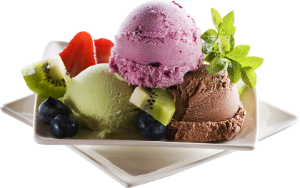

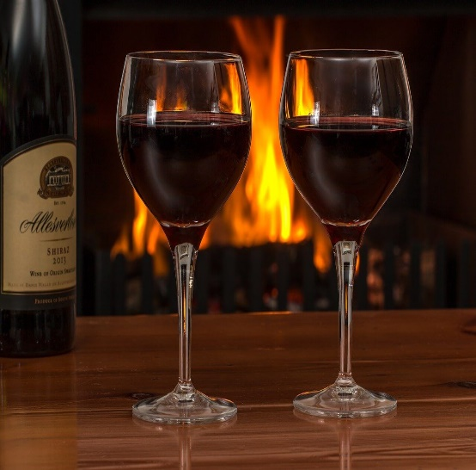
Main Courses
Chicken Penne Carbonara/8
Steak & Wild Mushrooms/12
Polo Asparagi/12
(Grilled Chicken in a creamy asparagus sauce)

Pork & Grilled mixed Vegetables/10
Wild Salmon in Creamy Sauce with Mediterranean salad/15
Beef with Pineapple Salad/12
Drinks
Coffee/5
Still/sparkling water/5

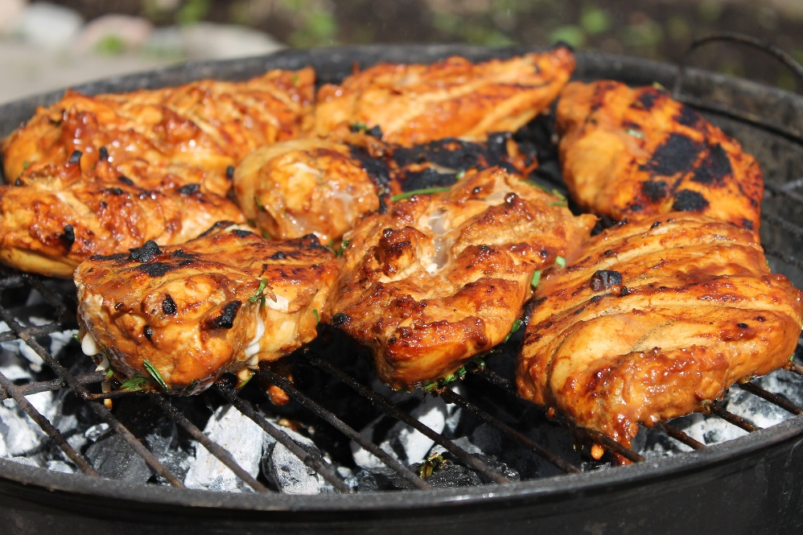
Wines
Millet Roger France White/ 30
(Amazingly with Pork & Grilled Vegetables)
La Jaglerie Rose d’Anjou/25
(It perfectly matches the flavours from the Beef & Pineapple Salad)

If you suffer from any allergic reactions or intolerances, please contact our staff before placing an order
To place an order or to speak to our staff please call : 01701234500



Hotel Trinity

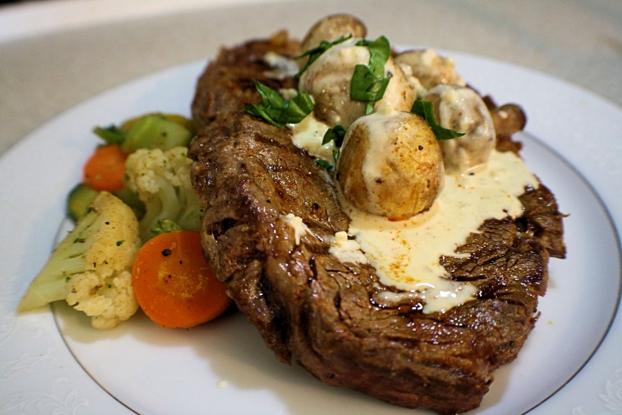
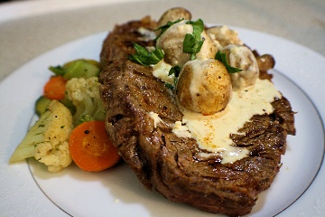
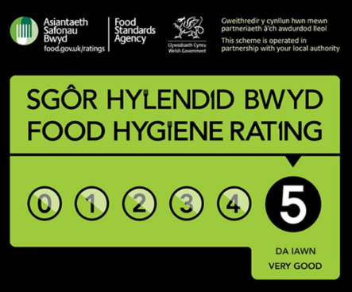

Opening Times:
Monday – 11:00 to 21:00
Tuesday– 11:00 to 21:00
Wednesday– 11:00 to 21:00
Thursday– 11:00 to 21:00
Friday– 11:00 to 21:00
Saturday - Closed
Sunday- Closed

Ewch i food.gov.uk/ratings i ganfod sgôr hylendid bwyd ein busnes neu gofynnwch inni beth yw ein sgôr hylendid bwyd wrth archebu /
Go to food.gov.uk/ratings to find out the food hygiene rating of our business or ask us for our food hygiene rating when you order.

Reference List:
Allergies and intolerances available at https://www.knowsleynews.co.uk/allergies-and-intolerances-information-for-businesses/ , Accessed on 18/02/2022
How to Design a Perfect Menu (And Design Tips!) (webstaurantstore.com) accessed on 17/02/2022
Menu Writing Explained - Robert Ancill Restaurant Consultant (globalrestaurantconsultant.com) accessed on 17/02/2022
Menu Engineering Course: Make the Most of Your Menu - Welcome to the Course | Rise 360 (articulate.com) accessed on 21/02/2022
Prepare to reopen: how to develop a restaurant menu (typsy.com)accessed on 19/02/2022
Swirl Ornaments available at https://www.freepik.com/free-vector/calligraphic-swirls-ornaments-decorations accessed on 20/02/2022
Wine pairing available at https://www.vivino.com/GB/en/ accessed on 21/02/2022

