Maria Nita id: 2128458

Developing Research Proposal
A Critical Evaluation of How Managers Motivate the employees to Increase Productivity in Organisations

Table of Contents
Task 1 4
1.0. Introduction 4
1.1. Background 4
1.2. Rationale 4
1.3. Aim and objectives 5
1.4. Research Questions 5
2.0. Literature Review 5
2.1. The role of motivation in increasing productivity of the employees working in soft drink manufacturing company in the UK 5
2.2. The ways based on which the managers of soft drink manufacturing companies motivate the employees 6
2.3. Challenges faced by the managers to provide motivation to the employees in soft drink companies 7
2.3. Theories and models to designate productivity improvements by motivation, organisational behaviour, and human relationship 8
2.4. Conceptual framework 9
2.5. Literature Gap 9
3. Methodology 9
3.1. Research Philosophy 9
3.2. Research Approach 10
3.3. Research Strategy 10
3.4. Research Design 10
3.5. Data Collection Method 10
3.6. Data Sampling Method 11
3.7. Data Analysis 11
3.8. Validity and Reliability 11
3.9. Ethics 11
3.10. Timeline 11
References 13
Appendix 17

Task one

Introduction
Employee motivation is crucial for improving organizational performance as motivated employees produce high-quality work. Numerous studies and reports focus on employee motivation, motivational factors, different methods of motivation, and their importance in enhancing overall organizational performance (Andreas et al., 2021). These studies are not industry-specific, such as beverage or soft drink companies in the UK. The study will evaluate how managers at Britvic motivate employees to improve productivity.

Background
Effective employee motivation is essential for improving their deliverables. Several ways to motivate employees include monetary compensation, health insurance, leave benefits, flexible working hours, a diverse work environment, and respectful behaviour. Not all ways are suitable for all sectors. Managers need to consider a specific sector when improvising motivational strategies. The literature studies focus on popular sectors like food retail, electronics, and automobiles, but often neglect the soft drink manufacturing or beverage sector (Basal Amah et al., 2022). The beverage industry, with annual revenues of 105 billion pounds, requires a focus on employee motivation to ensure high-quality work.

1.2. Rationale
The present study will focus on discussing various motivational perspectives targeted for improving the productivity of the employees working in the beverage sector, especially in the renowned organisation Britvic, to illuminate the helpful motivational strategies in this context. The rationale of the study lies in the fact that the findings of this research will provide valuable insights for the management team of Britvic on how organisational behaviour should be controlled to motivate the workers so that they can be retained in the organisation for a long time. This behavioural perspective is directly proportional to employee loyalty as well as employee motivation (Farahi et al., 2022).

1.3. Aim and objectives.
Aim- The aim of the study is to explain how managers can motivate the employees to increase productivity at Britvic, which is one of the most renowned soft drink companies in the UK. Objectives-
- To identify the role of motivational strategies used by the managers at Britvic.
- To evaluate the effectiveness of these strategies in employee motivation
- To explore different strategies used by the managers of Britvic to motivate the employees.
- To recommend the managers for optimising motivational practices to further enhance productivity at Britvic.

1.4. Research Questions
- What motivational strategies are currently in use by the managers at Britvic?
- How are these strategies related to improving the productivity of the employees?
- What is the relationship between human relations, organisational behaviour, and motivation?
- What challenges do managers face to provide motivation to the employees at Britvic?

2.0. Literature Review

2.1. The role of motivation in increasing productivity of the employees working in soft drink manufacturing company in the UK
According to Setiadi et al. n in 2023, motivation is crucial for enhancing innovation, performance, and operational efficiency in the UK beverage sector. The authors found that the industry is highly competitive, with an increasing number of brands offering natural health drinks to attract consumers. This reflects the competitive nature of the soft drink industry. Motivation is vital for improving companies' innovation, performance, and operational efficiency. Sugianti (2022) strongly supports the idea that motivation can engage employees in the workplace environment. The authors believed that employee engagement is the result of employee motivation, which is vital for the organization's success. The authors believe managers should motivate employees to stay engaged at work. "Engagement is essential for completing tasks on time."
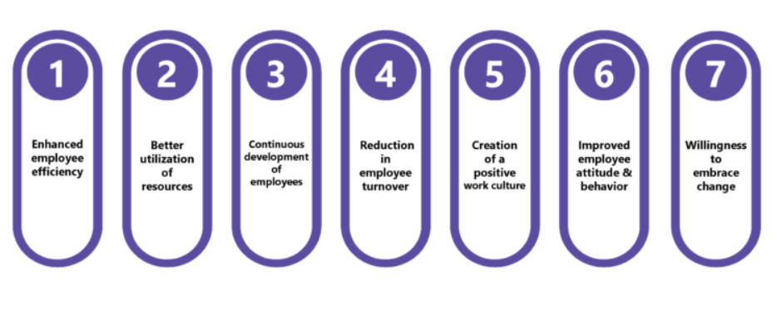
Figure: Role of motivation in increasing productivity of the employees
(Source: Sugianti, 2022)

2.2. The ways based on which the managers of soft drink manufacturing companies motivate the employees.
Managers in the UK beverage sector use various methods to motivate employees, as studies have shown. In the UK, 27% of workers are in the beverage sector (UK Govt., 2024). This affects motivation in the workplace. Soft drink companies use recognition, rewards, career programs, and positive workplaces to motivate employees. Managers play a crucial role in this context. Managers have the duty to decide how to motivate employees, as stated by Basal amah (2021). The authors emphasize the use of recognition and rewards to acknowledge employee challenging work, as well as career development programs tailored for older and new employees. Based on these principles, Kamarudin et al. Managers should determine how to motivate in different contexts (2023). Managers in the beverage sector rely on time and place to create effective motivational strategies for their employees.
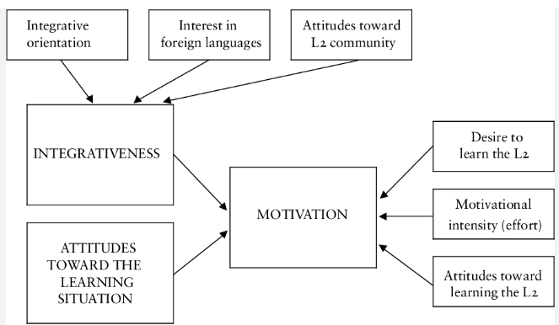
Figure: Motivational strategies to increase the productivity of the employees
(Source: Kamarudin et al., 2023)

2.3. Challenges faced by the managers to provide motivation to the employees in soft drink companies.
As noted by Abbas et al. In 2022, managers face barriers to improving employee motivation strategies. High turnover, monotonous work, communication barriers, economic constraints, and work-life imbalance are common in the beverage sector. The authors found that employees in the beverage sector often suffer from monotonous work. They kept making the same soft drinks for years. This makes the workers feel monotonous. The authors correctly note that monotonous work can lead to high turnover rates as employees seek to switch jobs. High turnover is related to high work pressure on remaining employees. This may create an imbalance in employees' work-life, leading to demotivation. Managers are dealing with economic barriers to hiring more workers to reduce workload pressure on current employees (Radwanska and Lopaka, 2020). Managers encounter communication barriers with employees due to hierarchy. Managers kept intertwined in devising motivational strategies for employees due to these barriers.
.

2.3. Theories and models to designate productivity improvements by motivation, organisational behaviour, and human relationship.
Vroom's expectancy theory states that employee motivation depends on their expectations, and leaders should try to understand these expectations. A strong manager-employee relationship can help managers understand employee expectations and plan motivational strategies. According to Edgar Schein's theory, organizational culture impacts employee morale and productivity. A positive organizational culture promotes good behaviour and increases employee motivation. Based on these theories, organizational behaviour and human relationships directly impact employee morale and motivation to deliver high-quality work (Kala and Nishida, 2022). It is linked to a healthy relationship between managers and employees.
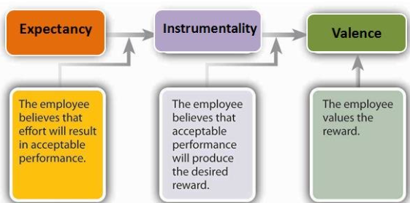
Figure: Vroom’s expectancy theory
(Source: Kala and Nishida, 2022)

2.4. Conceptual framework

Managerial Strategies
Employee Motivation
Diversified Workplace Environment
Human Relationship
Team Dynamics
Clear and transparent communication between managers and employees
The role of Management in enhancing employee productivity

2.5. Literature Gap
Although there is plenty of information on motivational roles and strategies utilised by managers to motivate employees; still, there is a gap in information on how the two components of motivation, i.e., human relationship and team dynamics, can influence to devise the correct motivational strategies for the employees in the beverage sector. Thus, a prominent lag of information is present in terms of the interrelationship between team cohesion and managerial styles to develop motivational strategies.

3. Methodology

3.1. Research Philosophy
The present study will follow a positivist philosophy because it will be dependent on collecting real-time truthful data directly from the sources. There will be no interpretation of data as the study will solely depend on the opinions of the participants (Mukherjee, 2019). Thus, the positivism philosophy will be the most suitable for the study.

3.2. Research Approach
The study will not use a mixed or abductive approach, and not an inductive approach. The study will use a deductive approach to test hypotheses and facts to create model or theory forms. It will also explain theories and models to interpret them as hypotheses (Pandey and Pandey, 2021). The study will explore various perspectives on employee motivation. The deductive approach will be suitable for the study.

3.3. Research Strategy
The study will use quantitative research to gather data from primary sources. Primary quantitative data strongly reflects the background scenario of a topic of discussion (Mukherjee, 2019). The study aims to uncover the true motivational perspectives of employees in the UK beverage sector created by their managers using primary objective data.

3.4. Research Design
The study will use an explanatory research design to explain the commentaries of the primary sources or the participants. This design is the most suitable one for primary quantitative research, as the study needs to explain the comments or opinions of the participants to answer the research questions (Nayak and Singh, 2021).

3.5. Data Collection Method
The study will gather primary data through participant questionnaires. The survey will have ten close-ended questions with four to five options each. Thirty beverage industry employees will be surveyed for the study. They will be contacted through social media platforms to select the first responders for the study. The survey questionnaire will be distributed via email and respondents will have 24 hours to fill out the Google form. Participants can select one option from four or five choices, and the Google Form will then generate visually appealing graphs for easy data interpretation (Eisen and Kuss, 2019).

3.6. Data Sampling Method
A simple random data sampling method will be followed to randomly select the participants from the social media platforms. The inclusion criteria will be the employees with a minimum of five years of experience in the beverage industry. Employees with less than five years of experience will be excluded from the study.

3.7. Data Analysis
After collecting primary quantitative data, we will analyse it descriptively using statistical measures. The mean values will be used to detect the response tendencies for each question. Based on these tendencies, various themes will be formed for thematic analysis. The participants' well-aligned opinions will shape the themes for thematic analysis (Mishra and Alok, 2022).

3.8. Validity and Reliability
A primary quantitative method of survey is known to provide valid and genuine results to the study. As the information is directly obtained from the participants it reflects the reliability of the study (Dubey and Kothari, 2022).

3.9. Ethics
The study will obtain consent from the participants prior to the initiation of the survey. The participants will have every authority to reject participation at any point in time. The confidentiality of their information will be protected by Data Protection Law 2018 (UK Govt., 2018).

3.10. Timeline
Activities | Week one | Week two | Week three | Week four | Week five
Collecting primary data
Analysis of data
Discussion of findings
Providing recommendation
Submission of the research paper
Table: Timeline
(Source: Created by learner)

Conclusion
In summary, this inquire about proposition looks for to handle the basic issue of worker inspiration and how it influences efficiency at Britvic Renowned Soft Drink Company. This ponder points to supply imperative commitments to the field of organizational conduct and administration by carefully analysing the strategies utilized by directors to rouse and propel their representatives.
A careful examination of the accessible investigate clearly appears that the motivation of workers incorporates a critical effect on expanding efficiency, work fulfilment, and by and large organizational victory. The comes about of this consider have the potential to not as it were affect Britvic emphatically, but moreover offer important experiences and commonsense suggestions for other organizations encountering comparable changes. To conclude, this investigate proposition lays the establishment for a careful examination of worker inspiration elements at Britvic Renowned Soft Drink Company. With the utilize of a basic point of view and a solid research approach, this consider looks for to uncover critical discoveries that can guide key decision-making and advance a culture of inspiration and efficiency within the organization.

References
Farahi, B., Blenkinsopp, J., de Arrogate, J.C.F. and Karim, M.S., 2022. Work disengagement: A review of the literature. Human Resource Management Review, 32(2), p.100822.
Ali, B.J. and Anwar, G., 2021. An empirical study of employees' motivation and its influence on job satisfaction. Ali, BJ, & Anwar, G. (2021). An Empirical Study of Employees' Motivation and its Influence on Job Satisfaction. International Journal of Engineering, Business and Management, 5(2), pp.21-30.
Andreas, D., 2022. Employee performance: The effect of motivation and job satisfaction. PRODUKTIF: Journal Keewatin dan Organizes, 1(1), pp.28-35.
Basal amah, S.A., 2021. The role of work motivation and work environment in improving job satisfaction. Golden Ratio of Human Resource Management, 1(2), pp.94-103.
Basal amah, S.A., 2021. The role of work motivation and work environment in improving job satisfaction. Golden Ratio of Human Resource Management, 1(2), pp.94-103.
Cash, P., Hicks, B., Culley, S. and Adlam, T., 2015. A foundational observation method for studying design situations. Journal of Engineering Design, 26(7-9), pp.187-219.
Jawadi, S., Shrestha, S. and Giri, R.A., 2021. Mixed-methods research: A discussion on its types, challenges, and criticisms. Journal of Practical Studies in Education, 2(2), pp.25-36.
Dubey, U.K.B. and Kothari, D.P., 2022. Research methodology: Techniques and trends. CRC Press.
Eisen, M. and Kuss, A., 2019. Research methodology in marketing (pp. 83-106). Cham, Switzerland: Springer International Publishing.
Ena goes Academy (2021). Research Ethics & Misconduct: What Researchers Need to Know. [online] Ena goes Academy. Available at: https://www.enago.com/academy/principles-of-ethical-research/. (Accessed On: 19 June 2024)
Gelato, T.F., Bacha, Y.D., Assefa, N., Mutuma, A., Roba, A.A., Ayele, Y. and Tsige, F., 2018. Acceptability of donor breast milk banking, its use for feeding infants, and associated factors among mothers in eastern Ethiopia. International breastfeeding journal, 13, pp.1-10.
Gul, Y.E., 2023. A theoretical perspective on survey method from quantitative research methods. Universe: психология и образование, (4 (106)), pp.64-68.
Gunn, J.M., Palmer, V.J., Dowrick, C.F., Herrman, H.E., Griffiths, F.E., Koka Novic, R., Bashkir, G.A., Hegarty, K.L., Johnson, C.L., Poteriids, M. and May, C.R., 2010. Embedding effective depression care: using theory for primary care organisational and systems change. Implementation Science, 5, pp.1-15.
Intrafirm, P., Bekius, F. and Führer, K., 2023. Visioning future transport systems with an integrated robust and generative framework. Scientific Reports, 13(1), p.4316.
Kamarudin, N., Nizam, N.Z., Mat Sani, A. and Khudri Harahan, A.Z.M., 2023. The Impact of Micromanage Issue Among Manufacturing Industry: Employees Perception and Job Satisfaction. International Journal of Industrial Engineering & Production Research, 34(2), pp.1-14.
King (2024). Research Philosophy. [online] Medium. Available at: https://medium.com/@kingbradleyfoo/research-philosophy-a9780d2346f3. (Accessed On: 19 June 2024).
Kings, H., 2020. Inductive content analysis. The application of content analysis in nursing science research, pp.13-21.
Makula, E., Mattiola, U. and Alanina, S., 2023. FINANCING COMPULSORY LAND ACQUISITION IN TANZANIA: ALIGNING LEGAL REQUIREMENTS AND PRACTICES. The Journal of Building and Land Development, 24(3), pp.1-19.
Management and Leadership Development — Management Systems (2014). Management Systems. [online] Management Systems. Available at: https://www.mgtsystems.com/management-and-leadership-development. (Accessed On: 19 June 2024).
Mellinger, C.D., and Hanson, T.A., 2020. Methodological considerations for survey research: Validity, reliability, and quantitative analysis. Linguistic Antependia, New Series–Themes in Translation Studies, 19.
Mishra, S.B. and Alok, S., 2022. Handbook of research methodology.
Mahajan, H.K., 2020. Quantitative research: A successful investigation in natural and social sciences. Journal of Economic Development, Environment and People, 9(4), pp.50-79.
Mukherjee, S.P., 2019. A guide to research methodology: An overview of research problems, tasks, and methods.
Newman, M. and Gough, D., 2020. Systematic reviews in educational research: Methodology, perspectives, and application. Systematic reviews in educational research: Methodology, perspectives and application, pp.3-22.
Nguyen, P.T., Yandi, A. and Mahapatra, M.R., 2020. Factors that influence employee performance: motivation, leadership, environment, culture organization, work achievement, competence, and compensation (A study of human resource management literature studies). Dinasti International Journal of Digital Business Management, 1(4), pp.645-662.
Nabucco, O., 2024. An Overview of Research Study Designs in Quantitative Research Methodology. American Journal of Medical and Clinical Research & Reviews, 3(5), pp.1-6.
Pandey, P. and Pandey, M.M., 2021. Research methodology tools and techniques. Bridge Centre.
Peloquin, D., DiMaio, M., Bierer, B. and Barnes, M., 2020. Disruptive and avoidable: GDPR challenges to secondary research uses of data. European Journal of Human Genetics, 28(6), pp.697-705.
Penetang, J.T. and Penetang, J., 2021. Quantitative data analysis. Holy Angel University Graduate School of Education: Research and academic writing. http://dx. Doi. org/10.13140/RG, 2(23906.45764), p.1.
Proudfoot, K., 2023. Inductive/deductive hybrid thematic analysis in mixed methods research. Journal of Mixed Methods Research, 17(3), pp.308-326.
Rahman, M.S., 2020. The advantages and disadvantages of using qualitative and quantitative approaches and methods in language “testing and assessment” research: A literature review.
Rounder, J., Saucier, O., Kinder, R. and Jans, M. (2021). What to Do with All Those Open-Ended Responses? Data Visualization Techniques for Survey Researchers. Survey Practice, [online] 14(1), pp.1–9. Available at: https://www.surveypractice.org/article/25699-what-to-do-with-all-those-open-ended-responses-data-visualization-techniques-for-survey-researchers.
Saliya, C.A., 2023. Research Philosophy: Paradigms, world views, perspectives, and theories. In Social Research Methodology and Publishing Results: A Guide to Non-Native English Speakers (pp. 35-51). IGI Global.
Setiadi, M.T., Sofi’s, I., Wahyudi, W. and Haryadi, D., 2023. Dynamic capability of servant leadership as a triggering factor for organizational commitment and employee performance. International Journal of Applied Finance and Business Studies, 11(2), pp.246-254.
Sugianti, E., 2022. The Influence of Training, Work Environment and Career Development on Work Motivation That Have an Impact on Employee Performance at PT. Surnames Elinda Primetime in West Jakarta. International Journal of Artificial Intelligence Research, 6(1), pp.1-11.
Sürücü, L. and Malaki, A., 2020. Validity and reliability in quantitative research. Business & Management Studies: An International Journal, 8(3), pp.2694-2726.
Third Space Learning. (2024). Quantitative Data - Math Steps, Examples & Questions. [online] Available at: https://thirdspacelearning.com/us/math-resources/topic-guides/statistics-and-probability/quantitative-data/. (Accessed On: 19 June 2024)
Thomas, C.G., 2021. Research methodology and scientific writing. Thrissur: Springer.
www.eslbuzz.com. (2023). Reliability vs. Validity: A Comparison for Research Study - ESLBUZZ. [online] Available at: https://www.eslbuzz.com/reliability-vs-validity/. (Accessed On: 19 June 2024).

Appendix
Questionnaire for survey
1. What is your age
- 20-25
- 25-30
- 30-35
- 35-40
2. How many years of work experience do you have?
- 5-10 years
- 10-15 years
- 15-20 years
- Above 20 years
3. Managers can motivate the employees in the workplace
- Strongly disagree.
- Disagree
- Neutral
- Agree
- Strongly agree.
4. Which motivational strategy inspires you most?
- Rewards and recognition
- Training and development
- Workplace diversity
- Work-life balance.
5. Are you planning to switch your job?
- Yes
- Unsure
- No
- Cannot expose.
6. According to you, which stage is appropriate to inculcate cultural values to the employees?
- Induction
- Quarterly basis
- Half-yearly basis
- Annually
7. Are you satisfied with your work-life balance?
- Never
- No
- May be.
- Yes
8. When do you get appraisal letters?
- Annually
- Half-yearly
- Twice per year
- On performance basis
9. Do you have a good relationship with your managers?
- Strongly disagree.
- Disagree
- Neutral
- Agree
- Strongly agree.
10. Are human relationships interrelated with the motivation of employees?
- Strongly disagree.
- Disagree
- Neutral
- Agree
- Strongly agree.

