Structure and Properties of Materials
ACMA5004 assignment
Anneliese Edwards 2205957
2024

Table of Contents
List of Figures 1
Task 1 2
Task 2 2
Task 3 4
Task 4 7
Task 5 8
References 10

List of Figures
Figure 1 – Types of Hip Prosthesis ………………………………………………………….3
Figure 2 – Fretting Corrosion in Hip Prosthesis .......……………………………………….3
Figure 3 – Powder Metallurgy Process...…………………………………………………….4
Figure 4 – Die Casting Process……………………………………………………………….5
Figure 5 – Sintering grain structure ….……………………………………………………….7
Figure 6 – Co/Cr Phase Diagram ...…………………………………………………………..9

Task 1

There are several applications in which the structure of properties of materials are important, one application of which is Biomaterials. Within this application, medical implants are a signification portion. These are predominantly used to replace large joints, such as, knees, hips or ankles.

Task 2

The chosen application for the research project is biomedical hip implants. This is an important topic as the use of biomedical implants are constantly changing to improve the quality, usability, and longevity of the implants to better the life of the user. Hip replacement surgery is completed to provide pain relief by replacing a damaged hip joint with a prosthetic implant. This is completed for several medical reasons, including, osteoarthritis, Rheumatoid arthritis, injury, fracture, or disease. (National Institute of Arthritis Muskuloskeletal and skin diseases, 2023)

There are 3 materials commonly used in hip implants, these are, Ceramic, Metal-on-Metal and Metal-on-Plastic. The most popular of which is a Metal-on-Plastic implant, these feature a metal femoral stem, commonly made of a cobalt chrome alloy, and a plastic ‘cup liner’, commonly made of polypropylene. (National Joint Registry , n/a)

There is very little difference in replacement hip designs as they are made to imitate the natural hip joint, therefore, they are all very similar in shape. However, there are differences in how the hip prosthesis is built. There are 3 different forms, these are, a fixed bearing hip implant, a hybrid total hip implant or a mobile bearing total hip implant.

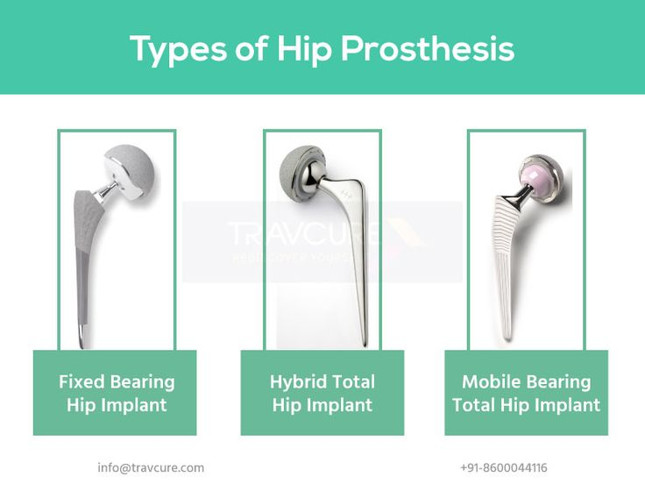
- Fixed bearing – in this form of implant, the prosthetic hip is cemented to the bone at both the femoral stem and the cup.
- Hybrid - in this form of implant the femoral stem is cemented to the bone, but not the cup.
- Mobile – in this form of implant the cup is cemented to the bone, but not the femoral stem.
Figure 1

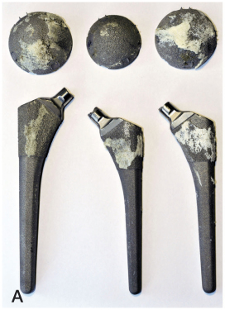
The most commonly used of which is the Fixed bearing implant as it has a low revision rate. The chosen material for the hip implant is a metal-on-plastic implant. This form of implant was chosen as it has less adverse effects than metal-on-metal implants. The metal-on-metal contact can lead to fretting corrosion. This wear and tear leads to the erosion of the metal component and leaching of metal particles into the blood stream. The friction between the metals can also lead to the premature failure of the implant, reducing the lifetime of the components. An example of fretting corrosion in a metal-on-metal implant can be seen in Figure 2. (Urish, 2019)
Figure 2

Crevice corrosion can also lead to the immature failure of the implant, this is common in hip implants where the cup and liner do not fit well together. This leads to liquid entering the joints, leading to the passivation layer no longer protecting the metal, leading to corrosion. In plastic-on-metal implants there is less chance of corrosion, the polypropylene cup is well fitted to the cobalt chrome alloy, preventing ingress of water, making it less likely for crevice corrosion to occur. As well as this, there should be less friction between the materials, slowly the physical wear and tear of the material. Plastic-on-metal was also chosen above a ceramic implant as they are less likely to be damaged or fractured during implantation. Ceramic implants, although very durable and long lasting, there is a chance of breaking the component during implantation due to how brittle ceramics are. (Urish, 2019)

Task 3
Bone is one of the strongest materials in the human body and consists of dense connective tissue. In order for a replacement limb to withstand the same weight and impact as a bone, the replacement joint must be strong and hard wearing.
There is a wide variety of manufacturing processes than can be used to produce the chromium cobalt component and the polypropylene cup separately.

For the metal section of the implant possible manufacturing processes include;
- Powder metallurgy: this is a manufacturing process involving pressing powdered metals into dies under high pressure in order to produce precision components.
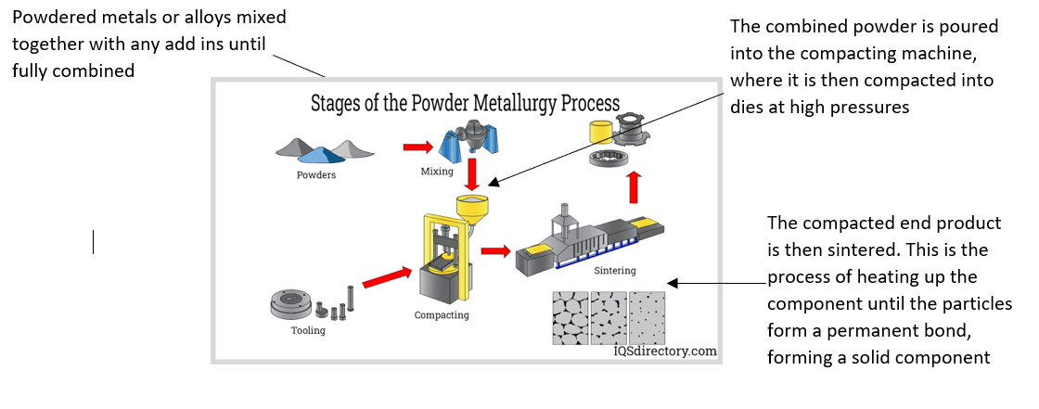

Figure 3

(IQS, 2023)

An advantage of using powder metallurgy is that there is minimal waste throughout the process, therefore, it has a high material utilisation. As well as this it can be used to produce very complex, precision components. Another advantage Is that you can control the amount of porosity in the final product. It can also be used for hard materials which are difficult to machine. (P.C., 2022)

- Die Casting - Die casting is a process which involves injecting molten nonferrous alloys into a cavity under high pressure to produce identical moulded products. In Hot chamber casting, Molten metal is poured into the chamber and the plunger forces the material through the nozzle into the cavity. In Cold chamber casting, a ladle is used to pout molten metal into the shot chamber and a plunger is used to force it into the cavity. (Ryobi, n.d.)
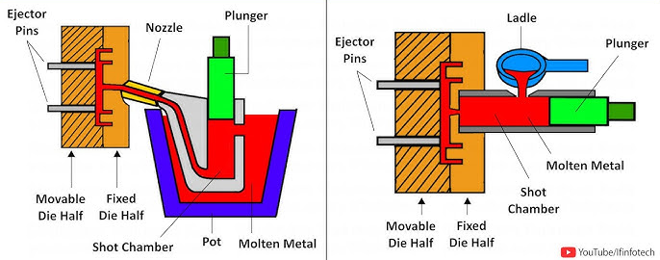

Figure 4

An advantage of die casting is that it can produce components with high mechanical strength, endurance, and harness. However, it is only economically viable for use in high volume production due to the high tooling cost.

- 3D printing - Selective laser sintering could also be used to produce the component in metal. Selective laser sintering or SLS is a powder-based additive manufacturing technology which uses a laser to fuse metal powder together, material is then stacked, layer by layer to form a printed part.
(Gan, 2020).
A benefit of using SLS is it can produce complex parts which are not able to be produced by typical manufacturing processes such as machining. It is also able to produce highly durable components as the direction of each layer of the print can be alternated to ensure strength in all directions.

To produce the hip implant, powder metallurgy was chosen as it is possible to produce a high precision component with desirable mechanical properties. This form of manufacturing also has high material utilisation so very little material is wasted. This will contribute to keeping manufacturing costs to a minimum. Another benefit to this form of manufacturing over other options is it is able to be used for a wide variety of biocompatible materials such as chromium cobalt, which is commonly used in hip implants. This form of manufacturing also allows for improved fixation of the implant to the surrounding tissue by stimulating bone and tissue ingrowth within the implants surface.
(Munir, 2020)

In the first stage of powder metallurgy the powdered metal or alloy is firstly mixed, then compacted into the desired shape using pressures of up to 1600MPa, finally it is then sintered. Sintering is the process of heating the material until all loose particles bond to form a solid component.
After the powdered material is compacted it is sintered at 900oC. The material forms a fine grained nanocrystalline and multiphase structure. During the sintering process, lubricant used in previous processes is evaporated and the surface oxide from the powder particles are reduced. During sintering, the grain size increases, closing the gaps between grains. As the grain structure becomes tightly packed the hardness of the material increases. (Akbarpour, 2020)

Grain structure prior to sintering
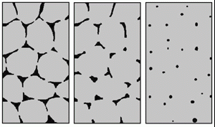
Grain structure post sintering

Figure 5

Task 4
Within the application of medical implants, it is desirable for the material to be biocompatible, so the implant is not rejected, however the mechanical properties of the implant are also important. For example, the material needs to be hard, strong, durable and impact resistant to withstand the weight and strain put on the artificial joint on a daily basis. This refers to the materials ability to withstand stress, force or impact. In order to achieve these properties, the grain structure of the material must be refined to ensure desirable properties.

A smaller grain structure will make the material more resistant to dislocations and dislocation movement which may eventually lead to the fracture and failure of the component. Therefore, by reducing the grain size, the strength of the material will increase. Similarly, hardness is a materials resistance to plastic deformation, this can be increased by reducing the grain size, as this resists dislocation movement and increases strength. As well as this solid solution hardening, or alloying, can be used to improve the physical properties of the material.

Therefore, in the application of the hip implant it is desirable to produce a material with a small grain size in order to achieve high strength and high hardness. During the sintering process, the grain size of the material is reduced, achieving ideal mechanical properties. (Akbarpour, 2020) It would also be desirable for the implant to be ductile, this is the materials ability to plastically deform before fracture, it is ideal for the material to be ductile to prevent early fracture and failure of the material. The ductility of a material can be improved by reducing the grain size or by using a heat treatment.
Cobalt-Chromium has a crystalline structure and can occur in 2 forms, either Hexagonal close packed (HCP) or Face Centred Cubic (FFC). (Zhang, 2024) (Helmenstine, 2021)

The closer packed the atoms within the unit cell are, the stronger the material should be as it will increase the density and atomic entanglement when under force. FCC has the highest atomic packing factor at 74% compared to the other crystalline structures where SC or simple cubic has an APF of 52% and BCC or Body Centred Cubic has an APF of 68%. Therefore, in applications where high density and strength is required, a material with an FCC structure is ideal. (Anon., 2024)

Task 5
Product designers need to be aware of the mechanical properties of structures of the materials they are using to ensure the product is fit for purpose. In the scenario of medical implants, the material needs to be able to withstand a high amount of force for everyday use i.e. walking, running, jumping etc. If this was not the case the implant could break and require revision which is extremely costly and time consuming, as well as causes physical pain and distress to the user. Therefore it is important the structure and properties are well considered prior to creating the product. A hybrid implant is less likely to require revision compared to fixed bearing implants, therefore, this would be the best form for implementation. (Singh, 2022)

Cobalt-Chromium alloy is metal chosen to implement into the hip implant, this alloy is made up of chromium atoms and cobalt atoms, this alloy works well in the medical field as it is biocompatible and non-corrosive as well as being high strength at high temperatures. CO-Cr has high corrosion resistance due to the protective passive film on the surface of the material, this is made up of Cr2O3. Co-Cr has a tensile strength of 655-1896MPa and a Elastic modulus of 210-253MPa. Co-Cr is typically not very ductile however, when additional materials such as nickel, carbon or nitrogen are added it improves the ductility without compromising the other mechanical properties of the material. (Guo, 2022) The highest force that a natural hip joint experiences during use is 2400N, The force that Co-Cr is able to withstand is much higher than this at – therefore, in terms of the highest tensile strength of the material, the Co-Cr is more than fit for purpose. (Bergmann G, n/a)

In different phases the material has drastically different mechanical properties, when CO-Cr is in its alpha phase it is very brittle and likely to fracture. However, when it enters its Y phase its crystal structure is a FCC, this state provides higher strength and ductility. Therefore in the application of the hip implant, it would be desirable for the Co-Cr alloy to be in its Y phase, which is achieve between approximately 1100K – 1800K, with under 40% Chromium composition. (Alfirano, 2021)
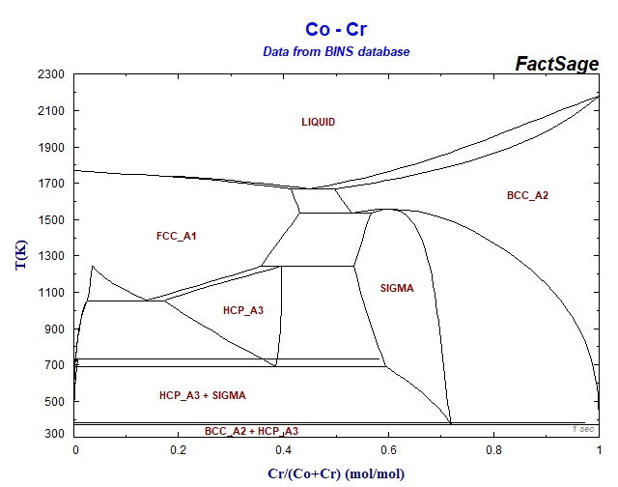

Figure 6
(Alfirano, 2021)

References
Akbarpour, M., 2020. Densification and Mechanical and Antibacterial properties of low cost Powder Metallurgy TiCu Alloy as a potential Biomedical Material. JOM, 72(9).
Alfirano, A., 2021. Phase Diagram. [Online]
[Accessed 31 10 2024].
Anon., 2024. Washington EDU. [Online]
Available at: https://courses.washington.edu/mse170/powerpoint/Adjorlolo/Chapter_03-12.pdf
[Accessed 31 10 2024].
Bergmann G, G. F., n/a. Standard loads - hip joint. [Online]
Available at: https://orthoload.com/test-loads/standard-loads-hip-joint/
[Accessed 31 10 2024].
Gan, X., 2020. Powder quality and electrical conductivity of selective laser sintered polymer composite components. oodhead Publishing Series in Composites Science and Engineering, Volume 2, pp. 149-185.
Guo, L., 2022. On the design evolution of hip implants: A review. Materials and design , 216(1).
Helmenstine, A., 2021. Ductility – Ductile Definition and Examples. [Online]
Available at: https://sciencenotes.org/ductility-ductile-definition-and-examples/
[Accessed 31 10 2024].
IQS, 2023. Powder Metallurgy. [Online]
Available at: https://www.iqsdirectory.com/articles/powder-metal-parts/powder-metallurgy.html
[Accessed 05 12 2023].
Munir, K., 2020. 5 - Powder metallurgy in manufacturing of medical devices. Metallic Biomaterials Processing and Medical Device Manufacturing, pp. 159-190.
National Institute of Arthritis Muskuloskeletal and skin diseases, 2023. Hip Replacement Surgery Basics. [Online]
Available at: https://www.niams.nih.gov/health-topics/hip-replacement-surgery/basics/symptoms-causes
[Accessed 20 10 2024].
National Joint Registry , n/a. Information on hip replacement. [Online]
Available at: https://www.njrcentre.org.uk/patients/hip-replacement/
[Accessed 21 10 2024].
P.C., A., 2022. Powder Metallurgy, Second Edition: Science, Technology and Applications. 2 ed. s.l.:s.n.
Ryobi, n.d. What is Die casting?. [Online]
Available at: https://www.ryobi-group.co.jp/en/glance/02.html#:~:text=Die%20casting%20is%20a%20metal,of%20aluminum%2C%20magnesium%20and%20zinc.
[Accessed 29 11 2023].
Singh, V., 2022. Dual-mobility versus Fixed-bearing in Primary Total Hip Arthroplasty: Outcome Comparison. Hip Pelvis , pp. 95-105.
Urish, K. L., 2019. The Challenge of Corrosion in Orthopaedic Implants. [Online]
Available at: https://www.aadlab.org/wp-content/uploads/2019/04/AAOS.NOW_.Corrosion.April_.2013.pdf
[Accessed 28 10 2024].
Zhang, Y., 2024. Developing high strength and ductility in cobalt alloy via chromium carbonitride addition. Materials Today Communications , Volume 39.

