Electronics System Design (ACDA6002)
Assignment 1
BNG Electrical & Electronic Engineering Course
UWTSD
By Krzysztof Matela
Student ID: 1804424

Page Index:
- Introduction
- Design
  - Requirements
  - Sensors
    - Temperature
    - RPM
    - MPH
    - Suspension
    - PRY
  - ADC Resolution
  - Storage Memory
  - Microcontroller
    - Pin requirements
    - PIC Modules Required
      - Analog-to-Digital Converter
      - MSSP (SPI)
      - USB
      - EUSART (RS-232)
    - PIC Choice
  - Power Source
  - Connectors
  - Casing
  - System Block Diagram
  - Circuit Schematic Diagram
  - PCB Design
- Future Improvements
- References
- Appendix

- Introduction
The following report describes the design phase of a data acquisition (DAQ) system which are used by scientists and engineers for research. Such DAQ system can be fitted inside vehicles to measure their performance and property or made part of weather station to predict natural events. They are capable of converting a real-world physical condition or property into digital values that can be handled by human or a computer [1]. DAQ is made out of:
Sensors and transducers
Field wiring
Signal conditioning
DAQ hardware
DAQ software
PC
Since transducers can detect a lot of different physical phenomena, like thermal, magnetic, and mechanical energy from one kind to another, they were used to collect data in real time and then stored this data for analysis.
A typical DAQ hardware is essentially a box loaded with peripherals: Analog-To-Digital Converters; communication protocols (USB, Ethernet, RS-485 etc.), and more. On their own they are not particularly useful until sensors are added to the system which depend on their application.
- Design
  - Requirements
This custom design for a vehicular data acquisition system is meant to be fitted inside a prototype car targeted for the family saloon market. The system needs to be portable, re-usable and adaptable for different kind of vehicles. The data gathered will be used to test if the vehicle is operating within a safe limit and is a comfortable means of transport.
The data gathered is:
- Engine temperature
- RPM
- Front and rear suspension travel
- Pitch, roll and yaw
- Vehicle speed (MPH)
The system is expected to collect and store data in a non-volatile memory which can also be connected to PC via USB to read and clear it.
Additionally, system is meant to be battery powered and sensors mustn’t be connected to vehicles electronics or signals.
The system will be used in rough environment, full of humidity and dust and thus, it must be robust.

  - Sensors
    - Temperature
Type | Solid State Sensor | Optical Sensor | Thermistor
Short Description | Output is linearly proportional to temperature applied across a diode ^{[1]}. | Sensor work by focusing infrared energy emitted by an object onto one or more photodetectors ^{[2]}. | Thermistor is essentially a resistor with resistivity based on temperature ^{[3]}.
Examples | LM35 | SA-IR200V6-000 | EPCOS B57863S0103F40
Robustness | Good | Very Good | Good
Complexity | Simple | Simple | Simple
Price | Cheap | Medium | Cheap
Temp. range | Yes | Yes | No
Mounting | Glue | Non-Contact | Glue
Connection Type | Linear + 10-mV/°C | Analog 0,+5V | Analog

    - RPM
Type | Magnetic | Reflective Optical | Retro-Reflective
Short Description | Hall effect sensor is integrated with amplifier to vary output based on strength of magnetic flux ^{[5]}. | The operation is based on photodiodes which senses presence and absence of light ^{[4]}. | Sensor uses infrared LED and measures the reflectivity of the object ^{[6]}.
Examples | SS495A | AEDR-8000-1K2 | GP2Y0A41SK0F
Robustness | Very Good | Very Good | Very Good
Complexity | Simple | Medium | Simple
Price | Cheap | Medium | Cheap
Connection Type | Digital | Digital | Analog
Mounting | Non-Contact | Non-Contact | Non-Contact
Distance | Magnet depended | 75-180mm | 30cm

    - MPH
RPM uses a retro-reflective sensor to measure number of revolutions and the same principle can be used to measure number of wheel revolutions.

    - Suspension
Type | Strain Gauge | Wire Pot | Ultrasonic
Short Description | Strain gauge is a strip that when stretched, change its resistance ^{[7]}. | Wire pot is capable of converting linear motion to proportional voltage output ^{[9]}. | This sensor works by sending sound at frequency above human hearing and as the sound bounces of an obstacle and returns to sensor, it gives time delay from which distance can be determined ^{[8]}.
Examples | RS PRO 865-6235 | SA-WP0760HQ-000 | MCUSD14A58S9RS-30C
Robustness | Good | Very Good | Low
Complexity | Simple | Simple | Medium
Price | Cheap | Medium | Cheap
Connection Type | Analog | Analog | Analog
Extended Length | 8mm | 760mm | 300mm

    - PRY
Type | Accelerometer | Gyroscope
Short Description | This sensor can measure static or dynamic acceleration. This acceleration causes mass to squeeze piezoelectric material within which then creates an electrical charge ^{[11]}. | Gyroscope works by maintaining angular momentum using a rotor mounted on a pivot which keeps it rotating on particular axis ^{[10]}.
Examples | MPU-6050 | MAX21001 | SA-GY200V4-000
Robustness | Low | Low | Very Good
Complexity | Medium | Medium | Simple
Price | Low | Low | Low
Connection Type | Digital (SPI) | Digital (SPI) | Analog

  - ADC resolution
ADC resolution is the definition of number of steps per bit. More bits will increase accuracy of Analog-to-Digital Converter (more details in section 2.5.2.1).
Resolution | Formula | Total number of steps
2 | 2^2 | 4
4 | 2^4 | 16
6 | 2^6 | 64
8 | 2^8 | 256
10 | 2^10 | 1024

The number of steps must be higher than sensors’ sensitivity:

Sensor | Temp (Celsius) | Gyro (Angular Momentum) | Suspension (Mechanical Stroke)
Min | -30°C | -200°/s | 0mm
Middle | 85°C | 0 | 380mm
Max | 200°C | 200°/s | 760mm
Total | 230°C | 400°/s | 760mm
Minimum Resolution | 8 bits (256 steps) | 9 bits (512 steps) | 10 bits (1024 steps)
This table shows that system needs a minimum resolution of 10 bits for ADC. The reason to not include sensor for MPH and RPM is because that sensor gives output based on reflectivity of an object but in this design, it will be used only to return high or low reflectivity and therefore, it is safe to use with low ADC resolution.
  - Storage Memory
To help decide on amount of storage memory required, a table was made to describe how data would be stored on a memory card based on how often data would be taken:
Time | Temperature |  | RPM | MPH | Suspension Front-Right |  | Suspension Front-Left |  | Suspension Rear-Right |  | Suspension Rear-Left |  | Pitch |  | Roll |  | Yaw
0 | Temp-MSB | Temp-LSB | RPM | Mph | Sus-fr-MSB | Sus-fr-LSB | Sus-fl-MSB | Sus-fl-LSB | Sus-rr-MSB | Sus-rr-LSB | Sus-rl-MSB | Sus-rl-LSB | Pit-MSB | Pit-LSB | Roll-MSB | Roll-LSB | Yaw-MSB | Yaw-LSB
50μS |  |  |  |  | X | X | X | X | X | X | X | X
100μS |  |  |  |  | X | X | X | X | X | X | X | X | X | X | X | X | X | X
150μS |  |  |  |  | X | X | X | X | X | X | X | X
200μS |  |  |  |  | X | X | X | X | X | X | X | X | X | X | X | X | X | X
…
999.95mS |  |  |  |  | X | X | X | X | X | X | X | X
1S |  |  | X | X | X | X | X | X | X | X | X | X | X | X | X | X | X | X
…
2S |  |  | X | X | X | X | X | X | X | X | X | X | X | X | X | X | X | X
…
5S | X | X | X | X | X | X | X | X | X | X | X | X | X | X | X | X | X | X
Temperature will be taken every 5 seconds,
RPM and MPH, every second,
Suspension data every 50μS,
And Pitch, Roll, and Yaw data, every 100μS.

Storage required for temperature can be calculated as:
$${Times}/{Second}*60Minutes*2Hours*2Bytes=\frac{60}{5}*60*2*2=2880Bytes$$
Formula for RPM
$$60Seconds*60Minutes*2Hours=60*60*2=7200Bytes$$
Formula for MPH
$$60Seconds*60Minutes*2Hours=60*60*2=7200Bytes$$
Formula for Suspension
$${Times}/{Second}*60Minutes*2Hours*2Bytes*4Wheels=\frac{60}{50*{10}^{-6}}*60*2*2*4=1152000000Bytes$$
Formula for Pitch, Roll, and Yaw
$${Times}/{Second}*60Minutes*2Hours*2Bytes*3PRY=\frac{60}{100*{10}^{-6}}*60*2*2*3=432000000Bytes$$
Therefore, a total storage required for 2 hours run is:
$$2880+7200+7200+1152000000+432000000=1584017280Bytes$$
In kilobytes:
$$\frac{1584017280}{1024}=1546891.9kB$$
In Megabytes:
$$\frac{1246891.9}{1024}=1510.64MB$$
In Gigabytes:
$$\frac{1510.64}{1024}=1.48GB$$
Hence, for 2 hours run, system requires at least 1.48GB of memory.
  - Microcontroller
    - Pin requirements
The pic would require a minimum of 10 analog pins because of a number of sensors: 1 for temperature; 1 for RPM; 1 for MPH; 3 for Pitch, Roll, and Yaw; and 4 for suspension – 1 for each wheel.
Additionally, to communicate with SD Card, it would need 4 SPI compatible pins and 3 pins for USB to read and write from it when connected to a PC.
Lastly, for debugging, PIC neds 2 pins for RS232.
Optionally, it could also have 2 digital pins for LED lights that could indicate for example: device is on or; memory is full.
    - PIC Modules Required
      - Analog-to-Digital Converter
Analog-to-Digital converter is required to take signal coming from sensors and convert it into a binary representation. In PIC microcontroller, analog inputs are multiplexed into a single sample and hold circuit which is connected to input of converter. This converter gives binary result using successive approximation which test outputs by feeding Digital-to-Analog converter and comparing results with analog existing at input comparator [12]. It does its job by first setting all bits to 0 and then going from Most Significant bit, it temporarily sets bit to 1. If D/A is less than input, it would leave that bit as 1 and else, it would set that bit back to zero. This process is called Binary Search [13].
      - MSSP (SPI interface)
Master Synchronous Serial Port (MSSP) module is required to communicate with SPI and I2C devices – in this case, an SD card. SPI was introduced by Motorola to communicate between ICs and I2C was made by Philips for communication between chips [14] [15]. SPI bus is a synchronous serial data communication bus that operates in Full-Duplex mode – meaning that data can go in both directions at the same time. Device’s communication is in a master/slave environment and master is the one to initiate communication. A slave device is controlled by a Chip Select which is also known as Slave Select ($\overline{SS}$). SPI is made out of 4 wires:
    - Serial Clock (SCK)
    - Serial Data Out (SDO)
    - Serial Data IN (SDI)
    - Slave Select ($\overline{SS}$)
In event where multiple SPI devices are present, each SCK, SDO, and SDI are connected together while each device has their own unique SS pins [16].
I2C, unlike SPI, only uses 2 wires as a bus where slave addressing is sent first in the same line as data. The communication is Half-Duplex – data going in one direction at the time. Also, any slave can take control of the bus if the master relinquishes the control [15]. The 2 wires in I2C are:
    - Serial Clock Line (SCL)
    - Serial Data Line (SDA)
      - USB
Universal Serial Bus (USB) was introduced in 1995 with main goal to simplify the connection between computer and peripherals. USB 1 had options for low speed (1.5Mb/s) and full speed (12Mb/s) and it was sufficient enough for keyboards, mouses and some external memory drives (thumb drives). In version 2, USB give hi-speed transfer up to 480Mb/s and is more suitable for serious data transfer for devices such as optical drives or external hard drives. Version 3 add another two shielded twisted pair cables that give Full-Duplex communication and speed up to 4.8Gb/s while version 3.1 can go in speed up to 10Gb/s and also increased power output from 5V@2A to 5A at either 12V or 20V. USB 1 and 2 are configured as Half-Duplex Master/Slave with 4-wires [17]:
    - Vbus (+5V)
    - D+
    - D-
    - Ground (GND)
While Vbus gives a constant voltage between 4.40V to 5.25V, the D+ and D- data lines operate at 3.3V [18].
      - EUSART (RS-232)
Enhanced Universal Synchronous Asynchronous Receiver Transmitter (EUSART) Module is a peripheral for serial I/O communication and it contains clock generators, shift registers, and data buffers required to do input or output of serial data transfer independent of device program execution. EUSART is also known as Serial Communication Interface and can be configured as either Full-Duplex or Half-Duplex [19].
In this design, it will be used for debugging microcontroller using RS-232. The RS-232 refers to electrical signalling scheme that uses voltages of both polarities (+ and -) to signal 1 and 0. When signalling starts, the transmitter rests at logic 1 and it change to 0 which is then followed by 8 data bits and ends with extra 1 or 2 trailing stop bits. The 8 bits data can sometimes by 7-bits long with 1 parity bit. The transmitter and receiver must have the same baud rate (e.g., 9600 bits/s).
    - PIC Choice
For the above reasons, the microcontroller of choice for this design is PIC18F45K50 which has the required amount of digital and analog pins and has embedded modules for ADC, MSSP, USB and RS232.
  - Power Source
The minimal power source requirements are defined by voltages and currents. Since Temperature sensor requires 12V [A1] and remaining sensors 5V [A2-A4], the battery must have at least 12V. The required Ah for 2 hours run is calculated by adding current draw of each component together and then multiplied by 2 to give 2 hours and multiplied by 2 again to make sure battery won’t die in the middle of testing:
Component | Current Draw
IR Temperature Sensor | 0.001A
IR Distance Sensor (2x) | 0.044A
Wire Potentiometer (4x) | 0.002A
Gyroscope (3x) | 0.15A
Microcontroller | 0.085A
Total | 0.282A
Total for 2 hours run | 0.564A
Doubled | 1.128A
Therefore, battery must have at least 1.128Ah capacity.
The choice for battery is TS B2 which is a 12V battery with 2.0Ah capacity [A7].
  - Connectors
Connectors’ robustness is defined by ingress protection (IP) and it is a defined standard rating used to protection levels of electrical enclosures. IP ratings have 2 digits with them: first digit represents intrusion protection (such as dust); and second digit represents moisture protection [21].
For the connector, choice is Lemo Cable Mount Connector, 4 Contacts part NO. FGG.0T.304.CLAC50Z [A8] and EGG.0T.304.CLL [A9] for mounting to casing. 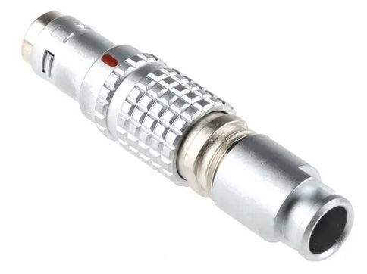 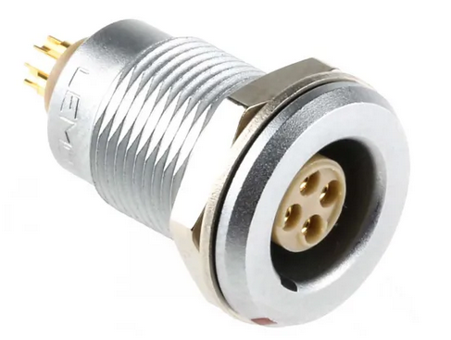
FGG.0T.304.CLAC50Z and EGG.0T.304.CLL are made out brass and both have IP68 ratings.

  - Casing
The choice for casing is: Peli 1150 with the size of 111 x 232 x 192mm. It has IP67 rating and is fully waterproof.
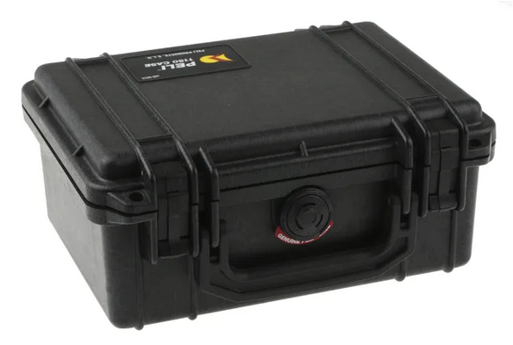
  - System Block Diagram
This diagram contains a microcontroller in the middle with USB and SD Card data going in and out and sensors output feeding signal conditioning which are then passing through clamps to prevent any voltages higher than +5V going into the PIC.

  - Circuit Schematic Diagram
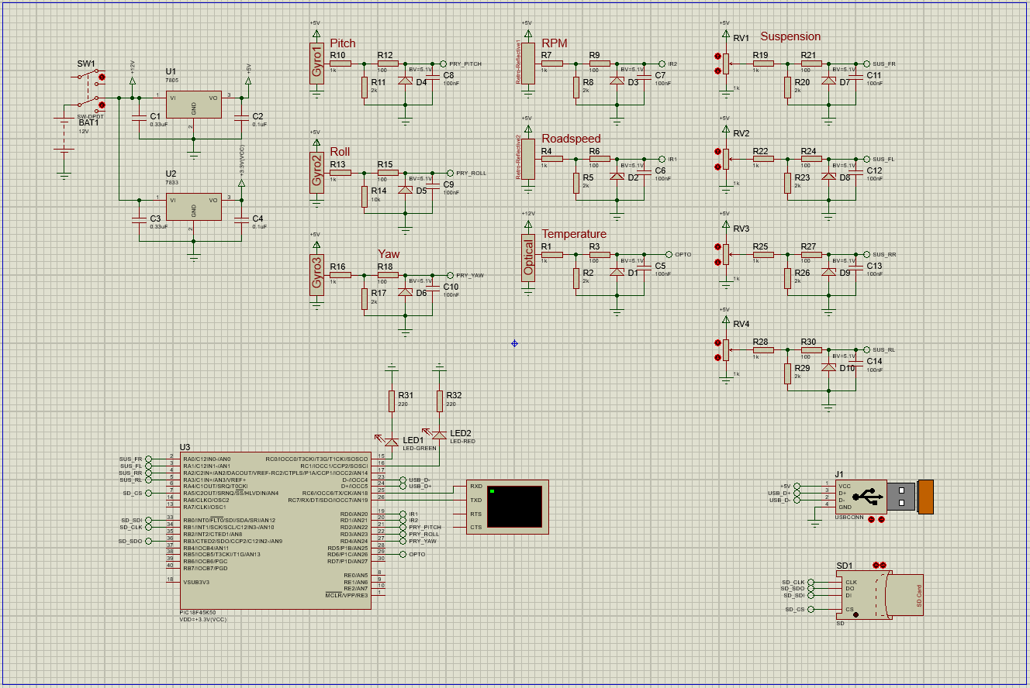In the top left, there is a power supply line coming from a battery with single +12V output going to IR temperature sensor along with 2 voltage regulators in parallel for +5V and 3.3V which have a pair of capacitors each to smooth out the current draw (values for capacitors sourced from their respective datasheets [A10-A11]). The +5V voltage regulator is providing power for 2 IR distance sensors, 3 Gyros, and 4 wire potentiometers while +3.3V voltage regulator is powering the microcontroller. The microcontroller must work at 3.3V because that is the operating voltage of an SD Card [A5] and also, because of lower operating voltage of microcontroller, the sensors require a signal conditioning in form of a potential divider to bring their voltage outputs from +5V [A1-A4] to +3.3V to match internal Vref of a PIC. Each sensor benefits from a clamp that keeps the voltage at maximum +5V before entering PICs analog inputs to keep it from burning. SD card [5], being SPI device, is connected to dedicated SCK, SDO, SDI, and $\overline{SS}$ pins and USB is connected to D+ and D- pins (which also operate at +3.3V) of a microcontroller with its +5V sourced from voltage regulator. There are also 2 LEDs powered by the PIC and terminal for RS-232 communication.

  - PCB Design
Each component name corresponds with components in Proteus schematic design.
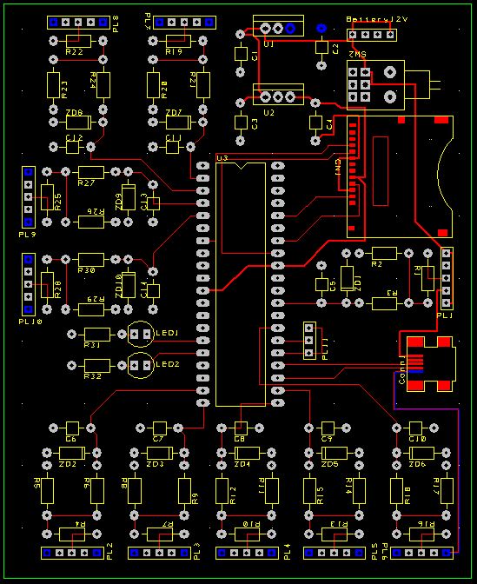

3D View:
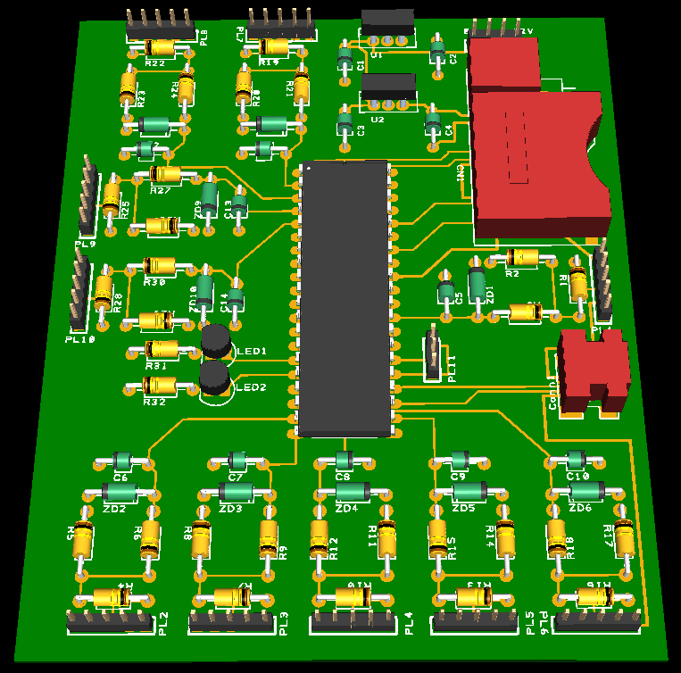
Connectivity Check: 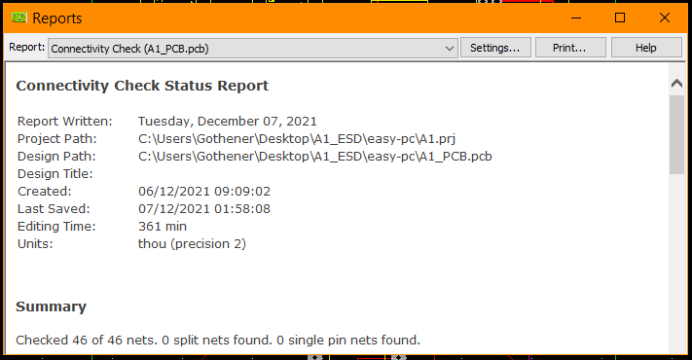
Design Rule Check:
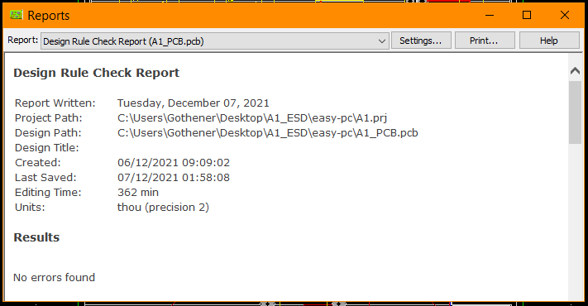
- Future Improvements
The design could benefit from increased ADC resolution that could improve accuracy of analog inputs. Further improvement could be by adding a USB 3.1 support to achieve high speed of data transfer and possibly Ethernet or Wi-Fi modules as alternative option to communicate with this DAQ. It would also be worth to add a circuitry that would allow to recharge the battery without having to unplug it. Lastly, the design could have more sensors to measure things such as: noise levels, vibrations, fuel consumption, or exhaust temperature.

- References
[1] Akshai M. URL: “https://akshaim.github.io/IoT/Sensors/LM35.html”. Accessed: 29/11/2021.

[2] Sure Controls Inc. URL: „https://www.surecontrols.com/infrared-temperature-sensors/”. Accessed: 29/11/2021

[3] Wavelength Electronics. URL: „https://www.teamwavelength.com/thermistor-basics/”. Accessed: 29/11/2021

[4] Avago Technologies. URL: „https://docs.rs-online.com/60cf/0900766b8130f673.pdf”. Accessed: 29/11/2021

[5] URL:” https://www.electronics-tutorials.ws/electromagnetism/hall-effect.html”. Accessed: 29/11/2021.

[6] SHARP. URL: „https://www.farnell.com/datasheets/2364614.pdf”. Accessed: 29/11/2021.

[7] All About Circuits. URL: „https://www.allaboutcircuits.com/textbook/direct-current/chpt-9/strain-gauges/”. Accessed: 29/11/2021

[8] Burnett R. URL: “https://www.maxbotix.com/articles/how-ultrasonic-sensors-work.htm”. Accessed: 29/11/21

[9] 2D Data Recording. URL: „https://www.datrontechnology.co.uk/wp-content/uploads/2016/10/SA-WPxxxxHQ-000-DINA4.pdf”. Accessed: 29/11/21

[10] Wat Electronics. URL: “https://www.watelectronics.com/what-is-a-gyroscope-sensor-working-its-applications/”. Accessed: 29/11/21

[11] OMEGA Engineering. URL: “https://www.omega.com/en-us/resources/accelerometers. Accessed 29/11/21”. Accessed: 29/11/21

[12] Microchip Technology Inc. PIC18(L)F2X/45K50 Datasheet. Chapter 18.0 Analog-To-Digital Converter (ADC) Module. Page 287

[13] P. Horowitz, W. H. (2015). ”The Art of Electronics”, Third Edition. Cambridge University Press. Chapter 13.7 Successive approximation. Page 908

[14] P. Horowitz, W. H. (2015). ”The Art of Electronics”, Third Edition. Cambridge University Press. Chapter 14.7.1 SPI. Page 1032

[15] P. Horowitz, W. H. (2015). ”The Art of Electronics”, Third Edition. Cambridge University Press. Chapter 14.7.2 I2C 2-wire interface (“TWI”). Page 1034

[16] Microchip Technology Inc. PIC18(L)F2X/45K50 Datasheet. Chapter 16.2 SPI Mode Overview. Page 206

[17] Microchip Technology Inc. PIC18(L)F2X/45K50 Datasheet. Chapter 14.7.13 USB. Page 1042

[18] Murphy R. Cypress. USB 101: An Introduction to Universal Serial Bus 2.0. Chapter 5 Physical Interface. Page 7

[19] Microchip Technology Inc. PIC18(L)F2X/45K50 Datasheet. Chapter 17 Enhanced Universal Synchronous Asynchronous Receiver Transmitter (EUSART). Page 258

[20] P. Horowitz, W. H. (2015). ”The Art of Electronics”, Third Edition. Cambridge University Press. Chapter 14.7.8 Asynchronous Serial (RS-232, RS-485). Page 1038

[21] The Enclosure Company. IP Ratings – What they mean. URL: „https://www.enclosurecompany.com/ip-ratings-explained.php”. Accessed: 05/12/21

- Appendix
[A1] Infrared Temperature Sensor. 2D Debus & Diebold Meßsysteme GmbH. 2D Data Recording. SA-IR200V6-006 Datasheet. URL: „http://2d-datarecording.com/Downloads/Datasheets/Sensors-temperature/Pdf/Archiv/2008/SA-IR200V6-006-DINA4.pdf”. Accessed: 05/12/2021

[A2] Distance Measuring Sensor Unit. SHARP. GP2Y0A41SK0F Datasheet. URL: „https://www.farnell.com/datasheets/2364614.pdf”. Accessed: 05/12/2021

[A3] Wire Potentiometer. 2D Debus & Diebold Meßsysteme GmbH. 2D Data Recording. SA-WPxxxxHQ-000 Datasheet. URL: „https://www.datrontechnology.co.uk/wp-content/uploads/2016/10/SA-WPxxxxHQ-000-DINA4.pdf”. Accessed: 05/12/2021

[A4] Yaw-rate-sensor. 2D Debus & Diebold Meßsysteme GmbH. 2D Data Recording. SA-GYxxxV4-000 Datasheet. URL: “https://www.datrontechnology.co.uk/wp-content/uploads/2016/10/SA-GYxxxV4-000-DINA4.pdf”. Accessed: 05/12/21

[A5] Components 101. MicroSD Card. URL: “https://components101.com/misc/microsd-card-pinout-datasheet”. Accessed: 05/12/21

[A6] PIC18F45K50. Microchip Technology Inc. PIC18(L)F2X/45K50 Datasheet. URL: “https://ww1.microchip.com/downloads/en/DeviceDoc/PIC18F2X_45K50-30000684B.pdf”. Accessed: 05/12/21

[A7] Battery TS B2. TLC Electrical Supplies Direct. URL: „https://www.tlc-direct.co.uk/Products/TSB2.html”. Accessed: 05/12/21

[A8] Cable Connector FGG.0T.304.CLAC50Z. Lemo. URL: „https://uk.rs-online.com/web/p/industrial-circular-connectors/8326647”. Accessed: 05/12/21

[A9] Panel Mount EGG.0T.304.CLL. Lemo. URL: „https://uk.rs-online.com/web/p/industrial-circular-connectors/8326638”. Accessed: 05/12/21

[A10] 7805 +5V Positive Voltage Regulator. Texas Instruments. URL: https://www.sparkfun.com/datasheets/Components/LM7805.pdf. Accessed: 05/12/21

[A11] 7833 +3.3V Positive Voltage Regulator. Taitron Components Inc. URL: “http://www.taitroncomponents.com/catalog/datasheet/lm7833.pdf”. Accessed: 05/12/21

