

Student Name: Tania Sultana
Student ID: 2516332

Module Name: Marketing Management
Module Code: LCMB7024

Lecturer’s Name: Dr. Laila Maazouz

Work Counts: 2690

Term 1

Table of Contents
1. Introduction 3
2. Task 1: Macro Environment Analysis 4
2.1 Overview of Organisations 4
2.2 Macro Factor 1: Technological Environment 4
2.2.1 Opportunities and Threats for Tesla (Pioneer) 4
2.2.2 Opportunities and Threats for Ford 6
2.2.3 Critical Analysis 7
2.3 Macro Factor 2: Environmental (Sustainability) Factors 7
2.3.1 Opportunities and Threats for Tesla (Pioneer) 7
2.3.2 Opportunities and Threats for Ford (Follower) 8
2.3.3 Critical Analysis 9
2.4 Comparative Evaluation 9
3. Task 2: Strategic Responses 10
3.1 Porter’s Generic Strategies 10
3.1.1 Tesla’s Differentiation Strategy 10
3.1.2 Ford’s Hybrid Strategy 11
3.1.3 Comparative Evaluation 12
3.2 Ansoff Matrix Application 12
3.2.1 Tesla’s Growth Strategy 12
3.2.2 Ford’s Growth Strategy 13
3.2.3 Comparative Evaluation 14
3.3 Overall Strategic Evaluation 15
4. Conclusion 16
5. Reference List 17

1. Introduction
Marketing environment is very important in the organisation strategy, decision making and long-term competitiveness. Organisations in modern markets are engaged in an intricate and dynamic environment affected by macro-level forces including technological progress and environmental sustainability (Klimova et al., 2023). These forces bring opportunities, as well as threats and the firms need to keep changing their strategies to remain relevant and gain a competitive edge. The global automotive industry, with the rapid modernization of electric vehicles (EVs), is a good example of such change and has disrupted the traditional market structures (Mu, 2023).
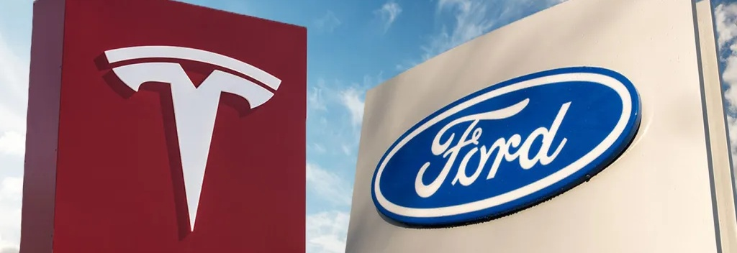
Figure 1: Tesla and Ford Logo
Source: (Tulay, 2019)
Tesla is an innovative pioneering organisation that has disrupted the sector of the automotive industry via its early investment in electric mobility, battery technology, and computer-based vehicles (Tang, 2023). In the year 2023 Tesla had sold more than 1.8 million cars in the world and had a market worth of more than 600 billion USD (Lu, 2024). On the contrary, Ford is a follower organisation that has more than a hundred years of experience in the manufacturing of vehicles (it produces more than 4 million cars per year) but it has entered the EV market rather late (Wayland, 2022).
This report critically discusses the effect of technological and environmental macro-environment factors of Tesla and Ford. It assesses the opportunities and threats that these forces generate and the way these forces affect the competitive position of each company. Moreover, the report also makes a comparison and an analysis of the strategic responses embraced by the two organisations based on the Porters Generic Strategies and Ansoff Growth Matrix to determine how they maintain and develop competitive advantage.

2. Task 1: Macro Environment Analysis

2.1 Overview of Organisations
The Tesla company is generally acknowledged as an innovative organisation in the EV market. As it was founded, the company is concerned with innovations, spending more than 3 billion USD each year on research and development to improve the battery technology and autonomous driving and digital integration (EBSCO, 2024). Tesla has several Gigafactories in various areas including Nevada, Shanghai, Berlin, and Texas that allow the company to produce in large volumes and have benefits of scale (Susanto and Ellitan, 2024).
Founded in 1903, Ford is a long-established, follower organisation in the automotive industry. Traditionally concentrated on internal combustible engines, Ford has developed a robust international brand with the help of such models as the F-150 (Roberson, 2022). But growing environmental regulations and technological progress have compelled Ford to move to the EV market. The company has also invested more than 50 billion USD in electrification by 2026, which is not an innovative move but a reactive action (Sotoodeh, 2025).

2.2 Macro Factor 1: Technological Environment
One of the strongest forces that have impacted the EV industry is the technological environment, especially with the improvement of battery efficiency, artificial intelligence, and the digital connection. These changes have drastically changed the product capabilities and demand.

2.2.1 Opportunities and Threats for Tesla (Pioneer)
Tesla has used technological advancements as one of the main sources of competitive advantage. The investment of the company in the research and development of products (over 3 billion USD each year) allowed it to create new battery systems that allow the company to provide ranges up to 400 miles on models (Yang, 2023). This helps increase product differentiation and decreases doubts by consumers about the charging infrastructure and range of the vehicle.
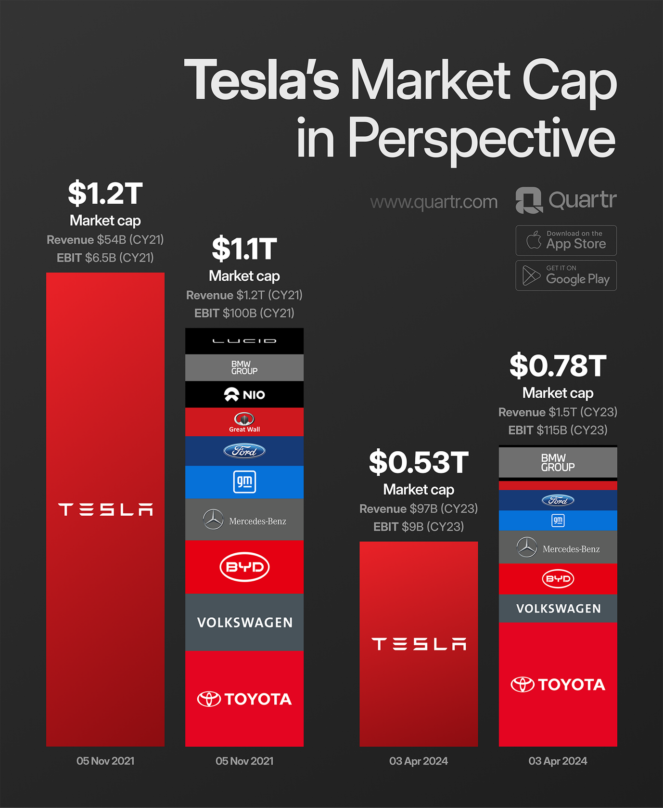
Figure 2: Tesla Market Capitalisation Comparison
Source: (Quartr, 2024)
Furthermore, billions of miles of real-world driving data that Tesla has gathered on its cars help it in the development of autonomous driving technology. Such fact-based solution enhances its standing in the artificial intelligence and gives it a long-term chance to dominate in self-driving technology. The use of software updates done over the air also distinguishes the products of Tesla as it is constantly enhanced without the need to add any physical changes (Zhang and Ding, 2024).
Nonetheless, the technological environment is also a major challenge. The high cost of operation and financial strain are the results of Tesla being dependent on constant innovation. Technological change is fast, and what was the latest technology a few days ago is now no longer one, which means that one should continue investing to keep up with it (Lu, 2024). Moreover, the competitors are also investing more in similar technologies and lessening the technological edge of Tesla over the years.

2.2.2 Opportunities and Threats for Ford
The technological advancement helps Ford to take advantage of innovations that have been proven, which minimizes uncertainty and development expenses. The launch of Mustang Mach-E and F-150 Lightning shows that Ford can adopt the electric technology within its product lineup (Su, 2024). F-150 Lightning has created more than 200,000 reservations, which means that the product is in high demand among consumers.
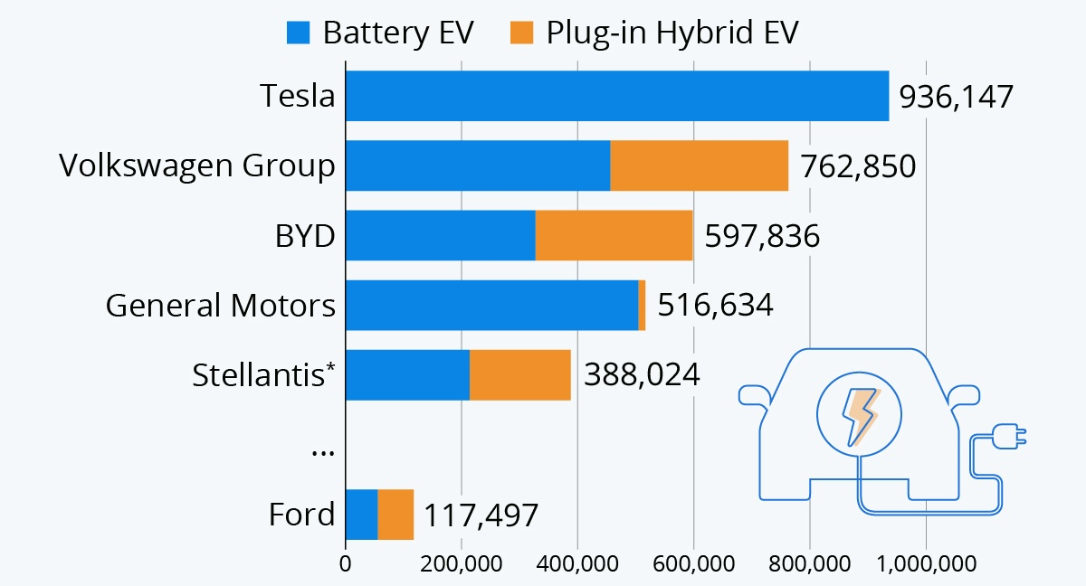
Figure 3: Global EV Sales Comparison by Manufacturer
Source: (Richter, 2022)
Nevertheless, Ford has disadvantages over Tesla. It is dependent on non-in-house collaborations regarding battery and software development which minimizes innovation control. Moreover, its late market adoption of EV lowers its access to the big data needed to support such advanced technologies as autonomous driving.

2.2.3 Critical Analysis
The technological environment establishes disproportionate benefits. The investment initiative undertaken by Tesla enables it to influence the industry standards and remain on the top. Conversely, the reactive strategy used by Ford restricts its competitiveness in terms of innovation. Despite technology adoption, which helps Ford to minimize risk, the company is relying on pioneers, which puts it in a worse competitive position.

2.3 Macro Factor 2: Environmental (Sustainability) Factors
The automotive industry has taken the center stage with climate change policies, emission policies, and consumer demand of sustainable products as the environmental factors. Governments all over the world are rolling out more restrictive measures and provide incentives to facilitate the use of electric vehicles.

2.3.1 Opportunities and Threats for Tesla (Pioneer)
The Tesla business model is naturally consistent with environmental sustainability as it is dedicated to the use of electric cars and renewable energy only. This synergy opens high potential opportunities, and Tesla can enjoy government-backed incentives like tax credits of several thousand dollars per vehicle in key markets (Williment, 2025).
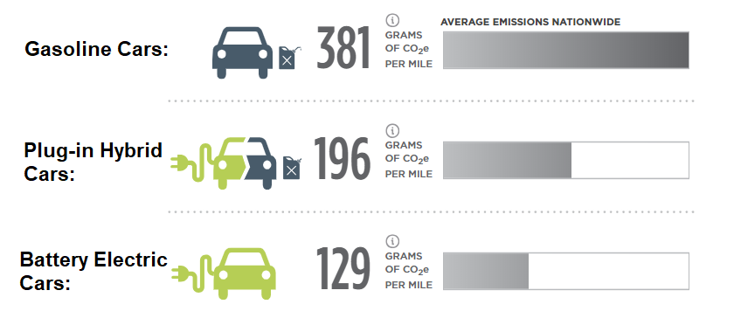
Figure 4: CO₂ Emissions by Vehicle Type
Source: (Parashar, 2019)
Moreover, Tesla also earns Tesla over 1 billion USD in a year by selling regulatory credits to other car manufacturers. This is a financial gain which is direct result of environmental policies. The good environmental image also promotes the brand image of Tesla, as it has strong environmental positioning which attracts environmentally conscious consumers and boosts customer loyalty.
Despite these benefits, there are challenges associated with the environmental factors. Tesla depends on essential raw materials like lithium and cobalt the demand of which has gone up tremendously. This poses constraints to the supply chain and escalates production expenses (Rejeb, Rejeb and Süle, 2025). Also, the environmental inspection with a focus on mining activities and the sustainability of resources can affect the activities of Tesla in the long term.

2.3.2 Opportunities and Threats for Ford (Follower)
For Ford, the environmental forces have required significant change of the business model. The firm has declared that it will manufacture more than 2 million electric cars in the year 2026, which needs a substantial investment in infrastructure, production, and distribution.
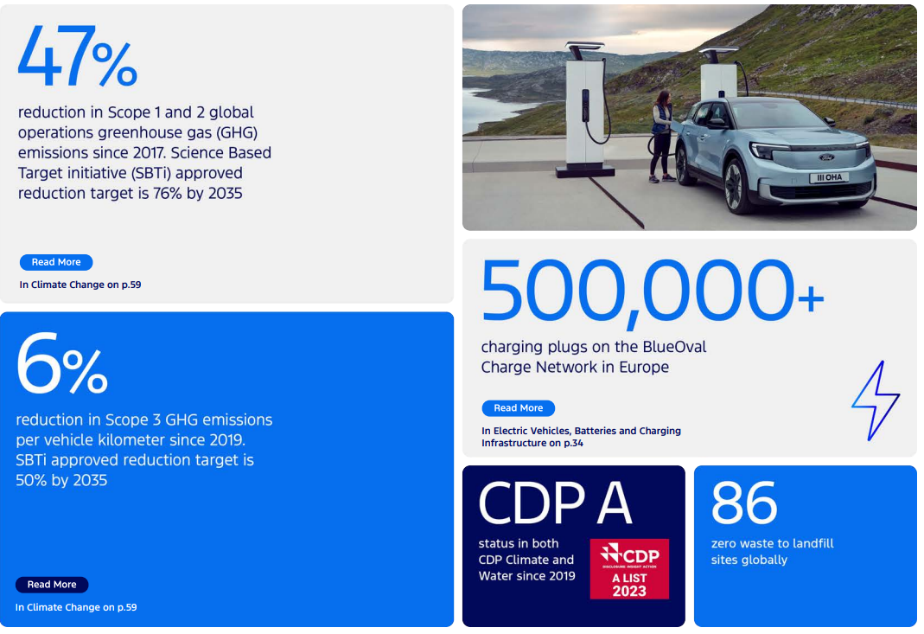
Figure 5: Ford Sustainability and EV Infrastructure Overview
Source: (Ucb, 2024)
The change opens up possibilities of Ford rebranding itself as a sustainable brand and winning a growing consumer market segment. The expenses involved in this transformation are however very high. In the transition phase, Ford has documented billions of dollars of investment losses in its EV segment, and this shows that it is a financially risky venture (Nair, Abhijith and Lienert, 2022).
Moreover, Ford must deal with the depletion of its conventional internal combustion engine to invest in electric cars. This two-fold task makes work more complicated and demands resources on an organisation.

2.3.3 Critical Analysis
The Tesla Company competes strategically on the aspect of environmental factors since sustainability is woven into its operations. Ford, on the contrary, has an expensive and complicated transition. Tesla is favored by the government and consumer demand, but Ford must reorganize its business which strengthens the competitive positionability of Tesla.

2.4 Comparative Evaluation
Tesla has a greater capacity to capitalize on opportunities presented in the macro-environment, transforming changes in technology and environmental changes into competitive edges. The reactive strategy of Ford restricts its capacity to make maximum out of these opportunities (Yang, 2023). Consequently, Tesla has a superior competitiveness in the EV market.

3. Task 2: Strategic Responses

3.1 Porter’s Generic Strategies
The framework of Generic Strategies by Porter shows three main ways in which organisations can develop competitive advantage, namely cost leadership, differentiation and focus. The Tesla and Ford strategic decision-making approaches reflect opposite strategies in competing in the market.

3.1.1 Tesla’s Differentiation Strategy
Tesla uses a differentiation strategy, which places it in the position of a company that provides innovative and technology-driven vehicles. It has high-performance batteries, autonomous driving features, and built-in software systems that characterise its products. Tesla vehicles, which typically sell at a rate of over 40,000 USD and top-quality models at over 100,000 USD are indicative of Tesla concentrating on its ability to provide high-quality instead of competing based on price (Qin, 2022).
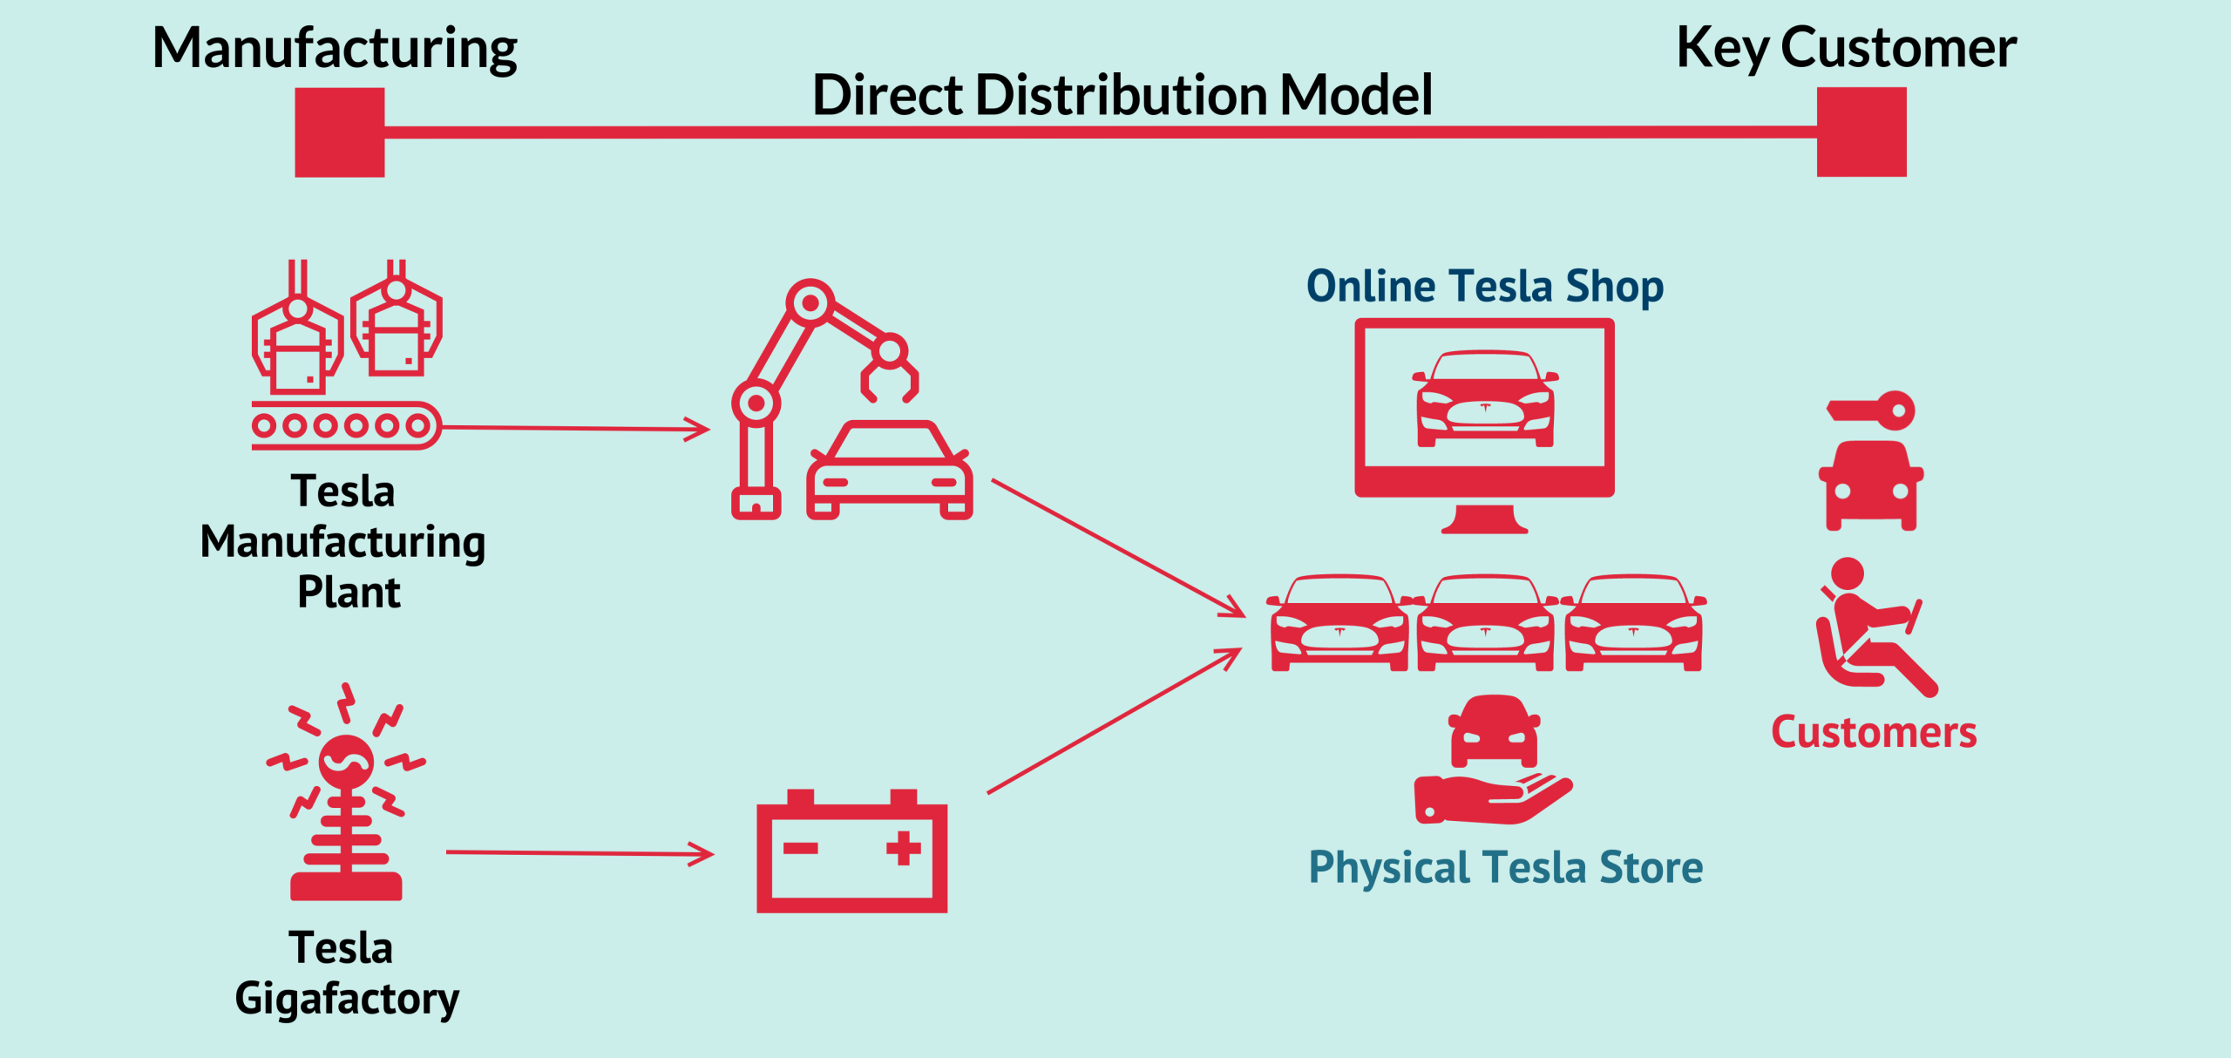
Figure 6: Tesla Direct Distribution Model
Source: (Gennaro Cuofano, 2026)
The ecosystem of Tesla supporting this differentiation strategy by providing software updates over the air, proprietary charging stations, and energy solutions is also in place. These factors generate a special customer experience that cannot be easily imitated by competitors. Subsequently, Tesla can ensure a high level of brand loyalty and minimise price sensitivity among its clientele.
Strategically, the differentiation of Tesla is well adjusted to the technological environment, which enables it to take advantage of innovation and hold on to the leadership positioning. Nevertheless, the method is also associated with risks, such as costly production and reliance on the constant innovation (Xiao, 2024). Lack of ability to maintain technological superiority may undermine its competitive edge in the long-term.

3.1.2 Ford’s Hybrid Strategy
Ford has a hybrid strategy to cost leadership and differentiation. The company aims at manufacturing electric cars which are comparatively cheap but do not compromise brand image or quality of products. The Mustang Mach-E and F-150 Lightning models are set to target a wider audience, and the pricing strategy is aimed at the existing customers of Ford and new EV purchasers (George et al., 2024).
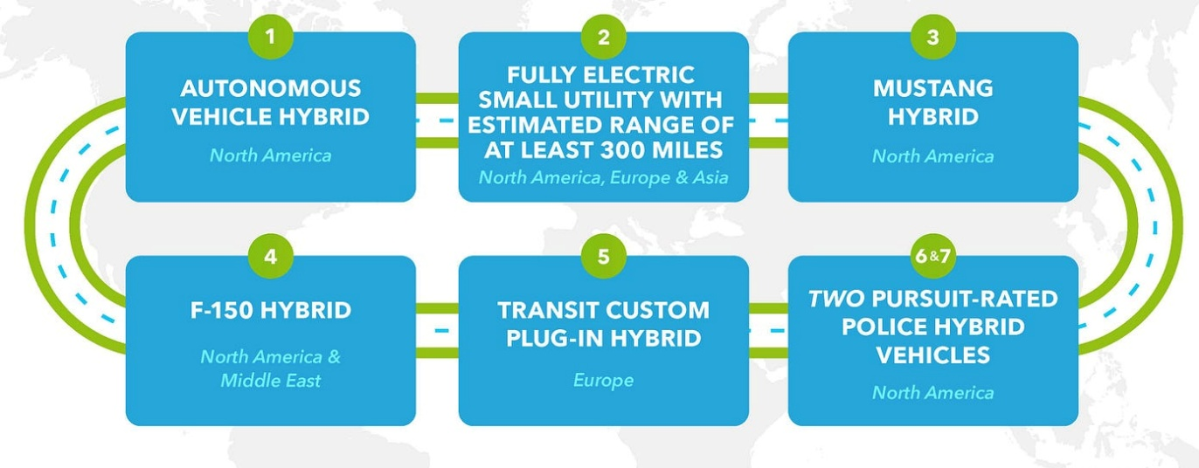
Figure 7: Ford Hybrid and Electric Vehicle Strategy Roadmap
Source: (Company, 2024)
The strategy will enable Ford to capitalize on its well-established manufacturing strengths and economies of scale. Ford manufactures more than 4 million vehicles per year, which helps it to attempt to compete on prices due to the cost efficiencies it enjoys. Meanwhile, the company has also adopted aspects of differentiation by means of design and brand heritage.
Nonetheless, there are challenges associated with the hybrid nature of the strategy of Ford. The effort by Ford to strike a balance between cost and differentiation means that it is likely to lose out in the two aspects. It lacks the technological differentiation Tesla has attained, and it is not entirely dominant on the cost leadership, because EV production is costly. This strategic ambiguity may become a weakness in its overall competitive advantage (Li, 2024).

3.1.3 Comparative Evaluation
Comparing the two strategies, it can be concluded that the clear differentiation of Tesla has a better and more stable competitive advantage. Its innovation-driven orientation enables it to charge high prices and develop a unique position in the market. On the other hand, the hybrid strategy of Ford is more conservative and responsive, potentially preventing it from competing efficiently in a technologically progressive market (Liu, 2024).
Although the strategy that Ford follows minimizes the risk and expands the range of customers, it does not have the strategic focus needed to compete with an innovative competitor. This leads to the significance of strategic clarity in the long-term competitive success.

3.2 Ansoff Matrix Application
The Ansoff Matrix offers a model of analysing organisational growth strategies with respect to the product and market. It recognizes four major strategies namely, the market penetration, product development, market development and the diversification.

3.2.1 Tesla’s Growth Strategy
Tesla uses product development, market development, and diversification as a combination to maintain growth. Its product development can be seen through its constant innovation, which can take the form of new models of vehicles, such as the Cybertruck and Tesla Semi. The products diversify the portfolio of Tesla and cover various market segments to broaden its competitive range (Naor, Coman and Wiznizer, 2021).
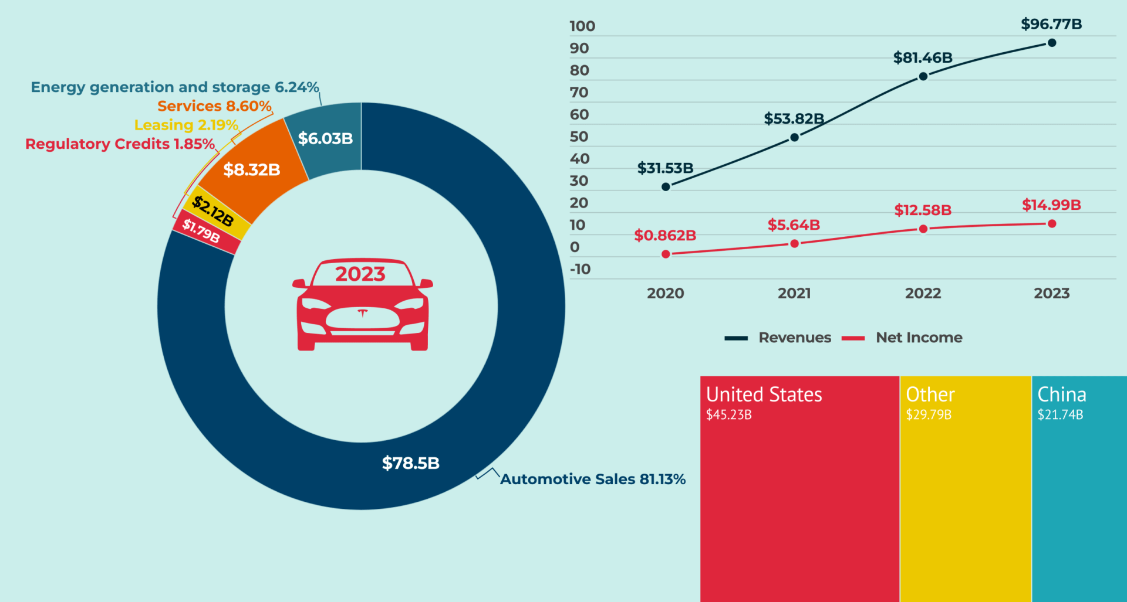
Figure 8: Tesla Revenue Breakdown and Growth Overview
Source: (Gennaro Cuofano, 2024)
Tesla is able to develop the markets by expanding globally. Gigafactories in such cities as Shanghai, Berlin, and Texas help Tesla to expand and enter new markets more efficiently. Tesla has not stopped growing its operations around the world as it produces over 1.8 million vehicles every year (Ghar, 2025).
Another diversification activity that Tesla undergoes is the penetration into the renewable energy segment, such as solar panels and battery storage systems. This diversification creates more sources of revenue worth billions of dollars per year and does not rely on the automotive segment.
Strategically, Tesla can take advantage of the macro-environmental opportunities especially in technological innovation and sustainability trend due to its aggressive growth strategy. Yet, the risks are also high in the given strategy, as it is associated with significant investment and complexity in its working (Miao, 2025).

3.2.2 Ford’s Growth Strategy
Ford concentrates mostly on market penetration and product development. One of the ways the company uses its good brand awareness, and an established customer base is by producing electric versions of its already existing models, including the F-150 Lightning. This will enable Ford to venture into the market of EV with less risk and leverage its current position.
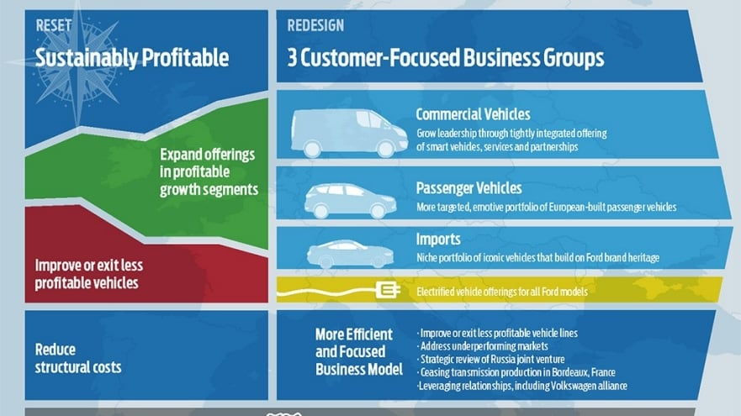
Figure 9: Ford Strategic Restructuring and Business Model Transformation
Source: (Ford, 2019)
Ford plan also involves increasing production capacity to satisfy increasing demand. The company has a target of making more than 2 million electric vehicles every year by 2026, which is an indication of its willingness to expand at a very high rate. Yet, this expansion is not very radical, but mostly incremental (Kaye, 2025).
Ford, in contrast to Tesla, is not diversified in other areas of its business. It is oriented on the transformation of the current operations and not the new markets or product lines. This a conservative strategy which is in line with its status as a follower but restricts its prospects of innovation-driven growth.

3.2.3 Comparative Evaluation
The Tesla growth strategy is more radical and innovative-driven, which allows the company to be in the leading position and respond to the changes on the market. Its product development, expanding its markets and diversification offers it a wide range of growth opportunities and eliminates dependence on one market.
Conversely, Ford expansion plan is less risky and risk averse. Although this strategy is stabilising, it restrains the company in terms of breakthrough innovation and competition with a pioneer organisation. The strategy of Tesla is more in line with the macro-environmental trends, especially in technology and sustainability (Sanci et al., 2021).

3.3 Overall Strategic Evaluation
Tesla is proactive and meets the trends of macro-environment and has a high level of competitiveness. Ford embraces a reactive strategy, whereby it emphasizes on adaptation. Although Ford possesses great resources, it should speed up the innovation to compete.

4. Conclusion
This analysis has shown that technological and environmental factors play a significant role in determining competitiveness in the automotive industry. These factors are well exploited by Tesla that uses method of innovation and differentiation to stay on the edge of the EV market. The legacy systems and reactive strategy make it difficult to Ford to adjust to these changes.
Through strategic analysis, Tesla has better potential to maintain competitive advantage due to its excellent differentiation and aggressive growth strategy. Ford is conservative, and it reduces its competitiveness, although it has invested heavily in electrification.
Finally, pioneering organisations stand at a better position to exploit changes on the macro-environment whereas the follower organisations have to keep adjusting to stay competitive. The success of Tesla and Ford shows that with the help of innovation, strategic focus, and proactive adaptation, the success in the long run is possible.

5. Reference List
Company, F.M. (2024). How Ford Will Electrify Vehicles to Make Them Better. [online] Medium. Available at: https://medium.com/newco/how-ford-will-electrify-vehicles-to-make-them-better-f4970fbd426e
EBSCO. (2024). Tesla Inc | Business and Management | Research Starters | EBSCO Research. [online] Available at: https://www.ebsco.com/research-starters/business-and-management/tesla-inc
Ford.com. (2019). Ford to Strengthen European Competitive Position and Profitability; Sets Vision for the Future | Nederland | Nederlands | Ford Media Center. [online] Available at: https://media.ford.com/content/fordmedia/feu/nl/nl/news/2019/01/10/ford-to-strengthen-european-competitive-position-and-profitabili.html
Gennaro Cuofano (2024). How Does Tesla Make Money? - FourWeekMBA. [online] FourWeekMBA. Available at: https://fourweekmba.com/how-does-tesla-make-money/
Gennaro Cuofano (2026). Tesla Business Model Analysis - FourWeekMBA. [online] FourWeekMBA. Available at: https://fourweekmba.com/tesla-business-model/
George, G.B., Linda, L.I., Pimpini, A. and Lau, V. (2024). Ford China Strategic Analysis. [online] ResearchGate. Available at: https://www.researchgate.net/publication/381458852_Ford_China_Strategic_Analysis
Ghar, S. (2025). Tesla’s International Business Strategy. SSRN Electronic Journal. [online] doi: https://doi.org/10.2139/ssrn.5258192.
Kaye, D. (2025). Ford to scale back electric vehicle plans, taking $19.5bn hit. [online] Bbc.com. Available at: https://www.bbc.com/news/articles/c0l9j65w30eo
Klimova, I., Hordieieva, I., Sereda, N., Pashchenko, O. and Petecki, I. (2023). STRATEGIC MARKETING IN A DYNAMIC MARKET ENVIRONMENT: Conhecimento & Diversidade, [online] 15(40), pp.98–118. doi: https://doi.org/10.18316/rcd.v15i40.11273.
Li, H. (2024). Financial Analysis and Future Outlook of Ford Motor Company. Advances in Economics, Management and Political Sciences, [online] 74(1), pp.84–90. doi: https://doi.org/10.54254/2754-1169/74/20241518.
Liu, Y. (2024). Tesla Market Strategy Analysis in the Future. Highlights in Business, Economics and Management, [online] 40, pp.941–949. doi: https://doi.org/10.54097/0qz1vs81.
Lu, M. (2024). Charted: Tesla’s Market Cap Nears Half of Global Auto Industry. [online] Visual Capitalist. Available at: https://www.visualcapitalist.com/charted-teslas-market-cap-nears-half-of-global-auto-industry/
Lu, S. (2024). Overcoming Obstacles of Tesla: Strategies for Problem-Solving. Highlights in Business, Economics and Management, [online] 40, pp.514–519. doi: https://doi.org/10.54097/cw7ssm33.
Miao, T. (2025). Strategic Analysis of Teslas Future Growth: Innovation, Expansion, and Market Trends. Advances in Economics, Management and Political Sciences, [online] 225(1), pp.24–29. doi: https://doi.org/10.54254/2754-1169/2025.cau27622.
Mu, Y. (2023). Research on Sustainable Competitive Advantage Strategy of Leading Electric Vehicle Enterprises. Frontiers in Business, Economics and Management, [online] 9(3), pp.193–200. doi: https://doi.org/10.54097/fbem.v9i3.9654.
Nair, A., Abhijith Ganapavaram and Lienert, P. (2022). Ford boosts EV spending to $50 billion, sets up new Model e unit. [online] Reuters. Available at: https://www.reuters.com/business/autos-transportation/ford-run-ev-ice-businesses-separately-2022-03-02/
Naor, M., Coman, A. and Wiznizer, A. (2021). Vertically Integrated Supply Chain of Batteries, Electric Vehicles, and Charging Infrastructure: A Review of Three Milestone Projects from Theory of Constraints Perspective. Sustainability, [online] 13(7), p.3632. doi: https://doi.org/10.3390/su13073632.
Parashar, J. (2019). Is Tesla Really Doing More Harm than Good to the Environment? [online] Market Realist. Available at: https://marketrealist.com/2019/04/is-tesla-really-doing-more-harm-than-good-to-the-environment/
Qin, K. (2022). Analysis of Tesla’s Innovation Strategy and Influence of Leadership. Advances in Economics, Business and Management Research, [online] pp.228–238. doi: https://doi.org/10.2991/978-94-6463-054-1_26.
Quartr. (2024). Tesla: Leading the EV Revolution. [online] Quartr.com. Available at: https://quartr.com/insights/company-research/tesla-leading-the-ev-revolution
Rejeb, A., Rejeb, K. and Süle, E. (2025). Key issues in electric vehicle battery supply chains based on English-language news articles: a machine learning approach. Energy Nexus, [online] 20, p.100595. doi: https://doi.org/10.1016/j.nexus.2025.100595.
Richter, F. (2022). Infographic: Ford Announces Restructuring to Catch Up With EV Leaders. [online] Statista Daily Data. Available at: https://www.statista.com/chart/26981/top-electric-vehicle-makers/
Roberson, R. (2022). Ford History | Robbie Roberson Ford Inc. | (912) 283-3131. [online] Robbierobersonford.net. Available at: https://www.robbierobersonford.net/ford-history.htm
Sanci, E., Daskin, M.S., Hong, Y.-C., Roesch, S. and Zhang, D. (2021). Mitigation strategies against supply disruption risk: a case study at the Ford Motor Company. International Journal of Production Research, [online] 60(19), pp.5956–5976. doi: https://doi.org/10.1080/00207543.2021.1975058.
Sotoodeh, A. (2025). Strategic Response to Market Disruption: Ford Motor Company’s Digital Transformation in the Age of... ResearchGate. [online] doi: https://doi.org/10.13140/RG.2.2.33689.68968.
Su, T. (2024). Comparative Analysis of Tesla and Ford: Investment Recommendations Based on the 7Ps Marketing Portfolio and Porter’s Five Forces Model. Transactions on Economics, Business and Management Research, [online] 13, pp.212–219. doi: https://doi.org/10.62051/f5tc1w57.
Susanto, M. and Ellitan, L. (2024). Unveiling the Tesla Touch in Supply Chain Effectiveness. International Journal of Research, [online] 11(2), pp.71–90. doi: https://doi.org/10.5281/zenodo.10647340.
Tang, Y. (2023). Tesla’s Pioneering Role in the New Energy Vehicle Industry: Strategies for Success. Highlights in Business, Economics and Management, [online] 23, pp.988–991. doi: https://doi.org/10.54097/fxhd6327.
Tulay, M. (2019). A tale of two companies: Tesla, Ford and the need for long-term plans. [online] Trellis. Available at: https://trellis.net/article/tale-two-companies-tesla-ford-and-need-long-term-plans/
Ucb. (2024). UCB net-zero targets validated by the Science Based Targets initiative: a critical step in our sustainability agenda | UCB. [online] Available at: https://www.ucb.com/about-ucb/magazine/detail/article/ucb-net-zero-targets-validated-by-the-science-based-targets-initiative-a-critical-step-in-our-sustainability-agenda
Wayland, M. (2022). Ford vs. GM: Same industry, two increasingly different companies. [online] CNBC. Available at: https://www.cnbc.com/2022/11/13/ford-vs-gm-same-industry-two-increasingly-different-companies.html
Williment, C. (2025). How Tesla is an EV, Renewable Energy & Sustainability Leader. [online] Sustainabilitymag.com. Available at: https://sustainabilitymag.com/news/how-tesla-is-an-ev-renewable-energy-sustainability-leader
Xiao, N. (2024). An Analysis of Tesla’s Disruptive Innovation Strategy. Advances in Economics, Management and Political Sciences, [online] 121(1), pp.63–69. doi: https://doi.org/10.54254/2754-1169/121/20242572.
Yang, R. (2023). Research on Teslas Business Model on Obtaining Competitive Advantages. Advances in Economics, Management and Political Sciences, [online] 25(1), pp.159–164. doi: https://doi.org/10.54254/2754-1169/25/20230492.
Zhang, R. and Ding, X. (2024). A study on the Impact of Tesla’s Autonomous Driving Technology on Its Performance. International Journal of Global Economics and Management, [online] 5(2), pp.72–78. doi: https://doi.org/10.62051/ijgem.v5n2.09.

