Name:Viktoriya Adrianova Adalbertova
Student number:1818237
Lecturer:Rexon Nting

Accounting Fundamentals

Assessment 1

Table of Contents
Task 1 4
a) Closing ledger accounts for the transactions of Maxim Bakery Business 4
b) List of closing balances as on April 30 9
c) Profit and Loss Statement and Balance Sheet for the month ended April 30 10
Task 2 11
a) Ledgers for the transactions 11
b) Trial Balance as at January 30 16
c) Statement of Profit or Loss and Balance Sheet for the month ended January 31 18
Task 3 20
a) Ledger accounts 20
b) Trial Balance as on January 31 28
c) Statement of Profit and Loss and Balance Sheet as on January 31 29
Task 4 31
Ledger accounts and Trial Balance as on June 27 for Ricardo, a sole trader 31
Task 5 Differences between Revenue Expenditure and Capital Expenditure by drawing inferences from International Accounting Standards 37
References 39

Task 1

Closing ledger accounts for the transactions of Maxim Bakery Business

Date | Original Journal Entries |  | £ | £
 |  |  | Dr. | Cr.
05-Apr | Cash Account |  | 300
 |  | To Capital Account |  | 300
 | (Being Capital brought into business)
07-Apr | Purchases Account |  | 250
 |  | To Cash Account |  | 250
 | (Being goods purchased)
08-Apr | Cash Account |  | 250
 |  | To Loan Payable Account |  | 250
 | (Being loan received from Tatiana to be repaid within twelve months)
15-Apr | Motor Van Account |  | 150
 |  | To Cash Account |  | 150
 | (Being Motor van purchased for cash)
20-Apr | Cash Account |  | 350
 |  | To Sales Account |  | 350
 | (Being goods sold for cash)
28-Apr | Rent Account |  | 50
 |  | To Cash Account |  | 50
 | (Being rent paid)
29-Apr | Loan Payable Account |  | 200
 |  | To Cash Account |  | 200
 | (Being part of the loan repaid)
30-Apr | Maxim, Drawings Account |  | 60
 |  | To Cash Account |  | 60
 | (Being Cash withdrawn from business)
Date | Month end closing Journal Entries |  | £ | £
30-Apr | Sales Account |  | 350
 |  | To Statement of Profit and Loss |  | 350
 | (Being sales transferred to Statement of Profit and Loss)
30-Apr | Statement of Profit and Loss |  | 200
 |  | To Purchases Account |  | 100
 | (Being purchases transferred to Statement of Profit and Loss)
30-Apr | Closing Stock |  | 100
 |  | To Statement of Profit and Loss |  | 100
 | (Being closing stock transferred to Statement of Profit and Loss)
30-Apr | Statement of Profit and Loss |  | 50
 |  | To Rent Account |  | 50
 | (Being expenses transferred to Statement of Profit and Loss)
30-Apr | Capital Account |  | 200
 |  | To Statement of Profit and Loss |  | 200
 | (Being Net Profit transferred to Capital Account)
30-Apr | Capital Account |  | 60
 |  | To Maxim, Drawings |  | 60
 | (Being drawings reduced from Capital Account)

Maxim's Books of Accounts
Cash Account
Date | Description | Amount ( £) | Date | Description | Amount( £)
05-Apr | Capital | 300 | 07-Apr | Purchases | 200
08-Apr | Loan Payable | 250 | 15-Apr | Motor Van | 150
20-Apr | Sales | 350 | 28-Apr | Rent | 50
 |  |  | 29-Apr | Loan Payable | 200
 |  |  | 30-Apr | Maxim, Drawings | 60
 |  |  | 30-Apr | By Balance c/d | 240
 |  | 900 |  |  | 900
01-May | To Balance b/d | 240
Capital Account
Date | Description | Amount ( £) | Date | Description | Amount( £)
 |  |  | 05-Apr | Cash | 300
30-Apr | Maxim, Drawings | 60 | 30-Apr | Statement of Profit and Loss | 200
30-Apr | To Balance c/d | 440
 |  | 500 |  |  | 500
 |  |  | 01-May | By Balance b/d | 440
Loan Payable Account
Date | Description | Amount ( £) | Date | Description | Amount( £)
 |  |  | 08-Apr | Cash | 250
29-Apr | Cash | 200
30-Apr | To Balance c/d | 50
 |  | 250 |  |  | 250
 |  |  | 01-May | By Balance b/d | 250
Sales Account
Date | Description | Amount ( £) | Date | Description | Amount( £)
 |  |  | 08-Apr | Cash Sales | 350
30-Apr | Statement of Profit and Loss | 350
Motor Van Account
Date | Description | Amount ( £) | Date | Description | Amount( £)
15-Apr | Cash | 250
Purchases Account
Date | Description | Amount ( £) | Date | Description | Amount( £)
07-Apr | Cash | 200
 |  |  | 30-Apr | By Statement of Profit and Loss | 200
Rent Account
Date | Description | Amount ( £) | Date | Description | Amount( £)
28-Apr | Cash | 50
 |  |  | 30-Apr | By Statement of Profit and Loss | 50
Maxim, Drawings Account
Date | Description | Amount ( £) | Date | Description | Amount( £)
30-Apr | Cash | 60
 |  |  | 30-Apr | Capital Account | 60

List of closing balances as on April 30 for Maxim Bakery Business

Maxim's Bakery Business
Trial Balance (before adjustments) as of April 30
 | Debit | Credit
 | £ | £
Cash | 240
Motor van | 150
Purchases | 200
Sales |  | 350
Capital |  | 300
Loan Payable |  | 50
Rent | 50
Drawings' | 60
 | 700 | 700

Profit and Loss Statement and Balance Sheet for the month ended April 30

Maxim Business
Statement of Profit and Loss for month ended April 30
 | £
Sales | 350
Less:
Purchases | 200
 | 150
Add: Closing Stock | 100
Gross Profit | 250
Less: Expenses
Rent | 50
Net Profit for the month | 200


Maxim Business
Balance Sheet for the month ended April 30
 | £ | £
Fixed Assets
Motor Van |  | 150
Current Assets
Inventory | 100
Cash | 240
 | 340
Current Liability
Loan Payable | 50 | 290
 |  | 440
Capital
Balance as on 5th April |  | 300
Add: Net Profit for the year | 200
Less: Drawings | 60 | 140
 |  | 440


Task 2

Ledgers for the transactions of Pendo’s Business

Date | Original Journal Entries |  | £ | £
 |  |  | Dr. | Cr.
01-Jan | Cash Account |  | 5000
 |  | To Pendo Capital Account |  | 5000
 | (Being Capital brought into business by Pendo.)
02-Jan | Motor Van Account |  | 600
 |  | To Cash Account |  | 600
 | (Being Motor van purchased for cash.)
03-Jan | Purchases Account |  | 1300
 |  | To Cash Account |  | 1300
 | (Being goods purchased for cash.)
04-Jan | Cash Account |  | 1000
 |  | To Loan Payable Account |  | 1000
 | (Being loan received from Sergei to be repaid within twelve months.)
10-Jan | Motor Van Repairs Account |  | 200
 |  | To Cash Account |  | 200
 | (Being expenses paid for Motor van)
13-Jan | Cash Account |  | 300
 |  | To Sales Account |  | 300
 | (Being goods sold for cash)
20-Jan | Cash Account |  | 500
 |  | To Sales Account |  | 500
 | (Being goods sold for cash)
20-Jan | Storage Expenses Account |  | 150
 |  | To Cash Account |  | 150
 | (Being storage expenses paid)
27-Jan | Loan Payable Account |  | 350
 |  | To Cash Account |  | 350
 | (Being part of the loan repaid to Sergei)
30-Jan | Pendo Drawings Account |  | 175
 |  | To Cash Account |  | 175
 | (Being Cash withdrawn from business)
Date | Month end closing Journal Entries |  | £ | £
31-Jan | Sales Account |  | 800
 |  | To Statement of Profit and Loss |  | 800
 | (Being sales transferred to Statement of Profit and Loss)
31-Jan | Statement of Profit and Loss |  | 1300
 |  | To Purchases Account |  | 1300
 | (Being purchases transferred to Statement of Profit and Loss)
31-Jan | Closing Stock |  | 800
 |  | To Statement of Profit and Loss |  | 800
 | (Being closing stock transferred to Statement of Profit and Loss)
31-Jan | Statement of Profit and Loss |  | 150
 |  | To Storage Expenses Account |  | 150
 | (Being expenses transferred to Statement of Profit and Loss)
31-Jan | Statement of Profit and Loss |  | 200
 |  | To Motor Van Repairs Account |  | 200
 | (Being expenses transferred to Statement of Profit and Loss)
31-Jan | Pendo Capital Account |  | 50
 |  | To Statement of Profit and Loss |  | 50
 | (Being Net Loss transferred to Capital Account)
31-Jan | Pendo Capital Account |  | 175
 |  | To Pendo Drawings |  | 175
 | (Being drawings reduced from Capital Account)

Pendo's Books of Accounts
Cash Account
Date | Description | Amount ( £) | Date | Description | Amount ( £)
01-Jan | Pendo Capital | 5000 | 02-Jan | Motor Van Repairs | 600
27-Jan | Loan Payable | 1000 | 03-Jan | Purchases | 1300
13-Jan | Sales | 300 | 10-Jan | Motor Van Repairs | 200
20-Jan | Sales | 500 | 20-Jan | Storage Expenses | 150
 |  |  | 27-Jan | Loan Payable | 350
 |  |  | 30-Jan | Pendo Drawings | 175
 |  |  |  | By Balance c/d | 4025
 |  | 6800 |  |  | 6800
01-Feb | To Balance b/d | 4025
Pendo Capital Account
Date | Description | Amount ( £) | Date | Description | Amount ( £)
 |  |  | 01-Jan | Cash | 5000
31-Jan | Pendo Drawings | 175
31-Jan | Statement of Profit and Loss | 50
31-Jan | To Balance c/d | 4775
 |  | 5000 |  |  | 5000
 |  |  | 01-Feb | By Balance b/d | 4775
Loan Payable Account
Date | Description | Amount ( £) | Date | Description | Amount ( £)
20-Jan | Cash | 350 | 27-Jan | Cash | 1000
31-Jan | To Balance c/d | 650
 |  | 1000 |  |  | 1000
 |  |  |  | By Balance b/d | 650
Sales Account
Date | Description | Amount ( £) | Date | Description | Amount ( £)
 |  |  | 13-Jan | Cash | 300
 |  |  | 20-Jan | Cash | 500
31-Jan | To Statement of Profit and Loss | 800
Motor Van Account
Date | Description | Amount ( £) | Date | Description | Amount ( £)
02-Jan | Cash | 600
Purchases Account
Date | Description | Amount ( £) | Date | Description | Amount ( £)
03-Jan | Cash | 1300
 |  |  | 31-Jan | By Statement of Profit and Loss | 1300
Storage Expenses Account
Date | Description | Amount ( £) | Date | Description | Amount ( £)
20-Jan | Cash | 150
 |  |  | 31-Jan | By Statement of Profit and Loss | 150
Motor Van Repairs Account
Date | Description | Amount ( £) | Date | Description | Amount ( £)
10-Jan | Cash | 200
 |  |  | 31-Jan | By Statement of Profit and Loss | 200
Pendo Drawings Account
Date | Description | Amount ( £) | Date | Description | Amount ( £)
30-Jan | Cash | 175
 |  |  | 31-Jan | Pendo Capital | 175

Trial Balance as at January 30

Pendo's Business
Trial Balance (before adjustments) as of January 31
 | Debit | Credit
 | £ | £
Cash | 4025
Motor van | 600
Purchases | 1300
Sales |  | 800
Capital |  | 5000
Loan Payable |  | 650
Storage Expenses | 150
Motor Van Repairs | 200
Drawings | 175
 | 6450 | 6450

Statement of Profit or Loss and Balance Sheet for the month ended January 31

Pendo Business
Statement of Profit and Loss for month ended January 31
 | £ | £
Sales |  | 800
Less:
Purchases |  | 1300
 |  | -500
Add: Closing Stock |  | 800
Gross Profit |  | 300
Less: Expenses
Storage Expenses | 150
Motor Van Repairs | 200 | 350
Net Loss for the month |  | 50

Pendo Business
Balance Sheet for the month ended January 31
 | £ | £
Fixed Assets
Motor Van |  | 600
Current Assets
Inventory | 800
Cash | 4025
 | 4825
Current Liability
Loan Payable | 650 | 4175
 |  | 4775
Capital
Balance as on 1st January | 5000
Less: Net Loss for the year | 50
Less: Drawings | 175 | 4775
 |  | 4775

Task 3

Ledger accounts for Mafuta’s Business

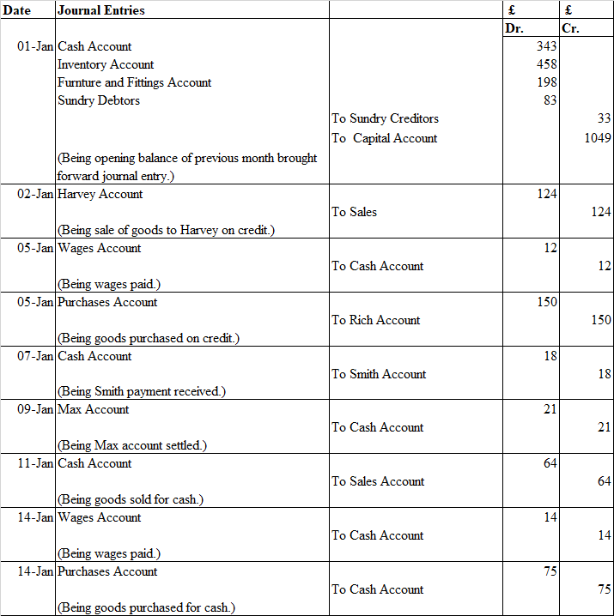

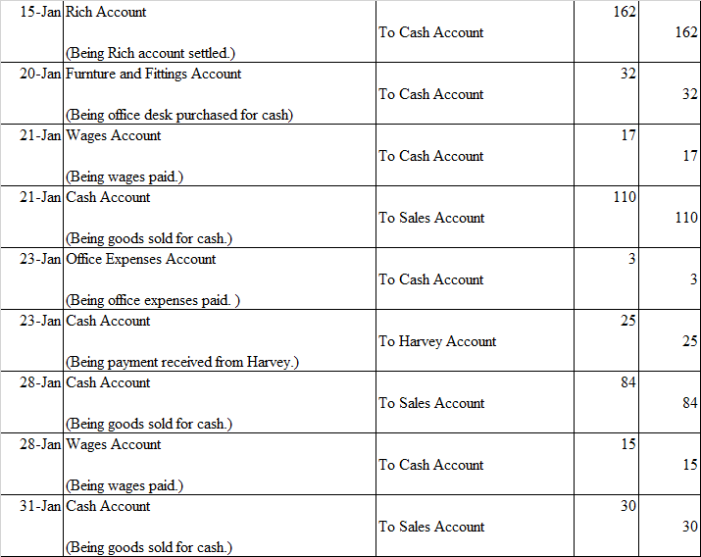

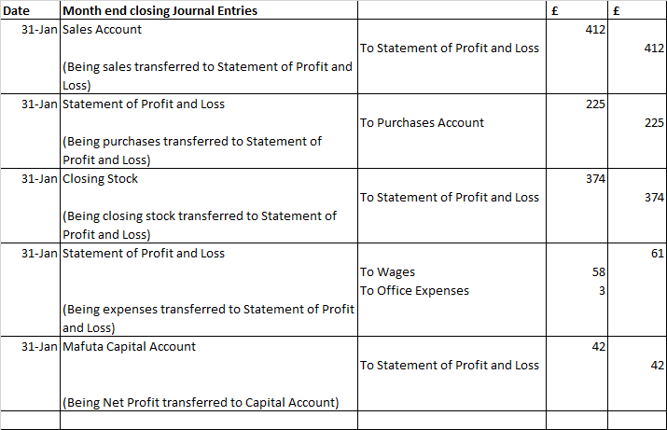

Mafuta's Books of Accounts
Cash Account
Date | Description | Amount ( £) | Date | Description | Amount ( £)
01-Jan | Balance b/d | 343 | 05-Jan | Wages | 12
07-Jan | Smith | 18 | 09-Jan | Max | 21
11-Jan | Sales | 64 | 14-Jan | Wages | 14
21-Jan | Sales | 110 | 14-Jan | Purchases | 75
23-Jan | Harvey | 25 | 15-Jan | Rich | 162
28-Jan | Sales | 84 | 20-Jan | Office Desk | 32
31-Jan | Sales | 30 | 21-Jan | Wages | 17
 |  |  | 23-Jan | Office Expenses | 3
 |  |  | 28-Jan | Wages | 15
 |  |  |  | Balance c/d | 323
 |  | 674 |  |  | 674
01-Feb | Balance b/d | 323
Mafuta Capital Account
Date | Description | Amount ( £) | Date | Description | Amount ( £)
 |  |  | 07-Jan | Balance c/d | 1049
 |  |  | 31-Jan | Statement of Profit and Loss | 42
31-Jan | To Balance c/d | 1091
 |  | 1091 |  |  | 1091
 |  |  | 01-Feb | By Balance b/d | 1091
Sales Account
Date | Description | Amount ( £) | Date | Description | Amount ( £)
 |  |  | 02-Jan | Harvey | 124
 |  |  | 11-Jan | Cash | 64
 |  |  | 21-Jan | Cash | 110
 |  |  | 28-Jan | Cash | 84
31-Jan | Statement of Profit and Loss | 412 | 31-Jan | Cash | 30
Furniture and Fittings Account
Date | Description | Amount ( £) | Date | Description | Amount ( £)
01-Jan | Balance b/d | 198
20-Jan | Cash | 32 | 31-Jan | Balance c/d | 230
 |  | 230 |  |  | 230
01-Feb | Balance b/d | 230
Purchases Account
Date | Description | Amount ( £) | Date | Description | Amount ( £)
05-Jan | Rich | 150
14-Jan | Cash | 75
 |  |  | 31-Jan | Statement of Profit and Loss | 225
Wages Account
Date | Description | Amount ( £) | Date | Description | Amount ( £)
05-Jan | Cash | 12
14-Jan | Cash | 14
21-Jan | Cash | 17
28-Jan | Cash | 15 | 31-Jan | Statement of Profit and Loss | 58
Office Expenses Account
Date | Description | Amount ( £) | Date | Description | Amount ( £)
23-Jan | Cash | 3
 |  |  | 31-Jan | Statement of Profit and Loss | 3
Sundry Debtors Ledger
Smith Account
Date | Description | Amount ( £) | Date | Description | Amount ( £)
01-Jan | Balance b/d | 18 | 07-Jan | Cash | 18
Harvey Account
Date | Description | Amount ( £) | Date | Description | Amount ( £)
01-Jan | Balance b/d | 39 | 23-Jan | Cash | 25
02-Jan | Sales | 124
 |  |  | 31-Jan | Balance c/d | 138
 |  | 163 |  |  | 163
01-Feb | Balance b/d | 138
Moon Account
Date | Description | Amount ( £) | Date | Description | Amount ( £)
01-Jan | Balance b/d | 26
 |  |  | 31-Jan | Balance c/d | 26
 |  | 26 |  |  | 26
01-Feb | Balance b/d | 26
Sundry Creditors Ledger
Rich Account
Date | Description | Amount ( £) | Date | Description | Amount ( £)
15-Jan | Cash | 162 | 01-Jan | Balance c/d | 12
 |  |  | 05-Jan | Purchases | 150
 |  | 162 |  |  | 162
Max Account
Date | Description | Amount ( £) | Date | Description | Amount ( £)
09-Jan | Cash | 21 | 01-Jan | Balance c/d | 21

Trial Balance as on January 31

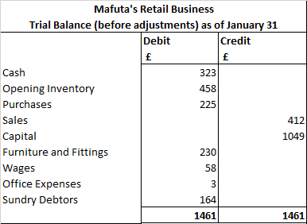

Statement of Profit and Loss and Balance Sheet as on January 31

Mafuta Business
Statement of Profit and Loss for month ended January 31
 | £ | £
Sales |  | 412
Less:
Cost of Goods Sold
Opening Stock | 458
Add: Purchases | 225
Less: Closing Stock | 374 | 309
Gross Profit |  | 103
Less: Expenses
Wages | 58
Office Expenses | 3 | 61
Net Profit for the month |  | 42

Mafuta Retail Business
Balance Sheet for the month ended January 31
 | £ | £
Fixed Assets
Furniture and Fittings |  | 230
Current Assets
Inventory | 374
Sundry Debtors | 164
Cash | 323
 |  | 861
 |  | 1091
Capital
Balance as on 1st January | 1049
Add: Net Profit for the year | 42
 |  | 1091

Task 4

Ledger accounts and Trial Balance as on June 27 for Ricardo, a sole trader
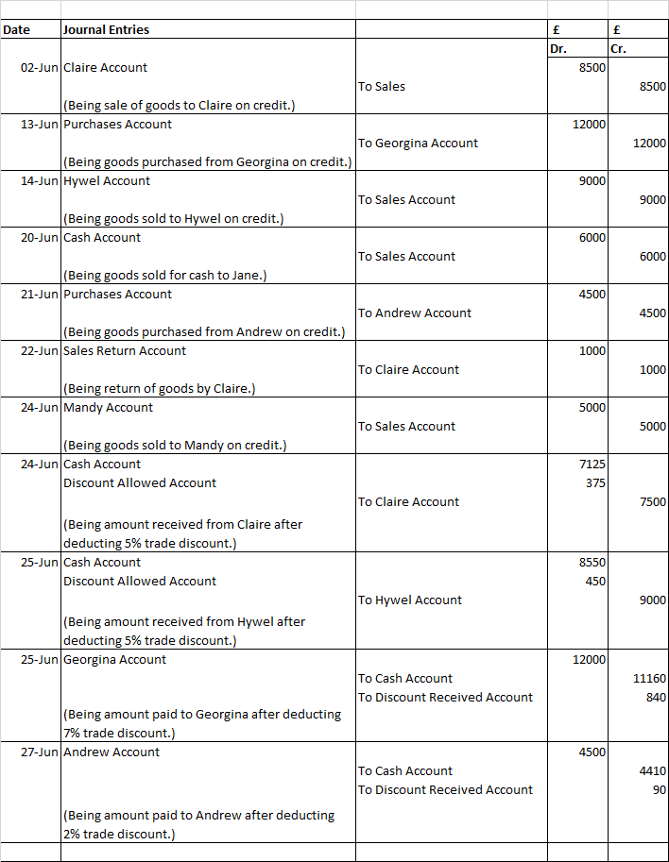

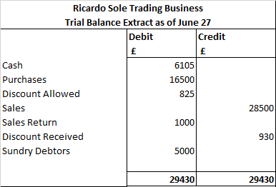

Ricardo's Books of Accounts
Cash Account
Date | Description | Amount ( £) | Date | Description | Amount ( £)
20-Jun | Sales | 6000 | 25-Jun | Georgina | 11160
24-Jun | Claire | 7125 | 27-Jun | Andrew | 4410
25-Jun | Hywel | 8550
 |  |  | 27-Jun | Balance c/d | 6105
 |  | 21675 |  |  | 21675
28-Jun | Balance b/d | 6105
Sales Account
Date | Description | Amount ( £) | Date | Description | Amount ( £)
 |  |  | 02-Jun | Claire | 8500
 |  |  | 14-Jun | Hywel | 9000
 |  |  | 20-Jun | Cash Sales (Jane) | 6000
 |  |  | 24-Jun | Mandy | 5000
27-Jun | Balance c/d | 28500
 |  | 28500 |  |  | 28500
 |  |  | 28-Jun | Balance b/d | 28500
Purchases Account
Date | Description | Amount ( £) | Date | Description | Amount ( £)
13-Jun | Georgina | 12000
21-Jun | Andrew | 4500
 |  |  | 27-Jun | Balance c/d | 16500
 |  | 16500 |  |  | 16500
28-Jun | Balance b/d | 16500
Sales Returns Account
Date | Description | Amount ( £) | Date | Description | Amount ( £)
22-Jun | Sales Return | 1000
 |  |  | 27-Jun | Balance c/d | 1000
 |  | 1000 |  |  | 1000
28-Jun | Balance b/d | 1000
Discount Received Account
Date | Description | Amount ( £) | Date | Description | Amount ( £)
 |  |  | 25-Jun | Georgina | 840
 |  |  | 27-Jun | Andrew | 90
27-Jun | Balance c/d | 930
 |  | 930 |  |  | 930
 |  |  | 28-Jun | Balance c/d | 930
Discount Allowed Account
Date | Description | Amount ( £) | Date | Description | Amount ( £)
24-Jun | Claire | 375
25-Jun | Hywel | 450
 |  |  | 27-Jun | Balance c/d | 825
 |  | 825 |  |  | 825
28-Jun | Balance b/d | 825
Sundry Debtors Ledger
Claire Account
Date | Description | Amount ( £) | Date | Description | Amount ( £)
02-Jun | Sales | 8500 | 22-Jun | Sales Return | 1000
 |  |  | 24-Jun | Cash | 7125
 |  |  | 24-Jun | Discount Allowed | 375
 |  | 8500 |  |  | 8500
Hywel Account
Date | Description | Amount ( £) | Date | Description | Amount ( £)
14-Jun | Sales | 9000 | 25-Jun | Cash | 8550
 |  |  | 25-Jun | Discount Allowed | 450
 |  | 9000 |  |  | 9000
Mandy Account
Date | Description | Amount ( £) | Date | Description | Amount ( £)
24-Jun | Mandy | 5000
 |  |  | 27-Jun | Balance c/d | 5000
 |  | 5000 |  |  | 5000
28-Jun | Balance b/d | 5000
Sundry Creditors Ledger
Georgina Account
Date | Description | Amount ( £) | Date | Description | Amount ( £)
25-Jun | Cash | 11160 | 13-Jun | Purchases | 12000
25-Jun | Discount Received | 840
 |  | 12000 |  |  | 12000
Andrew Account
Date | Description | Amount ( £) | Date | Description | Amount ( £)
27-Jun | Cash | 4410 | 21-Jun | Purchases | 4500
27-Jun | Discount Received | 90
 |  | 4500 |  |  | 4500

Task 5 Differences between Revenue Expenditure and Capital Expenditure by drawing inferences from International Accounting Standards

Capital Expenditure are expenditures related to fixed assets which will be used for generating revenue over a long time period in the business. For example, purchase of equipments, machinery etc. Revenue expenditures relate to routine and recurring expenditures incurred for revenue transactions or repairs and maintenance of non-current assets during the current operating period. For example, Expenses incurred for paying salary, distribution expenses, office expenses etc (O'Hare, 2016). To consider an expenditure or revenue expenditure, it has to be seen whether the expenditure is for the short-term or long-term. Revenue expenditures are usually recurring operating expenses whereas Capital expenditures are huge one-time expenditure incurred mostly for purchase of fixed assets ,used for generating revenue over many years. The benefit of revenue expenditure is derived in the current financial year (O'Hare, 2016) . Capital expenditure and Revenue expenditure are treated differently in the books of accounts due to their varying nature.

According to FRS 102 and tax rules of UK, if any expenditure is incurred to maintain a non-current asset or retain its earning capacity then the expenditure is classified as revenue expenditure. Expenditures incurred to provide incremental future benefits that results in better earning capacity or which lengthens the life of the non-current asset are classified as capital expenditures. When any expenditure has been incurred on a fixed asset, it should be seen whether such an expenditure extends the life of the asset or increases its earning power so at to call it capital expenditure and should be capitalised. (Ernst & Young LLP, 2019) .FRS 102 also talks about the treatment for replaced parts, i.e., if replaced parts were not separately depreciated, an estimate of its disposal book value is made by considering replacement cost and depreciating it for the time it has been utilised (Ernst & Young LLP, 2019) .

According to IAS 16 Property, Plant and Equipment, expenses incurred on maintenance and routine servicing of an asset is considered as revenue expense and includes labour, items of a recurrent nature and small parts. However, any addition to a non-current asset has to be capitalised whether they show an incremental future benefit or not thus reducing the occurrence of fraud in reporting. IAS 16 speaks about the replacement parts treatment, wherein, it states that if the replaced part does not have its own net book value, then it is valued as the cost of the replacement without applying any depreciation to it (Ernst & Young LLP, 2018).

The way to treat expenditure on a fixed asset, known as’ subsequent expenditure’ has been provided in FRS 15 which is about ‘Tangible Fixed Assets’ (Ernst & Young LLP, 2019). FRS 15 states that subsequent expenditure can be capitalised only, when it increases the value of the fixed asset from its current state, where a part of the fixed asset was treated separately for depreciation purpose or is replaced or restored and where a huge expenditure has been incurred on the fixed asset that reinstates its prior economic benefits.

Capital expenditure has to be capitalised and depreciated accordingly in income statement. Revenue expenditure is treated as an expense for the accounting period in which it is incurred (O'Hare, 2016).

References

Ernst & Young LLP, 2018. International GAAP 2019. Chichester: John Wiley & Sons.
Ernst & Young LLP, 2019. UK GAAP 2019: Generally Accepted Accounting Practice under UK and Irish GAAP. Chicester: John Wiley & Sons.
O'Hare, J., 2016. Analysing Financial Statements for Non-Specialists. Columbus: Routledge.

