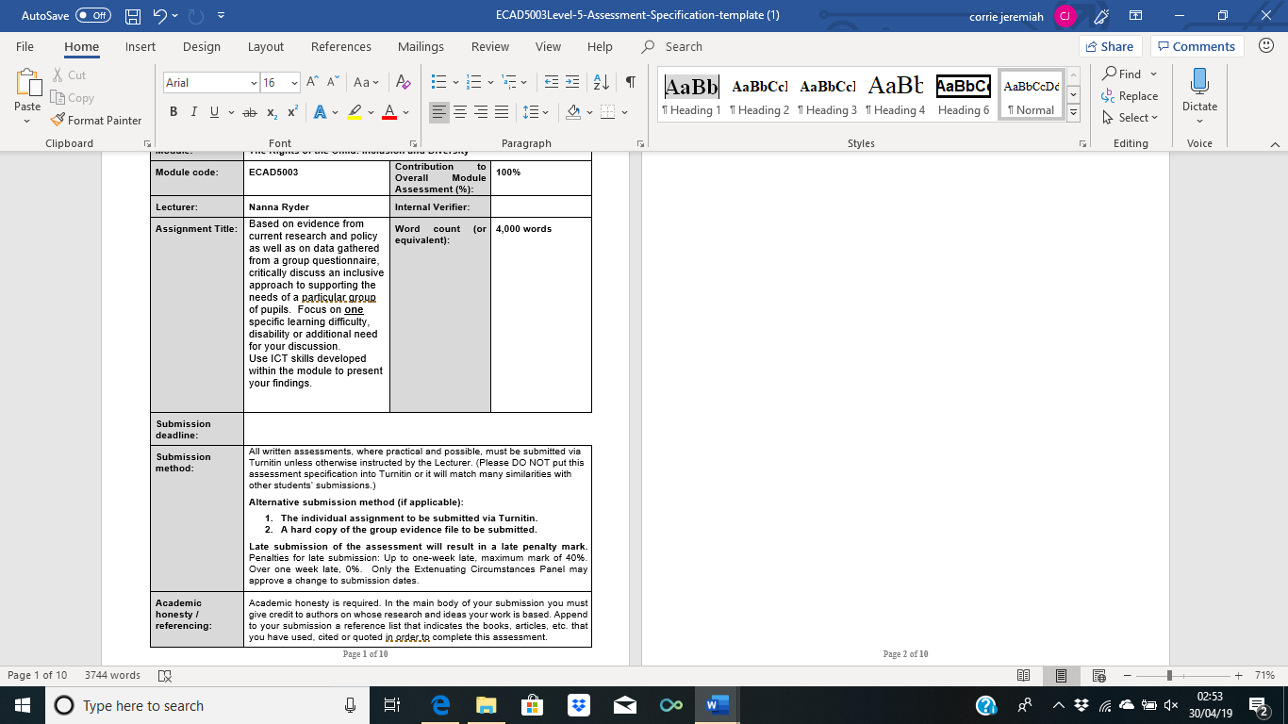
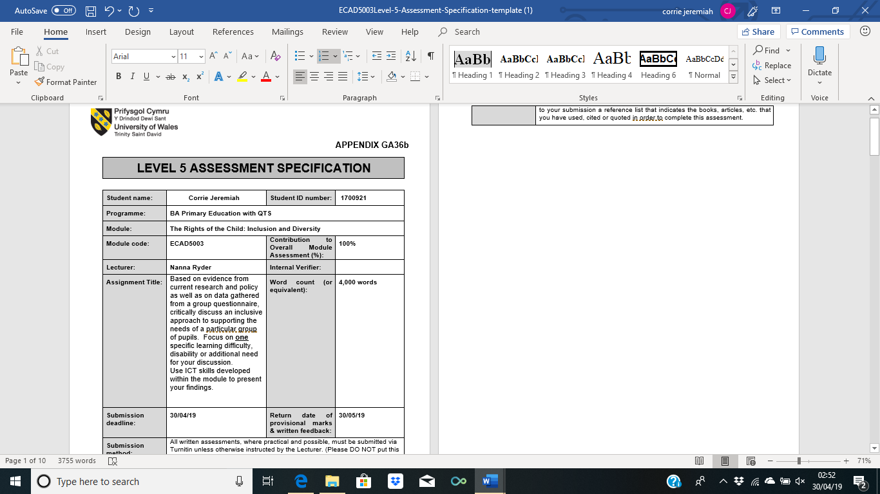

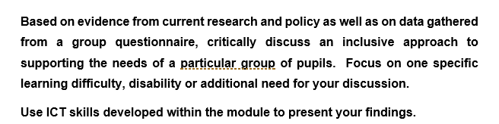
Inclusive education is schooling that strives to include each individual child in the learning which takes place within every classroom each day. Children should be given the opportunity to learn and grow together through mainstream schools regardless of whether or not they have any disabilities or additional learning needs. When in school all learners should be made to feel welcome and valued no matter their background or circumstance, and they should also have access to the right level of support which will help them develop their talents and achieve their goals. However, a reoccurring problem which is seen in the majority of mainstream schools across the Wales is the difficulty in implementing a completely inclusive learning environment when class sizes are rather large and where each learner is unique with their own strengths as well as their own limitations. Therefore, it is becoming increasingly difficult for a class teacher to cater to each of the pupils individual needs especially when they constantly encounter barriers which hinder the learning for specific individuals, particularly those who are deemed as having ‘learning disabilities’ or ‘special needs’. According to the NHS, around 1.5 million people in the UK have been identified as having a learning disability, and it is thought that up to 350,000 of these individuals have a severe learning disability (2018). Yet, alarmingly these figures which serve to identify the number of individuals who possess either a learning difficulty, disability or additional learning need continue to increase rapidly. It is estimated that around twenty-three percent of all learners within maintained schools in Wales have either special or additional learning needs (Welsh Government, 2018). Therefore, it is vital that a unified inclusion approach is designed and implemented both in mainstream primary and secondary schools across Wales and indeed the UK as when education is truly inclusive it benefits all learners, not only those with additional needs or disabilities.
There are many different learning difficulties, disabilities and additional learning needs which are known to be in existence. Each individual need and disability are known to differ in regard to the types of strategies and approaches that are used and implemented in order to help further progress the learning of the individual pupil. However, each individual need and disability is similar in the way that they all impact on an individual’s ability to gain knowledge and skills at the same rate as their peers. The three most commonly known additional learning needs amongst the population are dyslexia, ADHD and dyscalculia. However, despite the recent rise in awareness in regard to these additional learning needs there are still many which are overlooked or remain unacknowledged. Therefore, the particular group of pupils which will be critically discussed and examined for the duration of this assignment are those who are identified as being more able and talented (MAT).
The term ‘more able and talented’ is used within education in order to refer to pupils who are acknowledged to be ‘more able’ across the curriculum by showing a particular ability or aptitude for their age and stage of learning in one or more specific areas. However, despite the unified grouping of the term ‘more able and talented’ many schools within the UK separate the terms in order to identify pupils who are solely ‘more able’ academically or individuals who are deemed to be solely ‘talented’ through the use of creativity and sporting contexts. Therefore, it is not uncommon during a career in teaching to come across an individual who is either deemed to be solely more able, exclusively talented, or on occasion be both more able and talented. In Wales, the term ‘more able and talented’ has been adopted to describe pupils who ‘require opportunities for enrichment and extension that go beyond those provided for the general cohort of pupils’ (Welsh Assembly Government, 2008). The term ‘more able and talented’ is known to encompass approximately twenty percent of the total mainstream school population in Wales. Therefore, it is likely that there is a group of pupils in every school across Wales who require a ‘greater breadth and depth of learning activities’ than what is normally provided for the usual cohort of learners, and these groups of pupils are the ones who are deemed by the Welsh Government as being ‘more able and talented’.
MAT pupils are recognised for their higher than average ability for the national recommended stage/level of learning which they then demonstrate both in and outside of the classroom. To ensure that these pupils who are deemed to be MAT continue to make good progress and are not held back within the classroom whilst waiting for their peers to make the same level of progress as them they should be offered a range of differentiated tasks whilst also being given opportunities to learn through a range of challenges set. Teachers will be required to do extra planning and provide MAT learners with a wide range of opportunities and experiences in order to engage them and encourage them to continue their progression of learning. However, MAT pupils have not been considered to have additional learning needs in past nor recent national educational documents, in fact MAT pupils are only deemed to have additional learning needs if they are also known to have what is classed as a ‘special educational need’. Therefore, it is difficult for the teacher to make the necessary preparations and offer the correct level of advice and support to both MAT pupils and their parents without any funding nor much guidance from the government.
In order to gain a more practical and deeper level of understanding in regard to what it means to be ‘more able and talented’ the author of this essay along with several other colleagues produced and distributed a questionnaire in order to collect relevant data from a schools perspective. The questionnaire consisted of twenty-one questions each one asked specifically in order to understand how individual practitioners as well as whole schools challenge and support pupils who are deemed to be MAT. The questionnaire was sent to nineteen different schools located across five different local authorities. Each school was given three weeks to complete and return the questionnaire and were informed that it should not take a teaching practitioner more than ten minutes to complete. Not all schools were able to participate in the questionnaire, however, several responses were received and provided a valuable insight of the handling of MAT pupils from a working practitioners perspective. Questions one to three within the questionnaire serve to engage the recipients by asking for basic information which should be readily at their disposal; questions such as ‘which local authority do you fall under’, ‘how many pupils do you have in your class’ and ‘how many pupils within your class are MAT’. The recipients of the questionnaire were then asked to share their school’s definition of what it means to deemed as being ‘more able and talented’. The responses received although worded differently devised the same point. One respondent defined the term ‘more able and talented’ as being ‘a child who is progressing and achieving beyond the work appropriate for that age. A Talent that is excellent - art, sport etc’ and another defined it as being ‘pupils who achieve above and beyond other pupils who demand challenging activities to enhance their individual learning styles’. Through these responses as well as the others received via the questionnaire it is clear to see that the majority of schools have a shared clear and general understanding in regard to what it means for a pupils to be deemed as being ‘more able and talented’. Therefore, any misconception or incorrect course of action taken when educating MAT pupils does not arise from any misunderstanding nor misinterpretation of the term/definition of ‘more able and talented’. This idea is supported by Estyn who says that ‘most schools have an appropriate, shared understanding of how they define ‘more able and talented’ pupils within their individual schools’.
When educating MAT pupils there are a variety of roles and responsibilities which the school, individual teachers, parents and even the pupils themselves should undertake: Individual teachers are tasked with setting work which is both do-able yet challenging for MAT pupils; parents should be informed of their children’s progress and be given suggestions on how to help further their learning at home; pupils will either help or be asked to set their own targets and be given differentiated to complete in order to meet them. These are all important roles and responsibilities of individuals who work in partnership with each other in order to achieve the desired outcome. However, the school can also play a significant role in supporting MAT pupils either through the creation of a MAT policy or through the appointment of a MAT co-ordinator. The questionnaire created contained the question does your school have either a MAT policy or a MAT co-ordinator and the responses can be seen in the chart below.
Does your school have any of the following?

17%

83%
[Figure 1]

The chart above shows that eighty-three percent of respondents work in schools which have both a MAT policy and a MAT co-ordinator whilst the remaining seventeen percent report that they solely have a MAT co-ordinator. A MAT co-ordinator should create and keep a register of the children who have been identified and are acknowledged by the school ad being more able and talented. The co-ordinator is tasked with monitoring and tracking the progress of the children identified as well as lead staff discussion and raise awareness through ‘effective inset provision’ (Caerphilly County Borough Council, Unknown). The fact that all respondent schools have at least one of these provisions in place within their school emphasises that they recognise the importance of supporting MAT pupils. Correct and appropriate use of these two provisions should eliminate the majority of the difficulties which teachers face when tasked with identifying, tracking and monitoring, supporting and challenging MAT pupils correctly and effectively as teachers are given relevant and helpful advice and guidance in regard to supporting and extending the opportunities readily available to a MAT pupil. Furthermore, in order to successfully provide MAT pupils with the necessary experiences and opportunities in order to further support their learning it is vital that all parties involved are aware of and acknowledge their roles and responsibilities whilst also striving to communicate effectively together as successful provision is dependent on partnership.
Teachers are known to play a pivotal role in supporting more able and talented pupils and whilst all teaching practitioners have the potential to help and support these pupils who are deemed to be more able and talented, occasions can arise where subject specialism can be important particularly within a key stage two classroom. Dr Rebecca Montacute believes that teachers who hold a higher level of qualifications such as a master’s degree in specific areas are the most effective form of educators on average for ‘highly able students’ (2008). This would be beneficial as the educator would be more likely to have a better understanding of certain areas/subjects as well as be able to readily respond to any in depth question which a curious and MAT individual may ask. However, this suggestion is improbable as each pupil excels within different areas of learning therefore in order to keep learning inclusive a teacher with a high level of qualifications or degrees within multiple areas would be required. There is also the matter of the national shortage of teachers which schools across the UK are currently experiencing without the rise of unnecessary qualifications that Dr Montacute is suggesting. Yet Dr Rebecca Montacute continues to argue that there is a ‘growing body’ of research which indicates that ‘strong content knowledge does impact on student attainment’. There are two questions within the questionnaire which serve to indicate how confident individual teachers are when dealing with MAT pupils. The results of these two questions are represented in charts and are shown below.

17%

83%
[Figure 2]

33%

67%
[Figure 3]

Figure 2 serves to show how confident the respondents feel when dealing with MAT pupils. According to the results eighty-three percent of the respondents feel ‘very confident’ when supporting MAT pupils whilst the remaining seventeen percent feel somewhat confident. Figure 3 serves to show how much training the respondents have received in regard to supporting pupils who are deemed to be MAT. Together figure 2 and figure 3 demonstrates that although specific training is not required in order to effectively support a pupil who is deemed to MAT, specific training can help to increase the confidence displayed by a teaching practitioner when dealing with a MAT pupil. It is considered by the Welsh Assembly Government to be essential that all teaching practitioners are trained in understanding the needs of more able and talented pupils and how to provide for them in their daily classroom teaching in order to develop quality provision suitable for them (2008).
Estyn have found that in too few schools do teaching practitioners provide a ‘valuable range of enrichment and extra-curricular activities to cater for the needs of pupils who have more advanced skills’ (Estyn Training Materials, Unknown) The Welsh Assembly Government acknowledge that ability and talent of individuals can manifest itself in a variety of different ways within human activity whether it be academically, practically, creatively or socially (2008). However, it is generally thought that the majority of schools’ place more of an emphasis on provision for ‘more able’ pupils than they do for ‘talented’ pupils. This statement is supported by Estyn who claims that provision for ‘talented pupils’ remains limited in many schools across Wales. In order gain the perspective of a working teaching practitioner a statement was included within the questionnaire which was distributed to nineteen different schools. The teaching practitioners were asked to either agree or disagree with the following statement: ‘more is done to support the ‘more able’ than the ‘talented”. The results submitted are shown in pie chart located below.
20%

20%
20%

60%
[Figure 4]

The pie chart above shows that only twenty percent of respondents disagree with the above statement, another twenty percent of respondents neither agree nor disagree with the statement and forty percent of the respondents either agree or strongly agree with the statement shown above. Therefore, it is clear to see that more teaching practitioners who are currently teaching within a mainstream school agree with Estyn and believe that more is done to support the ‘more able’ rather than the ‘talented’. This may be because there is more opportunity within a classroom to support the ‘more able’ pupils then there are for those who are ‘talented’. Talented pupils are mainly limited to expressing and showing their abilities within specific lessons; for example, a child who excels in sports will only be given the opportunity to demonstrate their skill during PE lessons which are only twice a week in most schools across Wales. It is often the case within mainstream schools that opportunities to support and challenge creativity are somewhat limited to the lessons dedicated to teaching creative subjects such as art and music, therefore, teachers should attempt to include creative elements whenever appropriate in academic lessons such as English in order for talented individuals to feel included.
The best provision for able and talented pupils is one that challenges them and extends their knowledge, level of thinking and skill set (Thomas Tallis School, 2015). Individual schools should have strategies in place to help identify individual pupils (MAT) who will benefit from provision to suit their needs including attention to learning styles, teaching approaches and adding extra breadth, depth and flexibility to the curriculum (Guide to Law, 2009). There are a wide variety of different types of provisions available to teaching practitioners and the majority of these are useful to implement when attempting to support and challenge a MAT pupil. In order to see what different types of provision are implemented within schools, teaching practitioners were aske via the questionnaire to select the types of provision that they use within their classroom to help support pupils learning. The results given are shown on the next page via a simple bar graph (figure 5).
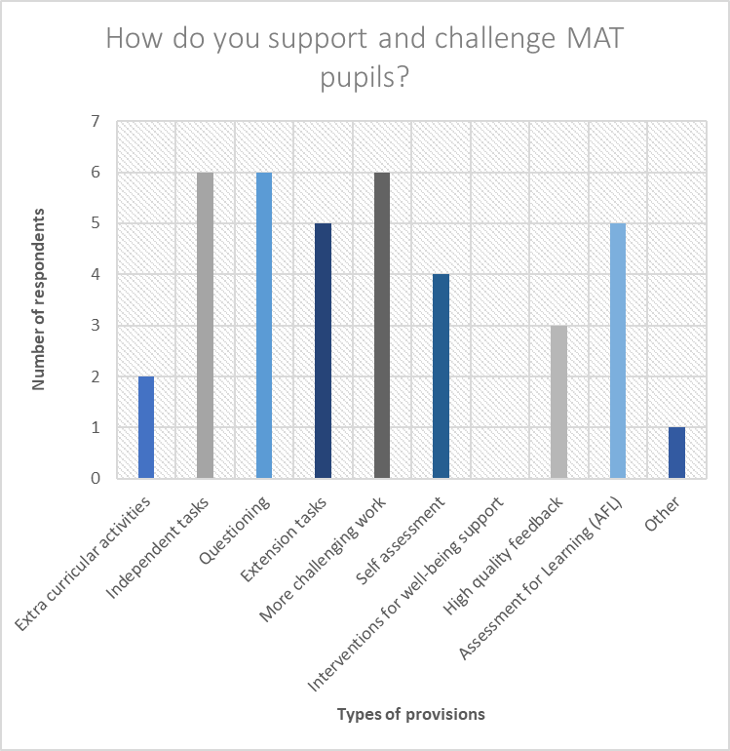
[Figure 5]
Figure 5 displays the responses from the question shown above in a clear format. From looking at the data shown on the graph the most popular use of provisions was the use of independent work and questioning as well as setting more challenging work. All respondents claimed to implement these three types of provision. These type of provisions can be used generically across all age groups within a school therefore it is not uncommon for these three provisions to be popular amongst teachers as they are easy to implement and to plan for. They are also used to encourage pupils to become ambitious learners and capable learners who are ready to learn throughout their lives (Donaldson, 2015). The only type of provision which has not been implemented by any of the respondents is the use of ‘interventions for well-being support’, which is rather surprising since recent research and evidence has served to show that attainment within education and health are closely linked (Public Health England, 2014). Furthermore, there is a wide range of possible provisions to implement within the classroom, many of which are known to be successful in creating learners which Professor Graham Donaldson strives to achieve through use of the four purposes of the Successful Futures document.
The pastoral care of individual pupils should also be considered when examining the needs of a MAT pupil. According to Public Health England, pupils with better health and well-being are likely to achieve better academically (2014). Professor Graham Donaldson also recognises the link between health and education as one of the four purposes in the new Successful Futures document is to ensure that pupils become ‘healthy, confident individuals, ready to lead fulfilling lives as valued members of society’ (2015). Schools are known to promote health and well-being through the use of PSE lessons as well as through specific science topics. All schools in Wales campaign the importance healthy eating and receiving three whole meals a day. The importance of eating breakfast is reinforced through the use of breakfast clubs which is accessible to all pupils due to the fact that there is evidence which suggests that eating breakfast each morning as opposed to skipping it has a positive influence on short term cognition and memory. However, health and well-being lessons and topics in school are not solely dedicated to issues such as exercise and healthy eating, they are also dedicated to mental health issues such as bullying and lack of self-confidence. According to the Education Act of 2002 and the Academies Act of 2010 the national curriculum should:
“Promote the spiritual, moral, cultural, mental and physical development of pupils at the school and of society, and prepare pupils at the school for the opportunities, responsibilities and experiences of later life.”
- Public Health England (November 2014)

It is extreme importance to acknowledge that a pupil’s emotions can either support their learning along with their academic level of engagement, work ethic and commitment or it can impede it. Furthermore, there is clearly a link between health and wellbeing and educational attainment as the children’s overall level of wellbeing has been observed to impact on their behaviour and level of engagement within the classroom at school.
The purpose of the questionnaire was to gather data which represented several working teachers’ perspectives in regard to how they along with their commendable school’s challenge and support pupils who are deemed to be MAT. Whilst the questionnaire served it is purpose, the data is somewhat limiting as not enough responses were received in order to reach a fully reliable judgement. The majority of the responses received were from the same local authority which is Pembrokeshire. This may have limited the reliability of the responses received as schools from the same local authority are highly likely to have access to the same policies, follow similar regulations and implement what the local council authorises. Therefore, it would have proven to be more beneficial to receive more responses from a wide range of local authorities across Wales. However, despite the lack of replies received in response the questionnaire it followed BERA guidelines which are designed to support educational researchers when conducting research in order to achieve the highest ethical standards in any and all contexts (BERA, 2018). All recipients of the questionnaire were immediately made aware that it is within their right not to take part in the questionnaire which they received and were also informed that they may withdraw their answers at any time. The structure and wording of the questionnaire was also of a satisfactory standard as the questions conveyed the correct meaning through simplistic language. The questionnaire also contained a mixture of open ended and closed questions in order to ensure that the respondents felt in control of their answers instead of being led or coerced to a specific viewpoint. Overall, the questionnaire was made to a good standard and sampled by ten individuals before being sent to the chosen nineteen schools.
To conclude, research conducted by the Welsh government shows that the schools within Wales that focus on the needs of more able and talented pupils improve the quality of learning and raise standards of achievement for all pupils. Therefore, it is advantageous to consider the needs of MAT pupils by taking the extra time to alter teaching methods and make appropriate provisions. It is vital to remember that there is no one way to meet the needs of individuals particularly for those who are deemed to be ‘more able and talented’ or those who may have additional learning needs. Each child is unique hence why it is important to both recognise and celebrate a pupil’s individual differences.

Total word count: 3638
References:
BERA (2018) Ethical Guidelines for Educational Research [fourth edition]. Available at: https://www.bera.ac.uk/bera-in-the-news/ethical-guidelines-for-educational-research-fourth-edition-2018 (Accessed 29th April 2019).
Caerphilly County Borough Council (Unknown) EXEMPLAR SCHOOL POLICY FOR MORE ABLE AND TALENTED CHILDREN: SECONDARY. Available at: https://resources.hwb.wales.gov.uk/VTC/ngfl/guidance/more_able_talented/eng/secondary_policy.html (Accessed: 24th April 2019).
Cicerchia, M. (August 2016) What are learning difficulties? Available at: https://www.readandspell.com/what-are-learning-difficulties (Accessed: 17th April 2019).
ERW (2019) Teaching and learning - Curriculum for Wales. Available at: https://www.erw.wales/schools/teaching-and-learning/curriculum-for-wales/ (Accessed: 27th April 2019).
Estyn (March 2018) Supporting more able and talented pupils. Available at: https://www.estyn.gov.wales/sites/default/files/documents/Supporting%20MAT%20pupils%20En.pdf (Accessed: 20th April 2019)
Estyn (Unknown) Supporting more able and talented pupils - Training Materials. Available at: https://www.estyn.gov.wales/thematic-reports/supporting-more-able-and-talented-pupils-training-materials (Accessed: 23rd April 2019).
Montacute, R. (July 2018) Potential for success. Available at: https://www.suttontrust.com/research-paper/potential-for-success-schools-high-attainers/ (Accessed: 26th April 2019).
NACE (May 2018) FAQs. Available at: http://www.nace.co.uk/faqs (Accessed:19th April 2019).
NHS (2018) Overview - Learning disabilities. Available at: https://www.nhs.uk/conditions/learning-disabilities/ (Accessed: 20th April 2019).
Public Health England (November 2014) The link between pupil health and wellbeing and attainment. Available at: https://assets.publishing.service.gov.uk/government/uploads/system/uploads/attachment_data/file/370686/HT_briefing_layoutvFINALvii.pdf (Accessed: 1st April 2019).
The Alliance for Inclusive Education (2019) What is inclusive education? Available at: https://www.allfie.org.uk/definitions/what-is-inclusive-education/ (Accessed: 20th April 2019).
Welsh Assembly Government (May 2008) Meeting the Challenge. Available at: https://gov.wales/sites/default/files/publications/2018-11/meeting-the-challenge-quality-standards-in-education-for-more-able-and-talented-pupils_0.pdf (Accessed:20th April 2019).
Welsh Government (2009) Children with Additional Learning Needs. Available at: https://gov.wales/sites/default/files/publications/2018-03/13-children-with-additional-learning-needs.pdf (Accessed: 25th April 2019).
Welsh Government (2018) Additional learning needs (ALN) transformation programme. Available at:https://gov.wales/sites/default/files/publications/2018-09/additional-learning-needs-aln-transformation-programme-v2.pdf (Accessed: 21st April 2019).
Welsh Government (2018) More able and talented learners. Available at: https://learning.gov.wales/docs/learningwales/publications/180208-mat-guidance-for-fe-sector-en.pdf (Accessed: 19th April 2019)
Welsh Government (December 2015) Review to identify more able and talented provision across Wales. Available at: https://gov.wales/sites/default/files/publications/2018-02/review-to-identify-more-able-and-talented-provision-across-wales.pdf (Accessed: 24th April 2019).
Welsh Government (December 2018) Draft Additional Learning Needs Code. Available at: https://gov.wales/sites/default/files/consultations/2018-12/consultation-document-draft-additional-learning-needs-code_0.pdf (Accessed:24th April 2019).

