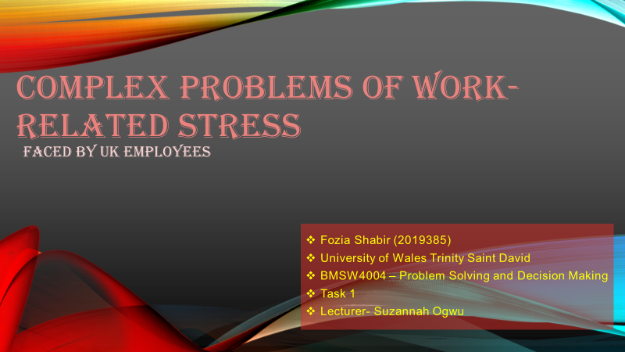
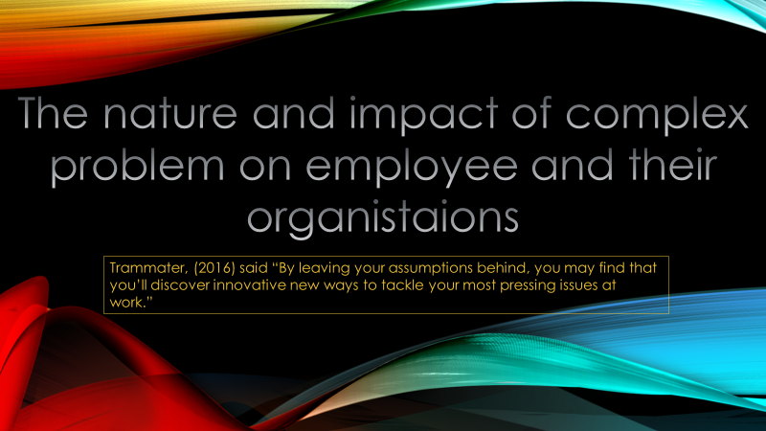
Trammater, (2016) said “By leaving your assumptions behind, you may find that you’ll discover innovative new ways to tackle your most pressing issues at work.”

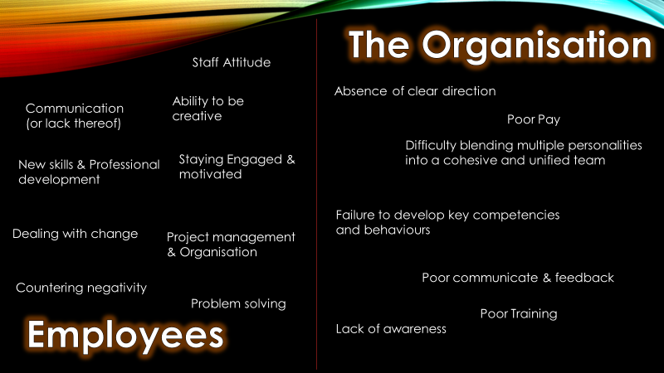
The nature and impact of complex problems on employees and their organisations are very common for people to face while working in a busy work environment, many people face this problem as most of these are very common in the work placement, I believe the most common complex problem an employee could face is dealing with change as this is not very easy to deal with when you have been working for a long period of time with no change and this can cause them in having problems in being flexible that can result in having conflicts or missed deadlines.
The complex problem that the organistaions could face within the company are facing bad communicate and feedback, this could prevent the company in fixing their errors and maintaining a good connection with the clients and customers and this will gain them in losing customers and having a bad repression Infront of new clients or customers.
Stuart (2014), said that “Complex problems are difficult to define because different people will have differing opinions about the cause, nature and extent of the problem. It is often their social complexity, rather than their technical complexity that makes complex problems so hard to address.”

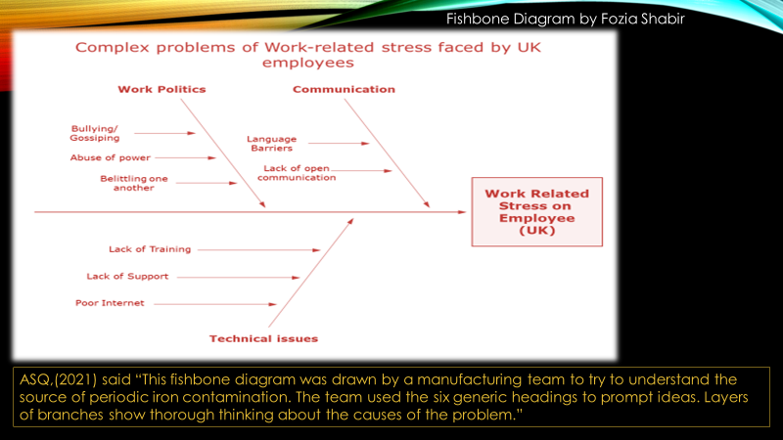
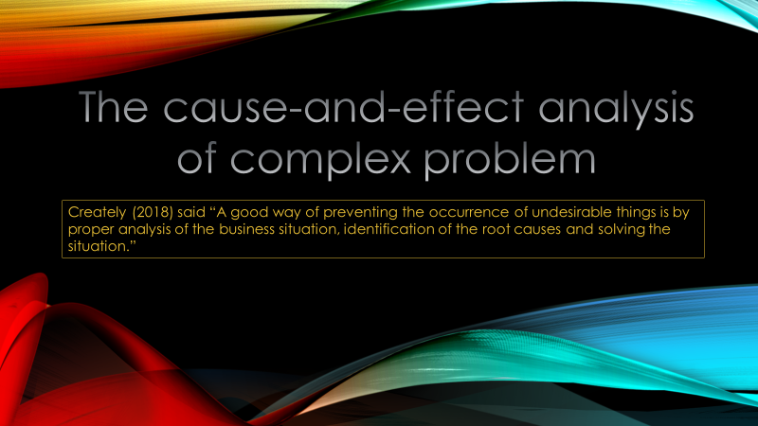
Creately (2018) said “A good way of preventing the occurrence of undesirable things is by proper analysis of the business situation, identification of the root causes and solving the situation.”
The cause-and-effect analysis of complex problem also known as the fishbone diagram, as you can see, I have used this method to show most common causes and effect of the work-related stress, the three main causes I believe are work polities, Communication and technical issue. There are several more, but I believe these are the main problems because it is very related to have problems with commutation between co-workers or bosses as these problem are could put a stop to having a team success as well as reason lots of employee stress as people could miss deadlines in bad communicate or cause conflicts between each other within a team or the company.
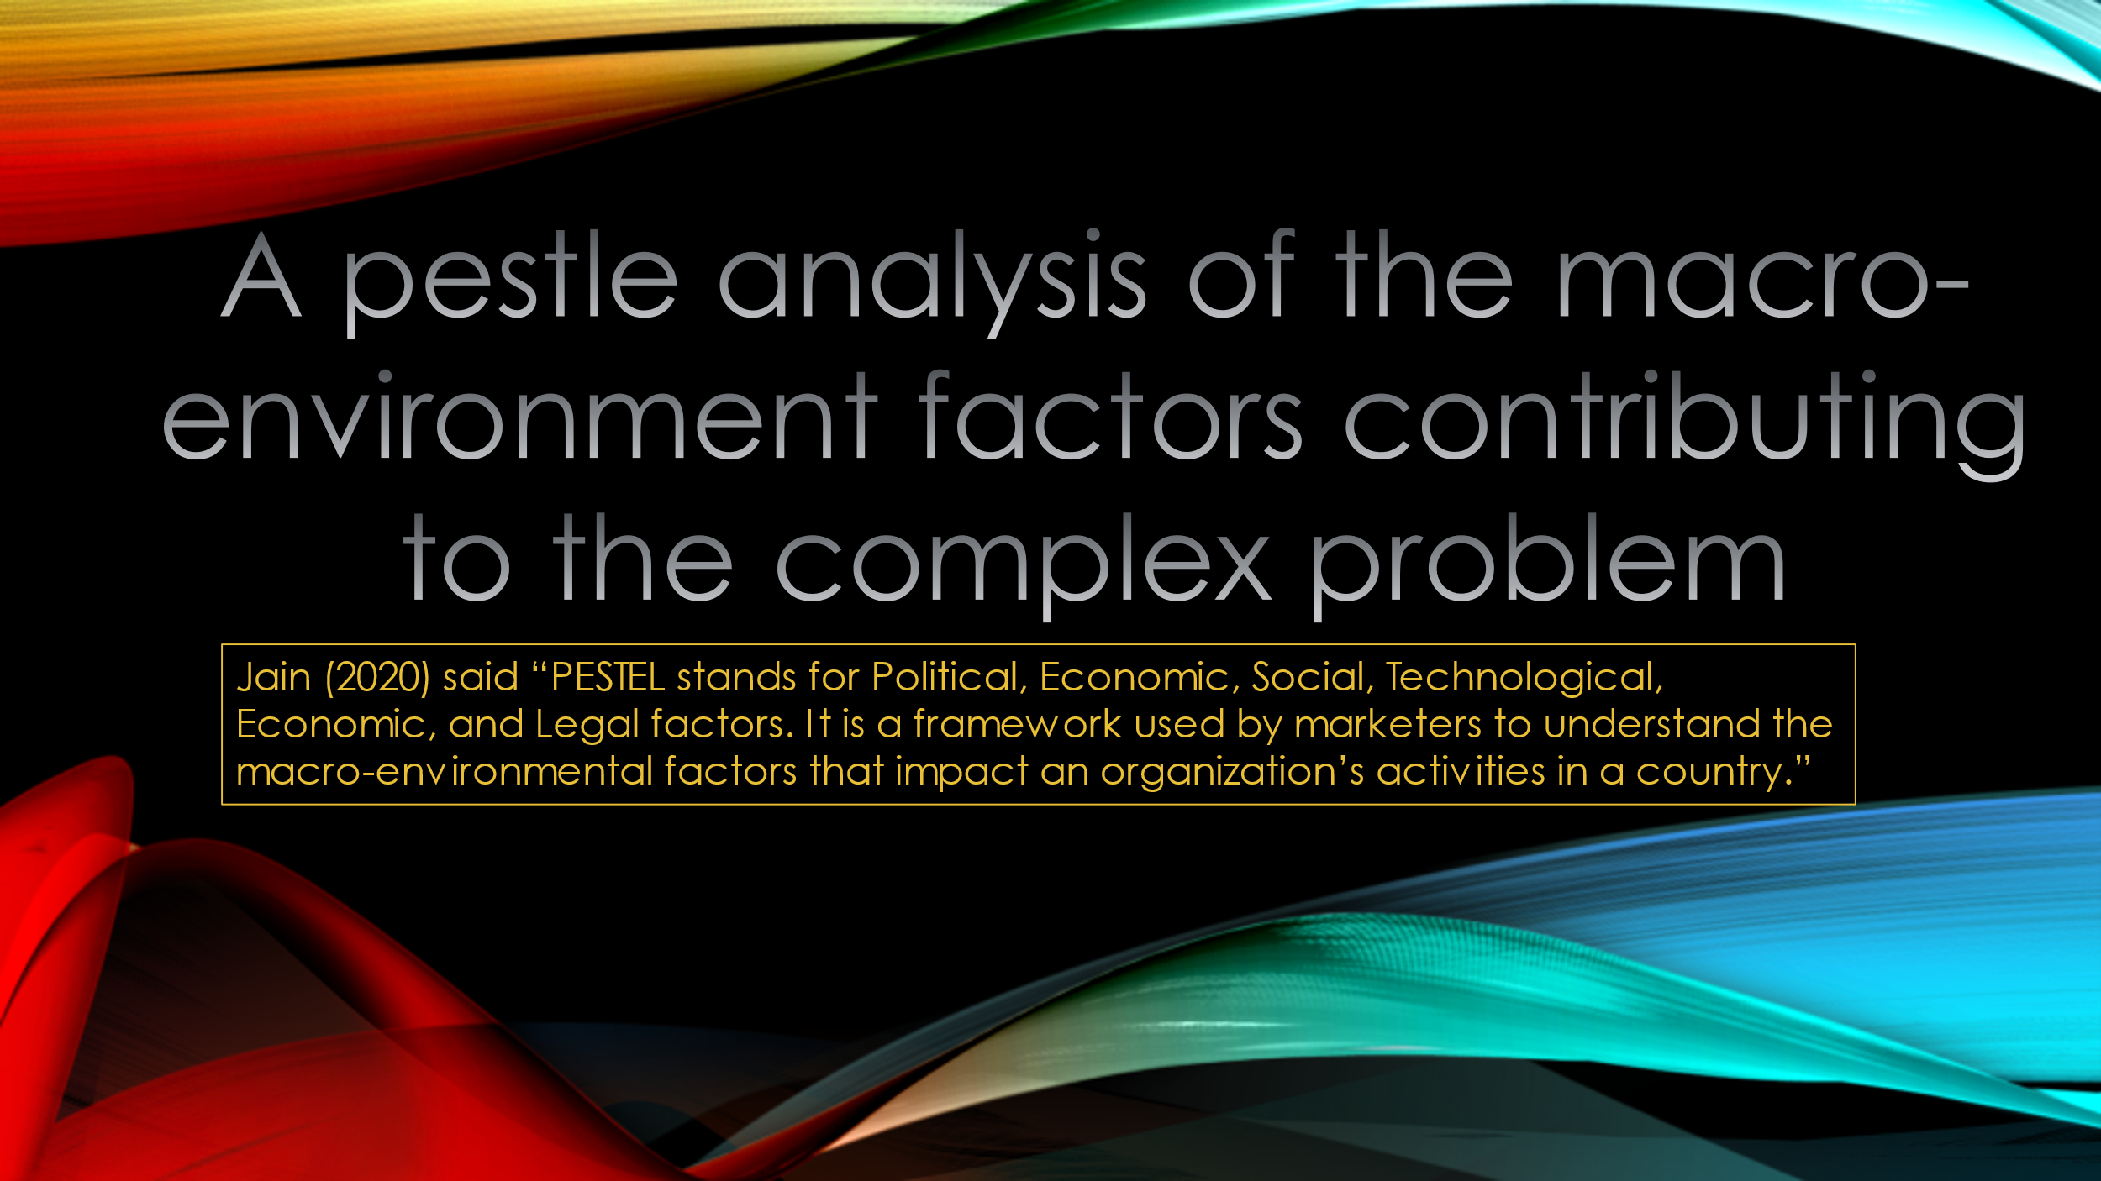
ASQ,(2021) said “This fishbone diagram was drawn by a manufacturing team to try to understand the source of periodic iron contamination. The team used the six generic headings to prompt ideas. Layers of branches show thorough thinking about the causes of the problem.”
Jain (2020) said “PESTEL stands for Political, Economic, Social, Technological, Economic, and Legal factors. It is a framework used by marketers to understand the macro-environmental factors that impact an organization’s activities in a country.”
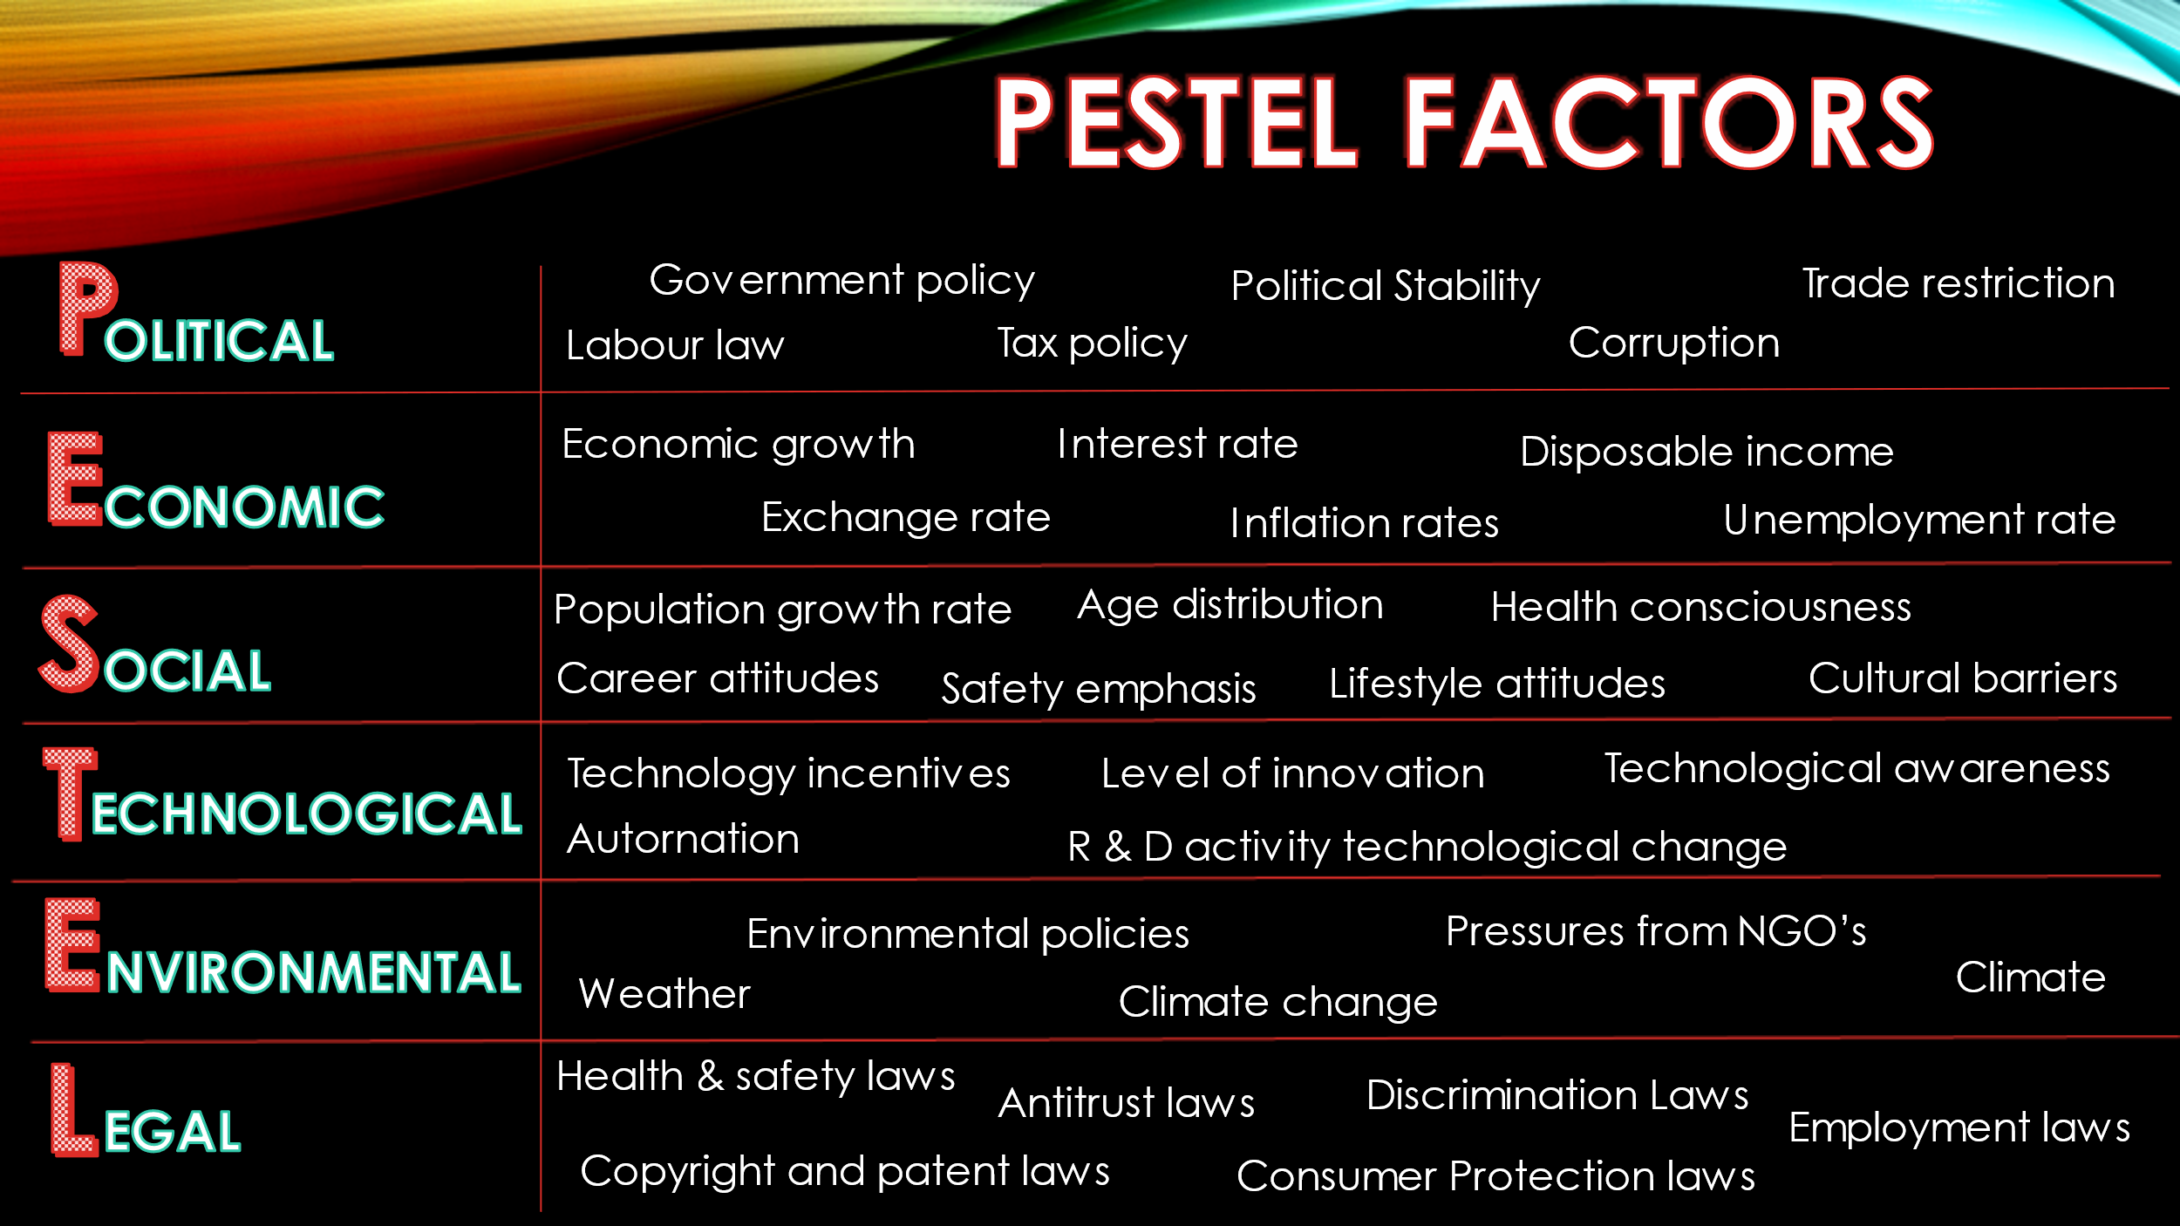
A pestle analysis is a useful tool for business to understand market growth or declines this could help them in choosing which positions, potential and directions are in best for the business. Pestle stands for P- Political E- economic S- social T- technological E- environmental L-legal, all of these are used to assess the market and to gain information which could be used for the good reasons of the business. Organisational use these factors so the business could make better and good decisions for the company.

Parhak (2021) said “PESTLE analysis sometimes referred to as PEST analysis, is a concept in marketing principles. This concept is used as a tool by organizations to keep a track of the external factors impacting the organization.”
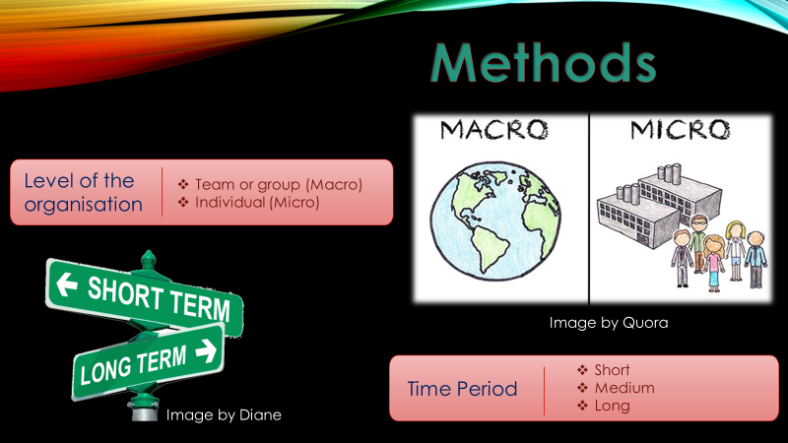
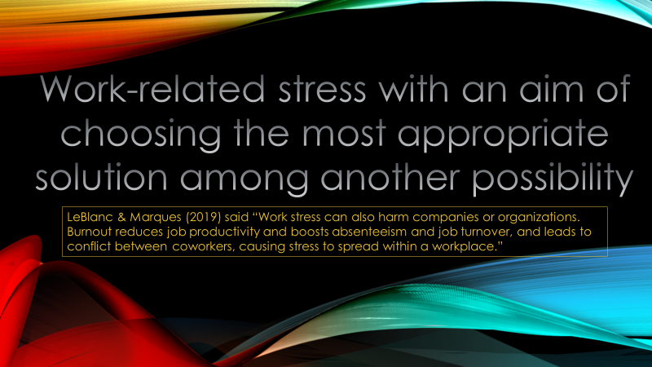
LeBlanc & Marques (2019) said “Work stress can also harm companies or organizations. Burnout reduces job productivity and boosts absenteeism and job turnover, and leads to conflict between co-workers, causing stress to spread within a workplace.”

Level of organisation

Macro means the big picture and micro gives a deep dive
Macro
Macro vision is that the company is always stepping back to see the bigger picture assessment. The company is not concerned with the little information of how the things are being done, but in its place there are trying to find out how the company is working in bigger areas that control success or failure of the company.
Micro
A micro view is continuously going to be dedicated on small details that can give the company answers about the big picture, in a micro viewpoint information are important and the skills to measure performance through the use of system of measurement is the stamp of this viewpoint.
Time period
SMART- Specific, Measurable, Achievable, Relevant, Timely
There are three stages of time period short-term, medium-term and long-term.
Short-Term
The companies and business should place a short-term solutions to see the problems. For examples, employees can get training courses that employers put in place for them, equipment servicing and quality fixes are short-term resolutions. These resolutions set the period for taking the problems more carefully in the longer-term.
Medium-Term
Medium-term planning put on more permanent explanations to short-term problems. For example, if the training course for employees solved problems in the short-term, companies could schedule training programs for the medium term. If there are quality issues, the medium-term response is to revise and find a way to strengthen the companies quality control programs.
Long-Term
In the long-term, companies want to solve problems permanently and to reach their overall goals and targets. When short-term and medium-term planning is successful, long-term planning builds on chose achievement to preserve accomplishment and ensure continued progress.
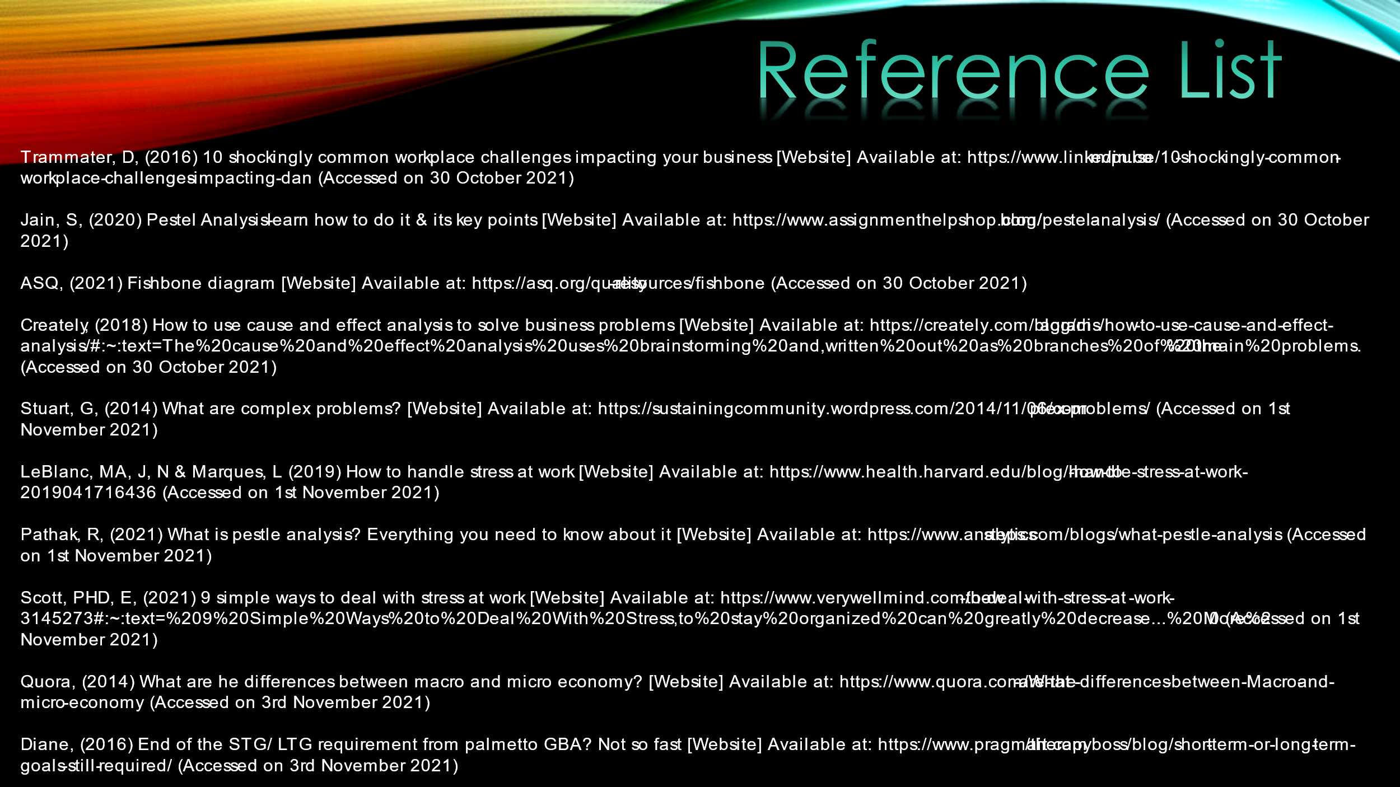
Trammater, D, (2016) 10 shockingly common workplace challenges impacting your business [Website] Available at: https://www.linkedin.com/pulse/10-shockingly-common-workplace-challenges-impacting-dan (Accessed on 30 October 2021)
Jain, S, (2020) Pestel Analysis- learn how to do it & its key points [Website] Available at: https://www.assignmenthelpshop.com/blog/pestel-analysis/ (Accessed on 30 October 2021)
ASQ, (2021) Fishbone diagram [Website] Available at: https://asq.org/quality-resources/fishbone (Accessed on 30 October 2021)
Creately, (2018) How to use cause and effect analysis to solve business problems [Website] Available at: https://creately.com/blog/diagrams/how-to-use-cause-and-effect-analysis/#:~:text=The%20cause%20and%20effect%20analysis%20uses%20brainstorming%20and,written%20out%20as%20branches%20of%20the%20main%20problems. (Accessed on 30 October 2021)
Stuart, G, (2014) What are complex problems? [Website] Available at: https://sustainingcommunity.wordpress.com/2014/11/06/complex-problems/ (Accessed on 1st November 2021)
LeBlanc, MA, J, N & Marques, L (2019) How to handle stress at work [Website] Available at: https://www.health.harvard.edu/blog/how-to-handle-stress-at-work-2019041716436 (Accessed on 1st November 2021)
Pathak, R, (2021) What is pestle analysis? Everything you need to know about it [Website] Available at: https://www.analyticssteps.com/blogs/what-pestle-analysis (Accessed on 1st November 2021)
Scott, PHD, E, (2021) 9 simple ways to deal with stress at work [Website] Available at: https://www.verywellmind.com/how-to-deal-with-stress-at-work-3145273#:~:text=%209%20Simple%20Ways%20to%20Deal%20With%20Stress,to%20stay%20organized%20can%20greatly%20decrease...%20More%20 (Accessed on 1st November 2021)
Quora, (2014) What are he differences between macro and micro economy? [Website] Available at: https://www.quora.com/What-are-the-differences-between-Macro-and-micro-economy (Accessed on 3rd November 2021)
Diane, (2016) End of the STG/ LTG requirement from palmetto GBA? Not so fast [Website] Available at: https://www.pragmait.com/therapyboss/blog/short-term-or-long-term-goals-still-required/ (Accessed on 3rd November 2021)

