

Cyber

Security
May 2

UWTSD
Authored by: Jake Semmens



Contents
Table of Contents
Contents 2
Introduction 3
NIST Framework 4
Nmap and WireShark 5
WannaCry and TeleRAT 6
Whaling and Pharming 7
Network Topology 8
Software and Hardware 9
Reference List 10

Introduction
Throughout this report I will be delving into various cyber-attacks faced in today’s world as well as the risks they pose, mitigation strategies, network security enhancements, and the vital role which cyber security plays in safeguarding data and assets. I will also be providing an example of a secure network design as well as evidence of the completion of Palo Alto’s Network Security Fundamentals and Cybersecurity Foundation.

NIST Framework
The primary objective of the NIST framework is to provide a structured approach to managing and mitigating privacy and cybersecurity risks which are so prevalent in today’s society. NIST plays a pivotal role in bolstering the defences against cyber threats to data. “NIST’s Privacy framework is designed to pinpoint and tackle privacy risks which ensures the protection of personal data” [1]. Furthermore, NIST provides an abundance of resources which aid in data protection, one of which is the “NIST Special Publication 800-122 which focuses on keeping Personally Identifiable Information confidential” [1]. The NIST framework advocates for a variety of data protection measures which prove remarkably useful in today's society such as:
- “Implementing strong encryption for data at rest and transit.” [1]
- “Employing robust access control measures to ensure only authorized individuals can access sensitive data.” [1]
- “Conducting regular security assessments and audits to identify and rectify potential vulnerabilities. “[1]
- “Ensuring the confidentiality, integrity, and availability of data through a well-designed cybersecurity policy following NIST guidelines.” [1]
- “Adopting a proactive approach to privacy by integrating privacy considerations into the development lifecycle of products and services, as suggested by the NIST Privacy Framework.” [1]
The NIST cybersecurity framework contains five functions: Identify, Protect, Detect, Respond and Recover. These five functions serve as a backbone to the framework and are crucial to the protection of data and digital assets in modern society. The identify function provides a guideline of how to “manage cybersecurity risks to systems, people, assets, data, and capabilities” [2]. It is vital that organisations understand the cybersecurity risks specifically related to them rather than general risks, by doing this organisation will be able to prepare and build a cyber risk management strategy aimed towards their needs. The protect function is designed to support the ability to limit the impact of cyber-attacks and threats, “it provides appropriate safeguards to ensure the delivery of critical infrastructure services” [2]. “The detect function defines the appropriate activities to identify the occurrence of a cybersecurity event” [2]. The detect function defines the suitable activities to recognise the occurrence of a cybersecurity event. The Detect Function enables timely discovery of cybersecurity events. The Respond Function includes the appropriate activities to act on a detected cybersecurity incident. The Respond Function “supports the ability to contain the impact of a potential cybersecurity incident” [2]. This function is possibly the most important when dealing with cyber threats and ensuring that they are dealt with in the appropriate manner. The Recover Function “identifies appropriate activities to maintain plans for resilience and to restore any capabilities or services that were impaired due to a cybersecurity incident” [2]. The Recover Function supports well timed recovery to standard operations to maximise the reduction of impact from a cybersecurity incident.

Nmap and WireShark
Nmap is an open-source Linux command-line tool that is used to scan IP addresses and ports in a network as well as to detect installed applications. Nmap allows network admins to “find what devices are running on their network, discover open ports and services, and detect vulnerabilities” [3].
Nmap includes scripts which can be used to gather information about a target. One of the commands is the ‘Whois’ command “which will return information about the registrar and contact names when used” [4].
Nmap is also able to “search for emails about the target host and spider the web server and extract email it discovers using the ‘http-google-email' and ‘http-email-harvest' commands”. [4]
Nmap can also perform brute force DNS (Domain Name System) records using the dns-brute script which will “extract DNS information during Nmap scans if the user requires it” [4].
Additional hostnames based on the same IP address can be discovered with the ‘http-reverse-ip' script in Nmap. “The script helps to find other web applications that exist on the same web server” [4].
Wireshark is a “network protocol analyzer that captures packets from a network connection, such your computer or the internet” [5]. Wireshark is most commonly used by cybersecurity specialists to trace connections and identify bursts of network traffic.
Wireshark can be used to capture packets by “listening to a network connection and then grabbing entire streams of traffic which can be tens of thousands of packets at a single time” [5].

WannaCry and TeleRAT
WannaCry is a ransomware worm which after infecting a computer “encrypts onto the PC’s hard drive which makes the impossible for users to access” [6], WannaCry then demands a ransom payment via bitcoin in return for decrypting the files.
One method of mitigating the damage caused by WannaCry is to deploy firewalls as well as detection and intrusion prevention systems which can reduce the spread of the ransomware worm.
Network segmentation helps to “prevent the spread of the threat internally” [7]. A well-designed network can help contain the spread and reduce its impact on the targeted organisation.
Application control based on a whitelist can prevent unknown applications from executing. This would prove effective against WannaCry which “drops several malicious components in the system to conduct its encryption routine” [7].
One final method which can help defend against WannaCry is behaviour monitoring which can “block unusual modifications to the system” [7]. This helps defend against WannaCry when it is carrying out its encryption routine by preventing modifications from being made.
TeleRAT is a Remote Access Trojan (RAT) which abuses Telegrams Bot API to communicate with the command-and-control server and exfiltrate data. TeleRAT creates two files on a device with one containing device information and the other containing a Telegram channel with a list of commands. Once installed, “the RAT informs cyber attackers via a message to a Telegram bot API, it then listens for changes to the clipboard and commands. Based on the commands received, the malware can grab contacts, locations file lists, take photos, make calls etc.” [8].
Installing an anti-malware software program helps limit RATs, although RATs are difficult to detect and remove, anti-malware programs are designed for this purpose, “by installing an up-to-date anti-malware program you will be able to reduce damage done by the RAT” [9].
Another method is to harden access control. By doing this the organisation will “make it more difficult for unauthorised users to access networks and systems” [9]. Examples of this method are two-factor authentication and stricter firewall configurations which can “help ensure that only authorised users have access to the device and its data, therefore reducing the damage caused” [9].
One final method is the adoption of a zero-trust model which enforces strict authentication and identification when accessing a network. The model includes “continuous monitoring and validations, minimum privileges for users, strict control on device access and lateral movement blockage” [9].

Whaling and Pharming
A whaling attack is a highly targeted phishing attack which is mainly aimed at senior executives within a company. The attacker will infiltrate the email account of the person they are impersonating. They will “attempt to build trust with their target through the impersonated email in order to gain desirable information which could help them access sensitive areas of the network, passwords, or other user information” [10].
One mitigation method is to implement multi-factor authentication, this ensures that systems remain secure in the event of a data leak of employee credentials.
Another method is to audit security controls in order to ensure that the only users who can access a system or database are those who need it.
Anti-phishing software can be installed which “observes both current and past email activity in order to highlight abnormal activity which is then blocked before they cause any further damage” [11].
By continuously scanning every endpoint to “discover vulnerabilities that can be exploited by cyberattack as well as having a better understanding of external attacks” [11].
A pharming attack redirects website traffic to a fake website which is used by attackers to collect sensitive information or install malware on their devices. There are two methods of carrying out this attack:
- “The attackers will redirect traffic via DNS poisoning by exploiting DNS server vulnerabilities so that the victims are rerouted to the IP address controlled by the attacker” [12].
- “The attackers compromise the victim’s machine and change the local hosts file which redirects the user when they try to access a site” [12].
One mitigation strategy is to install an antivirus solution which monitors malware which could have been planted on the user’s device when it suffered a pharming attack. “This software will prevent the infected file from executing which will mitigate the damage caused and prevent the attacker from infecting the organisations network” [13].
A further strategy is to ensure that systems have up-to-date security patches, this is because “pharming attacks rely on known vulnerabilities in software, so installing updated security patches will patch these vulnerabilities” [13].
One final strategy is to set up two-factor authentication, this will provide additional layers of security which means that “cyber criminals would have to be much closer to you to obtain the second authentication factor” [13].

Network Topology

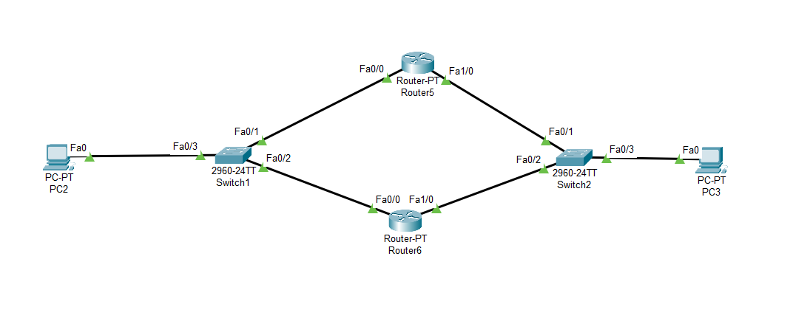
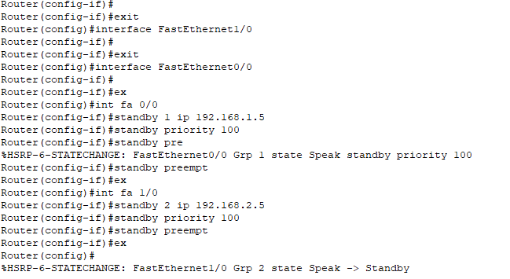
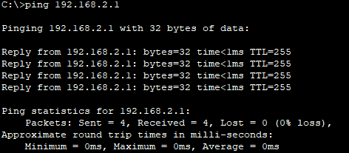
To create this high availability network, I implemented HSRP (Hot Standby Router Protocol) which is an “IP routing redundancy protocol designed that provides high network availability, because it routes IP traffic from hosts on networks without relying on the availability of any single router” [14]. By using this protocol, the network is able to send and receive packets at an average time of less than a milli-second as shown in the photos above.

Software and Hardware
One type of software which can enhance network security is a firewall, it “monitors incoming and outgoing network traffic and decides whether to allow or block specific traffic based on a defined set of security rules” [15].
Another piece of software which enhances network security is a reverse firewall which “protects the outside network from DDoS (Distributed Denial of Service) attacks that originate from the inside through ‘zombie computers’ which attackers have gained control of” [16].
A final piece of software is anti-virus software which “scans the user’s device regularly to detect and block known viruses and malware strains” [17]. For these types of software to be effective the user must allow regular updates, so that the software is able to detect new viruses.
A piece of hardware which can enhance security is an IPS (Intrusion Prevention System) which “provides policies and rules for network traffic along with an intrusion detection system for alerting system or network administrators to suspicious traffic” [17].
A further piece of hardware is a VPN (Virtual Private Network) which “uses encryption and other security mechanisms to ensure that only authorized users can access the network and that the data cannot be intercepted” [17].
A final piece of hardware is an antivirus scanning device which “searches a hard disk for viruses and removes any which are found” [17]. Most of these devices contain auto-update features that allow the hardware to recognise new viruses as soon as they are discovered.

Reference List
[1] Nheu. W, Navigating the NIST Framework: A Deep Dive into Data Protection and Backups, 2023.
[2] NIST, The CSF 1.1 Five Functions, 2024.
[3] Shivanandhan. Manish, What is Nmap and How to Use it – A Tutorial for the Greatest Scanning Tool of All Time, 2020.
[4] PenTest Lab, Information Gathering With Nmap, 2016.
[5] CompTIIA, What Is Wireshark and How Is It Used?, 2021.
[6] Fruhlinger. J, WannaCry explained: A perfect ransomware storm.
[7] Arghire. I, Android Trojan Leverages Telegram for Data Exfiltration
[8] Babu. S, How to Prevent Remote Access Trojan Attacks and Stay in Control of Your PC, 2022.
[9] Fortninet, What is a Whaling Attack (Whaling Phishing)?, 2022.
[10] Pagnotta. So, What is a Whaling Attack and How to Prevent It,2023.
[11] Swinhoe. D, Pharming explained: How attsckers use fake websites to steal data, 2020.
[12] Heimdal, The Anatomy of Pharming and How to Prevent It, 2023.
[13] Cisco, What Is a Firewall, 2020.
[14] Cisco, Implementing HSRP, 2020.
[15] CS3, The Reverse Firewall: Defeating DDOS Attacks, 2017.
[16] Beal. V, Network Security Appliances Explained, 2021.
[17] Corrons. L, What is antivirus?, Definition, types, and benefits, 2023.

Certificates


