Module: Data Handling and Business Intelligence
Module code: LCBB5000
Lecturer: Zahra Mohammadnazari
Assignment Title: Coursework (Written Report)
Student Name: Catalin-Alexandru Banciu
Student ID: 2124371

Contents
I. Introduction 2
II. Discussion 3
A. Current Trends in Business Intelligence 3
B. Business Intelligence Models and Processes 4
C. Importance of BI and Analytical or Predictive Software 6
III. Conclusion 7
IV. References 8

Introduction
To help executives make informed choices in the contemporary data-driven, technology environment, business intelligence (BI) tools are more valuable than before. The widespread availability of huge amounts of information, or "big data," has had a significant effect on corporate intelligence and its application (Puklavec et al., 2018). This study aims to inquire into and spark discussion about emerging tendencies in business intelligence in the context of recent advancements in the field. Several techniques and approaches to corporate intelligence will also be investigated. In addition to the use of data mining, information technology, and other applicable designs, data warehousing will be a major focus of this course. Data analysis, recognition of patterns, and evidence-based predictions are all skills highlighted in the research as crucial to the success of any business.
Business intelligence includes elements, such as integrating data, analytic capability, information correctness in firm activities, and a decision-making environment (Eidizadeh et al., 2017). Companies may benefit from implementing and employing BI techniques in this way. Leveraging this information to their benefit, companies could gain an edge ahead of rivals by making educated decisions based on thorough analysis of data made feasible by BI patterns, designs, and software applications. The purpose of this report is to synthesise the many ideas and arguments presented in the current literature. In order to provide a broad perspective on the topic, this article will examine recent trends in business intelligence, the associated concepts and procedures, and the value provided by analytical and predictive technology.

Discussion
Business intelligence (BI) is defined by Noble (2006) as the capacity to present the company with a competitive edge, which essentially amounts to the same thing that the company did in the past in a more efficient way. The following subsections discuss the current trends, models of practice, and importance of BI in today’s contemporary technology-driven world.

Current Trends in Business Intelligence
Significant changes have been made to business intelligence as a result of the "big data" phenomena. Fast analytics and the incorporation of data science are only two examples of the new directions it has taken business intelligence (BI) in recent years (Larson and Chang, 2016). By facilitating real-time or near-real-time data processing, fast analytics helps businesses act swiftly on the knowledge they obtain. In contrast, data science makes use of sophisticated methods of statistics, machine learning, and forecasting to explore and make sense of massive information.
Agile BI is an adaptation of the philosophy and values originally developed for Agile Software Development (ASD) and released in 2001. Since BI design is continuous and progressive, it is an ideal fit. Evaluation and integration of Agile concepts with BI, quick data analysis, and data analytics laid the groundwork for the Agile delivery methodology. Recent studies confirm the benefits of BI professionals adopting agile approaches. As a result of Big Data's influence on BI, the focus of analysis has evolved from description to prediction and prescription (Larson and Chang, 2016).
Another emerging pattern in BI is self-service analytics, as reported by Puklavec, Oliveira, and Popovi (2018). Rather than relying heavily on IT teams or data scientists, analytics via self-service allows company employees to get insight into, analyse, and visualise data on their own. The development of accessible analytical instruments and straightforward graphical user interfaces has helped propel this movement. In this way, businesses may encourage an environment that values data and speed up their process of decision-making. Higher efficiency and adaptability to evolving company demands are two further benefits of autonomous analytics.

Business Intelligence Models and Processes
Business Intelligence (BI) procedures, including those outlined here, play an important role in gleaning useful knowledge from information and in facilitating well-considered policymaking.
- Data Warehousing: Data warehousing is the process of collecting data from many different locations and storing it in one place, or "warehouse," as depicted in Figure 1. A data warehouse is an arrangement for collecting archival and real-time information, which facilitates effective retrieval and evaluation (Al-Okaily et al., 2022). For example, Amazon uses its data warehouse systems to track and assess shopper habits, such as the search queries, product selections, and page views to serve its clientele better.
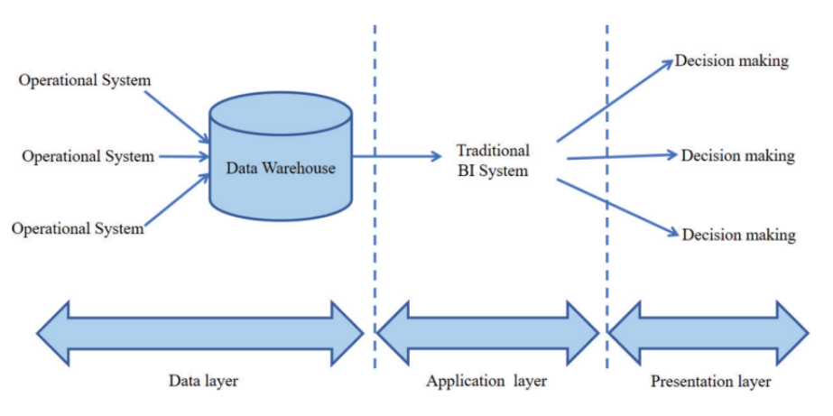
Figure 1 - Data Warehousing Process (Gad-Elrab, 2021).
- Data Mining: A schematic of the data mining process is depicted in Figure 2. This includes the steps of preparing the data, presenting it, comprehending it, and modeling it. Prospects, future developments, and making decisions are all aided by data mining's ability to unearth underlying connections and trends (Sikibi, 2022). For instance, Netflix classifies users based on their watching habits and tastes to provide personalized recommendations for what to watch next. Netflix's ability to tailor to each client's needs and boost participation is the resultant of this data-mining-driven strategy.
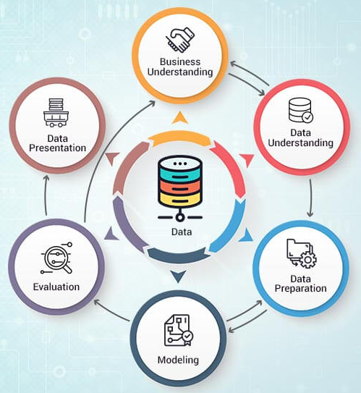
Figure 2 - Data Mining Process
- Information Systems: Capturing, storing, processing, and disseminating information inside a company all fall under the purview of IT systems. Gathering data, integration, evaluation, and dissemination are not possible without the support of computer systems in the setting of corporate intelligence. Accessibility and interaction with information are facilitated by means that include information databases, data warehouses, reporting applications, and display interfaces (Al-Okaily et al., 2022).
The data chain of value is the steps taken to create useful knowledge from raw data, and it serves as the central organizing principle for business intelligence (BI) delivery. The chain of value begins with data collection, continues with the application of rationality and company context to the information's contents to produce knowledge, and concludes with BI users consuming the knowledge to make choices and take action that yields economic benefit (Larson and Chang, 2016).

Importance of BI and Analytical or Predictive Software
Businesses may improve their intelligence, efficiency, and decision-making with the help of BI because of the function it plays as an enabler (Larson and Chang, 2016). Transfer of knowledge, corporate creativity, and achieving an edge over rivals are all positively affected by business intelligence, according to studies done by Eidizadeh et al. (2017). In addition, business data significantly improve the competitive edge by facilitating the dissemination of useful information and the introduction of novel ideas inside an organisation. The ability to achieve an edge over others is influenced favorably by the sharing of information.
If firms want to make informed decisions or increase productivity, BI is a crucial tool to employ (Gad-Elrab, 2022; Omar, Minoufekr, and Plapper, 2019). Improved alternative strategies can be found in fast-paced company settings because of BI's ability to improve the efficacy of operational regulations and their impact on corporate-level decision-making processes, supervision systems, leadership, financial management, and economic documentation (Gad-Elrab, 2021). There are various ways in which BI may improve the efficiency of a company, including the discovery of new possibilities, the illumination of hidden business knowledge, the illumination of hidden dangers, and the enhancement of decision-making procedures (Gad-Elrab, 2021).
The widespread use of BI and data intelligence also facilitates openness, the identification of unmet market requirements, the identification of procedure or product variation, the enhancement of efficiency, and the introduction of more environmentally friendly procedures. (Omar, Minoufekr, and Plapper, 2019). Moreover, by using predictive software, companies can effectively interpret big data for its benefits, predictive BI methodology allows corporations to be proactive, future-orientated, forecast outputs and behaviors based on data as shown the process diagram in Figure 3.
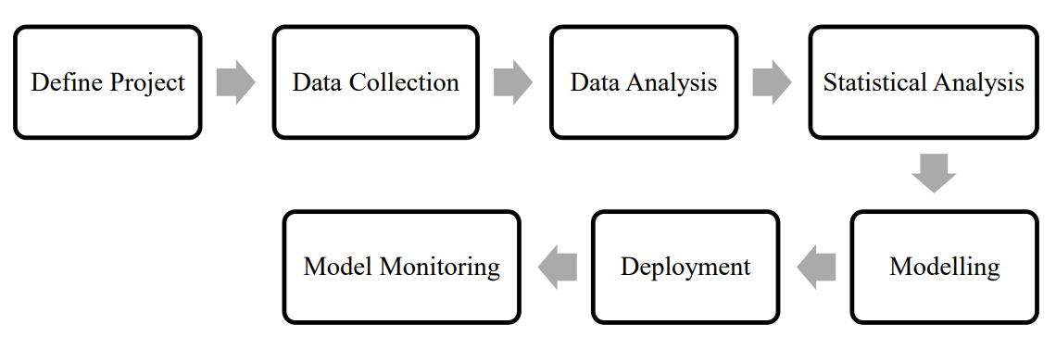
Figure 3 - Predictive BI Procedure

Conclusion
In summary, BI is the implementation of strategies and technologies used by enterprises for the data analysis and management of business information. New trends in BI include fast analytics, integration of data sciences, application of Agile Software Development practices and Big Data, and increased focus on self-service analytics. Common methods and processes of BI include warehousing, data mining, predictive analytics, and prescriptive analytics. Overall, BI enables companies to make smarter and better business decisions, enhance the productivity and efficiency of operations, and identify opportunities and trends in the growing market. It is crucial for gaining a competitive advantage through knowledge sharing and organisational innovation.

IV. References
Al-Okaily, A., Al-Okaily, M., Teoh, A.P. and Al-Debei, M.M., 2022. An empirical study on data warehouse systems effectiveness: the case of Jordanian banks in the business intelligence era. EuroMed Journal of Business, (ahead-of-print).
Eidizadeh, R., Salehzadeh, R. and Chitsaz Esfahani, A. (2017). Analysing the role of business intelligence, knowledge sharing and organisational innovation on gaining competitive advantage, Journal of Workplace Learning, Vol. 29 No. 4, pp. 250-267.
Gad-Elrab, A.A., (2021). Modern business intelligence: Big data analytics and artificial intelligence for creating the data-driven value. E-Business-Higher Education and Intelligence Applications, 135.
Larson, & Chang, V. (2016). A review and future direction of agile, business intelligence, analytics and data science. International Journal of Information Management, 36(5), 700–710. https://doi.org/10.1016/j.ijinfomgt.2016.04.013 Available at: https://www-sciencedirect-com.ezproxy.uwtsd.ac.uk/science/article/pii/S026840121630233X
Noble, J. (2006). The core of IT. pp. 15–17. CIO Insight.
Omar, Y.M., Minoufekr, M. and Plapper, P., 2019. Business analytics in manufacturing: Current trends, challenges and pathway to market leadership. Operations Research Perspectives, 6, p.100127.
Puklavec, B., Oliveira, T. and Popovič, A. (2018). Understanding the determinants of business intelligence system adoption stages: An empirical study of SMEs, Industrial Management & Data Systems, Vol. 118 No. 1, pp. 236-261.
Sikibi, M., 2022. Use data mining cleansing to prepare data for strategic decisions. In Data Mining-Concepts and Applications. IntechOpen.

