
SYNTHESISING A SOLUTION TO A POTENTIAL REAL-LIFE SCENARIO
Rhys Davies


Student University of Wales Trinity St David, Swansea, Wales
2104756@student.uwtsd.ac.uk

Table of Contents
Task 1 4
Data Forensics Tools 4
Autopsy 4
EnCase 5
FTK 5
Task 2 7
Abstract 7
Introduction 7
Methodology 7
The Problems 7
Summary of found issues 8
Solutions 8
Aftermath of the incident 8
Autopsy Forensic Report 9
Invoice 9
References 10

Figure 1 Image of the Autopsy Logo [1] 4
Figure 2 Image of the Logo of the EnCase software [4] 5
Figure 3 Logo of the software FTK [9] 5
Figure 4 Image of the Computer Forensics Report 9
Figure 5 Image of the custom created invoice 9

Task 1
Abstract
To Be Continued
Introduction
This report will conduct research on multiple different tools that are related to computer forensics that will help a computer forensics investigator to catch and extract any information that may benefit them when accessing new devices. The tools will be categorised in a table for easy viewing including the platform they can run on and the unique features that they have. Then they will be broken down and described with more detail.
Methodology
For this paper, research was conducted on three different computer forensics tools called Autopsy, FTK and EnCase, Analysis for each tool described was carried out and categorised into a neatly presented table for easy viewing.

Data Forensics Tools
Tools | Platforms | Features
Autopsy | Windows, MacOS & Linux | Timeline of all activity that has occurred on the device, scan emails and mobile devices, recover lost or deleted data
EnCase | Only available on Windows | Acquiring data from a storage device, Analysing the information and show an output. Recover deleted files that may be useful. Decrypt data that a criminal may have locked for their own privacy.
FTK | Available on Windows, Linux and macOS | Allows deep analysis of a computers file system which also relates to its other feature being able to recover deleted data

Autopsy

Figure 1 Image of the Autopsy Logo [1]
- Autopsy Features
Autopsy is a popular digital forensics tool that displays an easy-to-use graphical user interface which allows a user to interact with efficiently, this program digs deep into computers information including several different features like: [2]
- File Extraction: This feature allows a user to extract data from a storage device that is related to a crime, most storage devices can be tricky pulling data and or copying the data so the software will need to be used to extract the contents due to the storage device having a password or to automate the process quickly. [3]
This feature is used to extract data/files from a storage device, this can be executed by manually selecting individual files, keywords, or unique file types because an MP4 may be more important than a PDF for example. The data then can be copied, erased, or cloned depending on the investigators needs. [3]
- File Analysis: this awesome feature allows an investigator to analyse/scan lots of different file types that can be scanned and scanned for its contents, like metadata, file contents and other information like date of creation etc. [2]
Some files may be easier to scan then others but it’s important to scan each file carefully because it is possible for a criminal to hide important information in the meta data of the file in the file itself so it’s important to scan each to check for any hidden data like passwords, addresses or even keys to a local drive, etc. [3]
Hash Analysis: This feature allows a user to compare the hashes of a known malicious file to another file to detect if the file has malware or ransomware and how the file has changed over time which is useful for understanding how someone may change the code. [3]

EnCase
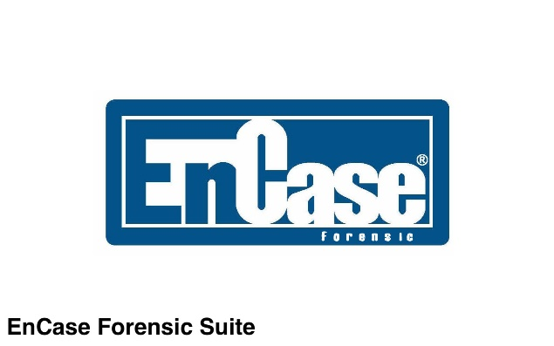
Figure 2 Image of the Logo of the EnCase software [4]
Encase is a computer forensics tool that has been used in cybersecurity and investigations in the early 90’s. [2] Over the years the program has gained popularity in the cybersecurity industry, but most choose a different option because of its high cost and large system requirements which isn’t possible for most computers to run, this program has the same goal as Autopsy. [4]
- EnCase Features
File Recovery: this feature has the ability to recover destroyed or corrupted files even if the user has deleted the file and emptied the recycling bin, [5] the feature works by copying all the data that is occupied on the drive and make an exact copy, then the feature will scan the unallocated space because files may have been deleted but small files may have survived that can be recovered, it scan the unallocated space and recovers data that may have survived like a .PNG or even a .MP4 but it’s not always guaranteed that the files may have survived. After all this the software will then attempt to reconstruct the file to the best of its ability, this process can take a few hours depending on the size of the file that is attempted to recover. Lastly the file is then validated to ensure that the file will work, and nothing is missing. [5]
Decrypt Data: Having the ability to decrypt data is a useful functionality that an investigator may use in an investigation due to a criminal locking illegal files or sensitive documents behind encryption which will need to be cracked to access the files. [6] This feature works by scanning a computers system for any encrypted files and once it has finished scanning it shows in a list of all the files that are encrypted on the computers storage device. The software does allow an investigator to crack a file without a password but if the encryption is too strong then the program will popup with a message asking for a password. [6]
Mobile Device Analysis: This feature is likely to be the most used feature on the program because of a mobile phones capabilities to take photographs, videos and store files which may be relevant to an investigation. This feature has many different functions that it can perform on a mobile device, first it can extract data including text messages, photos, phone calls and app data. Second it can do app analysis which can check for different social media accounts, messaging apps or even banking apps which can all be useful for gathering as much data as possible. [6]
Hash Analysis: A hash is a unique fingerprint for a particular file which can be used to compare to other known malicious files to see if they are a match and if they are then the original file is malicious and dangerous. Encase has many different hash algorithms already built in like SHA-256, SHA-1 and MD5 which are very popular algorithms when it comes to encryption. [7] To display the hash value of a file in Encase the investigator must open the file, select the correct hashing algorithm they may use, the program will then generate the hash which may take some time depending on the file size of the encryption type once the hash has been completed compare the value with other known malicious files and if there is a match then it’s dangerous. After the process has been finished Encase will output a report which will summarise its findings and it will say if the file is a match or not. [7]

FTK
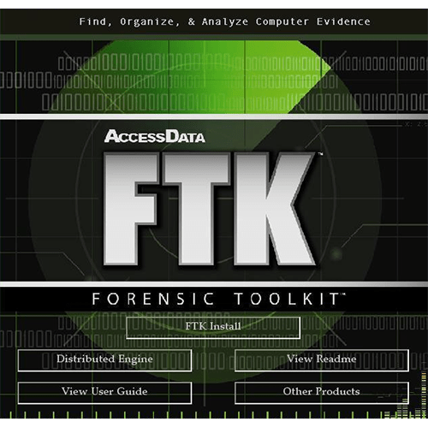
Figure 3 Logo of the software FTK [9]
FTK also known as Forensic Toolkits was developed by a company called “AccessData”, this program is the most popular program used in a criminal investigation by different agencies such as government agencies, private investigators, and law enforcement. [8] FTK is known to be incredibly comprehensive due to its large number of features and the effectiveness of each feature which tend to be more efficient than other similar programs. But on the other hand, it is known to be expensive, Proprietary, and very resource intensive for most computers which may cause delays in file scanning and file encryption. [8]
- FTK Features
File System Analysis: This feature is used often on multiple storage devices that use different file systems like FAT, NTFS and even HFS+, this feature comes in handy when dealing with multiple drives that are formatted differently and an investigator needs to extract the data quickly and without corruption if possible. This feature works by scanning the entire drive for existing files and already deleted files by organising the drive into allocated space which are existing files and unallocated files that are deleted files or empty storage space. There is an option built into this feature and its called, “File system journaling” which only allows ext4 and NFTS from logging all the changes that have been made on the file system which can then be utilised by an investigator to see what has been changed or configured. [8]
Data Carving: This feature allows an investigator to recover deleted or corrupted files from the unallocated storage section of a storage device, it identifies these deleted or corrupted files then tries to recover the files if another data still exists on the drive. This feature can identify over 350 different file types which makes this feature very accessible because it can access photos, videos, documents, and PDFs. [4]
Email Analysis: This is the first and most important step in a criminal investigation, criminals often use emails to send and communicate their thoughts about illegal items or illegal activities, so its important to be able to analyse and gather as much information as possible from each email because they often contains lots of different information that the average person may not realise that an email may collect or send. An investigator may be able to extract the email from a mobile or laptop and open the email on their own device, then can then scan the email for any meta data such as the message content, where the email is going, what client is it using and the message priority so they can filter the emails from junk mail to important emails. Downloading the email to a laptop will also download any attachments or links. [8]

Task 2

Abstract
In Task 2, the case study focuses on an incident which there was a sabotage within a company and important phone designs such as the Samsung Galaxy S20 Plus, the person who’s job it was to create the designs was an employee of CEC Mobile Manufacturing. The report that was mentioned which carried out an investigation by an experienced computer forensics investigator to try and recover the lost and deleted files also providing evidence of who stole the designs in the first place.

Introduction
The company that has been involved in this incident are called “CEC Mobile Manufacturing” they are well known for being one of the best phone and graphical user interface designers in the world, however recently the company suffered a data breach which resulted in the company to stop production due to an internal employee named “Rob Jengelley” stole several designs and secretly sold off the designs to CEC Mobile Manufacturing biggest competitors for profit. After he sold the designs, he decided to leave his position at his job and took several other designs with him but before he left, he deleted the files on the company’s systems so that the designs he had became very important due to no other backup being available.
Due to the leak the company has predicted it will lose a lot of money due to hiring computer forensics investigators and hiring new people that are able to create excellent user interfaces and designs. In the near future the company is looking forward to improving their security to prevent this from occurring again. The CEO of the organisation of which was affected mentioned that he felt “disturbed” by the events that occurred and will do whatever it takes to gather enough evidence to prove that Rob was responsible for all the damages he caused.

Methodology
The research design for this written case study will be written in a qualitative path because this report will require a lot of analysis for the case study and summarising the findings then finding the issues and then coming up with possible solutions. When writing this case study report it is important to have data to backup sources and facts that will be mentioned throughout. The data will mainly involve books from previous studies and from trusted sources that are relevant to the information at hand. The books will focus on data breaches and different software that an investigator may use as part of the investigation. Before implementing knowledge from relevant books, the backgrounds of the authors will be validated to make certain that the authors can be trusted and that their information is up to date and reliable.

The Problems
The case study has revealed several flaws in the companies security and their security policies, one of the biggest flaws that after carefully analysing the study is that Rob had full access to the documents when that shouldn’t be the case, different roles in an organisation require different levels of access due to uncertainty and lack of legal responsibility for Rob if he was going to commit a crime or a data breach against the company. [9]
After Rob had left the company another issue came into the picture, there were no backups on site or off site for the documents which resulted in the organisation to completely losing the documents with no other saves of the documents to be found. Having a secure backup is mandatory in today’s world but it’s also important to limit backups to only a very select people that have been audited heavily, signed a non-disclosure agreement (NDS) and are known for being trustworthy in the cybersecurity space. [9]
Before the incident took place the case study mentioned that the organisation had spent millions on research and development, spending such a large amount of money or a design or project will get the attention of most people malicious or not so having proper protections around spending a large amount of money such as keeping the project hidden is important to no attract as much attention as possible to the company. [9]
At the end of the case study, it appears that the CEO only recently hired a computer forensics investigator which means that during and before the attack the organisation did not have a proper security team in place to handle any future breaches which can be both internal and external attacks. [9]

Summary of found issues
- Authorised access was not configured correctly and allowed for unauthorised files changes
- No backup in place to recover any lost or damaged files
- Lack of a proper security team to handle the security incident during the attack and beforehand

Solutions
Many of the issues that have been discovered are fixable, but some may take some time or cost the organisation a fair bit to implement but the solutions are meant to be permanent solutions or improved upon fixes that will prevent any future issues the company may face. [10] There are a number of issues that were noticed when examining and analysing the case study and there are several issues that stand out from the rest.
The first issue involved Rob having access to the companies servers and was able to delete the files permanently and run off with the only copy which means he had full access to the server which is a major security flaw, to overcome this issue the network administration should assign any new and existing employee with their own unique group such as what position they are in the organisation, [11] if someone is a contract or a new employee place several different restrictions on what they are able to do like not being able to go into certain areas or buildings and even limiting what computers and directory’s they can access which will prevent any accidental deletions of any important documents by unauthorized users and lessen the chances of anyone trying to gain access to unauthorised areas. [10]
The other problem that appeared to stand out was the millions the company has spent on research and development, this is an issue because of the target the company is putting on their back and the best solution to prevent any possible large attacks is by keeping the information internal only, this may not work the majority of the time because other employees could leak the plans but it is important not to spread the message that an organisation is handling a lost of money at one time. [12]
One of the biggest issues that could be easily fixed is an effective backup solutions for the files on the company’s servers, because Rob deleted the only saved file and left the company with the only copy the organisation was not able to recover the file with a computer forensics investigator that the CEO had hired after the incident. The solution to the issue is to implement different servers but they aren’t directly connected to every computer on the network but are only configured by the network administrator and the I.T team, making sure the server is controlled by reliable personnel to prevent hackers from remotely accessing the server outside or inside the building. Having additional servers may cost the organisation a fair bit to implement but if they aren’t willing to go the local backup method, they could turn to Amazon Web Services (AWS) which they are able to backup their important documents in the cloud which is both in the cloud and secure. [13]

Aftermath of the incident
When the forensics investigators arrive to the organisation they will need to use unique pieces of software like FTK and Autopsy which are both computer forensics tools that may scan the drives on the server for any encrypted files or any recently deleted files, if Rob deleted the files and left then there is a high possibility that the files may still be recoverable but if Rob managed to override the disk several times after deleting then the files may be very hard or impossible to recover. Because the files are located on the server, they will need to figure out which drive the files were stored on, what server they are stored on and ask around other employees who have had access to the server before the incident to make the process quicker for everyone involved. [14]
When the laptops have been connected to the server it will be scanned using FTK and or Autopsy which scans the whole drive for unique file types and any recently deleted files, they will need to scope out the damage that may have been caused or any unknown changes that could have occurred. At the same time the investigators will need to collect any and all work-related devices that have access to that server to make sure that there aren’t any other malicious actors that are planning on doing the same thing. [15]

Autopsy Forensic Report
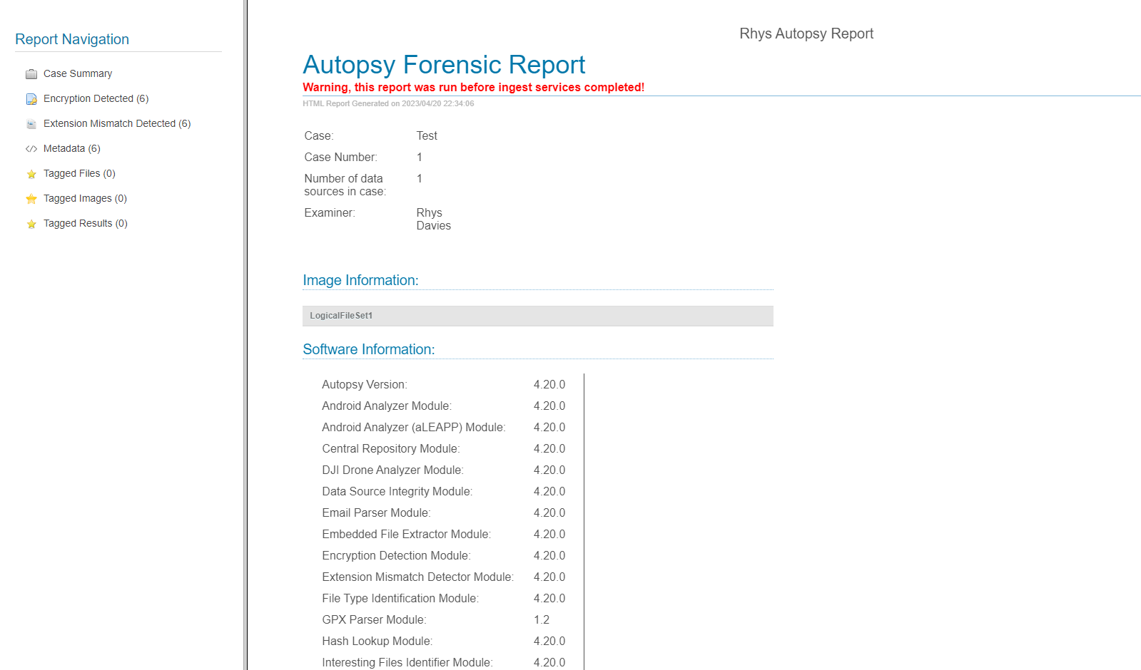
Figure 4 Image of the Computer Forensics Report
This is a report created from the incident and the program Autopsy has created a report which summarises its findings with the files and lays it out in an easy to use and easy to view format for anyone to be able to look at and understand.

Invoice
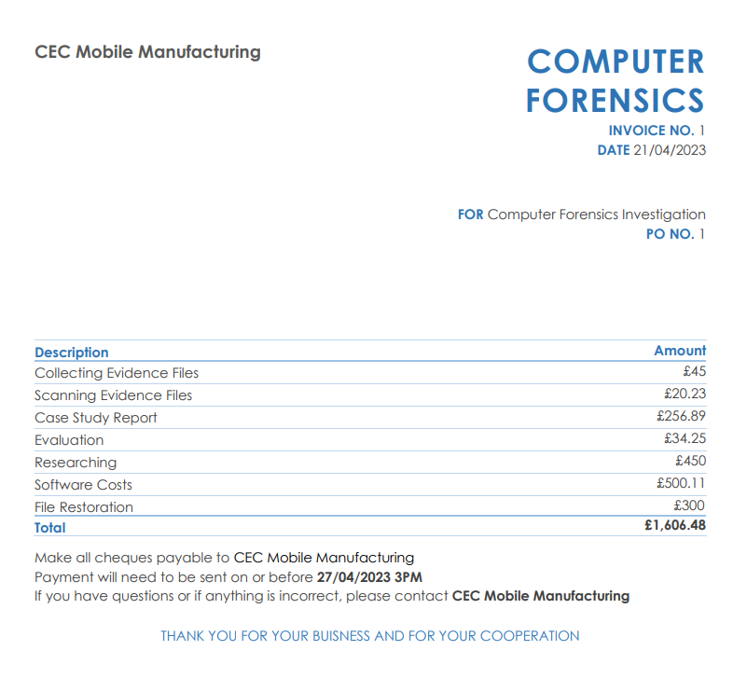
Figure 5 Image of the custom created invoice
This is an invoice that has been created after the work has been completed and the client is satisfied, this shows what services were carried out and how much its going to cost for each service.

Conclusion
In conclusion, cybersecurity and computer forensics are very important aspects for any business that uses the internet daily to complete tasks and to handle sensitive documents, as cybersecurity attacks begin to increase in numbers and severity it is important to have proper security policies and an I.T team to maintain and protect the business from any future attacks from leaking important documents. As the forensics tools are always changing because of new and better technologies its important to also have the latest protections like VPN’s, Firewalls, newer versions of operating systems.
Recommendation
After analysing the case study, the organisation is in need for a security upgrade, such as
- Having regular backups to make sure the data is kept secure and private
- Better access controls for each employee to prevent any data loss in the near future
- Monitor employee’s actions when accessing critical servers
- Better and more involved employee training on cybersecurity
- Regular security audits should be conducted to understand any vulnerabilities in their computer systems
Implementing strong security like VPN’s and Firewalls are simple and straight forward to setup, and both of those security measure are great for making sure network traffic is safe and secure for transferring secretive and important documents over the internet.

References

[1] | Autopsy, “Download Autopsy for free,” Autopsy, [Online]. Available: https://www.autopsy.com/. [Accessed 16th April 2023].
[2] | M. P. K. M. a. J. T. L. J. T. Luttgens, Incident response & computer forensics / Jason T. Luttgens, Matthew Pepe and Kevin Mandia, New York: McGraw-Hill Education, 2014.
[3] | Hershey, Digital forensics and forensic investigations : breakthroughs in research and practice, Pennsylvania: Information Science Reference, 2020.
[4] | N. Clarke, Computer forensics a pocket guide, Ely, U.K: IT Governance Pub, 2010.
[5] | A. P. a. C. S. B. Nelson, Guide to computer forensics and investigations, Boston: MA: Course Technology Cengage Learning, 2010.
[6] | M.-H. Maras, Computer forensics : cybercriminals, laws, and evidence, Burlington: MA: Jones & Bartlett Learning, 2015.
[7] | C. Easttom, System forensics, investigation, and response, Burlington: Jones & Bartlett Learning, 2017.
[8] | V. P. B. a. J. Mull, Judiciary-friendly forensics of software copyright infringement, Hershey, Pennsylvania: Information Science Reference, 2014.
[9] | S. Mitchell, How to survive a data breach a pocket guide, Ely, U.K: IT Governance Pub, 2009.
[10] | R. H. S. a. R. Warner, Why don’t we defend better? : data breaches, risk management, and public policy, Boca Raton: FL: CRC Press/Taylor & Francis Group, 2019.
[11] | C. B. a. C. Hunt, Mastering network security, San Francisco: Sybex, 2003.
[12] | D. Arditi, “The Voice: non-disclosure agreements and the hidden political economy of reality TV,” Popular communication, vol. 18, pp. 138-151, 2020.
[13] | A. Amiri, “Application placement and backup service in computer clustering in Software as a Service (SaaS) networks,” Computers & operations research, vol. 69, pp. 48-55, 2016.
[14] | M. A. Connor, Forensic methods : excavation for the archaeologist and investigato, Lanham: AltaMira Press, 2007.
[15] | A. Kolar, “Forensic pathology for police, death investigators, attorneys and forensic scientists,” Journal of Forensic and Legal Medicine, vol. 18, pp. 234-234, 2011.

