Consultancy on Financial Management of GAP Inc

Executive Summary
Project Aims
To give suggestions to Gap Inc. on how to better perform financial management activities in the coming financial year.
Project Objectives
a) To make business environment analysis using the tool of SWOT analysis and Porter Five Forces in order to understand the foundation of financial management.
b) To find data of the past five years of Gap Inc. and make comparisons within the retailing industry as well as beyond the industry.
c) To analyze the financial management data in order to obtain a view of Gap Inc.’s current financial situation.
d) To give recommendation on how to better operate financial management in the coming year.
Findings and Critical Analysis
The report of financial analysis of Gap, Inc. is mainly based on the data shown in annual reports and computed by software. Financial ratios, capital structure and dividend payout policy are the factors taken into consideration. The analysis found out that in year 2019 Gap, Inc.’s financial position and performance is slightly worse compared with the industry and its change during the year also deteriorated considerably. However, Gap, Inc. performed better compared with all industry in financial management.
Conclusion
There is a significant drop of Gap, Inc.’s financial performance in year 2019, making it more risky for investors. Nonetheless, there is still a chance for Gap, Inc. to win by making some moves in financial management in such a highly competitive business environment.
Recommendations
Firstly, decrease the debt-to-equity ratio. This ratio is the key element for Gap to obtain more profits and it could be achieved by attracting more investments or selling some assets which may not be utilized efficiently to finance its projects rather than debts.
Secondly, since the ROA is far lower than the average level of the industry, it could be suggested to close more shops which brought profits under the expected level or even suffered loss. It’s quite necessary to investigate in those stores and cut them done if necessary.
Lastly, keep the current internal growth rate to some extent. This way has shown to be productive for Gap to raise funds and gain investors’ trust for continuous investments.

Table of Contents
Executive Summary I
Project Aims I
Project Objectives I
Finding and Critical Analysis I
Conclusion I
Recommendation I
1. Introduction 1
1.1 Aims and Objectives of Project 1
1.2 Project Justification 2
2. External Analysis 3
2.1 Five Forces Model Analysis of GAP Inc. 3
3. Internal Analysis. 4
3.1 SWOT analysis of GAP Inc. 4
3.1.1 Strengths of GAP Inc. 4
3.1.2 Weaknesses of GAP Inc. 5
3.1.3 Opportunities of GAP Inc. 5
3.1.4 Threats of GAP Inc. 5
4. Research Methodology. 5
5. Financial Performance Analysis 6
5.1 Profitability ratios 6
5.1 Solvency ratios 7
5.1 Liquidity ratios 7
5.1 Activities ratios 8
6. Capital Structure Analysis 9
6.1 Debt-to-equity ratio 9
6.1 Internal and sustainable growth rate 10
7. Dividend Payout Policy Analysis 12
8. Conclusion 13
9. Recommendation 13
Reference 15
1. Introduction
This document is to perform consultancy on the financial management of GAP Inc, which is an international leading group specialized in apparel retailing. The consultancy starts from the internal analysis of the group, which supports the further analysis of financial management by setting a tone of the internal value, culture and control of the group, then to the budgetary control, financial policies, financial planning to diagnose any potential deficit exists in the group. Lastly, after considering and consolidating all available information, the consulting report will be drafted to give opinion on the current status of financial performance in GAP Inc, as well as potential changes to be made to enhance the financial performance of the firm.
The consulting object in this document is GAP Inc, the headquarter of which is located at San Francisco, USA. The group mainly expand through opening local stores, franchising its brand to foreign countries, and selling on the online website. Geographically, GAP Inc has penetrated in markets in United States, Asia, Europe, Canada, Africa. The franchising strategy prompts the group to develop rapidly globally, which is a strategic advantage in the apparel industry (GAP,2020). However, in the global retailing industry, the cost of entrance is relatively low, especially in the modern technology-advanced background it is convenient and cost-saving to start an e-commerce. Given the high competition in the industry, it is important to enhance the internal management process to achieve strategic advance in the industry (GAP, 2018).
1.1 Aims and Objectives of the project
The aim of this project is to provide solution to address on the current problem on financial management of GAP Inc. To address the problem, the first step is to analyze the internal condition of GAP Inc as well as the condition of the retailing industry to set a tone of the group’s internal culture and value and its position in the market. The second step is to analyze GAP’s financial statements in the annual reports which is the core area of the analysis. Thirdly, is to identify the potential financial problem hidden in the financial statements, such as financial ratio analysis, the efficiency of the working capital management, dividend policy and accounting issue interpretation. The potential suggestion could be made after communicating with those charge with management to address those problems identified.
1.2 Project Justification
By taking a simple glance of GAP, Inc.’ s annual report (GAP, 2020), it is noticeable that there is a big drop down in revenue thus profitability and there is a constant decrease in Gap brands’ sales from fiscal year 2014 to 2019. It would be essential for GAP Inc.’s better development in the future to improve internally by managing financial activities. The goal of financial management is to maximize the value of the company via various analysis methods such as financial ratios, capital structure etc. (Chandra, 2011). In order to achieve the goal of constant growing of GAP, Inc., conducting this project will help to understand of the current situation as well as make strategic change based on the results.

2. External Analysis
2.1 Five Forces Model Analysis of GAP Inc.

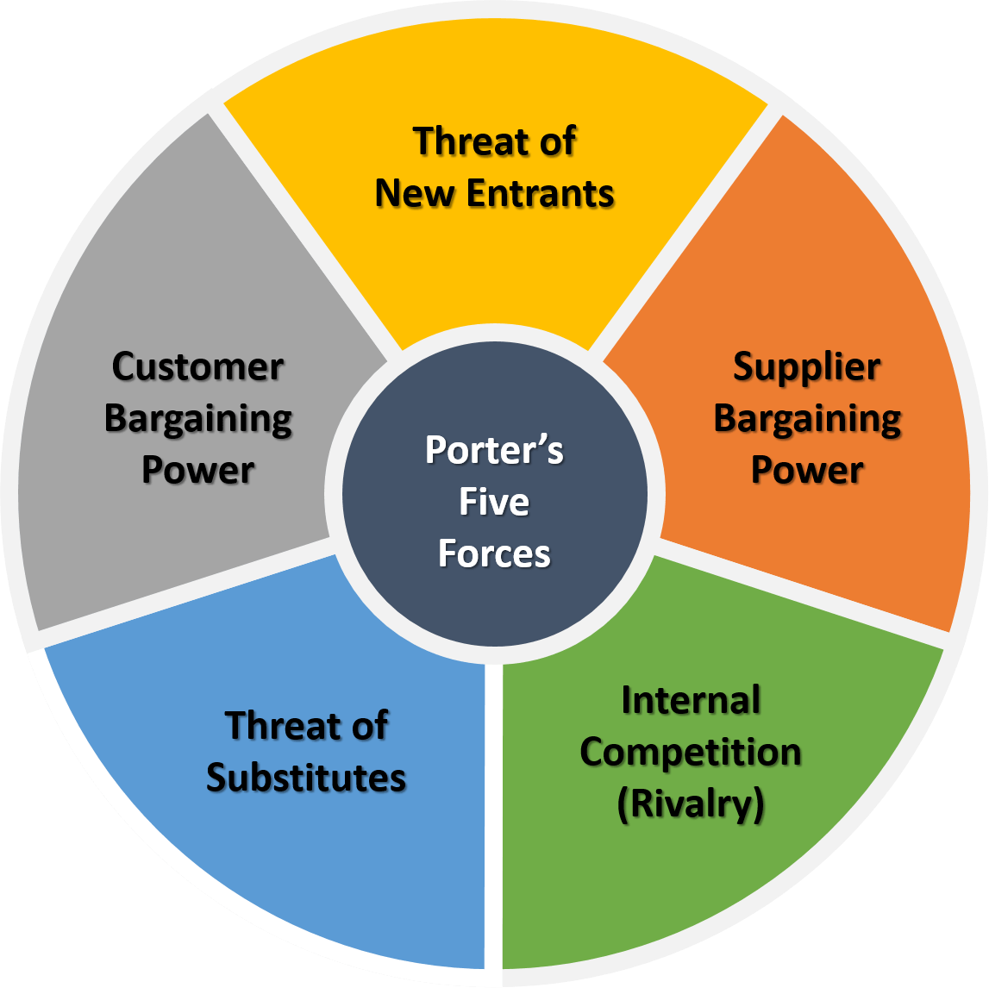

Figure 3.1 Porter’s Five Forces
Porter’s Five Forces is a business model applied for companies to understand the its situation in the industry by analyzing five competitive forces. This model also helps to explain why various industries are able to sustain different levels of profitability (Michael, 1980).
It’s very powerful to use Porter’s Five Forces model to determine the likeliness of profitability of a company within the industry. However, the limitation of this model is rather obvious that it assumes industry standstill since it was proposed in the 1980s while nowadays technology would have constant impact on market changes.
By utilizing Porter’s Five Forces model GAP, Inc. would be able to determine the full scope of competition in the fashion and apparel industries.
The competition companies in apparel industry is more and more fierce. GAP Inc. is mainly facing the challenge from the competitors including J. Crew Group, JC Penney, American Eagle Outfitters, Abercrombie & Fitch, Belk, Guess, and Urban Outfitters, Inc., etc.
It is worth noting that “despite being one of the largest apparel manufacturers in the United States, GAP Inc.’s market share is less than 5%, which clearly shows the diversity of the apparel industry in the United States. Multi-brand retail chain Macy ’s (9 %) And Walmart, a daily necessities retailer (over 7%), hold higher stakes. JC Penney (3.3%) and Target (5.4%) have similar market shares, while American Eagle Outfitters, Aeropostale, and Abercrombie & Fitch together account for US apparel More than 2% of total sales(Forbes,2015). Figure 2 below the figure illustrates the US retail industry overview.
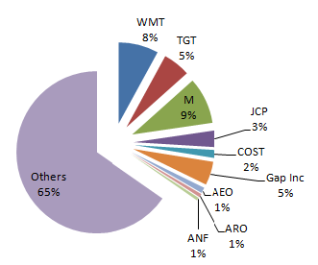

Figure 3.2 the US Apparel market share
The influence from the suppliers tends to be slight. GAP Inc. has 1,000 suppliers worldwide. G Inc. ’s biggest suppliers accounted for less than 5% from all suppliers in (GAP Inc., 2015). In this case, GAP Inc.'s business does not rely on any particular supplier and do not need to confront with the bargaining power. Also, for most suppliers, due to their large number of orders, business with GAP Inc. is critical.
New entrants pose a medium threat to the fashion and apparel industries. It is difficult for new entrants to access to distribution channels. Therefore, main players in the fashion and apparel industries such as Gap, Macy's and Zara also benefited greatly from the market, and at least during the first few years of operation, this opportunity could not be used for new market entry. Building a business requires a lot of money, and the expected revenge of current market participants is an additional challenge that potential new market entrants will face.

3. Internal Analysis
3.1 SWOT analysis of GAP Inc.
3.1.1 Strengths of GAP Inc.
Since it was started in 1969, GAP has been developing rapidly worldwide. GAP has developed from a store to a global brand. Nowadays Its products are sold in more than 85 countries around the world. Until December 2019, it had owned more than 3,000 stores, 400 franchisee-owned stores and also online shopping sites (GAP Inc., 2019).
GAP Inc. provides various products to meet the needs of customers. Its customers are loyal because of the product’s quality and durability. Its portfolio comprises Intermix brands, Gap, Banana Republic, Old Navy, and Athleta, addressing the needs of different customer within clothing and fashion industry. Gap signifies optimistic American casual style, whereas Banana Republic provides deliciated products for the young woman. Apart from that, there are different product lines such as GapKids, GapBody, GapMaternity, GapFit and babyGap in GAP Inc., which effectively meets the needs of various customers. GAP Inc.’s current portfolio of distinct brands is strong enough to indicate positive future on revenues (GAP Inc., 2019).

3.2 Weaknesses of GAP Inc.
The news that workers work under unsafe conditions has seriously affected GAP Inc.'s brand reputation. Similarly, some of the company’s suppliers have also been accused of using child labor, and delay workers payment. Even though GAP Inc. has terminated the collaboration with unethical suppliers, it still needs more efforts to win back many customers who are worthy of the problems above (McDougall, 2007).
Although branding has always been behind GAP Inc. 's success, there are still many problem with it. For example, many people think that GAP Inc. only aims at high-end customers. Therefore, this limits the interaction with them.
GAP Inc. owes a few failure stories that bring some information to customers. For example, it announced its decision to close 230 GAP stores around the world in early 2019 to save the brand, as GAP Inc. ’s homogeneous competition continues to decline. Similarly, it also the closed all stores in Australia in the recent years (Pash, 2017).
3.3 Opportunities for GAP Inc.
GAP Inc. has the opportunity to develop business in the United States and other regions. For example, it has plans to develop Athleta and Janie and Jack brands outside the United States through franchise agreements. This will help the company gain a foothold in Central America and the Caribbean (Thomas, 2019).
Fast fashion and cheap clothing are still very popular worldwide. This can an opportunity for GAP Inc. to use market penetration strategies to drive sales growth. The company can take advantage of this opportunity by licensing its sub- brand to the world's leading online giants such as Amazon, T-mall.
3.4 Threats to GAP Inc.
The main threat is fierce competition in global market. In fact, due to the challenges posed by retailers such as Forever 21, Primark, Zara, M & S and H&M the company has been in a difficult situation (Thomas, 2019).
4. Research Methodology
The project is made upon different analysis on data and resources. Data used in the project are collected mainly in GAP Inc.’s annual report for year 2018-2019. All data could be found in GAP Inc.’s financial statement including income statement and balance sheet. Then comparisons are conducted vertically and horizontally based on data collected to make further analysis and conclusion.

5. Financial Performance Analysis
In order to make further and deeper analysis on the financial situation of Gap, it’s essential to take the first glance at its financial ratios by computing data via its annual report or quarterly report. For this part, all data could be found in Gap’s related financial report.

5.1 Profitability ratios
For analyze the profitability ratios, three ratios are mainly taken into consideration, and these ratios are profit margin, ROE (return on equity) after tax, and ROA (Return on assets).
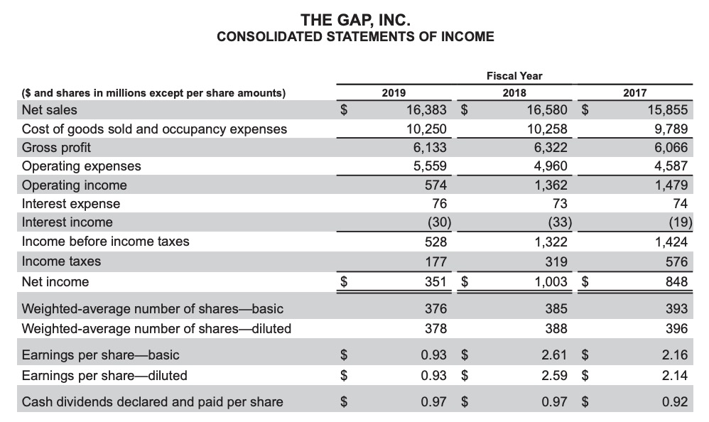
Figure 5.1 GAP, Inc.’s income statement from fiscal year 2017-2019 (GAP,2020)
To begin with, revenue of Gap reached $16,383 millions ranked number 2 out of 23 companies in the industry. To make it clear, a chart will be drafted to show the profitability ration with comparison within the industry and with all industries.
 | Gap/With the industry | Gap/With all industry
Profit margin | 2.1 / 2.4 | 2.1 / 3.3
ROE, after tax | 10.2 / 9.5 | 10.2 / 3.2
ROA | 3.2 / 14.4 | 3.2 / 2.4
Profit margin tells the amount of money left of each sales after all expenses are paid. From the statistic it’s very clear that Gap has a lower level in profit margin compared to both the industry and all industries.
At the same time, ROA is way lower than the median industrial ratio showing that Gap fails to make the fullest usage of its overall resources yet it’s a bit higher than the ratio of all industry, which shows that as a company in the retail trade industry Gap would have performed better in the usage of its assets.

5.2 Solvency Ratios
Solvency is significant to a company’s financial health and it refers to the ability to meet long-term financial commitments. Similarly, I would explain by comparison chart computing data from the annual reports.
The three main indicators concerned are Gap’s debt ratio, debt-to-equity ratio and interest coverage ratio.
 | Gap/With the industry | Gap/With all industry
Debt Ratio | 0.76 / 0.70 | 0.76 / 0.63
Debt-to-equity ratio | 3.13 /1.54 | 3.13 / 1.01
Interest coverage ratio | 7.95 / 3.22 | 7.95 / 1.94
Debt ratio reveals the proportion of a company’s assets financed by its debt. Obviously, the higher the debt ratio is, the higher financial risk it would have. As implied in the chart, the debt ratio of Gap is slightly higher than the median level, meaning that the business of Gap might be risky than its competitors, making it a major concern of its creditors.
In addition, debt-to-equity equals the percentage of total debt to total equity. This ratio indicates the degree of financial leverage being used by the business and includes both short-term and long-term debt. Similar to the debt ratio, a higher debt-to-equity ratio means high risk, affecting mainly on the company’s ability to raise more debt since its business is risky and there would be more interests as well. In a long run, continuously increasing debt-to-equity ratio would have a negative impact on a company’s credit rating. Currently the situation of Gap is slightly dangerous for it to raise funds because its debt-to-equity is higher than the average in the industry thus investors may consider transferring their investments to other safer options.
Interest coverage ratio indicates the company’s ability to pay its interests caused by debt. However, Gap still has enough ability to pay its interest due to the data shown.

5.3 Liquidity Ratios
Same as solvency ratios, liquidity ratios play an important role for a company’s financial health because they reveal a company’s capacity to pay its short-term debt or how easy and rapid it is for the company to raise cash by selling its assets.
To evaluate Gap’s ability, I would mainly discuss current ratio, quick ratio and cash ratio.
 | Gap/With the industry | Gap/With all industry
Current Ratio | 1.41 / 1.39 | 1.41 / 1.55
Quick ratio | 0.61 / 0.37 | 0.61 / 1.00
Cash ratio | 0.52 / 0.25 | 0.52 / 0.40
Current ratio equals current assets divided by current liabilities. This ratio gives people an idea of the ability of one company to pay its current liabilities by its current assets such as cash, account receivable etc. Gap performs not too bad to pay back its current liabilities by its cash or inventories etc.
Quick ratio is a comprehensive ratio which measure how a company could pay its short-term debt by most ‘quick’ current assets except inventories.
Cash ratio makes current liabilities payback easier, since it measures to what extent that a company could pay back its current liabilities by funds held currently like cash and cash equivalents.

5.4 Activity Ratios
Here the finding will introduce asset turnover and receivables turnover to demonstrate the situation.
 | Gap/With the industry | Gap/With all industry
Asset turnover (days) | 242 / 58 | 242 / 220
Receivables turnover(days) | 8 / 2 | 8 / 13
Asset turnover measures the extent to which the company generates sales through its assets, and asset turnover in days suggests how many days the company would use to achieve such sales within the assets. Obviously, the higher the ratio is, the lower efficiency of the management activities is because it means that the company generate less revenues with a certain level of assets. Gap’ asset turnover days is above 4 times to the median level in the industry especially compared to its main competitors, showing that its low efficiency of the management activities to promote sales by making use of assets.
Receivable turnover simply measures how many days the company could receive cash after the credit transaction is made. An increasing tendency would do no good to the company because it could only turn account receivables to cash lower. In the case of Gap, it basically remains at the level above average which implies that Gap needs more days than most of other companies in the same industry to transfer account receivables into cash.

6. Capital Structure Analysis
Capital structure measures how much debts and/or equity a company has to finance its operating activities or to fund its assets.
6.1 Debt-to-equity Ratio
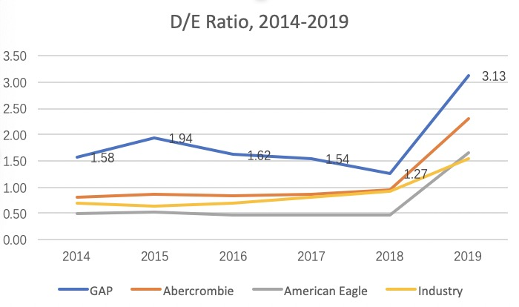
Figure 6.1 D/E ratio of main competitors and the average of industry from 2014 to 2019
The debt-to-equity ratio shows how a company distribute its capital. As seen in the graph above, GAP has a D/E ratio of 3.13 in financial year 2019 which is much higher than the median and its competitors. However, Gap’s ratio between year 2014 to year 2018 remained sustainably stable, so does the industry. Even though there is a soaring trend from 2018-2019 for companies in retailing industry, Gap showed the higher growth rate in the D/E ratio. For future development, Gap needs to keep the D/E ratio at a significantly lower level to gain more profits and become more competitive. Since Gap suffers from a higher D/E ratio, it may need to pay more interested and is less financed by debts thus making its business riskier which is the major concern of its investors.
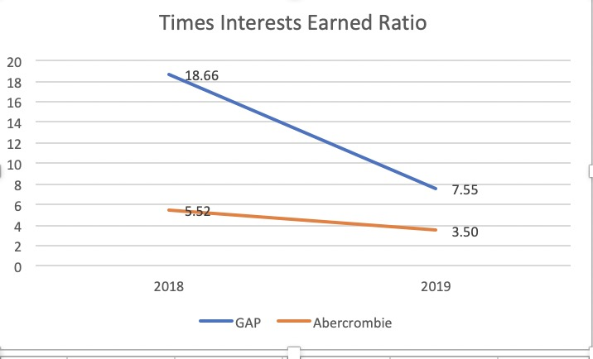
Figure 6.2 Time interests earned ratio of Gap, Inc. and Abercrombie in year 2018 & 2019

“The times interest earned ratio indicates the extent of which earnings are available to meet interest payments…A lower times interest earned ratio means less earnings are available to meet interest payments and that the business is more vulnerable to increases in interest rates” (Investopedia,2018). Even though Gap still is more capable to pay its interests by earning than the average but the sudden drop of this ratio needs to be taken into consideration seriously.
6.2 Internal and sustainable growth rate
Internal growth rate is defined as “the highest level of growth without obtaining outside financing” (Investopedia,2018). The internal growth rate (IGR) is important to evaluate how capable an enterprise is to remain profitable in the future.
Internal growth rate could be found by the formula of reinvested earnings divided by total assets, or when dividend payout ratio is known, the IGR could be calculated by (1-divident payout ratio) * ROA.
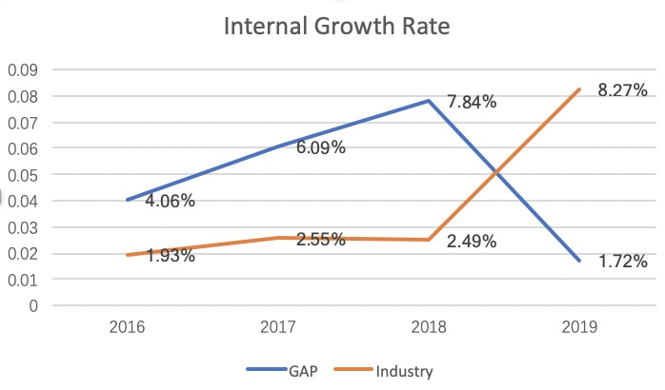
Figure 6.3 Internal growth rate of Gap, Inc. compared to the industry from year 2016 to 2019
Well, in the chart, the internal growth rate of Gap shrank in year 2019 while the internal growth rate increase at a significant level, meaning that Gap paid much more dividends on average. This message also hints that Gap allocated more of their money to investors with confidence that it’s valuable and worthy of the investment. In addition, when we look at the sales revenue of Gap and its main competitors, Gap has much higher sales probably for the reason that it opens more stores around the world. It’s also very impressive to see that with such a low internal growth rate Gap still obtains profits.
However, Gap needs to pay attention to the risk as well. If the internal growth rate continues to drop, Gap might face a lot of challenges such as being surpassed by competitors or meeting loss.
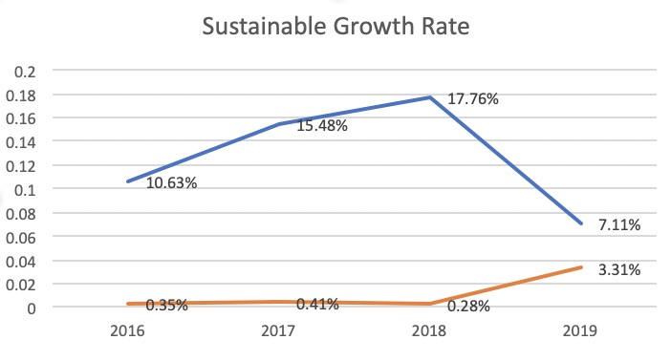
Figure 6.4 Substainable growth rate of Gap, Inc. compared to the industry from year 2016 to 2019
The Sustainable Growth Rate is the “maximum growth rate that a firm can sustain without having to increase financial leverage.” (Investopedia, 2019), it re-considers its external resource of debts. There are several ways that an enterprise could find to refunds projects, as discussed above, using internal growth rate could be very practical and efficient. But when the enterprise exceeds their internal growth rate, it might be a good idea to utilize the sustainable growth rate. Surely it could be more risky that investors care a lot about. When a company exceed their sustainable growth rate on their budget or limit expense, the company would needs raise more funds by using more of its credits and overspending is always a warning signal for creditors as well as investors.
When analyzing the graph, it’s obvious that during last year Gap has a decline in its SGR while the trend of the industry is opposite. Nonetheless, it still enjoys a higher level than the average in the industry showing a good sigh to the public because a higher sustainable growth rate means the company could better handle with investors’ money. This also benefits Gap in the strong competition in the industry.

7. Dividend Payout Policy Analysis
As stated in the report, Gap has 5,923 shareholders before March 11th, 2020 (Gap,2020). The table following shows how many dividends are distributed last two years.
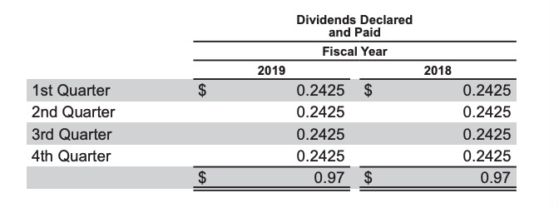

The annualized payout of Gap was $0.97 and It remained the same as in 2018. Due to calculation, pay out rate is 93.89% and the dividend yield is 12.37%.
There are mainly four types of dividend policy commonly used, which are surplus dividend policy, fixed dividend policy, steadily increasing dividend policy and fixed dividend payout rate dividend policy. In the case of Gap, it took the fixed dividend policy that the company annually allocates fixed per share dividend amount, and it would remain the same no matter what factors change (Xian & Xing, 2015). By implementing this policy Gap is highly likely to stabilize its stock price, Gap gives confidence to its investors the idea that the company would develop and improve at a stable speed, besides it’s also conductive for the financial management of the company. However, fixed dividend policy would put Gap under great pressure when it goes through financial difficulties such as plunge of net profits, eventually weakening the situation of cash flow and deteriorating the financial situation.
Overall, even though there will be some risks continuously taking the fixed dividend policy, it might be the safest movement for Gap at the moment to attract investors and strengthen its financial management.

8. Conclusion
Among financial ratios, the key profit margin ratio is 2.1 while the industry average level is 2.4 and in all industry the average is 3.3; ROA of GAP Inc. is 3.2 while the industry average level reaches 14.4, implying that GAP Inc. would thrive to cut off expense or increase sales to increase the profit margin, meanwhile measures to raise ROA is necessary. For liquidity ratios GAP Inc. performed basically near the average level so it is strongly suggested for GAP Inc. to keep up with this rate because a good liquidity ensures its ability to raise funds or remain more cash by current liabilities and to show its creditors it is quite creditable. However, assets turnover days reached 252 days which is way higher than the industry average level of 58 days while receivables turnover days is 8 days compared to 2 days of the average in the industry. Both activities ratios show that Gap needs a lot improvement in its management activities to at least keep up with the average level. Otherwise the efficiency of activities would remain too low that GAP Inc. won’t be able to generate enough cash or promote sales when needed, for example, it would be quite difficult for GAP Inc. to go through financial crisis with such activities ratios. Moreover, even though Gap has enough capacity to pay its interests, still it’s advisable to retain a lower Debt-to-equity ratio in the future.
Based on the financial analysis, we can see that even though Gap keeps gaining profits in the last five years, the increase pace became significantly slower during the last financial year 2019-2020. This growth rate decline could probably result from the highly competitive business industry or the global economic conditions with an adverse impact on Gap’s results of operation. For Gap’s performance compared to others, it operated at the below average level in the retailing industry.
Generally speaking, there is still a chance for Gap to improve its situation by making some financial management changes.

9. Recommendations
Firstly, decrease the debt-to-equity ratio. This ratio is the key element for Gap to obtain more profits and it could be achieved by attracting more investments or selling some assets which may not be utilized efficiently to finance its projects rather than debts. One measures to achieve this goal is to seek for new ways of debt financing with lower interest rate. Besides, mange inventories by taking up a big amount of working capital as well as adjusting unnecessary high inventory level beyond actual demands by customers.
Secondly, since the ROA is far lower than the average level of the industry, it could be suggested to close more shops which brought profits under the expected level or even suffered loss. It’s quite necessary to investigate in those stores and cut them done if necessary.
Lastly, keep the current internal growth rate to some extent. This way has shown to be productive for Gap to raise funds and gain investors’ trust for continuous investments. The very key to this point is to increase revenue. For Gap Inc. one of the ideal way to keep the internal growth rate or make it increase is to introduce some new products in the existing market to attract more customers. It requires further discussion based on the company’s strategy as well.

Reference
Adam. H (2019). Internal Growth Rate (IGR) Definition. [online] Available at:https://www.investopedia.com/terms/i/internalgrowthrate.asp
Annual report of GAP Inc. (2015). Gap Inc. 2015 annual report. [online] Available at:http://www.annualreports.com/HostedData/AnnualReportArchive/g/NYSE_GPS_2015.pdf
Annual report of GAP Inc. (2019). Gap Inc. 2019 annual report. [online] Available at: https://investors.gapinc.com/static-files/b7cbafda-5a38-44e1-aee5-e85b284d0455
BBC (2019) Gap to shut shops and hive off Old Navy. BBC. Available at: https://www.bbc.co.uk/news/business-47392738
Chandra, P. (2011). Financial management. Tata McGraw-Hill Education.
Chris. B.M (2019). Sustainable Growth Rate – SGR. [online] Available at: https://www.investopedia.com/terms/s/sustainablegrowthrate.asp
James.C (2019). Times Interest Earned (TIE) Ratio. [online] Available at : https://www.investopedia.com/terms/t/tie.asp
Jegers, M. (2003). The sustainable growth rate of non–profit organisations: the effect of efficiency, profitability and capital structure. Financial Accountability & Management, 19(4), 309-314.
McDougall. D (2007). Child sweatshop shame threatens Gap's ethical image. The Guardian. Available at: https://www.theguardian.com/business/2007/oct/28/ethicalbusiness.india
Pash. C (2017). Gap stores are closing in Australia. Business Insider. Available at:https://www.businessinsider.com.au/gap-stores-are-closing-in-australia-2017-8
Porter, M. E. (2008). The five competitive forces that shape strategy. Harvard business review, 86(1), 25-40.
Trefis Team (2015). Gap Inc Is Gradually Losing Its Share In The U.S. Apparel Market To Fast-Fashion Counterparts. Forbes. Available at: http://www.forbes.com/sites/greatspeculations/2015/07/15/gap-inc-is-gradually-losing-its-share-in-the-u-s-apparel-market-to-fast-fashion-counterparts/#7469a03e7817
Thomas, L. (2019) Gap’s second-quarter sales fall short of estimates, CEO calls out ‘challenging environment.’ CNBC. Available at: https://www.cnbc.com/2019/08/22/gap-reports-fiscal-q2-2019-earnings.html
Weaver, D. (2014). Successful Fashion Retailing in Grand Rapids, MI.
Xian Mei, & Xing Wei. (2015). Analysis of dividend policy of listed company and its financial impacts. International Symposium on Computers & Informatics.

