SCHOOL OF HOSPITALITY & TOURISM MANAGEMENT

Student name: SYED SHAHED AHMED
Student number: 2210199221019222101992101999
Lecturers: Tristan Hawkins, Ffion Cumberpatch, Laurence Blake, Rohan Dubrey
Assignment Title: Assessment of Practical Tasks (Menu Engineering)
Task Description: Hotel Trinity is a 4* city centre hotel, part of the Trinity Hotel chain, located in the United Kingdom (within your locality). Your task is to create and design a fixed price Valentine’s menu for Hotel Trinity (fictional hotel).. You must offer drinks packages on the menu. The menu will need to be designed on an A4 page format (Word / PowerPoint / Other). This can be a singular page, or 2 pages.
Attachments:
- PowerPoint Trinity Hotel Valentine’s Menu consisting of 2 pages.
- Reading & Reference list used for creating logo and gathering information for assignment menu. This is attached below.
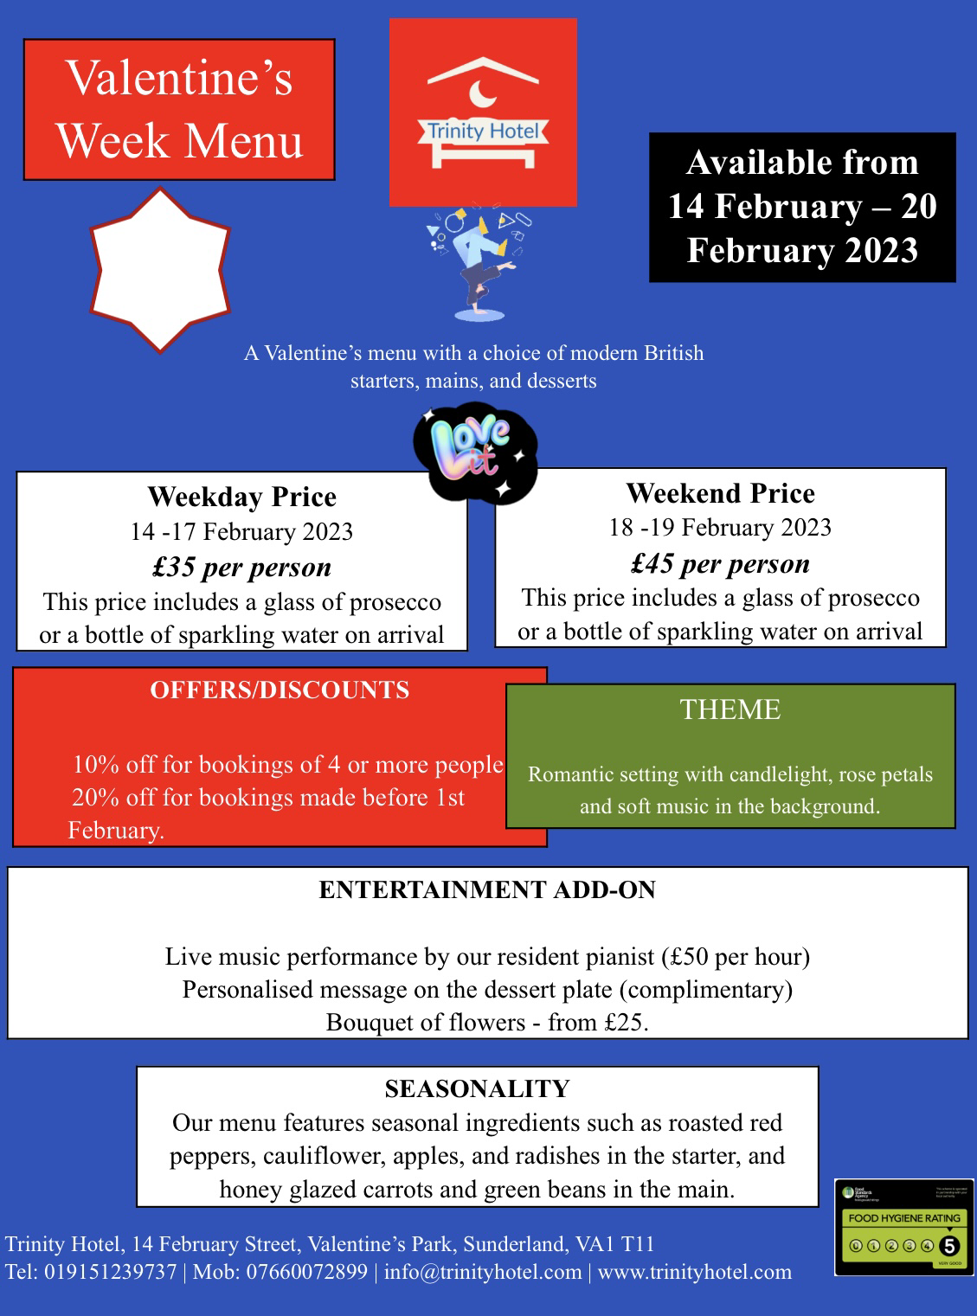
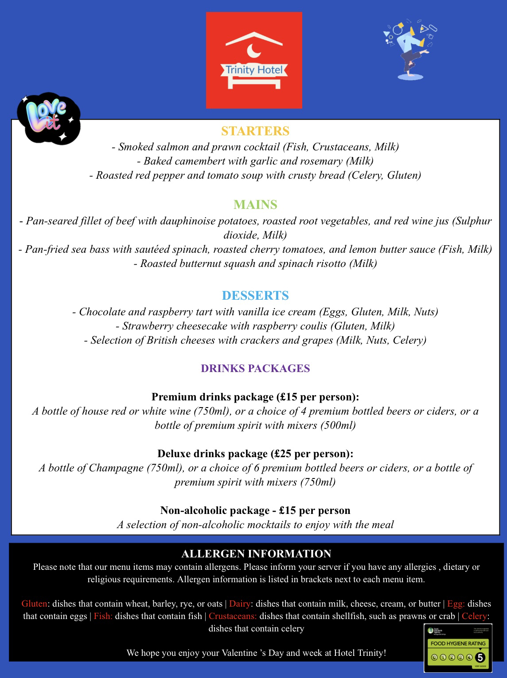

READING & REFRENCE LIST

- Adobe Express (2023). Available at: https://www.adobe.com/express/create/logo (Accessed: 11 February 2023).
- Heath and Safety Executive (2022). Available at: https://www.hse.gov.uk/simple-health-safety/law/health-safety-law.htm (Accessed: 14 February 2022)
- Food Standards Agency (2023) The FSA’s Food Hygiene Rating Scheme is 10 years old. Available at: https://www.food.gov.uk/news-alerts/news/the-fsas-food-hygiene-rating-scheme-is-10-years-old#:~:text=The%20scheme%20was%20developed%20to,to%20buy%20and%20eat%20food.&text=In%202010%2C%20the%20Food%20Standards,food%20hygiene%20standards%20in%20businesses (Accessed : 15 February 2023)
- Food Standards Agency (2023) 14 allergens. Available at: https://www.food.gov.uk/business-guidance/allergen-guidance-for-food-businesses#allergens (Accessed: 15 February 2023)
- Eurodus (2023) What are the 14 major food allergens? Available at: https://erudus.com/food-allergens/ (Accessed: 15 February 2023)
- Grand Hotel Sunderland (2023) Events. Available at: https://www.britanniahotels.com/hotels/grand-hotel-sunderland/events (Accessed: 11 February 2023)
- The Calerendon Hotel (2023) Valentine’s Menu. Available at: https://www.clarendonhotel.com/events/valentines-dinner-and-stay/ (Accessed: 13 February 2023)
- Lumley Castle Hotel (2023) Private Dining. Available at: https://www.lumleycastle.com/private-dining-menu-order/ (Accessed: 13 February 2023)
- Lemon Field Hotel (2023) Breakfast. Available at: https://lemonfieldhotel.co.uk/breakfast/ (Accessed: 13 February 2023)
- Beamish Hall Hotel (2023) Our Food. Available at: https://www.beamish-hall.co.uk/ourfood/ (Accessed: 14 February 2023)
- The Ritz Hotel (2023) The Ritz restaurant menus. Available at: https://www.theritzlondon.com/dine-with-us/the-ritz-restaurant/ritz-restaurant-menus/ (Accessed: 14 February 2023)

