Student Name: Diana Vukov
Student ID: 2234549
Module Title: Foreign Language & Cultural Awareness
Module Code: BMIH5003
Lecturer: Heidi Prosser
Date: 26/03/2024

INTERCULTURAL COMPETENCE REPORT

Executive Summary
The staff at the London-based Inclusivity Hotel & Spa are used as examples to show how the cultures of England and Southern Asia are different. It looks at leadership ideas and cultural practices using information from the GLOBE Project to show where there might be problems in the hotel industry. To encourage people to work together effectively, suggestions include training in cultural sensitivity and clear rules for communicating. The study shows how important it is for hospitality managers to be ready for cross-cultural problems so that the workplace is peaceful and productive.

Table of Contents
Introduction 4
Main Body 4
Culture Overview 4
GLOBE Project and Country Analysis 5
Challenges of Intercultural Leadership in the Hospitality Industry 9
Recommendations 9
Conclusion 10
References 11

Introduction
A five-star hotel in London called the Inclusivity Hotel & Spa is hiring more people from Indian cultures to join its staff. Before becoming Assistant General Manager, a trip to the India office was taken to learn about the local culture and get ready for the difficulties that would come with managing people from different cultures. The study talks about some of the main ways that England and India are different from each other culturally. It looks at cultural practices using data from the GLOBE Project and talks about issues that might arise when managing a diverse group of people in the hotel business.

Main Body

Culture Overview

Key cultural aspects of England
The UK has its own culture, even though it has a long history and many customs. As part of society, people are expected to be polite and follow the rules. This is seen in both work and everyday life (Bavik, 2020). In the context of English culture, they are careful and often use unclear words because they like to be on time. Tea is a sign of friendship and getting together in some cultures. Things work differently now because of the class system, but it will change in the future (Sürücü, and Sağbaş, 2021). In addition, sports, especially football, are very important to society. Being English means a lot to them, and they are very aware of who they are as people (Bavik and Mehmet, 2022). All of these cultural features make England's society unique and change the way people act at work and with each other.

Comparative analysis with India
There are clear cultural differences between England and India. People often think of English society as quiet and private, with a focus on organized decision-making in hierarchical systems (Halim et al. 2023). Being on time is emphasized, which shows an organized attitude to time. On the other hand, Indian society is more open and vocal, and family and neighbourhood ties are very important (Day et al. 2022). People put a lot of value on relationships and talk to each other in an honest and open way. There may be agreement on what to do, and time is seen as more flexible. In the hotel sector, recognizing and appreciating cultural differences is essential for cooperation and customer connections, therefore intercultural collaboration needs awareness and acceptance of these varied cultural dynamics.

GLOBE Project and Country Analysis

Overview of Globe Project
The GLOBE Project is a groundbreaking cross-cultural study that finds cultural aspects that are important for understanding how organizations and leaders work. Power Distance, Collectivism vs. Individualism, Uncertainty Avoidance, and Assertiveness are all topics that are relevant to our situation (Elkhwesky et al. 2022). Power Distance tracks how much people accept authority, while Collectivism focuses on how well a group works together. These factors give a way to look at cultural differences and guess what problems might come up in managing people from different cultures (Hassi, 2019). This helps the Indian team members’ work well with the rest of the staff at the Inclusivity Hotel & Spa in London.

Country analysis
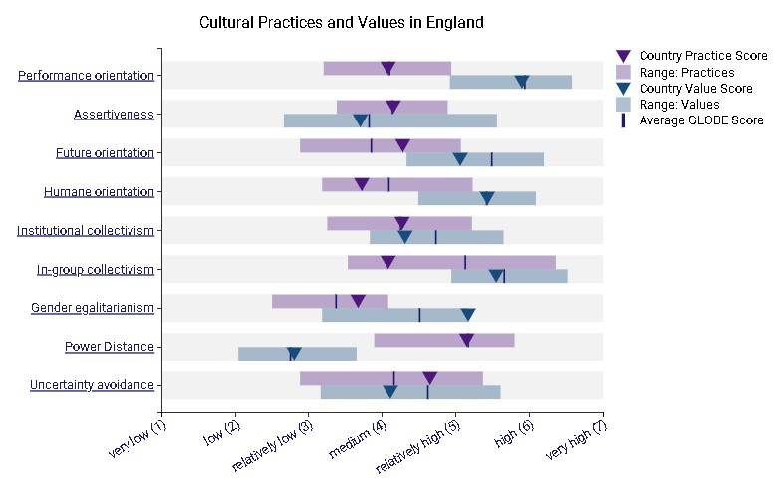

Figure 1: Cultural description in England

(Source: globeproject.com, 2024)
Based on the GLOBE Project categories, this figure shows the customs and beliefs in England. For Performance Orientation, Assertiveness, Future Orientation, Humane Orientation, Institutional Collectivism, In-Group Collectivism, Gender Egalitarianism, Power Distance, and Uncertainty Avoidance, it gives numbers that give a full picture of England's culture. As per the description of this figure, the majority of the factors lay in the range of relatively low to relatively high.
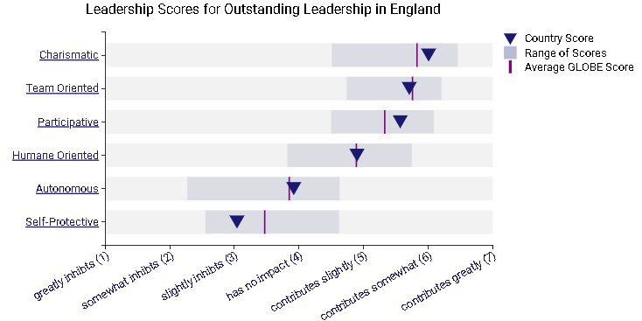

Figure 2: Leadership Description in England
(Source: globeproject.com, 2024)
This figure has outlined leadership scores for outstanding leadership in England, focusing on Charismatic, Team-Oriented, Participative, Humane-Oriented, Autonomous, and SelfProtective leadership styles. Scores range from greatly inhibits (1) to contributes greatly
(7), presenting a nuanced evaluation of leadership preferences within the cultural context. As per the description of this figure, the Charismatic factor has the highest range of value, and the Self-Protective has the lowest value.
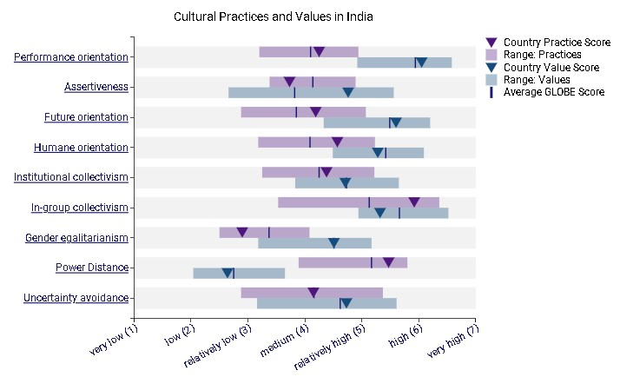

Figure 3: Cultural description in
India

(Source: globeproject.com, 2024)
The description of this figure has highlighted the cultural description in the Indian region. The description of this figure has highlighted that the power distance and performance orientation has the highest level of range in this context.
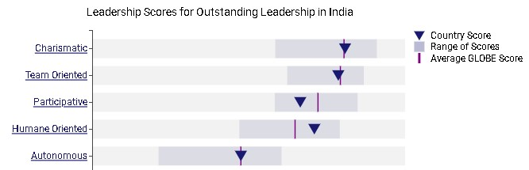

Figure 4: Leadership description in India
(Source: globeproject.com, 2024)
This figure has shown the scores for great leadership in India. Charismatic, TeamOriented, Participative, Humane-Oriented, Autonomous, and Self-Protective styles are all evaluated. The description of this figure has highlighted that autonomous has the lowest range of score in India. However, the other factors have a significant range of value in this globe project assessment.

Challenges of Intercultural Leadership in the Hospitality Industry
Navigating intercultural leadership in the hospitality industry presents potential conflicts arising from diverse communication styles, varying perceptions of hierarchy, and distinct approaches to teamwork (Huertas-Valdivia et al. 2022). For example, disagreements over what it means to be on time and follow a plan can lead to conflict. Different ways of knowing hierarchy could affect how decisions are made. Small differences in how you talk, like being clear or indirect, can cause misunderstandings. There may also be problems because people have different ideas about power and autonomy (Nguyen et al. 2022). These possible areas of disagreement show how important it is to raise cultural knowledge and use strategies to help the multiethnic team at the Inclusivity Hotel & Spa communicate and work together more effectively.

Recommendations
- Establish thorough cultural awareness training sessions to help people understand how people interact, perceive authority, and collaborate.
- Frequent training on how to communicate with people from various cultures may help bridge knowledge gaps, resolve misunderstandings, and promote workplace harmony (Qiu, and Dooley, 2019).
- Set communication norms and inform the multinational team. Once everyone knows their roles, they can do duties on schedule and correctly.

Conclusion
People from England and India are linked through the GLOBE Project. Conversations like these have changed things and made chances work. The leaders at London's Inclusivity Hotel & Spa need to be very careful with their Indian workers because of what they do and how they make decisions. Being ready for possible problems and giving cultural training and clear rules for how to talk to each other can help people from different countries work together more happily and efficiently.

References
Bavik, A., 2020. A Systematic Review Of The Servant Leadership Literature In Management And Hospitality. International Journal Of Contemporary Hospitality Management, 32(1), Pp. 347-382.
Bavik, A. And Mehmet, A.K., 2022. Intellectual Structure Of Leadership Studies In Hospitality And Tourism. International Journal Of Contemporary Hospitality Management, 34(12), Pp. 4562-4591.
Day, S.W., Lawong, D., Miles, A.K. And Effon, T., 2022. Leadership And Culture In Ghana's Tourism And Hospitality Industry: The Impact Of Transformational Leadership On Job Satisfaction In An Emerging Economy. Journal Of Leadership, Accountability And Ethics, 19(1), Pp. 127-134.
Elkhwesky, Z., Islam, E.S., Ramkissoon, H. And Castañeda-García, J., 2022. A
Systematic And Critical Review Of Leadership Styles In Contemporary Hospitality: A Roadmap And A Call For Future Research. International Journal Of Contemporary Hospitality Management, 34(5), Pp. 1925-1958.
Halim, H.T., Halim, Y.T. And Elsawy, O.M., 2023. Fostering Organisational Citizenship Behaviour In The Egyptian Hospitality Industry: The Role Of Internal Brand Management And Leadership Styles. Future Business Journal, 9(1), Pp. 101.
Hassi, A., 2019. Empowering Leadership And Management Innovation In The Hospitality Industry Context: The Mediating Role Of Climate For Creativity. International Journal Of Contemporary Hospitality Management, 31(4), Pp. 1785-1800.
Huertas-Valdivia, I., González-Torres, T. And Juan-José Nájera-Sánchez, 2022.
Contemporary Leadership In Hospitality: A Review And Research Agenda. International Journal Of Contemporary Hospitality Management, 34(6), Pp. 2399-2422.
Nguyen, L.V., Haar, J. And Smollan, R., 2022. Hospitality Leadership Competencies And Employee Commitment: New Insights From The Booming Hotel Industry In Vietnam.
Tourism And Hospitality Management, 28(2), Pp. 419-443.
Qiu, S. And Dooley, L., 2019. Servant Leadership: Development And Validation Of A Multidimensional Measure In The Chinese Hospitality Industry. Leadership & Organization Development Journal, 40(2), Pp. 193-212.
Sürücü, L. And Sağbaş, M., 2021. The Impact Of Leadership Styles On Job Satisfaction: A Study Of The Hospitality Industry. Çanakkale Onsekiz Mart Üniversitesi Yönetim Bilimleri Dergisi, 19(40), Pp. 323-346,510,519.

