  Component One: Student Journal (learning log) 750 words +/- 10%  Contribution to Overall Module Assessment: 25% | Student No: | 2220997
 | Module Title: | Hotel Placement – Hotel Administration &  Front Office Operations
 | Module Code: | BMIH4004
 | Lecturer:
Student
Name:Ionel Simion

1.1 Introduction
Gibbs' Reflective Cycle is something other than a hypothetical model. A viable tool engages leaders and professionals to transform their experiences into noteworthy knowledge (Adeani et al. 2020). This cycle supports a review of occasions and a basic investigation of emotions and responses, giving an exhaustive framework for self-improvement and personal and professional growth. My experience as a front office employee in the hospitality sector has been highlighted in this reflective journal using the Gibbs model
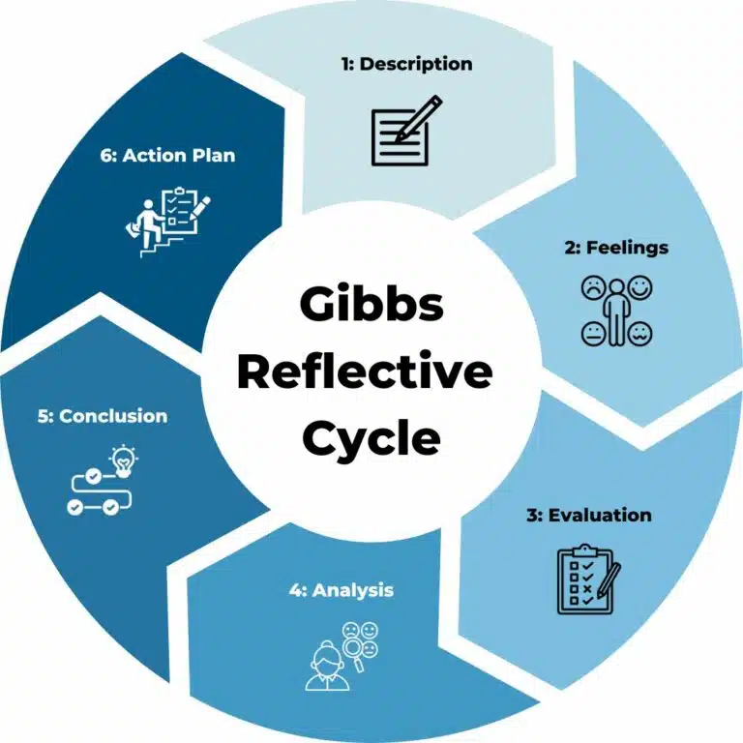
Figure 1: Gibbs Reflective Cycle
(Source: Adeani et al. 2020)

1.2 Description
To ensure that my guests receive a seamless experience, I took many activities as a front office employee. The major tasks that had to be done at the front desk were managing the inquiries of the guest, looking after checkout and check-in, resolving the issues during the stay of the guest and processing the reservations made (Rabiul et al. 2023). High standards of service that are expected in the hospitality industry are upheld by each and every task conducted (Hu et al. 2022). The two main factors that helped me in doing these tasks effectively were professionalism and effective communication at Marriott. I had effective interactions with the guests with the help of communication, and this also helped me in fostering teamwork with my colleagues. Due to this, a productive and cohesive work environment was gained, which led to the fulfilment of the desired objective of guest satisfaction (Septariani et al. 2020).

1.3 Feelings
I had various emotions while doing my task in this placement at Marriott. I entered the role with an eagerness to learn and contribute and nervousness about the challenges ahead. While I expected the speedy nature of the climate and the requesting nature of guest interactions, I was shocked by the sheer volume of tasks and the requirement for fast decision-making. Regardless of occasional strain, I tracked down tremendous satisfaction in caring for guests' necessities and guaranteeing their comfort during their stay. Nonetheless, there were occasions when dealing with multiple inquiries all the while felt overpowering, highlighting the significance of staying coordinated and focusing on tasks really to keep a cool head and convey uncommon service in any event during peak periods (Ruki, 2023).

1.4 Evaluation
In assessing my performance in the front office area, I perceive both my strengths and areas for improvement. My problem-solving and multitasking skills demonstrated significance in quickly tending to guests' interests and overseeing busy periods effectively. Moreover, my proficiency in conflict resolution helped resolve any questions or dissatisfaction, guaranteeing guests at Marriott had a positive impression of their experience. Be that as it may, I recognise the need to refine my time management skills further to deal with peak hours all the more successfully and upgrade my proficiency in utilising the hotel's reservation system to smooth out processes. Besides, while I showed competency in many aspects of the role, there are areas where I can make progress toward excellence through continuous learning and development.

1.5 Analysis
My placement experience gave me important knowledge about the basic role of the front office area in forming guests' general perceptions of their stay. Interactions with guests and colleagues highlighted the meaning of conveying remarkable customer service reliably at Marriott (Akgunduz et al. 2022). Besides, I acquired a more profound appreciation for the diverse cultural backgrounds of guests and staff, underscoring the significance of cultural sensitivity and inclusivity in hospitality. Taking care of circumstances that necessary sensitivity and respect for diversity reaffirmed the need to approach every interaction with empathy and understanding, paying little mind to cultural contrasts. Besides, the experience featured the ethical responsibility inherent in the hospitality industry, where the well-being and satisfaction of guests should constantly stay central (Xiang et al. 2022).

1.6 Conclusion
In conclusion, my placement at the hospitality front office has been a deeply enlightening experience that has changed the way I see the hospitality industry and my role within it. The significance of constant development in an ever-changing industry and the complexities of delivering outstanding guest service have been clarified for me. I have gained valuable experience that will help me in my career, and I am more fulfilled knowing that I have had a great impact on visitors' lives and on my coworkers'. In order to thrive in the hospitality industry and make a positive impact wherever I work, I am determined to adopt a development attitude going ahead.

1.7 Action Plan
To increase the knowledge and abilities in the front office, a thorough action plan has been developed (Markkanen et al. 2020). To begin, in order to hone my skills, I plan to participate in extra training programmes that centre on cultural competency, customer relationship management, and time management. In order to pinpoint areas for improvement and put plans into action, I also aggressively seek out feedback from coworkers and bosses. In addition, I make use of automation tools and technology to simplify procedures, improve the quality of guest encounters, and expedite administrative work. I am confident in my capacity to grow as hospitality professional, significantly impact any establishment's business, and provide outstanding service to customers by actively working to overcome my weak spots.

Component Two
Contribution to Overall Module Assessment: 25%
Trip Advisor Review Response 150 words +/-10%
We appreciate you taking the time to discuss your recent Marriott Park Lane experience. We're happy to hear that our whole staff contributed to your memorable stay, notably Carmela, Silvana, Vrinda, Marta, and Antony. What a relief to hear that our rooms were just what you needed and that the meals served in our Executive Lounge delighted you. Your feedback confirms that we're on the right road as we work to provide every one of our visitors with an amazing experience. We're happy to hear that you found our location handy for seeing the sights of London and that moving about the city was such a breeze. Please know how much we appreciate your kind words and look forward to having you return for another memorable stay at our property. I am really grateful for the praise you have given. Knowing you had a pleasant time with us warms our hearts. Your feedback is valuable.

Screen shot of referenced Trip Advisor review used:
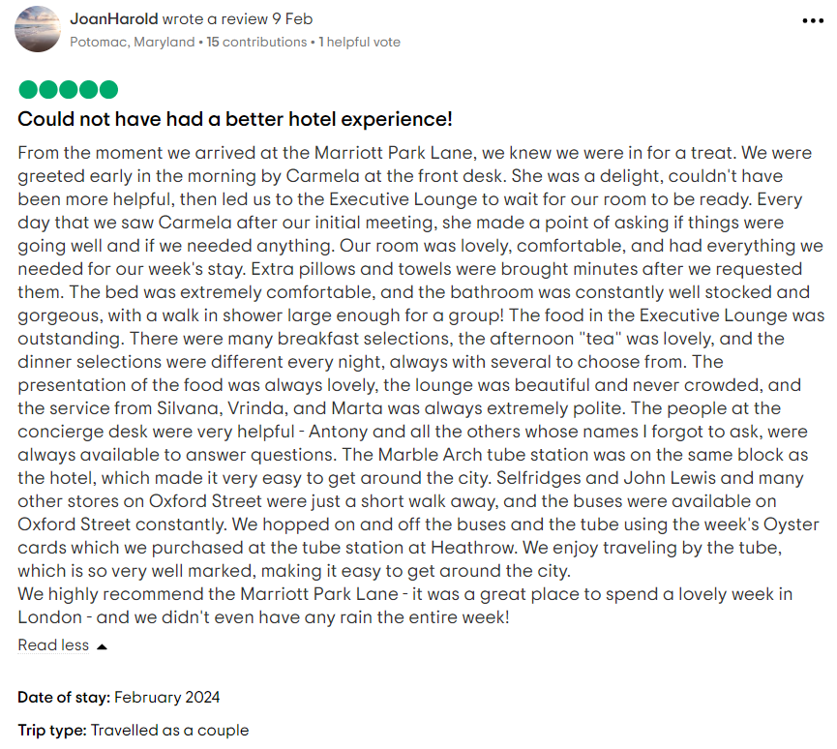
Figure 2: Positive Review of Marriot
(Source: Tripadvisor.in, 2024)
Letter of complaint response 500 words +/- 1-%
Customer Service Assistant
Marriott Park Lane
140 Park Ln, London W1K 7AA
United Kingdom
February 21st, 2024
Subject: Response against the Complaint
Dear Mrs. Blake,
First of all, I would like to apologise to you for the dissatisfaction and discomfort that you had to face during your recent stay at our hotel. We are extremely sorry that we could not meet your expectations. However we want you to know that your feedback is extremely valuable to us as it will help us to find the loopholes and improve our services.
From your letter, we have received feedback on the poor management of our hotel rooms. Currently, our management team is working on those issues. The cleanliness issue that you faced in room 330 has been looked after. We will opt for strict standards of hygiene and cleanliness in our hotel rooms. We were very sad to hear that your hygiene expectations were not met by us. As a solution, we will soon utilise training sessions so that our housekeeping employees can provide a clean and hygienic environment. Within our hotel rooms, strict inspection protocols have been instituted so that the standards of cleanliness are met in all the rooms before the check-in of the guests.
I know that it will not be enough of us to apology for the poor network connections at our hotel rooms. I can understand that it is very exhausting for businesspeople like you who constantly require Wi-Fi services. However, our unstable and poor connection became a serious problem for you. We have been looking into that issue. We had a conversation with our service provider regarding the connection problems that you have faced during your stage. Our network infrastructure is also being improved currently so that a more reliable and quick internet connection can be received by our valuable guests like you. Thank you for bringing up this issue since we have never faced such feedback before. I would assure you that the next time when you visit our hotel, you will not phase this network issue within our hotel rooms.
Another issue that you faced during your stay was regarding the noise disturbance that you had to hear from your hotel room. In light of that issue, we are currently focusing on noise mitigation techniques. It is very sad for us to know that our hotels have failed to provide you with a peaceful and relaxing environment during your stay. As a solution, we have adopted quite our policy and soundproofing in our rooms. This will help us to ensure that not only you, but other guests will also receive less disturbances during their stay.
To address guest demands and inquiries with the most significant level of amazing skill and effectiveness, we are likewise further developing our inside correspondence conventions. We are devoted to upgrading the whole visitor experience at our hotel, and your criticism has featured the requirement for proceeding with advancement around here. As an apology, we would like to offer you a complimentary three-night stay with us with all the upgrades and accommodations. We truly hope that you would like to opt for our services again and have a wonderful experience with us.
Warm regards,
XXX
Customer Service Assistant
Marriott Park Lane

Component Three:
Contribution to Overall Module Assessment: 50% (1000 words +/- 10%)
Writing in essay format

Key Skill 1 – Customer Service Skills

To guarantee flawless guest experiences and effective front office operations, the hotel depends largely on a set of critical skills. The customer service, communication, organisational, and problem-solving skills that are crucial for success in this role are all examined and evaluated in this essay. Each competency is essential for meeting guest requirements, building strong relationships, and solving problems quickly and efficiently.
Customer service is a type of job and a set of job skills. As a job customer service professionals are responsible for addressing customer needs and ensuring they have a good experience (Lucas, 2022). As a skill set, customer service entails several qualities like active listening, empathy, problem-solving and communication. With the help of these skills, front office employees can tailor and customise services to meet individual needs contributing to a personalised and exceptional experience for residents. Harnessing technology can streamline processes, automate tasks, and provide real-time reporting for efficient front desk operations (Xiang et al. 2022). Ensuring that every guest has a good experience at a hotel rests with the hotel front desk staff, also referred to as guest services staff.
Typical duties include handling bookings, helping guests with their check-in and check-out, and fielding any inquiries they may have. According to Tripadvisor.in (2017a), a person rented two hotel rooms for a night at the Hilton (Figure 3). He assumed he clicked Friday, April 15, but the email confirmation indicated Saturday, April 16. He quickly informed Hilton Honours and Advanced Purchasing about the error. Instead of rectifying it and changing the reservation to the following night, they informed him they would forfeit his room purchase price and refused to issue a refund or credit for the right check-in date. Front desk staff can help by showing empathy, actively listening to the guest's concerns, and quickly fixing the booking problem (Hu et al. 2022).
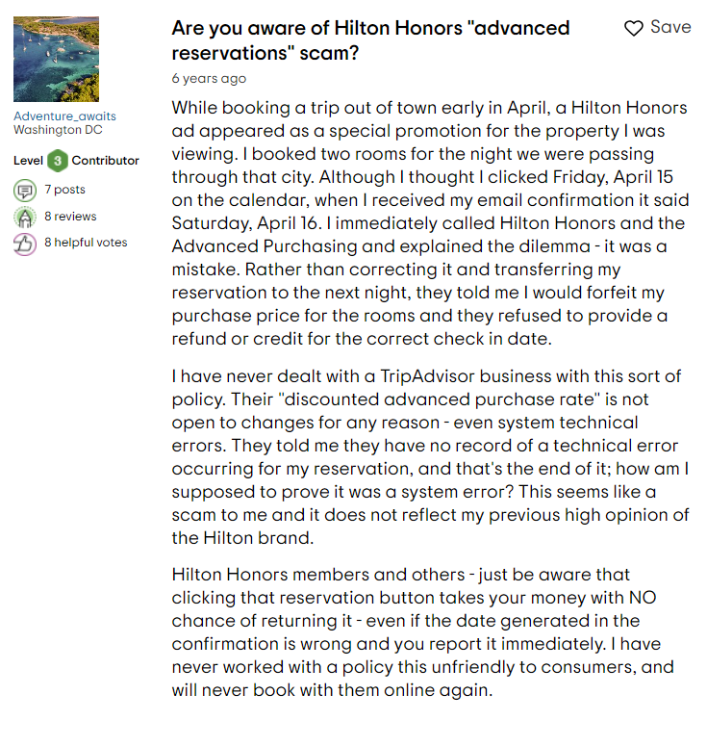
Figure 3: Negative Review of Hilton
(Source: Tripadvisor.in, 2017a)
Key Skill 2 – Communication Skills

For effective interaction with other people, one needs strong communication skills. Communication is more than just what people say. It is also about delivery and attentiveness (Back et al. 2020). Expressing oneself clearly and understanding others is an asset in many contexts and fosters positive relationships. Being proactive enhances the important quality of effective communication in front desk operations. Active listening to residents' and visitors' issues, predicting their requirements and demands, and seeing possible issues before they happen are all parts of proactive communication (Septariani et al. 2020). Building good relationships with the community, enhancing efficiency, and improving satisfaction levels may all be achieved via proactive communication practices by front desk personnel.
Active listening is an important part of being proactive in communication. Listening attentively entails taking the other person's point of view into account and responding intelligently. Active listening helps front desk workers better understand guests' and residents' underlying wants and worries, improving problem-solving and service delivery. Many customers have highlighted the poor communication skills at Hyatt. According to Tripadvisor.in (2020), one customer suggested that the hotel train their employees since they faced bad communication (Figure 4). Front desk personnel may avoid bad communication difficulties by listening to guests' feedback, resolving complaints quickly, and receiving frequent training to improve their communication skills (Rabiul et al. 2023).
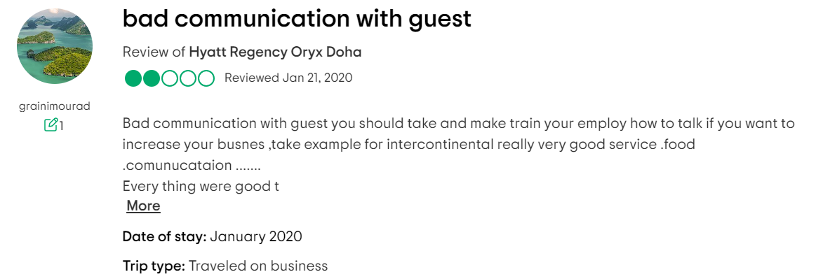
Figure 4: Negative Review of Hyatt
(Source: Tripadvisor.in, 2020)
Key Skill 3 – Organisational Skills

The ability to make good use of available resources is a key component of organisational skills. Being well-organized allows one to make good use of their time, energy, and workspace, allowing them to complete all of their responsibilities without fail (Manda and Abidin, 2023). Hotel front office managers need to be able to handle a lot of information and ensure that everything runs properly. Thus, organisation is a crucial ability. Additionally, they must possess strong communication skills to efficiently collaborate with other hotel departments, including engineering and cleaning. In addition to taking calls, greeting guests, answering inquiries, and processing payments, front desk staff are constantly juggling a number of other responsibilities (Akgunduz et al. 2022). The ability to multitask is essential for front-desk employees.

Key Skill 4 – Problem Solving Skills

The capacity to see issues, generate and evaluate potential solutions, and then put those ideas into practice is known as problem-solving skills. An employee with strong problem-solving skills is both a self-starter and a team player (Araiza-Alba et al. 2021). They are proactive in identifying the source of an issue and brainstorming potential solutions with others before settling on a course of action. Technology offers useful tools to help with problem-solving, which is a crucial ability for front desk staff. With digital channels for guest communication, concerns can be quickly addressed and remedies monitored, making sure that no guest complaint is overlooked. The front desk staff may also benefit from technology that gives them access to extensive databases and resources, which helps them locate answers faster (Hu et al. 2022).
Anyone who works the front desk will likely be the go-to person for guests with issues. Issues like these might be really small, like asking for restaurant suggestions. They could be rather significant, like a guest whose desired wheelchair-accessible room is unavailable. Unanticipated crises, such as a guest experiencing a medical emergency, are also possible. For example, Raddison is one of the prime examples when it comes to poor problem-solving skills. In a wedding at Raddison, the guests were food poisoned (Tripadvisor.in, 2017b). Instead of solving this problem, they made excuses. The steps were taken by a doctor from the guest, which was supposedly the responsibility of the management (Figure 5). Front desk staff can avoid Raddison-like problems by swiftly addressing guest concerns, working with management, and resolving situations efficiently and responsibly (Ruki, 2023).
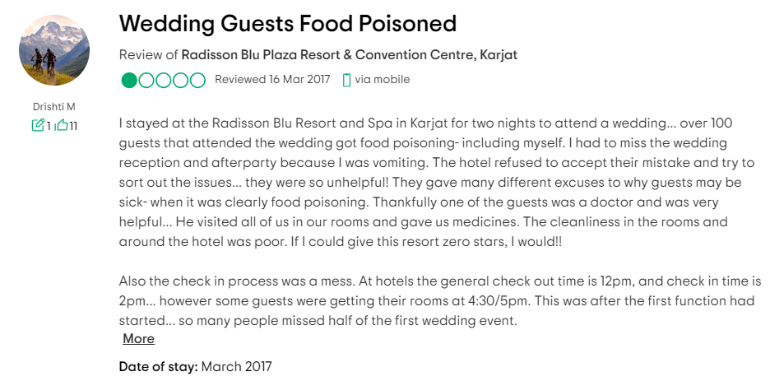
Figure 5: Negative Review of Radisson
(Source: Tripadvisor.in, 2017b)
In conclusion, the effectiveness of a hotel's front office operation depends on the staff's ability in critical skills such as customer service, communication, organisation, and problem-solving. Front desk staff may improve guest satisfaction, simplify operations, and efficiently resolve any difficulties that occur by prioritising these skills. To keep the hotel front office staff prepared to provide outstanding service and maintain the hotel's image, ongoing training and development in these areas is crucial.

Reference List

Akgunduz, Y., Alkan, C. and Adan Gök, Ö., 2022. How are the exchange relationships of front office employees reflected on customers?. The Service Industries Journal, 42(9-10), pp.798-821.
Araiza-Alba, P., Keane, T., Chen, W.S. and Kaufman, J., 2021. Immersive virtual reality as a tool to learn problem-solving skills. Computers & Education, 164, p.104121.
Back, A., Tulsky, J.A. and Arnold, R.M., 2020. Communication skills in the age of COVID-19. Annals of internal medicine, 172(11), pp.759-760.
Hu, F., Trivedi, R. and Teichert, T., 2022. Using hotel reviews to assess hotel frontline employees’ roles and performances. International Journal of Contemporary Hospitality Management, 34(5), pp.1796-1822.
Lucas, R., 2022. Customer service. McGraw-Hill US Higher Ed USE.
Manda, H.M. and Abidin, A.Z., 2023. The Role of Leadership in Managing Information Technology Change and its Impact on Organisational Human Resources. Technology and Society Perspectives (TACIT), 1(3), pp.112-121.
Rabiul, M.K., Shamsudin, F.M., Yean, T.F. and Patwary, A.K., 2023. Linking leadership styles to communication competency and work engagement: evidence from the hotel industry. Journal of Hospitality and Tourism Insights, 6(2), pp.425-446.
Ruki, M., 2023. Front Desk Personnel Qualities and Skills in Applying Upselling Hotel Products: Case Study of the Ritz Carlton Bali. International Journal of Multicultural and Multireligious Understanding, 10(4), pp.550-558.
Septariani, M.W., Sutarma, I.G.P., Sudiarta, M. and Sudarmini, N.M., 2020. The Front Office Strategy on Service Quality Improvement. International Journal of Glocal Tourism, 1(2), pp.88-98.
Tripadvisor.com (2020) Bad communication with guest - review of Hyatt Regency Oryx Doha, Doha, Qatar, Tripadvisor. Available at: https://www.tripadvisor.com/ShowUserReviews-g294009-d1862516-r740352400-Hyatt_Regency_Oryx_Doha-Doha.html (Accessed: 21 February 2024).
Tripadvisor.in (2017a) Are you aware of hilton honors ‘Advanced reservations’ scam? - tripadvisor support forum. Available at: https://www.tripadvisor.in/ShowTopic-g1-i12105-k10405661-Are_you_aware_of_Hilton_Honors_advanced_reservations_scam-Tripadvisor_Support.html (Accessed: 21 February 2024).
Tripadvisor.in (2017b) Mankani’s - review of Radisson Blu Plaza Resort & Convention Centre, ... Available at: https://www.tripadvisor.in/ShowUserReviews-g16743159-d10727247-r779916585-Radisson_Blu_Plaza_Resort_Convention_Centre_Karjat-Khandpe_Karjat_Raigad_Dist.html (Accessed: 21 February 2024).
Xiang, K., Huang, W.J., Gao, F. and Lai, Q., 2022. COVID-19 prevention in hotels: Ritualized host-guest interactions. Annals of Tourism Research, 93, p.103376.

