Business Skills for international hotel industry



Name: Robert Nicoale

Student Number: 1813617
Module Code: B4X 01917
Module Title: Business skills for international hotel industry
Assignment tittle and Module
Lecture name: Dale Clarke,
interview Techniques

Introduction

As part of the assignment I was task to generate 500 words based on our group presentation. In this assignment I will talk about the Gibbs cycle and try to cover each area of the process. (However, if they don't reflect on their experience, and if they don't consciously think about how they could do better next time, it's hard for them to learn anything at all.
This is where Gibbs' Reflective Cycle is useful. You can use it to help your people make sense of situations at work, so that they can understand what they did well and what they could do better in the future.) "Learning by Doing" by Graham Gibbs. Published by Oxford Polytechnic, 1988

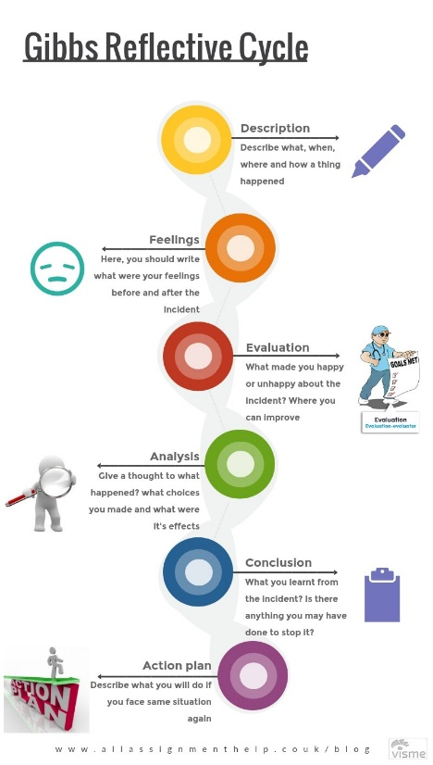

Reflective Report
Gibbs’ reflective cycle is popular among the experts from various fields. Whether it is the professionals from the healthcare field, education workers and leaders all of them use it. This approach helps these experts in reflection. In other words, they learn things through their own and others’ experiences. It helps them in continuous personal development .Furthermore, it leads them to perform their roles efficiently.

Description:

It might be difficult for some people to talk honestly about their feelings. We use the Emphatic Listening this stage to connect with them emotionally, and to try to see things from their point of view.
We can use the perceptual position technique to help this person see the situation from other people's perspectives.
We help a lot to meet with our presentation group for share the idea, to have a finish result for our assessment. A one of important point was to communicate and search an information about the interview and see some video on YouTube with different people than is make some presentation with different behaviour.

Feelings:
Our group assignment was interview skills, I was felt very enthusiastic and happy to have my opinions heard in my group I was to get involved, our presentation and research was done collaboratively. Emotional a strange feeling is make you to forget your opinions and is not leave you to finish your ideas.

Evaluation:
The evaluation helped me develop my presentation skills and helped me feel more confidence and able to address to people. Also the team work help me to expand and improve my own goals and we helped each other to pass fast the negative situation

Analysis
Analysis the process has helped me to understand the process of producing a C.V, and also has helped me to understand the complexity and flexibility needed to produce my own Interview

Conclusion:
In conclusion we successful deliver to the people our point and make them know where we came from and all our point was heard about our mates and we hope we make them understand the importance of the interview skills

Action Plan:
This tool is structured as a cycle, reflecting an ongoing coaching relationship. In the meantime I’m going to try facing the 15 minutes and try my best to give my all for the next assignment

References
Corfield, R. (2009). Successful interview skills. London: Kogan Page.
Soman, A. (2009). Interview skills. Mumbai [India]: Himalaya Pub. House.

"Learning by Doing" by Graham Gibbs. Published by Oxford Polytechnic, 1988

