STUDENT NAME :MARIA -MIHAELA AVRAM
STUDENT ID : 1809524
MODULE TITLE: LCBB5005
ASSIGNMENT TITLE: WAITROSE
LECTURER”S NAME: JOY BOTU

PROJECT MANAGEMENT
Table of Contents
Introduction 3
1. Project overview 3
2. Project arrangement 5
3. Plan of the managerial process 6
4. Plan for Technical process: Control 9
Conclusion and recommendations 14
References 15

Introduction
Project management could be defined as a method of estimating and organising various activities that are needed to empower the successful completion of a project. The study deals with the establishment of credit card facility for the customers of Waitrose, a company that deals with delivering groceries to the customers. Therefore, it could be stated that the company plans to evaluate a procedure through PRINCE2 that would initiate their plan of deploying credit card facility to the customers so that they would be able to avail the cashless service to buy their needs.

1. Project overview
1.1 Purpose and Objective: Scope
Waitrose Company aims to develop a credit card facility to their business execution so that customers would be able to buy their items in a cashless post-paid manner (waitrose.com, 2019). With the help of this aim, the company would be able,
- To expand their business through a wide range to attract more customers
- To obtain effective management of business execution
- To facilitate their procedures with modern technologies and innovations
1.2 Deliverables
Deliverables | Recipients | Delivery Time | Methods of Delivery | Comments
Login Module | Finance department | Business Execution time | Deployment | Initiates the database of the customers
Fund transfer | Company bank | During the initiation period | Net banking | Credits that the customer uses to buy items through credit card
Credit Card | Customers | After the date of pursue | Indoor | For cashless expenditure from the dedicated stores of the company
Monthly bills | Customers | At the end of the month | Indoor | To be submitted within time in order to avoid penalties
Table 1: Deliverables
(Source: Influenced by Jaber et al. 2018)
1.3 Assumptions
The assumptions that are to be noted down in order to develop the project management plan for Waitrose would include five constraints, including cost, features, quality, schedule and staff. Before the determination of the cost of the services, the company needs to evaluate the decisions for the customers to pressure the credit card facility. The cost of the credit card should be made free such that all customers would be able to pursue that. The bills that would be generated would be linked with the credit card number and the customer name.
1.4 Evolution
During the evaluation of the project management plan, certain constraints and resources change. The evolution criteria would be facilitating the changes that the company is planning to adopt. In the case of Waitrose, the credit card facility that the company plans to deploy would require an immense number of planning as it would deal with financial as well as business management criteria.To the help of their funding from the company's side, the customers would be able to order their needs. With due time, the customer has to pay the due amount back to the company's fund within a specified duration of time.

2. Project arrangement
2.1 Internal and external structure
The internal and external structure of the company's operating environment would be considered the stakeholders of the company as they play an important role in the development procedure of the proposed project management plan.
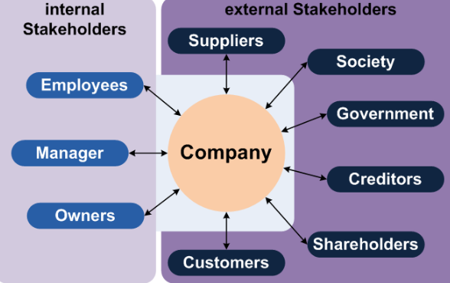
Figure 1: Stakeholder Identification
(Source: finance-ni.gov.uk, 2019)
Internal stakeholders
- Employees
- Manager
- Owners
External stakeholders
- Suppliers
- Society
- Government
- Creditors
- Shareholders
- Customers
2.2 Roles and responsibilities: Human Resources
The stakeholders that have been identified in the previous section plays an important role in the development of the proposed project of Waitrose.
- The manager, employee and the owners are the individuals that are involved in the initiation of the plan and its execution. In order to develop the software to manage the credit card facility for Waitrose, there must be a sufficient amount of funding that are needed to be built.
The external stakeholders, in this case, play an important role as the fundraisers of the developing project.
- The creditors are the entities that manage the amounts in the funds.
- The shareholders, in this case, are the ones who own the profit of the company.
- The suppliers are responsible for providing the company with the necessary materials needed for the successful completion of the project.
- The government plays the role of a legal facilitator to check whether all the operations are abiding the rules and regulations or not.
- The customers and the society are the main targets of the company for which the business execution would gain profit and success.

3. Plan of the managerial process
3.1 Estimation and training plan: Requirements
In this section of the project plan, the various estimations including the budget analysis and other funding assets would be evaluated as well as the delivery timing. The plans to deploy software to manage the credit card facility, the staff would require relevant training to use the systems effectively and provide the customers with the desired services. Excluding the training part of the project, the major estimations would be the cost of the materials that are required to develop the software as well as the data and funds. The company plans to collaborate their business with a bank so that the funding would be facilitated by the bank itself providing sufficient resources.
3.2 Project commitment
Commitment | Made By | Made To | Comments
Secured way of payment | Company | Customers | Secure transaction
Return the money along with interest | Company | Bank | Well managed relationship between bank and the company
Sufficient training and compensation in operating the software | Company | Staff | Efficient management of the software and its application
Practice business abiding by the laws | Company | Government | Uninterrupted business execution from legal sides
Table 2: Commitment
(Source: Influenced by Park et al. 2018)
3.3 Budget Plan
Activities | Cost ($) | Duration (Days)
Data collection | 320 | 30-40
Raw materials | 800 | 20-30
Manufacturing | 1400 | 40-50
Registration | 400 | 3-4
Card Issue | 40 | 5-10
Deployment | 200 | 4-5
Promotion | 30 | 10-20
Table 3: Budget Plan
(Source: Influenced by Rego et al. 2015)
3.4 Communication Plan
Type of Communication | Communication Schedule | Typical Communication Mechanism | Who Initiates | Recipient
Assistance | daily | Telephonic | Project manager | staff/ employees
Team meeting | monthly | Face to face | Project manager | Employees
Data update to Stakeholders | monthly | Email | Project manager | stakeholders
advertisement | daily | Social media | Project team | customers
audit | quarterly | Face to face meeting | executives | employees
Table 4: Communication Plan
(Source: Influenced by Foster, 2018)
3.5 Risk management Plan
Risk Factor | Affected task | Shutter factor | Responsibility | Solution
Disruption of services | Credit card services | Incapability of infrastructure | IT department | Technical assistance
Delay in deployment | Project time plan | Poor employee efficiency | Team/ Project manager | Availability of funds
Man in the middle attack | User data | Poor security measures | IT security department | Deployment of firewalls
Data redundancy | User data | Inefficient database management administrator | IT department | Distinct data input factors
Lack of interest from users | Project activities | Modification of competitive market situations | Project manager | Proper knowledge about customer demands
Table 5: Risk Management Plan
(Source: Influenced by Elzamly and Hussin, 2016)

4. Plan for Technical process: Control
4.1 Processing Model
The credit card facility that the company plans to provide to its users must be compromised off all the features. The project deals with financial matters hence, each and every factor must be cross-checked before the deployment of the final software. The waterfall model is a direct, successive way to deal with the software development life cycle (SDLC) that is well known in software designing and item development (Hedeman and Seegers, 2009). The waterfall model accentuates a coherent movement of steps (Elzamly and Hussin, 2016). Like the bearing water streams over the edge of a precipice, unmistakable endpoints or objectives are set for each period of development and can't be returned to after finishing. The term was first presented in a paper distributed in 1970 by Dr. Winston W. Royce and keeps on being utilized in applications of mechanical structure. Potential prerequisites, cutoff times and rules for the project are investigated and put into a practical detail.The framework details are dissected to create item models and business rationale that will control generation (Hedeman and Seegers, 2009). This is likewise when money related and specialized assets are reviewed for possibility. A structure determination record is made to layout specialized plan prerequisites, for example, programming language, equipment, information sources, engineering and administrations (Elzamly and Hussin, 2016). Ordinarily, the framework is structured in littler parts, or units, before being actualized together. Testing is when quality affirmation, unit, framework and beta tests occur to report gives that may should be settled. This may cause a constrained rehash of the coding stage for investigating. The item or application is considered completely useful and is conveyed to a live situation (Alshamrani and Bahattab, 2015). Prior to moving to the following stage, there is typically an audit and close down procedure to guarantee that every single characterized objective have been met (Hedeman and Seegers, 2009).
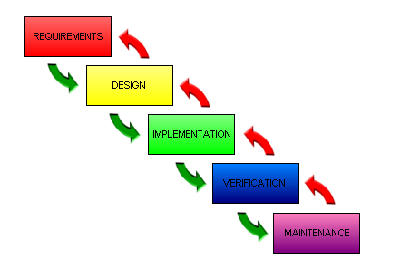
Figure 2: Waterfall Model
(Source: detech-automotive.co.uk, 2019)
The waterfall approach is perfect for projects that have explicit documentation, fixed necessities, sufficient assets, a set up timetable and surely knew innovation. Options in contrast to the waterfall model incorporate joint application development (JAD), quick application development (RAD), adjust and-settle, Agile project management (APM) and the winding model.This is work admirably for littler projects where necessities are clear (Alshamrani and Bahattab, 2015). The Procedure and yield of each stage are obviously referenced in the record (Elzamly and Hussin, 2016). Then again, It doesn't permit a lot of reflection or amendment (Hedeman and Seegers, 2009). At the point when the item is in trying stage, it is hard to return and change something which is left during the prerequisite investigation stage. It isn't prudent for complex and object-oriented projects. With the help of this model, it would be possible for the project management team to evaluate each and every aspect of the development procedure. As stated by Alshamrani and Bahattab (2015), since the waterfall model consisted of iterative steps, the detection of anomalies inside the system would be efficient compared to other models.
4.2 Methodologies
Overview
The appropriate application of the mentioned software would require accurate measures of each and every aspect of the features. As per Waitrose’s plans, the PRINCE2 methodology would be applied. As the name says, Projects In a Controlled Environment, the methodology provides the administrators with full control of their software and development mechanisms.
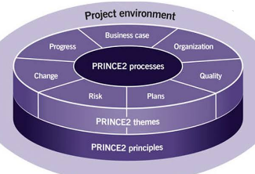
Figure 3: PRINCE2 Principles
(Source: common systems.co.uk, 2019)
The methodology provides assurance of the organisation’s all over control from the stage of project initiation to its delivery. Clearly defined roles and responsibilities
- The knowledge of each stage
- Each task is initiated as planned
- Exceptions are managed efficiently
- Consistent focus on quality
Application
In order to apply the mentioned methodology, Waitrose needs to initiate a development team that would have the capability to learn and apply their knowledge at each step of the project. According to Hedeman and Seegers (2009), the iterative nature of the waterfall model would provide relevant support to the PRINCE2 methodology as both the techniques used stepwise verification of the tasks and their outcomes. In this way, as exclaimed by Murray-Webster and Simon (2007), the company would be able to accomplish its goals and develop successful software that they are intended to.
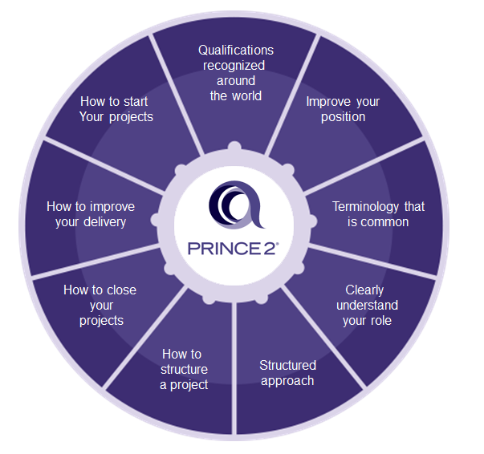
Figure 4: PRINCE2 Features and advantages
(Source: common systems.co.uk, 2019)
4.3 Quality assurance Plan
The development of the software that has been proposed by Waitrose, would require appropriate maintenance and process handling such that the transactions through credit card would be facilitated with security and error-free mechanisms. Therefore, as stated by Lawton (2017), it is important to maintain the quality of the software so as to deliver the services to the customers with optimised and stable assuredly.
- Verification of reliable tracking systems.
- Regular and timely updating of the database such that the data of the customers are kept intact and updated.
- Regular maintenance of the software by technicians such that no error occurs which may lead to data loss.
- Verification of clearly defined procedures by the staff as well as the developers.
4.4 Documentation plan
Document | Standard | Creator | Reviewer | Distribution
Vision statement | Standard | Project manager | Owner | Global
Software requirement specifications | standard | Development team | Project manager | Manufacturer
Iteration plan | standard | Development team | Project manager | Project manager
Architecture and design | convention | Development team | Project manager | Project members
Table 6: Documentation Plan
(Source: Influenced by Dunya and De Groote, 2017)
4.5 Improvement Plan
Improvement Field | Resources | Duration (Days)
Online registration of credit card facility for customers | Official website | 20-30
Efficient management of fundings with scarcity | Investors | 50-60
Security enhancement | Network security/ cryptography | 10-20
Table 7: Improvement Plan
(Source: Influenced by Giudice and Humans, 2016)

Conclusion and recommendations
As per the investigation of all aspects, it could be concluded that Waitrose would be applying a systematic approach in the development of their project management plan. In this way, the company would be able to gain full control of their tasks and activities that are needed to be initiated. The customer, on the other hand, would be applying for the credit cards using their registration services.
The credits that would be provided to the customers would be funded by the bank with which the company collaborates with. The details of these findings would be stored in the database of the company’s proposed software. The customers are required to pay their bills at the end of the month in order to continue their services. Hence, to ensure the success of the project management the company needs to meet all the criteria that would eventually satisfy these factors.

References
Alshamrani, A. and Bahattab, A., (2015). A comparison between three SDLC models waterfall model, spiral model, and Incremental/Iterative model. International Journal of Computer Science Issues (IJCSI), 12(1), p.106.
commonsystems.co.uk (2019). PRINCE2 – A Project Management methodology. Available at: https://www.commonsystems.co.uk/2019/03/28/prince2-our-default-methodology/ [Accessed on 19.11.2019]
detech-automotive.co.uk (2019). Develop with Detech… Available at: http://www.detech-automotive.co.uk/developmentmodel.htm [Accessed on 20.11.2019]
Dunya, B.A. and De Groote, S., (2017). Review Essay: The Documentation of Library Assessment Planning Process, Lessons Learned and Suggestions. Partnership: The Canadian Journal of Library and Information Practice and Research, 12(1).
Elzamly, A. and Hussin, B., (2016). Quantitative and Intelligent Risk Models in Risk Management for Constructing Software Development Projects: A Review. International Journal of Software Engineering and Its Applications, 10(2), pp.9-20.
finance-ni.gov.uk (2019). Stakeholder engagement within a programme or project Available at: https://www.finance-ni.gov.uk/articles/programme-and-project-stakeholders [Accessed on 16.11.201
Giudice, D.L. and Humans, L.L., (2016). How AI will change software development and applications.
Hedeman, B., Seegers, R. (2009), PRINCE2 Edition 2009: A Pocket Guide (Prince2: A Pocket Guide) Van Haren Publishing: NL
Jaber, H., Marle, F., Vidal, L.A. and Didiez, L., (2018). Criticality and propagation analysis of impacts between projpect deliverables. Research in Engineering Design, 29(1), pp.87-106.
Lawton, I., (2017) Made Simple: Updated 2017 Version. 2nd Revised edition, P2MS Press
Murray-Webster, R., Simon, P., (2007) Starting Out in Project Management: A Study Guide for the APM Introductory Certificate in Project Management, 2nd Ed.,
Park, J.J., Long, P., Choe, N.H. and Schallert, D.L., (2018). The contribution of self-compassion and compassion to others to students’ emotions and project commitment when experiencing conflict in group projects. International Journal of Educational Research, 88, pp.20-30.
Rego, H., Mendes, A.B. and Guerra, H., (2015). A decision support system for municipal budget plan decisions. In New Contributions in Information Systems and Technologies (pp. 129-139). Springer, Cham.
Waitrose.com (2019). Waitrose & partners. Available at: https://www.waitrose.com/ [Accessed on 19.11.2019]

