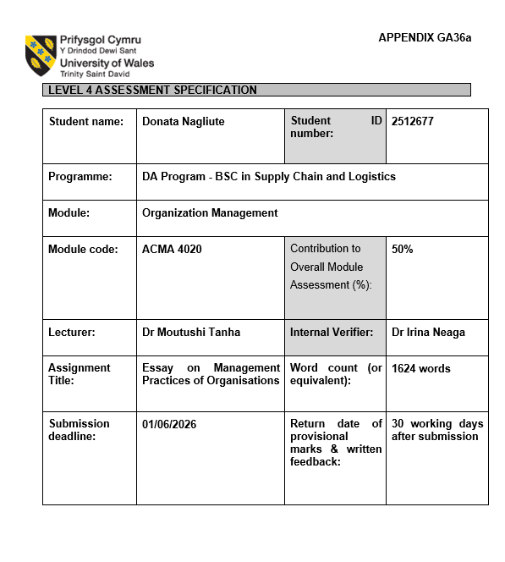
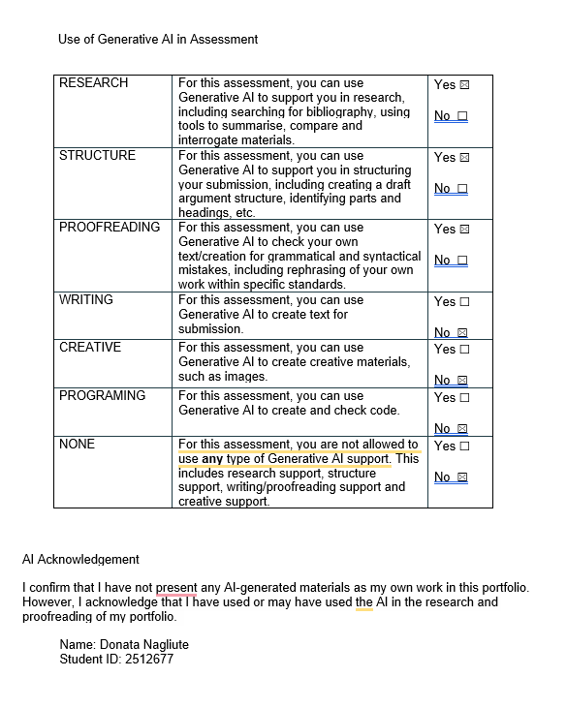

Table of Contents
Introduction 1
Planning 1
Organising 2
Leading 4
Controlling 5
Conclusion 6
References 7

Introduction
This essay analyses the four management functions within the Supply Chain and Logistics function at Coloplast. As a company operating within the healthcare sector, Coloplast depends on efficient supply chain operations to maintain customer service, product availability and operational performance. The management functions that will be analysed for the Supply Chain and Logistics function at Coloplast include planning, organising, leading and controlling, as well as implementing management theories to assist in the operation of each of these management functions.

Planning
Planning is an important management function that involves setting objectives for organisations as well as the actions that are to be taken to achieve these objectives (Robbins, Coulter and Randel, 2021, pp. 233 – 235). For the Supply Chain and Logistics functions within Coloplast, planning is particularly important due to the nature of the products that are supplied to hospitals and healthcare providers, and because of the company’s strategic direction for 2030 (Coloplast, 2025).
One of the key strategic objectives is to improve delivery reliability. Hospitals, healthcare providers and patients depend on the availability of Coloplast products, and the failure of the company to provide these products will have a negative impact on the relationship between the organisations that provide these products to patients. This objective can be supported by improved planning, supplier collaboration and demand forecasting, through monitoring delivery performance. To strengthen and make this more effective, the SMART principles can be applied by ensuring targets are specific, measurable and time-bound, for example improving one-time deliveries over a set timeframe (Aldridge and Colvin, 2024). According to Deloitte (2024), supply chains are relying upon the improvement of visibility into their supplies and the improvement of their relationships with their suppliers. However, increasing the number of products stocked within these supplies will increase the costs.
A second strategic objective is to increase operational efficiency. As a company that provides products to customers across the globe, Coloplast has to manage the costs associated with its logistics department while ensuring that the products that are provided to customers meet the quality compliance standards of the manufacturers of those products. Coloplast can improve its efficiency through investing in automation of certain processes within the company (Coloplast, 2025). Operationally, supervisors can optimise labour planning, monitor productivity, rework and reduce unnecessary stock movement. However, the increase in the expected efficiency of the employees may come at the cost of the well-being of those employees (Heizer, Render and Munson, 2023, pp. 40 – 60).
The third strategic objective is to support long-term growth through technology and data-driven planning. As customer expectations evolve, planning tools and operational dashboards that give them the necessary visibility into supply chain operations. Still, successful implementation requires investment and employee adaptation. Digital supply chain capabilities, including advanced analytics and real-time visibility tools, are now seen as essential for staying competitive and resilient (Gartner, 2025). Furthermore, digital supply chain transformation has been shown to improve the operational performance of supply chains (Rana, Daultani, Goswami and Kumar, 2025, pp. 3500 – 3515).
Coloplast can also benefit from using a Management by Objectives approach to implementing these objectives. MBO involves managers and employees working together by setting measurable goals and regularly reviewing progress against these targets (Robbins, Coulter and Randel, 2021, pp. 240 – 242). This method improves the accountability and motivation of the employees within a company. Unlike traditional top-down planning, MBO gets employees more involved and responsible by setting goals together. But in a global company such as Coloplast some strategic decisions need a more formal and centralised planning approach. In contrast, MBO requires clear communication and realistic target setting to be effective.
Overall, effective planning enables Coloplast to align the supply chain activities with strategic priorities, improve service performance and support long-term organisational growth.

Organising
Organising is a key management function that involves arranging resources and responsibilities to achieve organisational objectives efficiently (Robbins, Coulter and Randel, 2021, pp. 307 – 210). In the Coloplast Supply Chain and Logistics team, being organised is important, since Coloplast is a healthcare company and may need to operate a customer care centre 24 hours a day, 7 days a week. Therefore, the company will need to find a way to provide great customer service while looking after their employees well-being.
To provide continuous service coverage for Coloplast possible to implement a centrally based workforce consisting of approximately 12–18 employees. Table 1 shows the different shifts for each department and ensures that each shift is available to provide customer service, team leader and order processing staff.
Table 1. Proposed 24/7 shift structure.
A three-shift rotating system is suitable as it will provide 24/7 coverage while distributing the work evenly between the employees.
The centralised workforce model is appropriate for Coloplast due the need for communication and control over communications, as well as the nature of the industry. This indicates a more mechanistic organisation (Robbins, Coulter and Randel, 2021, pp. 313 – 314).
When designing the workforce, it is important to think about employees' external commitments, because flexible working arrangements, such as job sharing, compressed hours support work-life balance and improve retention (CIPD, 2025). According to Marchington et al. (2025, p. 231), flexible working practises allow employees to have a good work-life balance. However, managers must ensure that flexibility in the work schedule will not negatively impact the communication or quality of the services.
The work package model can be used based on job design principles to organise the employees in a way that operations run efficiently. For example, the customer care will take calls from customers regarding general questions and order tracking. Order processing staff will deal with complaints and urgent supply issues. Team leaders would monitor performance and support communication between shifts. Nevertheless, to generate better results, the employees can be cross-trained to improve staff flexibility.
Managers also have to ensure that all shifts get a fair rotation and let everyone know the schedules in advance to keep an eye on employee well-being. Also, employees should follow agreed schedules and complete shift handover. Overall, effective organising enables Coloplast to maintain continuous customer support while supporting operational efficiency and workforce flexibility.

Leading
Leading is an important management function that focuses on motivating, guiding and supporting employees to achieve the company's objectives (Robbins, Coulter and Randel, 2021, p. 392). At Coloplast, good leadership really matters to the team. I have taken on leadership roles by helping coordinate the team during busy times and support team members during challenging times.
My leadership style is democratic and adaptive. I encourage my colleagues to participate in problem-solving, even during busy periods. This increases the functionality of the team and the involvement of each staff. Perhaps the democratic leadership style can make it difficult to quickly make decisions in high-pressure situations. Depending on the situation and the experience of the team member, I also adapt my leadership style. This approach also reflects the ideas behind Situational Leadership Theory. This theory posits that leaders should adjust their leadership behaviour according to the capabilities of their staff and the requirements of the tasks that team members are to perform (Robbins, Coulter and Randel, 2021, pp. 486 – 487). For example, new employees may require more leadership behaviour and assistance than experienced team members who are capable of performing their tasks independently.
Some of my leadership strengths include good communication with colleagues, even when under high-pressure situations. However, there are some areas of my leadership that require further development. For example, Goleman (2021, pp. 22 – 25) suggests that leaders may develop “blind spots” that negatively affect communication and decision-making. In my experience, I sometimes hesitate to delegate tasks to staff out of concern for potential conflicts between team. This reduces efficiency and increases pressure on myself.
To improve my leadership effectiveness, I will seek out leadership training in the next six months and also increase the delegation of tasks to my team members by approximately 30% in the next three months. I will also continue to seek feedback from my colleagues and managers to assess my improvements in communication with the team and delegation of tasks. I believe that improving my communication, adaptability and decision-making skills will allow me to become more effective in my role as a leader for the logistics team (Owen, 2024, pp. 71 – 72).
Effective leadership within the supply chain team is essential to ensure that the teammates remain motivated, teams continue to work well together, and that the operations continue running efficiently. By continuing to develop my leadership skills, I can continue to contribute to the team’s performance and the success of the organisation.

Controlling
Controlling is a management function that involves monitoring, comparing and correcting work performance to ensure that organisational objectives are achieved (Robbins, Coulter and Randel, 2021, pp. 517 – 519). Controlling is important because it helps managers monitor operational performance and identify problems at an early stage (Sabri, 2016, p.43).
At an individual level, managers can assess employee performance in several ways. For example, managers can review the number of orders that are completed accurately and the speed at which those orders are fulfilled. According to Drury and Tayles (2024, p. 590), performance measurement systems play an important role in improving operational efficiency. However, managers should avoid focusing only on numerical targets, as excessive pressure on the employees may negatively impact their satisfaction with their jobs. An over-reliance on KPIs also leads to KPI fixation, where employees prioritise meeting targets rather than maintaining service quality, leading to increased stress and reduced engagement.
At the unit level in the company, there are also various KPIs that can be used to measure the overall results of each unit. For example, KPIs can be used to evaluate the on-time delivery of the products from Coloplast to their customers, the availability of the products that are required by the customers and the time it takes for the customers to receive these products in response to the order. Each of these KPIs is appropriate for Coloplast due to the critical nature of the delivery, availability, and responsiveness of healthcare products.
The qualitative measures, such as customer and employee feedback, will show additional insight into the supply chain.
Actual performance is reviewed against set targets and managers must decide whether any variation is acceptable or whether corrective action is needed. For example, if delivery performance fails, managers may investigate possible causes such as stock shortages, system errors or ineffective processes and implement corrective action.
The controlling process involves measuring performance, comparing results against standards and implementing corrective action where necessary. Control can also be applied through feedforward, concurrent and feedback mechanisms to ensure performance is managed before, during and after operations. The control systems improve accountability and visibility, but monitoring can reduce employee autonomy and create pressure in a high-performance environment. The standards that are established for the controlling process originate from the strategic objectives that are established during the planning stage of supply chain management. This indicates the relationship between planning and controlling functions. Furthermore, effective control will allow Coloplast to maintain a high standard of service, as well as increase the efficiency in the supply chain.

Conclusion
Overall, the four management functions are closely connected and play an important role within the Supply Chain and Logistics function at Coloplast. Effective planning helps the organisation achieve strategic objectives, while organising supports continuous customer service and workforce flexibility. Strong leadership contributes to teamwork, communication and employee development, while control ensures that operational performance and service standards are maintained. By applying these management functions effectively, Coloplast can continue improving supply chain performance while supporting both organisational goals and customer needs within the healthcare sector.

References
Aldridge, C.A. and Colvin, M.E. (2024) “Writing SMART objectives for natural resource and environmental management,” Ecological solutions and evidence, 5(1). Available at: https://doi.org/10.1002/2688-8319.12313 (Accessed: 26 May 2026).

CIPD (2025) Flexible and hybrid working practices in 2025. Available at: https://www.cipd.org/uk/knowledge/reports/flexible-hybrid-working/ (Accessed: 01 May 2026).

Coloplast (2025) Annual Report. Available at: https://www.coloplast.com/siteassets/sustainability/targets--reporting/11_2025_annual_report_2024-25.pdf (Accessed: 26 April 2026).

Coloplast (2025) Coloplast announces new financial ambition towards 2030. Available at: https://ml-eu.globenewswire.com/Resource/Download/249024da-b187-4090-8610-bd0a9b539943 (Accessed: 26 April 2026).

Deloitte (2024) Restructuring the supply base: Prioritizing a resilient, yet efficient supply chain. Available at: https://www.deloitte.com/us/en/insights/industry/manufacturing-industrial-products/global-supply-chain-resilience-amid-disruptions.html (Accessed: 26 April 2026).

Drury, C., Tayles, M. (2024) Management and cost accounting. Twelfth edition / Colin Drury, Mike Tayles. Australia: Cengage. Available at: https://app.kortext.com/borrow/2731848 (Accessed: 29 April 2026).

Gartner (2025) Top Trends in Supply Chain Technology for Industry Sector Leaders. Available at: https://www.gartner.com/en/documents/7027298 (Accessed: 27 April 2026).

Goleman, D. (2021) “LEADERSHIP BLINDSPOTS,” Leader to leader, 2021(100), pp. 22–25. Available at: https://doi.org/10.1002/ltl.20564 (Accessed: 08 May 2026).

Marchington, M. et al. (2025) Human resource management at work : the definitive guide. Eighth edition. London, England: Kogan Page, Limited (Accessed: 29 April 2026).

Owen, J. (2024) The leadership skills handbook : 100 essential skills you need to be a leader. Sixth edition. London: KoganPage. Available at: https://www.vlebooks.com/product/openreader?id=TrinityStD&accId=8886856&isbn=9781398615960 (Accessed: 08 May 2026).

Rana, J., Daultani, Y., Goswami, M. and Kumar, S. (2025) “Exploring the Impact of Supply Chain Digital Transformation on Supply Chain Performance: An Empirical Investigation,” Business strategy and the environment, 34(3), pp. 3497–3521. Available at: https://doi.org/10.1002/bse.4157 (Accessed: 27 April 2026).

Robbins, S.P., Coulter, M.K. and Randel, A. (2021) Management. 15th global ed. Harlow, England: Pearson Education (Accessed: 26 May 2026).

Sabri, E. (2016) Optimization of supply chain management in contemporary organizations. Edited by E.H. Sabri. Hershey, PA: Business Science Reference, an imprint of IGI Global. Available at: https://doi.org/10.4018/978-1-4666-8228-3 (Accessed: 12 May 2026).

