
Assessment 2 research skills for health care
LEVEL 4 ASSESSMENT SPECIFICATION
Programme: | Cert HE Health and Social Care
Module: | Digital Skills And Research Methods
Module code: | BMSW4003
Student Name: | Oana Dediu
Student ID: | 2027635

Table of Contents
Research Title 1
Research Rationale 1
Research Aim and Objectives 1
Research Methodology 2
Research Type 2
Research Method 2
Research Strategy 2
Population and Sampling 2
Data Collection and Analysis 3
Literature Review 4
Technology and Communications Systems in Healthcare Sector 4
Impact of Technology and Communications Systems in Healthcare 4
Secondary Data Analysis 5
Discussion on Data Analysis 8
Conclusion and Recommendations 9
References 10

Research Title
Analysing the impact of technology and communications systems in the care delivery at Care Homes.

Research Rationale
The healthcare sector has been become more updated with the integration of technological resources over time. According to Lewy (2015), every sector has got some touch of technological development and as part of this, the healthcare sector has also been integrated into the process of digitalisation. Healthcare sector organisations are more of focusing on the technological development and integration of communications tools to enhance the efficiency of caregiving service, which is the key issue to be investigated. Figueiredo and Eiriz (2017) had said that using the technological resources and other communication tools helps the healthcare sector organisations to work more effectively and efficiently, thus maintaining the internal consistency of care service giving. It is important to enlighten the key factors of technology and communications that are influencing the caregiving service of the healthcare sector, to come through an idea of how things are being integrated. Whiting (2018) putting an alternate opinion in this regard said that, though there are some constraint factors regarding the integration of technology such as many have reported the false alarm of telemedicine service. Supporting Whiting (2018), Snowdon and Wright (2018) had said that while also, the usability of the digital tools and components of the technological services is still limited by the numbers and experiences of the users, which are the prime target group of the service. service Vilcahuamán and Rivas (2017) replying in this regard said that but it is also a key fact that in the current context of the healthcare sector, the integration of the technology has substantially helped healthcare organisations in improving their ways of providing quality healthcare service. Through the study, the purpose would be to get a real insight of a healthcare organising that, how intensely the technological resources are being integrated with the process of giving care. Being a student from the health and social care, the learnings of the research as well knowledge inherited through conducting the study would have some long-term usability after joining the professional sector as well.

Research Aim and Objectives
The research aims to analyse the impact of technology and communications systems in the care delivery process of Care Homes.
Key research objectives are –
- To identify the integrated technology and communications tools used in the Care Homes.
- To evaluate the impact of using technology and communications tools in the care delivery process of Care Homes.
- To suggest strategic recommendations for improving the technological and communications systems in Care Homes.

Research Methodology

Research Type
Research methodology helps to formulate the path of conducting the study and report the findings of the study, as well as designing the entire research work to conduct. To undertake the study, secondary research was conducted by adaptation of the research data from the previous journals and research works. The purpose of the secondary research was to collect evident and proven data from the previous case studies and research works, that could give a valid foundation for the study. The primary type of research was avoided because it could limit by the quality and capacity of the data since there were high chances of getting invalid and unreliable data for the different perceptions of the participants (Goddard and Melville, 2017). Since secondary had already been used in a similar context, it was more reliable to use the old data to conduct the study, than collecting new data that could mislead.

Research Method
The chosen research method for the study was a mixed-method, regarding which both quantitative and qualitative research data were collected. A qualitative method was integrated along with numeric data because, such sort of data could help the researcher to get through identifying the inlying facts of technological impact on the healthcare organisations (Bell et al., 2018). In such ways, the original and real factors could have been identified along with statistical analysis through the quantitative method, which was more reliable to get through the valid research outcomes.

Research Strategy
The preferred research strategy was online desk researching, by the case study technique regarding which, previous case studies were used to collect the research data. The other research strategies such as survey strategy, observation techniques, interviewing etc. were avoided because those are the strategies used for the primary research. The researcher conducting secondary research was focusing on the case studies to access the research data.

Population and Sampling
The researcher had set the sample size by applying the convenience sampling technique since it was the most viable way to collect a maximum set of data (Welman et al., 2015). Depending on the population, which was all the published journals, publications and case studies on the healthcare sector and integration of technology, the researcher by applying the convenience sampling technique had selected 5 journals as the source of the secondary quantitative data.

Data Collection and Analysis
The journals for the research data were collected through accessing different reliable websites and publication sources for the journals and papers. The collected numeric data from the journals were statistically analysed and interpreted by the researcher, and the non-numeric data were analysed by the theoretical understanding and interpretation to understand how did actually healthcare sector organisations used the technology and communication tools. The researcher did not alternate or manipulate any sort of research data to reach through intended outcomes, as well maintained all the ethical considerations conducting the study.

Literature Review

Technology and Communications Systems in Healthcare Sector
According to Tamburis (2014), technology has been the greatest influence in the last century regarding the key development of the healthcare sector of the United Kingdom. Supporting Tamburis (2014), Taylor and Jones (2016) had said that technological development has given the healthcare sector around the world a new dynamic, that has helped to overcome many major public health crises. Technology has indeed been a very big influence in the overtime improvement and sophistication of the British healthcare system. Though to improve the quality of healthcare service it should be focused on creating a dynamic and skilled workforce, but technology is also essential as part of this. From the study of Mostashari (2017) on the healthcare sector, it was found that dealing the critical health crises had been lesser difficult for the healthcare system in the United Kingdom has been lesser difficult by the influence of technology. Mostashari (2017) further said that not only in diagnosing the diseases, rather the entire system has been more developed through using digital technology and communication strategies.

Impact of Technology and Communications Systems in Healthcare
As said by Macharia (2016), the technological integration in the infrastructural development of the healthcare sector has been very promising. Though Whiting (2018) disagreeing with Lewy (2015) said that, the administrative procedure and internal development of the human resources resulting in developing the professionals of the sector have always been the key to prosperity. But is also a considerable fact that technology had played a great role in creating and sustaining a dynamic workforce of the healthcare sector. Aburayya (2020) had said that technology had made it easier to develop the workforce by providing them global class training and opportunities, which was simply challenging in the earlier days. Yelton and Schoener (2020) agreeing with Aburayya (2020) had said that using the technology the internal managing system of the healthcare organisations has become more professional and focusing on the quality care service had been the key priority of this.

Secondary Data Analysis
Data Findings and Analysis
Information technology and communications networks have been significantly influencing the process of caregiving services of the healthcare sector. The following figures and data give an overall overview of the current trends and influences of the technological impact on the healthcare sector.
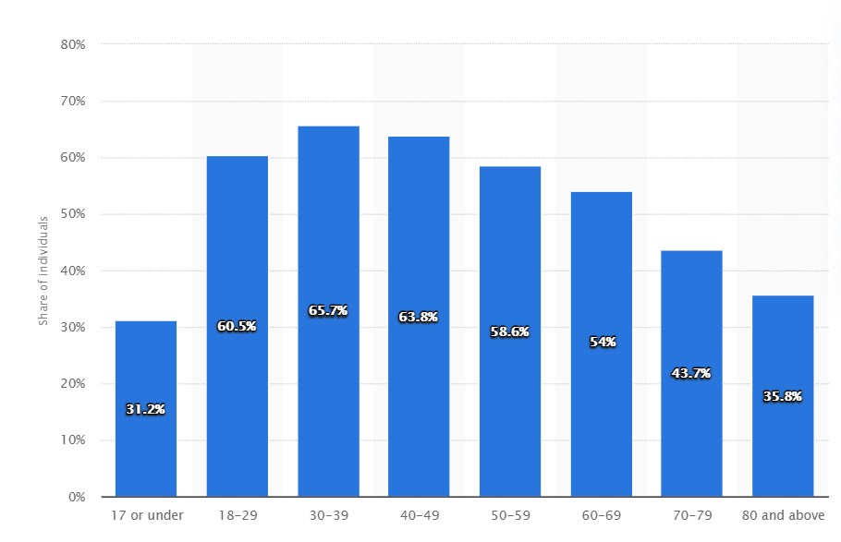
Figure 1: Accessibility of technological support
Source: (Rajeh et al., 2019)
Rajeh et al. (2019) has stated in the paper on digital technology and the healthcare sector that, majority of the people in the United Kingdom were appreciating and accessible through the technical service of the healthcare organisations. From the study, it was found that the maximum percentile of access to the digital healthcare service was the age group between 30 to 39 and 40 to 49. Also, a total of 60.5% of the young people ageing 18-29 was preferring and had access to digital healthcare services.
The study conducted by Macharia (2016) concluded by saying that, information and communication technology was going to be a key driver of changes for the healthcare sector of the United Kingdom. Macharia (2016) had further said that the rapid technological development and integration in the healthcare service was also going to be a key enabler of changes to face the upcoming and future challenges of the sector. Macharia (2016) latterly suggested that the future healthcare sector policies should emphasise the technological integration and digitalisation of the health and care service to be more efficient in the process of caregiving.
Taylor and Jones (2016) in their study on technological shaping of the healthcare sector had mentioned that the internal system development of the hospital and care homes through using wireless fidelity system improves the internal communication system. Taylor and Jones (2016) had also mentioned the electrical records of the patients in the hospitals that helps to easily diagnose the patients for fast and quick recovery.
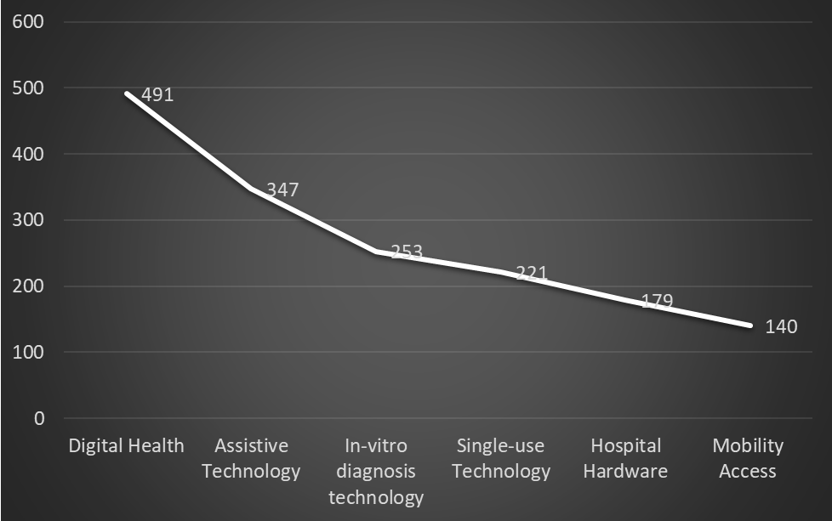
Figure 2: Increasing Number of Digital Health Services
Source: (Yelton and Schoener, 2020)
As per the study of Yelton and Schoener (2020), it was found that in the United Kingdom a greater number of external businesses are involving in digital health care services. Hospitals and care services are demanding more technological support, in response to which more businesses are involving in the digital health service. Apart from the direct digital health services, assistive technological development is also on the rise to support the healthcare sector.
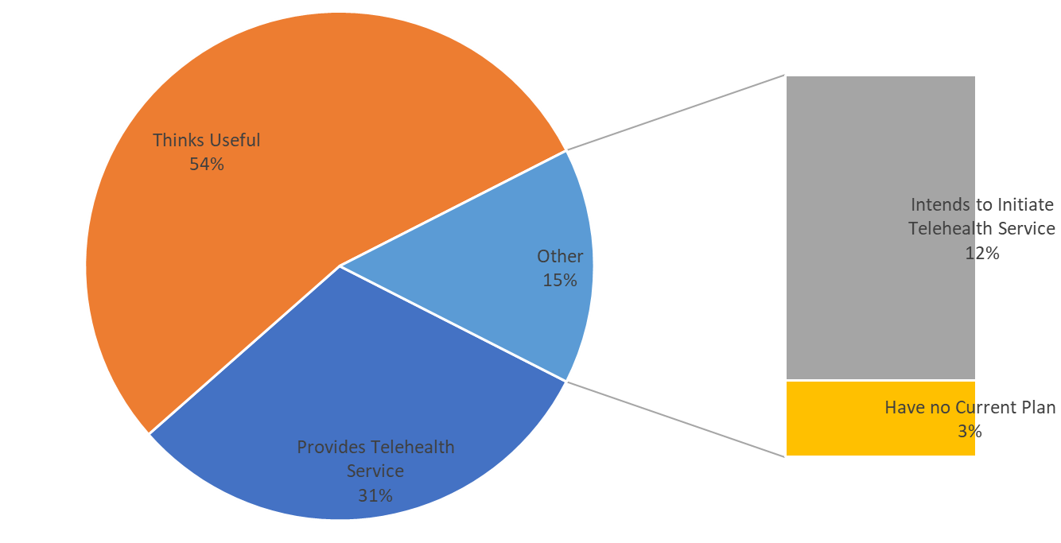
Figure 3: Use of telehealth services
Source: (Rajeh et al., 2019)
In the study conducted by Rajeh et al. (2019) on the use of telehealth services, data from the 52 healthcare organisations were collected. of the investigated organisations, 16 as in 31% of the organisations had their ongoing service of telehealth, while a total 28 (52%) of the healthcare practitioners opined that telehealth service was highly beneficial. Rajeh et al. (2019) had further said that the majority of the telehealth users were using it for early detection of their diseases based on the symptoms.

Discussion on Data Analysis
The researcher had been able to meet the first objective of the study by identifying the key technical services used by the healthcare sector. The major healthcare technological supports that are utilised are the digital infrastructural framework, telehealth service, record keeping, internal communication and network system. Similar research outcomes were found by Lubitz and Wickramasinghe (2016), which Lubitz and Wickramasinghe (2016) had mentioned that healthcare sector organisations were greatly relying on digital services, network systems and mobility of the healthcare support for improving the quality of the healthcare service. The second objective of the study was met by the researcher by being able to signify the use of technology and information systems in the healthcare sector. The researcher had been able to signify the fact that, healthcare organisations were greatly being able to increase their efficiency using the technological resources. The outcomes match with the outcomes found by Figueiredo and Eiriz (2017) in which Figueiredo and Eiriz (2017) had concluded that healthcare organisations intend to use technology and network system not to update themselves only, rather increase their efficiency in the process of providing care service to the patients. The third objective of the study was achieved by the researcher by identifying the further scopes of the improvement in the healthcare systems. Focusing on digital literacy for both healthcare professionals and people, telemedicine service should be more adapted were the key areas of improvement found by the researcher. Similar areas of improvement in the healthcare service were found by Aburayya (2020), by saying that if all the healthcare organisations had greater access to the telehealth service it could lead through a better way to deal with the regular patients during the high pressure of Covid-19 affected patients.

Conclusion and Recommendations
The researcher has been able to meet all the research objectives by conducting the study using secondary quantitative and qualitative data. The key outcomes of the study were focusing on the key technological resources used by the healthcare service organisations, as well key impacts of using the resources as well key areas of improvement in using the technological resources. The first objective of the study was met by identifying the key technological resources utilised in the healthcare sector. The second objective of the study was met by understanding the impact of technology in improving the quality of health care service. The researcher had found that using the digital infrastructural framework, telehealth service, internal communications and record-keeping network etc. were the key resources that had an impact on quality-of-care service as well internal efficiency of service. The researcher attaining the third research objective suggested that digital literacy, telehealth and public awareness were the key areas that need improvement in effective utilisation of the technological resources.
The researcher had suggested the following recommendations for Care Homes –
- Care Homes needs to develop its internal own network system, integrating all the technological components under the same network. The network should help in managing the schedules and records of the patients, as well as online service to the patients.
- For managing the regular schedules, third party software can be used by the Care Homes which will give a better interface for managing the schedules.
- For managing the database of the patients, record-keeping software – EHS software can be designed and used by Care Homes.
- The healthcare professionals in the Care Homes need to be digitally literate in using the technological resources, as well as learning about the effective utilisation of such components in caregiving service.
- The Care Homes service needs to initiate telehealth service and make the patients aware of the service. Through telehealth service, Care Home can provide basic monitoring and initial treatment/diagnosis to the patients over the telephone.

References
Aburayya, A. 2020. An Investigation of the Effect of Lean Six Sigma Practices on Healthcare Service Quality and Patient Satisfaction: Testing the Mediating Role of Service Quality in Primary Healthcare Sector. Journal of Advanced Research in Dynamical and Control Systems, 12(SP8), pp.56–72.
Bell, E., Bryman, A. and Harley, B. 2018. Business Research Methods. 5th ed. Oxford: Oxford University Press.
Figueiredo, J. and Eiriz, V. 2017. Analysis of the impact of technological innovation on healthcare services. International Journal of Behavioural and Healthcare Research, 1(3), p.234.
Goddard, W. and Melville, S. 2017. Research methodology. Kenwyn, South Africa: Juta & Co., Repr.
Lewy, H. 2015. Wearable technologies – future challenges for implementation in healthcare services. Healthcare Technology Letters, 2(1), pp.2–5.
Lubitz, D. and Wickramasinghe, N. 2016. Healthcare and technology: the doctrine of network-centric healthcare. International Journal of Electronic Healthcare, 2(4), p.322.
Macharia, P. 2016. IMPROVING QUALITY AND ACCESS TO HEALTHCARE BY ADOPTING EMERGING TECHNOLOGIES. International Journal of Digital Information and Wireless Communications, 6(1), pp.41–45.
Mostashari, F. 2017. Health information technology and Healthcare. Healthcare, 2(1), pp.1–2.
Rajeh, A., Steiner, M., Aldabayan, Y., Aldhahir, A., Pickett, E., Quaderi, S. and Hurst, J. 2019. Use, utility and methods of telehealth for patients with COPD in England and Wales: a healthcare provider survey. BMJ Open Respiratory Research, 6(1), p.e000345.
Snowdon, A. and Wright, A. 2018. Case Study: Supply Chain Transformation in the UK National Health Service. Healthcare Quarterly, 21(3), pp.24–27.
Tamburis, O. 2014. The specific role of ICT: different perspectives between traditional healthcare service and e-healthcare service. International Journal of Electronic Healthcare, 2(3), p.250.
Taylor, L. and Jones, J. 2016. Implementing a technology-enabled care service. British Journal of Healthcare Management, 22(1), pp.23–33.
Vilcahuamán, L. and Rivas, R. 2017. Healthcare technology management systems: toward a new organizational model for health services. London: Academic Press, An Imprint Of Elsevier.
Welman, J., Kruger, F. and Mitchell, B. 2015. Research methodology. Cape Town; Oxford: Oxford University Press.
Whiting, N. 2018. Digitisation vs compliance: How automation is saving the day for the healthcare sector. British Journal of Healthcare Management, 24(2), pp.88–89.
Yelton, S. and Schoener, B. 2020. Research: The Evolution of Healthcare Technology Management in Leading Healthcare Delivery Organizations. Biomedical Instrumentation & Technology, 54(2), pp.119–124.

