BSc Health and Social Care BMHP5003

Name : Naazneen Ara
Student ID : 1810991
Tutor : Mumtaz Golam
Due date : 06/11/20

FEMALE REPRODUCTIVE SYSTEM
OVERIES
This is the organ that produces the sex hormones.( Humanreproduvtion,2019)
They secrete two main hormones estrogen and progesterone. The ovaries help maintain the health of the female reproductive system. (Robert.M ,2020).

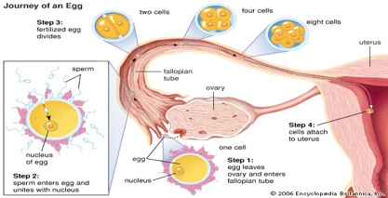
FALLOPIAN TUBE (oviduct)
A muscular tube that carries the ovum from the ovary to the uterus.
This connects the ovary to the uterus, lined with ciliated cells to push release into the uterus for fertilisation (Humanreproduvtion, 2019)

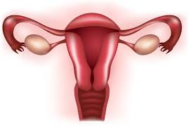
VAGINA
The sperm is deposited through the vagina. It is a muscular tube that leads to the uterus. (i Humanreproduvtion, 2019)
UTERUS (womb)
This is the organ where the embryo grows. It has a soft bag called the endometrium where the fertilised egg will be implanted to develop into a foetus. (Humanreproduvtion, 2019)
ENDOMETRIUM
This is the lining of the uterus. Here a good blood supply for implantation of the embryo. A fertilised egg will implant here to develop into a foetus.( Humanreproduvtion, 2019)
CERVIX
This is the neck of the uterus. It is a ring of muscle to keep developing foetus in place during pregnancy (Humanreproduvtion, 2019)

DISEASES AND
DISORDERS OF OVERIES
THE OVERY (MENOPAUSE)
The ovaries lie on the lateral wall of the pelvis they are approximately 2.5/3.5 cm long and 1-2 cm thick. They are attached to the upper part of the uterus by the ovarian ligament and the back of the broad ligament by a broad part of tissue called the mesovarium

(D.WEATHERSPOON,2020)
FLACTUATING MOODS
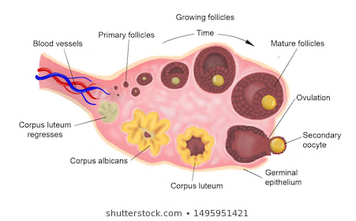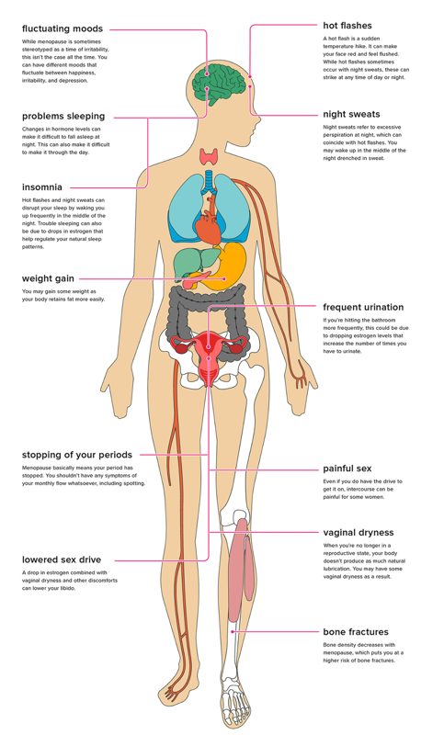
SURFACE- CUBOIDIAL EPITHELIUM
VIGINAL DISCHARGE
BONE FRACTURES
PAINFULL SEX
STOPPING OF PERIOD
LOWERED SEX DRIVE
WAIGHT GAIN
PROBLEM SLEEPING
FREQUENT URINATION
HOT FLUSHES
NIGHT SWEATS
CORTEX
CORPUS LUTEUM
RELEASED OVUM
MATURE FOLLICLE
MESOVARIUM
INSOMNIA
(ROSS AND WILSON 13T EDDITION)
MEDULLA
Female reproductive organ
The female reproductive system process starts with the male gamete the sperm entering the cervix and meeting with female gamete the ovum. The sperm fertilizes the egg here the process is called zygote. The zygote goes through a process of becoming an embryo and developing into a foetus
The external part of the female reproductive system is called the vulva the vulva is placed between the legs it is there to cover and protect the vagina and the other reproductive organs. The vagina connects to the uterus at the cervix with the thick walls. At the upper corner if the uterus the fallopian tubes connect to the uterus to the ovaries. They produce, store and release eggs into the fallopian tubes in the process called ovulation. (L.Hirsch, 2019)

The ovary and release of the egg
The ovary are grape like shaped and are approximately 2.5/3.5 cm. There are two ovaries on either side of the pelvic wall connected to the uterus. they are attached to the fimbria that are tissues connected to the ovaries to the fallopian tube. (Robert.M,2015)
The main components of the ovary are:
- The surface, this is formed by the cuboidal epithelium, underlying this layer is a dense connective tissue.
- The cortex, a connective tissue stroma and numerous ovarian follicles. Each follicle contains an octane surrounding by a single layer of follicular cells.
- The medulla, which is formed by loose connective tissue and a rich neurovascular network which enters via the hilum of the ovary. (L.Thomson, 2020)

Estragon and progesterone are necessary to prepare the uterus for menstruation the release of hormones is triggered by hypothalamus. Once you reach puberty the ovary releases a single egg each month which is called ovulation. The hypothalamus sends a signal to the pituitary gland to release gonaclothropic substances. These hormones are important for reproductive functions. The egg then travels though the fallopian tube where progesterone is released, the progesterone is then secreted to a temporary gland called the corpus luteum. Progesterone then prepares the body to get ready for pregnancy by causing the lining of the uterus to thicken. If the pregnancy is successful a high level of estragon and progesterone to stop the maturing of further eggs. (Robert.M,2015)

Menopause

There are many diseases and disorder that can occur in the female reproductive system such as ovarian cancer, ovarian cysts, polycystic ovary syndrome and osteoporosis which is commonly associated with menopause. (Robert.M,2015) during menopause a women will have a weaker estragon level where the estragon will decline rapidly. This is a sign that a women can no longer be fertile. (Robert.M,2015).

Signs of menopause
- When a women is going through menopause on of the first thing they will notice is changes in the menstrual cycle, where ethe period will seem to get lighter and eventually disappear.
- Complain of hot flushes can be a symptom of menopause where women may feel sweaty of flushed you may feel that your face and neck is getting red often. The heat can get intense first thing in the morning where a hot flash can last up to 10-30 seconds.
- Insomnia problems can cause you to stay up and find it difficult to drift away to sleep. Women may find themselves waking up in the middle of the night and finding it difficult to go back to sleep.
- Dryness in the vagina can be an uncomfortable symptom. This is caused due to the decreased production of estragon and progesterone which can affect the thin layer of moisture that coats the vaginal wall.
- Urinary incontinence is when women find it difficult to control their bladder, or they may feel that their bladder is constantly full. This is due to the fact that the tissues in the vagina and urethra lose their elasticity and the lining thins and the surroundings of the pelvic muscles weaken.
- Other symptoms can be mood swings, depression, change in skin and hair and weight gain etc.
(L.Cappelloni, 2018)

REFERNCES

https://www.healthline.com/health/menopause/symptoms-signs

https://www.endocrineweb.com/endocrinology/overview-ovaries

ROSS AND WILSON 12TH ADITION

ROSS AND WILLSON 13TH ADITION

https://kids.britannica.com/students/assembly/view/228268

https://jisoobiology.blogspot.com/2019/09/38-understand-how-structure-of-male-and.html

https://www.healthline.com/health/menopause/hrt-effects-on-body

https://www.shutterstock.com/image-vector/normal-ovary-follicular-development-ovulation-ovum-181288742

https://www.yourhormones.info/glands/ovaries/

