What can archaeology contribute to the study of the Ottoman Past?
Founded at the end of the 13th century by Osman I, the Ottoman Empire was one of the world’s greatest empires from the 14th century up until its collapse in the early 20th century (Baram and Carrol 2002). At its zenith during the 16th and 17th centuries under the reign of Suleiman the Magnificent, the Ottoman Empire was a vast multinational, multilingual empire that controlled a huge amount of territory that stretched from the regions that are today known as Croatia and Romania, much of North Africa all the way to Iraq and Yemen (Baram and Carrol 2002). Archaeology is crucial in understanding the Ottoman Empire and everything it achieved during both its early beginnings and its eventual fall. In order to do this though we must first understand what Archaeology is as a discipline and what techniques and methods can be utilized that will allow the past to reveal itself.

Archaeology is defined Renfrew and Bahn as “the study of human activity through the recovery and analysis of material culture. The archaeological record consists of artifacts, architecture, biofacts or ecofacts and cultural landscapes” (Renfrew and Bahn 2004). Archaeology has a range of goals from understanding culture history, explaining and documenting changes within human society throughout time to reconstructing past lifeways. In order to do this a vast array of techniques can be applied in order to further our understanding of the ancient and modern past. Some of these techniques and methods include but are not limited to:
Tree-Ring Dating (Denochronology)

The study of the concentric growth rings that can be observed within the cross section of the trunk of a felled tree. Tree’s normally produce two growth rings annually which are formed by the cambium between the wood and the bark (Fagan and Durrani 2016). Every year of growth is marked by a distinct ring that varies in thickness according to the tree’s age and annual climatic variations (Fagan and Durrani 2016). By examining these rings and their thickness is it possible to determine cycles of wet and dry years whilst the tree was alive. Tree-ring samples are taken with a borer from both living and felled trees. These ring sequences taken from the borer are then compared both to each other and to a master chronology of rings that has been built up from many trees with overlapping sequences tied to a known terminal date. The patterns of thick and thin rings for the new sequences are then matched to the master sequence and dated on the basis of their accurate fit to the master sequence (Fagan and Durrani 2016). Tree-ring experts have developed a master chronology that stretches over 8000 years by using a combination of the California bristlecone pine, European Oaks, and a multitude of other species. One of the advantages of this method of dating samples is that is it precise where as other methods such as radiocarbon dating produce a range rather than an exact date. It is also useful for dating samples that are too recent for methods such as radiocarbon dating. The limitations for this method of dating are that it can only be applied to trees in regions outside of the tropics where the pronounced differences between the seasons produce clearly defined annual rings of growth (Renfrew and Bahn 2004). To get a precise tree-ring date the wood from a species must have yielded a master sequence and also be a species that people commonly used in the past (Renfrew and Bahn 2004). The master chronologies only tend to go back as far as 8000 years so any material older than that is not able to be dated by this particular method.

This method has been applied to date Ottoman Monuments by Peter Ian Kuniholm since 1973. In his work “Dendrochronologically Dated Ottoman Monuments” he was able to precisely compile over fifty dated buildings or sites stretching from the 12th century up to the 19th. This ranges from major monuments such as imperial mosques, sarays, sifayes down to lesser known ones such as türbes, mescits, obscure medreses and privates houses (Kuniholm 2000). He states: “All these buildings are part of Ottoman history, no matter how big or how small they may be. Indeed, some of the lesser monuments have the most important tree-rings in this long chain and therefore merit inclusion in this tabulation for that reason alone” (Kuniholm 2000). This work exemplifies how useful a method of dating such as dendrochronology can be in dating and understanding the Ottoman Empire within an archaeological context, especially when cross referencing precise dating together with surviving written evidence to build a consistently accurate framework that allows fuller interpretation of Ottoman sites and monuments.

Radiocarbon Dating:
Radiocarbon dating is without question the most useful method of dating for archaeologists. This dating method determines the age of an object that contains organic material by utilizing the properties of radiocarbon which is a radioactive isotope of carbon. Developed during the late 1940’s by Willard Libby, the basis of the dating method is that radiocarbon (¹⁴C) is constantly being created in the atmosphere as a result of the interaction between cosmic rays and atmospheric nitrogen. The (¹⁴C) that is created then combines atmospheric oxygen to form radioactive carbon dioxide, which is incorporated into plants by photosynthesis; animals then acquire 14C by eating the plants. When the animal or plant dies, it stops exchanging carbon with its environment, and from that point onwards the amount of 14C it contains begins to decrease as the 14C undergoes radioactive decay. Measuring the amount of 14C in a sample from a dead plant or animal such as a piece of wood or a fragment of bone provides information that can be used to calculate when the animal or plant died. As with any other method of dating it does have limitations in terms of accuracy and the time range where it is useful (Renfrew and Bahn 2004). Despite some limitations it has helped archaeologists around the world establish a reliable chronology of world cultures (Renfrew and Bahn 2004). Radiocarbon laboratories provide an estimate of age that is based on the measurement of the amount of radiocarbon activity in a sample. The level of activity is converted to an age expressed in a number of years between the death of an organism and the present.
Electrical Resistivity Survey:

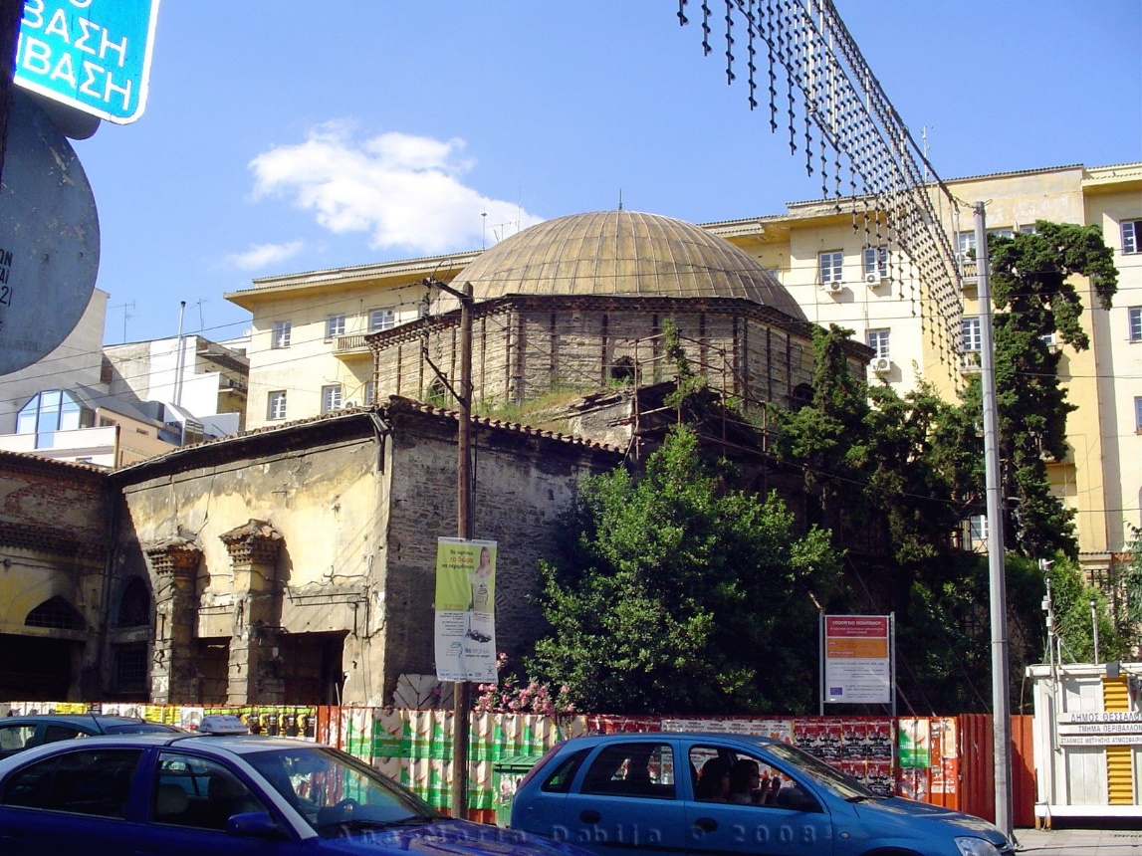
Electrical resistivity is a very useful and commonly used method of surveying in archaeology. The primary principle of this method of surveying is that the damper the soil is the more easily it will conduct electricity, i.e. the less resistance it will show to an electrical current (Renfrew and Bahn 2014). Electrodes are placed into the ground that is connected to a resistivity meter which allows the measurement of varying degrees of sub surface current passed between the electrodes (Renfrew and Bahn 2014). For example silted up ditches will retain more moisture than stone walls or roads so will therefore display a lower resistivity than stone structures (Renfrew and Bahn 2014) This technique is particularly useful for detecting ditches and chalk pits in chalk and gravel, and masonry in clay. The primary method is carried out by placing two stationary probes into the ground whilst two “mobile” probes which are fixed to a frame which also supports the resistivity meter are then inserted into the ground for each reading (Renfrew and Bahn 2014). A variant of this method of surveying is electrical resistivity tomography which was originally borrowed from the medical sciences (Renfrew and Bahn 2014). This is especially useful for sites and monuments that require a fully non-destructive approach where ground penetrating (GPR) would usually be preferable. Recent developments in the technology for electrical tomography has enabled substitutes for the traditional metal spike electrodes that might could potentially cause damage to ancient remains. This was put to use during the geophysical survey of the Haza Bey Mosque, an important ottoman monument situated in the city center of Thessaloniki (N. Greece) (Gregory N. Tsokas et al., 2012). The Hamza Bey Mosque was built during the reign of Mehmed II in 1467-8 by Hafsa, the daughter of Hamza Bey who was an ottoman military commander as a district muslim house of prayer (Gregory N. Tsokas et al., 2012). The original edifice originally consisted of the domed prayer hall which would become the kernel of the architectural complex that would follow with a porch, revak, along the northwest façade (Gregory N. Tsokas et al., 2012). During the mid-16th the Π shaped ambulatory with a minaret was relocated to the mescid which signified it’s conversion to a mosque. The monument was completed during the end of the 16th century with the rearrangement of the colonnade and superstructure of the ambulatory, with the addition of an asymmetrical three-sided portico to the northwest of the structure (Gregory N. Tsokas et al., 2012). By performing a geophysical survey using a combination of both ERT and GPR method Gregory N. Tsokas et al., were able to successfully map and locate the original floor of the monument which was buried 0.6 meters below the modern one along with possible anthropogenic structures that has been theorized could be related to the foundations of the monument or to remains buried below the atrium of the mosque façade (Gregory N. Tsokas et al., 2012). This is a prime example of how archaeology can contribute to a fuller understanding of the ottoman past. By applying archaeological surveying techniques to the Hamza Bey Mosque an insight has been gained into the building traditions, lives and religious practices of the Ottoman Empire for this period.
Hamza Bey Mosque (Alkazar), Thessaloniki, Greece 2011.

The Ottoman Empire undoubtedly had a significant influence on world history being huge in scope both geographically and chronologically (Petersen 2013). As such a multitude of archaeological disciplines are crucial if we are to build a clearer picture of Ottoman history. An important aspect of how archaeology contributes to the Ottoman past is when there is little written evidence available for a certain period or region. Archaeology can build a picture that we otherwise would not have based a textual evidence alone. Even when there is a large amount of written evidence such as the 16th century there are still some important subjects about which we know little (Peterson 2017). In his work “Under the Yoke”: The Archaeology of the Ottoman Period in Bulgaria Andrew Peterson highlights the archaeologies potential in adding to the Ottomans past: “Increasing archaeological activity in recent years combined with a more open approach to the Ottoman past have meant that there is now considerable potential for archaeological research of the Ottoman period” (Peterson 2017). Archaeology can offer a different perspective on the Ottoman past that it can be argued has been neglected by the archaeological community up until the last two decades (Baram and Carrol 2002). Baram and Carrol argue that the most challenging obstacle for Ottoman archaeology is that attitudes from archaeologists towards the Ottoman Empire have been largely negative until recently. The Ottoman Empire was seen as the “sick man of Europe” during its decline which may explain the lack of interest academically in the empires history by archaeologists. Baram and Carrol offer the view that the empires rise was and still is w seen in a negative light: “The unpopularity of the Ottoman Empire stems largely from the perception that its growth marked a delestrious period in world history. This view is propagated both by western scholars and people once living in the regions once ruled by the Ottomans” (Baram and Carrol 2002). Archaeology can dispel some of these pre-conceived notions and help reveal the immense scope of the potential for the exchange of peoples, ideas, and cultures (Peterson 2013) of the Ottoman Empire.
In conclusion it would be impossible in this work alone to fully explore the potential of what archaeology can add to the Ottoman past. Archaeological assessment of the empire is complex due to its scope and the very many subjects of interest that can be explored whether that be art, architecture, societal change, religion, movement of peoples and goods, production and much more. A small handful of techniques and methods within this work have attempted to demonstrate how archaeology is both useful and necessary for the advancement of understanding Ottoman history and how it’s shaped the modern world and still continues to do so.

References:
References
Baram, U. and Carroll, L. (2002). A Historical Archaeology of the Ottoman Empire: Breaking New Ground. American Antiquity, 67(1), p.182.

Batcharov, K. (2019). THE KITTEN SHIPWRECK: ARCHAEOLOGY AND RECONSTRUCTION OF A BLACK SEA MERCHANTMAN. Doctor of Philosophy. Texas A&M.

Fagan, B. and Durrani, N. (2016). Archaeology: A brief Introduction. 12th ed. London: Taylor & Francis.

Hameda, S. (2013). Electrical Resistance Tomography (ERT) Subsurface Imaging for Non- destructive Testing and Survey in Historical Buildings Preservation. Australian Journal of Basic and Applied Sciences, 7(1).

Kuniholm, P. (2000). Dendrochronologically dated Ottoman Monuments. New York: Plenum Publishers.

Petersen, A. (2017). “Under the Yoke”: The Archaeology of the Ottoman Period in Bulgaria. Journal of Islamic Archaeology, 4(1), pp.23-48.

Peterson, A. (2013). Historical Archaeology of the Ottoman Empire. 1st ed. [ebook] Springer Science+Business Media New York. Available at: https://moodle.uwtsd.ac.uk/pluginfile.php/214566/mod_resource/content/1/Article%20No%201%20Ottoman%20Empire%20Encyclopaedia%20of%20Global%20Arch.pdf [Accessed 22 Apr. 2019].

Renfrew, C. and Bahn, P. (2014). Archaeology: Theories, Methods and Practice. 5th ed. London: Thomas & Hudson Ltd.

Tsokas, G., Diamanti, N., Tsourlos, P., Vargemezis, G., Stampolidis, A. and Raptis, K. (2012). GEOPHYSICAL PROSPECTION AT THE HAMZA BEY (ALKAZAR) MONUMENT THESSALONIKI, GREECE. Mediterranean Arhaeology and Archaeometry, 13(1), pp.9-20.

Jamie Crofts

