

Visions for the Future – Theoretical Perspectives on Management (LCDB7006)

Student ID: 1712624
Lecturer: Dr John Lang
Word Count: 7690

Abstract
The purpose of this paper is to evaluate the e-commerce practices and its role of changing the business structure and changes in management practices of the specific industry. For the evaluation, the selected sector is the supermarket from the retail industry which was greatly influenced with development of digital market presence on online stores. This consist the use of new technologies as alternatives to perform exactly the same function that was already being done by another technology, in a different process. Smart phones, for example, replace computers in both internal operations, sending emails, and in the customer experience. This makes it easier to access the site, depending on needs at the moment, many employees use both methods. The key features of e-commerce varies significantly that based on creation of detailed reports data analysis replaces similar sources of information available by other methods. These changes are only useful when they improve performance or are more convenient than previously used methods. E-commerce practices are considered as a significant improvement in the performance or functionality of a process, all through technology. Through this supermarket presence it can provide complete information to outside workers via mobile devices, and eliminates the need to spend time at the office and make shifts. However, companies in digital environment tend to transform the management practices change and adopt different process for successful execution of transforming the traditional business into digital one.

Table of Contents
Abstract ii
Introduction 1
Evolution of E-commerce 2
E-Business 4
Supermarkets: From Ecommerce to Digital Marketplace 8
Digital transformation of Supermarkets 10
Know the technological level of the company 10
Invest in cutting-edge solutions 11
Create a group focused on digital transformation 11
Keep an eye on business strategy 12
Make changes in a global and integrated way 12
Strengthen the culture of innovation 13
Benefits of E-commerce for the Super Market 14
Changes in Organisational Structure of Supermarkets 16
Trends in E-commerce 20
1 - Artificial Intelligence 21
2 - Search by image 21
3 - Search by voice (voice search) 22
4 - Technology for product content management 22
Key features of E-commerce in Supermarkets 23
Selected by Region 23
Icons for departments 23
Search Engine 24
Brand registration 24
Hang tags 24
Saved lists 24
Recipe suggestions 25
Delivery scheduling 25
Important Role of E-commerce for Changes in Management 25
Benefits of Business Digital Transformation 28
1. Impulse towards efficiency 30
2. Increased customer satisfaction 30
3. Creation of new positions and functions 31
4. Obtaining competitive advantage 32
5. Simplification of production processes 33
6. Change of the business model 33
Conclusion 34
References 36

Introduction
E-commerce is defined as the trade carried out by the virtual platforms, such as the online purchases and sales. Currently, with the globalisation of the Internet and the diffusion of the Smartphone, this modality has become one of the main sources of commercial transaction of the market, in many sectors it gains more force than the physical sales. Another transformation that happened in this market was the change in the profile of consumers. According to Savastano, Amendola and D’Ascenzo, (2018) several years ago much of the sales made on the internet were represented by tangible goods, such as appliances, furniture and shoes. Nowadays, the consumers already look in virtual stores for products, like foods, products of cleaning and hygiene. This is the reason it becomes important for the supermarket to follow this transformation of the habit of buying consumers, an ecommerce tool for supermarkets is the opportunity to serve customers at all times of purchase. However, an ecommerce for supermarkets has some peculiarities that differ from other sectors of the market, which is not very different from the physical store, since the food retail has specific characteristics. With the significant transformation of technology this paper evaluates the adaptation of digital practices of supermarkets and how these practices influences the changes in organisational structure and management practices.
Moreover, Malić, Makitan, and Petrov, (2016) indicated that mobile platforms and social media presence of supermarkets require interactive approaches to establish efficient practices in the context of the market or the workplace in question. To make it work, the most common is to use technologies that are not usually available in companies. In this regard, analysis activities of this level, in large part require specific knowledge that most developers do not possess. To meet this demand, some IT departments have been building special units to develop innovative technology skills and methods (Chaffey, 2015). A portion of these companies maintains units specially focused on identifying how new technologies and practices can change their business. Still others seek help from outside the company, hiring help to address larger projects that require advanced technologies. Many of this external aid are indeed effective. However, some CEOs already express concern about a dependency they deem to be excessive (An, 2016). This is due to the reason that the mastery of new technologies still remains fragmented in different sectors, which makes integration difficult.
Indeed, companies in every industry have been benefiting from the roll-out of digital transformation, whether it's the way people work and collaborate, how business processes run within and beyond organisational boundaries, or how the business understands and delivers services to customers. Digital technology offers a wealth of opportunities for all. In this aspect, Chaffey, (2015) pointed out that market pressure to demand changes in business is increasing, that becoming more and more a matter of survival.

Evolution of E-commerce
E-commerce in supermarket industry is extremely promising. In 2014 alone, the segment grew more than 25% compared to 2013, with more than 57 million people making R $ 49 billion in purchases. By 2015, the growth forecast is around 26%. With numbers like these, it is natural that every day UK e-commerce has new entrants, companies that are attracted by the high growth rate. To understand how business got here, it is worth remembering some points of this journey (Falk and Hagsten, 2015). The e-commerce in UK is less than 20 years and in this time of evolution has undergone many significant changes, mainly in the technology question. A good example is the speed of the internet. Another important change occurred in consumer buying behaviour.
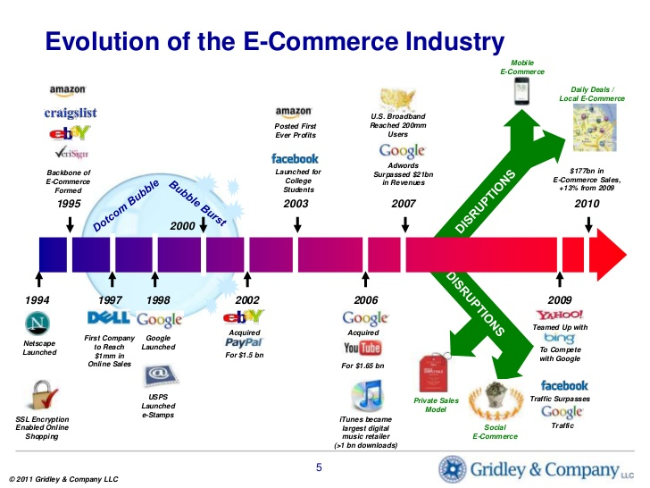
Figure 1: Evolution of E-commerce
(Source: Sari and Cassandra, 2016)
According to Zu, Zhou, Li and Zhang, (2019) it is common sense that young people are very accustomed to shopping on the internet. It is also natural; after all they were born connected! But with the benefits offered by online retailers - such as ease of trading, favourable pricing conditions and favourable payments - the number of e-consumers from other generations is growing, and that accounts for much of the double-digit growth year after year. The professionalization of the market also contributed much to the evolution. Although there is no degree in e-commerce, there are several initiatives, agencies and companies focusing energy in training professionals who know the segment better. According to Falk and Hagsten, (2015) that evolution of the market is beneficial to different business sector. Data from the e-Bit shows that consumers are willing to pay more provided the online retailer has a good reputation and offers security benefits at the time of payment. Therefore, today, in addition to the quality of service, companies and solutions that guarantee peace of mind in the completion of the purchase have an extremely important role. When consumers feel secure in a virtual store, even small online retailers have a chance to compete with big players in the market. In this regard, Zeng, Jia, Wan and Guo, (2017) specified that security of E-commerce by the way, is a critical point in the e-commerce chain. In this sense, the entry of financial institutions raises the level of consumer confidence. After all, most of the banked population is already accustomed to enjoying the online environment of their bank, so it also transfers this sentiment to the retailer.
Another innovation that contributed to the evolution of the sector and promoted online shopping by making the process simpler, safer and more efficient, was the digital portfolio. With it you can centralise virtually all services related to online transactions (authorisation, chargeback and rates) in a single solution (Malić, Makitan and Petrov, 2016). These contributions translate into generation of more sales, since cart abandonment is less and the credibility of the banks will undoubtedly bring new buyers who previously did not feel comfortable buying online. There have been many transformations, and many others must happen in the coming years due to the advancement of technology.

E-Business
The evolution of B2B e-commerce has been slow, gradual and silent, but do not be fooled by the size of this market. For many it may seem surprising, plus the business-to-business e-commerce is already bigger than its most famous brother, the B2C e-commerce. For B2B e-commerce platform vendors the recent times are being a lot of business and gaining new customers, as more and more companies are looking for this solution to grow their business and reduce costs (An, 2016). In UK the situation is no different. The B2B E-business segment has been growing in stride and already has several companies that specialise in providing this type of solution for companies.
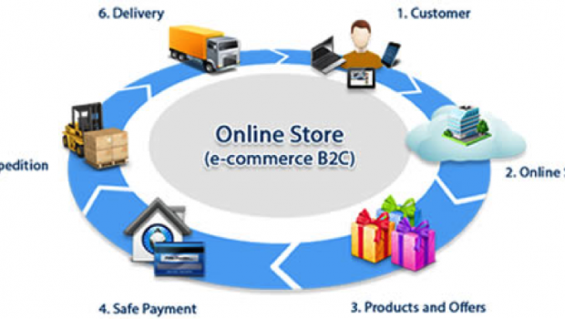
Figure 2: E- business process
(Source: Rgpacific.com, 2019)
Curious is that the evolution of B2B e-commerce has brought some problems for these developers with regard to sales. Although developers’ e-commerce platforms B2B understand creating systems that solve so incredible complex problems and improve the performance of individuals in all functions and at all levels of organisations, it seems, they do not understand about what it takes to succeed in e-business. This is not because your sales teams are bad at what they do (Malić, Makitan and Petrov, 2016). It is causing the buyers systems B2B taking paths notoriously complex to buy. In the info-graphic below, developed by the team, describes this path, and how websites are complementing off-line selling techniques. The info graphic also shows how the sale of e-commerce systems to buyers in the corporate world changed from 20 years ago to today. An important element to know in E-business is the difference in B2B and B2C which is summarised in the following figure:
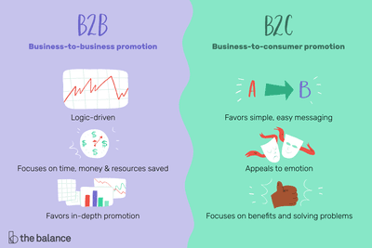
Figure 3: Difference in B2B and B2C
(Source: The Balance Small Business, 2019)
E-commerce for the supermarket sector grows and stands out more and more in an environment that spans multiple audiences. As a result, they have become a great solution to stimulate recurrence in both the B2B (wholesale) business model and the B2C (End-User Sales) business model (Turban et al., 2015). This has presented an online venture for this segment which makes it possible to encompass multiple sales channels. In this regard, the consumer can purchase the products through the physical store or through the computer, mobile, tablet or telesales. In addition, online grocery shopping is able to: leverage the number of customers; improve the consumer buying experience; increase the average ticket and company billing; innovate the brand; increase the repurchase rate; save time; customer loyalty. According to Doppelt (2017) that different results are attained with a well-structured e-commerce digital platform. For this, some functionality are fundamental for virtual stores of this segment, making the experience of the consumer more satisfactory.

Business Process Transformation
With introduction of internet based computing, innovation has quickly evolving to the next stage in which business tend to outsource supporting system or developed the system. Currently, company’s production planning can be merged with other inventory management system which managed by other parties and make it easy to see the next model. However, companies are transforming from physical presence to digital platform (Chaffey, 2015). In relation to this, e-commerce enable online trading based on making several prototypes for businesses. In coming years, it is expected that this model will increase challenges for business and increase competition.
It has been identified that traditional product development process is based on digital media which is quicker than conventional product development which enable involvement at broader scope. Additionally, it supports intervention of multiple technologies that work across the organization. In multinational enterprises, products are not developed in only one plant as it designed and developed across different geographic locations that made easier for global product development (Cantley, 2015). Similarly for supporting customers, business process for servicing them has dramatically transformed. In this regard, companies combine various technologies for creating internet based customer call centre in which business reach several customer based on their personalized needs and requirements.

Implications of E-Commerce
E-commerce has positive and negative effect on business. On the one hand it made it easier for companies to capture large market within minimum time, which saves business cost and expenditures as compared to traditional practices. Additionally, there is no need for setting up traditional stores and remote business location easily (Day, 2017). Contrarily, the cost of setting business online presence is economical and once it is developed access to large customer become easier. However, integration of business to digital platform is complicated for some companies for retaining market share (Cameron, and Green, 2015). This is due to the reason that more competitors enter in the market which fierce the competition for many companies.

Supermarkets: From Traditional to Digital Marketplace
Over the past 15 years businesses have seen a rising wave of Ecommerce coming up, and a very large annual growth in online sales. This is due to the growth of the internet as a whole. Not to mention the increased access to computers, smart phones, and other devices that allows individual to buy from anywhere. E-commerce has brought many benefits and has become an option for anyone who wants to start a new business (Cameron and Green, 2015). Among the main advantages of Ecommerce for the starting up supermarket retailing business are the lower initial cost of a physical store and a greater possibility of sales. In contrast, another model of online commerce has been working very well internationally for a long time. In UK it is something more recent, from about 5 years to here, and it is taking more and more force that is development of digital Marketplace for connecting different companies, buyers and sellers with each other as per their need and requirements. These developments have significantly increased the profit margin of these supermarkets. In this model these stores are only the Intermediaries. This means that they do not care about inventory, logistics and the manufacture of the products or services they sell (Lewis, Cantore and Passmore, 2016). For example, Americanas, Wal-Mart and Submarino which increase their market share by developing their presence on social media.

Figure 4: Supermarkets on Digital Marketplace
(Source: Stone, 2019)
As per the Study of Savastano, Amendola and D’Ascenzo, (2018) that there are various business models that is working out in business effectively in this world. The best example of these models for the successful companies is Amazon, Uber, Airbnb, Alibaba and eBay. However, the resemblance between all these deals is that they are Marketplaces, not simply E-commerce. Additionally, Rowles and Brown, (2017) discussed the most interesting thing that a Marketplace does not only sell products, but also services and experiences. Uber for example does not deliver any physical product, nor Airbnb. But even so are Marketplaces and sell online, that is, business are at a time of market share economy. That means allowing access to anything easily, be it a product or a service you need to buy or hire to make your life easier.

Digital transformation of Supermarkets
Once business understands that digital transformation can bring a number of benefits to business it tends to adopt these practices. This has been done by identifying the process from simplifying and cheapening processes to increasing customer satisfaction. An important thing is to consider the process which is applied for digital transformation (Romberg, 2018). The truth is that entering a market driven by digital transformation can be a great challenge that requiring resources and profound changes in the business model. But all of this can be far less traumatic and efficient if business follow a few steps;

Figure 5: Steps for digital Transformation

Know the technological level of the company
Before management even begin to plan the definitive introduction of Supermarket Company in the era of digital transformation. Management need to make a precise diagnosis of how technologies are being exploited within the corporate environment. To do this, management identify the processes that already have some digital assistance - from the simplest, such as the issuing of invoices, even more complex, as controllers of heavy machinery in an industry. According to Ivanschitz and Korn, (2018) that at this point, the most important thing is to be able to identify if the tools already used are adequate or are already outdated, if they integrate with the entire digital infrastructure of the company and if they are really bringing the best possible results.

Invest in cutting-edge solutions
To make digital transformation a competitive advantage for supermarkets it needs to have some investments. Therefore, business need to make sure the budget for this process is well spent by choosing the right tools for business, those with the potential to bring positive returns in the short to medium term. However, before actually purchasing any solution, do price surveys, conditions and even after-sales treatment (Romberg, 2018). It is important, to rely on virtualised or cloud-based servers. But an important thing to consider that is they able to integrate into the ERP system organically or not.
In the midst of constant changes in the world of technology, supermarkets also need solutions that will not be obsolete in a short time. Precisely for this reason, it is increasingly recommended to change the purchase of licenses of certain programs by contracting Software as a Service (SaaS) (Savastano, Amendola, and D’Ascenzo, 2018). In this modality, the supplier itself is responsible for maintaining and updating the solution, which happens constantly in which values are usually very affordable.

Create a group focused on digital transformation
To ensure that the digital transformation of the company is effective, it is important to mobilise a team of professionals to be responsible solely for this. This group should work separately from the operational one, focusing on capturing trends, conducting market research and creating digital implementation plans in the company. According to Romberg, (2018) that it is clear that after all, each step of the digital transformation team must be anchored by operational experience, since that is where the results will emerge. Ideally, this nucleus of innovation exists constantly, but if the business cannot internalise this team, it is worth having the services of an IT company specialised in the development and implementation of technological solutions.

Keep an eye on business strategy
Contrary to what many people may think, digital transformation is not enough to make the super marts simply trendy. In fact, such a revolution should serve very concrete business objectives, such as improving internal management practices, gaining new customers, and increasing profitability. In contrast to this Aulkemeier et al., (2016) is in the view that innovating means investing. Therefore, management needs to gauge the expenses for what can actually pay off. It is therefore worth initiating the digital transformation in stages, modifying first those areas that are at the heart of the company.
Laudon and Traver, (2018) suggested that supermarkets start investing in a good Customer Relationship Management (CRM) system that can be a good way to quickly increase lead conversion and customer loyalty. The company is confident about its role in the market, but does it find it difficult to maintain control over tax lawsuits. However, it is worth investing in a management system that automates payment and tax return processes.

Make changes in a global and integrated way
Based on the above discussion it has been found that the digital transformation can be applied gradually in your company through multiple stages. However, it is important that all the solutions found to be connected with each other, even if they are part of different sectors or practices of the company. As important aspect that has aligned values and practices rely on a cohesive technological infrastructure. This facilitates the exchange of information between different teams, ensures the stability of the system as a whole and even streamlines the work of the IT team, who starts working with a single language to solve a series of problems that, in principle, can be enough different from one another (Willoughby and Gore, 2018). Also management does not forget that the whole company should be involved in digital transformation. Therefore, investing in communication and in global trainings is important to ensure a smooth transition. In addition, cultivating constant communication between IT and other areas is a way to make solutions more quickly, with contributions from all sectors.

Strengthen the culture of innovation
The search for innovation and consequent insertion in a world ruled by digital transformations is not something that can be done in a single time or without certain constancy. To keep up with market changes, business must always be aware of the trends and also propose innovative solutions. This is only possible if the company develops a culture of innovation. It is therefore necessary to encourage employees to develop new processes, to dare, to carry out research on trends and to participate in training and conferences aimed at technological change (Stepchenkova, 2015). Remember that an innovative culture is never implemented overnight, requiring the company's own adaptation to be effective. In contrast to this, managers need to be encouraged to open channels of frequent dialogue with employees, giving and receiving feedback and stimulating the creation of new solutions - such as bonuses or benefits for attending special seminars. With this, digital transformation goes from just something to be pursued outside the limits of the company to a corporate equity that will add value and profit in the long and medium term (Steenkamp, 2017).This is true that most IT departments rely on solid methods of local development. However, these procedures address well-defined requirements and established technologies, not for the latest digital technologies and practices.

Benefits of E-commerce for the Super Market
As per the study of Stead and Hastings, (2018) that the internet in recent years has been developing at surprising levels, the internet today goes beyond sending emails and exposing institutional content. With all this development, it was predictable that the strengthening of online retailing would happen. In this regard, Roberts, Srivastava and Morrison, (2016) specified that e-commerce is more than ever becomes indispensable for companies and forces the generation of new business models. This development and strengthening of e-commerce has developed over the years which presented in the following discussion from 1997 to 2008
- 1997: Skepticism was evident; e-commerce was seen as a long-term reality and would take time to affect traditional retail.
- 1998: What was skepticism the year before turned into panic, e-commerce will revolutionise and destroy traditional retail.
- 1999: Equilibrium, e-commerce complements traditional retail
- 2000: Multichannel, e-commerce ends up contributing to the cannibalisation of multichannel business models.
- 2008: Multichannel, cross channel strategies, as an ally of e-commerce the customer buys through the virtual store and withdraws in the physical store.
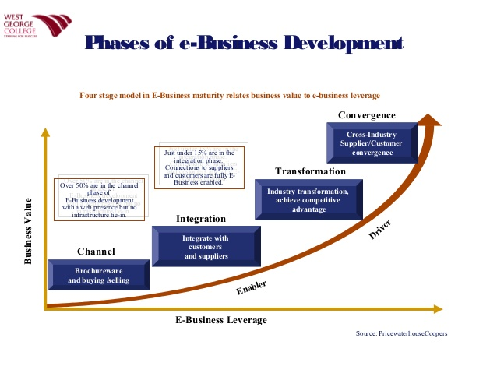
Figure 6: Phases of E-business
(Source: Cantley, 2015)
Nowadays e-commerce is no longer an isolated action, but an integrated action, and business are learning every day how to sell in this huge market. In short, the digital era is based on the transformation of e-commerce practices in business model of Supermarkets. In contrast to this, Stead, and Hastings, (2018) discusses the main benefits for the e-commerce in the supermarket that include speed, connectivity and intangibility. The process of supermarkets at e-commerce is summarised in the following:
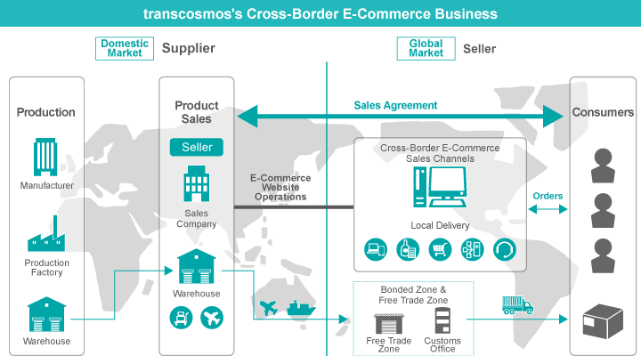
Figure 7: Practices on Digital Platform
(Source: Gofrugal.com, 2019)
Speed: customer at any time, real-time operation. Connectivity: online, interaction between customer and companies, possibility of customers anywhere in the world.
Intangibility: e-commerce, because it is an intangible service, it is necessary to maximise this service (Steenkamp, 2017). This is carried out through customisation of purchase processes, relationship using chats, generating value for the consumer, personalising their service. If it were to cite a pioneer in e-commerce that always innovates in these concepts would cite the renowned amazon.com
Finally, e-commerce grows every year and is already a reality, transforming and creating business models; it is already known that traditional sales techniques do not work in this new digital market. Hundreds of start-ups come up each year proposing new business models for this new digital age that has revolutionised global retail.

Changes in Organisational Structure of Supermarkets
The main difference between an ecommerce for supermarkets from other sectors of the market is the characteristic of the products marketed. Food can be perishable and delivery care needs attention. As the consumer does not choose exactly the product he or she will receive, it is up to the supermarket to guarantee the quality and integrity of the product until it reaches the customer(Wan, Ma and Pan, 2018). Another situation worth mentioning is cold products, which deserve special attention in handling and transportation. These products make the operation of ecommerce for supermarkets more complex and challenging as it is necessary for cold products to receive private treatment from the moment they are removed from the refrigerators. Prior to digital transformation of supermarkets the organisational structure was as below;
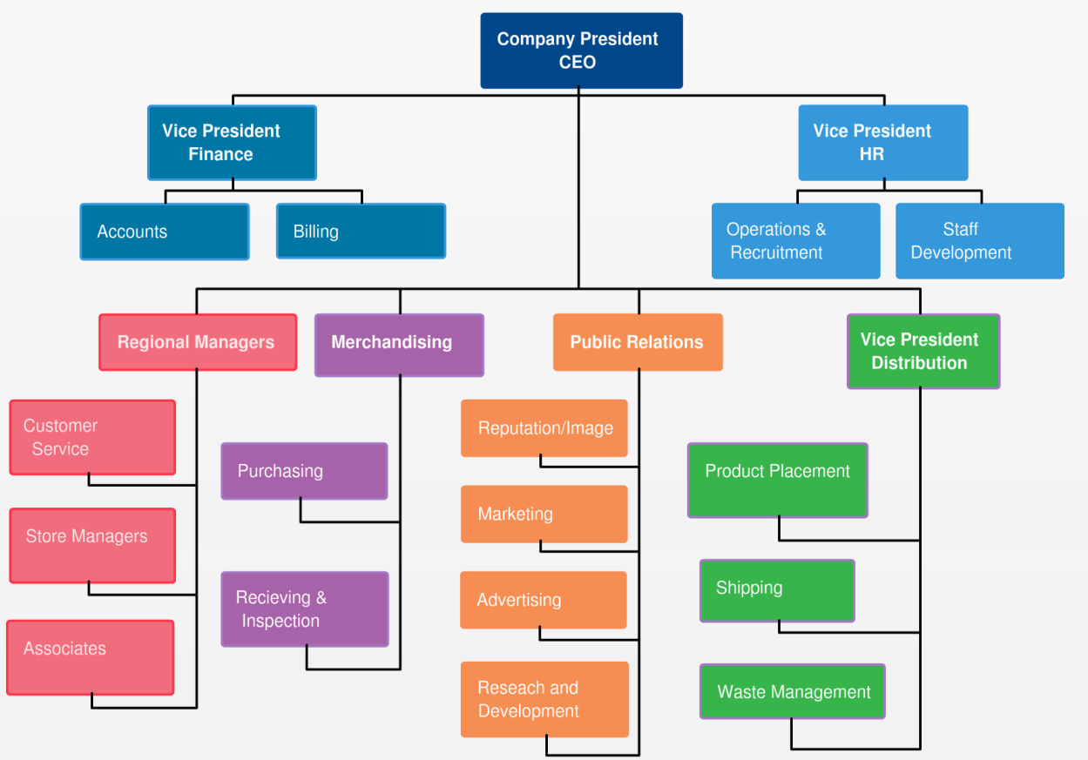
Figure 8: Organisational Structure of Supermarkets
The organisational structure of supermarkets has been transformed significantly over time from the traditional brick and mortar stores to digital store in which purchase and sell are made with one click (Laudon, and Traver, 2018). E-commerce Company specialised in supermarkets, recently launched the action "Digital Shelf". This initiative has had a positive impact on industries and supermarkets, since it brings concepts of collaboration between the parties, which generate value for the whole chain in the medium and long term. The structure transformation of super markets is applied following procedure:
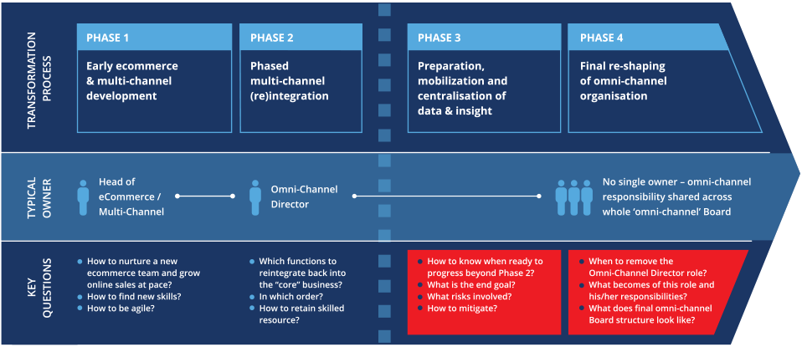
Figure 9: Structure Transformation process
(Source: FOSTEC & Company, 2019)
At the Digital Shelf, industries access information about their products available for sale at online supermarkets and may suggest item description updates or even update photos. The participation of the industry in this process is fundamental because it is the guardian of the brand, and its strategy of communication with the consumer must be executed without interference (Hua, Morosan and DeFranco, 2015). It has been identified that supermarket has more than 120 digital online marketplaces for supermarkets in its Digital Shelf, the expectation is that the reinforcement of the brands is bigger which contributing to the increase of sales. In addition, a single product upgrade is automatically replicated to all Partner Market partner stores, resulting in a great productivity gain. The organisational structure in the supermarket result in increased the sale of supermarket items over the internet has grown at a very great speed in recent months. The new consumer wants more agility in the search for items, does not want to waste time in queues and if possible, receive their purchase at home. This is already possible through websites and mobile applications to provide access on digital marketplace. For successful implementation of organisational structure for the e-commerce of Supermarkets must have the following elements

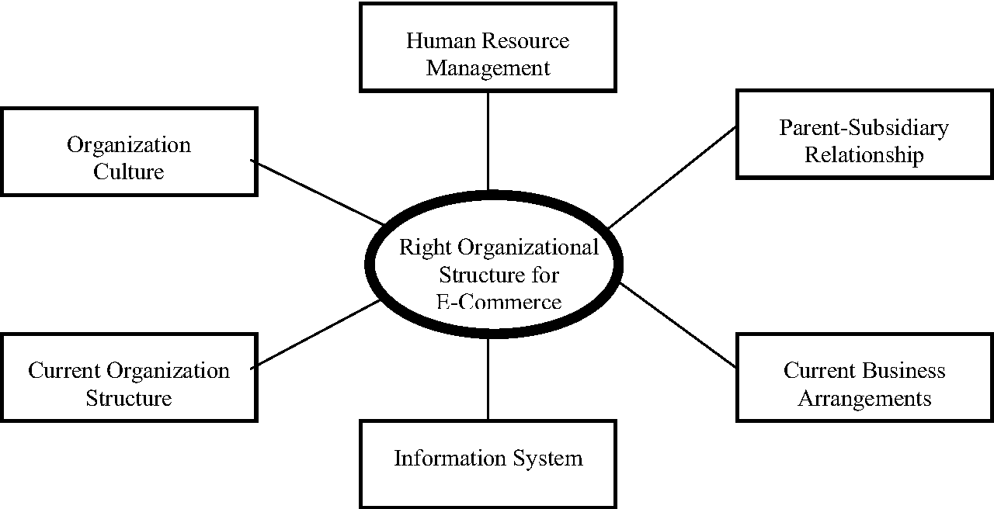
Figure 10: Organisational Structure for E-commerce
(Source: Periasamy, Loong, Ming and Wei, 2002)
In an increasingly competitive and dynamic market, ecommerce for supermarkets has been gaining ground. They are the main reasons for the trend of online shopping: changing consumer behaviour, new Millennium generation consumers , new easy-to-use and easy-to-access technologies, increasingly innovative and fluid offerings for consumers (Day, 2017). It has been identified that for the supermarket, this format is a great way to increase store sales and reduce the idle capacity of the operation. In order for the ecommerce platform for supermarkets to work, the entrepreneur needs to have full knowledge of the process and form of online sales.

Trends in E-commerce
The beginning of the Internet, when everything was new, the simple possibility of making purchases without leaving home already impressed. It was too simple for the supermarket industry of UK to just add the products on its online store to make the sales. At that time it did not matter if the picture was bad, missing complete technical descriptions or if there were no reviews or online instruction manuals. What people wanted was to enjoy the advantages of e-commerce (Festa et al., 2016). Today, however, the situation has reversed. E-commerce is already a reality in society and, to highlight, stores know that they need to go beyond the contents to not only attract the attention of the user, but mainly keep them inside site.
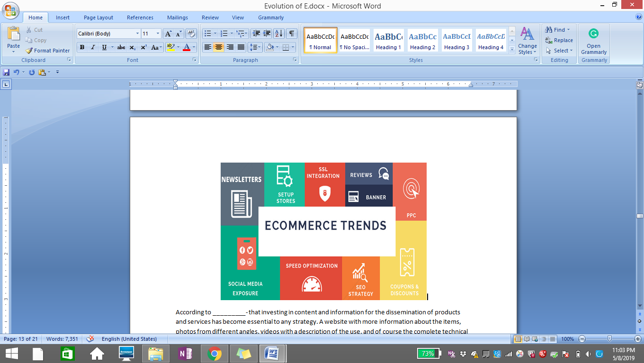
Figure 11: E-commerce Trends
(Source: amarinfortech.com, 2018)
According to Gowreesunkar, Séraphin and Morrison, (2018) that investing in content and information for the dissemination of products and services has become essential to any strategy. A website with more information about the items, photos from different angles, videos with a description of the use, and of course the complete technical specifications are more likely to convert a visitor to a sale than one that does not have at least one of these characteristics. The consumer searches more and tends to buy from the brand that offers the information he seeks. Check out four trends in the area of e-content and how they help retailers work in the digital environment.

1 - Artificial Intelligence
A good description of the products in digital sales channels is a preponderant factor in attracting and converting a customer. To optimise this service, large companies already bet on Artificial Intelligence to take care of the writing of the information of the products. Through a link of the current page of the product, a robot can produce different versions that can be used in different channels (Greg Wright, 2017). Chinese giant Alibaba, for example, is one of the first to use this feature on its sites. With this, it has been identified that companies start using Artificial intelligence for predictive analysis of the consumer demand for products and buying behaviour. In this regard, more than 60% of millennial tend to appreciate the retailers who use artificial intelligence for offering the more interesting products. The survey of the supermarket revealed that how these companies are using technology for testing the products that support them to find the ways for controlling business cost and return (Bbc.co.uk., 2019). In this aspect, farms of these supermarkets claims that they are using tech for producing cheaper, healthier meat and vegetables to meet the demand.

2 - Search by image
Taking a picture and searching the image in the main Internet search portals is already a reality both among companies and among consumers. Rather than searching for certain products through keywords, users can take a picture of the item and play it directly on the portal to check out companies that sell similar items (Laudon and Traver, 2018). In this way, it is essential that brands use numerous photos of their stock, as this increases the possibility of match with the researched image.

3 - Search by voice (voice search)
The advancement of Artificial Intelligence will not only change how the products are described, but also the whole process of searching. People today already use voice commands on smartphones to find items and terms. According to Google, 20% of searches on Android devices are already done that way (Laudon and Traver, 2018). This requires a strategic change on the part of the companies, which includes leaving the site adapted for mobile devices and even changing the SEO strategy.

4 - Technology for product content management
One of the major difficulties for players is to centralise and manage all information available for the production of content on digital channels. This, in fact, popularised the platforms aimed at this function. However, this technology needs to go beyond simple information management and offer a better experience for consumers. The Product Experience Management Greg Wright, (2017) concept is a more current view than conventional product data management services. In this case, it incorporates the best characteristics of each and above all, preparing to meet the dynamics of e-commerce, its data and integrations.

Key features of E-commerce in Supermarkets

Figure 12: Features of E-commerce

Selected by Region
Keeping inventory updated, especially when it comes to supermarkets is key. An important feature to offer is the choice of the region the consumer is in. In addition, for B2B businesses, it is possible to reduce freight costs by ensuring a better price for local consumer companies. With the evaluation of different retail store consumer can choose any retailer.

Icons for departments
It is interesting to separate the departments of the supermarket in the e-commerce (hygiene, cookies, bakery, self-care products and beverages), also using icons that reinforce the identification.

Search Engine
Ideally, the online search engine has auto complete functions to aid search. In addition, it is interesting to present similar results, with the well-known suggestion, in case the consumer enters a wrong word.

Brand registration
Registering product brands with the logo and making their search available (filter) are also great ways to optimise the consumer shopping experience at the grocery store.

Hang tags
A great option to highlight important information is the labels. It is possible to label the product with the country of origin, by offering discount or free shipping information.

Saved lists
The list allows the consumer to save a monthly shopping list so that it can be used again. After all, the purchase is repeated all month. Thus, the consumer can create a monthly or daily shopping list and leave it saved in e-commerce. With this, business can repeat the same requests, making only the adjustments that are necessary such as the inclusion or exclusion of products. Jackson and Ahuja, (2016) indicated this management practices as interesting for B2B business models, since it speeds up the choice of companies' products (which are often repeated) and guarantees a great experience.

Recipe suggestions
The sector is also promising for food products. Revenue suggestions can be presented at the time the consumer is viewing a product, with a list of the ingredients that are missing to make the dish (without offering unavailable products), the cost of the recipe, the preparation time, and the number of people who it suits (Greg Wright, D., 2017). It is also interesting here to present drinks suggestions as well as desserts.

Delivery scheduling
The delivery schedule plays a key role in virtual stores in this segment. With the delivery schedule, the consumer can set a better day and time to receive the purchase, avoiding that the order arrives at a time that cannot receive.
In B2B businesses, this is also interesting for companies that prefer to receive the products at specific times of operation, being able to tighten the relationship between both. By providing these functionalities, the consumer can have a complete experience in the e-commerce of the supermarket, which contributes even more to the recurrence with greater loyalty (McLaughlin, 2016).

Important Role of E-commerce for Changes in Management
Some caution is essential to success in an ecommerce operation for supermarkets. Starting with the management of the processes that already exist, the control must be meticulous, inventory management, financial and fiscal department, they need to be integrated and efficient. Logistics must be flawless to avoid mistakes that compromise the success of digital sales. The challenges faced by you, supermarket, is the subject of this article the great challenge you have already overcome: be able to carry out the good management of supermarket (Chaffey, 2015). To start selling online you need to add some controls in the operation and count on tools qualified for this activity. For the changes practices of supermarket the most common and effective theory is identified as the Kotter’s theory which is based on the following key elements.
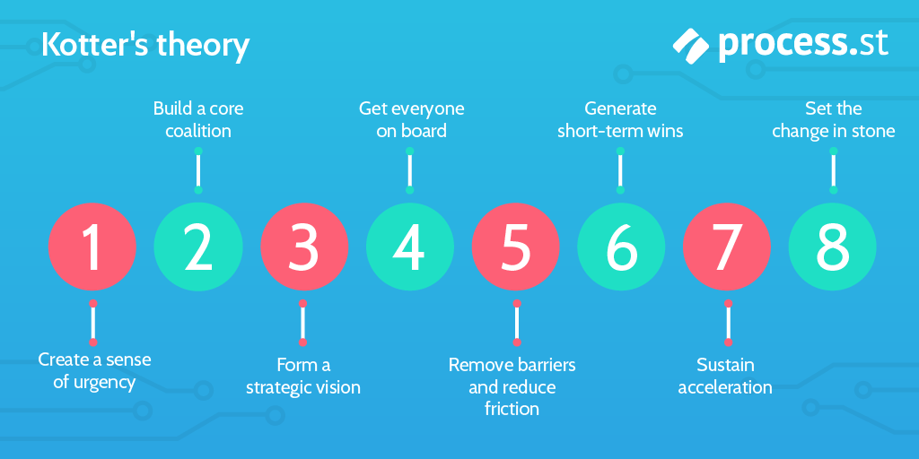
Figure 13: Elements of Kotter’s Management Theory
(Source: Process Street, 2017)
In contrast to this, the main difference between an ecommerce for supermarkets from other sectors of the market is the characteristic of the products marketed. Food can be perishable and delivery care needs attention. As the consumer does not choose exactly the product he or she will receive, it is up to the supermarket to guarantee the quality and integrity of the product until it reaches the customer (Falk and Hagsten, 2015). In relation to this, scientific management emerged in the early twentieth century through the American engineer Frederick W. Taylor. In his book Administration of Workshops (1903), Taylor proposes to rationalisation of work through the study of times and movements. This theory aimed to define a methodology that should be followed by all workers, preaching the standardisation of the method and tools used, aiming at optimising human benefit of organisational and organisational management(McLaughlin, 2016). The strong defence of efficiency and gain, using a method judged by Taylor as universal, constitutes the pioneering School of Management in an approach called scientific management Theory.
In addition to this, other theory of management was developed by Fayol who was the head of management theories. He based his idea where people interested in businesses, whether commercial, industrial or governmental, contributing to the diffusion of administrative doctrines (Romberg, 2018). Fayol determined that the management is an activity common to all human endeavours, such as: the family, business and government. All require a certain degree of planning, organisation, command, coordination and control (Wan, Ma and Pan, 2018).Another situation worth mentioning is cold products, which deserves special attention in handling and transportation. These products make the operation of ecommerce for supermarkets more complex and challenging as it is necessary for cold products to receive private treatment from the moment they are removed from the refrigerators. Digital products in the supermarket sectors are also introduced as a way to complement those already sold (Kabanda and Brown, 2017). Imagine a sportswear manufacturer that starts selling GPS and other digital devices to track and record data on the user's physical activities. Conversely, think of an airline that starts negotiating travel packages, allowing travellers an integrated multi-channel experience - which includes air traffic information, reservations and on-site purchase promotions.
In line with the integration of information, digital technology allows companies to project globally while remaining locally receptive. The benefits come from shared services across all sectors, such as finance and HR, and even those with less visibility, such as manufacturing and design (Turban et al., 2016). Global sharing promotes efficiency and reduces risk, being characterised by flexibility. Think about it nowadays, it is possible to change production around the world just a few days in advance, either in response to interruptions or to an excess of demand for the staple products. In this regard, Hayes, (2018) specified that strategic planning in the supermarket industry favours the company by attributing to it the ability to detect which actions are most relevant to that very moment. For example, Wal-Mart is accustomed to autonomy in making decisions in their area, gain a broader view of the business with the help of centralised data. With this, they can adapt the business to their local needs. It is worth mentioning that digital transformation also implies a different approach to the chain of command, with management issuing fewer orders and giving more guidelines.
On the other hand, the opposite is also true. Management can truly improve buyer satisfaction through digital transformation efforts. Break with these paradigms and imagine a platform, tool or strategy that can improve business image! By investing in digital transformation, the business gives you the feeling that it is customer oriented, that you value time and want to make your life easier (Doppelt, 2017). Business can bet: the audience will respond positively. The good news is that, in leading your business toward digital transformation, many of these bottlenecks can be eliminated! Replacing processes manually by automated workflows ensures greater control over current practices, which reduces friction in production.

Benefits of Business Digital Transformation
Cloud Computing, Business Intelligence, Internet of Things, Big Data: Technological advances are changing the world as business knows it, changing the way business acquire information and even how it relate. All this is part of the great impact of digital transformation. In addition to this, channels through which business communicate with its business partners, customers and internal employees are increasingly simple to access and use, facilitating the participation of an unlimited number of people who demand immediate and continuous information. In addition, Lewis, Cantore, and Passmore, (2016) specified that everyone wants to choose the configuration and the time to receive this information, being able to respond and give their opinion for the channel of their choice.
In this regard, Doppelt,(2017) specified that the business world is at the heart of this transformation. Additionally, direct processes of relationship with customers, employees, suppliers and shareholders are being transformed. It does not stop there! Even those sectors of lower visibility within companies must evolve to be able to increase efficiency and customer focus. Since large companies have a fundamental importance in this scenario, they must review and adapt all their processes to this new reality (Doppelt, 2017). Digital transformation in supermarket is the core element of its strategies. In order to inspire the social changes business are witnessing. It is about starting from different perspectives and giving more agility to the work, focusing on the Omni channel client.
In this regard, Rowles and Brown, (2017) indicated that by scanning the relationship with buyers, it is possible to improve the shopping experience at all points of contact with the company, always using different environments, channels and formats. In addition, working on the digitisation of operations, automating and fostering self-service and self-management, contributes to increased efficiency and productivity. Remembering: digital transformation represents a transcendental change in working practices. In addition to a challenge that affects business by providing several benefits to business for digital transformation: In this regard, the key benefits for business to transform its business practices into digitalisation include the following;

1. Impulse towards efficiency
It is important to know factors that are harmful to business and identify barriers exist in current processes that undermine efficiency. In relation to this, for some industry the answer can be found in manual data logging, as a consequence of sectors that are not sufficiently interconnected (Romberg, 2018). For others, the answer lies in the bottleneck created when the action, when going through a department, finds no solution. With this, it blocks the sequence of processes and ends up limiting the final production.
While the true goal of digital transformation is to bring the Omni channel customer a unique experience, its utility for the company is to achieve immunity to process corrosion. In the past, these mismatches were caused by difficulties in managing time, distance and difficult access to information, problems already adequately solved by new technologies (Ivanschitz, and Korn, 2018). Accompanying the digital transformation implies breaking with the status quo and promoting a corporate culture that can redefine values and foster business models that adapt to an ever-changing market.

2. Increased customer satisfaction
By itself, the smart phone already allows your product or service to reach customers at any time, 24 hours a day, 7 days a week. But think of the following: if business customers could receive information about company and make a purchase anytime, anywhere and if they wish to acquire products, but company has no mobile presence (Hayes, 2018). One of the biggest advantages of digital transformation is precisely the ability to make your business available to customers no matter where they are. When your site adapts to any device that business automatically becomes accessible all the time, which increases the chances of closing deals.
The main trend of digital transformation is to allow purchases to be made anytime, anywhere. This should be the goal of every business to minimise dropouts during the sales process, meet customer expectations and provide excellent service on any device. Keep in mind that digital technology users today expect to have what they want and exactly when they want. But all the work that makes it possible invisible to other. The focus should be solely on solving problem or meeting needs right now (Cameron and Green, 2015). With the rise of the massive use of mobile devices, business sees the expectations deepen even further. The modern customer wants all of this combined with ease of use. What will happen if business cannot provide the expected facility or offer an outdated experience. Simply the public will opt for other companies that meet these requirements.

3. Creation of new positions and functions
Business digital transformation is based on living the 4th industrial revolution. Soon, digital interactions will be unlimited and business keeps evolving in that direction, at exponential rhythms. The detail is that these massive changes coming along will impact society as a whole, especially the business world, including a focus on new skills for future jobs. Even in times of economic crisis, the demand for professionals with functions related to digital transformation does not stop growing. They are device and network management jobs, application development, digital security and privacy, business analytics, and more. As functions become more complex, successful candidates need to update themselves, composing a true mix of skills (Hayes, 2018)
Anyway, whatever the job, some level of technology skill will always be a prerequisite. Not to mention that new positions will be created due to the constant demand by professionals in the area. This revolution in the corporate world that is already beginning to be engendered by digital transformation will eventually involve educational institutions, incubators, innovation centres and companies, in order to foster, especially in young people, the development of skills appropriate to this new digital world. According to Hua, Morosan and DeFranco, (2015) that a new culture is already forming, with it also emerges a new conception in education for work. And it will happen faster than many think! With people prepared to pursue their successful job, companies, mindful of all these changes, will certainly benefit.

4. Obtaining competitive advantage
Those businesses that have already achieved high performance are translating their strategies into competitive advantage. Its initiatives have directly contributed to product creation, adding new revenue streams, reaching new customers, reducing costs, increasing productivity and improving customer and employee satisfaction (McLaughlin, 2016). Meanwhile, low-performing companies, those who begin their digital journey with fragmented initiatives, struggle to understand how to effectively put digital transformation into action. Their efforts lack the clarity and vision necessary to use digital strategies that differentiate them from competitors.
In this aspect, Roberts, Srivastava, and Morrison, (2016) specified that in coming years, business will see more and more companies rushing to build their digital maturity. Digital implementations can alter or even replace existing processes, directly affect business lines or shift the demand for professional talent. In short, they drive innovations that further transform the company and introduce new challenges. There is no escape: digital transformation is already an accomplished reality. Even though not even 10% of supermarket sector are digitalised, this is a path with no return (Steenkamp, 2017). Whether considering relatively simple deployments or more complex investments, those who are part of those 10% need to be prepared for significant changes as they move toward digital transformation. Supermarket sector understand now, that it is a great competitive advantage to be among the few companies that are able to at some level which bring the customer closer, narrowing the relationship, making it simpler and less bureaucratic.

5. Simplification of production processes
The experience of customers in applying social media in practice is more widespread than its use within companies. This reflects the general perception that consumers are increasingly adopting these technologies. As for business applicability, there is still some skepticism about how such media can be effective for internal collaboration (Bradbury and Day, 2016).Using Google Analytics, for example, is already commonplace for evaluating the customer experience. Hence business can understand that there is a growing effort by companies today to segment marketing activities and customise the consumer experience. Mobile technology is widely applied to both domains - personal and business (Greg Wright, 2017). In the business case, however, businesses have only a minority that effectively uses these innovations. It is very common among entrepreneurs to find those who claim they have not yet had contact with digital tools that can act on all the processes in their business.

6. Change of the business model
For MasterCard executives, the options are to change or die, in that case, changing the way technology is done means changing the way business activities are executed (Greg Wright, 2017). It is about finding ways to increase physical presence with digital offerings and use digital advancements to share content through organisational silos. Following the same line, there are other companies building service packages around traditional products. This is the case of the delivery company that, by investing heavily in mobile devices, allows the customer to choose the point of withdrawal and delivery of the goods via the internet, being possible even to select more than one destination. The system calculates the rate and payment is made at the stipulated location, directly to the delivery person.
According to the Study of Cameron, E. and Green, (2015) that digital capabilities span three pillars: they are a critical foundation for transforming customer experience, operational processes and business models. By leading companies' digital transformation initiatives, for IT departments to hire skilled or deploy separate units to help coordinate operations. In this context, the most fundamental technological need for making presence of supermarket is management of inventory that include the existence of a digital platform of integrated data and processes. It has been identified that many successful companies operate in silos, each with its own systems, specific data definitions, and proper business processing. Roberts, Srivastava, and Morrison, (2016) suggested that generating a common vision for customers and products is an objective that must be achieved, since this perspective provides advanced approaches to brand consolidation.

Conclusion
From the evaluation of supermarket industry organisational structure and change management practices, it is conclusive to state that there is difficulty of operating without a platform becomes ever greater as large companies continue to develop multichannel operations. Some businesses are unable to link to customer activity in stores or bank branches. It has been concluded that unification of data and processes is what makes web-based companies capable of achieving much greater advantages than traditional businesses, which make this investment worthy and generate higher return for business. It has been identified that most of the companies that already have ERP and CRM systems integrated to their sectors are, at least, one step ahead of the others. Unified platforms can also help manage the challenge posed by these global integrations. However, supermarket consider the media company using common technology platforms that allow the provision of content that developed in one place which can be easily exploited in other markets and in different forms of dissemination.

References
Amarinfotech.com. (2018). Top Ecommerce Trends 2017 | Future of E-Commerce | Amar Infotech. [Online] Available at: https://www.amarinfotech.com/trends-of-ecommerce-in-2017-and-future.html [Accessed 8 Sep. 2019].
An, D., 2016. Retail and E-commerce Reverse Logistics in China.
Aulkemeier, F., Paramartha, M.A., Iacob, M.E. and van Hillegersberg, J., 2016. A pluggable service platform architecture for e-commerce. Information systems and e-business management, 14(3), pp.469-489.
Bbc.co.uk., 2019. BBC iPlayer - Supermarket Secrets - Series 3: 1. Staying on Trend. [Online] Available at: https://www.bbc.co.uk/iplayer/episode/m000424r/supermarket-secrets-series-3-1-staying-on-trend [Accessed 11 May 2019].
Bradbury, J., and Day, N., 2016. How do supermarket ‘healthy’ range ready meals compare with the ‘standard’ equivalent?. Proceedings of the Nutrition Society, 75(OCE3).
Cameron, E. and Green, M., 2015. Making sense of change management: A complete guide to the models, tools and techniques of organisational change. Kogan Page Publishers.
Cantley (2015). E business. [Online] Slideshare.net. Available at: https://www.slideshare.net/DrewCantley1/e-business-54015607 [Accessed 8 Sep. 2019].
Chaffey, D., 2015. Digital business and e-commerce management. London: Pearson Education Limited.
Cox, J., 2018. Tesco and Morrisons fastest growing big supermarkets but cut price Aldi and Lidl continue to challenge, data shows. Independent (Online) Available at:< https://www. independent.co.uk/news/business/news/tesco-morrisons-supermarket-aldi-lidl-shopping-inflation-kantar-worldpanel-asda-sainsburys-a8241701.html> (Accessed on: 25th April 2018).
Day, J., 2017. Collaborative Economy and Destination Marketing Organisations: A Systems Approach. In Collaborative Economy and Tourism (pp. 185-202). Springer, Cham.
Doppelt, B., 2017. Leading change toward sustainability: A change-management guide for business, government and civil society. Routledge.
Falk, M. and Hagsten, E., 2015. E-commerce trends and impacts across Europe. International Journal of Production Economics, 170, pp.357-369.
Fernie, J. and Sparks, L. eds., 2018. Logistics and retail management: emerging issues and new challenges in the retail supply chain. Kogan page publishers.
Festa, G., Cuomo, M. T., Metallo, G., and Festa, A., 2016. The (r) evolution of wine marketing mix: From the 4Ps to the 4Es. Journal of Business Research, 69(5), 1550-1555.
FOSTEC & Company. (2019). B2C E-Commerce Distribution Strategy. [Online] Available at: https://www.fostec.com/en/competences/e-commerce-strategy/e-commerce-distribution-strategy/b2c-e-commerce-distribution-strategy/ [Accessed 8 Sep. 2019].
Gofrugal.com. (2019). Grocery Multiple Store Retail Chain Software, Supermarket Retail Enterprise Software. [Online] Available at: https://www.gofrugal.com/hq/retail-supermarket-multi-store-pos.html [Accessed 8 Sep. 2019].
Gowreesunkar, V. G., Séraphin, H., and Morrison, A., 2018. Destination marketing organisations: Roles and challenges. In The Routledge Handbook of Destination Marketing (pp. 16-34). Routledge.
Greg Wright, D., 2017. ‘The Best’ range provides boost for Morrisons. [Online] Yorkshirepost.co.uk. Available at: https://www.yorkshirepost.co.uk/business/retail/the-best-range-provides-boost-for-morrisons-1-8667655 [Accessed 26 Apr. 2019].
Haleem, F., and Jehangir, M., 2017. Strategic Management Practices by Morrison PLC, UK. Analysis, Lessons and Implications. Middle East Journal of Business, 12(3).
Hayes, J., 2018. The theory and practice of change management. Palgrave.
Hua, N., Morosan, C. and DeFranco, A., 2015. The other side of technology adoption: examining the relationships between e-commerce expenses and hotel performance. International Journal of Hospitality Management, 45, pp.109-120.
Ivanschitz, R. and Korn, D., 2018. Digital Transformation and Jobs: Building a Cloud for Everyone. University of Miami Inter-American Law Review, 49(1), p.39.
Jackson, G., and Ahuja, V., 2016. Dawn of the digital age and the evolution of the marketing mix. Journal of Direct, Data and Digital Marketing Practice, 17(3), 170-186.
Kabanda, S. and Brown, I., 2017. A structuration analysis of Small and Medium Enterprise (SME) adoption of E-Commerce: The case of Tanzania. Telematics and Informatics, 34(4), pp.118-132.
Laudon, K.C. and Traver, C.G., 2018. E-commerce 2017.
Lewis, S., Cantore, S. and Passmore, J., 2016. Appreciative inquiry for change management: Using AI to facilitate organisational development. Kogan Page Publishers.
Lu, L. and Reardon, T., 2018. An Economic Model of the Evolution of Food Retail and Supply Chains from Traditional Shops to Supermarkets to E-Commerce. American Journal of Agricultural Economics, 100(5), pp.1320-1335.
Malić, M., Makitan, V. and Petrov, I., 2016. Change control in project of web application development in e-commerce environment. ON APPLIED INTERNET AND INFORMATION TECHNOLOGIES, p.344.
Martínez-Navarro, J., Bigné, E., Guixeres, J., Alcañiz, M. and Torrecilla, C., 2018. The influence of virtual reality in e-commerce. Journal of Business Research.
McLaughlin, I. A., 2016. Strategic Human Resource Management Report-Morrisons Supermarket. GRIN Verlag.
Periasamy, K., Loong, H., Ming, P. and Wei, A. (2002). Organizational Structure for Electronic Commerce : A Qualitative Investigation. Undefined, [online] p. Available at: https://www.semanticscholar.org/paper/Organizational-Structure-For-Electronic-Commerce-%3A-Periasamy-Loong/f83f91ff71cb38fc6b0a6adf73be9a173e31c3e8 [Accessed 8 Sep. 2019].
Process Street. (2017). 8 Critical Change Management Models to Evolve and Survive | Process Street | Checklist, Workflow and SOP Software. [Online] Available at: https://www.process.st/change-management-models/ [Accessed 8 Sep. 2019].
Rgpacific.com. (2019). rg pacific ecommerce – RG Pacific. [online] Available at: https://www.rgpacific.com/los-angeles-e-commerce-and-online-store-strategy/b2c_en/ [Accessed 8 Sep. 2019].
Roberts, J. H., Srivastava, R., and Morrison, P. D., 2016. 3 Strategic Marketing Metrics to Guide Pathways to Growth. From Little's Law to Marketing Science: Essays in Honour of John DC Little, 49.
Romberg, M., 2018. Digitally Mature? Ready for the Digital Transformation?. In Digital Marketplaces Unleashed (pp. 57-64). Springer, Berlin, Heidelberg.
Rowles, D. and Brown, T., 2017. Building Digital Culture: A Practical Guide to Successful Digital Transformation. Kogan Page Publishers.
Sari, R. and Cassandra, C. (2016). Build e-Services satisfactory through e-commerce application infrastructure (a case study approach). undefined, [online] p. Available at: https://www.semanticscholar.org/paper/Build-e-Services-satisfactory-through-e-commerce-(a-Sari-Cassandra/2b73b4d7a3fcd8d61dfbaf576765194b274a2d22 [Accessed 8 Sep. 2019].
Savastano, M., Amendola, C. and D’Ascenzo, F., 2018. How Digital Transformation is Reshaping the Manufacturing Industry Value Chain: The New Digital Manufacturing Ecosystem Applied to a Case Study from the Food Industry. In Network, Smart and Open (pp. 127-142). Springer, Cham.
Stead, M., and Hastings, G., 2018. Advertising in the social marketing mix: getting the balance right. In Social Marketing(pp. 29-43). Psychology Press.
Steenkamp, J. B., 2017. Global Marketing Mix Decisions: Global Integration, Not Standardisation. In Global Brand Strategy (pp. 75-109). Palgrave Macmillan, London.
Stepchenkova, S., 2015. People, partnerships, packaging, and programming: 4Ps to success: a portrait of Alastair Morrison. Anatolia, 26(1), 129-136.
Stone, L. (2019). The Ups and Downs of Online Supermarkets – Buyer Stars. [online] Buyerstars.co.uk. Available at: https://www.buyerstars.co.uk/ups-downs-online-supermarkets/ [Accessed 8 Sep. 2019].
The Balance Small Business. (2019). What Is the Difference Between B2B and B2C Marketing?. [online] Available at: https://www.thebalancesmb.com/b2b-vs-b2c-marketing-2295828 [Accessed 8 Sep. 2019].
Turban, E., King, D., Lee, J.K., Liang, T.P. and Turban, D.C., 2015. Electronic commerce: A managerial and social networks perspective. Springer.
Wan, Y., Ma, B. and Pan, Y., 2018. Opinion evolution of online consumer reviews in the e-commerce environment. Electronic Commerce Research, 18(2), pp.291-311.
Willoughby, R., and Gore, T., 2018. Ripe for Change: Ending human suffering in supermarket supply chains.
Zeng, Y., Jia, F., Wan, L. and Guo, H., 2017. E-commerce in agri-food sector: a systematic literature review. International Food and Agribusiness Management Review, 20(4), pp.439-460.
Zhang, D., Zhu, P. and Ye, Y., 2016. The effects of E-commerce on the demand for commercial real estate. Cities, 51, pp.106-120.
Zu, X., Zhou, Z., Li, P. and Zhang, Z., 2019. The Construction of Brand Personality Dimensions of Fresh E-commerce Platform from the Perspective of Consumption Perception.

