Component 1- Coursework: Portfolio

Student Name | Danyal Khan
Student ID | 2410251
Programme of Study | CERTHE COMPUTING SKILLS FOR WORKPLACE
Module Name | Software Solutions for Business
Module Code | ACCA4026
Lecturer | Osman Elgawi
University | UNIVERSITY Of Wales Trinity Saint David
Campus | Quay Place
Date of Submission | November 17, 2026



Table of Contents
Introduction 3
Task 1 – e-Commerce Website Builders / Software Solutions 3
1.1 Wix 3
1.2 WordPress.com 4
1.3 Comparison 5
Task 2 – Mind Mapping of Contemporary Software Applications 6
2.1 Mind-Mapping Technique 6
2.2 Business Scenario Mind Map 7
Task 3 – Office Applications for Creating, Storing, Presenting and Analysing Information/Data 8
3.1 Microsoft Word 8
3.2 Microsoft PowerPoint 9
3.3 Microsoft Access 11
3.4 Comparison of Word, PowerPoint and Access 12
3.5 Practical Excel Test 1 – IF Function 12
3.6 Practical Excel Test 2 – VLOOKUP 13
Task 4 – Communication and Collaboration Applications 14
4.1 Microsoft Teams as a Communication and Collaboration Tool 14
4.2 Practical Test 1 – Team Chat 16
4.3 Practical Test 2 – Shared File Collaboration 16
Conclusion 17
References 18
Appendix A – Practical Evidence Notes 19

Introduction
This report evaluates software applications that can enhance workplace technology solutions by supporting website development, idea organisation, office productivity, data analysis, communication and collaboration. The discussion combines a brief review of each software area with simulated practical activities using non-sensitive business information. The selected scenario is a small online retail project because it provides a realistic setting in which the different applications can be connected: a website can support customer access, mind mapping can support planning, Office applications can create and analyse information, and Microsoft Teams can support communication and file collaboration.
The practical evidence is intentionally simulated. It does not use real customer records, employee information, financial accounts or confidential workplace material. This approach demonstrates the workflow and decision-making value of the software while protecting privacy and confidentiality.

Task 1 – e-Commerce Website Builders / Software Solutions

Wix
Avishai Abrahami, Nadav Abrahami, and Giora Kaplan founded Wix in 2006. The founders of wix realized how difficult and expensive it was to create websites and wanted to give non-coders a platform [1]. The visual website editor on Wix lets you drag and drop elements to design your site. Since technical skills are reduced, small businesses that want an online presence do not need a web developer. More apps and business tools Page and content editing, responsive design, media management, and templates. Wix added AI-powered website building and advanced development tools [1], [2]. E-commerce businesses can create product catalogs, product pages, shopping carts, payment methods, and promotional content on Wix. You can use specific e-commerce services depending on your plan. The best things about Wix are speed and usability. "With so many technical and creative options in one platform, firms can build and update sites quickly. It gives marketers and businesspeople a visual interface to make changes without HTML, CSS, or JavaScript knowledge. Wix's expertly designed templates and tools help businesses maintain their visual identity across product, service, contact, and promotional sites. As an integrated environment, you won't need separate hosting, content management, and website administration services. However, the free version has restrictions. Businesses may need a premium package for a custom domain, more functionality, and advanced e-commerce. Organizations must consider subscription prices, portability, and technical control due to platform reliance. Wix is a great choice for small businesses that want a fast, attractive website. It also improves office efficiency by letting staff make customer-facing changes without developers.

WordPress.com
Mike Little and Matt Mullenweg cloned b2/cafelog in 2003 to create WordPress. A successful open-source publishing platform with a global community emerged. WordPress code lives on WordPress.com. You can create a website on WordPress.com for free without a server. It offers managed infrastructure, SSL, themes, block editors, and basic website management tools. Instead of coding each page, the block editor lets you design with blocks—text, photos, headings, videos, and more. WordPress.com themes make a site work and look. Basic SEO, website analytics, and social media sharing tools can help businesses increase visibility and analyze website interaction. The massive WordPress ecosystem is probably the biggest benefit. Many learning resources, themes, development tools, and expert help. WordPress can grow from an informational website to a business platform as your needs change. However, the free plan has limitations. WordPress.com's free plan has 1 GB of storage. Your free WordPress.com site will have ads. Business and customization features are available in premium plans. Know the difference between WordPress.com and self-hosted WordPress. The latter gives you more hosting, security, upgrades, and maintenance control but more responsibility. Wordpress.com is a great option for a simple start and scaling. This is great for publishing, blogging, content marketing, and slow website growth.

1.3 Comparison
Criteria | Wix | WordPress.com
Ease of use | Very strong visual/no-code approach | Strong block-based editor
Free starting option | Yes, with limitations | Yes, with limitations
Design flexibility | Strong templates and visual editing | Strong themes and block layouts
E-commerce suitability | Good for small-to-medium online stores | Good, but advanced commerce may require additional setup/plan
Main limitation | Platform dependency and paid upgrades | Free-plan restrictions and increasing complexity
Table 1. Comparison of Wix and WordPress.com

Task 2 – Mind Mapping of Contemporary Software Applications

2.1 Mind-Mapping Technique
Mind maps are a visual way to organise information around a key idea. The technique inserts the main subject in the center and connects related ideas through branches instead of writing ideas in a straight list [5].
The technique was popularised by Tony Buzan and is related with visual thinking, memory, brainstorming and the discovery of linkages between ideas. The global structure of a subject matter and the relevance of its pieces can be represented by a mind map [5], [6].
Most mind maps begin with a focal idea. Major themes are then introduced as core branches, and more detailed subsidiary branches. This creates a hierarchy but still retains a visual overview of the complete subject.
Short words or phrases are generally favoured over long sentences as they keep the map concise and allow relationships to be scanned easily. You can also differentiate categories by colours, icons, photos and different line styles.
Mind maps can be useful for planning projects in business. For example a project manager could put the project aim at the center and branch out to resources, activities, clients, risks, finance, marketing and technology.
Mind maps can also help with brainstorming as you can add ideas without needing to put them in a rigid linear sequence. This is useful during early planning, when a team may not yet know which ideas will be in the final solution.
Another usage is for problem solving. A complex business challenge can be broken down into causes, impacts, restrictions, stakeholders and alternative remedies. Visual connections can reveal linkages that would not be obvious in a standard list.
Mind mapping also helps in decision making. Options can be put on different branches with proof, benefits, dangers and required resources linked to each alternative. This provides decision makers with a systematic overview.
The strategy can enhance communication since a good map gives people a shared visual image of a topic. team members can detect gaps and conflicts before detailed work starts.
The practical benefits of digital mind-mapping software include quick editing, rearrangement, sharing and display. So the map made in a meeting can be modified as the debate evolves.
There are limits. A really large map may be difficult to read, especially when you add too many branches or words to it. A mind map can potentially oversimplify a complex problem if relationships are shown with not enough explanation.
To summarise, mind mapping is best employed as a tool for structuring and thinking, rather than as a substitute for extensive records or quantitative analysis. It acts as a bridge from unstructured thoughts to a more formal business plan

2.2 Business Scenario Mind Map
The selected scenario is the planning of a small online retail business. The central objective is supported by four main branches: marketing, website development, operations and finance. Each branch is divided into practical activities. This demonstrates how a mind map can help a business move from a broad objective to manageable work packages.
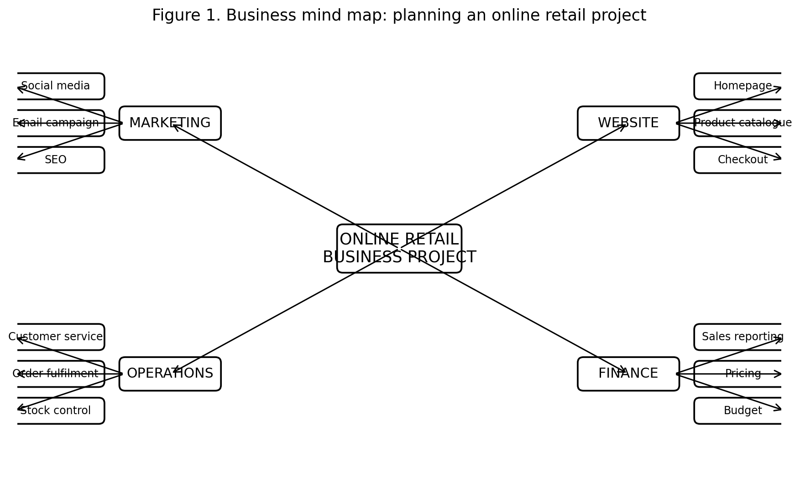
Figure 1. Business mind map: planning an online retail project
The map demonstrates several workplace benefits. Marketing is separated from operational activities, preventing important tasks from being hidden within a long list. Website activities identify the customer-facing technology, while operations focus on stock, fulfilment and service. Finance provides the control dimension through budgeting, pricing and reporting. The same map could later be converted into a project plan, presentation or task list.

Task 3 – Office Applications for Creating, Storing, Presenting and Analysing Information/Data

3.1 Microsoft Word
Microsoft Word is a word processing tool for creating, editing, formatting, reviewing and sharing documents. Microsoft provides templates, formatting tools, collaborative capabilities and reviewing tools to help individuals and teams create documents [7].
Word supports headlines, styles, tables, pictures, page layouts, headers and footers, references and page numbering. These characteristics are appropriate for official reports such as this assignment.
Styles are vital in business papers because they provide uniform formatting. They also offer navigation and development of a table of contents, so you have less manual formatting work to do.
Word has reviewing features like comments and Track Changes. These characteristics are useful when documents are passed between colleagues for drafting, checking and approval .
You can use mail merge to create personalised documents from a data source, such as letters, labels or email messages. This can reduce the repeated manual typing of the same document for sending to several recipients.
Word also has accessibility features, including as tools that assist users check and improve the accessibility of their documents. This is vital in businesses because the information has to be usable by a wide variety of employees and customers.
Microsoft 365 integrations can assist you with sharing and collaborative editing. This means that a document can be a shared working file instead of a standalone copy on one computer.
The key benefit of Word is its flexibility. You can use it for reports, letters, policies, meeting materials, proposals and academic projects without needing expert publishing tools.
Another plus is the professional look. Using consistent styles, tables, visuals, references and page controls can increase the clarity and credibility of corporate papers.
Word can also save documents in a number of formats, including PDF. This is helpful when distributing documents and the author wishes to keep the layout identical.
Disadvantages include poor document management if several versions are saved separately. Lacking unambiguous naming and storing processes, users may modify the wrong copy.
Database programs also manage large, highly structured databases better than Word. Word can display tables but is not built for database queries or the management of relational records.
In general, Word is a very appropriate tool for developing and communicating structured business information. Its strongest value at work is its capacity to combine document production, formatting, review and collaboration.

3.2 Microsoft PowerPoint
Microsoft PowerPoint is a presenting application to deliver information in the form of slides. It is appropriate for meetings, training, sales presentations and academic presentations [8], [9] and supports text, photos, tables, charts, audio, video, animations and transitions.
Themes and slide layouts in PowerPoint help you keep a consistent visual appearance. You can use a theme across a presentation so that fonts, colours and layout elements are consistent.
Users can input photos, shapes, SmartArt, charts and tables. They make it possible to transmit numerical or conceptual information visually rather than in long prose.
There is also Presenter View and Speaker notes in PowerPoint. These tools enable the presenter to have supporting information on hand without putting all the content on the slide that is visible to the audience.
You can use animations and transitions to control the sequence of information. Used sparingly, this can enhance understanding and attention, but too much animation might have the opposite effect.
Multimedia support is a big plus. Video and audio can be incorporated, or linked, as appropriate, enabling for the integration of a number of communication techniques in training or marketing presentations.
PowerPoint supports collaboration and can work with other Office programs. You might, for example, include Excel data to a presentation to support a business decision.
Another benefit is portability. You may electronically share presentations, show them on many devices, and save them as a PDF or video.
Powerpoint is beneficial for decision making in that it allows a complex subject to be summarised into a series of evidence, analysis, options and recommendations. It gives managers an organised story.
One issue is that slide presentations may promote oversimplification. A complex issue can get lost in brief bullet points.
Another limitation is a risk of poor visual design. Too much text, too much motion or inconsistent layout can diminish audience understanding rather than increase it.
Some complex capabilities vary across desktop, web, and mobile versions, so users should verify platform-specific functionality while preparing key presentations [8].
PowerPoint, by and large, is a powerful visual communication tool. Its significance in the workplace lies in marrying organised storytelling with visual and multimedia content.

3.3 Microsoft Access
Microsoft Access is a database program that allows you to create and manage collections of organised information. Microsoft’s support resources have identified the core aspects of Access as tables, queries, forms, reports, expressions and import/export operations [10].
Records are kept in fields in tables. For example, a small merchant might maintain merchandise in one database and customer orders in another. This structure is better for repetitive records than a big Word document.
Queries enable users to retrieve and inspect chosen information. The query can be used to find products under a threshold of stock, sum totals or pick records that fit certain criteria.
Forms offer a more convenient way of inputting and viewing records. Rather than changing a raw table directly, staff can use a form based on the information they need to enter.
Reports are printed outputs of stored data. A business might utilise a report to provide an overview of orders, stock levels or sales activities for managers.
One of the biggest strengths is relationships between tables. Relational design eliminates redundancy by storing relevant data separately and connecting it with keys.
Access can also import or link to data from other sources, making it a good small-scale database solution where the information needs a bit more structure than a spreadsheet.
The key advantage is better organization. Good database design can limit the amount of duplicated information and give you with consistent ways to enter, find and report on data.
Access can also enhance decision making as queries and reports can turn stored records into usable management information.
Good for departmental or small-business systems when the volume and complexity of data is minimal and a comprehensive enterprise database platform is not required.
Limitations 1. Scalability. Instead, large businesses with very high transaction volumes, many simultaneous users or complicated security requirements may need server-based database systems.
Access also demands good database design. Inconsistent information and incorrect reports can result from badly thought-out tables, relationships or data-entry standards.
Another constraint is that users need to have some knowledge of database principles like as fields, primary keys, relationships and queries. It means a steeper learning curve than a simple document editor.
In general, Access is useful for organisations that need to store, retrieve, and report on structured data. It gives Word and PowerPoint a more powerful environment in which to handle the information required in corporate reports and presentations.

3.4 Comparison of Word, PowerPoint and Access
Application | Primary purpose | Key workplace benefit | Main limitation
Word | Create and manage documents | Professional reports, editing and review | Not designed for relational data
PowerPoint | Present information visually | Clear visual communication and storytelling | Risk of oversimplifying complex information
Access | Store and analyse structured data | Queries, forms, reports and relationships | Requires database knowledge and has scalability limits
Table 2. Workplace roles of Microsoft Office applications

3.5 Practical Excel Test 1 – IF Function
For the practical activity, a fictional online retailer was used. Four fictional order records were created with a sales value and a target value. The IF function was then used to classify each order as either “Target Met” or “Below Target”. Microsoft describes IF as a logical function that returns one value when a condition is true and another when it is false [11].
The formula used was =IF(B2>=C2,"Target Met","Below Target"). The logical test compares the sales value in column B with the target in column C. If sales are greater than or equal to the target, Excel returns “Target Met”; otherwise, it returns “Below Target”.
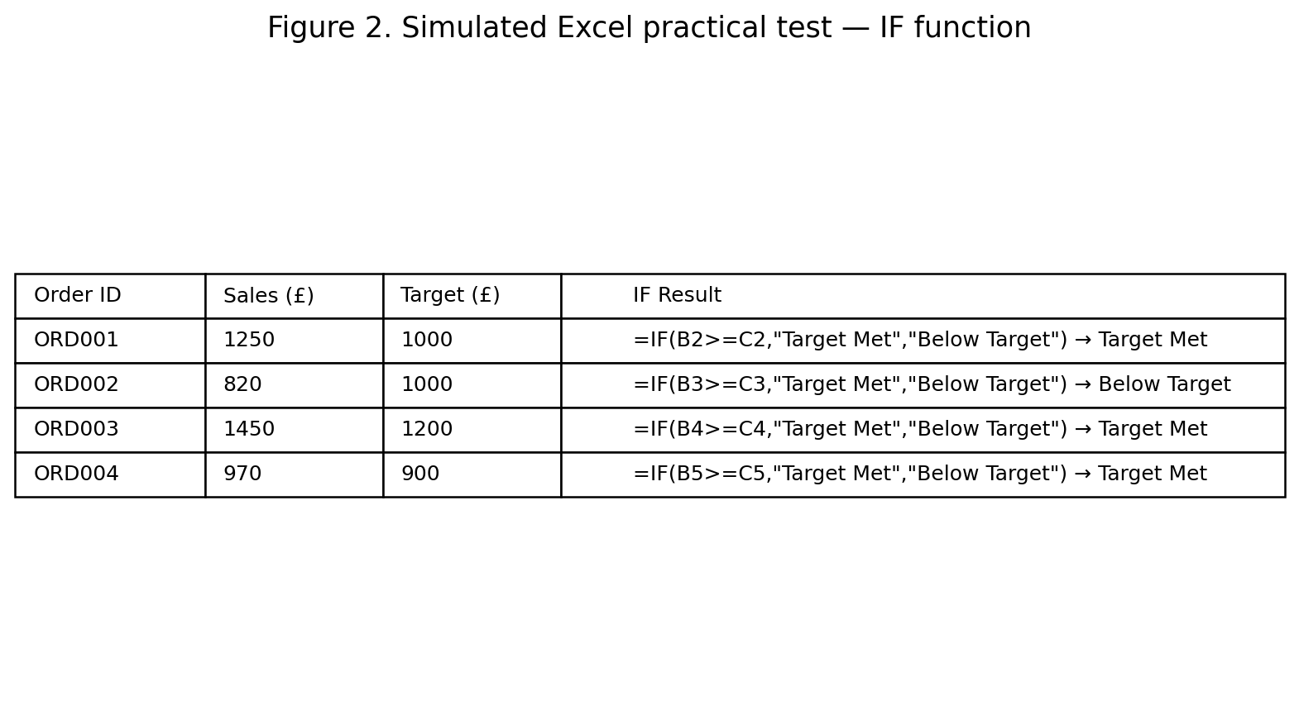
Figure 2. Simulated Excel practical test – IF function
The practical result demonstrates how IF can turn numerical information into a simple management indicator. In a real workplace, the same method could be applied to budgets, service-level targets, stock thresholds, attendance criteria or performance measures. The advantage is that a decision rule can be applied consistently across many records instead of being assessed manually.
The limitation is that the formula depends on the rule being correctly defined. If the threshold is wrong, or if source data is inaccurate, the result will also be misleading. Therefore, formulas should be checked and documented before being used for important decisions.

3.6 Practical Excel Test 2 – VLOOKUP
The second practical test used VLOOKUP to retrieve a product price from a small reference table. Microsoft explains that VLOOKUP can search a table and return information from another column; Microsoft also notes that XLOOKUP is a newer alternative in supported versions [12], [13].
The reference table contained product codes, product names and prices. The test entered product code P103 and used =VLOOKUP(F7,A2:C5,3,FALSE). The FALSE argument requests an exact match, and the formula returned the price associated with P103.
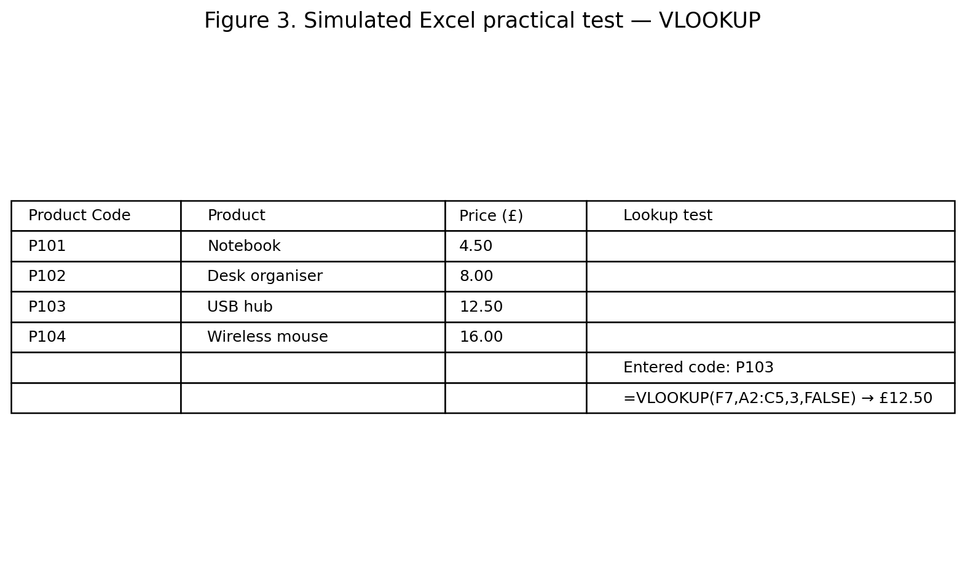
Figure 3. Simulated Excel practical test – VLOOKUP
This functionality can be used to increase productivity when a firm wants to pull information from a reference list on a recurring basis. For example, a product code may be used to automatically get a price, product description or category on an order processing spreadsheet.
One of the main disadvantages is that the standard VLOOKUP looks from the first column of the specified table and delivers data to the right. It can also cause errors if a code is missing or if the lookup range is not set up appropriately. Where available XLOOKUP may offer a more flexible alternative [13].

Task 4 – Communication and Collaboration Applications

4.1 Microsoft Teams as a Communication and Collaboration Tool
Microsoft Teams is a digital office tool that integrates chat, meetings, files and collaboration. Microsoft Teams was launched in 2016 as a chat-based workspace integrated with Office 365 and publicly available in 2017 [14], [15]. Teams includes persistent and threaded chat, private chats, channels, audio and video meetings and connectivity with Microsoft 365 apps. These functionalities allow to associate work discussions and business content in a common environment [14]. Teams can be used as a communication tool to reduce isolated email exchanges. Channels are great for staff to talk about project topics, chat is great for shorter conversations, helping keep information linked to the right work. Meetings can enable remote and hybrid working. Employees can work from home and use audio or video without being in the same location. Teams enables collaboration with shared files. Microsoft [16] states that files shared from OneDrive in Teams can be given rights such as edit, review or view. You can also access shared files from locations in channels and chats. This way you are left with one working copy instead of several email attachments with different versions. Teams also lets you link Office programs, so users can work together on familiar documents while staying in the collaboration space. This means less context switching between communication and productivity tools. Another benefit is the organization of projects. You can create separate teams and channels for different projects, departments or issues, which makes communication much more structured. Hence making teams more responsive as questions can be asked and answered in a common conversation. It also makes decisions and updates available to other team members that were not in the conversation. However, communication systems can result in information overload. If there are too many channels, notifications and conversations created without defined guidelines, employees might find it hard to identify the most relevant information. Teams also requires the right internet connectivity, organization setup and training of users. Improper rights management can lead to information security issues such as sharing confidential files to unauthorized audiences. Another disadvantage is not all features are consistent between desktop, web and mobile versions. Organizations therefore need to describe the workflows they enable and ensure staff understand the controls that apply. In general, Teams is very good for hybrid workplaces providing live conversation along with shared content and teamwork. The biggest advantage is that it can keep people, conversations and working materials in a connected digital workspace.

4.2 Practical Test 1 – Team Chat
A simulated project conversation was created to demonstrate persistent workplace chat. The participants are fictional roles rather than real employees. The purpose is to show how a project team can communicate an action, respond to it and coordinate the next step.
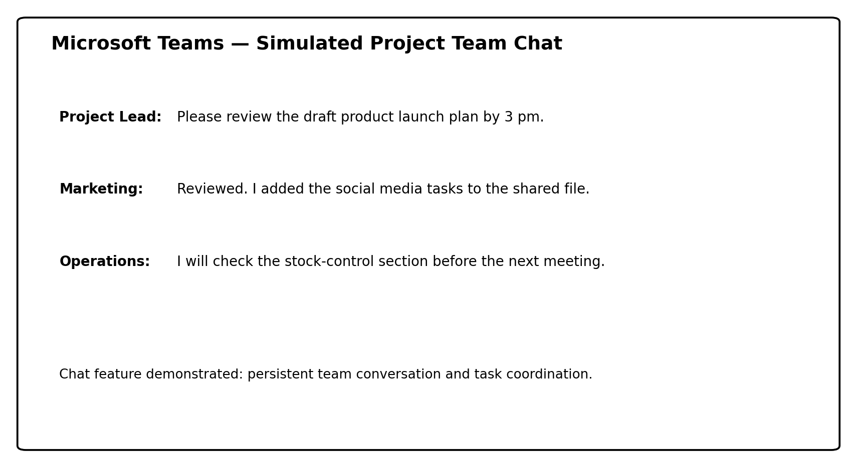
Figure 4. Simulated Microsoft Teams practical test – team chat
The screenshot demonstrates a simple communication sequence. The project lead requests a review, the marketing role confirms an update and the operations role accepts a related task. This demonstrates how chat can support coordination without using personal or sensitive information. In a real workplace, the same channel could be used for progress updates, questions, reminders and decisions.

4.3 Practical Test 2 – Shared File Collaboration
The second practical test demonstrates the shared-file capability of Teams. Three fictional files were assigned different permission levels: edit, review and view. Microsoft states that Teams can share files through OneDrive and allows permissions to be managed so that collaborators can edit, review or view content [16].
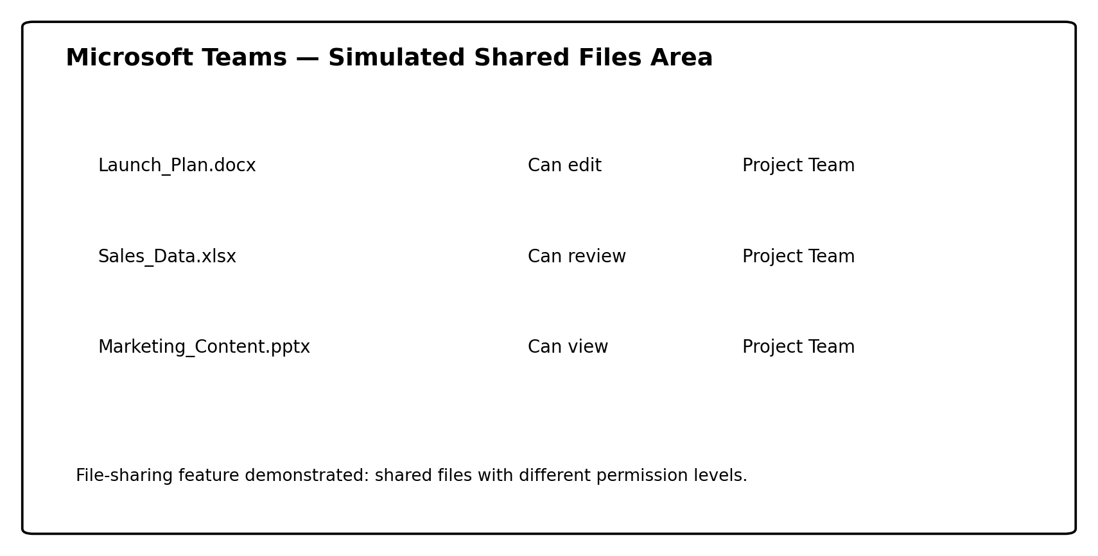
Figure 5. Simulated Microsoft Teams practical test – shared files and permissions
The practical value is version control and controlled collaboration. For example, the project team can allow a document owner to edit the launch plan, allow another employee to review a spreadsheet and give a stakeholder view-only access to a presentation. This reduces the need to email multiple file copies and can help protect documents from unintended changes.
The limitation is that permissions must be managed carefully. A user should receive only the level of access required for their role. File-sharing practices should therefore be supported by organisational policies for data protection, retention and access control.

Conclusion
The software examined in this report demonstrates how different applications can contribute to a technology-based workplace solution. Wix and WordPress.com can support the creation of an online presence, while mind mapping provides a visual method for planning and organising a business scenario. Word, PowerPoint and Access address different information needs: Word focuses on document production, PowerPoint on visual communication and Access on structured data management. Excel extends the analysis capability through functions such as IF and VLOOKUP. Finally, Microsoft Teams combines communication and collaboration by linking conversations, meetings and shared files.
The practical demonstrations show that software is most valuable when its features are connected to a business objective. The IF function converts raw values into a decision indicator, VLOOKUP retrieves reference information, a mind map converts a broad project into manageable branches, and Teams connects communication with shared work. At the same time, limitations such as platform dependency, data-quality problems, user training, scalability and access control must be considered. Effective workplace technology therefore depends not only on selecting applications, but also on establishing appropriate processes, permissions and user practices.

References
[1] Wix, “About Wix: Website Builder & Domain Registrar,” Wix, 2026. [Online]. Available: https://www.wix.com/about/us.
[2] Wix, “The Rise of Wix Studio,” Wix Press Room, 2024. [Online]. Available: https://www.wix.com/press-room/home/post/the-rise-of-wix-studio.
[3] WordPress.org, “History,” WordPress.org, 2026. [Online]. Available: https://wordpress.org/about/history/.
[4] WordPress.com, “Free Website Builder,” WordPress.com, 2026. [Online]. Available: https://wordpress.com/free/.
[5] Mind Tools, “Mind Maps,” Mind Tools, 2024. [Online]. Available: https://www.mindtools.com/ahlezc4/mind-maps/.
[6] Mind Tools, “Mind Mapping,” Mind Tools, 2025. [Online]. Available: https://www.mindtools.com/a2q80e8/mind-mapping/.
[7] Microsoft, “Word Help & Learning,” Microsoft Support, 2026. [Online]. Available: https://support.microsoft.com/en-us/word/.
[8] Microsoft, “PowerPoint Help & Learning,” Microsoft Support, 2026. [Online]. Available: https://support.microsoft.com/en-gb/powerpoint/powerpoint-help.
[9] Microsoft, “What is PowerPoint?,” Microsoft Support, 2026. [Online]. Available: https://support.microsoft.com/en-us/powerpoint/training/what-is-powerpoint.
[10] Microsoft, “Access Help & Learning,” Microsoft Support, 2026. [Online]. Available: https://support.microsoft.com/en-us/access/.
[11] Microsoft, “IF function,” Microsoft Support, 2026. [Online]. Available: https://support.microsoft.com/en-us/excel/functions/if-function.
[12] Microsoft, “Lookup and reference functions,” Microsoft Support, 2026. [Online]. Available: https://support.microsoft.com/en-us/excel/lookup-and-reference-functions-reference.
[13] Microsoft, “LOOKUP function,” Microsoft Support, 2026. [Online]. Available: https://support.microsoft.com/en-us/excel/functions/lookup-function.
[14] Microsoft, “Introducing Microsoft Teams—the chat-based workspace in Office 365,” Microsoft 365 Blog, 2016. [Online]. Available: https://www.microsoft.com/en-us/copilot/blog/2016/11/02/introducing-microsoft-teams-the-chat-based-workspace-in-office-365/.
[15] Microsoft, “Microsoft Teams rolls out to Office 365 customers worldwide,” Microsoft Source, Mar. 14, 2017. [Online]. Available: https://news.microsoft.com/source/2017/03/14/microsoft-teams-rolls-out-to-office-365-customers-worldwide/.
[16] Microsoft, “Collaborate on files in Microsoft Teams,” Microsoft Support, 2026. [Online]. Available: https://support.microsoft.com/en-us/teams/files/collaborate-on-files-in-microsoft-teams.

Appendix A – Practical Evidence Notes
The figures in this document are simulated practical evidence created for academic demonstration. The datasets, staff roles, file names and business scenario are fictional. They should not be presented as screenshots of a real employer system. If the module requires evidence of personally completed software activity, the student should reproduce the exercises in their own Microsoft Excel/Teams environment and replace the simulated figures with genuine screenshots from those sessions.
For Excel, the student should create the fictional data shown in Figures 2 and 3, enter the stated formulas and capture the worksheet and formula bar. For Teams, the student should use a non-sensitive test team or permitted educational workspace and capture the chat and file-sharing features. Any names, email addresses, customer data or employer information should be removed or replaced with fictional data before submission.

