Saba Humayan Essay –
MODULE ; ADAD5003
RESEARCH IN CONTEXT

Introduction;
My essay is about expressing my feelings and knowledge through my research and engagement with my practical study.
The aim of my essay is to demonstrate the body of the work I got and research which create the curiosity of their particular study.
It will also create the space for the body of the work though my life experience such as appropriate command of oral. Written work and other forms of communications.
The essay will demonstrate the life experience and challenges will also compare the artist work and my work which will shows the similarity and engagement with the materials of study also advantage and disadvantage.

The two artists photographer who I found them from Magnum photos.
Newsha Tavakolian and Peter van Agtmeal the famous artists photographers.
I choose to write about them because both of them have some similarity of work who documented the religious conflict and also worked in Iraq and others countries, they also documented other people life and how wars effected on them they both are multi award holder and their work been published in international magazines, newspapers also both are member with Magnum photos.

Chapter 1;
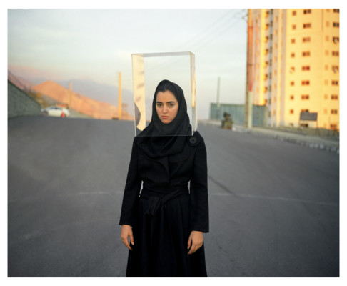

Newsha Tavakolian is a self-taught photographer known for her powerful work covering war in Iraq and social issues in Iran. she began other projects focusing on art using photography as well as social documentary. Tavakolian’s photographs became more artistic and involved social commentary.
she has photographed female gorilla fighter in Iraq Kurdistan. She also photographed famous singer about their lives and through the years her work been improved from photojournalism to photography art.
At the age of 16 she professionally starts working in the Iranian press for women’s daily press Zen. When she was 18 she was the youngest student to cover the 1999 uprising photographer which was the amazing movements for Tavakolian as a photographer.
Later on, she joined the New York based agency Polaris images.
Tavakolian start working internationally in 2013, covering the war in Iraq. She has covered many stories such as, natural disaster, religious conflict, and social documented stories in Iraq, Pakistan, Syria, Saudi, Arabia and Yemen. Her work also been published in many news like newspaper’s, international magazine and time magazines also get involved with projects and collect stories during covid 19.
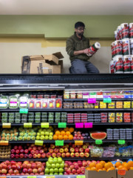

“Newsweek, Stern, Le Figaro, Colours, The New York Times, Der Spiegel, Le Monde, NRC Handelsblad, The New York Times Magazine and National Geographic. Commercial clients include Qatar foundation who commissioned her to make a book about education around the world and Shiseido, who commissioned a two-year assignment looking at the meaning of beauty in Paris, France” (copy)
Tavakolian work are photo stories of women, friends and neighbours in Iran; the evolving role of women in overcoming gender-based restrictions; and contrasting the stereotypes of western media.
“Her photo projects include Mother of Martyrs (2006), Women in the Axis of Evil (2006), The Day I Became a Woman (2010) and Look (2013)” and her work been exhibited and collected by the British museum where she was featured one of eight Iranian female photographers.
Tavakolian was finalist for the Inge Morath Award in 2007 for (GIRL POWER )
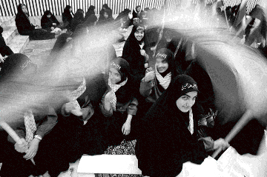
and in 2017 she become the nominee member for Magnum photos.
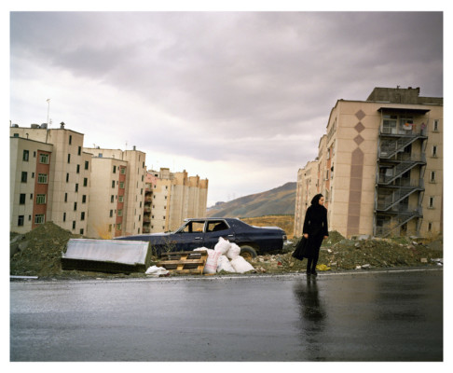

She then married to a Dutch journalist Thomas Edbrink
Chapter 2:
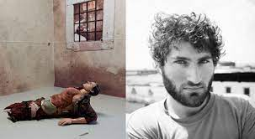
Peter Van Agtmael amriacn/dutch photographer based in New York. He studied history when he was 20 at Yale. After his graduating he start documenting America conflicts and continue his work. He also known for surreal images which explore theme of conflicts history, memory, nationalism, militarism, race and class.
Agtmael spent more then 10 years with America wars also with military wars in Iraq, Afghanistan to covered the civilian cost of wars. He also documented the Palestine/Israel conflict. He first visited Iraq in 2006 at age 24 and has returned to Iraq and Afghanistan a number of times, emedded with US military troops. Later he continued to investigate the effects of those wars within the US.
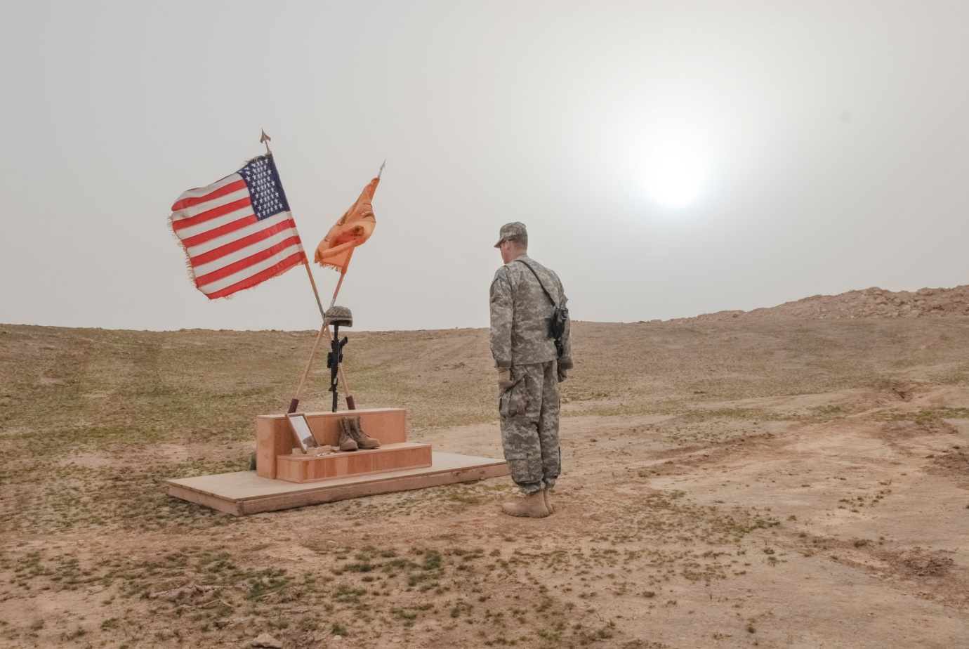
In 2007 his portfolio from Iraq and Afghanistan won the Monograph Award (softbound) in Photolucida's Critical Mass Book Award.

He published his first book called 2nd Tour, Hope I Don’t Die. Which was written between 2005 to 2008 about young jourlist how wars effected on him and on the soldiers and on the countries involved
In 2012 his 2nd book Disco Night Sept. 11, which "chronicles the lives of the soldiers he has met in the field and back home Iraq.
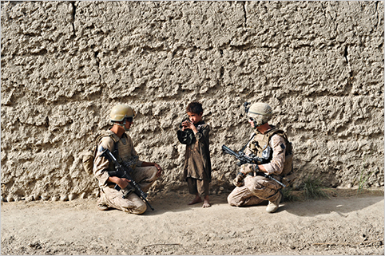

Agtmeal got offered few project which he photograph and his work been published in the newspapers and including times magazine.
“His work is held at International Center of Photography, Museum of Fine Arts Houston, Deutsche Börse, Photography Foundation and Yale University Art Gallery”

“He is the recipient of numerous awards, including the W. Eugene Smith Grant, the ICP Infinity Award for Young Photographer, the Lumix Freelens Award, the Aaron Siskind Grant, a Magnum Foundation Grant as well as awards from World Press Photo, American Photography Annual, POYi, The Pulitzer Center, The Center for Documentary Studies at Duke University, FOAM and Photo District News” (copy)
Agtmael joined Magnum Photos in 2008 and became a full member in 2013.
Chapter 3;
Newsha and Agtmael both photographers have worked for Iraqi wars and documented people life and how it affected their life,
Both photographers worked been published in the international magazines and been awarded from the worked they been doing for America wars and Iraqi conflict wars which they both collected the various storied of history, religious and civilisation.
Nawsha and Aftmael work has been developed over the years where people have recognised and gives views now more often in social media and their work is more demanding. both of them has established their career and settled in their life well and still continue to work as a photographer.
Chapter 4;
Their work has influenced me a lot by seeing different people from different background and working for America wars and Iraqi wars which shows the similarity of how passionate they are to work and documented other people life stories acknowledged the history of other countries.
I have taken a lot from this researched and found these photographers who really programmed well and into their life from the studied and experienced they got by working with different countries and documenting other people life stories.
I have also seen the same similarity from my life experience by working with different people and documented their life stories and how wars affected them especially from Newsha as she is a Muslim female photographer who started her early career as a journalist at the age of 16 and then studied for 6-month course in photographer to become a international photographer
This has shown the enthusiasms of her and also influenced other Muslim women by her work experienced and as a Muslim girl I have been influenced a lot from her life work experience which put extra potential to focus for my future and accomplished my dreams the way she has always managed to made her self ready for every challenge in her life.
However, both photographers are very well known and professional photographer who really set the ambitions for their life which most of the people been influenced from their work and how travelled all over the world and documented people life and work with them.in my opinion they really show the example of archiving dreams no matter how much struggles and conquers come into their life.

Conclusion ;

I have learnt a lot from these photographers and gain knowledge as they working in a wider place and conflict the wars, history, religion and race also they have balanced their personal life as well.
Also Seeing them working in a different a place and integrated with people shows the diversity they creating for other people and inspiring them by their photography skills and photo journalism.
I have also discovered from researching about them Is that both photographers started work at the early age and focus on their dreams to archive and today! they have established themselves.
In addition to that the research has really helped me to demonstrated my work into broad area as its clearly give me the chance to showcase my work through the degree course I am doing.
It has been a great success year 2023 to exhibit my group work for the project we did together and that has been showcase publicly. It gave me the 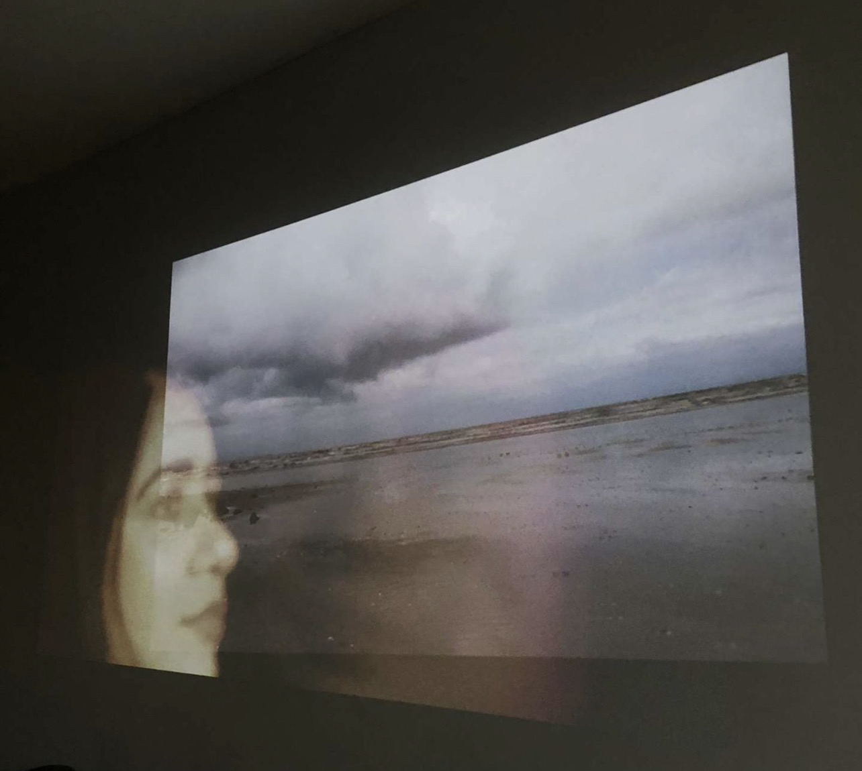
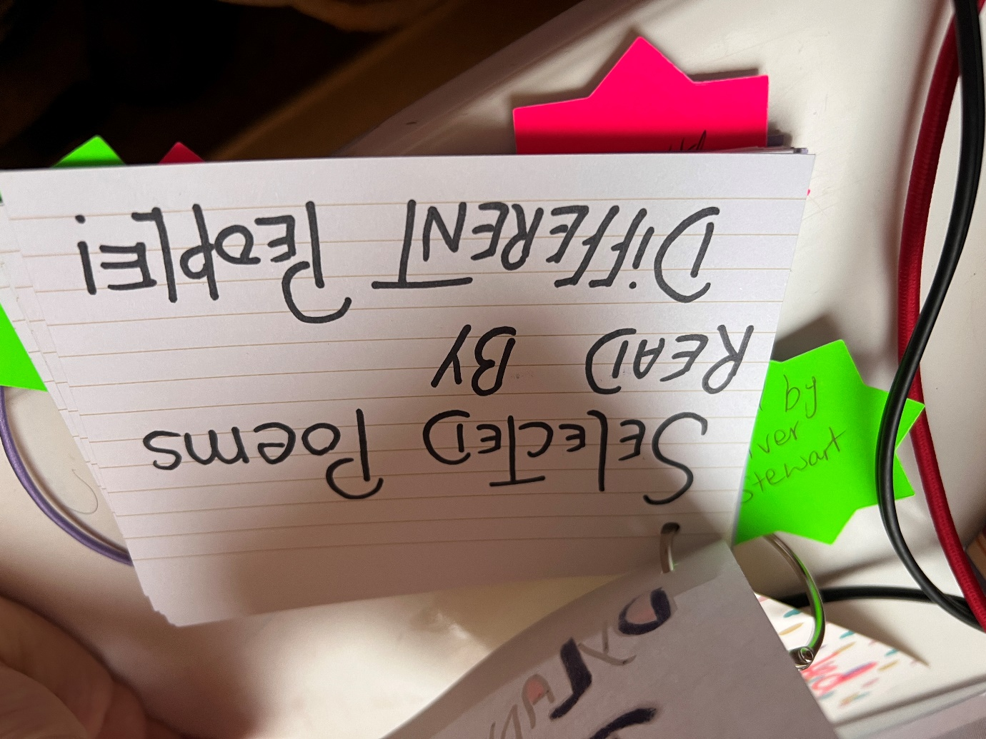
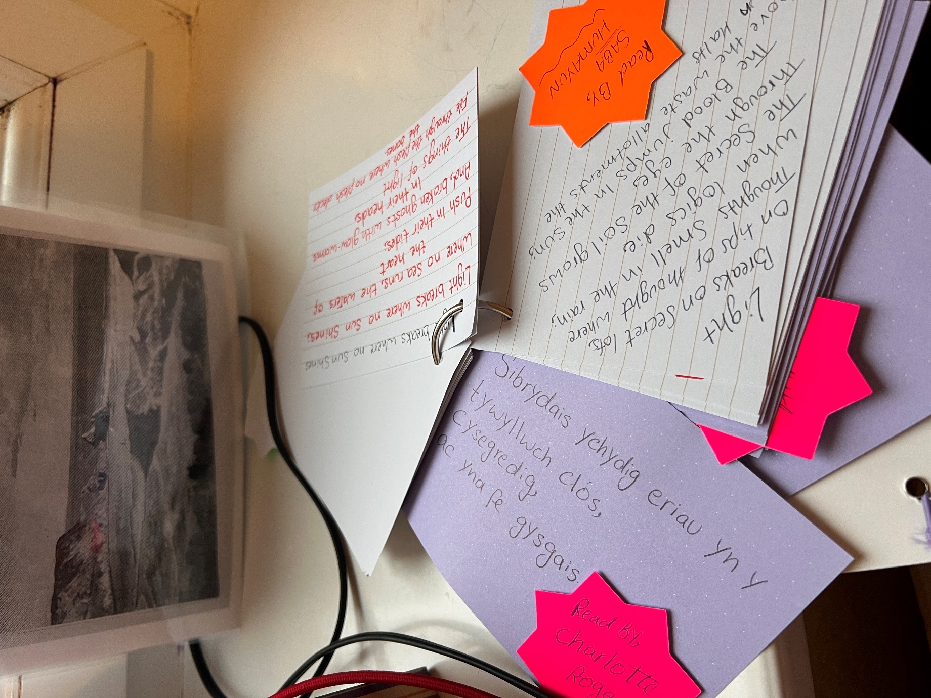
The exhibition developed my literature skills also cognitive and intellectual skills to managed the team work. It has given me the confidence to improve my knowledge and confidence to being able to engage with form of critical analysis arguments and debate.
To sum up with the I have really create the platform for my life through my degree and the experience I got and demonstrate intellectual curiosity through an engagement with the materials of individual study, that has empowered my body of the work into the wider place and archives a better understanding and communications for another work as well as to identify my research to find an artist and compare the life with them also to being able to see their success and achievements and follow my upcoming opportunities which will help in the future.

