UWTSD
Logistics company strategies for sustainability.
Cameron Rees
1900641
15th March 2020
Supply Chain Strategies (M5X01281)

Context Page
- Introduction
- Firm strategy
2a. Corporate Strategy
2b. Business unit strategy
2c. Functional strategy
- Evolution of manufacturing
3a. Mass Production
3b. Just-In-Time manufacturing
3c. Lean production
4. Role of Mass customisation supported by postponement.
5. Taxonomy of supply chain strategies
6. Conclusion
7. References

- Introduction

In this report I will be addressing and conducting an assignment based on the strategies used by logistic companies in order for them to achieve its sustainability. Firstly, I will be highlighting the role of logistics and supply chain strategy in the context of firm strategy and see how logistics and supply chain strategy can actually sometimes drive firm strategy. (Firm Strategy Business strategy can be defined as a firm's plan to generate economic profits based on lower cost, better quality, or new products.) Secondly, I will be outlining the transformation of manufacturing, from which various logistics and supply chain strategies have emerged. For example, Mass production (Mass production is the manufacturing of large quantities of standardised products, often using assembly lines or automation technology. Mass production is also referred to as flow production, repetitive flow production, series production, or serial production, lean production (which is the elimination of waste in a pull based value stream of activities with level production and just in time inventory management.) and mass customisation(Mass customisation is a marketing and manufacturing technique that combines the flexibility and personalization of custom-made products with the low unit costs associated with mass production. Other names for mass customization include made-to-order or built-to-order.) Next I will acknowledge both lean and agile logistics strategies (Agile logistics is the integration of manufacturing, transportation and information across the extended enterprise (i.e. the entire supply chain) to equip competitive advantage through real-time flexible response to unique and changing customer demands.) and the role of mass customisation supported by postponement (Postponement is a business strategy which maximizes possible benefit and minimizes risk by procrastinating further investment into a product or service until the last possible moment.) Finally, in this report I will also conduct a piece of work on the development of a taxonomy of a supply chain. A taxonomy is documented and systematic set of types, classifications, categorisations, or principles that are often accomplished through systems including but not limited to naming, defining or the grouping of attributes, and which basically help to define, differentiate, identify, organise, and provide contextual relationships between Logistic Items, Entities or Types. Using everything I have just wrote about I will investigate and give an answer on what strategies are used by logistics companies in order for them to achieve its sustainability.

- Firm Strategy

The first part of this report I will be highlighting the role of logistics and supply chain strategy in the context of firm strategy, and also see how logistics and supply chain strategies can actually drive firm strategy. A firm strategy business strategy can be defined as a firm's plan to generate economic profits based on lower cost, better quality, or new products. Strategy is all about planning. It is about developing a long-term plan, not just clearing up the daily problems and troubles that occur. In order for a firm to be successful they must have a good operation strategy which basically means the management of operations over the long term to accomplish business targets. It also, integrates all aspects of the operation, includes every level of management within the operations function and finally it will influence all areas including the supply chain. The supply chain strategy is a collective response to the demand by various firms working together to coordinate delivery of goods to the end customer which helps as they will not be limited to one functional area. In a firm strategy there are 3 main forms of strategies. These include Corporate strategy, business unit strategy and functional strategy.

2a) Corporate Strategy
The highest level of strategy out the 3 just mentioned is the corporate strategy. Corporate level strategy is concentrated on the whole scope of an organisation and how value can be improved to the business or organisation. There are 4 key aspects that a corporate strategy target they are:

- “Allocation of resources
- Organizational design
- Portfolio management (CFI, 2019)
- Strategic trade-offs”

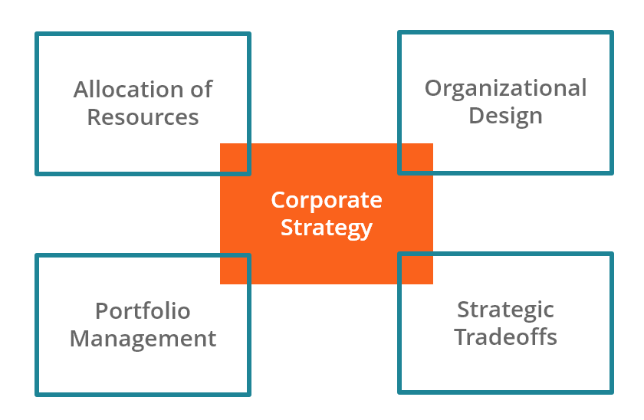

From the table above it shows the 4 aspects that a corporate strategy target. Firstly, People and capital are the two resources that the allocation of resources at a firm focus on. In order to maximise the value of the firm leaders and managers must decide correctly how to distribute these resources to various businesses. When allocating people, it is vital that the right skilled people are in the right place to work to match their capabilities in order to thrive in that part of the firm. Secondly, organisational designs involve making sure in order to create the maximum amount of value it is crucial the firm has the fundamental corporate structure and related systems in place. There are two key factors to think about when it comes to organisational design, they include the head office and the organisational structure. Firstly, at the head office it is the decision of how much independence to give to business units and also deciding if decisions are made at the top end (top-down) of the busines or bottom – up end of the business. The second the key factor which is organisational structure will determine how big initiatives and responsibilities will be divided into smaller projects. Separating responsibilities will allow the balance between risk and return to exist. Finally, it will also determine the right appointment of authority. Portfolio management will ultimately determine what businesses or organisations will or will not enter their own business. It looks at the ways business units complement each other and their correlations. There are several ways cooperate strategy can relate to portfolio management such as the decision of what businesses to be a part of the business or not, secondly, it can determine the amount of vertical integration the firm should have and finally, if appropriate opportunities that could be invested enormously occur it can make new strategic options. The fourth and final pillar of what makes a cooperate strategy is strategic trade-offs. In my opinion balancing the trade-offs between risk and return over the firm is one of the most challenging parts of corporate strategy. There are 3 main factors to think about when it comes to strategic trade-offs, they are managing the risk, generating returns and finally incentives.

2b) Business Unit Strategies
The second out of the three forms of strategy are business unit strategies. A business unit strategy can also be known as “business unit level strategies” (Olsen, 2018) due to them being applied at the business unit level. In order to achieve a product or service much greater than your competitors you must regularly execute a business wide strategy or a strategy that consistently shows you have created value. Two out of many advantages of a strategic business unit structure include “That it allows the parent company to avoid competitive convergence” and also “it offers financial benefits” (Brandon Gaille, 2018). Firstly, when talking about avoiding competitive convergence due to speed being a problem you tend to find parent businesses who do not have SBU Structures in order for them to find success they would replicate what their competition is doing. Due to this it has made it difficult to differentiate one company from another due to the creation of market convergence in some industries. The benefit of having SBUs can thrive as they would have established brand expertise, a developed unique identity and finally the ability to embrace more creativity. The second and final advantage I would like to talk about is how SBUs offer financial benefits. SBUs benefit as there is a better chance of profitability, this is due to demographics and markets being targeted by subunits of a company which are able to establish their own value propositions. This is because each subunit runs on a budget that is based on their specific needs which allows the parent companies to have control over their future due to them enhancing their ability.

2c) Functional Strategy
The third and final strategy is the functional strategy. A functional strategy is anxious with how components of an organisation deliver effectively the corporate and business level strategies in terms of resources processes and people i.e., IT strategies or Market strategies. Functional strategies are commonly a “complex of several operational level plans”(Wozniak, no date) This allows functional strategies to then concentrate on a single functional area where employees and resources can be expertly assigned to the roles about which they have the most intelligence and experience. This then allows employees to feel worthy as their abilities are being used effectively.

- Evolution of manufacturing

Even though there are artisans that exist today the evolution of manufacturing has been evolving over centuries. Dramatic changes have been issued in terms of techniques applied to produce products due to the advert of mechanisation, mass production, technological advances, and the emphasis on cost reduction. The impact shown by the industrial revolution on manufacturing was dramatic. Due to the arrival of the 18th century industrial revolution, manufacturing processes changed. Machinery had been brought in to manufacture items instead of items being hand made. Due to the installation of machinery, agriculture, mining, textiles, and glassmaking faced big changes in their industries. For example, in the textile industry due to machinery such as the spinning wheel and sewing machines being used, this meant that goods and products were being made in half the time and would cost a fraction of the price when they used to hand spin wool for textiles.

3a) Mass Production
The next part of the evolution of manufacturing was how to produce a system that would allow standardised products to be produced on a huge scale by companies, and this is how the term mass production found its identity. Assembly line techniques were crucial in the involvement of producing multiple versions of a product in the late 19th century and this is truly how the way of working really took off. Due to this technique being applied identical goods were being produced for an exceptionally low price and also the end result produced amazingly fast turnaround times.

3b) Just-in-time manufacturing
Just in time production is also referred to “Toyota production system”(Cut, 2015)where it was founded by the Japanese in the 1960s and 1970s. The main reason for this system was to cut out the 7 wastes by producing a business model that did not hold stock but ordered deliveries of raw components and resources whenever they were needed. The 7 wastes include, over production, waiting time, process, transport, motion, inventory, and finally defective goods. In terms of warehouse space businesses and organisations were able to see a big increase in cost savings. There was a decrease in overproduction as companies were now only buying when they needed to so this caused a waste decrease, inventory costs decreased and finally the efficiency increased. This popular system was introduced by western industry in the 1980s and it is still popular as many manufacturing organisations use this system in today’s world. This system proved popular because the old “Just in case” strategy was removed as companies would store large inventories in case, they received a surplus of orders.

3c) Lean Production
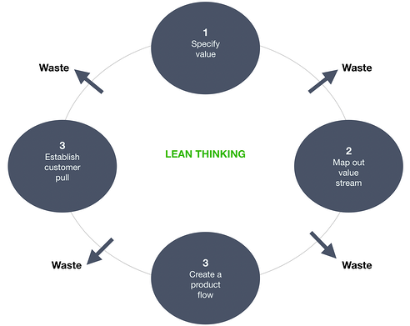
Businesses in the west in the 1990s first took on this lean manufacturing method by concentrating on anything that increased value to the production process and reducing back on anything that seemed superfluous. In order to improve the quality of the service provided, fine cut adopted the lean manufacturing process to its processes. For this to take place and for the final product to be improved they eliminated every activity that absorbs unnecessary material or takes up time that does not increase value. Due to this time of inactivity, excessive transportation, processing, and irrelevant inventory and overproduction is eliminated. In the manufacturing mechanism timing is key. The procedures that are undertaken are closely monitored to check how long the process takes to complete and in order to make it more efficient they are streamlined. To meet the demands of the customers, consumption is kept to a minimum and materials are not stored and manufactured needlessly.

When it comes to lean production there are 4 key principles of lean logistics. They are “Specifying Value, Mapping out value stream, creating a product flow and finally, establishing customer pull”.(Fredrik Ramstad, 2019)
The first principle specifying value means that the value and identity of a customer will be added along the supply chain system. Secondly mapping out a value stream allows to you to see gaps in your process. Due to seeing he gaps you can have broader scope of the picture and see excessive inventory. Restrains and also where the delays are. From the customers vision you can understand how value is made into a product. Creating a product flow will run efficiently at the customers whilst reducing interruptions inventories and down time id the factors I mentioned above are applied and making the value creating steps to occur in tight sequence. Finally establishing customer pull
Is like I mentioned before with the just in time system where it only supplies goods to customers when they need it instead of building up stock. In order for the pull system to be required demand information must be available throughout the supply chain.

- Role of Mass customisation supported by postponement.

A marketing and process technique that interacts both flexibility and personalisation of custom-made products that has low unit costs is called mass production. Postponement can be defined as the delaying of one or more final steps in the manufacturing process until the product has been bought. This helps businesses reduce their costs by gaining the last expensive step of customisation until the end and after a purchase has been made.

The term “Leagile”(Can, 2012) is the term that cements the relationship between mass customisation and postponement. Leagile is the combination of the Lean and agile paradigms within a supply chain strategy by positioning the decoupling point as to best suit the need for responding to a volatile demand downstream yet providing level scheduling. upstream from the marketplace. Mass customisation is shown in Leagile as the lean part of Leagile shows the mass part of mass customisation and the agile bit of Leagile shows the customisation part of mass customization. A vital approach to the attainment of agility can be identified as postponement. Postponements efforts to customisation of goods and services can be shown by the use of customer information, through the supply chain and also cross functional. It is especially important that postponement is part of any agile strategy. The success of mass customisation strategy is purely based on both efficiency and responsiveness as mass customisation requires leagile supply chain. Also, efficiency and responsiveness are both contributed by postponement Therefore it is clear that postponement contributes to the leagile supply chain of mass customisation.

- Taxonomy of supply chain strategies
A taxonomy is a documented and organised set of “types, classifications, categorisations and/or principles”(IF4IT, 2009) that are usually accomplished through systems that include but not limited to naming, defining and the gathering of attributes. These fundamentally help to describe, separate, identify sort and give contextual relationships between logistic items entities or types.
An example of a taxonomy for selecting global supply chain strategies would be:
Supply demand characteristics | Resulting pipelines
Short lead time & predictable demand | Lean, continuous replenishment
Short lead time & unpredictable demand | Agile, quick response
Long lead time & predictable demand | Lean, planning and execution
Long lean time & unpredictable demand | Leagile production/logistics postponement

- Conclusion
In Conclusion, from writing this report about logistics company strategies for sustainability I believe that the world of logistics looks very bright for the future as from my research and my report I have seen evidence of this as firstly if a company as a good firm strategy they will be successful as they will have included a corporate strategy, business unit strategy and also a functional strategy. Next, in my report I discussed the evolution of manufacturing. In my opinion I think it is obvious that manufacturing has come along way since the birth of manufacturing as strategies have devolved immensely due to the introduction of mass production, just in time manufacturing, mass customisation and most importantly lean production. With all these implemented in a business the business will have the 7 Rs which include:
- Right product
- Right quantity
- Right condition
- Right place
- Right time
- Right customer
- Right price
Finally, a taxonomy is greatly affective as you can see where you have gone wrong in your business and you can just mend the issue in order for your business to be successful. To conclude, after finishing this report and research I believe that the strategies used by logistic companies today are sustainable.

- References

Brandon Gaille (2018) 10 Strategic Business Unit Structure Advantages and Disadvantages, BrandonGaille.com. Available at: https://brandongaille.com/10-strategic-business-unit-structure-advantages-and-disadvantages/ (Accessed: 14 March 2021).
Can, K. C. (2012) ‘Postponement, Mass Customization, Modularization and Customer Order Decoupling Point: Building the Model of Relationships’, p. 81.
CFI (2019) Corporate Strategy - Learn the 4 Pillars of Corporate Strategy, Corporate Finance Institute. Available at: https://corporatefinanceinstitute.com/resources/knowledge/strategy/corporate-strategy/ (Accessed: 11 March 2021).
Cut, F. (2015) The evolution of manufacturing techniques (A guide to how manufacturing techniques have evolved over time) - Guides - Insights - FineCut. Available at: https://www.finecut.co.uk/insights/guides/the-evolution-of-manufacturing-techniques-a-guide-to-how-manufacturing-techniques-have-evolved-over-time (Accessed: 15 March 2021).
Fredrik Ramstad, K. (2019) What is Lean Logistics? Available at: https://www.mixmove.io/blog/what-is-lean-logistics (Accessed: 15 March 2021).
IF4IT (2009) Logistics Taxonomy. Available at: https://www.if4it.com/SYNTHESIZED/GLOSSARY/L/Logistics_Taxonomy.html (Accessed: 15 March 2021).
Olsen, E. (2018) ‘Business Unit Level Strategies: Choosing Your Leading Strategic Focus’, dummies, 12 March. Available at: https://www.dummies.com/business/business-strategy/business-unit-level-strategies-choosing-your-leading-strategic-focus/ (Accessed: 14 March 2021).
Wozniak, K. (no date) Functional strategy, CEOpedia | Management online. Available at: https://ceopedia.org/index.php/Functional_strategy (Accessed: 14 March 2021).

