Developing Relationships and Workplace Achievements(BMSW5102)
University of Wales Trinity Saint David London
Student name:Monica Cernat 191391
Lecturer name:Molly Jack

Executive Summary
The report is focused on the development of the need and expectation of employees within River Island. The company is one of the leading stalwart in the UK market that deals in fashion products. Clothing and apparels constitute the primary port-folio for the brand. The brand was founded in 1948 by Bernard Lewis and is headquartered in London. Will Kernan is the standing CEO of River Island since September 2019.

Table of Contents
Introduction 4
a) Evaluation of the development vehicles available in River Island and the appropriate in meeting the development needs of the company. 5
b) Plan to meet the identified development needs and expectations of an individual 9
Smart goals 9
Strategies to implement the employee development plan 10
Action Plan and recommendation 13
Conclusion 15
References 16

Introduction
The developing of the relationship in the workplace increases the work efficiency in the organisation. The organisation that will be chosen for the report is River Island. The academic models, method and theories will be elaborated in this report. The critical evaluation of the vehicles used for development within the organisation will be presented in the report. The appropriate meeting in development need will also be portrayed in this report. Various human resource theories will also be presented in this report. A case study will also be presented regarding the development vehicles of River Island and appropriate ways of meeting the development needs.
Background of the organisation
River Island is a clothing company which have large networks in the global market. The annual revenue of this organisation is 87.77 crores in GBP as of December 2018. This brand is famous for its stylish fashion, and the price of the products is very affordable. They are known for their unique creativity that helps the company to stand out from the existing market. Therefore, it helps them to attract many customers. The most positive thing about this company is, they aim to bring the latest fashion and great designs to their customers. In this report, different types of training and coaching are shown, as development method and benefits.

a) Evaluation of the development vehicles available in River Island and the appropriate in meeting the development needs of the company.
There are various development vehicles followed by the company to improve the potential working of the company. River Island follows various development vehicles that help in maintaining a proper organisational culture and efficiency in workability (Olenski, 2015). The organisation follows various development vehicles such as-
Training- The organisation performs proper training in order to enhance the workability of the employees. The development of work efficiency will develop the quality of work in the organisation and maintain good work efficiency (Peebles, 2020). This will increase the sales and development of the organisation River Island. Various training sessions are provided by the organisation to enhance the performance of the employees.
Training methods of an organisation generally include different types of videos, podcasts and assignments based on groups or an individual. Both formal and informal approach to ability development includes in the training program of an organisation. Formal approaches are classroom centred training, online learning courses. Informal approaches are self-directed learning, seeing the educational blog and watching videos on YouTube (R, 2020). All this training program helps the employees to enhance their skills set that each and every employee need to develop. This helps to increase the productivity of the River Island Company and also meet the expectation of an individual. Training also helps the employees to obtain a new set of skills, polish their performance, increase their productivity and be a great leader in the organisation.
The advantage of training is, training act as an opportunity to find the weakness of an employee, and this makes an employee more effective and productive in their work. Training also provides a framework that helps to upgrade the strengths of an employee. It also helps to strengthen the morale and job pleasure, which helps an employee to accomplish according to an organisation wants and expectation. The most vital reason for increased competitiveness in society is creativity and the advancement of technology. For this, corporate training helps the employees to have the necessary skills to have knowledge on innovation, which enhances their work progress. An important and primary part of a training program is, training on soft skills, this benefits an employee to have improved communication and other characteristics of an industry. Several studies prove that training of an employee helps to boost up their retention rate, which benefits the River Island Company to have a skilled workforce.
The types of training that the River Island Company can follow are:
1.The training program on retail sales- This training program helps an employee to boost up the performance of sales. This program educates them on the ways in which they can improve their trade's score result. These days there is the availability of many online training programs related to sales that provide productive tools and techniques. That helps an employee to enhances their trade’s score and sales performance (Barlow, 2021). Therefore, it helps the River Island Company to increase their revenue and profitability of their organisation.
2. Training for customer service- This training emphasis enhancing the experience and satisfaction of the customers. The customer service training includes the teaching of skills set and recognise areas that require improvement. By giving this customer service training helps the employees to develop in their careers and also enhancing their service to the customers. That ultimately can help the employees to improve satisfaction and trust of the customer and to gain a new set of skills and a better thought of the business(Tracey, 2018). Using this training, the productivity of the River Island company get increased.
3. Training on leadership skills- Training allows a chance for retail workforces to develop skills set on leadership. Leaders of an organisation help to sets the strategic goals, motivating employees to work more efficiently. The set of skills are the capability to make a tough decision, the capability to influence people to follow the employee's order, the skill to increase the trust of others and at last, the capability to stay confident in tough situations. This helps the River Island company to generate more revenue and also helps the employees to develop their interpersonal skills (Barlow, 2021).

Coaching- The process of coaching aims in providing improvements towards the performance of the employees. A coach performs various activities and helps the individual to improve their performance. Workplace coaching is performed in River Island, and the coach applies various tools and equipment to gain ad enhance skills and knowledge about the work and the workplace (Barlow, 2021). Efficient coaching improves the resiliency of the organisation and helps in maintaining effective change in the performance to enhance the performance (Craig, 2017).
The varieties of coaching that the River Island Company can follow are:
1.Coaching on Executive leadership- This is the most important coaching that helps to nourish the performance of the employees and also assist the employees in making essential transitions. This training helps the employees to boost up their performance and increase their level of commitment (Olenski, 2015).
2.Coaching on Integration- Reinforcing the latest skills and strategies are the teachings of integrated Coaching. The employees learn the ways to try new actions in the workplace of an organisation. For this reason, the employees learn to create new and justifiable habits. This way, employees develop to make their own decisions about maintaining the performance of an organisation.
3.Coaching on teamwork- Teamwork coaching teaches the employees to work effectively along with teams. This teaching includes different types of methodologies for the purpose to create good interactions with the teammates. Thus, help the employees to interact more efficiently with their teams.

The River Island is a leading company of fashion brands, which runs in the worldwide market. As the employee act as a backbone of an organisation. The organisation must look after the needs and expectations of its employees. This helps the River Island Company to generate more revenue and also help to increase profits. They must provide online learning to the employees, which allow them to get access from everywhere at any time. Some studies have done where it is proven that online learning generally requires 40 to 60 per cent less time of an employee than in an old-fashioned classroom (Athmika, 2021). Online learning also helps the employees to complete any courses from their comfortable place. River Island Company must conduct training to improve the employee’s communication skills, interpersonal skills, capability to make their own decisions and problem-solving skills. Thus, these are the relevant development needs River Island Company must lookout.

b) Plan to meet the identified development needs and expectations of an individual
Smart goals need to be identified at the beginning of any developmental plan as they would be the definite objectives to be achieved. The acronym basically stands for specific, measurable, attainable, relevant and timely (Neill, 2019).
River Island may start with setting up the smart goals at first for their employee development plan in the following method.
Specific: The aim cannot be ambiguous. There is a need to be very particular about the objective, and it should be absolutely clear to all in the organisation. For example, River Island should conduct 5-week onboarding training for new hires that should make them efficient in their roles.
Measurable: The goal has to be analysed through parameters to examine the defined method that is being used to achieve the goal. For instance, River Island can measure their goal by using LMS reports, survey reviews and feedback.
Achievable: This stage focuses on the resources available and the tools needed to make the goal achievable. The goals set should be achievable. The focus has to be on training and how the goals should be exactly achieved.
Relevant: The new hire onboarding training is relevant to River Island as they have a huge employee turnover rate annually. There is also a need for adequate training for the employees as product knowledge and skill set is important to acquire for all.
Timely: Setting up mini-goals for each department is important here to identify and complete the goal within the due date. The approach needs to be realistic for the goal to be achievable within the set time frame. Implementing LMS and creating training materials for all new hires should be helpful (Neill, 2019).

Strategies to implement the employee development plan
Strategy 1
River Island can make use of Democratic Leadership as a strategy to enhance employee development. Democratic leadership focuses on the equal rights of the employees and the leader when it comes to decision making. This makes the employees' feel empowered, which boosts the team morale, resulting in better productivity and higher contributions from team members (Beerbohm, 2015).
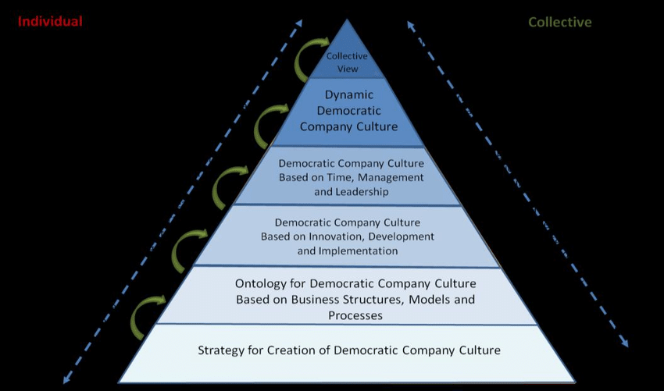
Dynamic Democratic Company Culture
Source: (Markopoulos, 2014)

Advantages and characteristics of democratic leadership
1) All the members of the group are allowed to suggest their own ideas and opinions for employee development. However, the leader can modify them and include relevant ideas before taking the final decision along with the team.
2) The employees of River Island will feel involved in the process of decision making. This will enhance their will to perform better as they realise their rights of authority.
3) The process also involves rewarding employees from time to time for their creativity.
4) More ideologies and solutions can be achieved through the process as fashion keeps on evolving constantly, and River Island will be able to come up with innovation in due time (Cherry, 2020).
5) The team not only focuses on individual targets, but they also become concerned about the final result in the end in alignment with the company's objective.
Enhanced knowledge and intelligence of employees, creativity at work as employees can speak freely, and fairness to all employees shall be observed at the end by the management of River Island.
Strategy 2
Motivation can be one of the most influential strategies to frame up employee behaviour in order to develop an employee development plan. It induces enthusiasm, commitment and focuses in an employee in order to achieve specific goals for self-development. Maslow’s Hierarchy of Needs is one of those strategies that River Island can apply to bring about employee developments.
The Theory states five categories of human needs in a specific order forming a pyramid that impacts the behaviour of an individual (Lester, 2013).
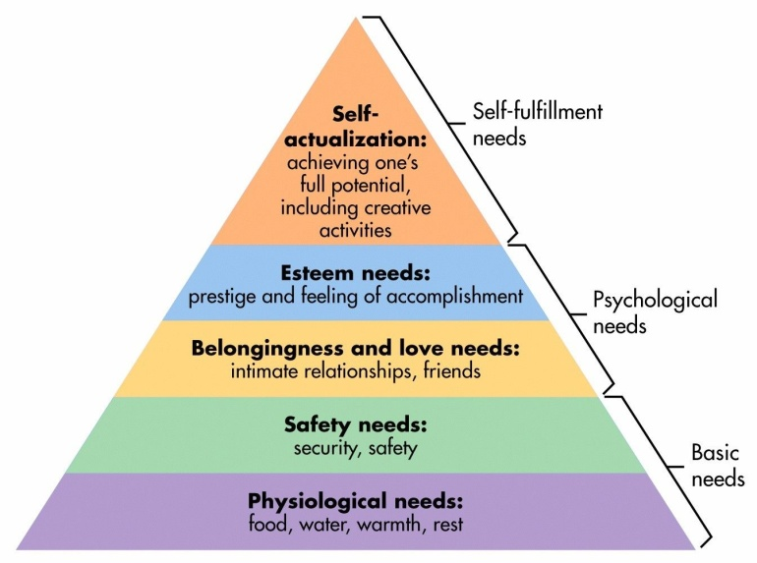
Maslow’s Hierarchy of Needs
Source: (McLeod, 2020)
Physiological – The primary and the most basic need comprises of food, shelter, rest, clothing, water and good health. River Island shall make sufficient efforts in terms of salary and remuneration to make sure that their employees are able to achieve all these needs in their lives.
Safety – An employee is always concerned about their safety and security both inside and outside the organisation. Appropriate security and safety measure shall be demonstrated by River Island to ensure that an employee is protected from violence and theft at the workplace. Installation of security cameras and fire extinguishers would make an employee feel contended. Alongside, HR authorities should also keep a check on an individual's emotional state of well being, health and financial security (MasterClass, 2020).
Love and Belonging – Inside the organisation, River Island HR management shall include enough recreational and employee-centric activities from time to time so that each employee feels cared for. There should be an element of belongingness that should reside in the employees of the organisation. Team outings and random huddle activities shall make socialisation easier.
Esteem – Respect and appreciation from co-members and management should be in regular practice if an employee has finished a task adequately. Any employee of River Island would love to get recognised and valued for a job they have carried out well. This helps in personal growth and boosts the self-esteem of employees.
Self-actualisation – These are all related to hobbies and other activities that an individual is associated with so that they feel their potentiality at its peak. Cooking, travelling, gardening and such other activities might help here. Employees should get time to assess their self-actualisation needs.

Action Plan and recommendation
A plan of action is basically a systematic approach to categorically analyse and evaluate the objective that is to be achieved. Data analysis is also a parameter in an action plan if the process demands so (Strategy and Plan, 2017). An action plan might include cross-training for employees within River Island.
An example for conducting the above training assessment has been illustrated below.
Name | Assessment Parameter | Time Period | Submission on date
Employee ‘A’ | Cross-Training | 12 weeks | _______________

River Island, as a fashion organisation, must realise the importance of innovation in their field. New and creative ideas need a lot of brainstorming for employees, and there should also be the right amount of fresh air available to the employees to churn their creativeness. The salary and perks, reward system, appraisals, leave policy, and medical allowances should be well revised. These factors are highly influential for an employee to feel energised and interested in carrying out their part of work for the organisation with more efforts.

Conclusion
Development is a basic need for any organisation to keep up with the pace at which the demands of human beings are changing daily. Organisations like River Island shall thus be focusing on internal developments. Employee development is thus a major concern for them so that as a result, employees feel enthusiastic about work which will result in better overall productivity. Proper evaluation of the development vehicles available at River Island has been illustrated in this report. These development vehicles have been further analysed to demonstrate how they can be appropriate to achieve the development needs of an employee. The evaluation is further supported with appropriate plans and strategies that would help to identify these needs and expectations of an employee at River Island.

References
Books & Journals
Beerbohm, E., 2015. Is Democratic Leadership Possible?. American Political Science Review, pp.639-652.
Craig, R.L., 2017. Training and Development Handbook.
Lester, D., 2013. Measuring Maslow's hierarchy of needs. Psychological reports, 113(1), pp.15-17.
Strategy, T.B.I. and Plan, A., 2017. 2021. Wellington: Accident Compensation Corporation.
Tracey, W.R., 2018. Designing training and development systems. AMACOM, Division of American Management Association, 135 West 50th Street, New York, NY 10020.
Website References

Athmika, 2021. The Importance of Online Training: 5 Benefits For Your Employees. [Online]
Available at: https://blog.commlabindia.com/elearning-design/online-training-benefits-for-employees
Barlow, A.-M., 2021. What is coaching?. [Online]
Available at: https://www.imeche.org/news/news-article/what-is-coaching
[Accessed 22 3 2021].
Cherry, K., 2020. The Democratic Style of Leadership. [Online]
Available at: https://www.verywellmind.com/what-is-democratic-leadership-2795315#:~:text=Democratic%20leadership%2C%20also%20known%20as,businesses%20to%20schools%20to%20government.
Markopoulos, E., 2014. Dynamic Democratic Company Culture Co Evolutionary Method. [Online]
Available at: https://www.researchgate.net/figure/Dynamic-Democratic-Company-Culture-Co-Evolutionary-Method_fig5_311708912
MasterClass, 2020. A Guide to the 5 Levels of Maslow’s Hierarchy of Needs. [Online]
Available at: https://www.masterclass.com/articles/a-guide-to-the-5-levels-of-maslows-hierarchy-of-needs#what-is-maslows-hierarchy-of-needs
McLeod, D. S., 2020. Maslow's Hierarchy of Needs. [Online]
Available at: https://www.simplypsychology.org/maslow.html#gsc.tab=0
Neill, E. O., 2019. Setting Up SMART Employee Development Goals To Increase Productivity. [Online]
Available at: https://elearningindustry.com/smart-employee-development-goals-increase-productivity
Olenski, S., 2015. 8 Key Tactics For Developing Employees. [Online]
Available at: https://www.forbes.com/sites/steveolenski/2015/07/20/8-key-tactics-for-developing-employees/?sh=5e9214df6373
[Accessed 22 3 2021].
Peebles, J., 2020. what is training management?. [Online]
Available at: https://info.getadministrate.com/blog/what-is-training-management
[Accessed 22 3 2021].
R, K., 2020. businessmanagementideas. [Online]
Available at: https://www.businessmanagementideas.com/employee-training/importance-of-training-in-an-organisation/2151

