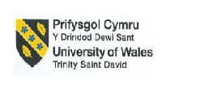
Module Name: Sustainable Hospitality & Tourism Management
Assignment Name: Report
The future of hospitality and is it profitable to be green
Student Name: Liliana Petrache
Student ID: 2025333
Lecturer: Kathryn Roberts
Table of Contents
Introduction 3
Conventional belief in measuring Performance in the Hospitality Industry 4
Changing Beliefs in the Hospitality Industry 5
Current Market Condition of the Hospitality Industry 7
Measuring the performance of the hospitality Industry using the Triple-Bottom Line 8
The future of hospitality and is it profitable to be green 12
Conclusion 13
References 14
List of Figures
Figure 1- Statistical results for how many people believe in sustainable travel 6
Figure 2- Triple Bottom Line theory 9
Figure 3- Butler’s tourism area life cycle 10
Figure 4- Doxy’s Irridex model 11

Introduction
Sustainability can be defined as a concept which promotes the idea of meeting the current demand without hampering the ability of meeting future needs. The hospitality industry is not new and the existence of this industry can be traced back to 15,000 BC (Hollander, 2022). Since then, the industry has changed itself enormous times according to the demand and various factors inside and outside the industry. Similarly, in the 21st century, the hospitality industry is going through some major changes. One of the major changes the hospitality industry is currently witnessing is in the demand of consumers. Today, consumer demands have shifted towards sustainable products and services and consumers are keen to buy those products and services which are environmentally friendly. Thus, today this industry is trying to figure out the future of the hospitality industry and whether it is profitable to be green. This report will look into the conventional beliefs of measuring performance and changing beliefs in this industry. The report will further discuss how the triple bottom line is essential to measure the performance of the industry in this changing environment. In the end, the report will suggest what the industry can do to become truly green and become more sustainable.

Conventional belief in measuring Performance in the Hospitality Industry
The Industrial Revolution in the late 18th century was an event in human history which changed the whole concept of economic activity and created a belief that businesses are established to generate profits (Desoutter Industrial Tools, 2023). Since then, businesses and organisations focused on increasing productivity and started taking measures to monitor the efficiency of their operations. The following years helped in developing this belief as a common concept of success among the business fraternity and various scholars from the 20th century developed management theories which were solely focused on increasing the efficiency and productivity of the company (Benard Marr & Co, 2023). Those were times when increased production and efficiency were used to help companies earn more money. Thus, as the revolution increased the cash circulation in the world economy the hospitality industry which was still growing during the 20th century felt the impact of this major change. It was the year 1950 when this industry became an organised sector and rich people started seeing this sector as a major source of investment (SOEG, 2023). These investments were solely driven by the motive of profit generation. Great economists of the world over a long period of time believed that profit generation is the only scale on which the success of a business can be measured. Even Milton Friedman a great American economist and scholar in his comment highlighted that the only social responsibility of an organisation is to generate profit. This shows that the conventional measure of success in the hospitality industry was based on profit generation.

Changing Beliefs in the Hospitality Industry
Today the world is going through a crisis of climate change. Unregulated human activities have raised serious questions about the survival of the human race. At this time when every human is facing the consequences of unregulated human activities, the business community is witnessing a serious change in the needs and wants of customers. This shift in the customers' preferences is also visible among the customers of the hospitality industry as 81% of tourist in the world believes that sustainable tourism is important (Statista, 2022). In recent years when the hospitality industry has witnessed the increased demand for sustainable practices in their operations, the conventional belief of success has lost its effectiveness. The UK which has one of the most developed hospitality industries in the world has seen a remarkable increase in demand for sustainable tourism. In the year 2022, the market of sustainable tourism generated a total revenue of £ 7.32 billion (Global Data, 2023). Whereas, worldwide the market size of sustainable tourism in the year 2022 was £ 139.81 billion (Statista, 2023). These data support the idea that today businesses operating in the hospitality industry are witnessing an increase in demand for sustainable practices. Thus, as the number of environmentally and socially aware customers is increasing companies operating in this industry are also adopting sustainable practices for profit as well as ethical reasons. Thus, this change in customer preference has somehow connected profit with the overall well-being of the society and environment. Thus, the measure of success is changing in the hospitality industry.
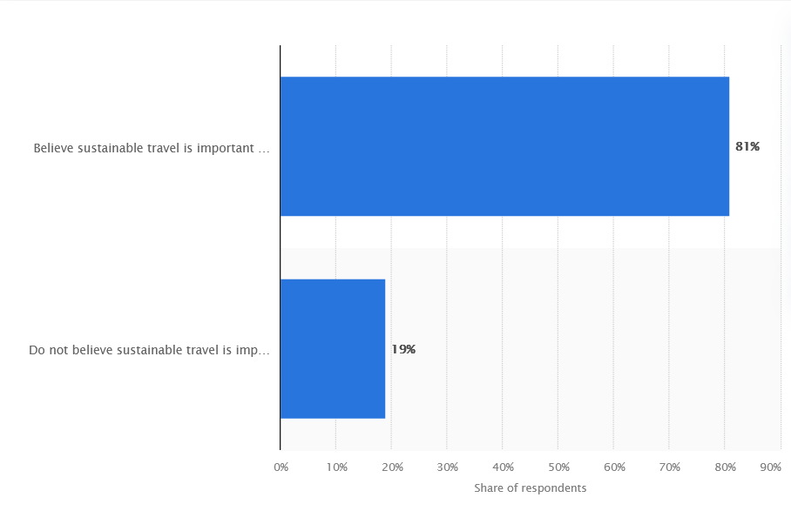
Figure 1- Statistical results for how many people believe in sustainable travel
Source: (Statista, 2022)

Current Market Condition of the Hospitality Industry
The changing beliefs of success in the hospitality industry are shaping the future of the businesses operating in this industry and many companies are continuously investing towards the adoption of sustainable practices. IHG Hotels and Resorts is one such company which has recently adopted sustainable practices to attract more customers, showing the belief that sustainable practice is the new future of the hospitality industry. It launched a programme named Journey to Tomorrow in the year 2021 (Hotels Group PLC, 2023). This program is a ten-year plan for the company which was created to help the company to increase its contribution and promotion of sustainable practices in the firm and industry. This plan was created by the company in the alignment of the UN SDGs. The company has highlighted in its annual report how sustainability is gaining importance and helped it to attract more customers after the Pandemic. The company has taken various measures towards sustainable practices which helped the company to reduce its carbon emission by 3.4% in the year 2022 (IHG HOTELS & RESORTS, 2022). Besides this, the company is continuously trying to contribute to the development of the community. So, in the year 2022, the company has trained around 7400 people through its IHG academy program.
Hyatt is another company which shows how the concept of measure of success is changing in the hospitality industry. The company has adopted a plan named World of Care which helps it to successfully channel its efforts towards the betterment of the environment and society. Under this plan, the company has started operating on 100% renewable energy in the year 2022 (Hyatt, 2022). Besides this, the company follows a policy which helps it successfully diversify its workforce. This policy of diversification helps the company in providing equal opportunity to every member of the society. Thus, these two examples of the major companies in the hospitality industry show that the current market of the hospitality industry is changing and acknowledging sustainable practices as a major factor for success.

Measuring the performance of the hospitality Industry using the Triple-Bottom Line
Thus, as the hospitality industry is acknowledging sustainability as an important factor for success the concept of success in the industry has broadened. Now along with profit, there are two more dimensions which are essential for measuring the success in the industry. The triple bottom line which promotes the idea of encouraging businesses to focus on social and environmental concerns along with profit can be used to measure the success of the businesses operating in the industry (Business. com, 2023). There are three dimensions of the triple bottom line which are profit, planet and people. Each of these dimensions meets at one point. The point at which these three meet is the true measure of the sustainability as well as the performance of the firm (Edgell, 2020). To better understand how the triple bottom line measures the success of a company understanding the three dimensions and their relationship is necessary. These three dimensions and their interrelationship are discussed below.
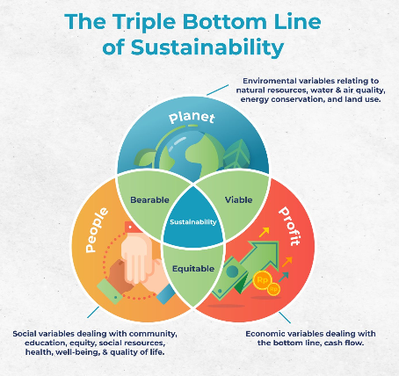
Figure 2- Triple Bottom Line theory
Source: (Business. com, 2023)
Planet: As human activities are growing its impact on the planet each business has a responsibility to reduce the negative impact of its activities on the planet. Similarly, for the hospitality industry, saving the environment by adopting sustainable practices is important (Kraaijenbrink, 2019). Thus, to understand how the hospitality industry can contribute to the betterment of the planet it is essential to understand the Butler’s tourism area life cycle. Butler’s tourism area life cycle shows how a particular tourism destination evolves. This theory says that a tourism area develops through six stages over time (BBC Bitesize, 2023). These stages are exploration, involvement, development, consolidation, stagnation and decline. The exploration stage is the first stage where the local people and government start promoting the place as a tourist place. The involvement stage witnesses the development of infrastructure which is essential for meeting the basic needs of tourists. The development stage observes the arrival of tourists in the region and in this stage, the number of tourist arrivals increases enormously. Following the development stage later comes the consolidation stage where the suddenly increasing number of tourists arriving in the region starts slowing down and this slowing rate in tourist arrival later in the stagnation stage starts declining. The declining stage is the last stage where the region loses its popularity among tourists and the future of the tourist place depends on various factors like plans and actions of the stakeholders (Mize, 2023). Thus, in the second stage of Butler’s tourism area life cycle, businesses from the hospitality industry enter into the picture of a tourist place. It is that stage where development takes place in the region and so before starting its operation if a business in the hospitality industry considers all the factors which will affect the environment of the region, it will help the region as well as the businesses operating in the region (Korstanje et al., 2020). By adopting sustainable measures in this stage, the businesses will elongate the period of consolidation and stagnation and subsequently, the tourist arrival decline will be delayed.
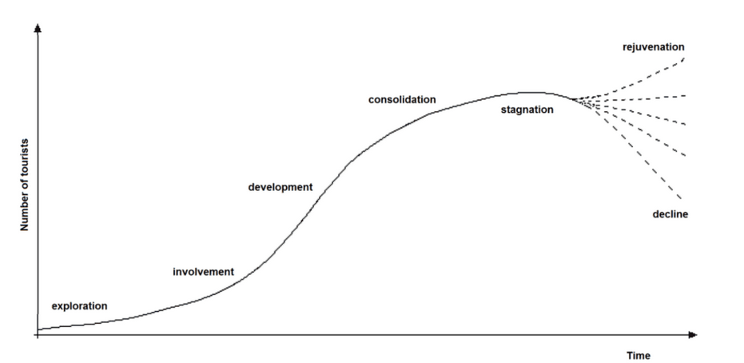
Figure 3- Butler’s tourism area life cycle
Source: (Mize, 2023)

People: The second dimension of the triple bottom line is people. People can be referred to as the stakeholders or the society on which the impact of the hospitality industry is the most (Farnham, 2023). The Doxy’s Irridex model shows how the attitude towards tourists changes over time in a tourist place. It says that there are four stages or attitudes that local people develop towards tourists over time. These four attitudes are Euphoria, Apathy, Irritation and Antagonism. Euphoria is the stage where tourists are welcomed by the locals with enthusiasm and excitement. Apathy is the stage where locals become more formal towards the tourists. The irritation stage develops an annoying attitude among the locals toward the tourists and antagonism is the stage where the incidents of conflict between the tourists and locals rise (Tourism Teacher, 2023). Thus, sustainability the meeting point of the three dimensions of the triple bottom line helps a business to effectively balance the interests of locals and tourists consequently helps in the betterment of the people. Subsequently, it helps in the success of the businesses.
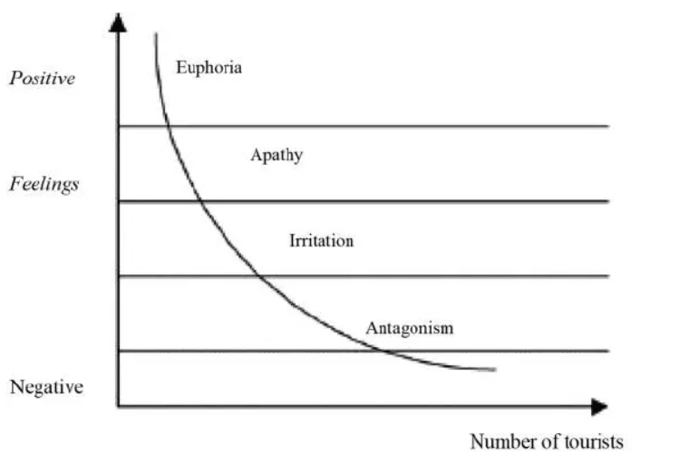
Figure 4- Doxy’s Irridex model
Source: (Tourism Teacher, 2023)

Profit: Profit is a concept which often people relate to the financial gain of the business is totally different concept. Profit can be related to any gain which empowers and sustains the community as a whole. Thus, when a business operating in the hospitality industry cares for the people and planet in return, they receive various benefits from them. This overall helps businesses in its sustenance and empowers them with various profit-generating opportunities.

The future of hospitality and is it profitable to be green
There are various reasons which support the idea that being green hospitality industry will succeed. Thus, by adopting sustainable practices hospitality industry will not only help itself but also the community. There are various methods through which a business operating in the hospitality industry can adopt sustainable practices like using renewable energy for operations, educating locals about sustainability and environmental issues, and many more (Sloan et al., 2017). There are various examples in the hospitality industry which highlight that sustainability practices have a major impact on businesses and their performance. However major challenge which discourages a business from adopting sustainable practices is the financial challenge (Jauhari, 2021). Still, looking at the bigger benefits of sustainable practice the challenge related to finances is nothing. Sustainable practices will not only help a business to earn profit but also help it to become more efficient and effective in meeting the customers' needs and wants (Tai and Chuang, 2014).

Conclusion
The hospitality industry has been identified as one of the oldest industries in the world. Over the years this industry has gone through major changes which shaped its beliefs. It has been found that over a long period many economists like Milton Friedman and hospitality business community believed that profit is only measurement of success for a company. However, the changing demand of customers in the 21st century is changing the belief of the hospitality industry for success measures. Various reports suggest that more customers prefer sustainable services and products due to which the demand and needs of the customers in the industry have shifted towards eco-friendly products and services in the industry. It has been found that there are various companies in this industry which are taking steps to meet the changing demand of the customers and consequently, it is changing the idea of success in the industry.

References
BBC Bitesize, (2023). Butler's life cycle model - Changing pattern and nature of tourism - Eduqas - GCSE Geography Revision - Eduqas - BBC Bitesize. [Online] Available at: https://www.bbc.co.uk/bitesize/guides/z2nnqty/revision/2 [Accessed 03 October 2023].
Benard Marr & Co, (2023). The Evolution of Performance Measurement: From the Industrial Revolution to AI-Driven Analytics. [Online] Available at: https://bernardmarr.com/the-evolution-of-performance-measurement-from-the-industrial-revolution-to-ai-driven-analytics/ [Accessed 02 October 2023].
Business. com, (2023). Why You Should Pay Attention to the Triple Bottom Line. [Online] Available at: https://www.business.com/articles/triple-bottom-line-defined/ [Accessed 03 October 2023].
Desoutter Industrial Tools, (2023). Industrial Revolution - From Industry 1.0 to Industry 4.0 - Desoutter Industrial Tools. [Online] Available at: https://www.desouttertools.com/your-industry/news/503/industrial-revolution-from-industry-1-0-to-industry-4-0 [Accessed 02 October 2023].
Edgell. (2020). Managing sustainable tourism: a legacy for the future (Third edition). Routledge.
Farnham, K., (2023). What is the triple bottom line and why is it important to your organization?. [Online] Available at: https://www.diligent.com/resources/blog/triple-bottom-line [Accessed 03 October 2023].
Global Data, (2023). United Kingdom (UK) Sustainable Tourism Market Summary, Competitive Analysis and Forecast to 2027. [Online] Available at: https://www.google.com/url?sa=t&rct=j&q=&esrc=s&source=web&cd=&ved=2ahUKEwjqu_WgpfCBAxUobmwGHW3mBUcQFnoECAgQAw&url=https%3A%2F%2Fwww.globaldata.com%2Fstore%2Freport%2Fuk-sustainable-tourism-market-analysis%2F&usg=AOvVaw3jgG9zdVRSUvJorQkOsW-Y&opi=89978449 [Accessed 02 October 2023].
Hollander, J., (2022). Modern History of the Hospitality Industry: The Last 100 Years. [Online] Available at: https://hoteltechreport.com/news/modern-history-hospitality-industry [Accessed 02 October 2023].
Hotels Group PLC, (2023). Responsible Business - InterContinental Hotels Group PLC. [Online] Available at: https://www.ihgplc.com/en/responsible-business [Accessed 03 October 2023].
Hyatt, (2022). World of Care Highlights - 2022WOCHighlights.pdf. [Online] Available at: https://about.hyatt.com/content/dam/hyatt/woc/2022WOCHighlights.pdf [Accessed 03 October 2023].
IHG HOTELS & RESORTS, (2022). annual-report-2022.pdf. [Online] Available at: https://www.ihgplc.com/en/-/media/ihg/annualreports/2022/annual-report-2022.pdf?la=en&hash=1Kw5dWvvnPu2pv7abgxyfnLHWjZxGhnwrp [Accessed 03 October 2023].
Jauhari, V (2021) Managing Sustainability in the Hospitalityand Tourism Industry: Paradigms and Directions for the Future. 9th edn. Oakville: Apple Academic Press. Inc.
Korstanje, George, B., & Nedelea, A. (2020). Strategies forpromoting sustainable hospitality and tourism services. IGI Global.
Kraaijenbrink, J., (2019). What The 3Ps Of The Triple Bottom Line Really Mean. [Online] Available at: https://www.forbes.com/sites/jeroenkraaijenbrink/2019/12/10/what-the-3ps-of-the-triple-bottom-line-really-mean/?sh=75e9e2035143 [Accessed 03 October 2023].
Mize, (2023). The 6 phases of a tourist destination's life cycle - Mize. [Online] Available at: https://www.hotelmize.com/blog/the-6-phases-of-a-tourist-destinations-life-cycle/ [Accessed 03 October 2023].
Sloan, P., Legrand, W. and Chen, J.S. (2017) Sustainability in the hospitality industry: principles of sustainable operations. 3rd edn. London: Butterworth-Heinemann.
SOEG, (2023). Historical Background of the Hospitality Industry – A Fascinating Journey. [Online] Available at: https://www.soegjobs.com/hospitality-industry-historical-background/ [Accessed 02 October 2023].
Statista, (2022). Global travelers' views on green travel 2022 | Statista. [Online] Available at: https://www.statista.com/statistics/1126996/traveler-attitudes-sustainability/ [Accessed 02 October 2023].
Statista, (2023). Global ecotourism market size 2022 | Statista. [Online] Available at: https://www.statista.com/statistics/1221034/ecotourism-market-size-global/ [Accessed 02 October 2023].
Tai, F.M. and Chuang, S.H., (2014). Corporate social responsibility. Ibusiness, 6(03), p.117.
Tourism Teacher, (2023). What Is Doxey's Irritation Index And How Does It Work? - Tourism Teacher. [Online] Available at: https://tourismteacher.com/doxeys-irritation-index/ [Accessed 03 October 2023].

