Academic and Employability Skills

Gous Khan

Student ID: 1705786

Lecturer: Peter Allen

Module number: BMSK4001

Date: 06/01/2018

Table of Contents
Introduction 2
UK Recruitment Sector Overview: 3
The demand of seeking employability skills: 5
Requirements for Relationship Manager Position: 7
Educational qualifications: 7
Other qualifications: 7
My contribution in developing skills for Relationship manager: 9
Academic skills: 9
Practical skills: 9
Job offerings in Sainsbury’s 10
Requirements & Procedures: 10
Conclusion 11
References 12

Introduction
The knowledge of basic theory in different subjects or facts helps to concrete any conditions in organizational term is known as academic skills. On the other hand, the ability of reasonable thinking, responsibility and real-life implementation is referred as employability skills. Students require achieving these by earning bright career pathway. According to the UK job market, organizations look for effective employability skills among applicants. The competitions among industries are increasing day by day which intends a rapid change in development in the organization. To have different ideas, organizations are looking for managers who have potential ability to develop instant planning (Almeida, 2012). Through a manager, an organization can estimate necessary steps for upcoming trends. While analyzing the UK job market, the demand for management job is increasing as it has great appeal such as higher wages, flexibility, ability to control people, freedom of decision making etc. (Pitan, 2016) Though it has some barriers, the advantages have motivated me to choose this sector as a career pathway.

UK Recruitment Sector Overview:
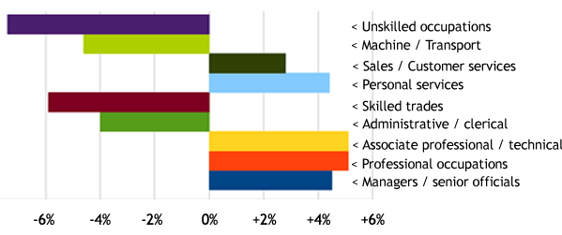
According to last 30 years, there is a vast change in employment of UK. Industries tend to look for skilled people more rather than unskilled people. Because it will reduce the training cost. The use of transportation and machinery is increasing day by day. The organization seeks for people who have wide knowledge about handling machinery (Hind, 2011). Along with, industries believe that customer satisfaction brings increasing volume of sales and for this, they pay attention to customer services. Employers who have great knowledge about customer handling, trades, and administrative regulations are highly appreciable to the respected organizations. The demand for leading particular tasks or management job is increased by 4.5% compared with the twentieth century.
Figure 01: The movement of Employments in the UK
Source: (UK commission, 2014)
The graduates nowadays look for professional jobs to fulfill their demands and can have a better place to disclose their skills in a wider way. Management job is also appealed their attention because of higher salaries, flexibility, leading ability and freedom of decision taking (Pitan, 2016). Management job can be several types such as operation manager, production manager, relationship manager, HR manager, hospitality manager etc.

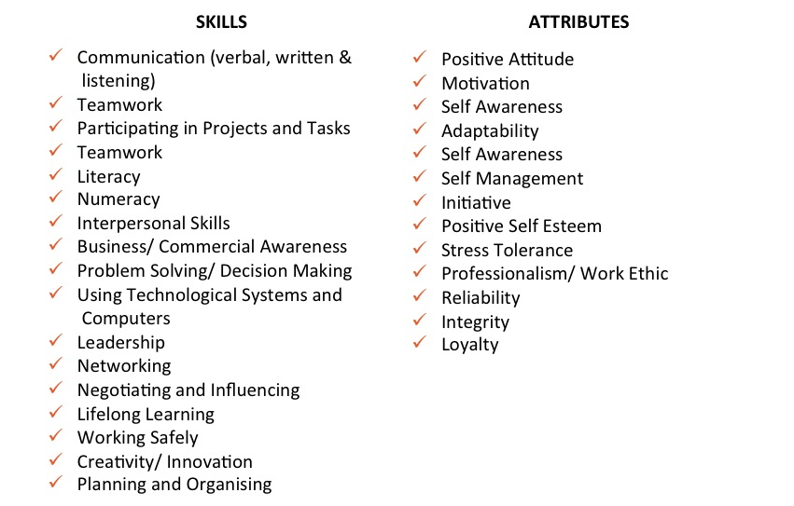
All of them requires some common characteristics such as:
Chart 01: Employability skills and attributes for a manager
Source: (Pinterest, 2018)
The demand for business and management is about 17% and the supply of managing that demand is about 22% (Eskilz College, 2018). This indicates the number of applicants for a management related job is increasing according to the demand. According to Youth Central (2018), ‘employee with higher employability can reduce operational costs, increase productivity as well as revenue maximization’. To become a manager, one must conquer both academic and employability skills. A production or operational manager know the process of producing service or goods and rule over other functional areas as well. A relationship or hospitality manager have the idea to build a successful relationship with employers, parties, suppliers, and customers (Miller, 2013). This role can anticipate the promotional and production strategy.
For being a relationship manager, employers must have instant interaction ability, adaptability, positive self-esteem, integrity, creativity, commercial awareness, planning and organizing capability. Through academic skills, one can obtain some general curriculum for increasing long-term learning and helps to develop behaviors. A student can be able to identify the problem, solve it, research, interpret and think broadly as well as critically (Kleinaltenkamp, 2016). On the other hand, employability skills include group work, teamwork, continuous interaction, cooperation, creativity, ethics and problem solving etc. Nowadays, most of the organizations seek for those employees who have outstanding employability skills.

The demand of seeking employability skills:
Building a successful relationship with customers, suppliers, and competitors or other investment parties can provide a huge number of advantages. Successful relationship gains customers’ beliefs and loyalty (Almeida, 2012). As a result word of mouth tends to increase, profitability will increase. Relationship with suppliers is another important term; organization who inherits a reliable source of suppliers can help in producing effective goods, attain customer satisfaction and meets up the demand timely (Rob Martin, 2008).
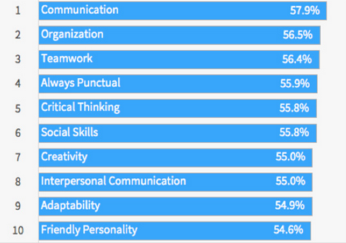
There have been several types of research on the employee to judge their skills. In England, organizations look for 5 specific skills such as education, communication, courage, commitment and time management (Rob Martin, 2008). Employability skills have an immense influence on any job as it is considered as job-readiness skills. The responsibility or job may vary but the core employability skills are almost same.
Figure 02: Demand for employability skills
Source: (Business.linkedin.com, 2017)
Top ten employability skills are ranked according to their demand and organizations tend to look for these skills for any job. Analyzing the relationship role, communication, social skills, adaptability, friendly personality, interpersonal interaction, punctuality, and organizing are the required skills. These skills contribute different types of benefits such as communication and social skills manage the role of spokesperson and indirectly it reduces the cost. Relationship manager is hired for different purposes and they can be hired for long-time operations. In fact, this job has the security of longevity (Hind, 2011). Customer satisfaction can be built through effective communication which refers their demand and opinion towards the organization. Relationship manager can play the role of expertise by giving appropriate suggestions in respective contexts. Moreover, it helps to provide several skills which are required in other professions. A relationship manager can easily adopt any other management related job because of these skills. According to UK market 2017, the demand of relationship manager is about 12.5% of total jobs as part-time or full-time job medium (Sconul.ac.uk, 2017).

Requirements for Relationship Manager Position:
In the previous recruitment process, organizations follow a traditional method of hiring any participants. But that term is nowadays modified in various ways to hire the best participants for the welfare of the industry. There are some requirements to apply for the position of relationship manager in any organization.
Educational qualifications:
To apply for a relationship manager in any company, applicants must attend and pass HND or any institutional degree from a reputed university. Companies may focus on the type of HND programs or institutional programs as it is about management, marketing or any other subjects. A postgraduate degree can be worked as an extra advantage for applicants.
Other qualifications:
Applicants must inherit some other skills regarding employability skills such as communication, interactional ability, effective time management, teamwork, friendly personality, ethical duties, social and organizational skills.
- Through prosperous communication skills, the manager can know about the intention of suppliers, investment parties, competitors, and customers. This can help them to estimate the further and appropriate duties of any organization.
- The interactional ability allows a person to compound with other for acknowledging their desire or opinions. Work can be easier through constant interaction process.
- Being punctuality for any responsibility is helpful to attain certain goals. Effective time managing helps him to accomplish his task in time.
- Sometimes a manager has to work with workers for better leading and understanding. Through teamwork, the demand of employers can be known. Meeting up their demand can make them satisfied and a satisfied employer can perform better than a dissatisfied employer.
- To sustain or overcome the certain situation, employers must have the ability of frequent decision-making ability (Kleinaltenkamp, 2016).
- Wide knowledge about the respective organization is another area to operate successfully. The broader idea can help to realize the demand for promotional activity or developing the behaviors of workers.
- Maintaining ethical duties admires to be hired for the desired position. Organizations look for people who are well-known in managing organizational operations in an ethical way and can instantly maintain responsibilities.

My contribution in developing skills for Relationship manager:

Academic skills:
I am preparing myself eligible for the position through continuing my institutional degree at the University of London. There, I am doing an HND program specialized in management. I am learning about the basic ideas of management. Several workshops and fieldworks have been done during different relative courses of this program and will be held more in future. I have learned the basic of organizing, collaborating and controlling of operational tasks in an organization. The way of behavior with others including outsiders and insiders are also been taught here.

Practical skills:
Study tours and exhibitions programs are also held in here which has given a wide knowledge about the managerial job. The variety level of responsibilities are broadly discussed and I can myself explore the ideas and relates to real-life context.
I have participated in different competitions to achieve higher knowledge and experience of cooperation and compete with others. I have enlisted myself in different academic clubs to explore my specialty in definite roles and I have come up with extraordinary ability in maintaining good relations with people of all levels. This, basically, has motivated me to choose this pathway.
I have also done several courses on IT to have wide knowledge in maintaining technology. I am seeking for an internship program for the position of relationship manager to polish my capability and to have a professional practice.

Job offerings in Sainsbury’s
Sainsbury’s is a recognized and progressive supermarket chain in UK market. This organization maintains a wide area of goods and services. Recently, it is facing downward market positioning because of poor relationship management. According to the previous analysis of this organization, Sainsbury’s has maintained efficient relationship management. To maintain their reputation, it has been looking for effective employers who can manage all the barriers held by workers, customers, suppliers, and investors. As it is an old organization, there is a positive consideration that people have about this organization. They are now broadcasting about hiring executive in relationship managers in different branches. The starting salary is about $15000 but after 6 months this will be $20000.

Requirements & Procedures:
The demand of the following is an institutional degree in specific subjects related to management, marketing or human resource. Effective employability skills are also required for the job. Any professional experience, multi-language efficiency, and good communication are highly appreciated.
There are some procedures required to maintain while managing the recruitment task such as identifying the best candidates by judging the CVs, interview, and workshops. Employees can be judged according to their performance ongoing interview board. People who have the excellent cooperative ability are highly appreciated. They also have the ability to frequent interaction, adaptability, friendly behaviors and teamwork. They must have wide knowledge about different techniques in manipulating suppliers, buyers or investors.

Conclusion
The following description has covered up the idea of employability and academic skills. Some say that employability skills are the application of academic skills. Management related job is becoming a highly appreciated sector for the graduates (Hind, 2011). As managerial jobs consist of different dimensions, the characteristics of these dimensions are almost alike. Here, proper research on relationship management is illustrated. Requirements of such job have been demonstrated. My contributions regarding the post are also illustrated. An example of practical application through recruitment of the following post in Sainsbury’s and required professional practices are also figured out.

References
Almeida, R., Behrman, J., and Robalino, D. (2012). The right skills for the job? Washington, D.C.: World Bank.
Eskilz College. (2018). Most in-demand jobs in South Africa - Popular Sectors and careers. [Online] Available at http://www.eskilzcollege.co.za/2017/11/16/demand-jobs-south-africa/
Hind, D. and Moss, S. (2011). Employability skills. Sunderland: Business Education.
Kleinaltenkamp, M. (2016). Business relationship management and marketing. [S.l.]: Springer-Verlag Berlin An.
Leg.wa.gov. (2017). Cite a Website - Cite This for Me. [online] Available at: http://leg.wa.gov/JointCommittees/Archive/CEOTF/Documents/Background/CareerReadyBrief_ACTE.pdf
Miller, L., Biggart, A., and Newton, B. (2013). Basic and employability skills. International Journal of Training and Development, 17(3), pp.173-175.
Pitan, O. (2016). Employability development opportunities (EDOs) as measures of students’ enhanced employability. Higher Education, Skills and Work-Based Learning, 6(3), pp.288-304.
Rob Martin. (2008). Employability skills examined. Ten key messages from LSN's quest to understand employability skills. London: Learning and Skills Network.
Sconul.ac.uk. (2017). Cite a Website - Cite This for Me. [online] Available at: https://www.sconul.ac.uk/sites/default/files/documents/Employability%20Literature%20Review%20June%202014_0.pdf
Youth Central. (2018). Employability Skills. [Online] Available at http://www.youthcentral.vic.gov.au/jobs-careers/planning-your-career/employability-skills

