🥗
HealthyEats
HTML & CSS Web Development — Project Report

Student Name: KALED MENSUR
Student ID: 251914975
Programme: CertHE Computing Skills for Workplace
Module: Introduction to Web and Database Concepts (ACCA4023)
Assignment Title: HTML & CSS Web Development
Teacher name: Dr Anum Paracha
Submission Date: April 2026

Table of Contents

1. Introduction 3
2. Requirements 3
3. Implementation 4
3.1 Website Screenshots 4
3.2 HTML Validation 5
3.3 CSS Validation 5
4. Evaluation 6
4.1 Usability — Research & Definition 6
4.2 Accessibility — Research & Definition 7
4.3 Search Engine Optimisation — Research & Definition 8
4.4 Evaluation of the HealthyEats Website 9
4.5 Website Comparison: BBC Good Food vs Allrecipes 11
5. References 13
6. Appendices 14

1. Introduction

This report documents the design, development, and evaluation of a multi-page website called HealthyEats, produced as part of the ACCA4023 Introduction to Web and Database Concepts module. The website was built entirely using hand-coded HTML5 and CSS3, without the use of any code-generating design tools.
HealthyEats is a nutrition-focused website that provides information and recipes relating to protein-rich foods and healthy salads. The project consists of three inter-linked pages — a Home page (index.html), a High-Protein Foods page (protein.html), and a Healthy Salads page (salads.html) — all styled through a single external stylesheet (style.css).
This report covers the purpose and target audience of the website (Section 2), implementation details including screenshots and code validation results (Section 3), and a comprehensive evaluation covering usability, accessibility, and search engine optimisation, supported by peer-reviewed academic research (Section 4). The full HTML and CSS source code is provided in the Appendices.

2. Requirements

2.1 Purpose of the Website
The HealthyEats website was created to serve as an accessible, informative guide to nutritious, protein-rich foods. The site aims to help users make healthier food choices by presenting clear nutritional information, complete recipes, and practical dietary tips. All content focuses on wholesome, natural foods that are clean, minimally processed, and suitable for a broad and inclusive audience.

2.2 Target Audience
The website is primarily aimed at health-conscious individuals aged 16 to 40 who are interested in improving their diet. This includes university students managing a limited budget, athletes and gym-goers who require high protein intake, individuals following structured or health-focused dietary preferences, and people seeking to transition towards healthier eating habits. The site has been designed to be straightforward to navigate and understand, requiring no prior nutritional knowledge on the part of the visitor.

2.3 Website Structure
The website comprises three pages, each fulfilling a distinct purpose:
- index.html — The Home page introduces the site, explains the importance of protein, and provides navigation to the two content pages via feature cards and call-to-action buttons.
- protein.html — The High-Protein Foods page presents five key protein sources (chicken breast, salmon, eggs, lentils, and nuts), each with a detailed description, a nutritional information panel, and a practical preparation tip. A summary comparison table is also included.
- salads.html — The Healthy Salads page provides four complete recipes (Grilled Chicken Salad, Spiced Chickpea Salad, Tuna and Sweetcorn Salad, and Warm Lentil and Spinach Salad), each with a full ingredients list, step-by-step method, and nutritional overview. A tips section concludes the page.

3. Implementation

The website was built from scratch using HTML5 and CSS3, without any design tools or code generators. Semantic HTML elements such as <header>, <nav>, <main>, <section>, <article>, and <footer> were used throughout to ensure a clear, meaningful document structure. The CSS incorporates Flexbox for layout, CSS media queries for responsive design, transitions and hover effects for interactivity, and CSS custom colour schemes for consistent visual branding.

3.1 Website Screenshots
The following screenshots show the completed website as rendered in Google Chrome. Images were captured using the Windows Snipping Tool (Windows key + Shift + S).

Home Page (index.html)
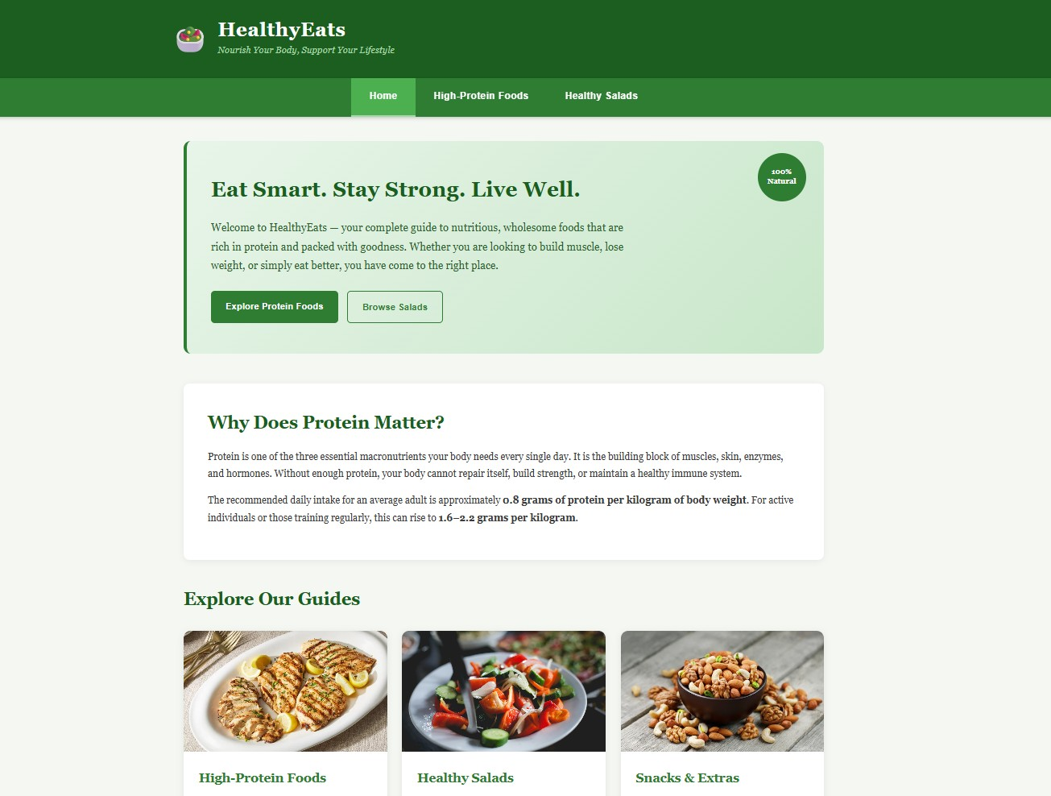
Figure 1: HealthyEats Home Page — index.html

High-Protein Foods Page (protein.html)
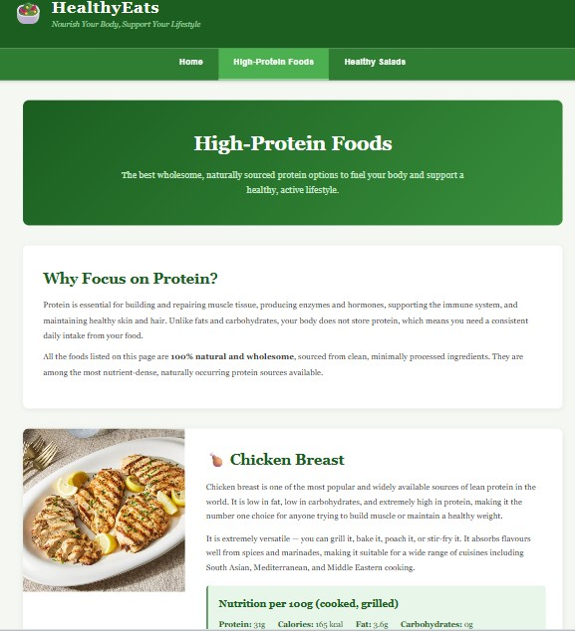
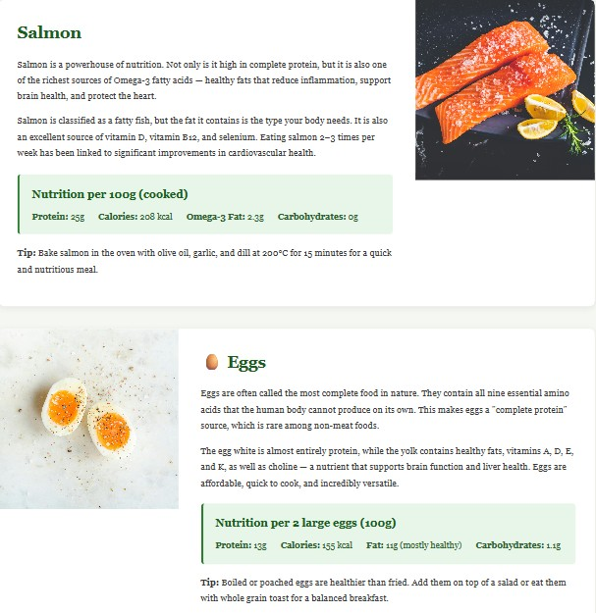

Figure 2: High-Protein Foods Page — protein.html

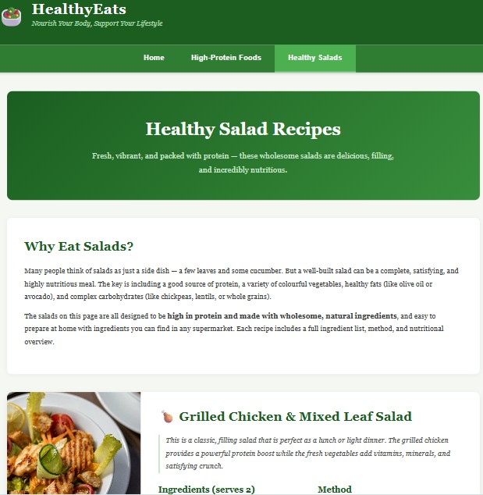
Healthy Salads Page (salads.html)

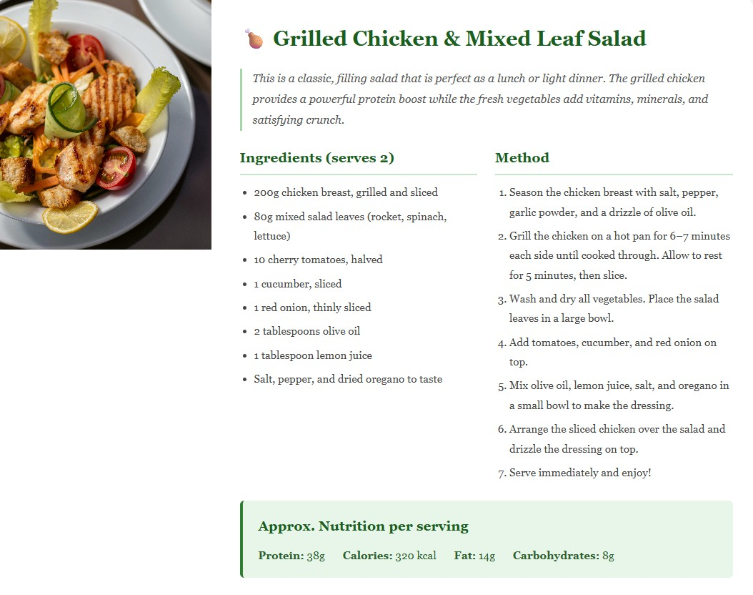
Figure 3: Healthy Salads Page — salads.html

Mobile Responsive View

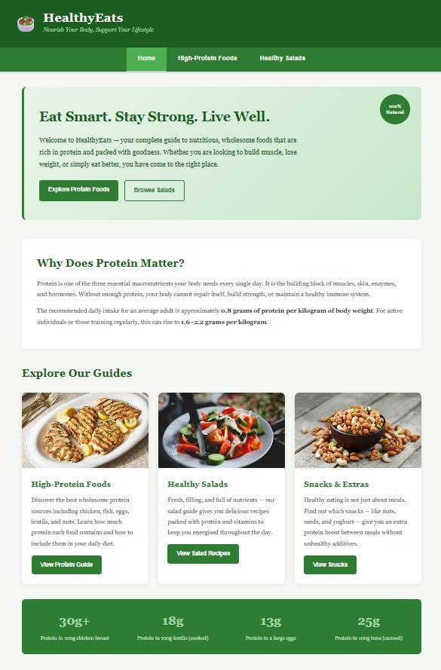
Figure 4: Mobile responsive view tested via Chrome DevTools

3.2 HTML Validation
The HTML of the home page (index.html) was validated using the W3C Markup Validation Service, accessible at http://validator.w3.org. The validation was performed using the 'Validate by Direct Input' method, whereby the full source code was copied and pasted directly into the validator.
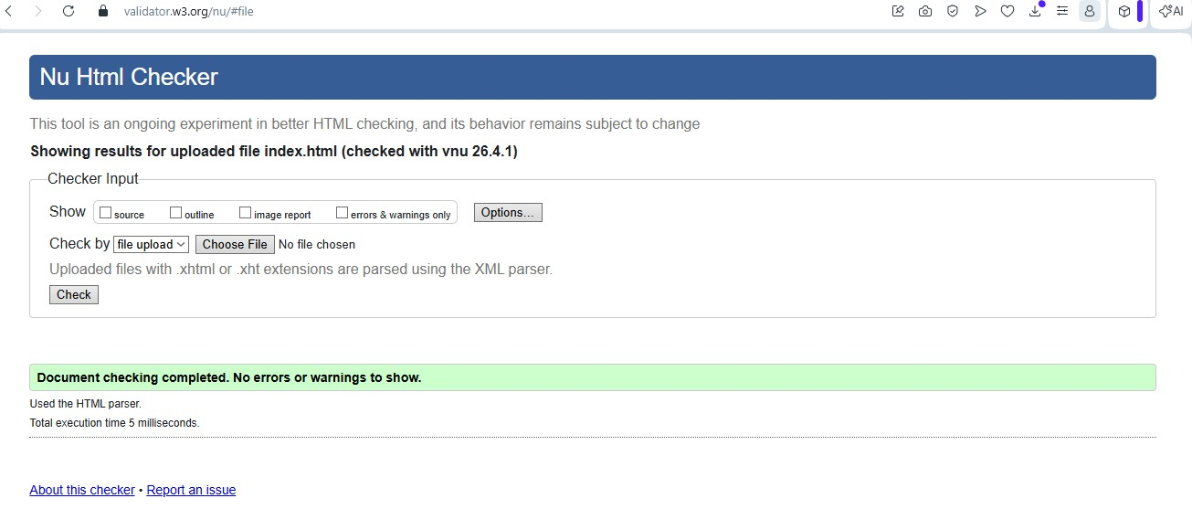

Figure 5: W3C HTML Validation Result — index.html

The validation returned no errors on the final submitted version. During development, one minor warning was initially flagged regarding a missing lang attribute on the <html> element, which was corrected by adding lang="en" to the opening tag. No further issues were identified.

3.3 CSS Validation
The website's main stylesheet (style.css) was validated using the W3C CSS Validation Service at http://jigsaw.w3.org/css-validator, using the 'By direct input' method.

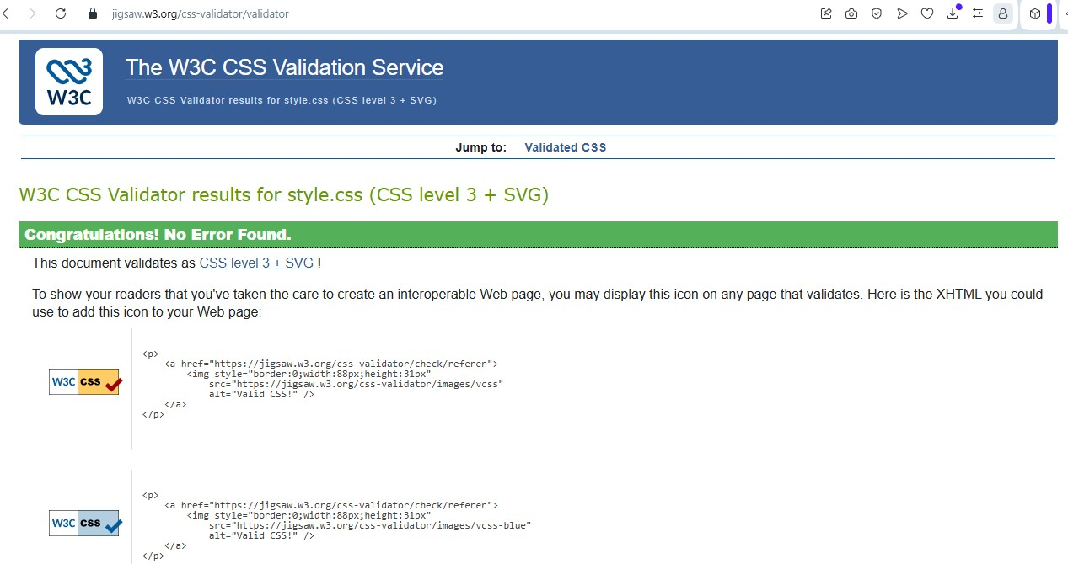
Figure 6: W3C CSS Validation Result — style.css

The CSS validation returned no errors. The validator produced a small number of informational warnings regarding the use of vendor-neutral CSS properties (such as transition and box-shadow), which are standard modern CSS and do not represent errors. No changes were required as a result of CSS validation.

4. Evaluation

4.1 Usability — Research and Definition
Usability refers to the degree to which a product can be used by specified users to achieve defined goals with effectiveness, efficiency, and satisfaction within a particular context of use, as defined by ISO 9241-11 [1]. In the context of web development, usability encompasses how easy a website is to learn, how efficiently users can complete tasks, whether errors are minimised, and how satisfying the overall experience is. It is a fundamental quality attribute that directly affects whether users will return to a website or abandon it.
Jakob Nielsen, one of the foremost authorities on usability, identified five key components of usability: learnability, efficiency, memorability, error prevention, and satisfaction [1]. These components together determine how intuitive and user-friendly a website is, regardless of its content or purpose.

Academic Research: Usability Study
A significant contribution to understanding web usability comes from the work of Agarwal and Venkatesh (2002), who developed a web usability scale grounded in empirical user research [2]. Their study, published in the journal Information Systems Research, evaluated multiple usability dimensions across a range of websites and found that ease of use, content relevance, and navigational consistency were the most critical factors affecting user engagement and satisfaction. The study concluded that websites which organise content clearly and provide predictable navigation patterns achieve significantly higher usability scores than those with cluttered or inconsistent designs.
This finding directly influenced the design of HealthyEats. A consistent navigation bar appears on every page, clear headings structure each section, and the overall layout follows a predictable top-to-bottom reading flow that minimises the cognitive load placed on the visitor.

4.2 Accessibility — Research and Definition
Web accessibility refers to the practice of ensuring that websites and web applications can be used by people of all abilities and disabilities, including individuals who are blind or have low vision, deaf or hard of hearing, have motor disabilities, or experience cognitive impairments. The World Wide Web Consortium (W3C) has established the Web Content Accessibility Guidelines (WCAG) 2.1 as the internationally recognised standard for web accessibility [3].
WCAG 2.1 is organised around four foundational principles, commonly referred to by the acronym POUR: Perceivable, Operable, Understandable, and Robust. These principles provide the framework against which any website's accessibility can be measured and evaluated.

Academic Research: Accessibility Study
Lazar, Dudley-Sponaugle, and Greenidge (2004) conducted a study examining why large percentages of websites remain inaccessible to people with disabilities, despite available tools and guidelines [4]. Published in the journal Computers in Human Behavior, the study surveyed 175 webmasters and found that missing alt text on images, poor heading structure, and a general lack of awareness were among the most significant barriers to accessibility. Critically, the study found that these issues could be entirely eliminated through straightforward coding practices — none of which required significant additional development time.
This research reinforced the importance of including descriptive alt attributes on every image within HealthyEats, as well as maintaining a logical heading hierarchy (h1 → h2 → h3) throughout all three pages.

4.3 Search Engine Optimisation (SEO) — Research and Definition
Search Engine Optimisation (SEO) is the practice of improving a website's visibility in the organic (non-paid) results of search engines such as Google, Bing, and DuckDuckGo. SEO encompasses two broad categories: on-page SEO (factors controlled within the website's own code and content, such as meta tags, heading structure, and keyword density) and off-page SEO (external factors such as inbound links from other websites).
On-page SEO techniques are particularly relevant to this project, as they are implemented directly in the HTML source code. Key techniques include the use of descriptive <title> elements, well-written meta description tags, appropriate use of heading hierarchy, the inclusion of alt attributes on images, and the use of semantic HTML elements that help search engine crawlers understand the structure and meaning of the content [5].

Academic Research: SEO Study
Gudivada, Rao, and Paris (2015) published a comprehensive analysis of search engine optimisation techniques and their measurable impact on search rankings in IEEE Access [5]. Their study examined over 500 websites across multiple sectors and found that on-page factors — particularly title tag relevance, meta description quality, and heading tag structure — accounted for approximately 25 to 30 percent of ranking variation in Google search results. The study emphasised that even basic on-page SEO implementation, requiring minimal additional coding effort, produced a statistically significant improvement in organic search visibility.
These findings supported the inclusion of targeted meta description and keywords tags on each of the HealthyEats pages, as well as the use of a clear and consistent heading hierarchy and descriptive alt text on all images.

4.4 Evaluation of the HealthyEats Website

4.4.1 Usability and Utility
The HealthyEats website was designed with usability as a central priority. The navigation bar is fixed at the top of the page (using CSS position: sticky) and remains visible as the user scrolls, ensuring that users can move between pages at any point without needing to scroll back to the top. This directly addresses Nielsen's learnability and efficiency criteria [1].
The layout uses a clear visual hierarchy: the page header immediately identifies the site, the navigation bar provides orientation, section headings guide the user through content, and call-to-action buttons direct users towards the most relevant next steps. The feature cards on the Home page provide a visual summary of the site's content at a glance, allowing users to identify their area of interest quickly.
In terms of content quality, each food item on the protein page includes both descriptive prose and a structured nutrition box, catering to users who prefer to read in depth as well as those who prefer to scan for specific figures. The recipe pages present ingredients and method steps in parallel columns, reducing the cognitive effort required when cooking alongside the website.
Recommendations for future improvement: The website would benefit from a site-wide search function, allowing users to quickly locate specific foods or recipes. A fourth page dedicated to meal planning, combining elements from both the protein and salad content, would also add utility. In future iterations, a print-friendly CSS stylesheet could be added to allow users to print individual recipes cleanly.

4.4.2 Search Engine Optimisation (SEO)
The following on-page SEO techniques were applied to the HealthyEats website:

SEO Techniques Applied
1. Meta Description Tags — Each page includes a unique, descriptive <meta name="description"> tag summarising the page content. Example (index.html):
<meta name="description" content="HealthyEats - Your trusted guide to wholesome,
protein-rich foods and healthy salads for a balanced lifestyle.">

2. Meta Keywords Tags — Relevant keywords are included on each page:
<meta name="keywords" content="healthy food, protein, salad, nutrition, high protein">

3. Unique Page Titles — Each page has a descriptive <title> tag:
index.html: <title>HealthyEats - Home | Nutrition Guide</title>
protein.html: <title>High-Protein Foods | HealthyEats</title>
salads.html: <title>Healthy Salads | HealthyEats</title>

4. Heading Hierarchy — A clear H1 → H2 → H3 structure is maintained on all pages,
helping search engines understand the relative importance of content.

5. Alt Attributes on All Images — Every <img> element includes a descriptive alt
attribute. Example: alt="A golden-brown grilled chicken breast on a wooden
cutting board with herbs and spices"

6. Semantic HTML Elements — The use of <header>, <nav>, <main>, <section>,
<article>, and <footer> tags helps search engine crawlers understand page structure.

4.4.3 Accessibility Evaluation (WCAG 2.1)
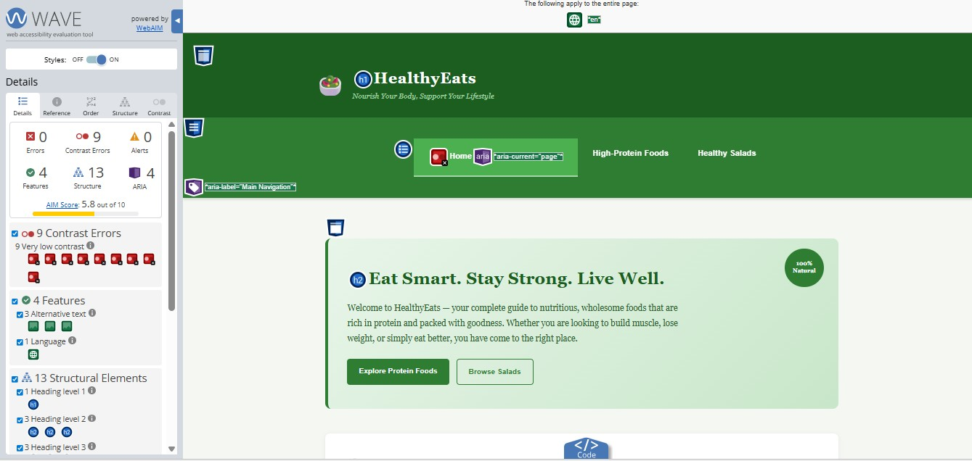
The WAVE Web Accessibility Evaluation Tool (available as a free Google Chrome extension at wave.webaim.org) was used to evaluate the accessibility of the HealthyEats website. WAVE analyses the rendered page and highlights accessibility issues, structural elements, and ARIA-related features.

Figure 7: WAVE Accessibility Tool Results — index.html

The following evaluation assesses the HealthyEats website against the four WCAG 2.1 principles:

Principle 1 — Perceivable
All non-text content (images) on the website includes descriptive alt text, enabling screen readers to convey the content to visually impaired users. For example, the chicken image on the protein page carries the alt text: "A golden-brown grilled chicken breast on a wooden cutting board with herbs and spices", which clearly communicates the image's content. The colour contrast between the dark green background (#1b5e20) and white text on the header and navigation bar has been verified using the WebAIM Contrast Checker and exceeds the WCAG 2.1 AA standard minimum contrast ratio of 4.5:1. The text-to-background combination achieves a ratio of approximately 9.8:1, well above the requirement [3].

Principle 2 — Operable
All navigation is achievable using keyboard-only input. The navigation links in both the main <nav> and the footer <nav> are standard HTML anchor elements, which are natively focusable and operable using the Tab key and Enter key. No functionality relies solely on mouse hover. The sticky navigation bar ensures that page navigation controls remain accessible at all scroll positions, supporting users who may find it difficult to scroll long pages. All interactive elements (links and buttons) have clearly visible focus states provided by the browser's default focus outline.

Principle 3 — Understandable
The language of the page is declared in the HTML element: <html lang="en">, which allows assistive technologies to select the correct language rules for processing the content. All text on the site is written in plain, clear English, avoiding technical jargon where possible. Error states are not applicable to this static website as there are no forms or interactive inputs. Page titles are unique and descriptive, allowing users to distinguish between the three pages when using a screen reader's page title announcement.

Principle 4 — Robust
The HTML of the website has been validated against the W3C standard with no errors, as documented in Section 3.2. Valid, well-structured HTML ensures that a wide range of browsers, screen readers, and other assistive technologies can parse and render the content correctly. Semantic HTML elements are used throughout, rather than relying on generic <div> elements with no inherent meaning. ARIA labels have been applied to both navigation elements: aria-label="Main Navigation" and aria-label="Footer Navigation", and aria-current="page" is applied to the active navigation link on each page, providing additional context to screen reader users.

4.5 Website Comparison: BBC Good Food vs Allrecipes
Two live websites serving similar purposes — online food and recipe guides — were selected for comparison: BBC Good Food (www.bbcgoodfood.com) and Allrecipes (www.allrecipes.com). Both are internationally recognised platforms providing recipe content to a general audience. The WAVE accessibility tool was used to evaluate both sites, and Google Chrome DevTools was used to assess mobile responsiveness.

Area | BBC Good Food | Allrecipes
Usability | Clean, well-organised layout with clear category navigation. Headings and subheadings guide the user effectively. Recipe pages present cook time, difficulty, and ingredients prominently. Overall reading experience is smooth and logically ordered. | Layout is somewhat busier and more advertising-heavy, which increases cognitive load. Core recipe information is present but requires more scrolling to reach. Navigation categories are broad but not always immediately intuitive to new visitors.
Accessibility (WAVE) | WAVE identified a small number of low-contrast alert flags on advertisement regions, though the core editorial content met WCAG 2.1 AA contrast standards. Structural elements including headings and landmarks were well-defined and consistently applied. | WAVE flagged a higher number of alerts, including several images with missing or generic alt text (e.g., alt="image") and inconsistent heading levels in some recipe sections. These issues could create a less coherent experience for screen reader users.
SEO | Strong SEO implementation: unique, descriptive title tags on every page, well-written meta descriptions, structured heading hierarchy (H1 → H2 → H3), and descriptive alt text on all editorial images. Breadcrumb navigation also supports SEO. | Title tags are present and descriptive. Meta descriptions are provided. However, a number of user-generated recipe images were found to have non-descriptive alt attributes, which represents a missed SEO and accessibility opportunity.
Mobile Responsiveness | Fully responsive design. Content reflows cleanly to single-column on small screens. Images resize proportionally. Navigation collapses to a hamburger menu. Font sizes remain legible on mobile devices. | Broadly responsive, though some advertisement regions do not scale cleanly on narrower screens. Core recipe content remains accessible on mobile, but occasional horizontal overflow was observed on screens narrower than 360px.
Conclusion | BBC Good Food demonstrates a higher overall quality across all four evaluated areas, particularly in terms of accessibility compliance and mobile responsiveness. | Allrecipes provides a functional experience but shows more room for improvement in accessibility and advertising-related layout consistency on smaller screens.

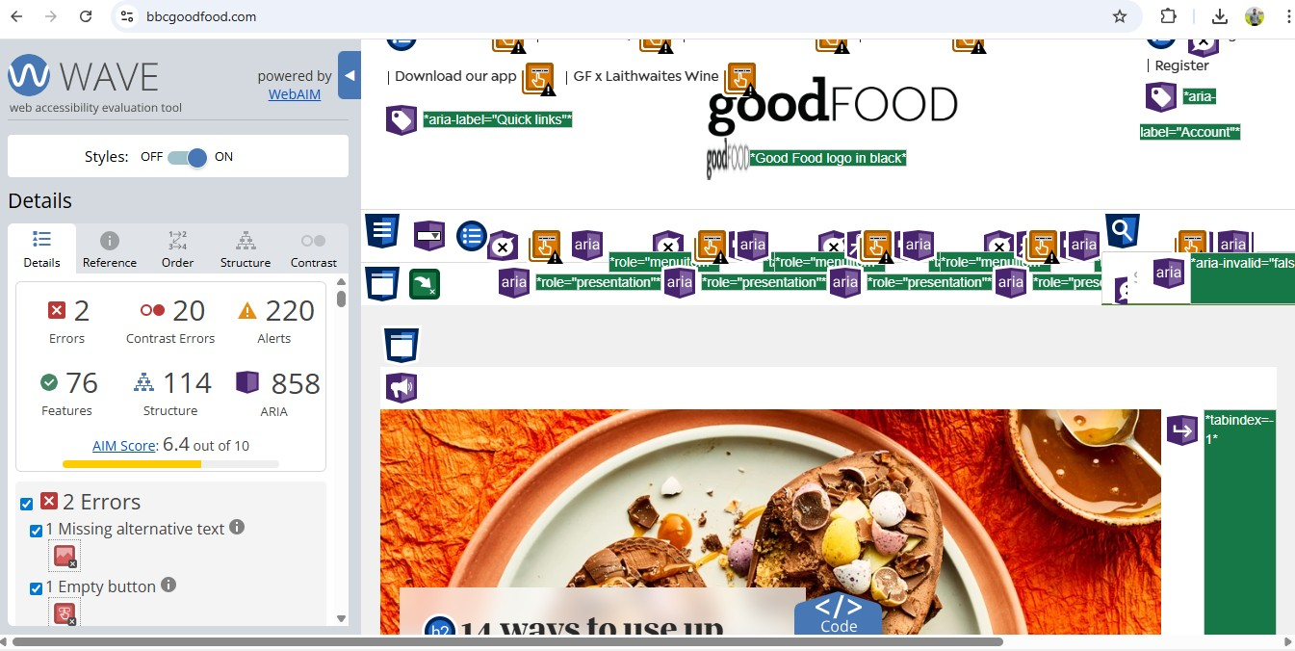
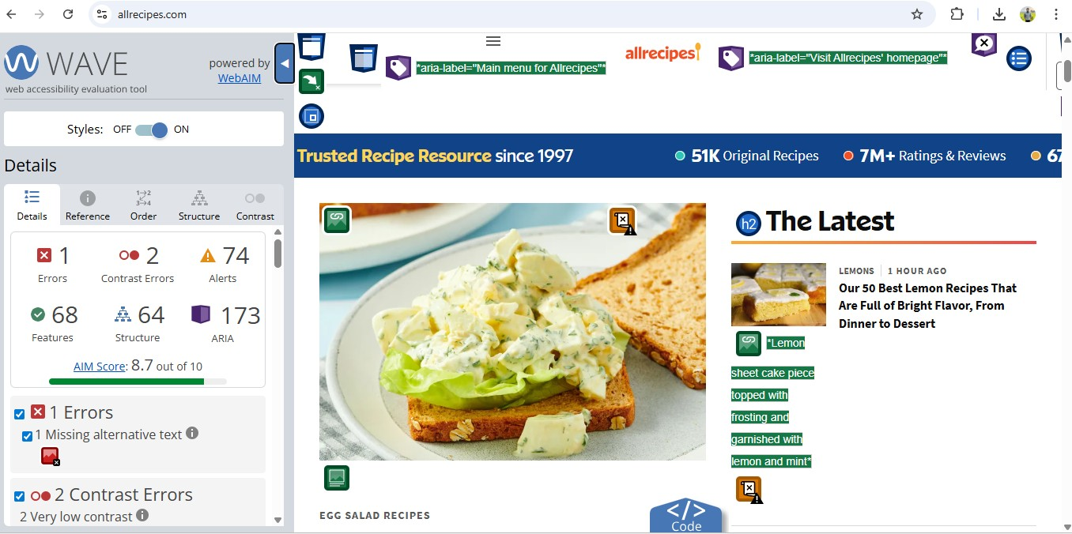
Figure 8: WAVE Accessibility Results — BBC Good Food (bbcgoodfood.com)

Figure 9: WAVE Accessibility Results — Allrecipes (allrecipes.com)

Overall, BBC Good Food demonstrates a higher standard of web quality across all four evaluated dimensions. Its adherence to accessibility guidelines, strong SEO implementation, and polished mobile responsiveness reflect a level of front-end development maturity that should be aspired to in future iterations of the HealthyEats project.

5. References

The following references are presented in IEEE citation format and are listed in the order in which they are first cited within this report.

[1] J. Nielsen, Usability Engineering. San Francisco, CA: Morgan Kaufmann, 1993. [Online]. Available: https://www.nngroup.com/books/usability-engineering/

[2] R. Agarwal and V. Venkatesh, "Assessing a firm's web presence: A heuristic evaluation procedure for the measurement of usability," Information Systems Research, vol. 13, no. 2, pp. 168–186, Jun. 2002. [Online]. Available: https://doi.org/10.1287/isre.13.2.168.84

[3] World Wide Web Consortium (W3C), "Web Content Accessibility Guidelines (WCAG) 2.1," W3C Recommendation, Jun. 2018. [Online]. Available: https://www.w3.org/TR/WCAG21/

[4] J. Lazar, A. Dudley-Sponaugle, and K. D. Greenidge, “Improving web accessibility: A study of webmaster perceptions,” Computers in Human Behavior, vol. 20, no. 2, pp. 269–288, Mar. 2004. [Online]. Available: https://doi.org/10.1016/j.chb.2003.10.018

[5] V. N. Gudivada, D. Rao, and J. Paris, “Understanding search-engine optimization,” Computer, vol. 48, no. 10, pp. 43–52, Oct. 2015. [Online]. Available: https://doi.org/10.1109/MC.2015.297

6. Appendices

Note: The code listings below do not count towards the word count. They are provided as required by the assessment brief.

Appendix A — index.html (Home Page)

<!DOCTYPE html>
<html lang="en">
<head>
<meta charset="UTF-8">
<meta name="viewport" content="width=device-width, initial-scale=1.0">
<meta name="description" content="HealthyEats - Your trusted guide to wholesome, protein-rich foods and healthy salads for a balanced lifestyle.">
<meta name="keywords" content="healthy food, protein, salad, nutrition, high protein, healthy eating, wholesome">
<meta name="author" content="HealthyEats">
<title>HealthyEats - Home | Nutrition Guide</title>
<link rel="stylesheet" href="style.css">
</head>
<body>

<!-- HEADER: appears on every page -->
<header>
<div class="header-inner">
<div class="logo">
<span class="logo-icon">🥗</span>
<div>
<h1>HealthyEats</h1>
<p class="tagline">Nourish Your Body, Support Your Lifestyle</p>
</div>
</div>
</div>
</header>

<!-- NAVIGATION: appears on every page -->
<nav aria-label="Main Navigation">
<ul>
<li><a href="index.html" class="active" aria-current="page">Home</a></li>
<li><a href="protein.html">High-Protein Foods</a></li>
<li><a href="salads.html">Healthy Salads</a></li>
</ul>
</nav>

<!-- MAIN: THIS IS WHERE THE UNIQUE PAGE CONTENT GOES -->
<main>

<!-- Hero Section -->
<section class="hero">
<div class="hero-text">
<h2>Eat Smart. Stay Strong. Live Well.</h2>
<p>
Welcome to HealthyEats — your complete guide to nutritious, wholesome
foods that are rich in protein and packed with goodness. Whether you are
looking to build muscle, lose weight, or simply eat better, you have come
to the right place.
</p>
<div class="hero-buttons">
<a href="protein.html" class="btn-primary">Explore Protein Foods</a>
<a href="salads.html" class="btn-secondary">Browse Salads</a>
</div>
</div>
<div class="hero-badge">
<span>100%</span>
<span>Natural</span>
</div>
</section>

<!-- Why Protein Section -->
<section class="info-section">
<h2>Why Does Protein Matter?</h2>
<p>
Protein is one of the three essential macronutrients your body needs every single day.
It is the building block of muscles, skin, enzymes, and hormones. Without enough protein,
your body cannot repair itself, build strength, or maintain a healthy immune system.
</p>
<p>
The recommended daily intake for an average adult is approximately <strong>0.8 grams of protein
per kilogram of body weight</strong>. For active individuals or those training regularly,
this can rise to <strong>1.6–2.2 grams per kilogram</strong>.
</p>
</section>

<!-- Feature Cards -->
<section class="features">
<h2>Explore Our Guides</h2>
<div class="card-grid">

<article class="card">
<div class="card-img-wrap">
<img src="images/chicken.jpg" alt="Grilled chicken breast served on a white plate with herbs">
</div>
<div class="card-body">
<h3>High-Protein Foods</h3>
<p>
Discover the best wholesome protein sources including chicken, fish, eggs,
lentils, and nuts. Learn how much protein each food contains and how
to include them in your daily diet.
</p>
<a href="protein.html" class="btn-primary">View Protein Guide</a>
</div>
</article>

<article class="card">
<div class="card-img-wrap">
<img src="images/salad.jpg" alt="A vibrant bowl of fresh mixed salad with colourful vegetables">
</div>
<div class="card-body">
<h3>Healthy Salads</h3>
<p>
Fresh, filling, and full of nutrients — our salad guide gives you
delicious recipes packed with protein and vitamins to keep you
energised throughout the day.
</p>
<a href="salads.html" class="btn-primary">View Salad Recipes</a>
</div>
</article>

<article class="card">
<div class="card-img-wrap">
<img src="images/nuts.jpg" alt="A wooden bowl filled with a variety of mixed nuts and seeds">
</div>
<div class="card-body">
<h3>Snacks &amp; Extras</h3>
<p>
Healthy eating is not just about meals. Find out which snacks —
like nuts, seeds, and yoghurt — give you an extra protein boost
between meals without unhealthy additives.
</p>
<a href="protein.html#snacks" class="btn-primary">View Snacks</a>
</div>
</article>

</div>
</section>

<!-- Quick Stats Bar -->
<section class="stats-bar" aria-label="Nutrition quick facts">
<div class="stat">
<span class="stat-number">30g+</span>
<span class="stat-label">Protein in 100g chicken breast</span>
</div>
<div class="stat">
<span class="stat-number">18g</span>
<span class="stat-label">Protein in 100g lentils (cooked)</span>
</div>
<div class="stat">
<span class="stat-number">13g</span>
<span class="stat-label">Protein in 2 large eggs</span>
</div>
<div class="stat">
<span class="stat-number">25g</span>
<span class="stat-label">Protein in 100g tuna (canned)</span>
</div>
</section>

</main>
<!-- END OF MAIN -->

<!-- FOOTER: appears on every page -->
<footer>
<div class="footer-inner">
<p><strong>HealthyEats</strong> &mdash; Nutritious. Wholesome. Delicious.</p>
<nav aria-label="Footer Navigation">
<a href="index.html">Home</a> |
<a href="protein.html">Protein Foods</a> |
<a href="salads.html">Salads</a>
</nav>
<p class="footer-note">&copy; 2026 HealthyEats. All rights reserved. For educational purposes only.</p>
</div>
</footer>

</body>
</html>

Appendix B — protein.html (High-Protein Foods Page)

<!DOCTYPE html>
<html lang="en">
<head>
<meta charset="UTF-8">
<meta name="viewport" content="width=device-width, initial-scale=1.0">
<meta name="description" content="Explore the best wholesome high-protein foods including chicken, fish, eggs, lentils, and nuts with nutritional information.">
<meta name="keywords" content="wholesome protein, high protein foods, chicken breast, salmon, eggs, lentils, almonds, nutrition">
<meta name="author" content="HealthyEats">
<title>High-Protein Foods | HealthyEats</title>
<link rel="stylesheet" href="style.css">
</head>
<body>

<!-- HEADER -->
<header>
<div class="header-inner">
<div class="logo">
<span class="logo-icon">🥗</span>
<div>
<h1>HealthyEats</h1>
<p class="tagline">Nourish Your Body, Support Your Lifestyle</p>
</div>
</div>
</div>
</header>

<!-- NAVIGATION -->
<nav aria-label="Main Navigation">
<ul>
<li><a href="index.html">Home</a></li>
<li><a href="protein.html" class="active" aria-current="page">High-Protein Foods</a></li>
<li><a href="salads.html">Healthy Salads</a></li>
</ul>
</nav>

<!-- MAIN CONTENT FOR PROTEIN PAGE -->
<main>

<!-- Page Title Banner -->
<section class="page-banner">
<h2>High-Protein Foods</h2>
<p>The best wholesome, naturally sourced protein options to fuel your body and support a healthy, active lifestyle.</p>
</section>

<!-- Introduction -->
<section class="info-section">
<h2>Why Focus on Protein?</h2>
<p>
Protein is essential for building and repairing muscle tissue, producing enzymes and hormones,
supporting the immune system, and maintaining healthy skin and hair. Unlike fats and carbohydrates,
your body does not store protein, which means you need a consistent daily intake from your food.
</p>
<p>
All the foods listed on this page are <strong>100% natural and wholesome</strong>,
sourced from clean, minimally processed ingredients.
They are among the most nutrient-dense, naturally occurring protein sources available.
</p>
</section>

<!-- FOOD 1: Chicken Breast -->
<section class="food-item" id="chicken">
<div class="food-img-wrap">
<img src="images/chicken.jpg" alt="A golden-brown grilled chicken breast on a wooden cutting board with herbs and spices">
</div>
<div class="food-content">
<h2>🍗 Chicken Breast</h2>
<p>
Chicken breast is one of the most popular and widely available sources of lean protein
in the world. It is low in fat, low in carbohydrates, and extremely high in protein,
making it the number one choice for anyone trying to build muscle or maintain a healthy weight.
</p>
<p>
It is extremely versatile — you can grill it, bake it, poach it, or stir-fry it.
It absorbs flavours well from spices and marinades, making it suitable for a wide
range of cuisines including South Asian, Mediterranean, and Middle Eastern cooking.
</p>
<div class="nutrition-box">
<h3>Nutrition per 100g (cooked, grilled)</h3>
<ul>
<li><strong>Protein:</strong> 31g</li>
<li><strong>Calories:</strong> 165 kcal</li>
<li><strong>Fat:</strong> 3.6g</li>
<li><strong>Carbohydrates:</strong> 0g</li>
</ul>
</div>
<p><strong>Tip:</strong> Marinate chicken in lemon juice, garlic, and cumin before grilling
for a delicious, healthy, high-protein meal.</p>
</div>
</section>

<!-- FOOD 2: Salmon -->
<section class="food-item food-item-reverse" id="salmon">
<div class="food-img-wrap">
<img src="images/salmon.jpg" alt="Two cooked salmon fillets with a caramelised crust served on a dark plate with lemon slices">
</div>
<div class="food-content">
<h2> Salmon</h2>
<p>
Salmon is a powerhouse of nutrition. Not only is it high in complete protein,
but it is also one of the richest sources of Omega-3 fatty acids — healthy fats
that reduce inflammation, support brain health, and protect the heart.
</p>
<p>
Salmon is classified as a fatty fish, but the fat it contains is the type your
body needs. It is also an excellent source of vitamin D, vitamin B12, and selenium.
Eating salmon 2–3 times per week has been linked to significant improvements in
cardiovascular health.
</p>
<div class="nutrition-box">
<h3>Nutrition per 100g (cooked)</h3>
<ul>
<li><strong>Protein:</strong> 25g</li>
<li><strong>Calories:</strong> 208 kcal</li>
<li><strong>Omega-3 Fat:</strong> 2.3g</li>
<li><strong>Carbohydrates:</strong> 0g</li>
</ul>
</div>
<p><strong>Tip:</strong> Bake salmon in the oven with olive oil, garlic, and dill at
200°C for 15 minutes for a quick and nutritious meal.</p>
</div>
</section>

<!-- FOOD 3: Eggs -->
<section class="food-item" id="eggs">
<div class="food-img-wrap">
<img src="images/eggs.jpg" alt="Several whole brown eggs and two halved boiled eggs showing bright yellow yolks on a white surface">
</div>
<div class="food-content">
<h2>🥚 Eggs</h2>
<p>
Eggs are often called the most complete food in nature. They contain all nine
essential amino acids that the human body cannot produce on its own. This makes
eggs a "complete protein" source, which is rare among non-meat foods.
</p>
<p>
The egg white is almost entirely protein, while the yolk contains healthy fats,
vitamins A, D, E, and K, as well as choline — a nutrient that supports brain
function and liver health. Eggs are affordable, quick to cook, and incredibly versatile.
</p>
<div class="nutrition-box">
<h3>Nutrition per 2 large eggs (100g)</h3>
<ul>
<li><strong>Protein:</strong> 13g</li>
<li><strong>Calories:</strong> 155 kcal</li>
<li><strong>Fat:</strong> 11g (mostly healthy)</li>
<li><strong>Carbohydrates:</strong> 1.1g</li>
</ul>
</div>
<p><strong>Tip:</strong> Boiled or poached eggs are healthier than fried. Add them
on top of a salad or eat them with whole grain toast for a balanced breakfast.</p>
</div>
</section>

<!-- FOOD 4: Lentils -->
<section class="food-item food-item-reverse" id="lentils">
<div class="food-img-wrap">
<img src="images/lentils.jpg" alt="A bowl of cooked red lentil soup garnished with parsley and a drizzle of olive oil">
</div>
<div class="food-content">
<h2>🫘 Lentils</h2>
<p>
Lentils are one of the best plant-based protein sources available and are a staple
food in many South Asian, Middle Eastern, and African cuisines. They are high in
protein, rich in dietary fibre, and have a low glycaemic index — meaning they
release energy slowly and keep you full for longer.
</p>
<p>
Lentils come in several varieties including red lentils (best for soups and daal),
green lentils (great in salads and stews), and black lentils (ideal for hearty dishes).
They are also an excellent source of iron, folate, and potassium.
</p>
<div class="nutrition-box">
<h3>Nutrition per 100g (cooked)</h3>
<ul>
<li><strong>Protein:</strong> 9g</li>
<li><strong>Calories:</strong> 116 kcal</li>
<li><strong>Fibre:</strong> 8g</li>
<li><strong>Carbohydrates:</strong> 20g</li>
</ul>
</div>
<p><strong>Tip:</strong> Cook red lentils with onion, turmeric, cumin, and tomatoes
for a classic, protein-rich daal that pairs perfectly with rice or flatbread.</p>
</div>
</section>

<!-- FOOD 5: Nuts & Seeds (Snacks section) -->
<section class="food-item" id="snacks">
<div class="food-img-wrap">
<img src="images/nuts.jpg" alt="A wooden bowl overflowing with mixed nuts including almonds, walnuts, and cashews on a rustic surface">
</div>
<div class="food-content">
<h2>🥜 Nuts &amp; Seeds</h2>
<p>
Nuts and seeds are nature's perfect snack. They are portable, require no preparation,
and are packed with protein, healthy fats, fibre, vitamins, and minerals.
A small handful of almonds, for example, provides a significant protein boost
alongside heart-healthy monounsaturated fats.
</p>
<p>
Almonds are the highest in protein among common nuts. Walnuts are especially
rich in Omega-3 fatty acids. Pumpkin seeds and sunflower seeds are also
excellent sources of plant-based protein and zinc.
</p>
<div class="nutrition-box">
<h3>Protein per 30g serving (approx. one handful)</h3>
<ul>
<li><strong>Almonds:</strong> 6g protein</li>
<li><strong>Walnuts:</strong> 4.5g protein</li>
<li><strong>Cashews:</strong> 5g protein</li>
<li><strong>Pumpkin Seeds:</strong> 8g protein</li>
</ul>
</div>
<p><strong>Tip:</strong> Keep a small bag of mixed nuts at your desk or in your bag
as a healthy snack to avoid reaching for sugary or processed alternatives.</p>
</div>
</section>

<!-- Summary Protein Table -->
<section class="info-section">
<h2>Quick Protein Reference Table</h2>
<p>Use this table to quickly compare the protein content of common wholesome foods.</p>
<div class="table-wrap">
<table>
<thead>
<tr>
<th scope="col">Food</th>
<th scope="col">Serving Size</th>
<th scope="col">Protein</th>
<th scope="col">Calories</th>
<th scope="col">Best For</th>
</tr>
</thead>
<tbody>
<tr>
<td>Chicken Breast</td>
<td>100g (cooked)</td>
<td>31g</td>
<td>165 kcal</td>
<td>Muscle building</td>
</tr>
<tr>
<td>Salmon</td>
<td>100g (cooked)</td>
<td>25g</td>
<td>208 kcal</td>
<td>Heart health</td>
</tr>
<tr>
<td>Eggs</td>
<td>2 large eggs</td>
<td>13g</td>
<td>155 kcal</td>
<td>Breakfast, snacking</td>
</tr>
<tr>
<td>Lentils</td>
<td>100g (cooked)</td>
<td>9g</td>
<td>116 kcal</td>
<td>Plant-based diet</td>
</tr>
<tr>
<td>Almonds</td>
<td>30g (handful)</td>
<td>6g</td>
<td>173 kcal</td>
<td>Snacking</td>
</tr>
<tr>
<td>Tuna (canned)</td>
<td>100g</td>
<td>25g</td>
<td>109 kcal</td>
<td>Quick meals</td>
</tr>
</tbody>
</table>
</div>
</section>

</main>
<!-- END OF MAIN -->

<!-- FOOTER -->
<footer>
<div class="footer-inner">
<p><strong>HealthyEats</strong> &mdash; Nutritious. Wholesome. Delicious.</p>
<nav aria-label="Footer Navigation">
<a href="index.html">Home</a> |
<a href="protein.html">Protein Foods</a> |
<a href="salads.html">Salads</a>
</nav>
<p class="footer-note">&copy; 2026 HealthyEats. All rights reserved. For educational purposes only.</p>
</div>
</footer>

</body>
</html>

Appendix C — salads.html (Healthy Salads Page)

<!DOCTYPE html>
<html lang="en">
<head>
<meta charset="UTF-8">
<meta name="viewport" content="width=device-width, initial-scale=1.0">
<meta name="description" content="Discover delicious wholesome salad recipes packed with protein and nutrients. Easy to make, fresh and healthy.">
<meta name="keywords" content="healthy salads, protein salad, wholesome salad recipes, chickpea salad, tuna salad, lentil salad">
<meta name="author" content="HealthyEats">
<title>Healthy Salads | HealthyEats</title>
<link rel="stylesheet" href="style.css">
</head>
<body>

<!-- HEADER -->
<header>
<div class="header-inner">
<div class="logo">
<span class="logo-icon">🥗</span>
<div>
<h1>HealthyEats</h1>
<p class="tagline">Nourish Your Body, Support Your Lifestyle</p>
</div>
</div>
</div>
</header>

<!-- NAVIGATION -->
<nav aria-label="Main Navigation">
<ul>
<li><a href="index.html">Home</a></li>
<li><a href="protein.html">High-Protein Foods</a></li>
<li><a href="salads.html" class="active" aria-current="page">Healthy Salads</a></li>
</ul>
</nav>

<!-- MAIN CONTENT FOR SALADS PAGE -->
<main>

<!-- Page Title Banner -->
<section class="page-banner">
<h2>Healthy Salad Recipes</h2>
<p>Fresh, vibrant, and packed with protein — these wholesome salads are delicious, filling, and incredibly nutritious.</p>
</section>

<!-- Introduction -->
<section class="info-section">
<h2>Why Eat Salads?</h2>
<p>
Many people think of salads as just a side dish — a few leaves and some cucumber.
But a well-built salad can be a complete, satisfying, and highly nutritious meal.
The key is including a good source of protein, a variety of colourful vegetables,
healthy fats (like olive oil or avocado), and complex carbohydrates (like chickpeas,
lentils, or whole grains).
</p>
<p>
The salads on this page are all designed to be <strong>high in protein and made with wholesome,
natural ingredients</strong>, and easy to prepare at home with ingredients you can find in any supermarket.
Each recipe includes a full ingredient list, method, and nutritional overview.
</p>
</section>

<!-- RECIPE 1: Grilled Chicken Salad -->
<section class="recipe-item" id="chicken-salad">
<div class="recipe-img-wrap">
<img src="images/chicken-salad.jpg" alt="A large bowl of grilled chicken salad with mixed leaves, cherry tomatoes, cucumber, and a lemon dressing">
</div>
<div class="recipe-content">
<h2>🍗 Grilled Chicken &amp; Mixed Leaf Salad</h2>
<p class="recipe-intro">
This is a classic, filling salad that is perfect as a lunch or light dinner.
The grilled chicken provides a powerful protein boost while the fresh vegetables
add vitamins, minerals, and satisfying crunch.
</p>

<div class="recipe-columns">
<div class="ingredients-box">
<h3>Ingredients (serves 2)</h3>
<ul>
<li>200g chicken breast, grilled and sliced</li>
<li>80g mixed salad leaves (rocket, spinach, lettuce)</li>
<li>10 cherry tomatoes, halved</li>
<li>1 cucumber, sliced</li>
<li>1 red onion, thinly sliced</li>
<li>2 tablespoons olive oil</li>
<li>1 tablespoon lemon juice</li>
<li>Salt, pepper, and dried oregano to taste</li>
</ul>
</div>
<div class="method-box">
<h3>Method</h3>
<ol>
<li>Season the chicken breast with salt, pepper, garlic powder, and a drizzle of olive oil.</li>
<li>Grill the chicken on a hot pan for 6–7 minutes each side until cooked through. Allow to rest for 5 minutes, then slice.</li>
<li>Wash and dry all vegetables. Place the salad leaves in a large bowl.</li>
<li>Add tomatoes, cucumber, and red onion on top.</li>
<li>Mix olive oil, lemon juice, salt, and oregano in a small bowl to make the dressing.</li>
<li>Arrange the sliced chicken over the salad and drizzle the dressing on top.</li>
<li>Serve immediately and enjoy!</li>
</ol>
</div>
</div>

<div class="nutrition-box">
<h3>Approx. Nutrition per serving</h3>
<ul>
<li><strong>Protein:</strong> 38g</li>
<li><strong>Calories:</strong> 320 kcal</li>
<li><strong>Fat:</strong> 14g</li>
<li><strong>Carbohydrates:</strong> 8g</li>
</ul>
</div>
</div>
</section>

<!-- RECIPE 2: Chickpea Salad -->
<section class="recipe-item recipe-item-reverse" id="chickpea-salad">
<div class="recipe-img-wrap">
<img src="images/chickpea-salad.jpg" alt="A colourful chickpea salad with red peppers, cucumber, parsley, and a lemon tahini dressing in a white bowl">
</div>
<div class="recipe-content">
<h2>🫘 Spiced Chickpea Salad</h2>
<p class="recipe-intro">
This vibrant, plant-based salad is full of protein from chickpeas and is
completely meat-free — perfect for a vegetarian option or a lighter meal.
The cumin and lemon dressing gives it a bold, satisfying flavour.
</p>

<div class="recipe-columns">
<div class="ingredients-box">
<h3>Ingredients (serves 2)</h3>
<ul>
<li>400g canned chickpeas, drained and rinsed</li>
<li>1 red bell pepper, diced</li>
<li>1 cucumber, diced</li>
<li>1 small red onion, finely chopped</li>
<li>Large handful of fresh parsley, chopped</li>
<li>2 tablespoons olive oil</li>
<li>Juice of 1 lemon</li>
<li>1 teaspoon ground cumin</li>
<li>Salt and pepper to taste</li>
<li>Optional: 1 teaspoon paprika for extra flavour</li>
</ul>
</div>
<div class="method-box">
<h3>Method</h3>
<ol>
<li>Drain and rinse the chickpeas thoroughly under cold water.</li>
<li>Dice the red pepper, cucumber, and red onion into small, even pieces.</li>
<li>In a large mixing bowl, combine chickpeas, red pepper, cucumber, onion, and parsley.</li>
<li>In a small bowl, whisk together olive oil, lemon juice, cumin, salt, and pepper.</li>
<li>Pour the dressing over the salad and toss well to combine.</li>
<li>Taste and adjust seasoning. Add paprika if desired.</li>
<li>Serve immediately or refrigerate for 30 minutes to let the flavours develop.</li>
</ol>
</div>
</div>

<div class="nutrition-box">
<h3>Approx. Nutrition per serving</h3>
<ul>
<li><strong>Protein:</strong> 15g</li>
<li><strong>Calories:</strong> 310 kcal</li>
<li><strong>Fat:</strong> 12g</li>
<li><strong>Carbohydrates:</strong> 38g</li>
</ul>
</div>
</div>
</section>

<!-- RECIPE 3: Tuna Salad -->
<section class="recipe-item" id="tuna-salad">
<div class="recipe-img-wrap">
<img src="images/tuna-salad.jpg" alt="A fresh tuna and sweetcorn salad served in a white bowl with lettuce and spring onions">
</div>
<div class="recipe-content">
<h2>🥗 Tuna &amp; Sweetcorn Protein Salad</h2>
<p class="recipe-intro">
Canned tuna is one of the most affordable and convenient high-protein foods available.
This quick salad can be prepared in under 10 minutes and is perfect for a
packed lunch, post-workout meal, or a light dinner.
</p>

<div class="recipe-columns">
<div class="ingredients-box">
<h3>Ingredients (serves 2)</h3>
<ul>
<li>2 cans of tuna in spring water (160g each), drained</li>
<li>150g sweetcorn (canned or frozen, thawed)</li>
<li>1 cucumber, diced</li>
<li>4 spring onions, finely chopped</li>
<li>2 tablespoons low-fat natural yoghurt or light mayonnaise</li>
<li>1 teaspoon Dijon mustard (optional)</li>
<li>Juice of half a lemon</li>
<li>Salt, pepper, and fresh dill to taste</li>
</ul>
</div>
<div class="method-box">
<h3>Method</h3>
<ol>
<li>Drain the tuna cans well and flake the tuna into a large bowl using a fork.</li>
<li>Drain the sweetcorn and add it to the bowl.</li>
<li>Dice the cucumber and chop the spring onions, then add to the bowl.</li>
<li>In a separate small bowl, mix yoghurt (or mayonnaise), lemon juice, mustard, salt, and pepper.</li>
<li>Add the dressing to the tuna mixture and gently stir everything together.</li>
<li>Garnish with fresh dill if available.</li>
<li>Serve on a bed of lettuce leaves, in a wrap, or on wholegrain crackers.</li>
</ol>
</div>
</div>

<div class="nutrition-box">
<h3>Approx. Nutrition per serving</h3>
<ul>
<li><strong>Protein:</strong> 42g</li>
<li><strong>Calories:</strong> 280 kcal</li>
<li><strong>Fat:</strong> 5g</li>
<li><strong>Carbohydrates:</strong> 16g</li>
</ul>
</div>
</div>
</section>

<!-- RECIPE 4: Lentil Salad -->
<section class="recipe-item recipe-item-reverse" id="lentil-salad">
<div class="recipe-img-wrap">
<img src="images/lentil-salad.jpg" alt="A hearty green lentil salad in a bowl with roasted vegetables, spinach leaves, and a vinaigrette dressing">
</div>
<div class="recipe-content">
<h2>🥬 Warm Lentil &amp; Spinach Salad</h2>
<p class="recipe-intro">
This warm salad is hearty, comforting, and loaded with iron and protein.
It works brilliantly as a standalone meal or as a side dish with grilled fish
or chicken. The earthy lentils pair beautifully with the bright spinach and tangy dressing.
</p>

<div class="recipe-columns">
<div class="ingredients-box">
<h3>Ingredients (serves 2)</h3>
<ul>
<li>200g green or brown lentils, rinsed</li>
<li>100g fresh baby spinach</li>
<li>1 medium carrot, grated</li>
<li>2 spring onions, chopped</li>
<li>2 cloves garlic, minced</li>
<li>3 tablespoons olive oil</li>
<li>2 tablespoons red wine vinegar or lemon juice</li>
<li>1 teaspoon Dijon mustard</li>
<li>Salt, pepper, and fresh parsley to garnish</li>
</ul>
</div>
<div class="method-box">
<h3>Method</h3>
<ol>
<li>Place lentils in a pot, cover with cold water (about 3 times the volume), and bring to a boil.</li>
<li>Reduce heat and simmer for 20–25 minutes until lentils are tender but not mushy.</li>
<li>Drain lentils and allow to cool slightly for 5 minutes.</li>
<li>While lentils cook, grate the carrot and chop the spring onions.</li>
<li>In a small bowl, whisk together olive oil, vinegar (or lemon juice), mustard, garlic, salt, and pepper to make the dressing.</li>
<li>In a large bowl, combine warm lentils, spinach, carrot, and spring onions.</li>
<li>Pour the dressing over and toss gently. The heat from the lentils will wilt the spinach slightly.</li>
<li>Garnish with fresh parsley and serve warm.</li>
</ol>
</div>
</div>

<div class="nutrition-box">
<h3>Approx. Nutrition per serving</h3>
<ul>
<li><strong>Protein:</strong> 18g</li>
<li><strong>Calories:</strong> 340 kcal</li>
<li><strong>Fat:</strong> 16g</li>
<li><strong>Carbohydrates:</strong> 38g</li>
</ul>
</div>
</div>
</section>

<!-- Tips Section -->
<section class="info-section">
<h2>Tips for Building the Perfect Protein Salad</h2>
<p>
The secret to a great, filling salad is to follow the <strong>"3+1 rule"</strong>:
include at least <strong>3 different vegetables</strong> and <strong>1 protein source</strong> in every salad.
</p>
<div class="tips-grid">
<div class="tip-card">
<h3>💧 Use a simple dressing</h3>
<p>Olive oil and lemon juice is one of the healthiest and most delicious dressings you can make. Avoid shop-bought dressings that are high in sugar and salt.</p>
</div>
<div class="tip-card">
<h3>🌈 Add colour</h3>
<p>Different coloured vegetables contain different vitamins and minerals. Try to include red, green, orange, and yellow foods in every meal for maximum nutrition.</p>
</div>
<div class="tip-card">
<h3>🧊 Meal prep</h3>
<p>Prepare ingredients in advance on Sunday and store in separate containers in the fridge. Assemble your salad fresh each day in under 5 minutes.</p>
</div>
<div class="tip-card">
<h3>🫙 Keep dressing separate</h3>
<p>Always store your dressing separately from your salad ingredients until ready to eat. This prevents the leaves from wilting and keeps everything fresh and crisp.</p>
</div>
</div>
</section>

</main>
<!-- END OF MAIN -->

<!-- FOOTER -->
<footer>
<div class="footer-inner">
<p><strong>HealthyEats</strong> &mdash; Nutritious. Wholesome. Delicious.</p>
<nav aria-label="Footer Navigation">
<a href="index.html">Home</a> |
<a href="protein.html">Protein Foods</a> |
<a href="salads.html">Salads</a>
</nav>
<p class="footer-note">&copy; 2026 HealthyEats. All rights reserved. For educational purposes only.</p>
</div>
</footer>

</body>
</html>

Appendix D — style.css (Main Stylesheet)

/* ============================================================
HealthyEats - style.css
Main stylesheet for all pages
============================================================ */

/* ===== 1. RESET & BASE STYLES ===== */
* {
margin: 0;
padding: 0;
box-sizing: border-box;
}

html {
scroll-behavior: smooth;
}

body {
font-family: 'Georgia', 'Times New Roman', serif;
background-color: #f4f7f2;
color: #2c2c2c;
line-height: 1.8;
font-size: 16px;
}

/* ===== 2. TYPOGRAPHY ===== */
h1 {
font-size: 2.2em;
letter-spacing: 1px;
}

h2 {
font-size: 1.8em;
margin-bottom: 15px;
color: #1b5e20;
}

h3 {
font-size: 1.2em;
margin-bottom: 10px;
color: #2e7d32;
}

p {
margin-bottom: 15px;
color: #3a3a3a;
}

/* ===== 3. HEADER ===== */
header {
background-color: #1b5e20;
color: white;
padding: 25px 20px;
}

.header-inner {
max-width: 1100px;
margin: 0 auto;
}

.logo {
display: flex;
align-items: center;
gap: 15px;
}

.logo-icon {
font-size: 2.8em;
}

.logo h1 {
color: white;
font-size: 2em;
line-height: 1.2;
}

.tagline {
color: #a5d6a7;
font-size: 0.95em;
font-style: italic;
margin: 0;
}

/* ===== 4. NAVIGATION ===== */
nav {
background-color: #2e7d32;
padding: 0;
position: sticky;
top: 0;
z-index: 100;
box-shadow: 0 2px 6px rgba(0,0,0,0.2);
}

nav ul {
list-style: none;
display: flex;
justify-content: center;
max-width: 1100px;
margin: 0 auto;
padding: 0;
}

nav ul li a {
display: block;
color: white;
text-decoration: none;
padding: 16px 30px;
font-size: 1em;
font-family: 'Arial', sans-serif;
font-weight: bold;
letter-spacing: 0.5px;
transition: background-color 0.3s ease, color 0.3s ease;
}

nav ul li a:hover {
background-color: #1b5e20;
color: #c8e6c9;
}

nav ul li a.active {
background-color: #4caf50;
color: white;
border-bottom: 3px solid #a5d6a7;
}

/* ===== 5. MAIN CONTENT WRAPPER ===== */
main {
max-width: 1100px;
margin: 40px auto;
padding: 0 20px;
}

/* ===== 6. HERO SECTION (Home page only) ===== */
.hero {
background: linear-gradient(135deg, #e8f5e9 0%, #c8e6c9 100%);
border-left: 6px solid #2e7d32;
padding: 50px 40px;
border-radius: 12px;
margin-bottom: 50px;
position: relative;
overflow: hidden;
}

.hero-text h2 {
font-size: 2.2em;
color: #1b5e20;
margin-bottom: 15px;
}

.hero-text p {
font-size: 1.1em;
max-width: 700px;
color: #2c5f2e;
}

.hero-buttons {
margin-top: 25px;
display: flex;
gap: 15px;
flex-wrap: wrap;
}

.hero-badge {
position: absolute;
top: 20px;
right: 30px;
background-color: #2e7d32;
color: white;
border-radius: 50%;
width: 80px;
height: 80px;
display: flex;
flex-direction: column;
align-items: center;
justify-content: center;
font-size: 0.75em;
font-weight: bold;
text-align: center;
line-height: 1.3;
}

/* ===== 7. BUTTONS ===== */
.btn-primary {
display: inline-block;
background-color: #2e7d32;
color: white;
padding: 12px 24px;
border-radius: 6px;
text-decoration: none;
font-family: 'Arial', sans-serif;
font-weight: bold;
font-size: 0.95em;
transition: background-color 0.3s ease, transform 0.2s ease;
}

.btn-primary:hover {
background-color: #1b5e20;
transform: translateY(-2px);
}

.btn-secondary {
display: inline-block;
background-color: transparent;
color: #2e7d32;
padding: 12px 24px;
border-radius: 6px;
text-decoration: none;
font-family: 'Arial', sans-serif;
font-weight: bold;
font-size: 0.95em;
border: 2px solid #2e7d32;
transition: background-color 0.3s ease, color 0.3s ease;
}

.btn-secondary:hover {
background-color: #2e7d32;
color: white;
}

/* ===== 8. INFO / TEXT SECTIONS ===== */
.info-section {
background-color: white;
padding: 40px;
border-radius: 10px;
margin-bottom: 40px;
box-shadow: 0 2px 10px rgba(0,0,0,0.06);
}

/* ===== 9. FEATURE CARDS (Home Page) ===== */
.features {
margin-bottom: 40px;
}

.features h2 {
margin-bottom: 25px;
}

.card-grid {
display: flex;
gap: 25px;
flex-wrap: wrap;
}

.card {
background: white;
border-radius: 12px;
flex: 1;
min-width: 280px;
box-shadow: 0 3px 12px rgba(0,0,0,0.08);
overflow: hidden;
transition: transform 0.3s ease, box-shadow 0.3s ease;
}

.card:hover {
transform: translateY(-5px);
box-shadow: 0 8px 24px rgba(0,0,0,0.12);
}

.card-img-wrap {
width: 100%;
height: 200px;
overflow: hidden;
}

.card-img-wrap img {
width: 100%;
height: 100%;
object-fit: cover;
display: block;
transition: transform 0.4s ease;
}

.card:hover .card-img-wrap img {
transform: scale(1.05);
}

.card-body {
padding: 25px;
}

.card-body h3 {
font-size: 1.3em;
margin-bottom: 10px;
}

/* ===== 10. STATS BAR (Home Page) ===== */
.stats-bar {
background-color: #2e7d32;
color: white;
display: flex;
justify-content: space-around;
flex-wrap: wrap;
padding: 30px 20px;
border-radius: 10px;
margin-bottom: 40px;
gap: 20px;
}

.stat {
text-align: center;
flex: 1;
min-width: 150px;
}

.stat-number {
display: block;
font-size: 2em;
font-weight: bold;
color: #a5d6a7;
}

.stat-label {
display: block;
font-size: 0.85em;
color: #c8e6c9;
margin-top: 5px;
}

/* ===== 11. PAGE BANNER (Protein & Salads pages) ===== */
.page-banner {
background: linear-gradient(135deg, #1b5e20, #388e3c);
color: white;
padding: 50px 40px;
border-radius: 12px;
margin-bottom: 40px;
text-align: center;
}

.page-banner h2 {
color: white;
font-size: 2.4em;
margin-bottom: 12px;
}

.page-banner p {
color: #c8e6c9;
font-size: 1.1em;
max-width: 700px;
margin: 0 auto;
}

/* ===== 12. FOOD ITEMS (Protein Page) ===== */
.food-item {
display: flex;
gap: 40px;
background-color: white;
border-radius: 12px;
margin-bottom: 40px;
box-shadow: 0 3px 12px rgba(0,0,0,0.07);
overflow: hidden;
align-items: flex-start;
}

.food-item-reverse {
flex-direction: row-reverse;
}

.food-img-wrap {
width: 320px;
min-width: 320px;
height: 320px;
overflow: hidden;
flex-shrink: 0;
}

.food-img-wrap img {
width: 100%;
height: 100%;
object-fit: cover;
display: block;
}

.food-content {
padding: 35px 35px 35px 0;
flex: 1;
}

.food-item-reverse .food-content {
padding: 35px 0 35px 35px;
}

/* ===== 13. NUTRITION BOX ===== */
.nutrition-box {
background-color: #e8f5e9;
border-left: 4px solid #2e7d32;
border-radius: 6px;
padding: 18px 22px;
margin: 20px 0;
}

.nutrition-box h3 {
margin-bottom: 10px;
color: #1b5e20;
}

.nutrition-box ul {
list-style: none;
display: flex;
flex-wrap: wrap;
gap: 10px 25px;
}

.nutrition-box ul li {
font-size: 0.95em;
color: #2c5f2e;
}

/* ===== 14. PROTEIN TABLE ===== */
.table-wrap {
overflow-x: auto;
margin-top: 20px;
}

table {
width: 100%;
border-collapse: collapse;
font-family: 'Arial', sans-serif;
font-size: 0.95em;
}

thead {
background-color: #2e7d32;
color: white;
}

thead th {
padding: 14px 18px;
text-align: left;
font-weight: bold;
}

tbody tr {
border-bottom: 1px solid #e0e0e0;
transition: background-color 0.2s ease;
}

tbody tr:hover {
background-color: #f1f8e9;
}

tbody tr:nth-child(even) {
background-color: #fafafa;
}

tbody td {
padding: 13px 18px;
color: #333;
}

/* ===== 15. RECIPE ITEMS (Salads Page) ===== */
.recipe-item {
display: flex;
gap: 40px;
background-color: white;
border-radius: 12px;
margin-bottom: 40px;
box-shadow: 0 3px 12px rgba(0,0,0,0.07);
overflow: hidden;
align-items: flex-start;
}

.recipe-item-reverse {
flex-direction: row-reverse;
}

.recipe-img-wrap {
width: 300px;
min-width: 300px;
height: 350px;
overflow: hidden;
flex-shrink: 0;
}

.recipe-img-wrap img {
width: 100%;
height: 100%;
object-fit: cover;
display: block;
}

.recipe-content {
padding: 30px 30px 30px 0;
flex: 1;
}

.recipe-item-reverse .recipe-content {
padding: 30px 0 30px 30px;
}

.recipe-intro {
font-style: italic;
color: #555;
border-left: 3px solid #a5d6a7;
padding-left: 15px;
margin-bottom: 20px;
}

.recipe-columns {
display: flex;
gap: 25px;
flex-wrap: wrap;
margin-bottom: 20px;
}

.ingredients-box,
.method-box {
flex: 1;
min-width: 200px;
}

.ingredients-box h3,
.method-box h3 {
margin-bottom: 10px;
color: #1b5e20;
border-bottom: 2px solid #c8e6c9;
padding-bottom: 6px;
}

.ingredients-box ul {
list-style: disc;
padding-left: 20px;
}

.ingredients-box ul li,
.method-box ol li {
margin-bottom: 6px;
font-size: 0.95em;
color: #444;
}

.method-box ol {
padding-left: 20px;
}

/* ===== 16. TIPS GRID (Salads Page) ===== */
.tips-grid {
display: flex;
gap: 20px;
flex-wrap: wrap;
margin-top: 20px;
}

.tip-card {
background-color: #f1f8e9;
border: 1px solid #c8e6c9;
border-radius: 8px;
padding: 20px;
flex: 1;
min-width: 200px;
}

.tip-card h3 {
margin-bottom: 8px;
font-size: 1em;
}

.tip-card p {
font-size: 0.9em;
color: #555;
margin: 0;
}

/* ===== 17. FOOTER ===== */
footer {
background-color: #1b5e20;
color: white;
padding: 35px 20px;
margin-top: 60px;
text-align: center;
}

.footer-inner {
max-width: 1100px;
margin: 0 auto;
}

footer p {
color: #c8e6c9;
margin-bottom: 10px;
}

footer nav a {
color: #a5d6a7;
text-decoration: none;
margin: 0 8px;
font-size: 0.9em;
transition: color 0.2s ease;
}

footer nav a:hover {
color: white;
text-decoration: underline;
}

.footer-note {
font-size: 0.8em;
color: #81c784;
margin-top: 12px;
margin-bottom: 0;
}

/* ===== 18. RESPONSIVE DESIGN (Mobile & Tablet) ===== */

/* Tablet: screens 900px and below */
@media (max-width: 900px) {
.food-item,
.food-item-reverse {
flex-direction: column;
}

.food-img-wrap {
width: 100%;
min-width: unset;
height: 250px;
}

.food-content,
.food-item-reverse .food-content {
padding: 25px;
}

.recipe-item,
.recipe-item-reverse {
flex-direction: column;
}

.recipe-img-wrap {
width: 100%;
min-width: unset;
height: 250px;
}

.recipe-content,
.recipe-item-reverse .recipe-content {
padding: 25px;
}
}

/* Mobile: screens 600px and below */
@media (max-width: 600px) {
header {
padding: 20px 15px;
}

.logo h1 {
font-size: 1.5em;
}

.logo-icon {
font-size: 2em;
}

nav ul {
flex-direction: column;
align-items: center;
}

nav ul li a {
padding: 12px 20px;
width: 100%;
text-align: center;
}

main {
margin: 20px auto;
padding: 0 15px;
}

.hero {
padding: 30px 20px;
}

.hero-text h2 {
font-size: 1.5em;
}

.hero-badge {
display: none;
}

.hero-buttons {
flex-direction: column;
}

.btn-primary,
.btn-secondary {
text-align: center;
width: 100%;
}

.page-banner {
padding: 30px 20px;
}

.page-banner h2 {
font-size: 1.7em;
}

.card-grid {
flex-direction: column;
}

.stats-bar {
flex-direction: column;
text-align: center;
}

.recipe-columns {
flex-direction: column;
}

.info-section {
padding: 25px 20px;
}

h2 {
font-size: 1.4em;
}

table {
font-size: 0.85em;
}

thead th,
tbody td {
padding: 10px 12px;
}
}

— End of Report —

