MARKETING FUNDAMENTALS

GROUP BLOG

Superdry

Aneliya Yordanova-1905211
Mariyana Mavrodieva 1908837
Nikoleta Georgieva 1908764
Miroslava Tosheva 1907385
Vanya Toleva 1906675

SUPERDRY STORY
Aneliya Yordanova-1905211

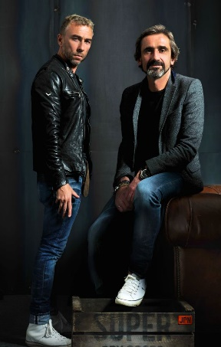Superdry PLC is a UK fashion brand. Is Incorporated on 02 November 2010.However, the story began much earlier in the distant 1985 from Julian Dunkerton when he has been founded vintage looking clothing shop "Cult Clothing” later grow into chain. Furthermore rebranded 2012 as Superdry.
The inspiration for the Superdry label came from a trip to Japan between the creators of Superdry Julian Dunkerton and James Holder who is designer behind skate-wear brand “Bench”. In the beginning the creative duo sells the product in the stores of “Cool Clothing” introducing and popularise the label “Superdry”.
The first flag ship store been open 2011 on Regent Street, London. Over the years “Superdry” continued to grow and in the present moment is with more than 768 branded location over the world in 65 countries, 245 from them across the UK.
It's no surprise at Superdry that we're thinking for exclusive clothes. And if you've been shopping our products before, you'll realise we're just as much involved in the experience. We agree that acts speak louder than words, so seek to demonstrate how much we care for the way things Superdry family doing for You. What's more, we always have some bonuses in our stores and if you want to come to us, we'll also come to you.
The driving “motor” to achieve our mission:” Build a creative and product Led Brand to inspire and engage the contemporary style obsessed consumer-always.” is:

OUR VALUES:
FAMILY: Our international Superdry family look out for each other-we are together in this.
INDIVIDUALITY: We love peoples for what they are their uniqueness we don’t like stereotypes.
FUN: We enjoy our work, and this do not reflect to our professionalism.
PASSION: We love Superdry, and everything we do. We aim to be the best.
CREATIVATION: We are boldly pushing the boundaries of what is possible in our quest to create our own unique blend - creative innovator.
QUALITY: Our obsession is quality, and this is what make us unique.
Our sustainable missions:
This is more of a vision statement
In the next decade to expand green energy use in international aspect into many parts of Superdry, just like we did in a huge part of our representations of different kind such as Head Office, own stores and many more in the UK.
From the next winter season, we will use large number recycled bottles as a filler for our jackets.
Until 2030 we aim to extend the use of organic cotton from 10% to 100% in all our cotton products.

The mission statement is: Build a creative and product led brand to inspire and engage the contemporary style obsessed consumer-always.
Source: https://corporate.superdry.com/about-us/at-a-glance/

SUPERDRY PRODUCTS
by Mariyana Mavrodieva 1908837

With the power of tradition and
with a thought for the future!

Keeping up with new material trends, the company has developed a collaboration program (Super Responsible 40). Superdry works with its cotton suppliers from India. This guarantees the protection of farmers' health, the protection of nature and, at the same time, the high quality of their products. By 2040, all-cotton clothing will be 100% organic cotton.

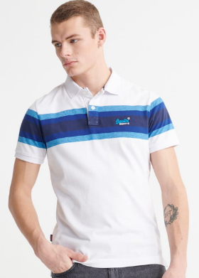
Introducing - Polo and basic (non-printed) tees –
one of the largest product categories,
first made entirely of organic cotton.

Superdry is a story, success and fashion of high-quality products created by quality fabrics, unique workpiece design in different styles

All products available at superdry.com
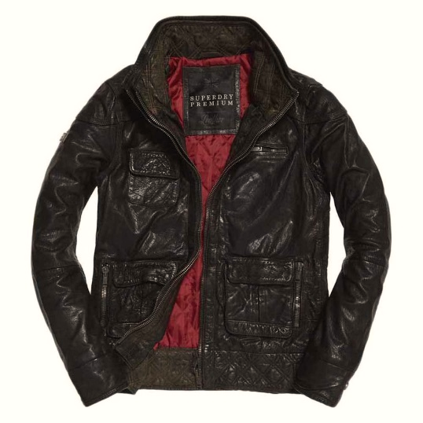
Superdry Leather Jackets - a Lifetime Investment!
Soft leather combined with incredible detail, the finest materials and stunning silhouette. Developed in a variety of styles and models:
- heavy leather and chunky zippers as the perfect outfit for motorcyclists
- soft leather, smoky colours and decorations like real jewellery
- clean design and discreet vision
- and countless other combinations

They bring to their owner's self-esteem, exceptional vision, a sense of association, and belonging to the brand, to the mission and values of the company.
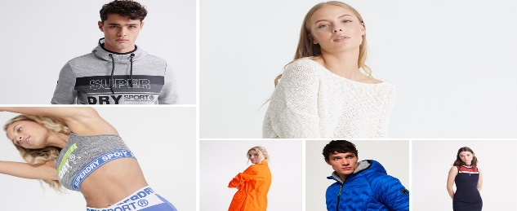
Clothes – For men, women and children Every day with Superdry - comfortable, beautiful, reasonable, responsible! Exciting design and style suitable for a broad audience, creating a fashion line for the brand with loyal, satisfied and happy customers.
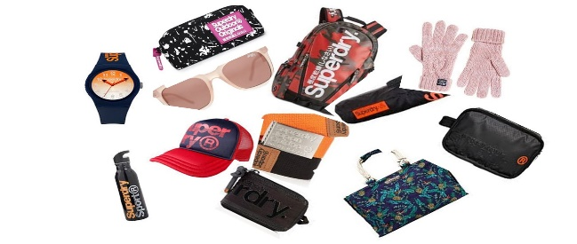
Accessories – For perfect street style, fitness, travelling abroad, school or work.
There is a rich range of backpacks, small bags, hats, belts, scarves, gloves, umbrellas, watches, glasses, water bottles, etc.
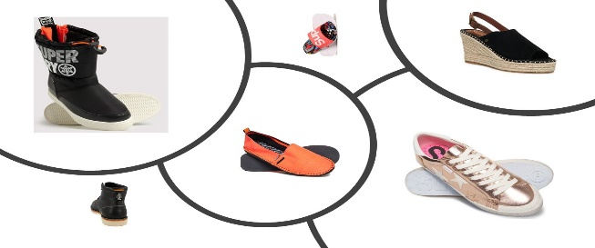
Shoes – Shoes complete the whole vision, so it's essential to find the perfect pair for you! They come in a variety of colours, styles and materials.
The brand offers fitness trainers, espadrilles, sandals, 100% genuine leather shoes for both men and women
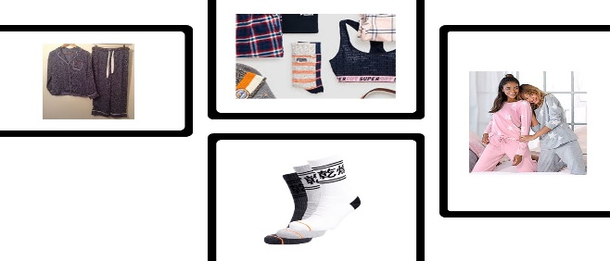
Sleepwear, underwear and socks
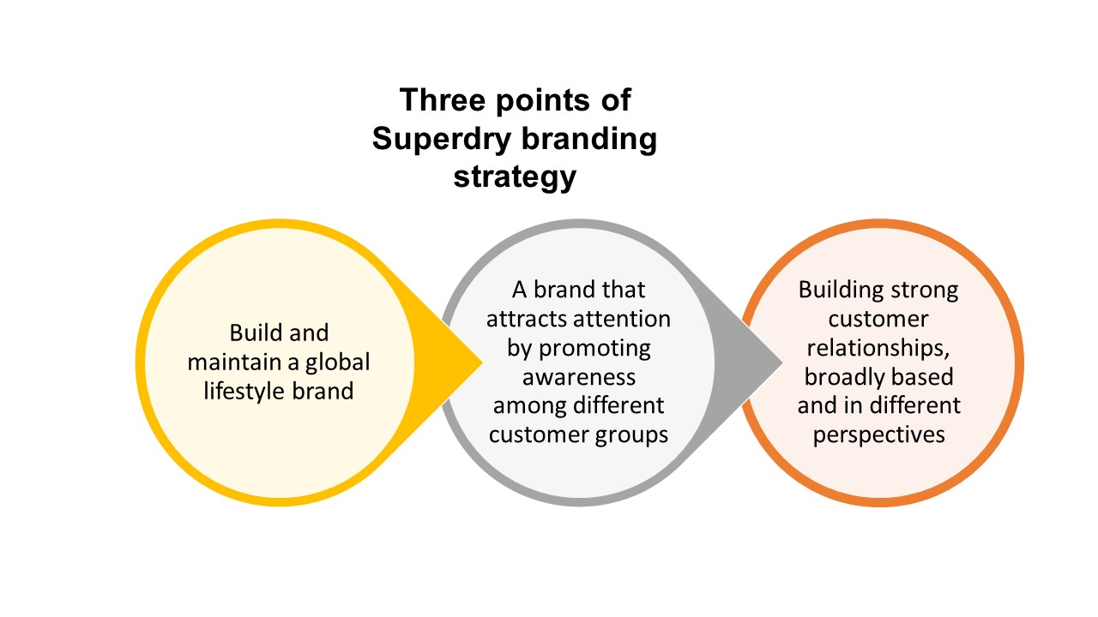
All the bedroom clothes are cotton-based, but we moved them to organic cotton two years earlier than our plan
Why us?

Superdry's teamwork is focused in several areas concerning the product line and the customer.
Firstly, an affirmation of the well-known brand products by continually working on the type and quality of the materials. At the same time, we expand our product range and enter adjacent categories.
Secondly, we are working to attract new customers by broadening the age range, socio-economic status and lifestyle.
Thirdly, we occupy new territories and markets (such as the USA and China) as we integrate their social values in our mission. We offer what is being sought in these regions.
We do not miss any part of the production cycle of the company. We strive to reduce costs and accelerate the time to bring new products to the market while we rely on the experience of our customers in contact with our products.
The Superdry business model is vibrant, generates quick turnovers and cash receipts and guarantees a good return for our shareholders.

Price
Nikoleta Georgieva 1908764

Superdry has targeted those people who want to be cool but not flashy and people who are not prepared to pay a premium price for having the brand name. The company has always tried to its prices low. The success of the organization is all because of the fact that the brand has actually identified the gap in the market to fill in. As a contemporary brand that focuses on high-quality products, we feature hand-painted graphics and authentic vintage washes. The Superdry provides a wide range of products from clothing to footwear and sportswear too.

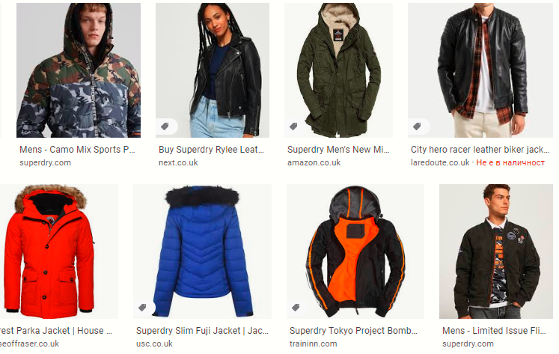Our extensive collection of leather jackets, parkas, bombers and wool jackets are available in a wide range of colours. The different ways
to style each jacket (removable hoods, removable collars and trims) allows you to modify these coats to fit any event at affordable prices.

The primary reason for the Superdry for promoting low price products is because of the availability of free advertisement the brand gets, which helps it in lower its price. This makes the Superdry products to be attractive for the customers to have it. Superdry provides products with a varied range from low to premium pricing products. The key strength of the brand is the high or premium quality products with fashion ability and product style.
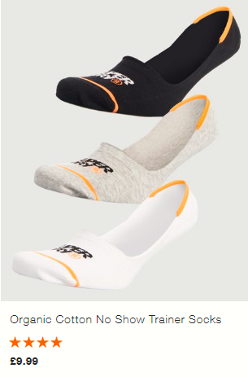
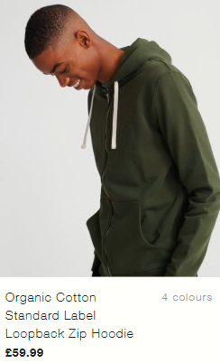
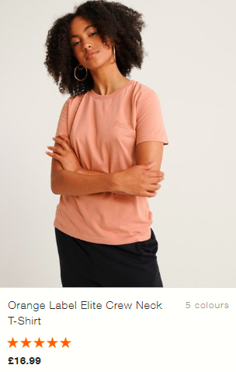
If you are looking for a combination of style and comfort, our organic cotton products are your solution. Superdry offers you a wide variety of organic cotton products starting at £ 9.99 to £ 59.99.

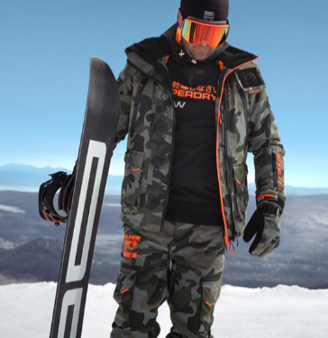For winter sports enthusiasts, Superdry offers a wide selection of competitively priced assortments. You can find complete information on the prices of these and more thousands of products online at superdry.com.
In our online store, you can find both the latest collections and promotional items. For our customers to be completely satisfied, we offer free delivery, and extended return. And for our most eager customers, we offer next day delivery priced from £ 3.95 to £ 6.95
Superdry offers products at 10-15% cheaper in comparison to Abercrombie and other competitors like Fitch and Jack Wills. The brand also provides promotional discounts to its customers so that customers of competitors can switch to it and enhance the customer experience and satisfaction level. The Superdry brand price its products zonally all across the globe for maximizing its brand image globally in each and every market (McCabe and Weaver, 2018).

Place

(Miroslava Tosheva ID:1907385)

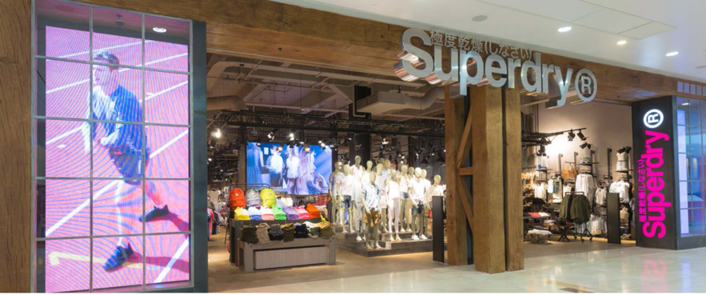
Superdry Plc design, produce and offer premium marked clothing to a worldwide commercial centre. Including an adaptable, capital-light, multi-channel way to deal with business sectors implies we can develop rapidly to expand opportunity.
Multichannel promoting is the execution of a solitary procedure over numerous channels or stages, in this way augmenting chances to interface with imminent clients. A channel may be email, a print advertisement, a retail store, a site, a limited time occasion, a portable application, SMS informing, an item's bundle, or verbal. In other words, our company is using dual distribution system.

From a little slow down in Cheltenham advertise, it proceeded to turn into a genuinely worldwide marvel and a business achievement.
Mr Dunkerton established the business with Ian Hibbs in 1985 from a market slowdown in Cheltenham and opened its first store in Covent Garden in 2004.
Superdry turned into an open organization in 2010, posting
its offers on the London Stock Exchange.

Currently we have in excess of 768 outlets in 65
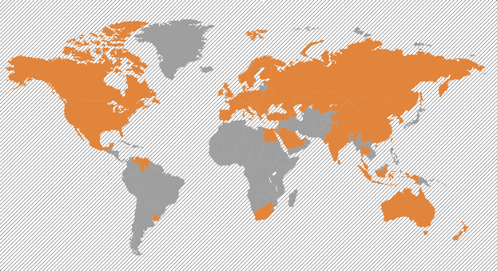
nations.

Our company keep on concentrating on growing Superdry all around, utilizing an omni-channel approach concentrated on capital-light courses to clients. In conveying this system the profit by profound experience and set up capacity in the accompanying eight courses to our customers:

- Multi-brand independents and distributors
- Franchise and licence stores in secondary catchments and developing markets
- Physical and online department stores
- Superdry branded websites
- Partner websites that build brand awareness and access a different customer base (16 in all)
- Off-price E-commerce (eBay UK, Germany, Australia and USA)
- Owned stores in primary catchments
- Outlet stores

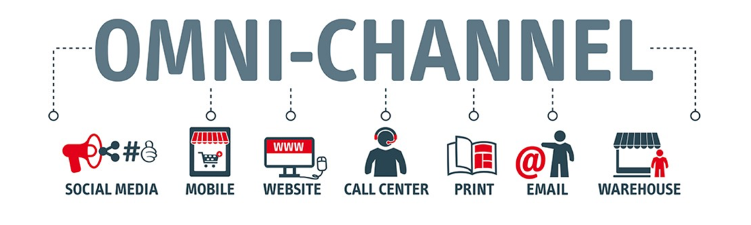

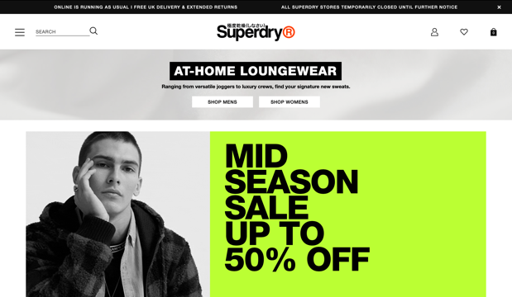
Inside the E-business channel, claimed Superdry marked sites are frequently our vehicle for beginning passage into new markets, permitting us to get to neglected client request and to fabricate brand mindfulness, with insignificant capital speculation and the capacity to satisfy orders from our consumed appropriation arrange. We have 36 worldwide sites (counting outsider sites, covering 15 distinct dialects) and will keep on quickening our online nearness to catch developing customer request.

Internet business interfaces with discount through our accomplice program, for instance Zalando, Next or La Redoute, and to stores by means of Click and Collect and ikiosk.

Promotion
Vanya Toleva 1906675

“CLEAR OPPORTUNITY TO ENGAGE AND BUILD RELATIONSHIPS WITH OUR CONSUMERS”
Our company is using the global and local partnerships such as IRIS ,Google , Facebook , Instagram , Tweeter ,Pinterest NYC collective and more. We work as well with a lot of the influencers ,they have the creative control at heart of the action to make their stories with our products. Our social media increase 129% / 2.3M fans since November 2016 AND 226& in engagements per month since November 2016.That happen when we go to the next level with social ready to assets , social to drive sales, influencers and ambassadors and partnerships with the social networks.




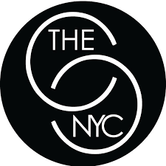


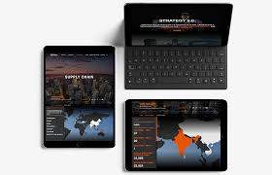
Innovation and technology

IN-HOUSE : Design team 716 grows during the last 12 months + 200 percent growth since 2015.
ROBUST SOFTWARE RELEASE CYCLE :1.5 Launches an automatic check week ,no downtime.
PROTOTYPING: Application development approach offers continuous enhancement of consumer experience.
GLOBAL SCALABLE INFRASTRUCTURE :Get the whole AWS suite worldwide to bring fast, stable browsing experience.
BEST OF BREED APPLICATIONS: Our core is tailor-made, and where appropriate we implement best value solutions.
BUG & Protection Research Using the bug finders to expand our system check coverage. Still began a bug bounty on Security Check mode.
Remove the information in red

We have two of our company which we made specially for our loyal customers one is the IDRIS brand and the GLOUCESTER RUGBY clothing range.
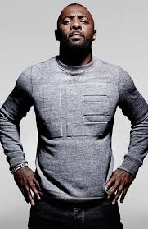
Elba Idris the brand witch its change the generation , the famous Britain The wire actor and star become a global lifestyle brand. Show that not only younger but and elder can go for that fashion and bring new collection of the Superdry company. This is the most and luxyry lifestyle clothing with the big range such as jackets , denim , sportswear and many more.


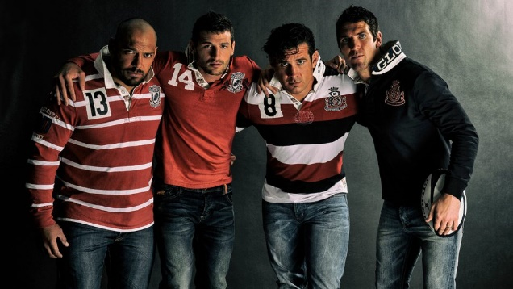
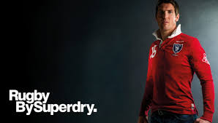
Superdry has partnered with rugby legends Gloucester Rugby to launch a premium rugby shirt range for Cherry and White fans and players, influenced by retro sports apparel and classic varsity style. The four-jersey line, influenced by the classic trends of the 60s and 70s, has been crafted with the rugby player in mind – ranging from XS to XXXL. As a famous, reputable global brand, Superdry offers Gloucester Rugby an opportunity to connect with people beyond its conventional, local fan base, particularly at such an exciting time for English Rugby. We think the collection of retro shirts would be a big success across the spectrum with our fans.


The future growth focuses on creating many websites, additional marketplaces, more product accessible, market leading proposal in Europe and the United States as well as the United Kingdom, increased investment in digital marketing budgets, new warehouses, continued weekly website launches using fast prototype model.

I have moved your references on a separate page

Reference
Aneliya Yordanova-1905211

1.Companies House (2020) GOV.UK-Superdry PLC, available at: https://beta.companieshouse.gov.uk/company/07063562 [Accessed 24 March 2020]

2.Gloucestershire Live (2020) “Julian Dunkerton battling to return to Superdry after reports of the company's share plunge” News, Cheltenham-news ,picture, available at:
https://www.gloucestershirelive.co.uk/news/cheltenham-news/julian-dunkerton-battling-return-superdry-2145896 [Retrieved 24 March 2020]

3.Gloucestershire Live (2020) BY Helen Blow (2018) 10:14, 14 AUG 2018 UPDATED21:29, 18 AUG 2018 Julian Dunkerton:” All you need to know about the Superdry co-founder who has just married designer Jade Holland Cooper”, available at: https://www.gloucestershirelive.co.uk/news/cheltenham-news/julian-dunkerton-jade-holland-cooper-1894755[Accessed 24 March 2020]

4.Superdry (2020)” Bay From the Brand” , available at: https://www.superdry.com/component/content/article/813[Accessed 24 March 2020]

5.Superdry (2020) “Our Board” , available at: https://corporate.superdry.com/about-us/leadership/our-board/julian-dunkerton/ [Accessed 24 March 2020]

6.Superdry (2020) “Our History” opened: 24, available at: https://corporate.superdry.com/about-us/our-history/[Accessed 24 March 2020]

Mariyana Mavrodieva 1908837
7.Careers.superdry.com (2020) Available at: https://careers.superdry.com/retail
(Accessed: 2 April 2020)

8.Corporate.superdry.com (2020)
Available at: https://corporate.superdry.com/about-us/
(Accessed: 1 April 2020)

9.Ryan, (2017), A brand case study: The Superdry Appeal, The branding Journal,
Available at: https://www.thebrandingjournal.com/2016/03/the-superdry-appeal/
[Accessed: 30 Mart 2020]

10.Superdry.com (2020) Available at: https://www.superdry.com/
(Accessed: 1 April 2020)

Nikoleta Georgieva 1908764
11.McCabe, M. B. and Weaver, R., 2018. Social Media Marketing Strategies for Educational Programs. Global Journal of Business Research. 12(2). pp.53-62.

12.Superdry (2020) Superdry Careers. Available at: https://careers.superdry.com/about-us/blog# (Accessed: 09 April 2020)

Miroslava Tosheva ID:1907385

13.BBC ‘Superdry co-founder gives £1m to charity’ 27 March 2018.
https://www.bbc.co.uk/news/business-43552844 [Accessed: 12th April 2020].

14.BBC ‘What went wrong at Superdry?’ 12 March 2019.
  - https://www.bbc.co.uk/news/business-47524589 [Accessed: 12th April 2020].

15.Riaz, Waheed and Tanveer, Asif (n.d) “Marketing Mix, Not Branding”,
16.Asian Journal of Business and Management Sciences, Vol. 1 No. 11 pp.43-52

17.Superdry (2020) ‘About us’
  - https://www.superdry.com/about-us [Accessed: 10th April 2020].

18.Superdry (2020) ‘Superdry Plc Annual Report 2019’
  - https://corporate.superdry.com/media/2654/superdry-annual-report-web-ready.pdf [Accessed: 11th April 2020].

Vanya Toleva 1906675

19.Corporate Superdry ‘’Capital market day,,2016 available at: https://corporate.superdry.com/media/2165/cmd_presentation_chelt_final.pdf
Accessed: 15th April 2020

20.Gloucester rugby ‘’ GLOUCESTER RUGBY AND SUPERDRY TEAM UP TO CREATE EXCLUSIVE CLOTHING RANGE’’ Available at: https://www.gloucesterrugby.co.uk/2015/07/07/gloucester-rugby-and-superdry-team-up-to-create-exclusive-clothing-range/
Accessed: 15th April 2020

21.Simon Kingsnorth, 2019, Digital Marketing Strategy : An Integrated Approach to Online Marketing , 2nd Edition .

22.This is Money, ‘Celebrity endorsements from stars including Idris Elba’ available at: https://www.thisismoney.co.uk/money/markets/article-3926648/Celebrity-endorsements-work-wonders-Superdry-sales-rocket-30.html
Accessed:15th April 2020

