BA Business Management

Accounting Fundamentals
LCBB4001

Assessment 1

Anastasia Ursu
Student number: 2024744
Submission date:26.07.2021

2021

Table of Contents

Introduction 3
Definition of Accounting Fundamentals 4
Types of Accounting 4
Accounting Principles 5
3.1. Revenue Recognition Principle 5
3.2. Historical Cost Principle 6
3.3 Matching Principle. 6
3.4. Full Disclosure Principle 6
3.5. Objectivity Principle 6
4.Practical problem solving and evaluation 6
Required: 7
a) Prepare a Profit and Loss statement for the year ended 31st December 2020 for Kedison PLC and a statement of financial position as at that date. 7
b) Why does the statement of financial position balance? 7
Solution Question 1 a: 8
b) Why does the statement of financial position balance? 9
Required 2: 12
a. Calculate the following ratios for Chocco plc for 2020 and 2019, showing the formulas and workings. 12
b. Using the information in the financial statements and the ratios you have calculated, comment on the financial performance and position of Chocco plc. 12
Solution Question 2 a: 12
b. Using the information in the financial statements and the ratios you have calculated, comment on the financial performance and position of Chocco plc. 14
Conclusion 15
References 15

Introduction
Accounting is a commercial language. It's a method for keeping track of, summarizing, and evaluating the financial transactions of an economic institution. Every business's success hinges on the ability to effectively communicate this information. Internal users, such as a company's managers and employees, as well as external users, such as banks, investors, governmental agencies, financial analysts, and labour unions, rely on financial data. Accountants must offer financial information about a company in clear, succinct reports that make inquiries like these simple to answer. Financial statements are the most typical type of accounting report.

Definition of Accounting Fundamentals
Accounting is the act of identifying, measuring, and disseminating financial information about a company in order for users of the information to make informed judgments and decisions. Accounting is the process of entering and recording data, summarising, analysing, and reporting the results. This information pertains to business and corporate financial transactions. Financial statements are based on the operations of a company entity over an accounting period, which is usually a year. Accounts are used by a corporation to assess its financial position. They contribute to decision-making, cost planning, and evaluation. Above all, accounting reports are critical to external stakeholders like as investors, creditors, and regulatory organisations. Formatting...
Financial reports and general-purpose financial statements are examples of financial information. Financial statements have the goal of providing information about an entity's financial status, financial performance, and cash flows that may be used by a variety of users to make economic decisions. Recording, processing, and presenting are the major functions.

Types of Accounting
Accounting is a set of principles and methods for calculating and reporting financial data about a company. Accounting data is used by a wide range of people, including managers who use it to make decisions, owners and investors who want to know their return on investment, suppliers who are concerned about the company's capacity to make payments, and tax authorities who use it to compute taxes. As a result, multiple forms of accounting are employed to provide the information in different formats to meet the needs of these various users.

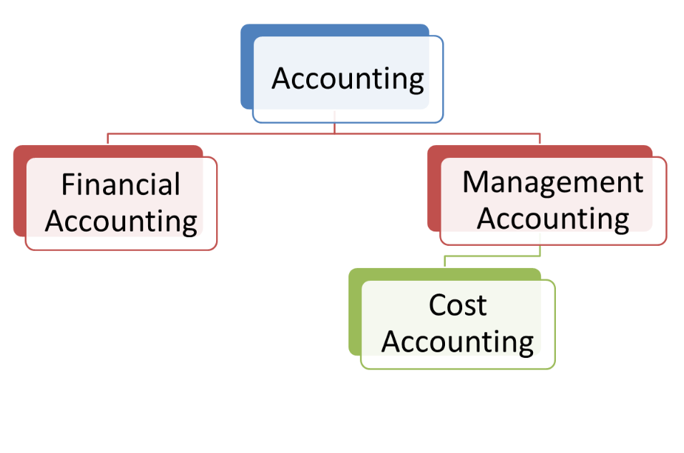

What is the definition of financial accounting?
The production of financial statements for external presentation to third parties such as investors, lenders, suppliers, and tax authorities is referred to as financial accounting.
What is Management Accounting and How Does It Work?
The word management accounting, sometimes known as managerial accounting, refers to the process of preparing financial statements and other accounting data for internal use by a company's management. Cost accounting, which is the application of costing principles, methodologies, and strategies to cost control for the sake of managerial decision making, is included in management accounting. (Wood, Frank, Stangster, Alan, 2011)

Accounting Principles

3.1. Revenue Recognition Principle
According to this approach, income is recognised at the time of transaction execution. Whether or if payment or cash is received. More significantly, the transaction of goods or services should be complete, and payment should be due. Also included are the corresponding charges that were incurred throughout the same time frame.

3.2. Historical Cost Principle
This principle states that all assets should be listed at their acquisition cost rather than their current market value. This rule does not apply to highly marketable securities. They are assigned a reasonable market value. (Jones, 2006)

3.3 Matching Principle.
This principle dictates that money produced during an accounting period be compared to expenditures made during the same time. Similarly, all expenditures associated with a sale or revenue reported in a specific quarter are only included in that period.

3.4. Full Disclosure Principle
This principle emphasises that all relevant information in an entity's books of accounts should be fully disclosed to its consumers. There should also be no wilful obscuring of information. The concept and goal are for those who are affected to be able to make appropriate and well-informed decisions based on the reports.

3.5. Objectivity Principle
All information in the books of accounts should be objective, dependable, and accurate, according to this principle. They should also be free of the reporting person's personal bias. Above all, each transaction must be supported by proper evidence such as vouchers, receipts, invoices, and other documents. (Sangster, Alan, Gordon, Lewis, Wood Frank, 2018).

(Walker, 2011)

4.Practical problem solving and evaluation
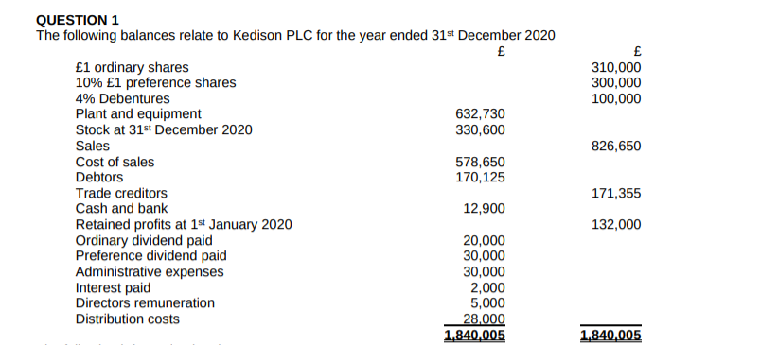
The following information is relevant:
1. Corporation tax for the year is estimated at £68,000.
2. Salesmen are owed commission of £3,000 in respect of December sales. It will be paid on 31st January 2021 and has not been recorded in the ledger accounts yet.
3. Goods valued at £980 were sent to customers on 31st December 2020. Payment is due on 28 February 2021. This has not been recorded in the ledger accounts yet.
4. The preference shares should be included within equity.

Required:

a) Prepare a Profit and Loss statement for the year ended 31st December 2020 for Kedison PLC and a statement of financial position as at that date.

b) Why does the statement of financial position balance?

Solution Question 1 a:
Profit and Loss Statement for the year ended 31st December
2020
£
Sales 827,630
Cost of sales (578,650)
Gross profit 248,980
Distribution costs (28,000)
Administrative expensive (30,000)
Salesmen owed commission ( 3,000)
Directors' remuneration (5,000)
Operating profit 182,980
Interest paid (2,000)
Profit loss before tax 180,980
Taxation (68,000)
Profit for the year 112,980

Statement of Financial Position

Non-Current assets
Plant and equipment 632,730

Current assets
Stock at 31st December 2020 330,600
Debtors 170,125
Cash and bank 12,000
513,625
Total assets 1,146 355
Current liabilities
Trade creditors 171,355

Non-current liabilities

Net assets 975,000

Equity
£1 ordinary shares 310,000
10% £1 preference shares 300,000
4% Debentures 100,000
Retained profits at 1 January 2020 132,000
Ordinary dividend paid 20,000
Preference dividend paid 30,000
792,000

b) Why does the statement of financial position balance?
A balance sheet is a summary of all your company's assets and liabilities what the business owes. It shows you how much money you would have left over if you sold all your assets and paid off all your debts at any given time. Because it gives a snapshot of your assets and obligations — and thus net worth — at a particular point in time, a balance sheet is also known as a 'statement of financial status unlike other financial statements, such as profit and loss reports, which give you information about your business over a period. A balance sheet is divided into three components, which are represented by the formula: (Atrill, Peter, Mc Laney, 2017).
-Owner's equity is equal to assets less liabilities. It's called a balance sheet because each side of the equation must 'balance' out at any given time.
-Current assets are assets that your company intends to hold for a short length of time, typically less than a year. They are as follows: petty cash currency in the bank short-term investments stock trade debtors those who owe the company money.
-Fixed assets, also known as non-current or capital assets, are assets that your company intends to keep, such as: plant and equipment modifications to the building, automobiles and office equipment.
-Intangible assets are those that cannot be touched. Any or all of the following can be found among them: intellectual property refers to the knowledge, information, or processes that distinguish your company from the competition. Patents and trademarks are formally registered concepts that add value to your company. When you buy a firm, you pay a certain amount for its reputation and performance, which is frequently referred to as value.
- Liabilities are short-term obligations. Short-term liabilities are items that you anticipate paying or may be expected to pay within the next 12 months. They may include the following: short-term loan creditors, especially trade creditors, must settle overdrafts or overdraft costs.
- After total liabilities are subtracted from total assets, owner's equity also known as shareholders equity is the remaining portion of a business that belongs to the owners. Assets minus liabilities equals owner's equity. The amount of equity accessible is determined by the company's success or failure.
- When evaluating your balance sheet, depreciation is a key subject to keep in mind. When your company uses a fixed asset, such as office equipment or a vehicle, it loses some of its value.

What's the difference between a balance sheet and a financial statement?
In that they both provide a summary of an organization's financial condition at the end of the year; balance sheets and statements of financial position are very similar. However, there are a few key distinctions between a balance sheet and a statement of financial condition. (Atrill, 2017)
- Businesses that make a profit develop balance sheets, while not-for-profit organisations create statements of financial status.
- The assets reported in the statement of financial position are also not the same as the assets reported on a balance sheet.
- Total assets should equal total liabilities and capital on the balance sheet, with capital being the difference between assets and liabilities. Assets – Liabilities = Capital is the formula utilised. (Weetman, )

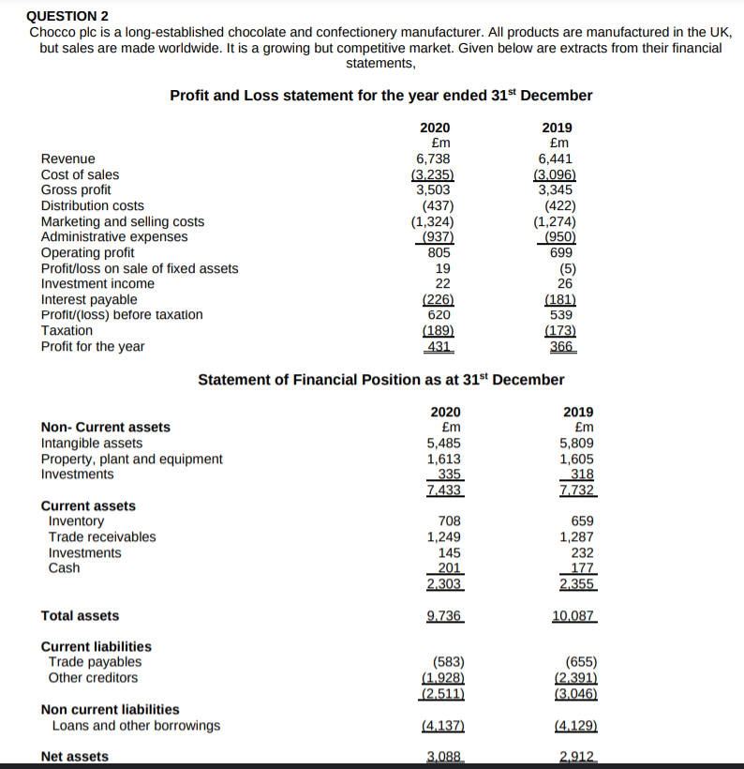

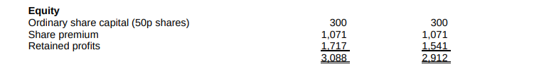

Additional information: I. During 2020 a total dividend of £255m was paid (2019: £242m)
II. The average share price during 2020 was £5.12 (2019: £4.00).

Required 2:

a. Calculate the following ratios for Chocco plc for 2020 and 2019, showing the formulas and workings.
1- ROCE
2- ROE
3- Earnings per share
4- Net profit margin
5- Asset turnover
6- Stock holding days
7- Debtors collection period
8- Current ratio
9- Gearing ratio
10- Invertor cover

b. Using the information in the financial statements and the ratios you have calculated, comment on the financial performance and position of Chocco plc.

Solution Question 2 a:
1. ROCE, RETURN ON CAPITAL EMPLOYED = Profit before interent/assets employed x 100.
2020, 805/9,736-2,511 x 100=805/7,225=11,1%
2019, 699/10,087-3,046 x 100=7,041 x 100=9.9%

2. ROE, Return on Equity=EARNINGS/ORDINARYSHARE+RESERVES x 100
2020, 431/3088 x 100=13,9%
2019, 366/2912 x 100=12,5%

3. EPS, Earning per share =EARNINGS/NUMBER ORDINARY SHARE RANKING FOR DIVIDEND
2020, 431/300=1.44 P
2019, 366/300=1.22 p

4. NPM, Net profit margin =NET PROFIT/SALES X 100
2020, 805/6,738 X100 =11.9 %
2019, 699/6,441 X100=10.8%

5. ASSET TURNOVER = SALES/ASSETS EMPLOYED
2020, 6,738/ (9,736-2,511) = 6,738/7,225=93.2%
2019, 6,441/ (10,087-3,046) =6,441/7,041= 91.4 %

6. STOCK HOLDING DAYS = INVENTORY /COSTS OF SALES X 365
2020, 708/3,235 X365 = 80 DAYS
2019, 659/3,096 X365= 78 DAYS

7. DEBTORS COLLECTION PERIOD = TRADE RECEIVABLES/CREDIT SALES X 365
2020, 1,249/6,738 X365 =68 DAYS
2019, 1,287/6,441 X365 =73 DAYS

8. CURRENT RATIO = CURRENT ASSETS/CURRENT LIABILITIES
2020, 9,736/2,511=3.9
2019, 10,087/3,046=3.3

9. GEARING RATIO = DEBT/DEBT+EQUITY X100%
2020, 4,137/4,137+3088 X100% =57%
2019, 4,129/4,129+2,912 X100% =58.6 %

10. INTEREST COVER = PROFIT BEFORE INTEREST/INTEREST
2019, 699/181 =3.9 times
2020, 805/226=3.6 times

b. Using the information in the financial statements and the ratios you have calculated, comment on the financial performance and position of Chocco plc.
In my opinion investment ratios are calculated using Choco plc's ROCE, ROE, and EPS. When comparing 2019 to 2020, we can detect an improvement in performance. Profitability ratios in 2020, the net profit margin will improve over 2019. A higher net profit margin indicates that a business is more efficient at turning revenues into profit. Efficiency ratio, an increase of 1.8 percent in asset turnover is expected in 2020. The asset turnover ratio indicates how efficient a firm is at producing revenue from its assets. The higher the asset turnover ratio, the more efficient the company is at generating money from its assets. A high day's inventory suggests that a business is unable to turn its inventory into sales rapidly. This could be due to poor sales success, or an overabundance of inventory purchased. Liquidity ratios, an increase in the current ratio indicates the company's ability to generate cash to satisfy its short-term obligations. Finance structure, compared to 2019, the gearing ratio falls by 1.6 percent in 2020. Low gearing denotes a low debt-to-equity ratio and lesser financial risk. A low gearing ratio, overall, indicates that a business is financially sound. Because the interest cover decreases, the amount of profit available to cover the debt's interest expenditure decreases. (Walker, 2011) (Atrill, Peter, McLaney, 2017).

Conclusion
To recap, accounting fundamentals are critical for business. Accounting entails recording financial transactions in books of accounts, classifying them into different heads and sub-heads, summarizing accounting data into reports and financial statements, and interpreting financial data to aid decision making.

References
Atrill, P., Mc Laney. (2017). Accounting and finance for non-specialists (10th ed.). Pearson.
Atrill, P., McLaney. (2017). Financial accounting for decision makers (8th ed.). Pearson.
Jones, M. (2006). Accounting (2nd ed.). Wiley.
Sangster, Alan, Gordon, Lewis, Wood Frank. (2018). Frank Wood's business accounting 1 (14th ed.). Pearson.
Walker, J. (2011). Accounting in a Nutshell, Accounting for the non specialist (3rd ed.). Elsevier Science.
Weetman, P.Financial accounting an introduction (6th ed.). Pearson.
Wood, Frank, Stangster, Alan. (2011). Frank Wood's Business accounting 1. Pearson.

