Katie Grandon (2403612)
Module code – BMLW4008
From learning to earning: future career plan
Preparing for employment

Table of Contents
Success in the workplace 2
Curriculum vitae 4
Covering letter 7
LinkedIn Profile 9
Bibliography 14

Success in the workplace

Success within the workplace can be illustrated in a multitude of ways due to the broadness of the term ‘success’ and the many aspects where individuals may experience this in their career. According to Cambridge Dictionary (2019), Success can be defined as “the achieving of desired results, or someone or something that achieves positive results”, so in the workplace this could be demonstrated in a range of ways. Success in the workplace may range from just straightforward, everyday tasks that eventually lead to the completion of what was once deemed as an impossible job or could even be receiving a promotion for hard work and dedication. Therefore, success within the workplace looks different to many and comes in a variety of forms. Many individuals would argue that success means to have an impact. For example, in a survey including sixty individuals, they were asked how they would define success. Many of the respondents claimed that they believe success was to be able to create a positive impact in where they can help others. Other respondents said that gaining promotions and making money was their ideas of success in the workplace (Kestel, 2022).
Some individuals a blocked from succession within the workplace due to barriers such as their work environment. This a factor to consider as to be able to flourish and succeed within the workplace, it is essential that the environment promotes growth as well as supporting you, making it a place that allows you to achieve to your full potential. According to Mayne (2025), approximately 10% of staff members feel as though they are engaged at work. This statistic reveals how often employees work ethic is a reflection of their surroundings and support systems in the workplace. Another piece of research suggests that employees are 13% more productive when they are happy (University of Oxford, 2019). Thus, workers are more likely to be inspired when their co-workers are driven and ambitious, they get some sense of recognition for their work and when their surrounded by positivity. People’s workspace is crucial as it is where they will develop relationships and allowing them to gain further qualities and skills which will aid them in succession.
Succession is somewhat a reflection of the individual and the drive that they have to make progress within their career. This being said, it is important that individuals have good qualities, skills and knowledge on their profession in order for them to achieve. Some workplace qualities include adaptability, communication and interpersonal skills, leadership, teamwork and decision-making (MVNU Communications, 2024). These skills are fundamental because they allow the individual to transmit success by using them effectively, whether it be in meetings, general tasks or recruitment processes. Furthermore, employers look for specific skills when it comes to employing someone. For example, they usually look for the individual to have planning and research skills, adaptability, resilience and relevant work experience. All of these qualities show that you are dedicated and serious about the job that you are applying for. Employers will look for these qualities to ensure that you fit their team and are able to contribute high levels of engagement. In the UK, 80% of employers were struggling to recruit due to lack of skills shown within applicants (Swain, 2023). They were having issues finding applicants with skills such as reliability, creativity, critical thinking and problem solving. This statistic shows the importance of having diverse strengths because employers are more likely to take notice of them, potentially resulting in them recruiting the individual.
Moreover, identifying personality types within the workplace is significant because it can aid employers in finding what roles fit their employees, leading to succession and limiting conflict (www.indeed.com, 2024). According to Myers and Briggs Foundation (2024), the Myers Briggs personality type assessment is made to help individuals to understand how they come to decisions and retain information. It consists of 16 personality types, some of which include the mediator (INFP), the advocate (INFJ), the executive (ESTJ) and logician (INTP). When it comes to success in the workplace, some personality types will suit certain roles. As people with the executive personality which involves them being organised, punctual and a leader, they might be fitted to management roles as they have strong leadership skills, contributing to success within teams. People with the mediator personality type tend to be compassionate meaning that they would be suited to roles that involve teamwork as their listening skills and understanding would navigate to success. Therefore, the use of MBTI in the workplace can push individuals to strive for personal growth as they know that their strengths can provide efficacy withing their role, as well as an improvement in collaboration because colleagues will be aware of each other’s abilities making communication more effective within the environment (Arnold, 2024).

Curriculum vitae

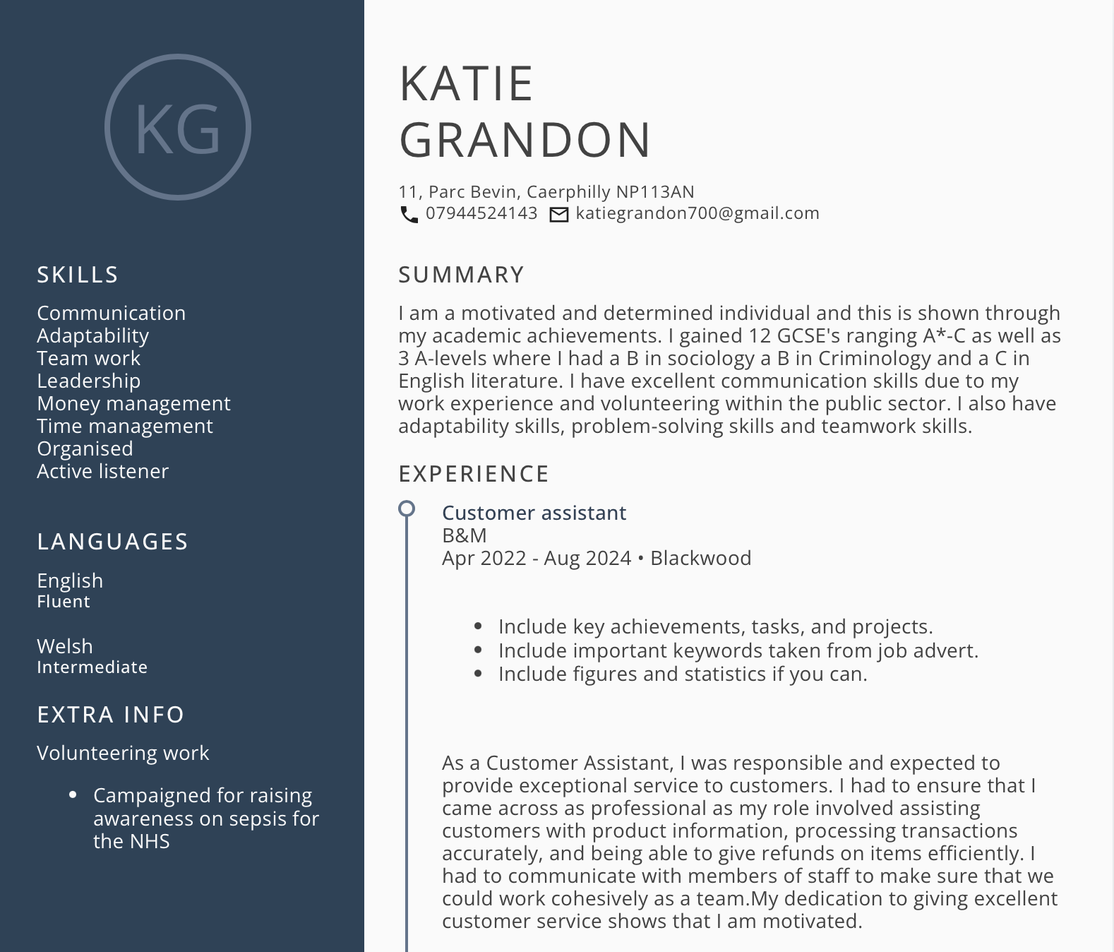

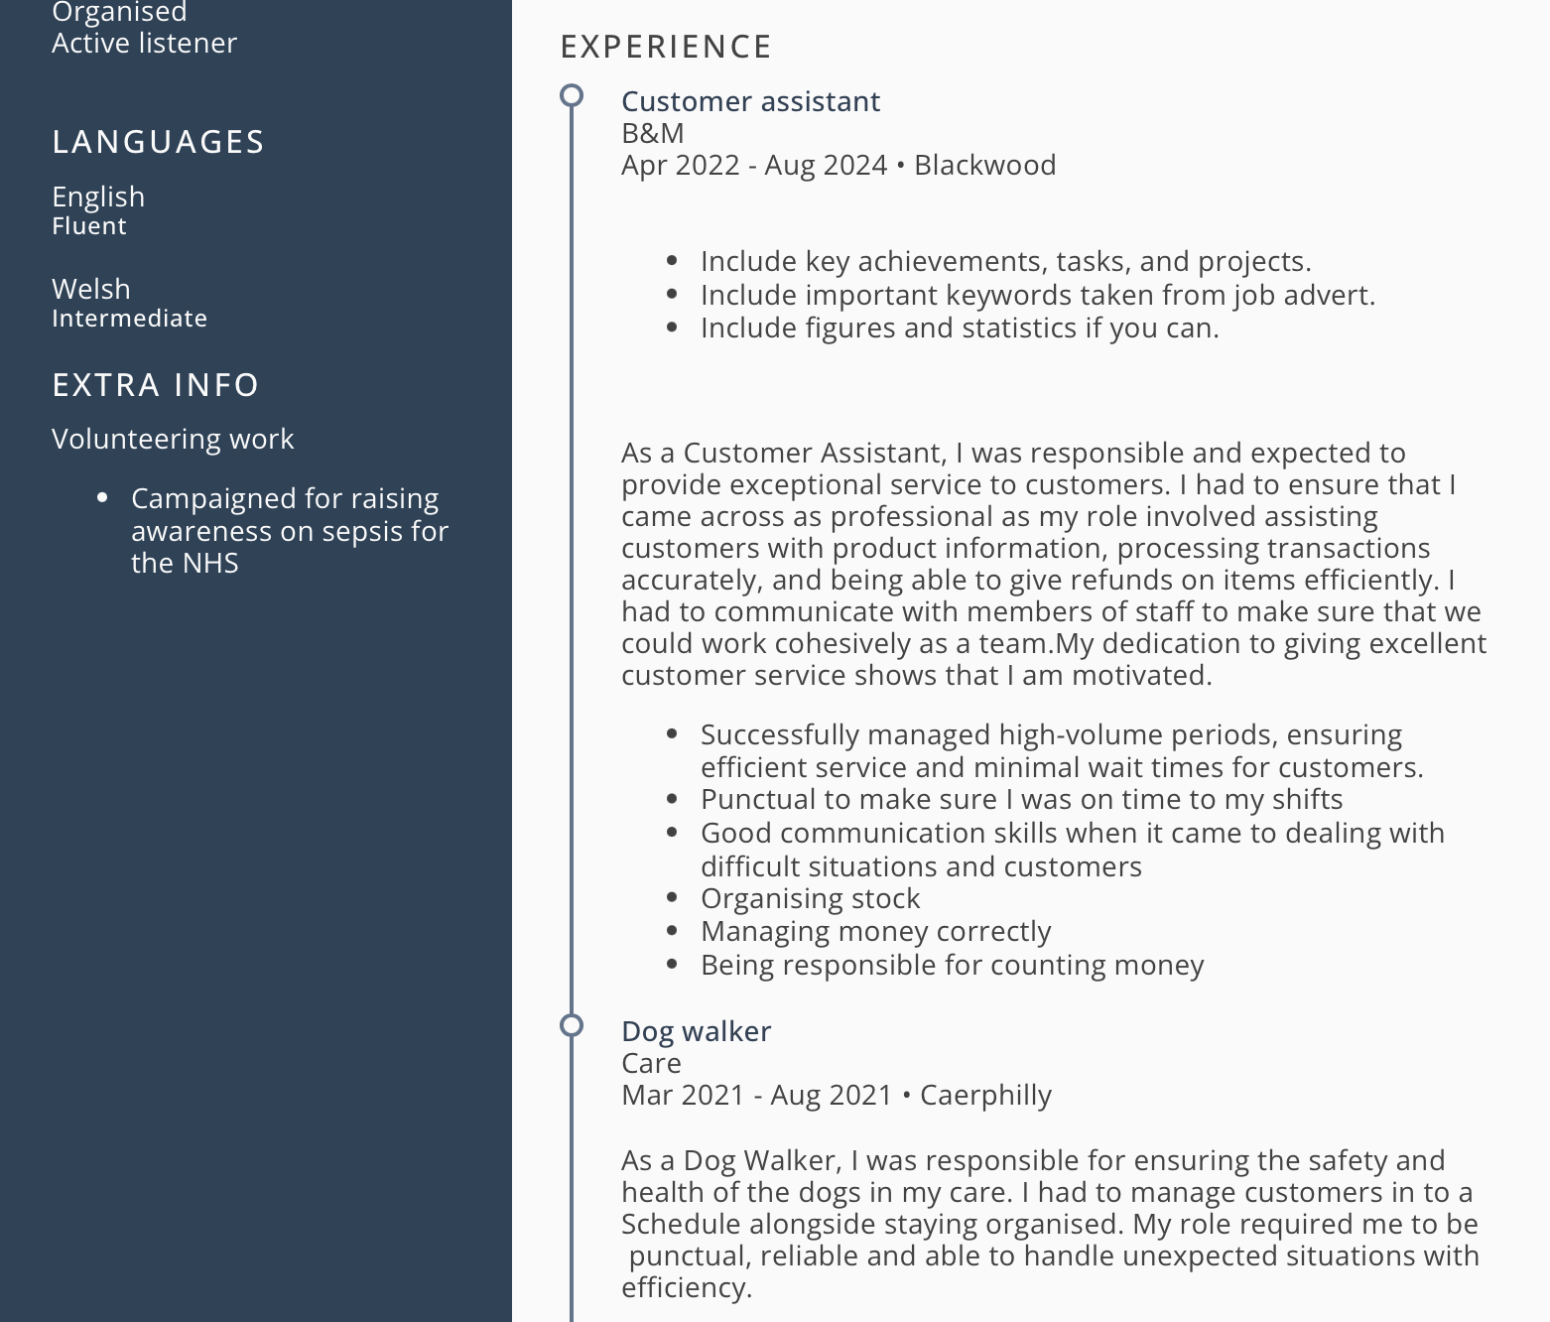

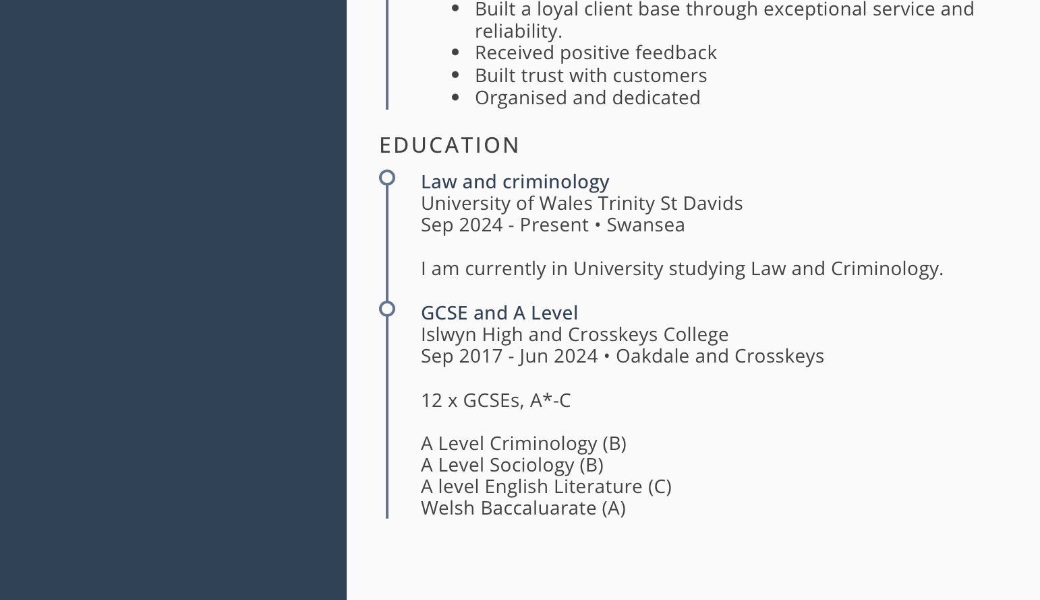

Covering letter

Katie Grandon
11 Parc Bevin
Caerphilly, Np11 3AN
Katiegrandon700@gmail.com, 07400578250
16th April 2025

Recruitment team
Boots
The Market Place, Blackwood
Caerphilly, NP12 1AU

Dear Sir/Madam,
I am writing as I would like to apply for the position for Customer Assistant at Boots store as advertised on Indeed. I believe that I have the fundamental skills that a required for this role and I am confident that I would fit the demand of the role.
I am currently studying Law and Criminology at the university of Wales Trinity St Davids and have stayed dedicated throughout my studies and is a quality that I would bring to the workplace. During my time in university, I have developed skills such as confidence, which I think is an essential skill to have in this position.
In my previous retail role, I have internalised all the essential skills such as customer communication, problem solving, handling and organising stock as well as managing money. Any issues that customers or staff propose, I deal with effectively and in a professional manner which is a large aspect of working in retail.
As you can see from my CV my experience lays in:
- Retail- Working on tills, serving customers and handling money. I was a large contribution to the team as I worked efficiently and harmoniously with colleagues.
- Dog walking- Which allowed me to gain organisational skills and time management skills.

Additionally, I have:
- Been flexible in terms of covering members of staff with very short notice
- Dealt with complaints from customers in a respectable manner
- Balanced work and study effectively

My voluntary work for the NHS improved my communication skills and adaptability skills. I have attached my CV and look forward to hearing from you.
Yours sincerely
Katie Grandon

LinkedIn Profile
Link - www.linkedin.com/in/katie-grandon-6168ba363

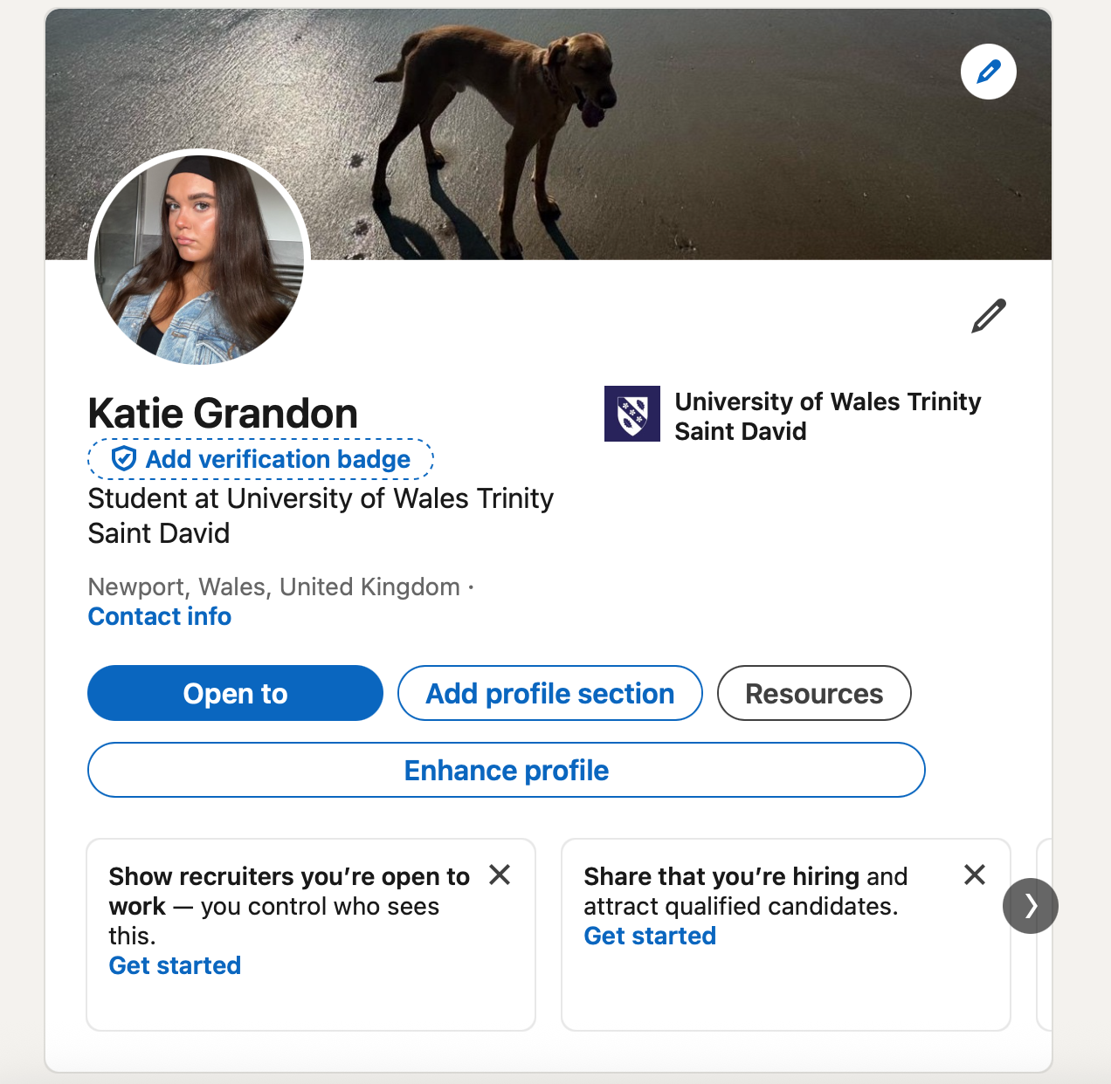
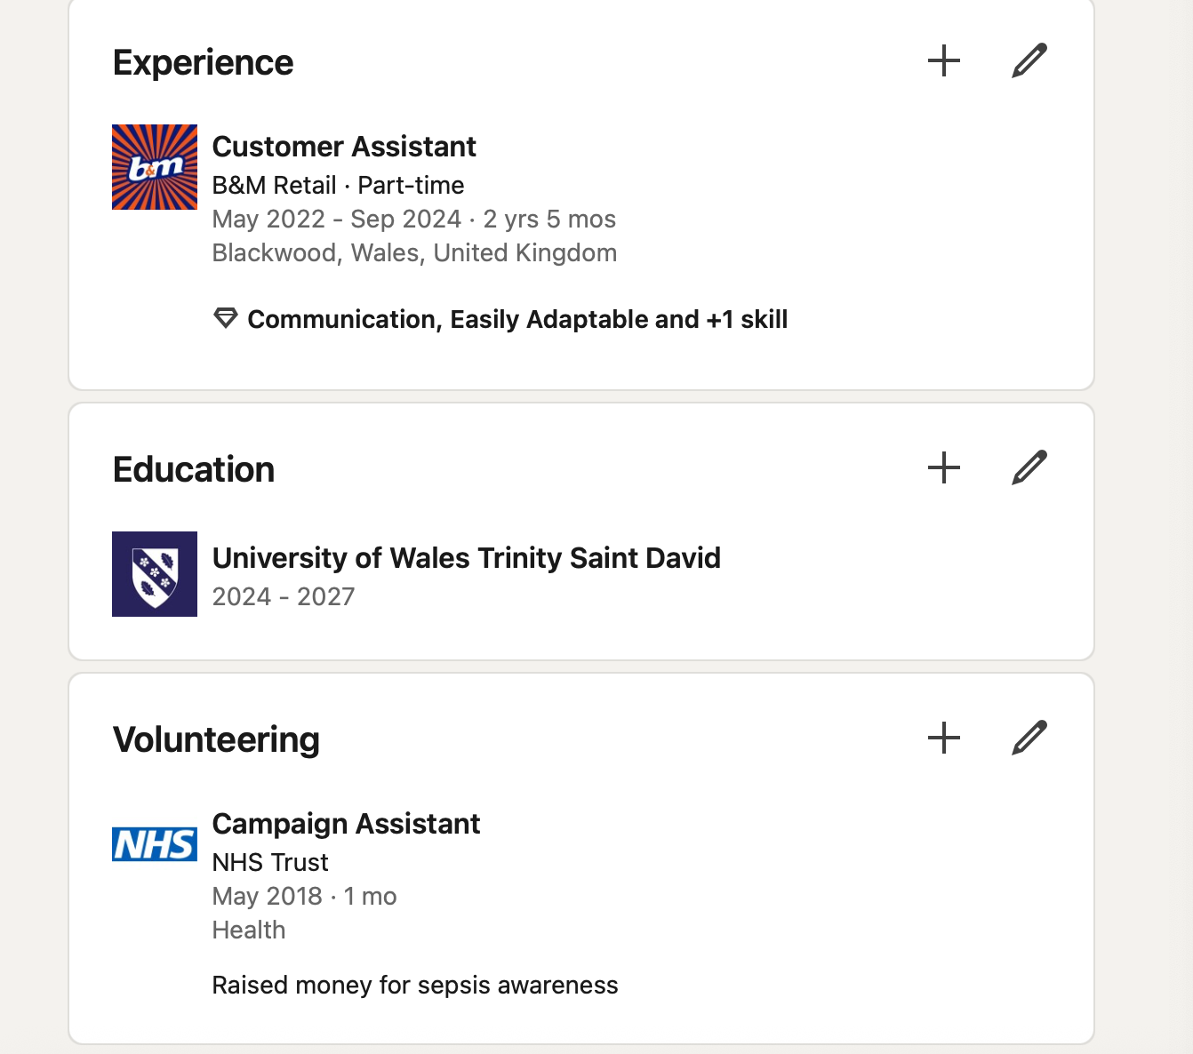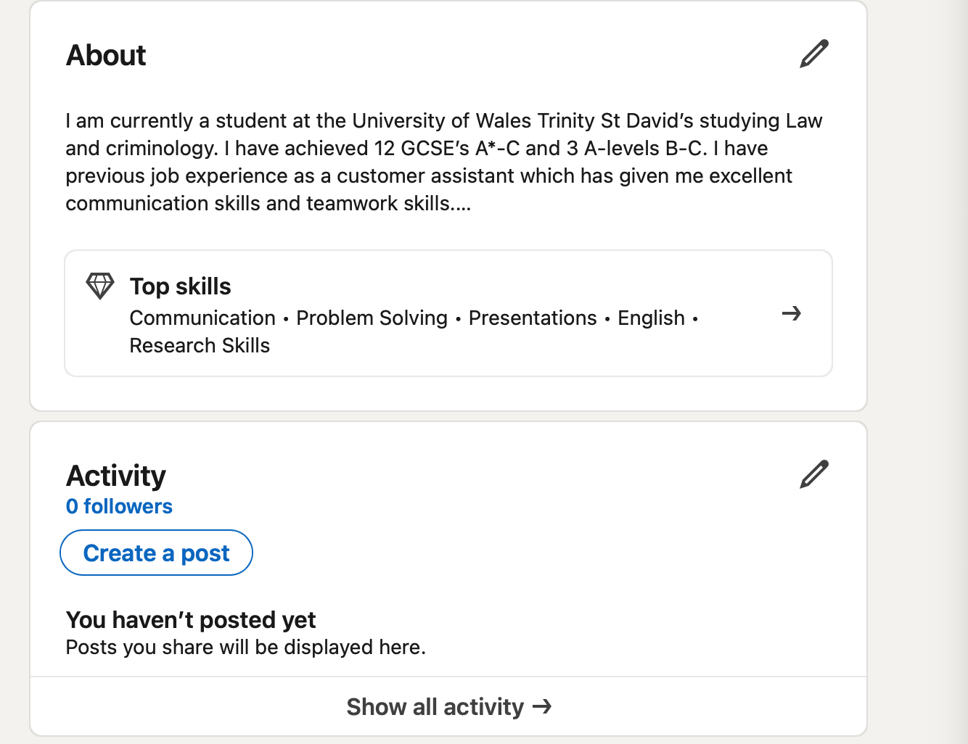

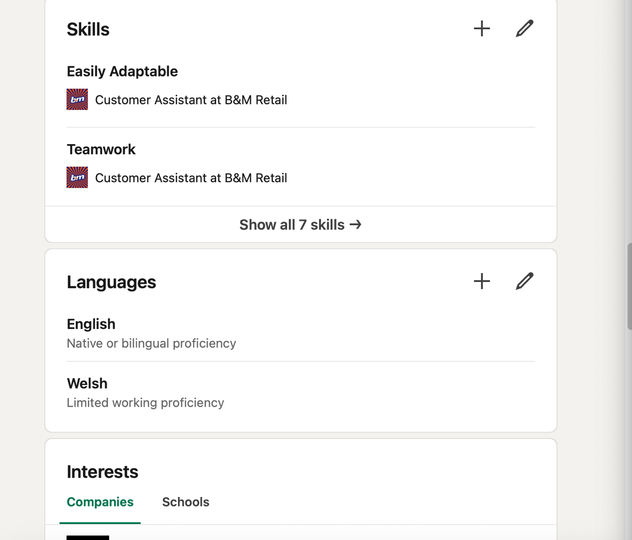
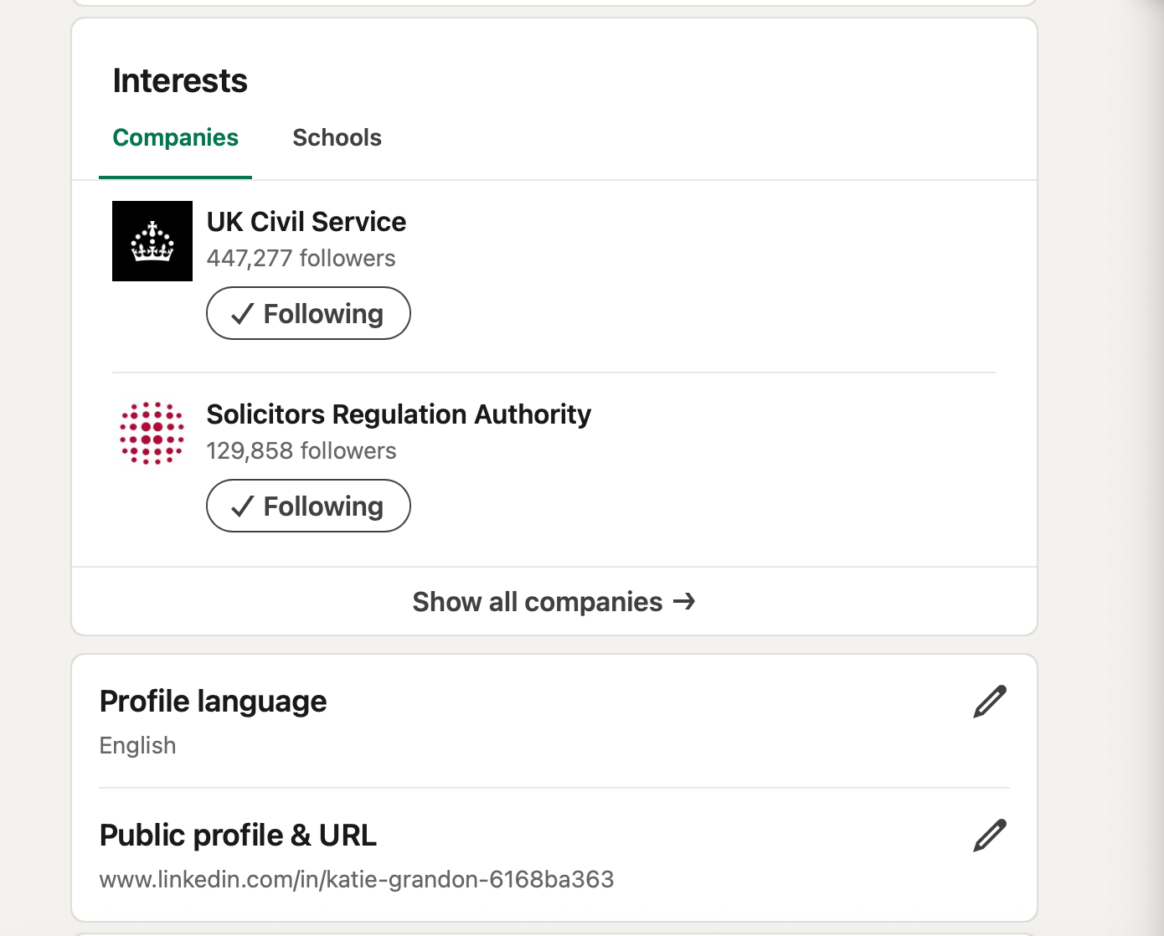

Bibliography
Arnold, J. (2024). Myers-Briggs Team Management: Effective Strategies for All Personality Types. Available at: https://atarim.io/blog/myers-briggs/ (Accessed: 16 April 2025)
Cambridge Dictionary (2019). SUCCESS | meaning in the Cambridge English Dictionary. Available at: https://dictionary.cambridge.org/dictionary/english/success (Accessed 15 April 2025)
www.indeed.com. (2024). How Myers-Briggs Assessments Can Help You Build Better Teams. Available at: https://www.indeed.com/hire/c/info/myers-briggs-assessments (Accessed: April 15 2025|)

Kestel, E., (2022). We asked: How do you define success? What does success look like for you? Available at: https://fearlessbr.com/we-asked-how-do-you-define-success-what-does-success-look-like-for-you/. (Accessed: 15 April 2025)
Mayne, M. (2025). UK workforce among Europe’s least engaged and most emotionally burdened, report shows. Available at: https://www.peoplemanagement.co.uk/article/1915475/uk-workforce-among-europes-least-engaged-emotionally-burdened-report-shows (Accessed: 15 April 2025)
MVNU Communications (2024). A Comprehensive List of Job Skills Employers Value Most. Available at: https://mvnu.edu/blogs/top-10-job-skills-employers-value/ (Accessed: 16 April 2025)
Myers & Briggs Foundation (2024). Myers-Briggs Overview. Available at: https://www.myersbriggs.org/my-mbti-personality-type/myers-briggs-overview/ (Accessed: 16 April 2025)
Swain, R. (2023). What Skills Do Employers want. Available at: https://www.prospects.ac.uk/careers-advice/applying-for-jobs/what-skills-do-employers-want (Accessed: 16 April 2025)
University of Oxford (2019). Happy Workers Are 13% More Productive. Available at: https://www.ox.ac.uk/news/2019-10-24-happy-workers-are-13-more-productive (Accessed: 15 April 2025)

