Analytical Methods Assignment 1
Module: Analytical Methods (ACHA4000)

Student name: Dylan Lewis
Student number: 2400993

University of Wales Trinity Saint David
School of Engineering

10/01/25

Contents Page
Contents
Contents Page 2
Introduction 5
Question 1 5
Question 2 9
Question 3 12
Question 4 13
Question 5 16
Question 6 17
Reference List 18

Introduction

In this assignment, I will be demonstrating an understanding of algebra and various other mathematical functions used and required in many engineering disciplines. This assignment will feature photos of the required work written on paper due to the ease of writing mathematical equations compared to using computer applications.

Question 1
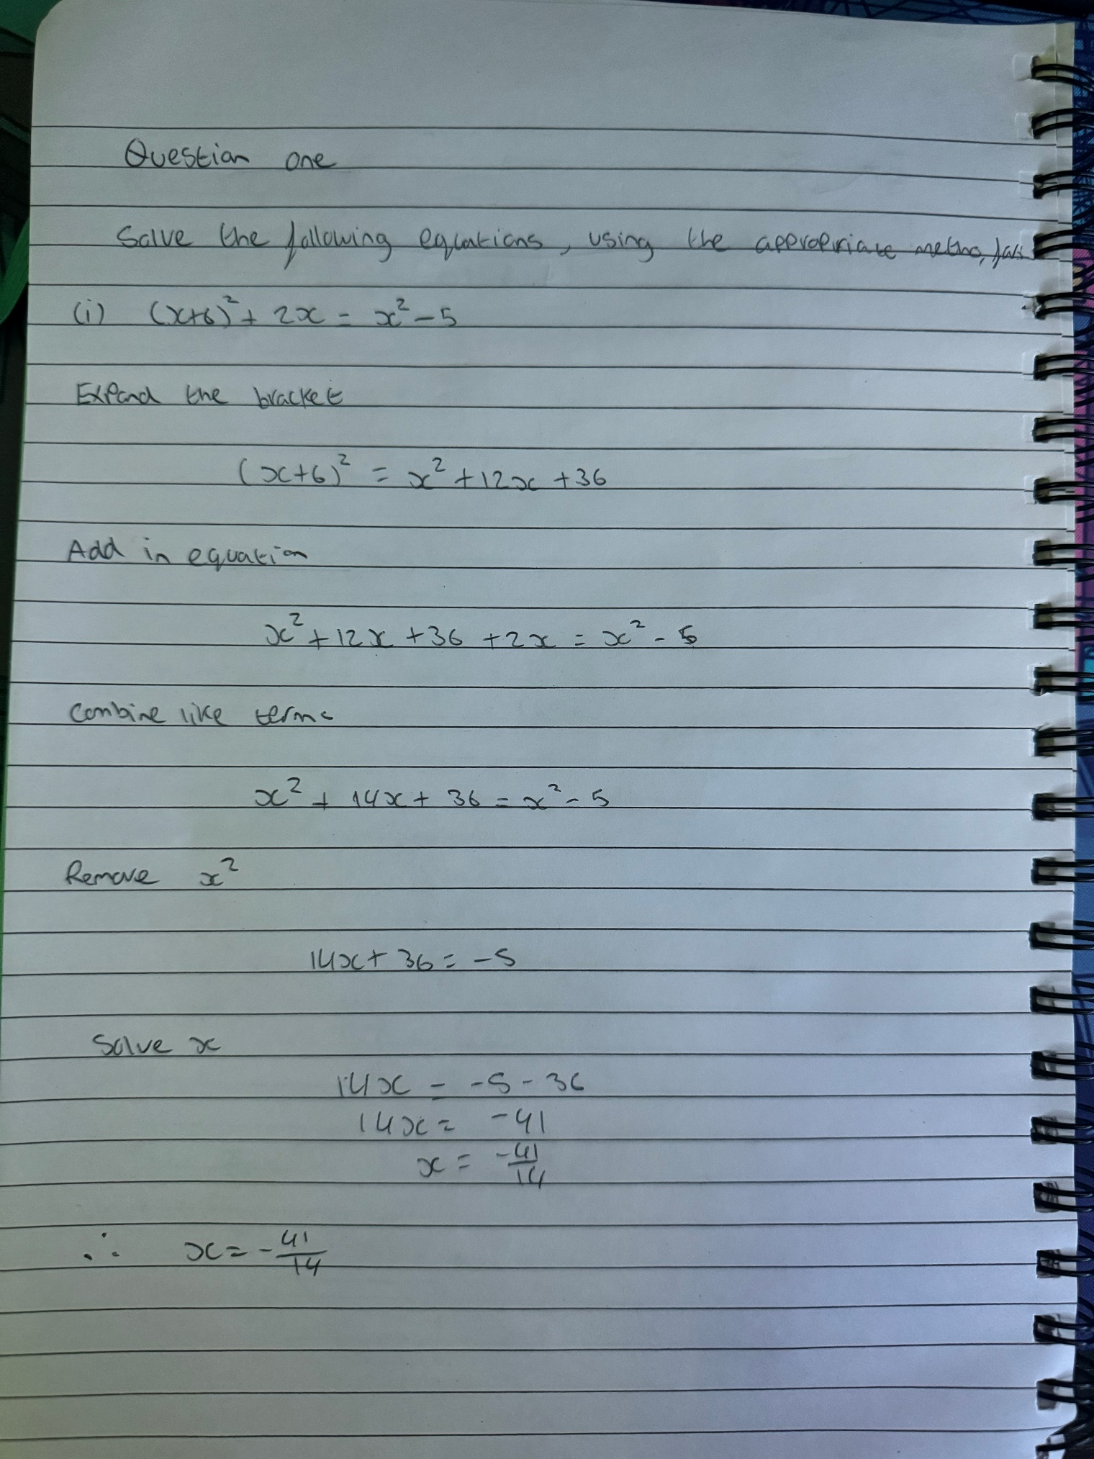
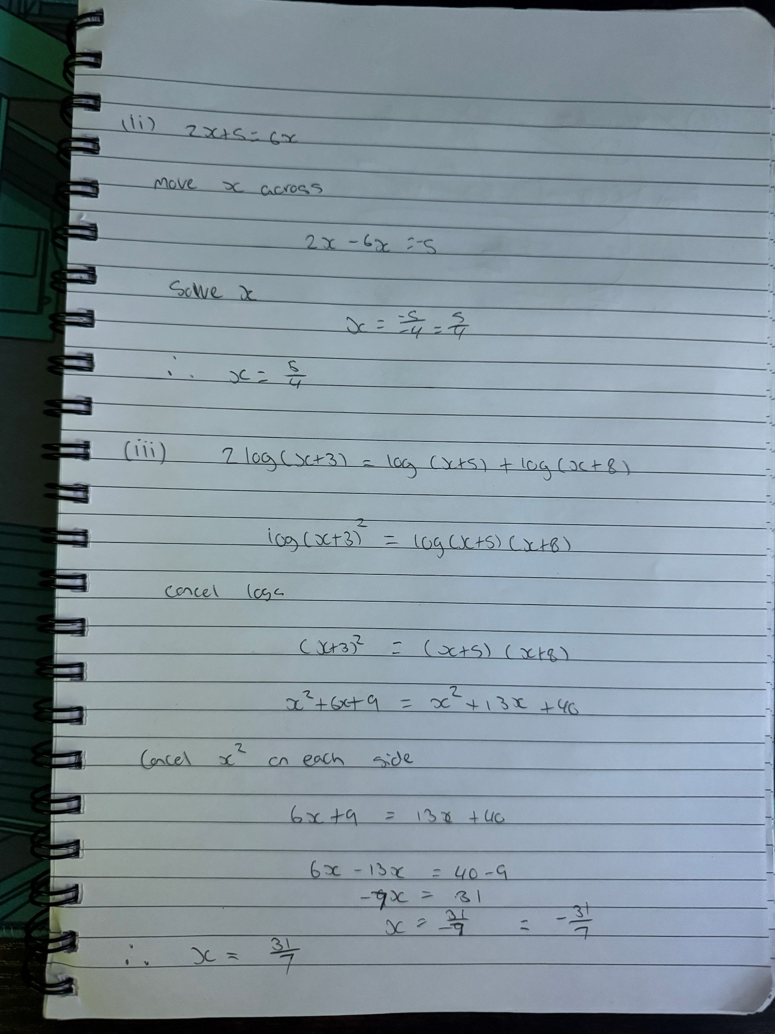
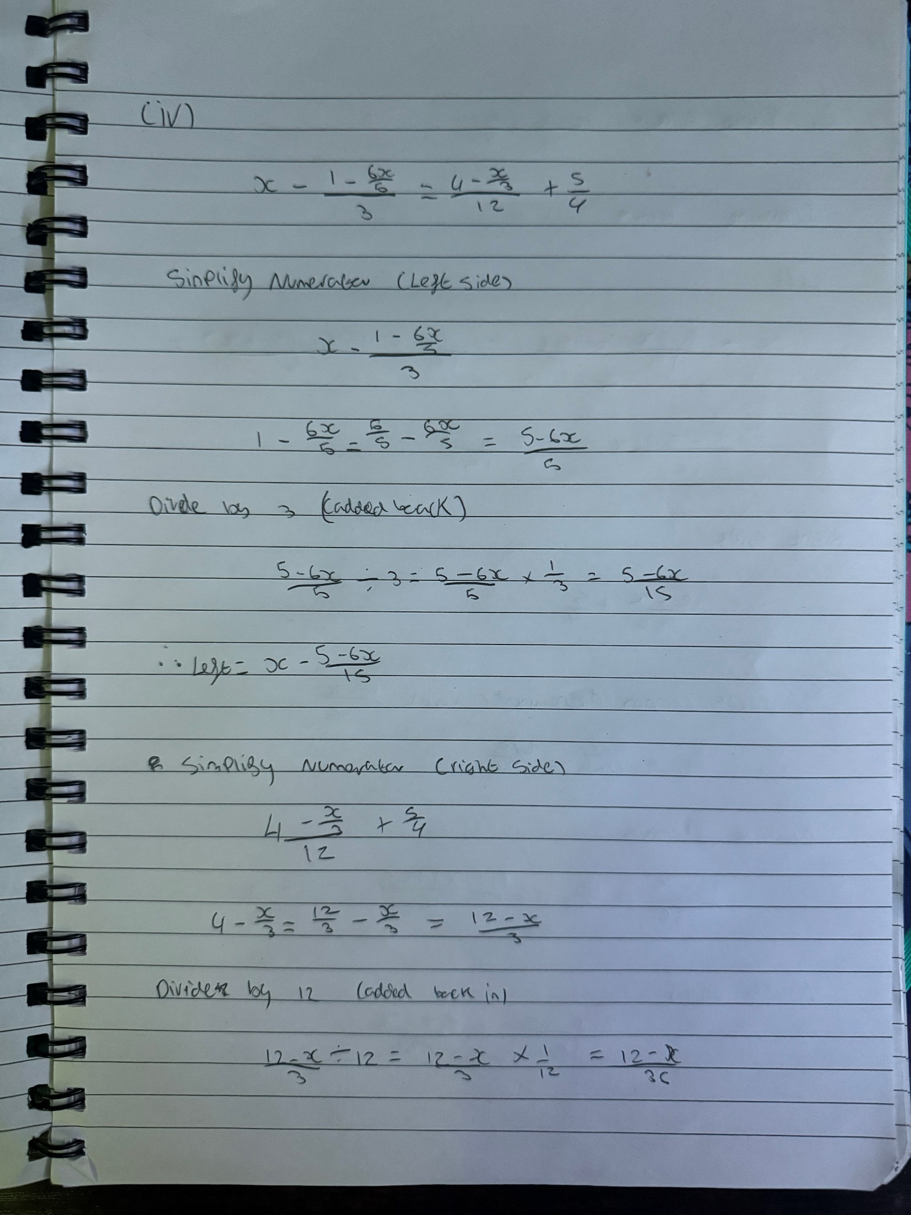
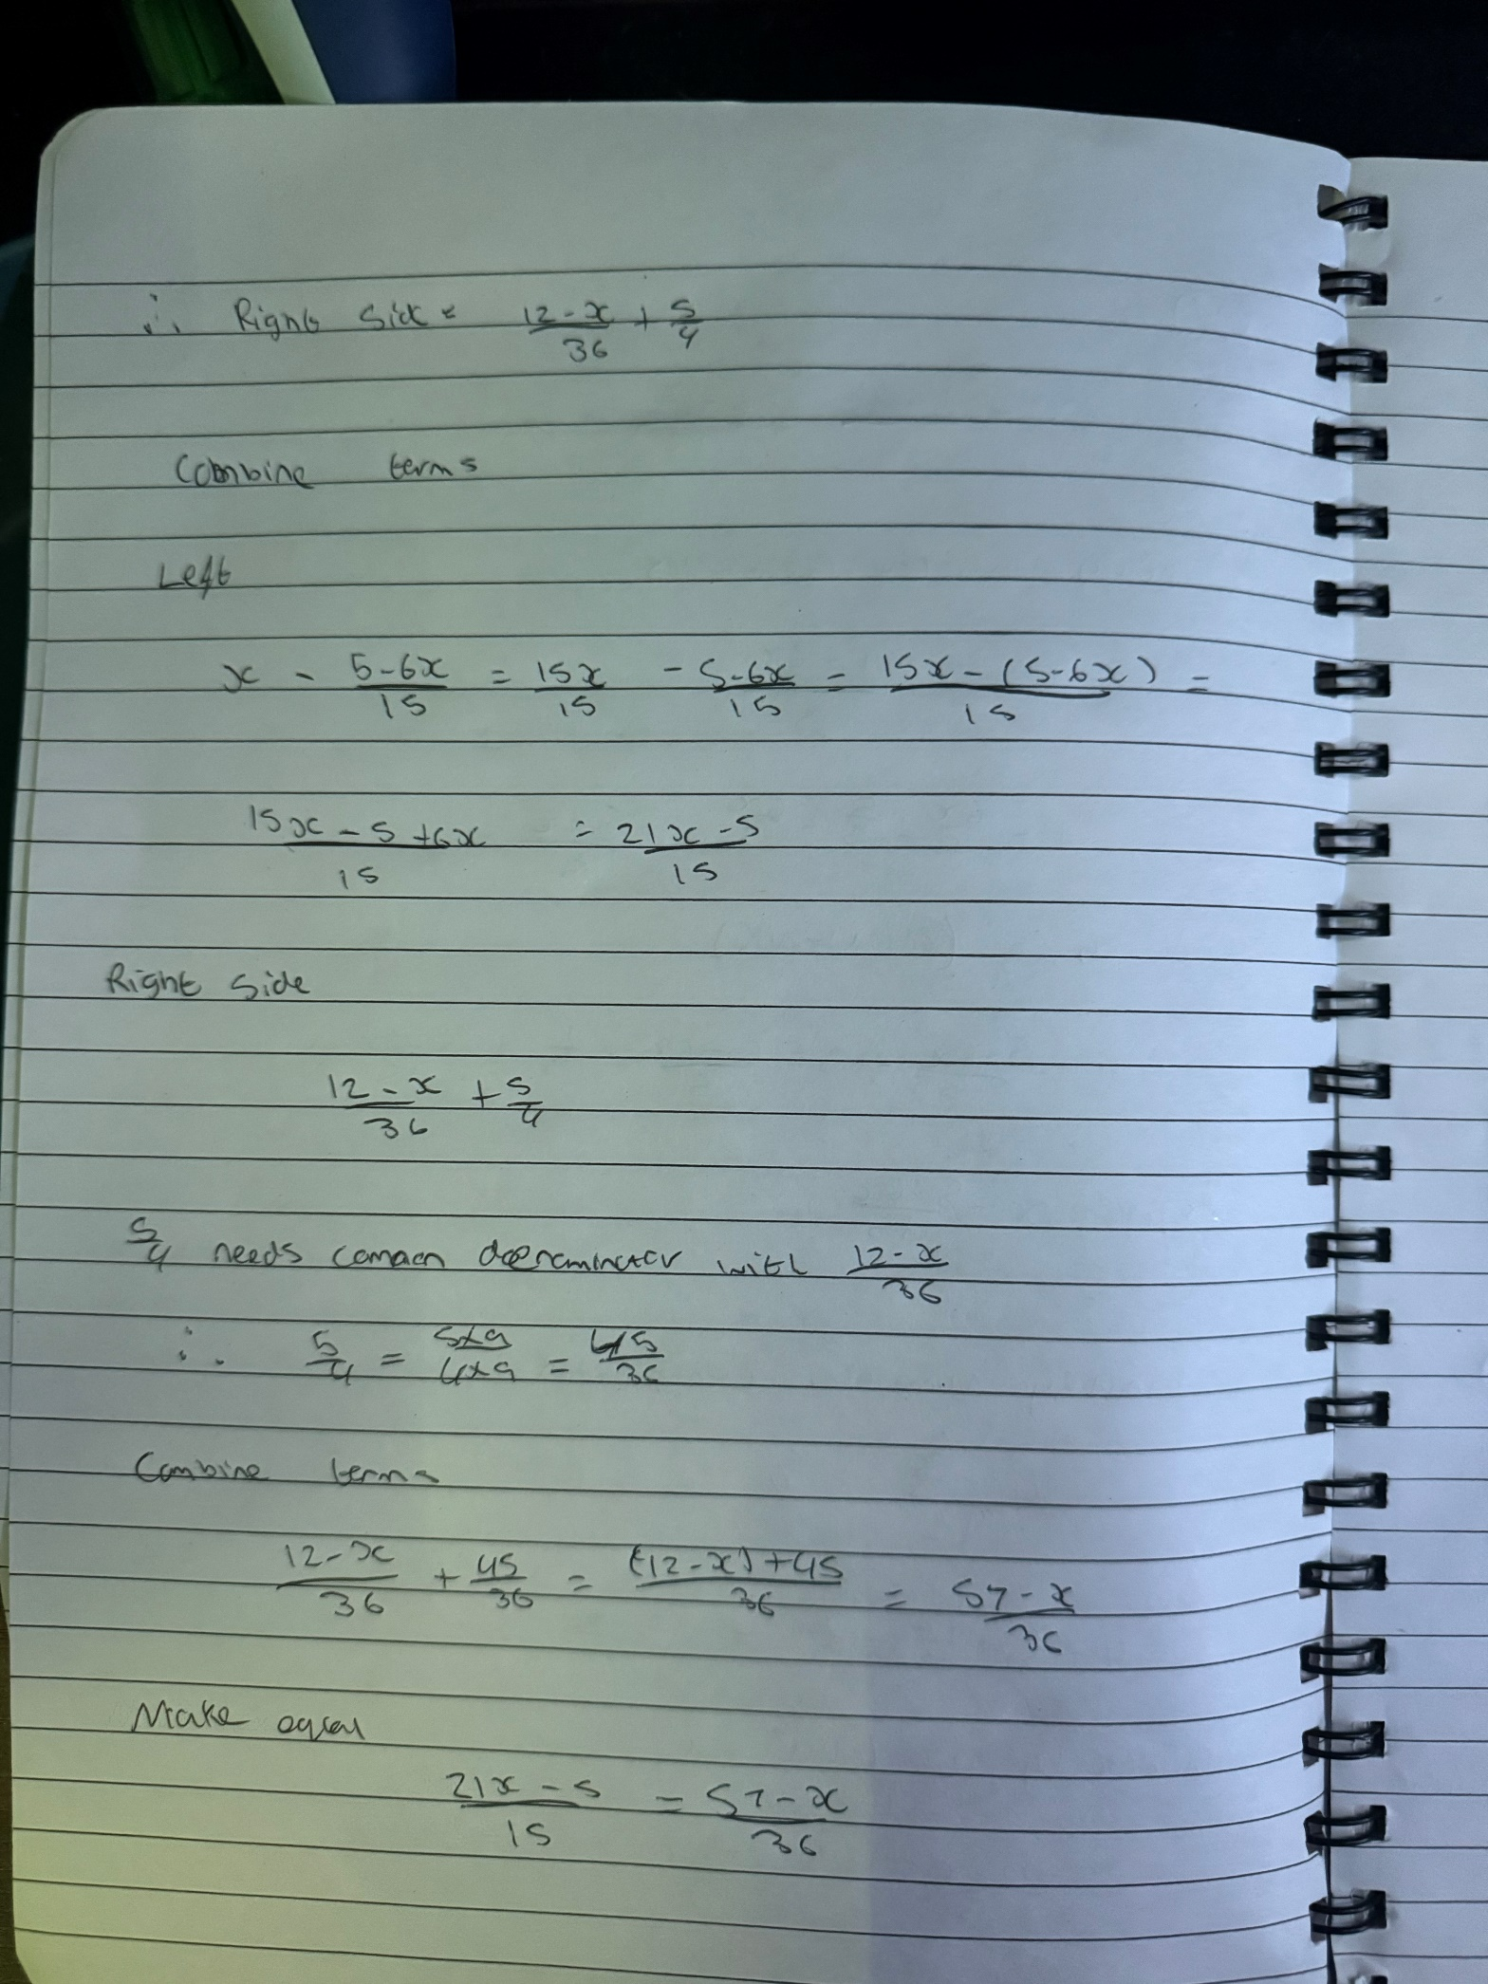

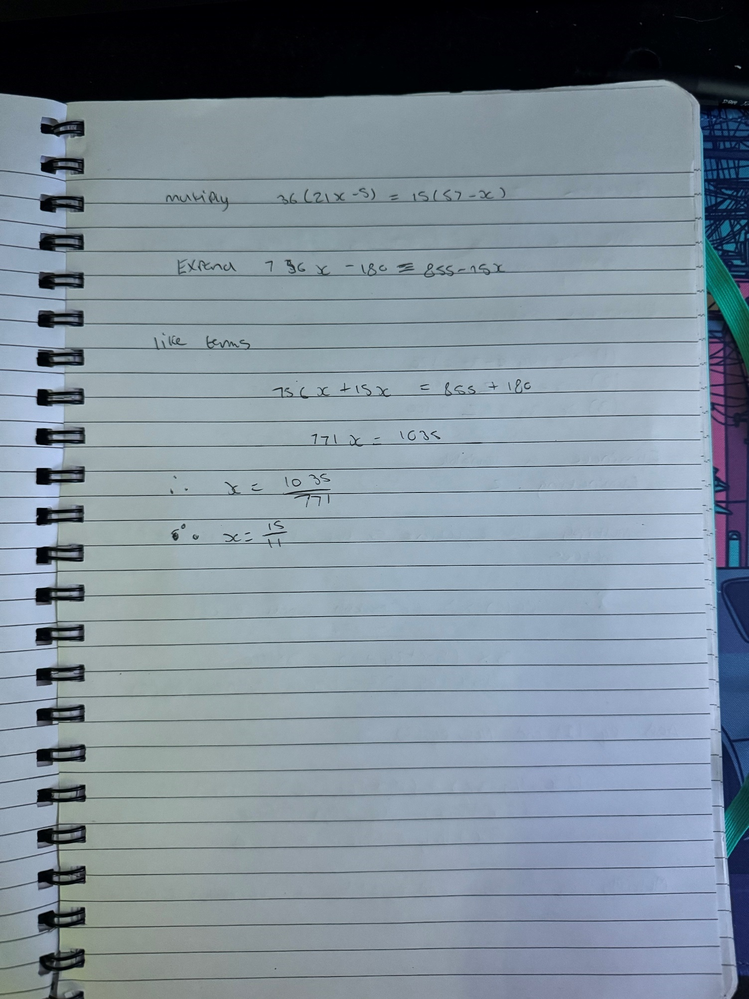

Question 2
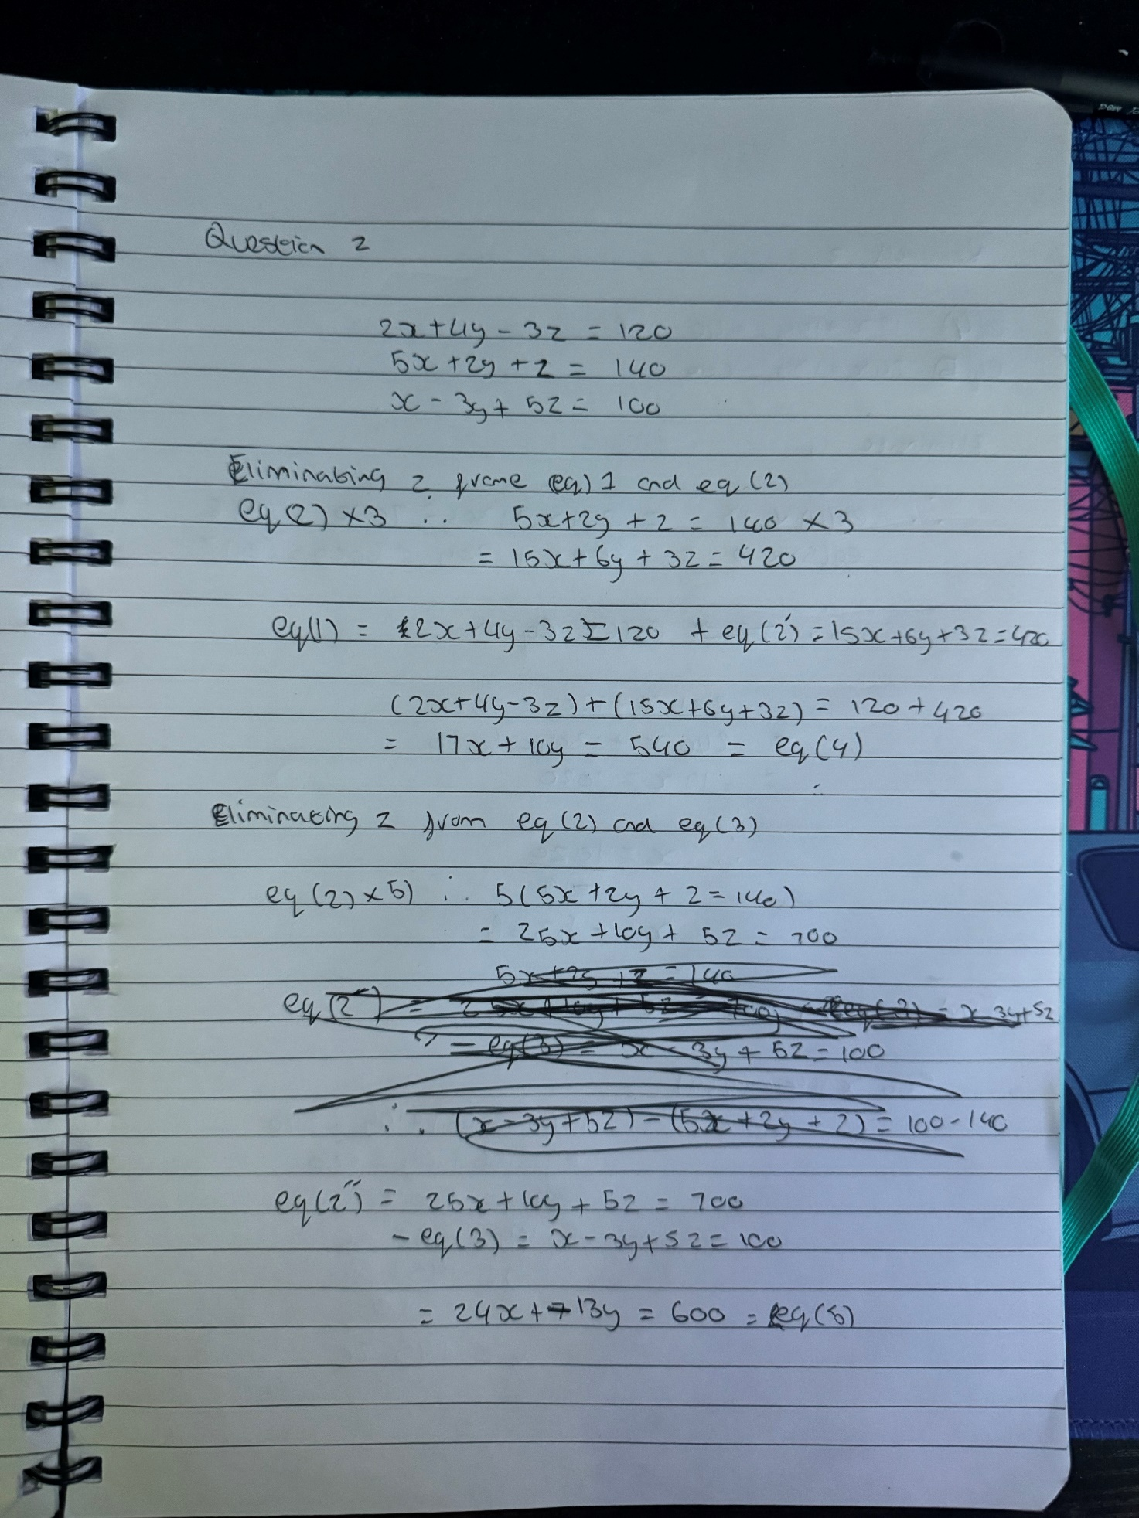
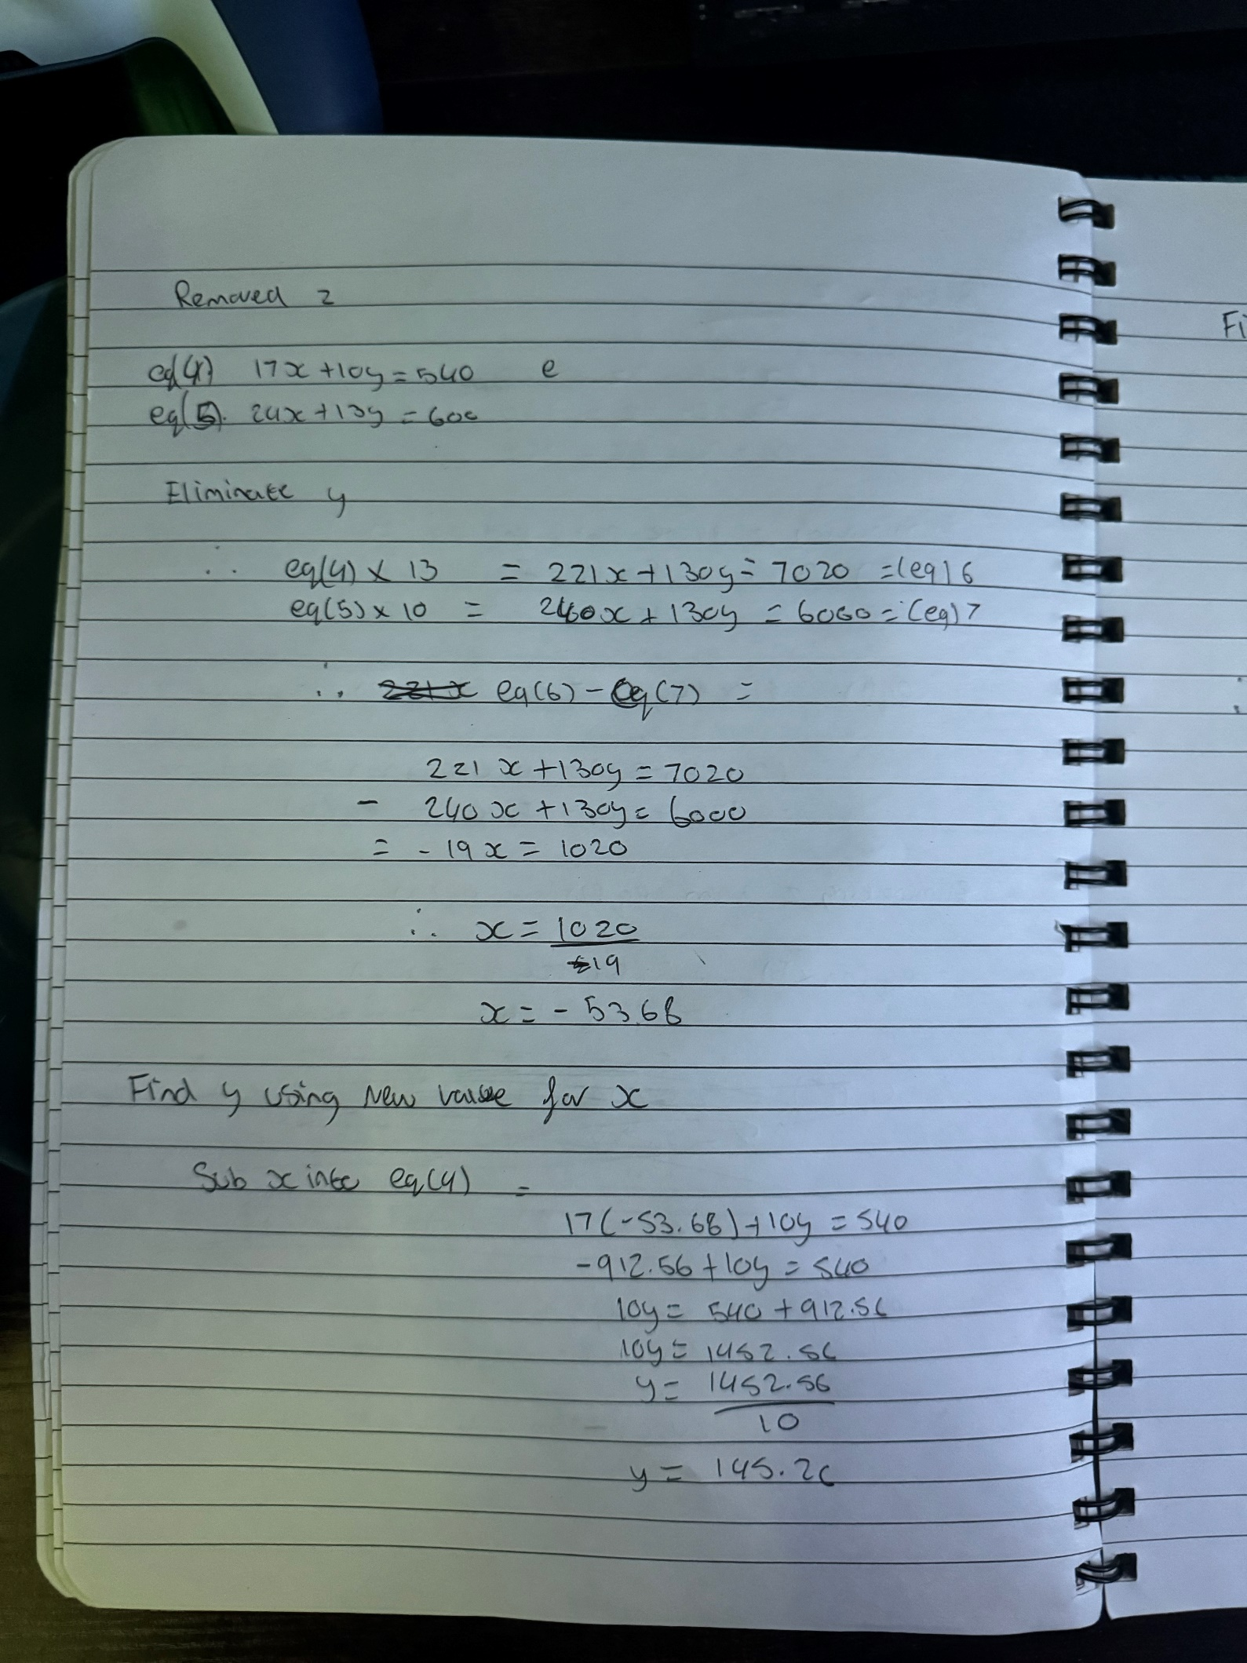
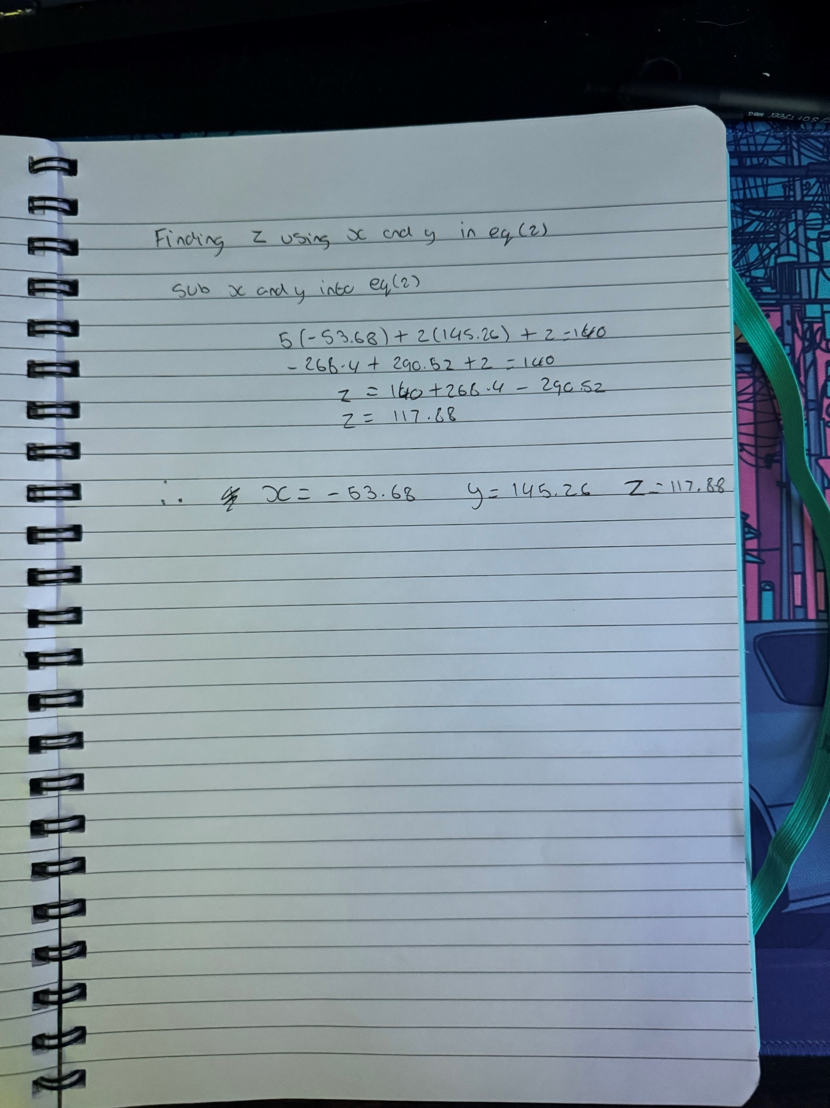

Question 3
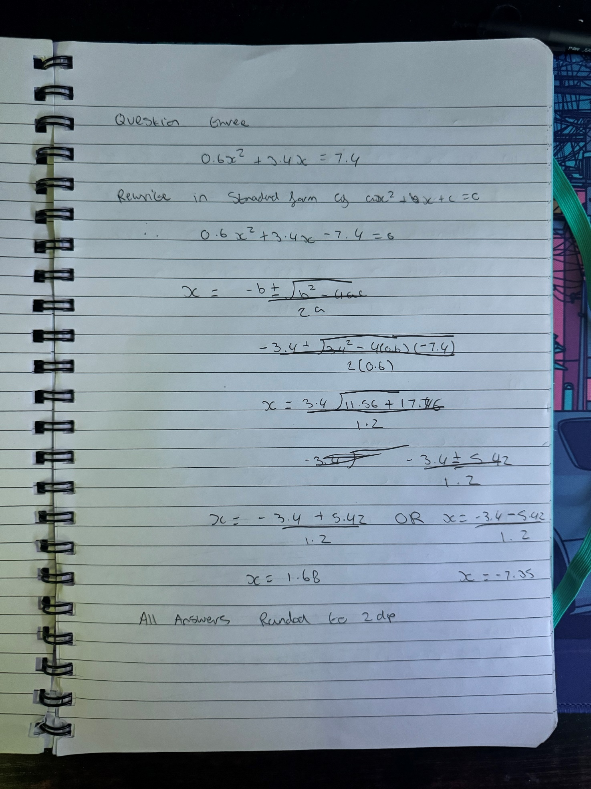

Question 4
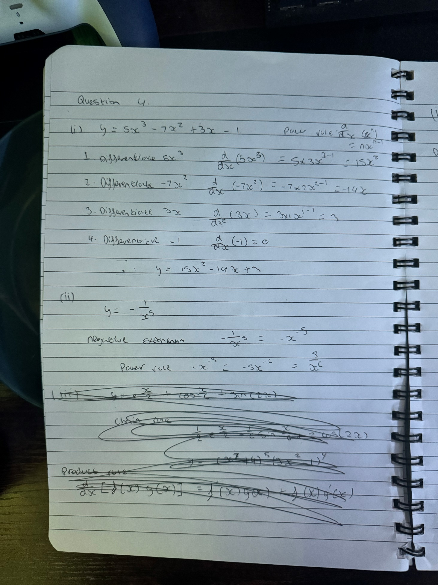

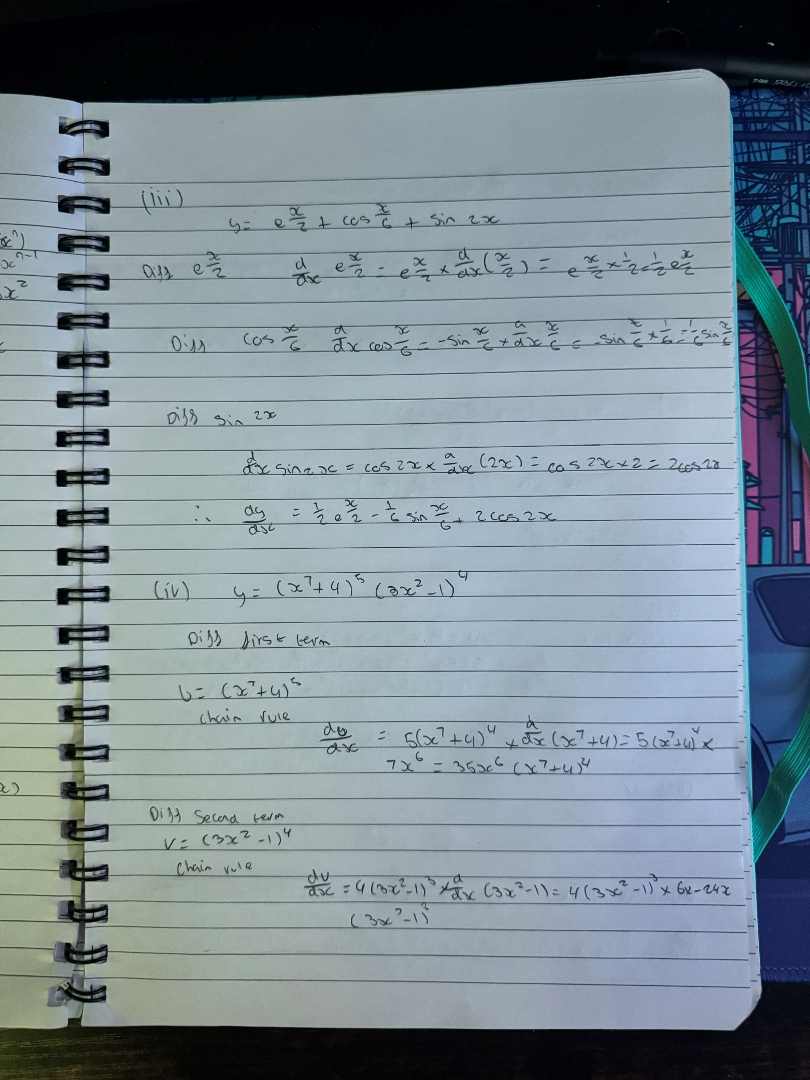

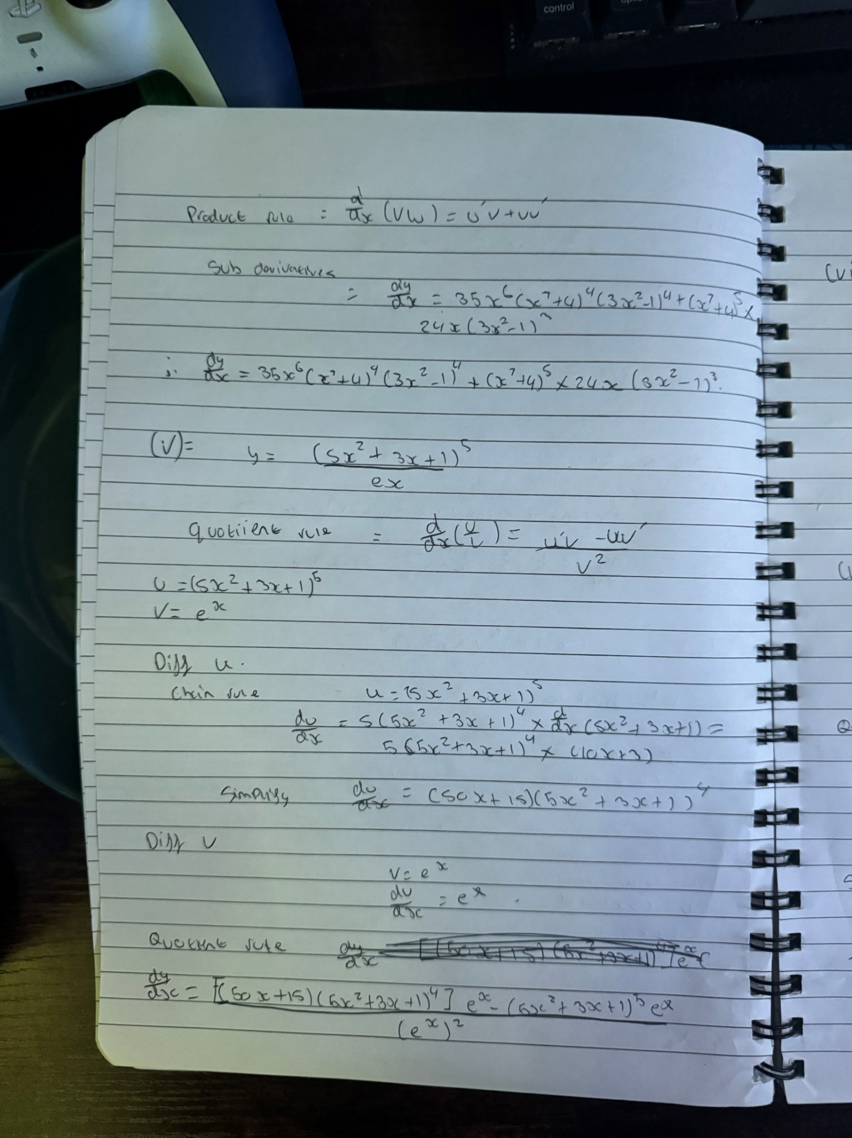

Question 5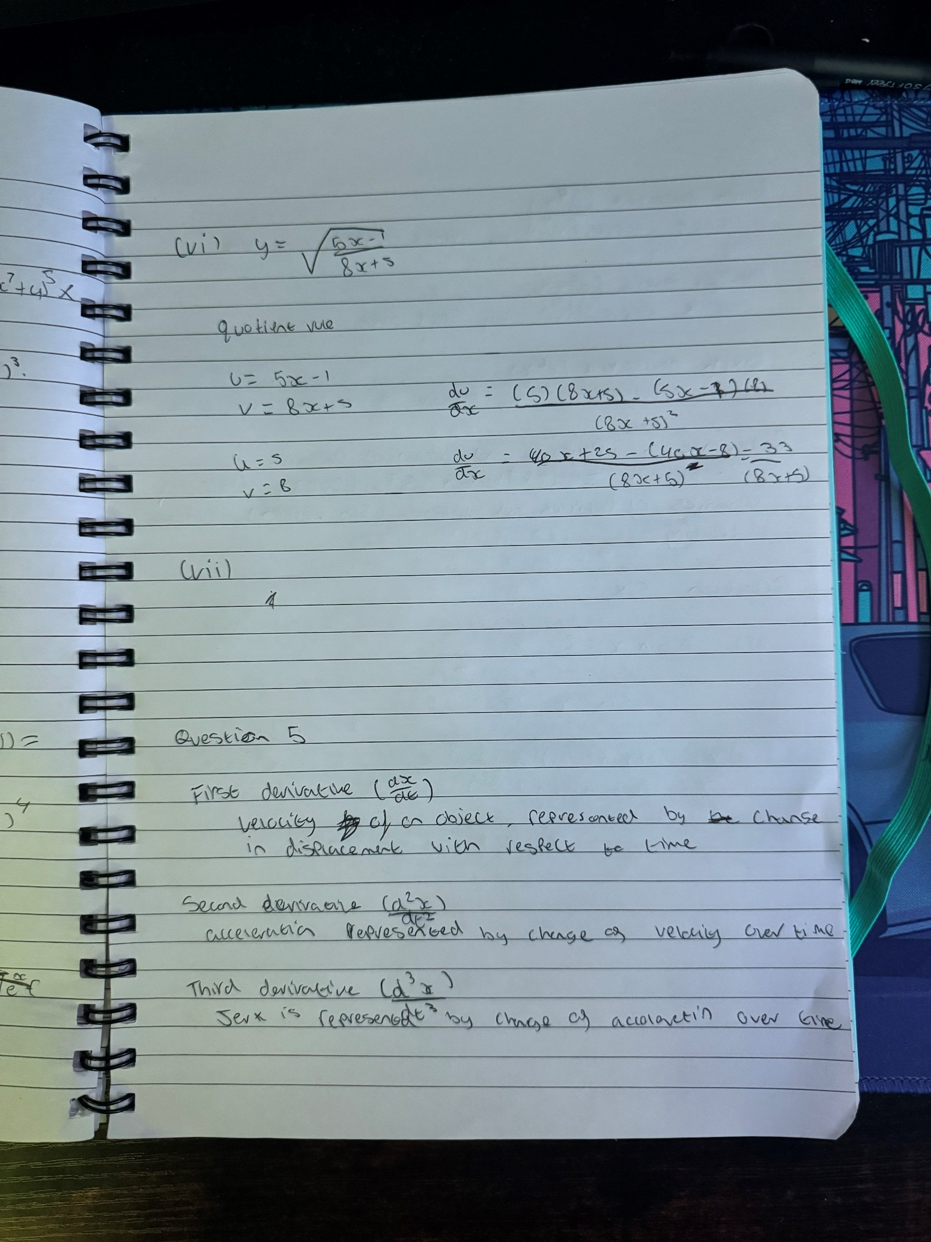

Question 6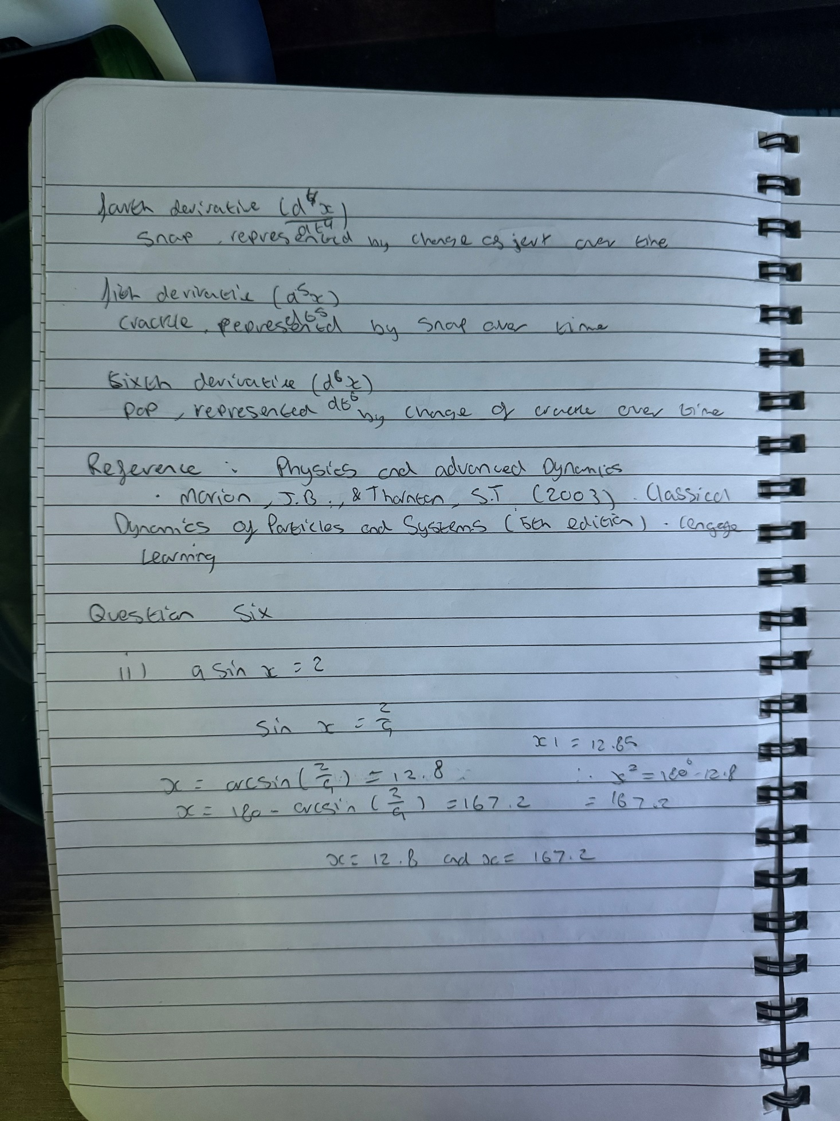

Reference List

Physics and Advanced Dynamics
Marion, J.B, & Thornton, S.T. (2003). Classical Dynamics of Particles and Systems (5th Edition). Engage learning.

