

Module name: Introduction to Public Health
Module code: LCHS4008

Student name: Rachel Amon
Student ID: 2532272

Coronary Heart Disease: A Report on a Non-Communicable Health Issue in the UK and Globally

Table of Contents
Introduction 3
Main Body 4
Incidence, Prevalence, Morbidity and Mortality 4
Determinants of CHD: Applying the 3Ps of Public Health 5
Implications for Individuals and Communities 6
Impact on Health and Social Care Provision 7
Factors Influencing Health and Wellbeing 7
Conclusion 8
References 10

Introduction
Coronary heart disease (CHD) is a condition where the coronary arteries that carry blood to the muscles of the heart are narrowed due to the accumulation of fatty material (atheroma) which causes blood and oxygen to be cut off from the heart. Narrowing may cause chest pain or discomfort (this is called angina) or a complete blockage can cause myocardial infarction (also known as a heart attack) (British Heart Foundation, 2026a). CHD is the most prevalent type of heart disease and the top killer in the world. In total, 240 million people were living with CHD in 2023 globally and CHD is the leading cause of death in the world, causing about 13% of all deaths (World Health Organisation, 2024; British Heart Foundation, 2026a). The burden is still high in the UK, despite reductions in age-standardised mortality rates over the last 30 years or more; approximately 2.3 million people in the UK are living with CHD, with an estimated 66,000 deaths annually, equivalent to 180 deaths per day; CHD is one of the biggest causes of premature death in the UK (British Heart Foundation, 2026b). Symptoms of CHD are chest pain or tightness (angina), breathlessness, fatigue, and in a heart attack, extreme chest pain that spreads to the arm or jaw, sweating and nausea. Others, especially those who have diabetes, may not have any symptoms until a major heart event occurs (NHS, 2024). This report will critically analyse the burden, risk factors and consequences of CHD at individual, community and health service level in the UK and make recommendations for policy-makers and evidence-based recommendations for the control of CHD.
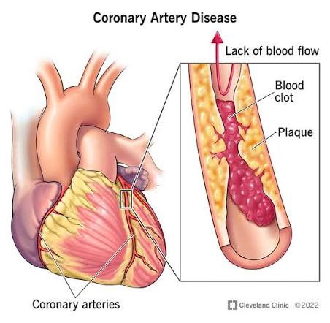
Figure 1: Coronary Artery Disease (CAD): Symptoms & Treatment, (Cleveland Clinic, 2023)

Main Body

Incidence, Prevalence, Morbidity and Mortality
Like many cardiovascular disease inequalities, there are significant social and geographical inequalities in CHD prevalence in the UK. More than twice as many women in the UK die from CHD as women die from breast cancer, with around 1.5 million men compared to 830,000 women being affected by CHD, suggesting that CHD is under-recognised as a threat to women's health (British Heart Foundation, 2026b). In the UK, one in eight men and one in 14 women die from CHD and approximately 25,000 of these men and women die before the age of 75, which is a significant proportion of working-age deaths. The morbidity burden of CHD is significant, with an estimated 100,000 hospital admissions annually in the UK for heart attack alone, and about 80% of individuals with heart and circulatory diseases having at least one additional long-term condition, typically diabetes or hypertension, which adds to the burden of care and its associated costs (British Heart Foundation, 2026b). In the UK, more than 40,000 people suffer out of hospital cardiac arrest, caused by CHD, and less than one in ten survive, highlighting the devastating effects of untreated or undiagnosed CHD.

Determinants of CHD: Applying the 3Ps of Public Health
Insights into the determinants of CHD can be gained from the three domains of public health practice, prevention, protection and promotion, and these determinants are rarely "one-behaviour or one-exposure" issues (Su et al., 2024). As a prevention strategy, modifiable risk factors such as smoking, lack of exercise, dietary issues, high blood pressure, high cholesterol and high blood sugar make up the bulk of CHD risk, and NICE (2023) highlights statin therapy and structured risk assessment (NHS Health Check) as essential preventive measures. However, the uptake of health checks within the NHS continues to be lowest in the most deprived communities, often those with the greatest risk; unless there is a commitment for access, prevention policy alone will not ensure equal outcomes. Determinants linked to protection are those that will decrease exposure to the key risk factors at the population level without requiring any change in behavior, such as tobacco control legislation, smoke-free public spaces and food reformulation policy. These have helped reduce cardiovascular death rates in the UK by half since the 1960s, but critics say the voluntary reformulation initiatives for salt and saturated fat have not achieved as much as the mandatory tobacco regulation, meaning that protection strategies work as well as they are actually enforced (Garrett et al., 2014). Promotion activities are designed to develop personal capability and awareness, e.g. physical activity campaigns and education about cardiac health. But, as in the case of obesity, promotion alone will not overcome structural inequality. The Marmot Review (2020) shows that the social gradient in cardiovascular mortality has become wider in the most deprived areas of England, suggesting that the determinants of CHD are acting at the individual, environmental and structural levels.
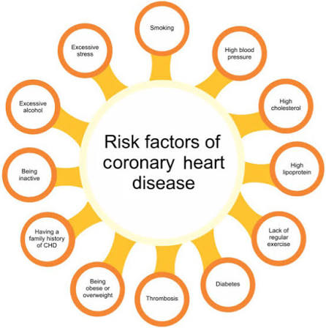
Figure 2: Social determinants of health, (El-Baz and Suri, 2021)

Implications for Individuals and Communities
The consequences of CHD on the individual are immediate, such as chest pain that limits activity, anxiety about the risk of another cardiac event, and after myocardial infarction a well-established risk of depression that can last for months after hospital discharge. Long-term effects include decreased life expectancy, higher risk of heart failure and stroke, and poor quality of life, especially in patients with other conditions like diabetes (Xu et al., 2024). CHD is a driver and a result of health inequality at community level. The highest prevalence and mortality rates are in more deprived areas and parts of northern England, consistent with the cumulative effect of smoking prevalence, occupational stress, less access to a good diet and less engagement with healthcare among these populations. This is a vicious cycle where deprivation increases the risk of cardiovascular diseases, and when people fall ill and die, their families' incomes are further reduced and their communities are further weakened (Ratnasabesar and Kunadian, 2026).
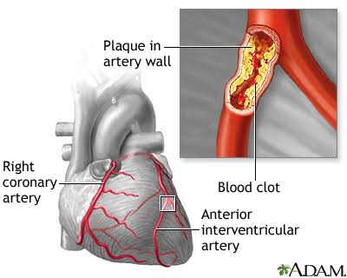
Figure 3: Coronary heart disease, (MedicinePlus, 2024)

Impact on Health and Social Care Provision
CHD imposes a significant and ongoing burden on NH services, starting from primary care treatment of hypertension and hyperlipaidaemia, through to cardiac arrest and heart attack response services, and extended cardiac rehabilitation and secondary prevention medications (Shakya et al., 2025). There are approximately 100,000 admissions for heart attacks per year and CHD is a significant component of the estimated cost of cardiovascular disease in the UK economy, with this increasing as the population ages (British Heart Foundation, 2026b). Cardiac rehabilitation is one of the interventions that is known to reduce repeat events and there is a significant variation in the availability of cardiac rehabilitation in the region and also by deprivation, which could actually increase inequalities, rather than reduce them, as those at most risk is least likely to access the cardiac rehabilitation services that have the highest evidence of benefit (Taylor, Dalal and McDonagh, 2021).

Factors Influencing Health and Wellbeing
In addition to clinical factors, there are broader factors influencing the wellbeing of an individual with CHD and care cannot be viewed solely through a biomedical lens. Anxiety and depression is a psychological response to cardiac events and may be associated with non-adherence to secondary prevention medication and rehabilitation programmes, which in turn may compromise recovery and contribute to the risk of recurrence of cardiac events (Jones et al., 2025). This relationship is important as adherence to medication and rehabilitation attendance are among the strongest predictors of long-term survival after a cardiac event, which makes psychological distress a true clinical risk factor and not a ‘secondary concern'. One other key determinant, especially for older adults living alone after a heart attack or stroke, is social isolation and low levels of support for daily monitoring, medication management and emotional coping are consistently linked to poorer outcomes. This is made even more difficult when dealing with other medical conditions like diabetes or chronic kidney disease, which make treatments more complex and require more care, especially if there is a lack of health literacy or social support. All of these factors suggest that the psychological and social dimensions of wellbeing play an integral part of recovery from CHD and should not be, and often are not, considered as an additional 'add-on' component. The implications for cardiac rehabilitation services design are that programmes that allow for greater psychological support and social prescribing will be more likely to have long-term benefits than those that are purely physical, especially for older people, those living alone and those with multiple long-term conditions.

Conclusion
CHD is the primary cause of mortality and one of the biggest non-communicable disease burdens in the world, particularly in deprived areas and creating a constant challenge for health and social care services. Effective intervention at this level will require an intervention strategy that works on more than just individual behaviour change or clinical treatment. Policy makers should be advised to: Make food reformulation targets mandatory not voluntary; Make the continuation of tobacco control measures a priority; Ensure there is greater investment in prevention, including increasing uptake of NHS Health Check in deprived areas, not where it is easiest to access; To ensure cardiac rehab and secondary prevention services are resourced equitably across regions, not where they are easiest to access. Unless structural and environmental factors that contribute to CHD are dealt with, alongside clinical management, prevalence and inequalities will be likely to continue to be high.

References
British Heart Foundation (BHF) (2026a) Global Cardiovascular Disease Factsheet. London: BHF. Available at: https://www.bhf.org.uk/-/media/files/for-professionals/research/heart-statistics/bhf-cvd-statistics-global-factsheet-jan26.pdf (Accessed: 11 August 2026).
British Heart Foundation (BHF) (2026b) England Cardiovascular Disease Factsheet. London: BHF. Available at: https://www.bhf.org.uk/-/media/files/for-professionals/research/heart-statistics/bhf-cvd-statistics-england-factsheet-jan26.pdf (Accessed: 11 August 2026).
Cleveland Clinic (2023). Coronary artery disease. [online] Cleveland Clinic. Cleveland Clinic. Available at: https://my.clevelandclinic.org/health/diseases/16898-coronary-artery-disease [Accessed 11 Aug. 2026].
El-Baz, A.S. and Suri, J. (2021). Cardiovascular and coronary artery imaging. Elsevier.
Garrett, B.E., Dube, S.R., Babb, S. and McAfee, T. (2014). Addressing the social determinants of health to reduce tobacco-related disparities. Nicotine & Tobacco Research, [online] 17(8), pp.892–897. doi:10.1093/ntr/ntu266.
Jones, D.L., Yue, J., Nguyen, T.N., Ahmad, F. and Chow, C.K. (2025). Impact of depression on medication non-adherence in coronary artery disease: A systematic review and meta-analysis. Open Heart, [online] 12(2), p.e003680. doi:10.1136/openhrt-2025-003680.
Liang, Y.Y., Chen, Y., Feng, H., Xue, H., Nie, Y., Ai, Q.-Y.H., Ma, J., Yang, L., Zhang, J. and Ai, S. (2023). Social isolation, loneliness and subsequent risk of major adverse cardiovascular events among individuals with type 2 diabetes mellitus. General Psychiatry, [online] 36(6), p.e101153. doi:10.1136/gpsych-2023-101153.
Marmot, M., Allen, J., Boyce, T., Goldblatt, P. and Morrison, J. (2020) Health Equity in England: The Marmot Review 10 Years On. London: Institute of Health Equity.
MedicinePlus (2024). Coronary heart disease: MedlinePlus medical encyclopedia. [online] medlineplus.gov. Available at: https://medlineplus.gov/ency/article/007115.htm [Accessed 11 Aug. 2026].
National Institute for Health and Care Excellence (NICE) (2023) Cardiovascular disease: risk assessment and reduction, including lipid modification (NG238). London: NICE.
NHS (2024). Symptoms - coronary heart disease. [online] NHS. Available at: https://www.nhs.uk/conditions/coronary-heart-disease/symptoms/ [Accessed 11 Aug. 2026].
NHS England (2025) NHS Health Check. Available at: https://www.nhs.uk/conditions/nhs-health-check/ (Accessed: 11 August 2026).
Ratnasabesar, V. and Kunadian, V. (2026). Health inequalities across England and their impact on cardiovascular diseases. Heart, [online] pp.heartjnl-2025–327508. doi:10.1136/heartjnl-2025-327508.
Shakya, S., Shrestha, A., Robinson, S., Randall, S., Mnatzaganian, G., Brown, H., Boyd, J., Xu, D., Man, C., Brumby, S., Peeters, A., Lucas, J., Gauci, S., Huxley, R., O’Neil, A. and Gao, L. (2025). Global comparison of the economic costs of coronary heart disease: A systematic review and meta-analysis. BMJ Open, [online] 15(1), pp.e084917-e084917. doi:10.1136/bmjopen-2024-084917.
Su, X., Zhang, Y., Zhou, H., Ma, F., Jin, X., Bai, Y., Wei, W., Zhang, X. and Zhou, M. (2024). Perceived determinants of health-related behaviors among patients with coronary heart disease after percutaneous coronary intervention: A longitudinal qualitative study. Patient preference and adherence, Volume 18, pp.591–606. doi:10.2147/ppa.s452943.
Taylor, R.S., Dalal, H.M. and McDonagh, S.T.J. (2021). The role of cardiac rehabilitation in improving cardiovascular outcomes. Nature Reviews Cardiology, 19(3), pp.1–15.
World Health Organisation (WHO) (2024) The top 10 causes of death. Geneva: WHO. Available at: https://www.who.int/news-room/fact-sheets/detail/the-top-10-causes-of-death (Accessed: 11 August 2026).
Xu, L., Zhai, X., Shi, D. and Zhang, Y. (2024). Depression and coronary heart disease: Mechanisms, interventions, and treatments. Frontiers in psychiatry, 15. doi:10.3389/fpsyt.2024.1328048.

