University of Wales Trinity Saint David

School of Engineering



Design and Analysis of Extended Surfaces

Advanced Thermofluid Mechanics

ACMA6011

Rachel Williams

2208603

April 2026

Contents

1 Contents 2
2 Introduction 3
3 Literature Review 4
3.1 Applications of Extended Surfaces 4
3.2 Extended Surfaces in Micro-Processors 6
4 Fin Parameter ($mL$) and Its Role in Heat Transfer Performance 8
5 Numerical Analysis 10
6 Conclusions 14
7 References 15
8 Appendices 17
8.1 Appendix 1 17
8.2 Appendix 2 17

Figure 1 – Depiction of Automotive Radiator (Yadav & Raj Singh, 2011) 4
Figure 2 – Heat Transfer Ratio as a Function of $mL$ 9
Figure 3 – Temperature Distribution for Handles of 200mm Length 11
Figure 4 - Temperature Distributions for Handles of Optimised Length 12

Introduction
Effective thermal management is an essential design consideration in many engineering applications, such as large-scale industrial systems to compact electronic devices. A key method of enhancing heat transfer is the use of extended surfaces, which increase the available surface area for convection, as such increases the heat transfer rate of the system. Over time, fin-based designs have evolved significantly, driven by the need for higher heat loads, reduced spatial constraints, and improved system reliability.
This report explores the principles and applications extended surfaces through theoretical analysis. A review of existing literature highlights the development of fin technologies in automotive radiators and micro-electronic cooling systems, illustrating how advances in material selection and geometric design have enabled increasingly efficient heat exchangers. The governing equations for fin performance are then examined, with particular focus on the dimensionless parameter $mL$, which characterises the balance between conduction and convection. The concept of an optimal fin length is introduced, demonstrating how near-maximum heat transfer can be achieved without unnecessary increases in size.
To apply these principles, a numerical analysis is conducted on a saucepan handle modelled as a fin. The study evaluates different materials to determine their thermal performance and suitability under practical constraints.

Literature Review

Applications of Extended Surfaces
Early automotive radiators were relatively simple in construction, offering limited heat dissipation. As engine power outputs increased, improved heat transfer became essential. This led to the development of fin-and-tube heat exchangers, now widely used in automotive, refrigeration, and power plants (Reshaeel et al., 2024; Sadeghianjahromi & Wang, 2021; Shah & Gaurvadkar, 2023).
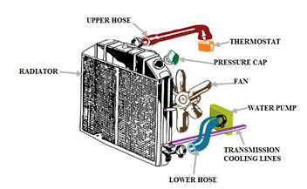
Figure 1 – Depiction of Automotive Radiator (Yadav & Raj Singh, 2011)
An example of a general depiction for an automotive heat exchanger can be seen in Figure 1. In these systems, a hot fluid flows through a network of tubes while a cooler fluid flows over externally attached fins. These systems increase surface area via fins, enhancing convective heat transfer and disrupting boundary layer flows to improve performance (Reshaeel et al., 2024). This transition marked a critical shift from simple heat exchangers to more efficient, surface enhanced designs.
For a uniform fin, temperature decays exponentially along its length, as can be seen in Equation 1.
Equation 1 –(Incropera et al., 2017)
$$T_{L}=T_{∞}+\frac{\left(T_{B}-T_{∞}\right)}{cosh⁡(mL)}$$
Where $T_{L}$ is the temperature at length $L$ ($m$), $T_{∞}$ ($°C$) is the temperature of the environment that is unaffected by the base temperature, $T_{B}$ ($°C$), and $m$ is the fin performance factor ($m$).
The fin performance parameter, $m$, depends on the convective heat transfer coefficient $h (W m^{-2} K^{-1}$), the thermal conductivity of the fin material $k$ ($W m^{-1} K^{-1}$), , and the ratio of the fin perimeter $P$($m$) to its cross-sectional area $A_{C}$ ($m^{2}$). The relationship for which is shown in Equation 2 (Almendros-Ibáñez et al., 2015).
Equation 2 - (Almendros-Ibáñez et al., 2015)
$$m=\sqrt{\frac{hP}{kA_{C}}}$$
These relationships highlight an important consideration within fin design, increasing fin size improves surface area, but effectiveness declines if conduction is insufficient. Modern radiator design therefore optimises fin geometry, spacing and materials, to enhance heat transfer while adhering to spatial constraints.
From the early 1900s through to the 1970s, radiators were predominantly manufactured from copper and brass due to their high thermal conductivity (Copper Development Association Inc., 2013). Aluminium later began to gain popularity, due to lower weight, cost, and improved manufacturability, enabling thinner and denser fins (Copper Development Association Inc., 2013).
The evolution of fin design has also been significant, reflecting advances in manufacturing capabilities and the understanding of fluid flow behaviour. Early fin configurations were relatively simple and widely spaced, which limited their effectiveness. For example, Sadeghianjahromi & Wang (2021) describe plain fins as being easy to manufacture, durable, and straightforward in design. These fins are typically produced by punching holes into flat plates to accommodate tubes carrying the hot fluid, allowing heat to be transferred to the surrounding cooler fluid. However, due to their simple geometry, the airflow over plain fins remains largely uninterrupted, resulting in relatively low levels of turbulence and, consequently, lower convective heat transfer performance compared to more advanced designs.
Advances in manufacturing capabilities and understanding of fluid dynamics have enabled the development of more complex geometries, including louvred, wavy and offset strip fins, which are now commonly employed in modern heat exchangers (Sadeghianjahromi & Wang, 2021). These designs promote local flow mixing and turbulence increasing the convective heat transfer coefficient without substantially increasing the size of the heat exchanger (Yadav & Raj Singh, 2011). As highlighted by Yadav & Raj Singh (2011), the increasing demand for higher engine performance, coupled with restricted space within modern vehicle design, has driven the optimisation of fin configurations to maximise heat transfer within compact volumes.
The importance of these developments is emphasised by the critical role of thermal management in preventing engine failure. Inadequate heat dissipation can lead to excessive temperatures, resulting in thermal expansion of engine components and reduced lubrication of engine oil due to its decreased viscosity at higher temperatures, ultimately leading to mechanical failure (Mukkamala, 2017; Yadav & Raj Singh, 2011). The incorporation of optimised finned structures within radiators enables efficient heat removal through a continuous cooling cycle, in which coolant absorbs heat from the engine and releases it to the surrounding air via the extended surfaces (Yadav & Raj Singh, 2011).

Extended Surfaces in Micro-Processors
The application of extended surfaces has become increasingly important in the thermal management of modern electronic devices, driven by the need to dissipate high heat fluxes within increasingly compact geometries. As highlighted by Ismail et al. (2024), extended surfaces are widely employed in electronic systems due to their relatively low cost and their effectiveness in promoting heat transfer. Their use is further justified by the significant impact of elevated operating temperatures on device performance and reliability, making efficient thermal management a critical design consideration.
As electronic devices have continued to advance, with increasing processing power and miniaturisation, traditional cooling methods such as conventional forced convection have approached their practical limits (Ahmed et al., 2018). This has necessitated the development of more advanced thermal management strategies. Ahmed et al. (2018) emphasise the severity of thermal constraints in such systems, noting that even a marginal increase of 1°C above the maximum operating temperature can results in a substantial reduction in device lifespan. This highlights the sensitivity of micro-electronic systems to temperature variations and the need for highly efficient heat dissipation techniques.
In response to these challenges, extended surfaces have been extensively integrated into micro-electronic design, including applications in microprocessors, Micro-Electro-Mechanical systems (MEMS), laser diode arrays, and light-emitting diodes (LEDs) (Ahmed et al., 2018). In particular, microchannel heat sinks (MCHS) represent a significant advancement in extended surface technology. These systems utilise arrays of microscale channels, effectively acting as highly dense fin structures, to maximise surface area for heat transfer while requiring minimised volumes. This enables substantial heat removal rates while maintaining compact device dimensions.
The advantages of MCHS extend beyond thermal performance. Their compact design reduces the overall size of the heat exchanger, which in turn decreases material usage and the volume of cooling fluid require, contributing to lower manufacturing costs and reduced environmental impact (Ahmed et al., 2018). Furthermore, the high surface-area-to-volume ratio inherent in micro-scaled extended surfaces enhances convective heat transfer, making them particularly suitable for high heat flux applications.
More recent developments have explored the use of porous metal structures as advanced extended surfaces within electronic cooling systems. As identified by Ahmed et al. (2018), porous materials significantly increase the effective surface area available for heat transfer while simultaneously promoting local fluid mixing and turbulence. This enhances the convective heat transfer coefficient and improves overall thermal performance. The incorporation of such structures represents a shift towards more complex, three-dimensional extended surface geometries, design to maximise heat transfer within constrained volumes.
Overall, the evolution of extended surfaces in microelectronic applications demonstrates a clear progression from conventional cooling approaches towards highly optimised, compact, and surface enhanced designs. This transition has been driven by increasing thermal loads, stringent space limitations, and the demand for improved device reliability. Modern cooling solutions, including MCHS and porous structures, exemplify the continued advancement of extended surface technology in meeting these challenges.

Fin Parameter ($mL$) and Its Role in Heat Transfer Performance
The dimensionless parameter $mL$ characterises fin performance by balancing conduction and convection. As $mL$ increases, heat transfer improves but eventually reaches diminishing returns.
For an adiabatic tip;
Equation 3 – Heat Transfer Rate of Adiabatic Tip of Finite Length (Incropera et al., 2017)
$$Q_{finite}=\sqrt{hPkA_{c}}θ_{b}\tanh\left(mL\right)$$
Equation 4 – Heat Transfer Rate of Adiabatic Tip of Infinite Length (Incropera et al., 2017)
$$Q_{∞}=\sqrt{hPkA_{c}}θ_{b}$$
Equation 5 – Ratio of Heat Transfer
$$\frac{Q_{finite}}{Q_{∞}}=tanh⁡(mL)$$

Combining Equations 3 and 4 yields Equation 5. This relationship shows that performance approaches a maximum asymptotically. A value of $mL≈2.65$ achieves ~99% of maximum heat transfer, making it a widely accepted design optimum (Lienhard, 2024).
To investigate this behaviour, the ratio of heat transfer from a finite fin to that of an infinitely long fin, $Q_{finite}/Q_{∞}$, can be evaluated as a function of $mL$. By analysing this relationship over a range of $mL$ values, it is possible to identify an optimal design point at which the achieves near-maximum thermal performance without unnecessary increases in size. At this point, the fin achieves most of the heat transfer capability of an infinitely long fin, while maintaining a finite and practical length.
The analysis presented within this section is based on several simplifying assumptions commonly employed within heat transfer calculations. These include steady-state heat transfer, one-dimensional temperature variation along the length of the fin, and constant thermal conductivity of the fin material. Additionally, the convective heat transfer coefficient is assumed to the uniform along the fin surface, implying consistent fluid flow conditions. The fin is also assumed to have a constant cross-sectional area and perimeter, and heat transfer is considered to occur primarily through convection, with heat loss through radiation deemed negligible. Boundary conditions further assume a constant base temperature and perfect thermal contact at the fin base, as well as an adiabatic tip. These assumptions have been deemed suitable for the review of fin performance (Krishnayatra et al., 2020).
Equation 5 forms the basis of the analysis conducted in this section. This relationship is implemented within the MATLAB code provided in Appendix 1 to evaluate the variation of fin performance with respect to the dimensionless parameter $mL$. The resulting expression describes the ratio of heat transfer from a finite fin to that of an infinitely long fin, and is represented as a hyperbolic function.
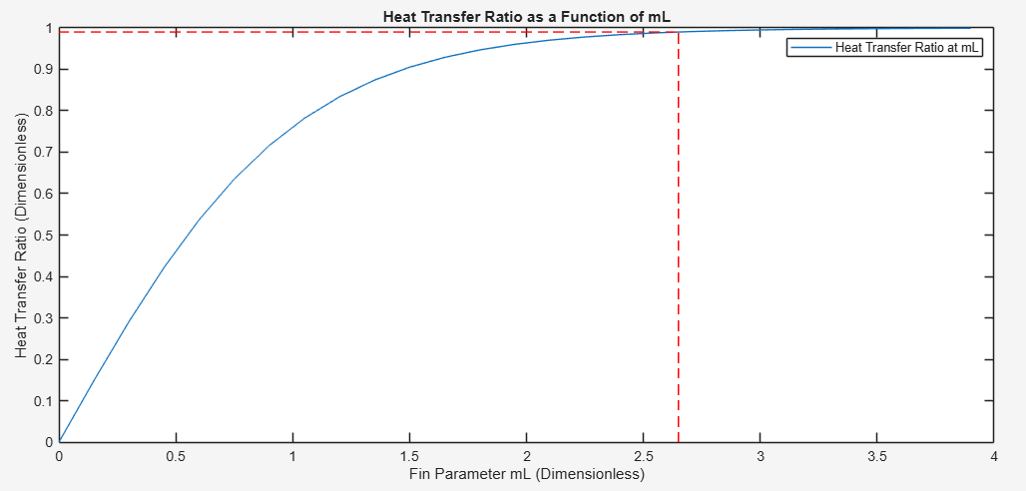
Figure 2 – Heat Transfer Ratio as a Function of $mL$
Figure 2 shows the change in heat transfer ratio as a function of $mL$, where 0.99 is highlighted as well as where this point intersects the graph.
The computational analysis yields an optimal value of $mL=2.6467$, which is in close agreement with the widely accepted design guidline of $mL≈2.65$. This confirms the validity of the analytical approach and demonstrates the practical applicability of the optimisation criterion in fin design.

Numerical Analysis
This analysis evaluates heat transfer along a saucepan handle under boiling conditions, modelling the handle as a rectangular fin. The base system is a copper saucepan, with the handle dimsions 30mm x 5mm and a length of 200mm. Four materials (copper, brass, aluminium and steel) are assessed for their suitability. A uniform surface heat transfer coefficient of 7.5 $W m^{-2} K^{-1}$ is applied across all materials. The ambient temperature is assumed to be 22°C, while the base temperature of the handle is taken as 100°C. The fin tip is considered adiabatic, meaning no heat loss occurs at the free end.
Several simplifying conditions are adopted. Heat transfer is treated as steady state with one-dimensional conduction along the handle. The convective heat transfer coefficient is assumed constant, and both cross-sectional area and perimeter remain uniform. Radiative heat transfer is neglected, as convection dominates under these conditions. These assumptions enable analytical modelling while maintaining reasonable accuracy.
Copper is commonly used in cookware due to its high thermal conductivity, which allows rapid and uniform heat distribution. This justifies the assumption of a 100°C base temperature.
A MATLAB model (Appendix 2), developed using Equations 1 and 2, was used conduct this numerical analysis.
The calculated temperatures for the tip of the handles are displayed in Table 1.
Table 1 – Temperature at Free end of the Handles
Material | Temperature at L (°C)
Copper | 87.6900
2024 Aluminium Alloy | 79.2963
Brass (70 Cu/30 Zn) | 65.4680
304 Stainless Steel | 29.3345

According to BS EN 12983-1, cookware handles temperatures must not exceed 55°C (BSI Standards, 2023). Only stainless steel satisfies this requirement at the given length, making it the only material that would be safe for manufacture.
Displayed in Table 2 is the calculated values for heat loss of a 200mm handle and a handle of optimised length, based on a fin parameter of 2.65.

Table 2 – Heat Loss for Original and Optimised Lengths of Handles
Material | Heat Loss for Length of 0.2m (W) | Heat Loss for Optimised Length (W)
Copper | 7.3231 | 13.447
2024 Aluminium Alloy | 6.7246 | 9.8121
Brass (70 Cu/30 Zn) | 5.7185 | 6.8187
304 Stainless Steel | 2.6689 | 2.6689

Copper and aluminium exhibit significant increases in heat loss when extended to their optimum lengths, reflecting their high thermal conductivity. Brass shows a smaller increase, while stainless steel remains unchanged, indicating that its optimal length is already achieved within the 200mm length. This behaviour is consistent with its lower thermal conductivity, which limits heat transfer sensitivity to length.
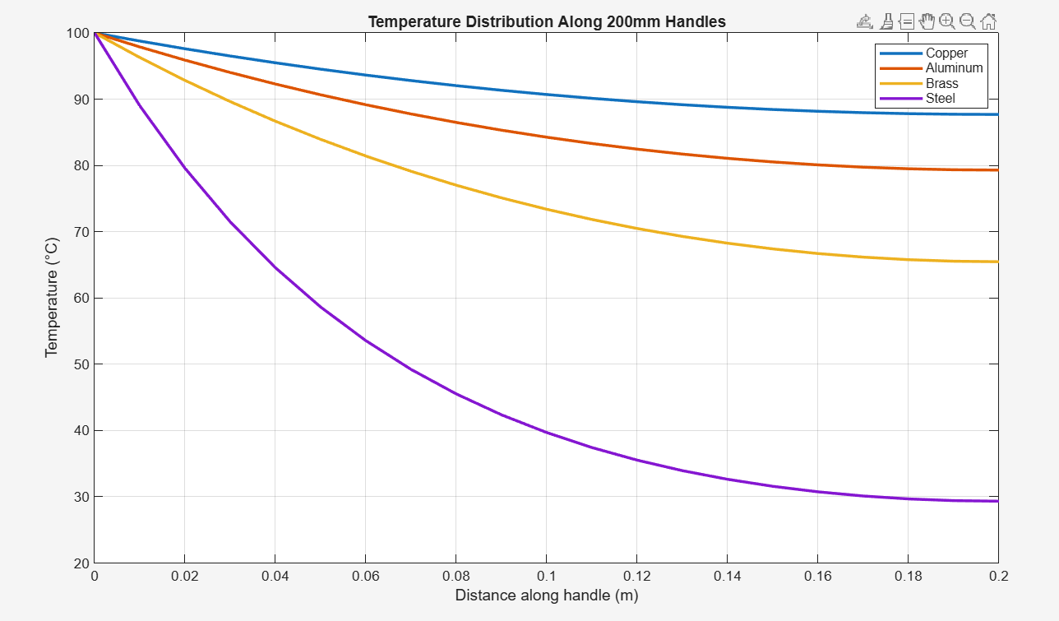
Figure 3 – Temperature Distribution for Handles of 200mm Length
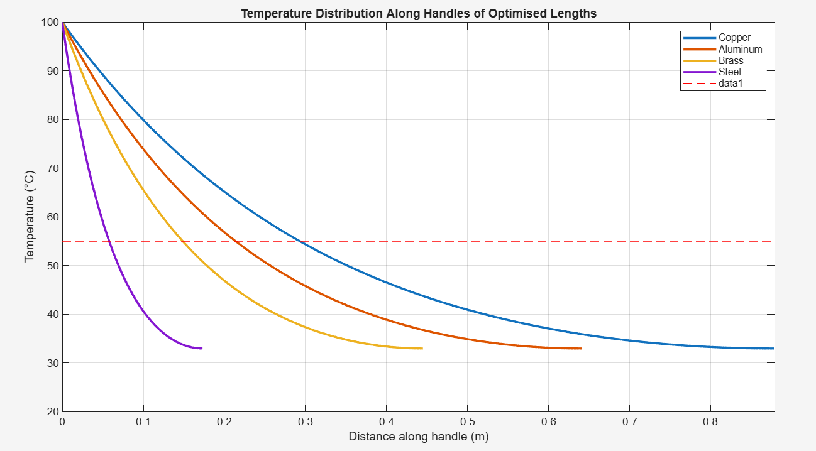
Figure 4 - Temperature Distributions for Handles of Optimised Length
The temperature distributions, shown in Figures 3 and 4, show clear differences between materials. Stainless steel demonstrates the sharpest drop in temperature along the length of the handle, due to its low thermal conductivity, restricting heat flow from the base.
Contrastingly, copper, brass, and aluminium conduct heat more efficiently, producing higher temperatures along the handles, which render them inappropriate material choices for this application. For optimised lengths, these materials can achieve tip temperatures below the 55°C limit, however, this requires significantly extended handles, introducing practical limitations. According to kaylamind.net (2024) typical saucepan handles range between 150mm and 200mm, meaning such extended lengths are generally impractical.
Table 3 – Minimum Lengths for 55°C at Free End of Handle
Material | Minimum Length (mm)
Aluminium | 364.3
Steel | 98.5
Brass | 253.2
Copper | 499.2

The values displayed in Table 3 indicate the minimum handle lengths required for each to achieve a tip temperature of 55°C. These results further reinforce stainless steel as the only viable material option, as it achieved the required temperature limit within a comparatively short and practical handle length. Although brass approaches feasibility, it still exceeds typical lengths, and even at 253.2mm, only the tip satisfies the temperature constraint, while sections closer to the base, where the handle would be gripped, would remain above safe handling temperatures. Copper and aluminium require substantially greater lengths to meet the same criterion, rendering them unsuitable for this application due to impractical design requirements.

Conclusions
This study has examined the role of extended surfaces in enhancing and controlling heat transfer across a range of engineering applications, with particular emphasis on their theoretical foundations and practical performance. A review of automotive and micro-electronic cooling systems demonstrated how fin-based heat exchangers have evolved in response to increasing thermal demands, tighter spatial constraints, and advances in manufacturing. These developments have led to increasingly optimised geometries and material selections that improve convective heat transfer while maintaining compact and efficient designs.
The governing fin equations and the dimensionless parameter $mL$ were then used to evaluate thermal performance. The analysis showed that while increasing fin length improves heat dissipation, benefits diminish beyond an optimal length. The widely accepted value of $mL≈2.65$ was confirmed as an effective design guideline, providing near-maximum heat transfer without unnecessary material usage or size increases.
The numerical analysis of saucepan handles further demonstrated the practical implications of these principles. Modelling the handle as a fin revealed significant differences in thermal performance between materials. Materials with high values for thermal conductivity, such as copper and aluminium produced excessive heat transfer along the handle, leading to unsafe surface temperatures unless impractically long geometries were used. In contrast, stainless steel consistently limited heat transfer, maintaining safe temperatures while maintaining typical handle lengths.
Overall, the findings emphasise that effective thermal design requires a balance between conductivity, geometry, and application requirements. While high-conductivity materials are advantageous for heat transfer systems, lower conductivity materials are more suitable where thermal insulation is required.

References
Ahmed, H. E., Salman, B. H., Kherbeet, A. S., & Ahmed, M. I. (2018). Optimization of thermal design of heat sinks: A review. In International Journal of Heat and Mass Transfer (Vol. 118, pp. 129–153). Elsevier Ltd. https://doi.org/10.1016/j.ijheatmasstransfer.2017.10.099
Almendros-Ibáñez, J. A., Belmonte, J. F., & Molina, A. E. (2015). Fins with a prescribed temperature at the tip: Efficiency and effectiveness expressions. Applied Thermal Engineering, 91, 447–455. https://doi.org/10.1016/j.applthermaleng.2015.08.044
BSI Standards. (2023). BS EN 12983-1:2023. https://www.en-standard.eu/bs-en-12983-1-2023-cookware-domestic-cookware-for-use-on-top-of-a-stove-cooker-or-hob-general-requirements/
Copper Development Association Inc. (2013). History of Car and Truck Radiators. https://www.copper.org/applications/automotive/radiators/no_flux_history.html
Incropera, F., DeWitt, D., Bergman, T., & Lavine, A. (2017). Fundamentals of Heat and Mass Transfer (8th ed.). John Wiley & Sons.
Ismail, M., Manasrah, A., Ali, A. M., & Abedalaziz, M. (2024). Hydrothermal performance of a heat sink using Plate-fins: Experimental and numerical investigations. International Journal of Thermofluids, 23. https://doi.org/10.1016/j.ijft.2024.100813
kaylamind.net. (2024, August 7). Saucepan Handles: The Ultimate Guide to Understanding Their Design and Functionality. https://kaylamind.net/why-are-saucepan-handles/
Krishnayatra, G., Tokas, S., & Kumar, R. (2020). Numerical heat transfer analysis & predicting thermal performance of fins for a novel heat exchanger using machine learning. Case Studies in Thermal Engineering, 21. https://doi.org/10.1016/j.csite.2020.100706
Lienhard, J. H. (2024). A Heat Transfer Textbook, 6th edition (6th ed.). Phlogiston Press.
Mukkamala, Y. (2017). Contemporary trends in thermo-hydraulic testing and modeling of automotive radiators deploying nano-coolants and aerodynamically efficient air-side fins. In Renewable and Sustainable Energy Reviews (Vol. 76, pp. 1208–1229). Elsevier Ltd. https://doi.org/10.1016/j.rser.2017.03.106
Reshaeel, M., Abdelsamie, M. M., & Ali, M. I. H. (2024). A critical review of the thermal-hydraulic performance of fin and tube heat exchangers using statistical analysis. In International Journal of Thermofluids (Vol. 24). Elsevier B.V. https://doi.org/10.1016/j.ijft.2024.100858
Sadeghianjahromi, A., & Wang, C.-C. (2021). Heat transfer enhancement in fin-and-tube heat exchangers – A review on different mechanisms. In Renewable and Sustainable Energy Reviews (Vol. 137). Elsevier Ltd. https://doi.org/10.1016/j.rser.2020.110470
Shah, A. P., & Gaurvadkar, A. (2023). Design and development of automotive radiator for better cooling efficiency. Materials Today: Proceedings, 72, 1028–1034. https://doi.org/10.1016/j.matpr.2022.09.153
Yadav, J., & Raj Singh, B. (2011). Study on Performance Evaluation of Automotive Radiator. A Journal of Physical Sciences, Engineering and Technology, 2(2), 2229–7111. https://doi.org/18090/samriddhi.v2i2.1604

Appendices

Appendix 1
clear
clc
close all

mL=0:0.1:4;
ratio=tanh(mL);
ratioopt=0.99;
mLopt=atanh(0.99)
plot(mL,ratio);
xlabel('Fin Parameter mL (Dimensionless)')
ylabel('Heat Transfer Ratio (Dimensionless)')
title('Heat Transfer Ratio as a Function of mL')
hold on
plot([mLopt mLopt], [0 ratioopt],'r--')
hold on
plot([0 mLopt], [ratioopt ratioopt], 'r--')
legend('Heat Transfer Ratio at mL')

Appendix 2
%workspace mangement
close all
clc
clear

%Defining material properties
width=30e-3;
depth=5e-3;
P=(width*2)+(depth*2);
Ac=width*depth;
L=200e-3;
h=7.5;
Tinf=22;
Tb=100;
kcu=385;
kal=205;
kbr=99;
kst=15;
%part 1
%copper
mcu=sqrt((h*P)/(kcu*Ac));
TLcu=Tinf+((Tb-Tinf)/cosh(mcu*L))

%al
mal=sqrt((h*P)/(kal*Ac));
TLal=Tinf+((Tb-Tinf)/cosh(mal*L))

%br
mbr=sqrt((h*P)/(kbr*Ac));
TLbr=Tinf+((Tb-Tinf)/cosh(mbr*L))

%st
mst=sqrt((h*P)/(kst*Ac));
TLal=Tinf+((Tb-Tinf)/cosh(mst*L))

%Part 2
x=0:10e-3:L;
Txcu=Tinf+(Tb-Tinf).*(cosh(mcu*(L-x))./cosh(mcu*L));
Txal=Tinf+(Tb-Tinf).*(cosh(mal*(L-x))./cosh(mal*L));
Txbr=Tinf+(Tb-Tinf).*(cosh(mbr*(L-x))./cosh(mbr*L));
Txst=Tinf+(Tb-Tinf).*(cosh(mst*(L-x))./cosh(mst*L));

figure('Name', 'Figure 1')
plot(x, Txcu, 'LineWidth',2);
hold on
plot(x, Txal, 'LineWidth',2);
hold on
plot(x, Txbr, 'LineWidth',2);
hold on
plot(x, Txst, 'LineWidth',2);
colororder("gem");
xlabel('Distance along handle (m)');
ylabel('Temperature (°C)');
title('Temperature Distribution Along 200mm Handles');
legend('Copper', 'Aluminum', 'Brass', 'Steel');
hold on
plot([0 0.2], [55 55],'r--')
grid on

%part 3
Qcu=sqrt(h*P*Ac*kcu)*(Tb-Tinf)*(tanh(mcu*L));
Qal=sqrt(h*P*Ac*kal)*(Tb-Tinf)*(tanh(mal*L));
Qbr=sqrt(h*P*Ac*kbr)*(Tb-Tinf)*(tanh(mbr*L));
Qst=sqrt(h*P*Ac*kst)*(Tb-Tinf)*(tanh(mst*L));

%part 4
L_cu=2.65/mcu;
L_al=2.65/mal;
L_br=2.65/mbr;
L_st=2.65/mst;
Q_cu=sqrt(h*P*Ac*kcu)*(Tb-Tinf)*(tanh(mcu*L_cu));
Q_al=sqrt(h*P*Ac*kal)*(Tb-Tinf)*(tanh(mal*L_al));
Q_br=sqrt(h*P*Ac*kbr)*(Tb-Tinf)*(tanh(mbr*L_br));
Q_st=sqrt(h*P*Ac*kst)*(Tb-Tinf)*(tanh(mst*L_st));

Material=["Copper"; "Aluminium Alloy"; "Brass"; "Stainless Steel"]
HeatLoss=[Qcu; Qal; Qbr; Qst]
HeatLossWithOptimalLength=[Q_cu;Q_al;Q_br;Qst]
HeatLossValues=table(Material, HeatLoss, HeatLossWithOptimalLength)

%part 5
xcu=0:1e-3:L_cu;
xal=0:1e-3:L_al;
xbr=0:1e-3:L_br;
xst=0:1e-3:L_st;
Txcu2=Tinf+(Tb-Tinf).*(cosh(mcu*(L_cu-xcu))./cosh(mcu*L_cu));
Txal2=Tinf+(Tb-Tinf).*(cosh(mal*(L_al-xal))./cosh(mal*L_al));
Txbr2=Tinf+(Tb-Tinf).*(cosh(mbr*(L_br-xbr))./cosh(mbr*L_br));
Txst2=Tinf+(Tb-Tinf).*(cosh(mst*(L_st-xst))./cosh(mst*L_st));

figure('Name', 'Figure 2')
plot(xcu, Txcu2, 'LineWidth',2);
hold on
plot(xal, Txal2, 'LineWidth',2);
hold on
plot(xbr, Txbr2, 'LineWidth',2);
hold on
plot(xst, Txst2, 'LineWidth',2);
colororder("gem");
axis([0 L_cu, 20 100])
xlabel('Distance along handle (m)');
ylabel('Temperature (°C)');
title('Temperature Distribution Along Handles of Optimised Lengths');
legend('Copper', 'Aluminum', 'Brass', 'Steel');
hold on
plot([0 0.9], [55 55],'r--')
grid on

%part 6
T=55
Lal=(1/mal)*(acosh((Tb-Tinf)/(T-Tinf)))
Lst=(1/mst)*(acosh((Tb-Tinf)/(T-Tinf)))
Lbr=(1/mbr)*(acosh((Tb-Tinf)/(T-Tinf)))
Lcu=(1/mcu)*(acosh((Tb-Tinf)/(T-Tinf)))

