Engineering design 4008:
1)
A machine tool manufacturer needs to create a new type of drill press to the market where they need to create over 1000 drill presses per week.
So first we must consider what the customer requires for the drill press. From this we will consider the Kano model.
Image (1)
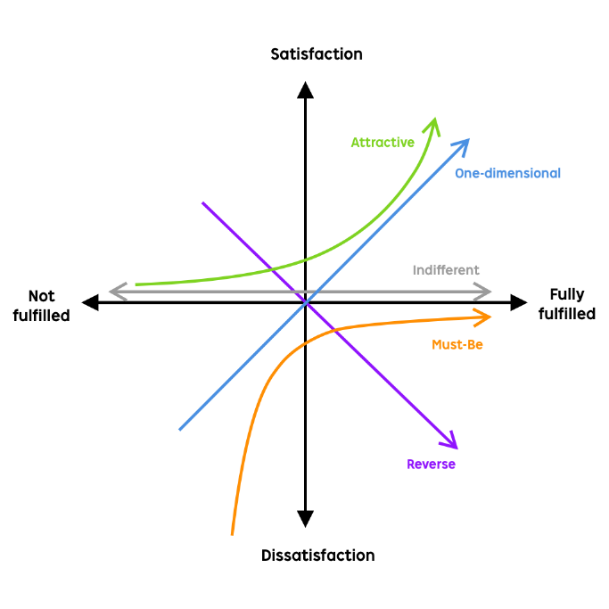
The kano Model is an approach that identifies the features and needs that satisfies the customers. The model will then allow different companies to show the difference and choose between high satisfaction and the cost of implementation. This will determine if adding some of these features and designs is a strategically good decision. (“Customer Delight/satisfaction vs implementation investment”) [3]
The kano Model also will then identify the different features and categories for the Drill press. This includes the Excitement, performance, and Basic features to ensure that they are satisfied with they’re product. With the existing DPMSU design we can identify that this showed a lot of the basic features including the ability to mount a drill, a way to bring the drill down and up. That’s all the feature that the drill press shows. On the DPMSU there isn’t any attractive/ Excitement features so no spring or automatic retraction feature to bring back into the home position.
Once the customer needs of the DPMSU have been shown the functional requirements can now be determined. The functional requirements are what specifies on what the DPMSU must do, this is the ability to hold and clamp the Drill whilst keeping it straight when drilling into the material securely. But the overall functional requirements for the drill press can be more defined and when critiquing the design more functional requirements can be added.

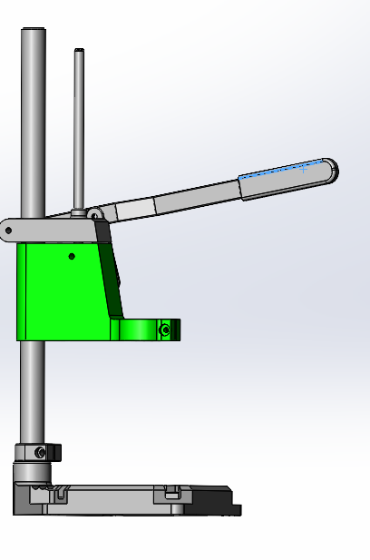
The aesthetic considerations of the DPMSU design are also important. From the design the main sliding unit is flush with the rest of the drill press. The design of the DPMSU is simple and looks pleasing to the eye but this could be improved upon, for example one thing this I would improve upon is create a safety feature on the drill press for example when researching different drill press’s made by other companies it shows that safety shields are a key aesthetic that customer like[6].
From the functional and aesthetic requirements, the serviceability of the Drill Press needs to be identified. Service ability is an important requirement because it allows the DPMSU to have a longer life span of the DPMSU. To allow for this to happen and make it more serviceable and easier to maintain the DPMSU can be done by using fixings and using nuts and bolts. This allows for separate parts to be taken apart and joined back together simply without having parts being difficult to remove which will require more labour and potentially affect the life of the DPMSU.
One consideration that is important to the design and marketing of the DPMSU is the ethical considerations. The ethical considerations include safety standards where designs such as a safety shield which will stop debris flying off which machining. End of life targets, this is important for the consumer since customers would want a press that is strong and can withstand years of use without breaking. Therefore, the serviceability is important to the design of the DPUSM, as having a good design and to have a prolonged life span and ease of use. The safety of the DPMSU is an important ethical choice because when someone feels safer when using the product there is a higher chance that they may purchase the product over one without safety features and ease of use. Again, this would go back to the Kano model which will improve customer satisfaction while keeping the investment cheap for the manufacturer. One of the important considerations that is crucial for all manufacturers to impose and develop is the recyclability of the product once it has reached its end of life. Therefore, the design should be had of a recyclable plastic as this would be cheap to produce and light weight to be able to move the Drill press around.
When producing a new product, it is important to identify the codes of practice when making a drill press. The ethical code of practice is the legal aspects when making a new drill dress. Some of these include Safety features, Pattern infringements, use of drill press and many other ethical practices. For example, when designing the drill press, we need to ensure that the design does not infringe on a certain % of similarity from the patterned drill press to the designed one. If the % of the press is higher than X% then the designer would have to pay a Fee or not be able to use the design unless it is different from the patented design[1]. Another important aspect on the manufacture is to ensure that no child labour is being used when creating the press as this is against all European and most international laws of child labour[2]. When using the drill press there needs to be some types of standards to ensure that operation is suitable for everyday use, for example using a standard supply in most households (240v) instead of higher voltages which will then require extra hardware to be fitted and used.
4 + 6 + 7 + 7 + 5 + 6 = 35 score
7 +2+4+6+2+
7+2+4+6+2+4 = 25 score

[5] Above is a design specification table that shows when using a scoring system from 1-8 and using specific categories will judge the overall design specification. For example, some of these categories will include aesthetics, Cost, Life in service and performance. The higher the score then this will show that there is good quality and high manufacturing standards when producing the drill press mount. This is judge against other design methods, manufacturing and material uses. For example, the two different design specifications that I have choose is injection moulding with plastic, this will ensure that high out put can be achieved. Is light weight and ascetical pleasing for the customer. The other design specification that I have chosen was machining using aluminium. This is a high finish product with a higher life in service compared with using plastic injection moulding. But machining is a slow process and has a high manufacturing cost therefore will not be a suitable manufacturing method. Overall after weighing up all of the scores from both of the design specifications, I chose the first specification as this is more pleasing to the customer as it is cheaper and lighter while maintaining tight tolerances.
3.
When creating the drill press the manufacturing is important as we want to compromise between efficiency of the manufacturing and the quality vs cost of manufacturing. First the material that I am going to be using is a high tensile form of plastic as this would be cheap to manufacturer and will be strong enough to handle the drill press under pressure of working.
The rate at which we need to make the DPMSU is at a rate of 1000 per week. Therefore, the process that I would use is injection moulding. Injection moulding is a process that uses aluminium moulds to inject molten plastic which is compressed into the mould. The advantage with using injection moulding is that it is a cheaper and more efficient process than die casting and machining. But also, able to keep up with the tight tolerances of 0.05mm +/-, Thus have a high quality of manufacturing the high quantities[4].
4.
After creating and developing the design from the previous DPMSU that was designed I have changed a few aspects including rounding off the edges of the drill press. On top of that I have taken the safety of the consumer into consideration therefore in my finished design I have added a safety shield on the bottom of the DPMSU. This will stop any debris from coming into the consumer. So overall I have made a safer design and more aesthetically pleasing design compare with the original DPMSU design. For the consumer this would be more suitable for the consumer as they would feel safer So overall the customer needs using the Kano model does fulfil and excite the customer. But also, the cost of the manufacturing and implementation is low compared with other designs as injection moulding is a cheap process with the ability to have high quality and tolerances. Therefore, we would be able to produce the overall DPMSU at a low cost, thus allowing to sell the drill press at a lower cost. So overall the customer needs using the Kano model does fulfil and excite the customer but allow will have low costs to implement and design

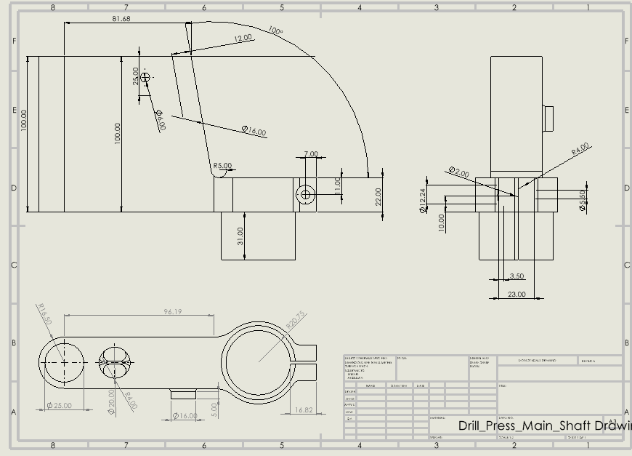

Bibliography
[1] An introduction to patents and patent infringement. (2020). Retrieved from TaylorWessing: https://www.taylorwessing.com/synapse/ip_patentsintro.html
[2] Fotolia., T. /. (2020). A priority for EU human rights action. Retrieved from Child labour: https://www.europarl.europa.eu/RegData/etudes/BRIE/2019/633142/EPRS_BRI(2019)633142_EN.pdf
[3] Kano Model . (n.d.). Retrieved from Productplan: https://www.productplan.com/glossary/kano-model/
[4] Plastic Injection Moulding. (n.d.). Retrieved from PROTOLAB: https://www.protolabs.co.uk/services/injection-moulding/plastic-injection-moulding/
[5] PP Design Specifications. (n.d.). Retrieved from Wordpress: https://isslearningcommons.wordpress.com/middle-years/myp-personal-project/pp-design-specifications/
[6] ReQtest. (2012, April 5th ). Retrieved from Functiona and non functional requirements : https://reqtest.com/requirements-blog/functional-vs-non-functional-requirements/#:~:text=In%20other%20words%2C%20a%20functional,%E2%80%9COpen%20a%20new%20account%E2%80%9D.

