Task 1 A

Written summary on essential academic and employment skills.

Why are essential skills for employment or studying so important?
The reason that essential skills are so important to have is that it will help progress you through your career and educational areas and keep peoples operating at a higher level.
Some of the best skills employers look out for are:
- Communication.
- Collaboration.
- Information literacy.
- Problem solving and decisive skills.
- Creative Thinking.
These skills are both essential employment and educational skills as they will help learners and new workers to adapt and work at a higher level of skill [1].

Essential skills.
Academic success doesn't just rely on good attention and time management skills instead it relies on students learning more complex methods of processing information [2]. One of the most valuable skills to learn especially in computing and other Stem Fields Is Quantitative Literacy, it allows people to learn how to use data to construct compelling articles. It covers areas from gathering and analysing sources to being able to then synthesise that information into a document [3]. This will also help users in the IT workplace to analyse forums and databases [3].
The use of academic skills and the use of digital platforms in university and shows that most students already have some experience in many platforms these are good bases to use in the workplace Aswell.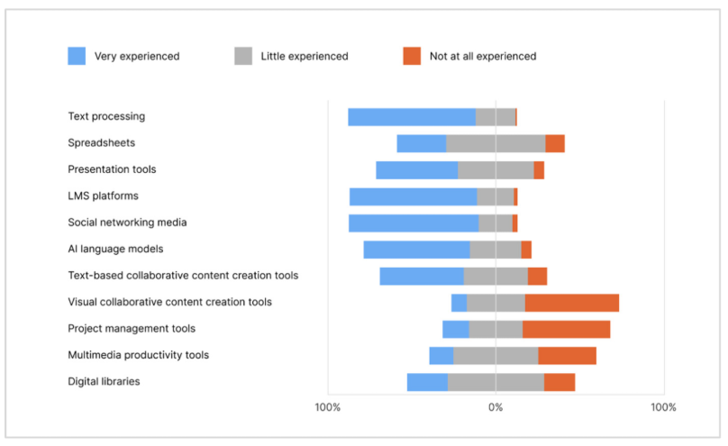
Figure 13. Level of proficiency in using various digital platforms [4].
Conclusion
How the use of the digital platforms and skills will help progress in an IT Role.
As the organisations conform more to the use of IT and cloud ecosystems the development on all these skills has been covered would considerably boost your employability and functionality in any workplace in IT.

Task 1B

Different Ai Assistants and Their Uses
The here AI assistants I will be covering are Chat GPT, Microsoft Copilot, Google Gemini and Adobe Firefly. I Have chosen to cover these as they are ahead of the game when it comes to assisting users in completing basic tasks.

Chat GPT.
Chat GPT has many great uses including Image generation, a coding assistant, a way to compare different products and designs and helping with general research [5].
The best use of Chat GPT would have to be its ability to help users with collecting and digesting data it has many uses including helping students understand the task given to them [5].

Microsoft Copilot.
Copilot assists users by helping draft and edit documents, emails in apps like Outlook or word, it also assists with data analysis and formatting presentations [6].
The best uses of copilot would be allowing uses by being able to assist users in meetings it keeps track makes notes and allows users to revise what has been said [6].

Adobe Firefly.
Adobe firefly consists of a few ai models to help users create and edit images. It offers a collective of features such as text – image creation and generative fill. Moreover, you can also make use of it in other products such as photoshop and illustrator[7].

Microsoft Copilot Uses in the workplace.

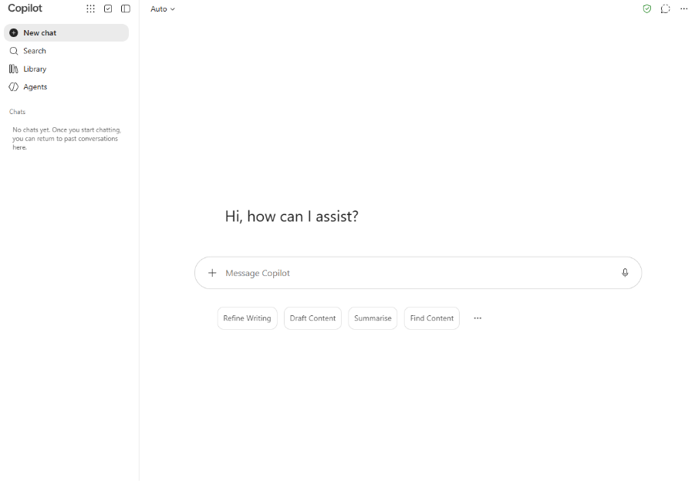
Figure 1 – Copilot Home screen
Copilot has a basic yet efficient home screen allowing the user to ask questions to access the different Microsoft apps and previous searches.

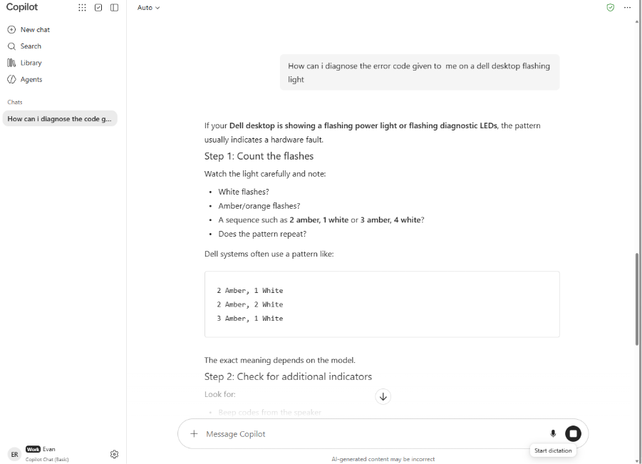 Figure 2 – Copilot Search Example
In the workplace Copilot is used to generate and assist users in many fields for example how to diagnose error messages.

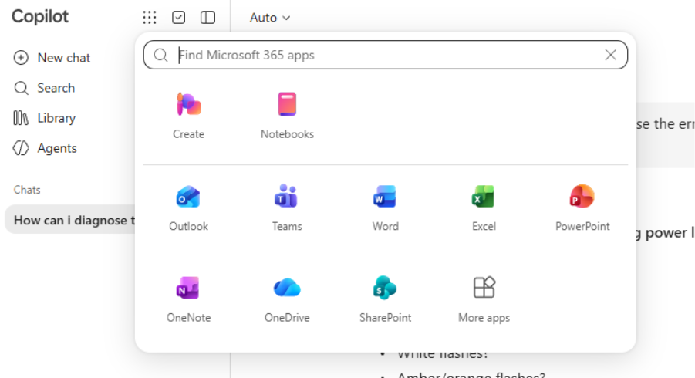 Figure 3 – built in apps
It has built in Microsoft apps into the home page where you can quickly access other Microsoft software making the workplace more efficient.

Citation list:
[1]
B. Jeffreys and H. Rhodes, ‘Six Essential Skills Employers Say Job Seekers Should Have to Stand Out’, BBC News, Aug. 27, 2026. Accessed: Sep. 30, 2026. [Online]. Available: https://www.bbc.co.uk/news/articles/cn9n9n5p9eqo
[2]
‘Essential Academic Skills for Success’, Gemini. [Online]. Available: https://gemini.google.com/share/0dc1a0065547
[3]
C. H. Brock, L. R. Wiest, and L. (Darian) Thrailkill, “Learning Quantitative Literacy: A Sixth-Grade Disciplinary Literacy Unit,” The Reading teacher, vol. 74, no. 6, pp. 733–746, May 2021, Doi: 10.1002/trtr.2008.
[4]
M. S. Georgopoulou, Christos Troussas, Akrivi Krouska, and C. Sgouropoulou, ‘Digital Literacy in Higher Education: Examining University Students” Competence in Online Information Practices’, Computers, vol. 14, no. 12, pp. 528–528, Dec. 2025, doi: 10.3390/computers14120528.
[5] A. Wright, ‘6 ways I like to use ChatGPT’. Accessed: Oct. 05, 2026. [Online]. Available: https://alaniswright.com/blog/6-ways-i-like-to-use
[6] Microsoft, “Copilot top 10 things to try first,” Microsoft 365 Copilot, [Online]. Available: https://www.microsoft.com/en-gb/microsoft-365-copilot/copilot-top-10-things-to-try-first. [Accessed: 05-Oct-2026].
[7] C. Staff, ‘Adobe Firefly: Key Features and Use Cases’, Coursera. Accessed: Oct. 05, 2026. [Online]. Available: https://www.coursera.org/articles/adobe-firefly

